**Hackathon Project Phases Template** for the **AI-Powered Nutrition Science App** project.

# Hackathon Project Phases Template

**Project Title:**

**Advancing nutrition science through gemini ai**

**Team Name:**

Food and science team

**Team Members:**

* A.Manisha
* A.Hruthika sri
* D.Pavani

## Phase-1: Brainstorming & Ideation

**Objective:**

*Personalized Nutrition guidance-using AI to analyze individual health data, genetics and life style to provide tailored dietary recommendation.*

*Using AI to predict risks of conditions like diabetes ,obesity, and cardiovascular dieses based on diet health records*

**Key Points:**

1. **Problem Statement:**

A web-based application designed to provide users with detailed nutritional information about various food items. By leveraging Google Generative AI, the application delivers instant, comprehensive data on macronutrients(protein, fat, carbohydrates), micronutrients(vitamins, minerals),and calorie content. This tool aims to assist individuals in making informed dietary choices and understanding the nutritional value of the food they consume.

1. **Proposed Solution:**

Many individuals struggles with creating healthy and satisfying meals plans that align with their specific needs and preferences. NutriGen addresses this challenge by generating personalized meal plans based on user input. Users can provide information about their dietary restrictions, allergies, health conditions, activity levels and taste preferences. The AI then crafts a week-long meal plan with recipes and grocery lists, ensuring nutritional balance, variety, and enjoyment

**Target Users:**

* **Doctors and Health care providers**
* **Dietitians and Nutritionists**
* **Researches and Academics**
* **Patients with Chronic conditions**

1. **Expected Outcome:**

1.**personalized nutrition plans**-AI-driven meal plans and diet recommendations.

2.**dietry analysis-**automated food tracking, nutrient breakdown, and health insights.

3.**Research and Data insights-**AI-powdered analysis of nutrition trends and health impacts

4.**Food science Innovation-**AI-assisted formulation of healthier ad sustainable food products

5. **Public health reports-** AI-generated policy recommendations and intervention strategies.

**Objective:**

**Key Points:**

1. **Technical Requirements:**

* 1. Programming Language: **Python**

○ Backend: **Google Gemini Flash API**

○ Frontend: **Streamlit Web Framework**

○ Database: **Not required initially (API-based queries)**

1. **Functional Requirements:**

* **Data processing &integration-** Collect, clean, and integrate nutritional data from multiple sources(food data bases , clinical studies , user inputs).
* **AI-powered analysis& recommendation-**Use Gemini AI to analyze dietary patterns, detect deficiencies, and generate personalized nutrition plans.

1. **Constraints & Challenges:**

* **Data quality &availability-**limited or inconsistent nutrional data.
* **Personalization complexity-**adapting to diverse dietary needs.

## Phase-3: Project Design

**Objective:**

Develop the architecture and user flow of the application.

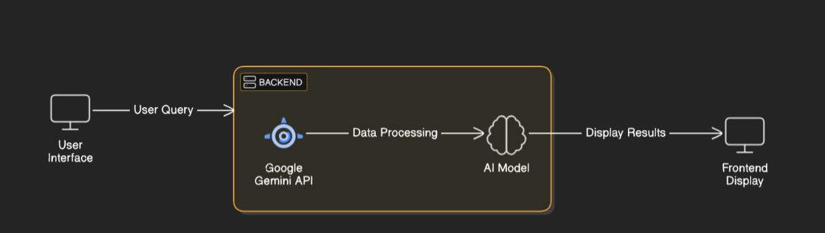

**Key Points:**

1. **System Architecture:**

* **Data layer-**collects and stores nutritional data from food data bases, clinical studies, and user inputs in cloud-based system
* **AI& processing layer-**uses Gemini AI for nutrient analysis, dietary pattern recognition, and personalized recommendations.
* **Application layer-**Provides a web /mobile interface foe users to input data, track nutrition , and receive AI- driven insights
* **Integration layer-**connects with APIs(EHRs, fitness apps) and ensures data security (GDPR/ HIPAA compliance).

1. **User Flow:**

* **User signup &profile setup-**Enter health data and dietary goals
* **Data input &Tracking -**log meals, biometrics, or sync with wearables.
* **AI analysis &insights-** Gemini AI provides personalized nutrition recommendations
* **User dash board and feedback-**view reports , track progress, and refine AI suggestions.

1. **UI/UX Considerations:**

* **Simple intuitive UI-**Easy navigation and data input.
* **Personalized Experience -**Adapts to user goals and preferences .
* **Clear data visualization-**Chats and insights for better understanding .
* **Accessibility and integration-** Responsive design, voice input , and app syncing.

## Phase-4: Project Planning (Agile Methodologies)

**Objective:**

Break down development tasks for efficient completion.

|  |  |  |  |  |  |  |  |
| --- | --- | --- | --- | --- | --- | --- | --- |
| **Sprint** | **Task** | **Priority** | **Duration** | **Deadline** | **Assigned To** | **Dependencies** | **Expected**  **Outcome** |
| Sprint 1 | Environment Setup  & API Integration | 🔴 High | 6 hours  (Day 1) | End of Day  1 | Member 1 | Cloud DB ,python, Gemini  AI | API connection established & working |
| Sprint 1 | Frontend UI Development | 🟡  Medium | 2 hours  (Day 1) | End of Day  1 | Member 2 | API response format finalized | Basic UI with input fields |
| Sprint 2 | Vehicle Search &  Comparison | 🔴 High | 3 hours  (Day 2) | Mid-Day 2 | Member 1& 2 | API response, UI elements ready | Search &recommendation system |
| Sprint 2 | Error Handling &  Debugging | 🔴 High | 1.5 hours  (Day 2) | Mid-Day 2 | Member 1&4 | API logs, user inputs | Improved API stability |
| Sprint 3 | Testing & UI  Enhancements | 🟡  Medium | 1.5 hours  (Day 2) | Mid-Day 2 | Member 2& 3 | API response, UI layout completed | Responsive UI, better user experience |
| Sprint 3 | Final Presentation  & Deployment | 🟢 Low | 1 hour  (Day 2) | End of Day  2 | Entire Team | Working prototype | Demo-ready project |

**Sprint Planning with Priorities**

**Sprint 1 – Setup & Integration (Day 1)**

**(**🔴 **High Priority)** Set up the **environment** & install dependencies.

**(**🔴 **High Priority)** Integrate **Google Gemini AI API** for nutritional analysis.

**(**🟡 **Medium Priority)** Build a **basic UI with input fields**. (e.g., food logging, health data)

**Sprint 2 – Core Features & Debugging (Day 2)**

**(**🔴 **High Priority)** Implement **food** **search & comparison functionalities**.

**(**🔴 **High Priority)** Debug API issues & handle **errors in queries**. **Sprint 3 – Testing, Enhancements & Submission (Day 2)**

**(**🟡 **Medium Priority)** Test AI responses accuracy, refine UI, & fix UI bugs.

**(**🟢 **Low Priority)** Final **demo preparation & deployment**.

## Phase-5: Project Development

**Objective:**

Implement core features of the **AI-Powered Nutrition Science** **App.**

**Key Points:**

1. **Technology Stack Used:**

* 1. **Frontend:** Streamlit

○ **Backend:** Google Gemini Flash API

○ **Programming Language:** Python

1. **Development Process:**

* 1. Implement Ai models, data base, and front-end/back-end components.

1. **Challenges & Fixes:**

* 1. **Challenge:** Inconsistent nutritional from various sources

**Fix:** Use data validation preprocessing , and reliable APIs.

○ **Challenge:** Potential errors in AI-generated recommendations

**Fix:** Train models on diverse data and continual refine with user feedback.

## Phase-6: Functional & Performance Testing

**Objective:**

Ensure that the AutoSage App works as expected.

|  |  |  |  |  |  |
| --- | --- | --- | --- | --- | --- |
| **Test Case ID** | **Category** | **Test Scenario** | **Expected Outcome** | **Status** | **Tester** |
| TC-001 | Functional  Testing | Query "Best foods for vitamin D deficiency" | Relevant food recommendations should be displayed. | ✅ Passed | Tester 1 |
| TC-002 | Functional  Testing | Query "AI meal plan for weight loss” | AI should generate personalized meal plan | ✅ Passed | Tester 2 |
| TC-003 | Performance  Testing | API response time under 500ms | AI should return results quickly. | ⚠ Needs Optimization | Tester 3 |
| TC-004 | Bug Fixes & Improvements | Fixed incorrect nutrient calculations. | Data accuracy should be improved. | ✅ Fixed | Develop er |
| TC-005 | Final Validation | Ensure UI works on mobile& desktop | UI should be fully responsive. | ❌ Failed - UI broken on mobile | Tester 2 |
| TC-006 | Deployment  Testing | Host the app using  Cloud services | App should be accessible online. | 🚀 Deployed | DevOps |

## Final Submission

1. **Project Report Based on the templates**
2. **Demo Video (3-5 Minutes)**
3. **GitHub/Code Repository Link**
4. **Presentation**