**SOPHOMORE**

**Group Members :-**

1. **Hrutvik Desai(1580007)**
2. **Aditya Sahani(1580038)**

**Guide: Mrs. S. Geetha**

**Index : -**

1. **Introduction**
2. **Problem Statement**
3. **Modules**
4. **Block Diagram**
5. **Component Description**
6. **Hardware and Software Requirements**
7. **Applications**
8. **Limitations**
9. **Future Scope**

**System Abstract**

The Sophomore is a management system that can be used by many educational institutes and universities for sophisticated and efficient management of student data. It reduces the efforts and the redundancy which occurs in the manual management of student data. The website Student Information System is aimed towards recording a considerable number of student records and needs online assistance for managing records of students.

1. **Introduction**

The Sophomore management system will help the teachers, students, mentors and authorities of a particular institution to access the information with respect to their roles in a particular institute. It also helps in keeping the track record of which student is associated with which subjects. This might also help in recording the backlog subjects of a particular student. Student Information System will not depend on the availability of any other website. It also authenticates every user through a login page to avoid ungranted access of sensitive information to an intruder. The system will have an administrator who will have full-fledged rights with regards to performing all actions that are needed to control and manage the website. Overall, it will make Student Information Management an easier job for the administrator and the student of any organization.

1. **Problem Statement**

A traditional student management is done manually on paper with written registration and the student information papers need a huge amount of storage and sometimes that too runs out and discarding them is riskier and time-consuming. In our current, introduced student management system, the data is stored in a database which solves the problem of physical storage hence; there is no need of paper. Another problem of a traditional system is that any unauthorised entity who is in the physical reachability of the sensitive student information papers can access and manipulate them but our system could overcome such unreliable shortcomings by providing access to only authorised personnel through a webpage and database authentication mechanism. Another advantage of our system is that searching becomes easy and can be done by just inputting the required entity’s data and the result would be available on the click of a button.

1. **Modules**

**Login :** Login module will help the Users and Administrators to get authenticated by supplying a valid username and a password . After providing a valid username and password they can log on to their respective accounts.

**Search :** This module will help the administrator to search for a particular student by various search criteria like name , roll no , etc.

**Registration module & Account Management :** This module will help the student to get themselves registered from anywhere if internet is available. This module will really simplify the task of subject registration. After successful registration the user can update their accounts, change their passwords, etc.

**User Management :** This module will help the administrator in enabling/disabling a user account and updating user information as required. This module will contain the following the fields:-

Student id, Student password, Student name, Student DOB, etc.

**Subject :** This module will help the user to view the subject he has registered and if he has a backlog in a subject that he had registered.

1. **Block Diagram**

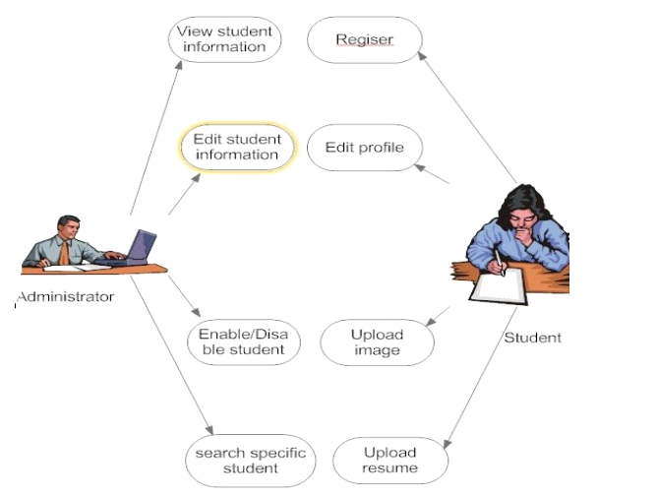

1. **Component Description**

* **PHP :** PHP is a general-purpose scripting language that is especially suited to server side web development where PHP generally runs on a web server. PHP code is embedded into the HTML source document. Any PHP code in a requested file is executed by the PHP runtime, usually to create dynamic web page content. It can also be used for command-line scripting and client-side GUI applications. PHP can be deployed on many web servers and operating systems, and can be used with many relational database management systems (RDBMS). It is available free of charge, and the PHP Group provides the complete source code for users to build, customize and extend for their own use.
* **MySQL :** MySQL is a relational database management system (RDBMS) that runs as a server providing multi-user access to a number of databases. MySQL is a popular choice of database for use in web applications and is an open source product. The process of setting up a MySQL database varies from host to host, however we will end up with a database name, a user name and a password.
* **APACHE :** The Apache HTTP Server is a web server software notable for playing a key role in the initial growth of the World Wide Web. In 2009 it became the first web server software to surpass the 100 million web site milestone. Apache is developed and maintained by an open community of developers under the auspices of the Apache Software Foundation. Since April 1996 Apache has been the most popular HTTP server software in use. As of November 2010 Apache served over 59.36% of all websites and over 66.56% of the first one million busiest websites.
* **XAMPP :** XAMPP is a small and light Apache distribution containing the most common web development technologies in a single package. Its contents, small size, and portability make it the ideal tool for students developing and testing applications in PHP and MySQL. XAMPP is available as a free download in two specific packages: full and lite. While the full package download provides a wide array of development tools, XAMPP Lite contains the necessary technologies that meet the Ontario Skills Competition standards .The light version is a small package containing Apache HTTP Server, PHP, MySQL, phpMyAdmin, Openssl, and SQLite.

1. **(i)Hardware Requirements**

* Intel Pentium IV processor or equivalent or higher
* 512 MB Ram or Higher
* 20 GB HDD or Higher
* Network Connectivity

**(ii)Software Requirements**

* PHP 5.0
* APACHE HTTP Server
* Dreamweaver, FrontPage for Front End Programming
* Microsoft Windows or Linux

1. **Applications**

* It can be used by educational institutes or colleges to maintain the records of students easily.
* It will be used for online registration and profile creation of students.
* It can be used by the teachers to search a student with various criteria easily.
* This system will be used to help the students get registered from anywhere if internet is present, therefore it will really simplify the task of, on-paper registration.

1. **Limitations**

* Always requires internet connectivity.
* If the database is unavailable or malfunctions, the entire system might suffer.
* Additional data storage will need purchase of additional space which might increase the cost of the system.
* If an unauthorised entity logs into the the system with an authenticated ID, the sensitive student information can be exploited, hence ; we might need additional security.

1. **Future Scope**

* Sophomore can be enhanced by adding functionality such as talent management based on performance evaluation.
* Online Class Functionality can be added.
* Online resume builder functionality can also be added.
* Online exam functionality can be added.
* Functionality of chat and messages can be added.