Bright Spots and Blind Spots

A kick-ass project

05 December 2019

# Abstract

# Main Text

## Intro

The famous Blue Marble photograph taken by the crew of Apollo 17 embodies the abundance of water that supported the emergence of life on Earth and is intrinsically linked to human health, ecosystem function, and economic prosperity. Yet, this iconic picture belies the pressures facing freshwater resources today, brought about by anthropogenic threats of human population growth and urbanization, climate variability and change, economic growth and consumption patterns, and the spread of misinformation and mistrust in science (IPCC 2014). To support society’s water needs in this context, decision-making must be based on evidence from robust water resources research in a diversity of scientific fields, which spans spatial and temporal scales of resource management, and is connected by collaborations within and across countries and disciplines (Astudillo 2016). This definition of robust research can be used to identify bright and blind spots of past scientific inquiry, that is topics and locations where water issues are more- or less-thoroughly understood, respectively (Cvitanovic and Hobday 2018).

Latin America embodies these water challenges as a region with unequal distribution of abundant water resources, mounting pollution and the highest income inequality in the world (Varis, Taka, and Kummu 2019). Marked disparities between countries affect water resources management, such as water supply, climate change vulnerability, urbanization level, culture, and scientific productivity (Ciocca and Delgado 2017; **???**). Countries with abundant surface water resources, such as Brazil, experience water-scarcity due to a disconnection between the locations of available water and population centers (Formiga-Johnsson and Kemper, n.d.), while others face flooding and melting glaciers, such as Argentina and Bolivia (**???**). Latin America is among the most urbanized regions in the world and these high density areas face particular vulnerability to water quality and supply risks (**???**). The city of Sāo Paulo almost ran out of water during a drought in 2014, while Mexico City is steadily and rapidly depleting their groundwater supply (**???**). Pressures on water resources from urban populations are compounded by poor farming practices, unregulated industry, and aging infrastructure across the region. These water challenges are expected to intensify due to climate change as variations in precipitation, temperature, and evaporation threaten water availability for current and future water users around the globe, and particularly in Latin America (Dussaillant et al. 2019; Garreaud et al. 2017; Zaninelli et al. 2019). Uncertainty surrounds the reliability of water supplies to meet future needs and availability of funds for scientific research to address future water scarcity (Andrade 2019; **???**).

## Challenge

Given these circumstances, it is critical to assess whether water resources research across Latin America contributes the knowledge necessary to successfully manage water. We performed an unprecedented, multilingual review of the state of water resources research literature across the region and a range of topics and disciplines to assess the state of this research. This literature review reveals bright spots and blind spots of past water research to provides insight for scientists to advance the relevance and impact of future scientific inquiry and for decision-makers to design effective policy solutions to resource management challenges.

## Action

Our two-fold, novel and comprehensive research approach combines advanced computation with stakeholder engagement to describe past water research in Latin America. First, we assembled a corpus of water resources research articles were analyzed with Latent Dirichlet Allocation (LDA, (Blei, Ng, and Jordan 2003)), a generative Bayesian model, describing topics as a probability distribution over words and documents as a probability distribution over topics. Human reading validated the probabilities and provided the country of study of 2 000 articles. Combined with article metadata and text mining, this information was used to predict the country of study across the corpus with machine learning. In-corpus citing and cited references were used to build a citation network which, combined with topic and location information, infers connectivity between research communities. Second, we collected publicly available data and conducted an on line survey to understand the landscape of water research in Latin America. Countries within Latin America were statistically clustered into four groups with distinct physiographic and socioeconomic characteristics. To ground our data-driven results in the reality of the current research climate, we invited nearly 20 000 corresponding authors to share their experiences through the survey.

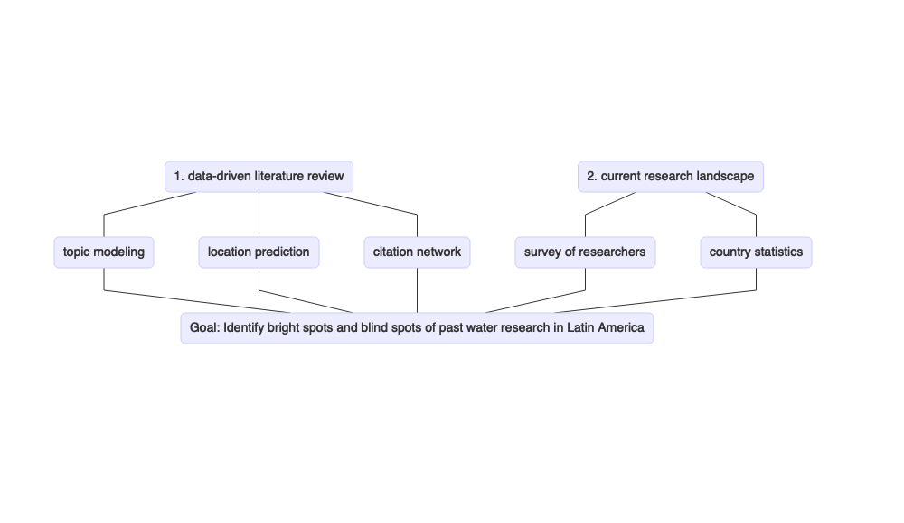

# References

Andrade, Rodrigo de Oliveira. 2019. “Brazil Budget Cuts Threaten 80,000 Science Scholarships.” NATURE PUBLISHING GROUP MACMILLAN BUILDING, 4 CRINAN ST, LONDON N1 9XW, ENGLAND.

Astudillo, Pablo. 2016. “Manifesto for Science.” *Editorial: CATALONIA-Fundaci  ’o N Science  & Life Collection ó N: Science  & Life*.

Blei, David M, Andrew Y Ng, and Michael I Jordan. 2003. “Latent Dirichlet Allocation.” *Journal of Machine Learning Research* 3 (Jan): 993–1022.

Ciocca, Daniel R., and Gabriela Delgado. 2017. “The Reality of Scientific Research in Latin America; an Insider’s Perspective.” *Cell Stress and Chaperones* 22 (6): 847–52. <https://doi.org/10.1007/s12192-017-0815-8>.

Cvitanovic, Christopher, and Alistair J Hobday. 2018. “Building Optimism at the Environmental Science-Policy-Practice Interface Through the Study of Bright Spots.” *Nature Communications* 9 (1): 3466.

Dussaillant, I, E Berthier, F Brun, M Masiokas, R Hugonnet, V Favier, A Rabatel, P Pitte, and L Ruiz. 2019. “Two Decades of Glacier Mass Loss Along the Andes.” *Nature Geoscience* 12 (10): 802–8.

Formiga-Johnsson, RM, and KE Kemper. n.d. “Institutional and Policy Analysis of River Basin Management in the Alto-Tiete River Basin, Sao Paulo, Brazil, the World Bank.” *Policy Research Working Paper* 3650.

Garreaud, René D, Camila Alvarez-Garreton, Jonathan Barichivich, Juan Pablo Boisier, Duncan Christie, Mauricio Galleguillos, Carlos LeQuesne, James McPhee, and Mauricio Zambrano-Bigiarini. 2017. “The 2010-2015 Megadrought in Central Chile: Impacts on Regional Hydroclimate and Vegetation.” *Hydrology & Earth System Sciences* 21 (12).

IPCC. 2014. “Climate Change 2014: Synthesis Report. Contribution of Working Groups I, Ii, and Iii to the Fifth Assessmetn Report of the Intergovernmental Panel on Climate Change.” Geneva, Switzerland: IPCC.

Varis, Olli, Maija Taka, and Matti Kummu. 2019. “The Planet’s Stressed River Basins: Too Much Pressure or Too Little Adaptive Capacity?” *Earth’s Future*.

Zaninelli, Pablo G., Claudio G. Menéndez, Magdalena Falco, Noelia López-Franca, and Andrea F. Carril. 2019. “Future Hydroclimatological Changes in South America Based on an Ensemble of Regional Climate Models.” *Climate Dynamics* 52 (1): 819–30. <https://doi.org/10.1007/s00382-018-4225-0>.