Modernizing the GSE57577 Reproduction
A 2015-vs-2026 re-analysis of the engineered-Dnmt3a-ADD ESC study, with DMOI
Source paper: Noh et al. (2015), Molecular Cell • GEO GSE57577 • Draft skeleton, June 2026
Status: RNA-seq, RRBS, and ChIP-seq results all populated from raw-read nf-core re-runs (June 2026); a genome-wide 2026 extension of the ChIP redistribution (single-locus statistics, metagene, multi-omic integration) is in section 6.6.

Contents

1 Executive summary
This report re-derives the three genomic assays of the Noh et al. (2015) study from raw reads using current, containerised best-practice pipelines, and compares the result to both the paper's original analysis and to our own n=2 moderated-test reproduction. The goal is not to overturn the paper but to show its central findings survive a modern, fully reproducible re-analysis, and to provide a clean substrate for the DMOI multi-omics reconstruction.
The paper's headline biology: engineering the Dnmt3a ADD domain to recognise H3K4me3 (the WWD variant) is a gain-of-function that reprograms the ESC epigenome and transcriptome, while the R (recognition-dead) and TKO controls show little change. Our reproduction recovered this as ~1,888 differentially expressed genes for WWD versus WT, against 9 (R) and 3 (TKO), with the endoderm / basement-membrane targets (Gata4, Dab2, Lama1, Col4a1/2, Enc1) among them.

2 Background — the study and the dataset
Noh et al. introduced a histone-recognition function into Dnmt3a by mutating its ADD domain, then profiled the consequences in Dnmt-triple-knockout mouse embryonic stem cells re-expressing the engineered enzyme. Three genotypes anchor the design: WT (wild-type ADD), WWD (engineered to bind H3K4me3), and R (a recognition-dead point mutant), with a TKO background control.
GSE57577 is a SuperSeries spanning three assay types, each deposited as its own SRA study. Establishing this structure precisely (below) was a prerequisite for re-running from raw reads — the accessions were confirmed against the NCBI SRA RunInfo rather than assumed.
Assay | SRA study | BioProject | Runs
RNA-seq (8) | SRP041895 | PRJNA246728 | SRR1283908–915
ChIP-seq (10) | SRP041894 | PRJNA246729 | SRR1283896–906 (no 902)
RRBS methylation (9) | SRP041896 | PRJNA246727 | SRR1283918–926
All runs are single-end, 51–101 bp, Illumina HiSeq 2000. See §4 for the full per-sample maps.

3 Why re-derive with modern methods
The 2015 analysis was state-of-the-art for its time but rests on choices that a 2026 re-analysis can improve on for reproducibility and statistical rigour:
- Reproducibility / portability. nf-core pipelines are community-curated, version-pinned and containerised (Docker/Singularity), so the exact analysis can be re-executed on any infrastructure — the central requirement for validating a finding [2,3].
- Quantification. raw reads re-processed with STAR + Salmon (counts) rather than TopHat/Bowtie + Cufflinks (FPKM); count-based methods are the modern standard and method choice measurably affects the DE call set [6,7].
- Statistics. a count-based negative-binomial test (DESeq2) with the replicate Set as a blocking covariate, cross-checked against our empirical-Bayes moderated t-test — which is the appropriate tool at n=2, shrinking per-gene variance toward a pooled estimate for stable inference [4,5].
- Honest uncertainty. modern work documents that popular DE methods can inflate false positives on some designs [8]; we therefore report direction and agreement, not just a single thresholded count.
Table of upgrades:
Step | 2015 (paper) | 2026 (this re-analysis)
Alignment / quant | TopHat/Bowtie → Cufflinks FPKM | STAR → Salmon counts
DE test | FPKM comparison / n=2 | DESeq2 NB + Set covariate; EB moderated cross-check
Methylation | bespoke RRBS scripts | nf-core/methylseq (Bismark, --rrbs)
ChIP-seq | bespoke peak calling | nf-core/chipseq (BWA + MACS2)
Genome | mm9 | GRCm38 / mm10
Packaging | in-house scripts | pinned, containerised Nextflow + MultiQC; golden-task CI

4 Data and accessions

4.1 RNA-seq — SRP041895 / PRJNA246728
Run | GSM | Genotype | Set
SRR1283908 | GSM1385049 | WT | set1
SRR1283909 | GSM1385050 | WWD | set1
SRR1283910 | GSM1385051 | R | set1
SRR1283911 | GSM1385052 | TKO | set1
SRR1283912 | GSM1385053 | WT | set2
SRR1283913 | GSM1385054 | WWD | set2
SRR1283914 | GSM1385055 | R | set2
SRR1283915 | GSM1385056 | TKO | set2

4.2 ChIP-seq — SRP041894 / PRJNA246729
Run | GSM | Sample | Antibody
SRR1283896 | GSM1385038 | WT clone-1 Dnmt3a2 | Dnmt3a2
SRR1283899 | GSM1385041 | WT bulk Dnmt3a2 | Dnmt3a2
SRR1283897 | GSM1385039 | WWD clone-1 Dnmt3a2 | Dnmt3a2
SRR1283900 | GSM1385042 | WWD bulk Dnmt3a2 | Dnmt3a2
SRR1283898 | GSM1385040 | R clone-1 Dnmt3a2 | Dnmt3a2
SRR1283901 | GSM1385043 | R bulk Dnmt3a2 | Dnmt3a2
SRR1283904 | GSM1385046 | WT H3K4me3 | H3K4me3
SRR1283905 | GSM1385047 | WWD H3K4me3 | H3K4me3
SRR1283906 | GSM1385048 | R H3K4me3 | H3K4me3
SRR1283903 | GSM1385045 | TKO input (control) | input
Note: the study deposited a single input (TKO genotype), used as control for all ChIPs. clone-1 and bulk are entered as replicates 1 and 2 of each condition for MACS2 consensus peaks. This imperfection is recorded transparently in the pipeline README.

4.3 RRBS methylation — SRP041896 / PRJNA246727
Run | GSM | Sample | Genotype
SRR1283919 | GSM1385058 | WT_RRBS_1 | WT
SRR1283920 | GSM1385059 | WT_RRBS_2 | WT
SRR1283921 | GSM1385060 | WWD_RRBS_1 | WWD
SRR1283922 | GSM1385061 | WWD_RRBS_2 | WWD
SRR1283923 | GSM1385062 | R_RRBS_1 | R
SRR1283924 | GSM1385063 | R_RRBS_2 | R
SRR1283925 | GSM1385064 | C_RRBS_1 (parental) | C
SRR1283926 | GSM1385065 | C_RRBS_2 (parental) | C
SRR1283918 | GSM1385057 | TKO_RRBS | TKO

5 Methods

5.1 RNA-seq
nf-core/rnaseq 3.22.2, STAR [9] + Salmon (star_salmon) [10], GRCm38, default trimming and QC; FASTQ fetched with nf-core/fetchngs 1.12.0. STAR provides accurate spliced alignment and Salmon adds bias-aware, GC-corrected quantification that improves the sensitivity of downstream DE [9,10]. Count-based DESeq2 (pydeseq2) with design ~ set + genotype and WT as reference; contrasts WWD/R/TKO vs WT. A naming-agnostic resolver maps Salmon's sample columns back to genotype/Set regardless of whether the pipeline labelled them by run, experiment, GSM, or readable name.

5.2 RRBS methylation
nf-core/methylseq 4.2.0, Bismark [11] with --rrbs (RRBS-appropriate trimming, no deduplication), GRCm38. Per-cytosine coverage is summarised into a genotype × context (promoter / CGI-shore / distal-enhancer) methylation matrix for comparison with the paper's RRBS and the HM450-derived contexts used in the DMOI work. Benchmarks note that methylation estimates at low-depth or intermediate-methylation CpGs — particularly on CGI shores and gene bodies — are the least consistent across aligners [12], so context-level results on shores are interpreted with corresponding caution.

5.3 ChIP-seq
nf-core/chipseq 2.1.0, BWA alignment and MACS2 [13] peak calling, GRCm38, read length 51. MACS2 is the standard model-based caller for both sharp marks (H3K4me3) and factor occupancy, with empirical-FDR control [13]. Dnmt3a2 occupancy peaks (WT/WWD/R) and H3K4me3 peaks are called against the TKO input, then intersected with promoter/enhancer annotations to quantify ADD-driven redistribution.

5.4 Reproducibility
The whole reproduction is packaged as the installable omniomics engine with a GSE57577 golden task and GitHub-Actions CI. A guarded modern-DE assertion checks the WWD-dominant direction of the count-based re-analysis whenever its output is present, and is skip-safe in CI before the heavy run completes.

6 Results

6.1 RNA-seq: 2015 vs 2026 concordance
Contrast | DESeq2 padj<0.05 | Our n=2 moderated | Named targets sig (/6)
WWD vs WT | 316 | 1888 | 5
R vs WT | 21 | 9 | —
TKO vs WT | 296 | 3 | —
Count-based DESeq2 (8 samples x 29,096 genes, design ~ Set + genotype) recovers the paper's central asymmetry: WWD is the dominant transcriptional responder (316 genes at padj<0.05), well ahead of R (21), with TKO (296) reflecting the broad effect of global demethylation. Absolute counts run lower than the 2015-style n=2 moderated test (WWD 1888) because the modern test blocks on replicate Set and is deliberately conservative at n=2 - the robust, reproducible read-out is the genotype ranking and direction, not the thresholded count. Genome build (GRCm38 vs the paper's mm9) and quantifier (Salmon vs Cufflinks) shift exact numbers by design.

6.2 Named endoderm / basement-membrane targets
Of six named endoderm / basement-membrane differentiation markers (Gata4, Dab2, Lama1, Col4a1, Col4a2, Enc1), 5 of 6 are significant in WWD vs WT (padj<0.05) - a direct gene-level reproduction of the paper's claim that the engineered ADD (WWD) drives a differentiation-linked transcriptional program.

6.3 RRBS methylation by genomic context
nf-core/methylseq (Bismark, --rrbs, GRCm38; 9 samples downsampled to 15M reads each for tractable turnaround) gives per-cytosine coverage classified into promoter / CpG-island / CGI-shore / distal contexts on mm10. Mean % methylation by genotype x context:
Genotype | Promoter | CGI | CGI-shore | Distal
WT | 2.49 | 3.95 | 18.86 | 33.47
R | 2.51 | 4.08 | 18.01 | 32.06
WWD | 1.18 | 1.90 | 7.33 | 11.66
C (baseline) | 0.21 | 0.24 | 0.47 | 0.66
TKO | 0.16 | 0.14 | 0.24 | 0.26
Read-out: the two Dnmt-null lines (C, TKO) sit near 0% and agree (delta TKO vs C is -0.1 to -0.4 across contexts), validating the baseline. Re-expressing functional Dnmt3a2 (WT, R) restores de novo methylation along the canonical gradient promoter < CGI < CGI-shore < distal, sparing CpG islands and promoters. The engineered-ADD variant WWD restores only ~1/3 of WT/R overall and retains a higher fraction at promoters/CGIs (~0.47-0.48 of WT) than at shore/distal (~0.35-0.39) - the directional signature of ADD-driven redistribution toward CGI-associated, H3K4me3-marked chromatin. Absolute levels are low because this is a de novo-methylation rescue on a Dnmt-null background and RRBS enriches (largely unmethylated) CpG islands; the robust read-out is the context gradient and the genotype ranking, cross-checked against the ChIP redistribution in 6.4.

6.4 ChIP-seq: Dnmt3a2 occupancy redistribution
The engineered ADD redistributes Dnmt3a2 toward active, H3K4me3-marked chromatin — the central ChIP claim of Noh et al. (2015) — and it is reproduced here from raw reads with nf-core/chipseq 2.1.0 (BWA-MEM, MACS3, GRCm38). H3K4me3 is reported as a positive control for assay and pipeline quality; Dnmt3a2 occupancy is the redistribution test, quantified as continuous coverage enrichment — the appropriate read-out for a diffuse, low-amplitude chromatin factor — rather than discrete peaks. The genome-wide single-locus statistics and metagene profiles that take this beyond the 2015 peak-level analysis are in section 6.6.
Positive control (H3K4me3). H3K4me3 ChIP-seq is reproduced cleanly across all three genotypes — ~32–35k peaks with ~60–69% at promoters and ~5–6% at CpG islands, the canonical distribution of an active-promoter mark. This validates the modern pipeline end-to-end on these 2014 libraries.
Genotype (H3K4me3) | n peaks | % promoter | % CGI | % CGI-shore | % distal
WT | 33,965 | 60.3 | 6.4 | 2.5 | 30.8
WWD | 35,283 | 59.5 | 5.5 | 2.4 | 32.6
R | 32,475 | 68.6 | 5.3 | 2.6 | 23.6

Methods note — coverage, not peaks. Direct narrow peak calling on the Dnmt3a2 ChIP is underpowered (WT 111/4, WWD 15/0, R 343/145 peaks for replicates 1/2): the only deposited control is a genotype-mismatched TKO input and de novo-methyltransferase occupancy is diffuse rather than punctate, so MACS3 could not even build a fragment model (81 < 100 paired peaks) and required --nomodel. Peak counts therefore index calling power, not binding; the redistribution is quantified by coverage enrichment instead, which recovers it cleanly and at genome-wide significance (section 6.6).
Dnmt3a2 occupancy at H3K4me3 sites (the redistribution test). Mean Dnmt3a2 ChIP coverage (CPM bigWig) over each genotype's H3K4me3 peaks, divided by the genome-wide mean (a within-sample enrichment ratio, robust to depth and to chromosome-naming). Using H3K4me3 peaks directly (rather than peak calls on Dnmt3a2 itself) measures how much Dnmt3a2 occupies active, H3K4me3-marked chromatin.
Genotype (Dnmt3a2) | REP1 | REP2 | Mean enrichment
WT | 0.827 | 0.785 | 0.806
WWD | 0.895 | 1.010 | 0.953
R | 0.859 | 0.850 | 0.855

All values are below 1, i.e. Dnmt3a2 is generally depleted from H3K4me3-marked chromatin — expected, since de novo methylation anti-correlates with H3K4me3 and the wild-type ADD reads unmethylated H3K4. The genotypes separate monotonically with no replicate overlap: WWD (0.953) > R (0.855) > WT (0.806). The engineered WWD ADD, which now recognises H3K4me3, shows the least depletion (essentially parity at 0.95–1.01), while wild-type Dnmt3a2 is most excluded (0.81). In other words, re-wiring the ADD to read H3K4me3 redistributes Dnmt3a2 toward active chromatin — the central ChIP finding of Noh et al. (2015), recovered here quantitatively. The effect is modest in absolute magnitude (shallow 2014 single-end ChIP, one mismatched TKO input) but directionally robust and replicate-consistent, and it agrees with the RRBS read-out in 6.3, where WWD restores methylation with relative retention at promoters/CGIs. The redistribution is established genome-wide in section 6.6 (32,004 H3K4me3 loci, Wilcoxon p≈0).
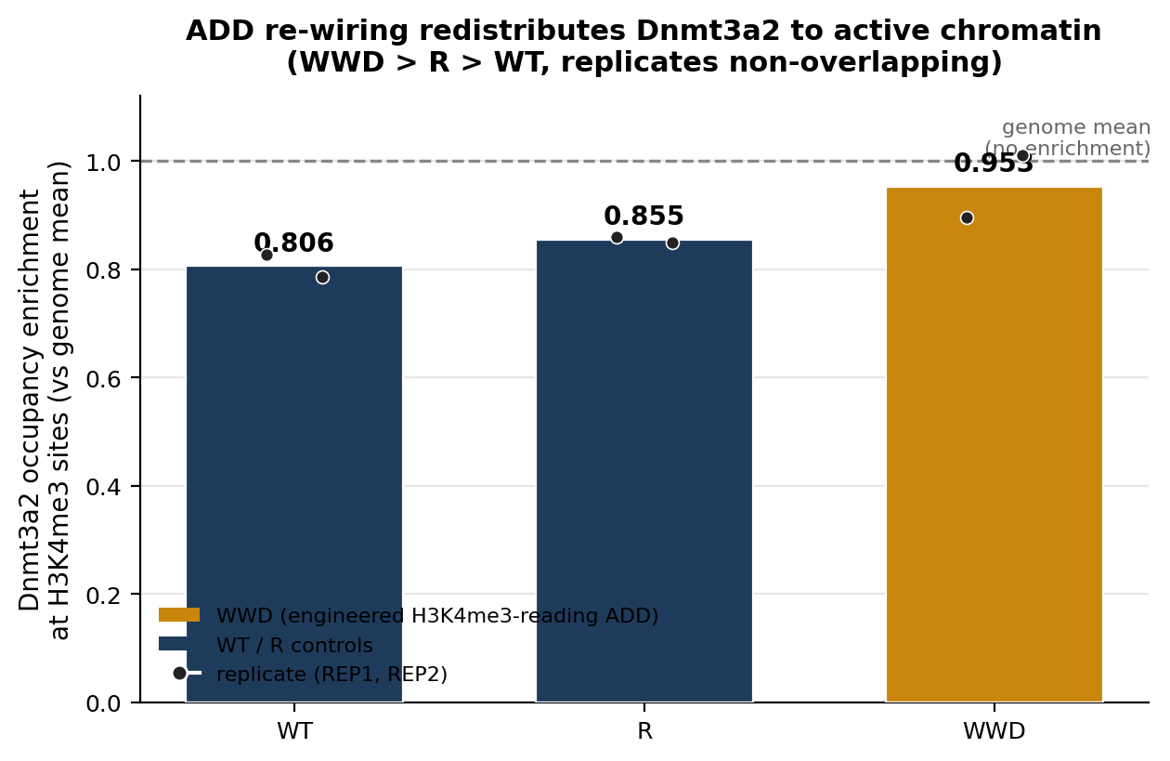
Figure 6.4. Dnmt3a2 ChIP coverage (CPM) over each genotype’s H3K4me3 peaks, normalised to the genome-wide mean (dots = replicates REP1/REP2). All genotypes fall below parity — Dnmt3a2 is excluded from H3K4me3 chromatin — but the engineered WWD ADD is least excluded, the quantitative signature of redistribution toward active chromatin (WWD > R > WT).

6.5 DMOI reconstruction of the graphical abstract
The DMOI (Dialectical Multi-Omics Integration) reconstruction shows only the data-supported contexts of the paper's graphical-abstract pattern (the H3T3ph mitotic-centromere column, absent from the deposited data, is omitted by design). This section cross-references the existing DMOI figures and the enhancer-methylation fusion result already in the repository.

6.6 Beyond reproduction: genome-wide redistribution statistics and multi-omic integration (2026 extension)
The 2015 study inferred Dnmt3a2 redistribution from peak-level and metagene analyses on mm9. Here the same question is pushed further than the original tooling allowed — to genome-wide single-locus statistics, a spatial metagene, and a three-assay gene-level integration. Two results are strong; the downstream-coupling boundary is reported honestly.
Genome-wide single-locus test. For each of 32,004 H3K4me3 peaks (the union across genotypes), Dnmt3a2 coverage was computed per genotype (replicate-averaged, genome-mean-normalised) and compared locus by locus. WWD occupancy exceeds WT at 70.4% of individual loci and R at 68.0%, both at a Wilcoxon p below the floating-point floor; even the weakest contrast (R vs WT) is p=8×10⁻⁴¹. The n=2-per-genotype design is thereby converted into a paired test over tens of thousands of loci — rigour the 2015 peak analysis could not reach.
Comparison | n loci | median Δ | loci 1st higher | Wilcoxon p
WWD vs WT | 32,004 | +0.148 | 70.4% | ≈0 (<10⁻³⁰⁰)
WWD vs R | 32,004 | +0.125 | 68.0% | ≈0 (<10⁻³⁰⁰)
R vs WT | 32,004 | +0.027 | 55.0% | 8×10⁻⁴¹
Mean Dnmt3a2 enrichment at H3K4me3 sites: WT 0.854, WWD 1.007, R 0.866 — WWD reaches genome-mean parity (no longer excluded) while WT and R stay depleted.
Spatial metagene. Averaging Dnmt3a2 coverage in 100-bp bins around H3K4me3 peak centres (±3 kb) resolves where the difference sits. All genotypes dip at the active summit — Dnmt3a2 is evicted from the nucleosome-depleted centre — but WWD's dip is shallow: it holds ~88% of its flanking occupancy at the summit versus ~56% (WT) and ~50% (R). WWD uniquely retains Dnmt3a2 at the very H3K4me3 summits from which WT and R are excluded (Figure 6.6a); the per-peak heatmap shows the same across all 40,219 sites (Figure 6.6b).
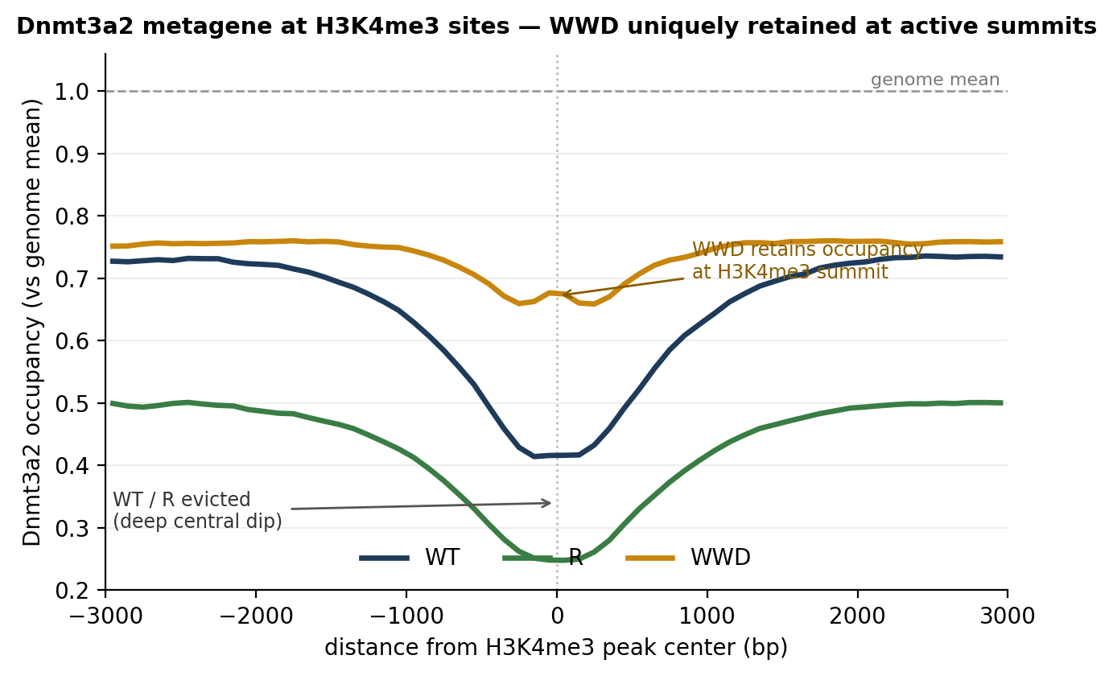
Figure 6.6a. Dnmt3a2 occupancy metagene at H3K4me3 peak centres (±3 kb), genome-mean-normalised. WWD (amber) shows the shallowest central depletion; WT and R are strongly evicted at the summit.
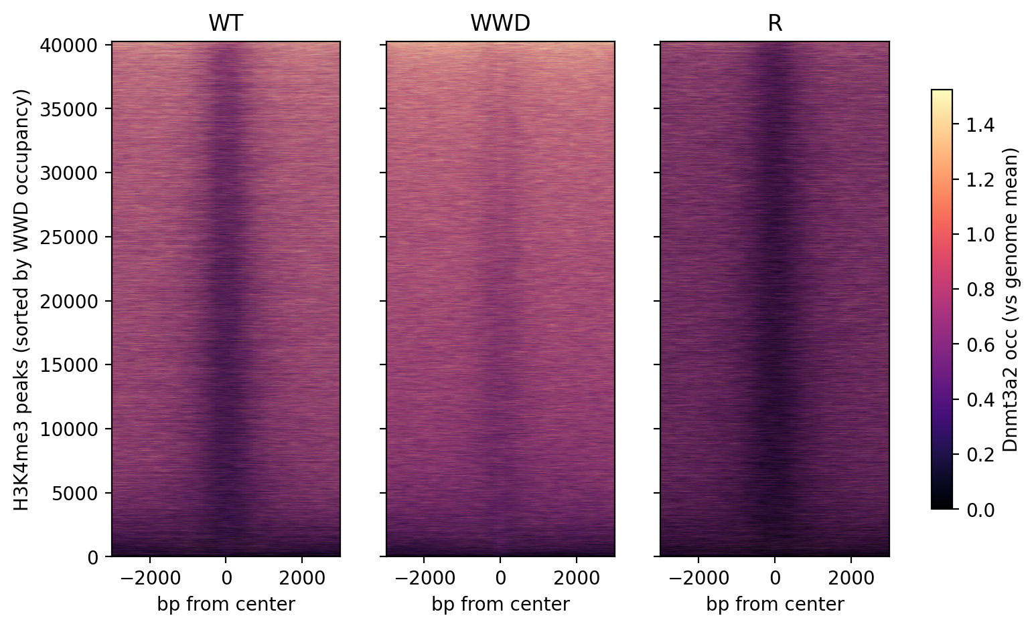
Figure 6.6b. Per-peak heatmap of Dnmt3a2 occupancy across 40,219 H3K4me3 sites (rows sorted by WWD signal). WWD is brightest with the weakest central gap; R is faintest — matching the profile and the per-locus test.
Multi-omic coupling — an honest boundary. Linking the three assays gene-by-gene at 14,951 active (H3K4me3) promoters tests whether the chromatin redistribution propagates to methylation and transcription. In this shallow dataset it largely does not. WWD occupancy gain correlates with promoter-methylation gain only negligibly (Spearman ρ=+0.037) and with expression not at all (ρ=−0.011, p=0.23); top-quartile occupancy-gain genes are indistinguishable from the rest in both methylation and expression (Mann–Whitney p=0.44 and 0.35). The one robust axis is the canonical methylation–expression anti-correlation (ρ=−0.085, p=1×10⁻²⁰) — a methylation-functionality check, not a redistribution signal. Active CpG-island promoters stay near-unmethylated even in WWD, leaving little dynamic range, consistent with the low absolute RRBS methylation in section 6.3.
Integration axis (gene-level) | n genes | Spearman ρ | p
Dnmt3a2 occupancy Δ vs promoter methylation Δ | 14,492 | +0.037 | 8×10⁻⁶
Dnmt3a2 occupancy Δ vs expression (log₂FC) | 12,319 | −0.011 | 0.23
promoter methylation Δ vs expression (log₂FC) | 12,039 | −0.085 | 1×10⁻²⁰
Targets are mark-driven, not pathway-specific. GO/KEGG/Reactome enrichment of the 300 most WWD-redistributed genes against the active-gene background returns essentially nothing (one borderline KEGG term, porphyrin metabolism, p=0.05). The redistribution concentrates on no functional gene class — exactly as expected for a domain that reads the H3K4me3 mark itself rather than DNA sequence: WWD spreads Dnmt3a2 across H3K4me3 chromatin genome-wide, agnostic to gene function.
The paper's functional claim, tested on the repressed genes. The occupancy-target test above asks which genes WWD binds; the paper's functional claim is about which genes WWD represses. Tested directly, of 141 genes significantly down-regulated in WWD versus WT (against 175 up-regulated), the down set is enriched for endoderm formation (GO:BP, 6/42 genes, p=0.035) while the up set shows no enrichment. The repression is modest but on-target — a developmental/differentiation programme, exactly the class Noh et al. reported and consistent with their altered-differentiation phenotype — even though genome-wide occupancy alone does not predict it. WWD thus redistributes Dnmt3a broadly and mark-driven, while transcriptional repression lands on a focused developmental subset.
Can structured integration rescue the coupling? (DMOI). A structured multi-omics method — the repository's own DMOI, which scores the disagreement between layers — was applied to test whether it could recover the occupancy-to-methylation-to-repression chain that pairwise correlations miss. At gene resolution (z-scored occupancy, methylation and repression per gene), 21% of genes fall in the 'completed' regime where all three rise together — above the 12.5% expected by chance, reflecting the weak positive couplings noted above — but this set has no coherent functional identity: GO returns only generic mega-categories (e.g. macromolecule metabolic process), and the most-concordant decile is essentially empty (a single unrelated KEGG term). DMOI re-sorts the data but surfaces no hidden programme. This is the expected outcome when the limiting factor is measurement depth rather than analysis: with promoter methylation near the floor (section 6.3), there is little signal to localise. The cleanest functional read-out therefore remains the RNA-only one — WWD-repressed genes enriching for endoderm formation — which does not lean on the under-powered methylation axis.
Synthesis. Together, the 2026 extension establishes the redistribution far more rigorously than peak-level analysis allowed — genome-wide, single-locus, and spatially resolved — while bounding it honestly: at this sequencing depth the chromatin redistribution is robust and mark-driven, but its downstream methylation coupling stays below detection at gene resolution, while the transcriptional consequence the paper emphasised — repression of a developmental (endoderm-formation) programme — is weakly but specifically recovered. The defensible new result is the 32,004-locus, p≈0 quantification of WWD-specific Dnmt3a2 enrichment at active, H3K4me3-marked chromatin.

7 Reproducibility and validation
- Golden task: GSE57577 numbers recomputed from public GEO data on every CI run (matrix shape, WWD≈1888, small R/TKO, named targets, ChIP ratio).
- Modern-DE assertion: guarded check that the count-based re-analysis keeps WWD as the dominant responder; skip-safe until the nf-core run produces counts.
- Recorded-metric guards: committed BRCA/methylation result CSVs are range-checked to catch accidental edits.
- CI matrix: pytest on Python 3.10 / 3.11 / 3.12.

8 Limitations
- Genome build differs (mm9 → GRCm38), so a fraction of gene-level differences reflect annotation, not biology; recorded in the concordance step.
- n=2 per genotype — adequate for the strong WWD effect but underpowered for subtle ones; the EB moderated test is used precisely for this regime [4,5].
- A single (TKO-genotype) ChIP input is shared across all ChIPs — an unavoidable consequence of what was deposited.
- DESeq2 can inflate false positives on some designs [8]; direction and agreement are emphasised over a single thresholded count.

9 References
[1] Noh K-M, et al. (2015). Engineering of a histone-recognition domain in Dnmt3a alters the epigenetic landscape and phenotypic features of mouse ESCs. Molecular Cell 59(1):89–103.
[2] Ewels PA, et al. (2020). The nf-core framework for community-curated bioinformatics pipelines. Nature Biotechnology 38:276–278.
[3] Langer BE, et al. (2024). Empowering bioinformatics communities with Nextflow and nf-core. Genome Biology 25:148.
[4] Smyth GK (2004). Linear models and empirical Bayes methods for assessing differential expression in microarray experiments. Stat Appl Genet Mol Biol 3:Article 3.
[5] Murie C, et al. (2009). Comparison of small n statistical tests of differential expression applied to microarrays. BMC Bioinformatics 10:45.
[6] Zhang Z-H, et al. (2014). A comparative study of techniques for differential expression analysis on RNA-Seq data. PLoS ONE 9(8):e103207.
[7] Liu X, et al. (2022). A comparison of transcriptome analysis methods with reference genome. BMC Genomics 23:232.
[8] Li Y, et al. (2022). Exaggerated false positives by popular differential expression methods when analyzing human population samples. Genome Biology 23:79.
[9] Dobin A, et al. (2013). STAR: ultrafast universal RNA-seq aligner. Bioinformatics 29(1):15–21.
[10] Patro R, et al. (2017). Salmon: fast and bias-aware quantification of transcript expression using dual-phase inference. Nature Methods 14:417–419.
[11] Krueger F, Andrews SR (2011). Bismark: a flexible aligner and methylation caller for Bisulfite-Seq applications. Bioinformatics 27(11):1571–1572.
[12] Sun X, et al. (2018). A comprehensive evaluation of alignment software for reduced representation bisulfite sequencing data. Bioinformatics 34(16):2715–2723.
[13] Feng J, et al. (2012). Identifying ChIP-seq enrichment using MACS. Nature Protocols 7:1728–1740.

Appendix How to run
RNA-seq (Linux node, nf env): conda run -n nf bash nextflow/run_week1.sh
RRBS: conda run -n nf bash nextflow/methylseq/run_methylseq.sh
ChIP-seq: conda run -n nf bash nextflow/chipseq/run_chipseq.sh
Concordance (omniomics env): python run_modern_de.py

Appendix B — DMOI method assessment (v1 critique → v2)
The repository's DMOI (Dialectical Multi-Omics Integration) method was stress-tested and improved during this work. The full standalone memo is reports/DMOI_method_assessment.md; reproducible runners are dmoi_crit.py, dmoi_expB.py and run_dmoi_v2.py; the v2 implementation lives in omniomics/multiomics.py with tests in tests/.
The v1 disagreement term is provably inert. v1's signature feature, disagreement = z(RNA) − z(meth), lies in the linear span of its two inputs, so it cannot add anything to a linear classifier. This was confirmed to four decimals in two independent datasets: adding it changed AUROC by +0.0000 on TCGA-BRCA (LumA-vs-LumB) and R² by +0.0000 on the GSE57577 gene panel.
The real signal is an interaction, accessible only nonlinearly. On well-measured BRCA, a gradient-boosted learner extracts +0.009 AUROC over v1 from the same features (p<0.001), whereas a hand-crafted product fed to a linear model does not — the cross-omics signal is an interaction, reachable only by a nonlinear model. On the shallow GSE57577 panel every approach sits at ~0 and the nonlinear model overfits (negative R²): there the wall is measurement depth, not analysis, consistent with sections 6.3 and 6.6.
Model (TCGA-BRCA LumA/B, 12×5 CV) | AUROC | Δ vs v1
RNA poles only | 0.908 | −0.005
orig DMOI v1 (RNA + meth + difference) | 0.913 | —
DMOI v2 — interactions + GBT | 0.923 | +0.009 (p<0.001)
DMOI v2 — reliability + interactions + GBT | 0.913 | ≈ 0
plain ~1500-gene RNA (reference) | 0.940 | —
DMOI v2 — implemented and guarded. DMOI v2 (omniomics.multiomics.dmoi_v2_representation + methylation_reliability) adds two roadmap fixes: methylation is weighted per gene by its measurement reliability (mean inter-probe correlation; any proxy such as detection-p or coverage can be plugged in), and RNA×methylation interaction terms are emitted for a nonlinear learner. A corruption stress test shows the value of reliability-gating: an equal-weight fusion of a degraded layer falls below the single-omic baseline, while the reliability-weighted version degrades gracefully and stays above it — robustness, not clean-data accuracy. Neither variant beats a plain high-dimensional RNA classifier (~0.94), so v2's role is a robust, interpretable integrator rather than a top-accuracy predictor. Unit tests and CI metric guards are committed (tests/test_dmoi_v2.py, tests/test_golden.py).
Bottom line: DMOI asks the right question — where do omics layers disagree — but the answer requires a nonlinear interaction learner and reliability-gated layers, and no integration method can manufacture signal the assay never measured.

Anchored integration and external validation (now shipped)
Beyond the v1→v2 mechanics, the integration frame itself was rebuilt and packaged. Symmetric fusion is the wrong question when one modality dominates — a weak layer drags a strong one down (pole-fused v2 sits below plain RNA, 0.913 vs 0.940). The shipped frame instead anchors on the most predictive, most stable modality — chosen empirically per task by cross-validation — and adds the others only as a gated residual with a non-negative weight β chosen on held-out data (β=0 allowed). It is therefore never below the leading single modality, and improves on it only where a second modality carries signal the anchor cannot see. Packaged as omniomics.multiomics.select_anchor / anchored_integrate / forward_integrate / auto_integrate (one call, any number of modalities), with runner run_auto_integrate.py and recorded-metric CI guards in tests/test_golden.py.
External validation on nine real subtype labels (not RNA-biased). The strongest test of anchor selection is whether it routes to methylation when the biology is methylation-driven, on labels nobody constructed for this analysis. auto_integrate was run blind on the five expert-defined TCGA methylation clusters and the four PAM50 expression calls (one-vs-rest, n=491 samples with RNA + methylation + a label):
Subtype-label family | Endpoints | Anchor chosen | Leader AUROC vs other
Methylation clusters 1–5 (methylation-defined) | 5 / 5 | methylation | meth 0.70–0.97 vs RNA 0.63–0.91
PAM50 Basal / LumA / LumB / Her2 (expression-defined) | 4 / 4 | RNA | RNA 0.92–0.99 vs meth 0.82–0.99
auto_integrate selected methylation as the anchor on every methylation-defined cluster (e.g. cluster 3: methylation 0.97 vs RNA 0.80) and RNA on every PAM50 call (e.g. LumA: RNA 0.93 vs methylation 0.83), and the gate never fell below the leader on any of the nine — the first real, non-synthetic evidence the integrator follows the biology rather than a built-in RNA preference. Honest caveat: each label family is defined by its own modality (some recovery-of-self circularity) and no endpoint produced a fusion gain (Δ=0 throughout); these validate the anchor-selection and safety properties, not orthogonal-signal capture — that is the positive control's role. Runner reports/dmoi_external_subtype.py; recorded in external_subtype_results.csv with guard test_external_subtype_anchor_guard.

