GA4 Data Layer
Hryvinskyi_DataLayer
GA4 ecommerce tracking for Magento 2 through Google Tag Manager or gtag.js, with optional server-side delivery and a guided setup wizard.
Module version 1.0.3 · Magento 2.4.8 · PHP 8.3 · Published 2026-10-20
Magento Open Source and Adobe Commerce · © 2026 Hryvinskyi

Contents

Note
GA4 ecommerce events for Magento 2: a clean dataLayer for Google Tag Manager or gtag.js, product lists and promotions, cart and checkout steps, purchase and Google Ads conversion, optional delivery from the server through the Measurement Protocol or a server-side Tag Manager, and a setup wizard that configures it all scope by scope.
This guide is for shop owners, marketing staff and administrators who set up and maintain GA4 tracking, and for the developer who installs the modules. It explains what the store sends to Google, how to configure it (with the setup wizard or on the settings page) and how to check that it works. A short section at the end describes the extension points for developers.
The admin screenshots were taken on a test installation with two websites, Main Website (www.example.com, store view English) and Wholesale (b2b.example.com, store view Trade), container GTM-AB12CD3 and measurement ID G-7KQ2XM4P1N. Storefront output is shown as dataLayer JSON rather than as screenshots, because what matters is the data, not the theme.

1 Overview
The GA4 Data Layer replaces Magento’s own Google modules with one consistent implementation of the GA4 ecommerce specification.
It does six things:
- Loads Google on every storefront page: a Google Tag Manager container, gtag.js with a GA4 measurement ID, or both.
- Fills window.dataLayer with GA4 events: product views, product lists and promotions, cart changes, checkout steps, purchase, login and sign-up, plus a Google Ads conversion after purchase.
- Builds items the same way everywhere: the same item ID, name, brand, categories, variant and price rules in every event, with a choice of tax basis and a defined behaviour for prices hidden from some customers.
- Routes each event to the browser (dataLayer), to the server, or to both. Server delivery is optional and sends events from Magento itself, so ad blockers and closed tabs do not lose them.
- Keeps settings in Magento: every setting is an ordinary configuration value under Stores › Configuration › Sales › GA4 Data Layer, scoped to default, website and store view.
- Guides the setup: the setup wizard (Sales › GA4 Data Layer › Setup) walks through the same settings in six steps, previews what a product page and an order send, and saves nothing until you press Save all.

What it replaces
The core package declares that it replaces magento/module-google-analytics, magento/module-google-gtag, magento/module-google-adwords and magento/module-google-optimizer. A Composer installation therefore removes those modules. In an installation that keeps them in another way, disable them yourself so that two implementations never push events at the same time.
Settings are migrated on install. A one-time data patch reads every stored setting of the old modules (google/gtag/…, google/adwords/…, google/analytics/…, google/optimizer/…) at every scope and writes their successors:
New setting | Taken from
Google Analytics (gtag.js) › Measurement ID | The GA4 measurement ID of Magento’s gtag module, where that module was active. Upper-cased; kept only when it has the G-… format.
Google Ads conversion › Enabled | On when Magento’s gtag Ads or the older Google AdWords pixel was active.
Conversion ID | The gtag Ads conversion ID, else the AdWords pixel’s ID. A bare number gets the AW- prefix.
Conversion label | The matching conversion label.
Conversion value / Fixed value | Fixed value with the pixel’s constant value when the pixel used a constant; otherwise Purchase value.
At each scope the patch writes the value the old module actually used there after inheritance, so a website that had switched a module off below a default that had it on keeps it off. Values that are not valid are written empty and logged. Universal Analytics, Google Optimize and the pixel’s language, format and colour settings have no successor and are dropped with a log line. An existing data-layer setting at the same scope is kept. The old rows are deleted in the same transaction.
Note
Tracking is off after installation. General › Enabled defaults to No, so nothing is output until you switch it on, either in the wizard (step 2) or on the settings page.

2 Modules and installation

Module map
Module | Package | What it does | Needed?
Hryvinskyi_DataLayerApi | hryvinskyi/magento2-data-layer-api | Published interfaces only: events, items and the extension points. | Always
Hryvinskyi_DataLayer | hryvinskyi/magento2-data-layer | Core: settings, the event catalogue and channels, event and item builders, list and promotion data, the session queue, Google Ads conversion, the settings migration. Renders nothing itself. | Always
Hryvinskyi_DataLayerFrontendUi | hryvinskyi/magento2-data-layer-frontend-ui | Storefront: GTM and gtag.js loaders, page events, list and click tracking, the queue endpoints, Content Security Policy entries. Plain ES modules, no RequireJS, jQuery or Knockout. Requires hryvinskyi/magento2-head-tag-manager. | For browser tracking
Hryvinskyi_DataLayerAdminUi | hryvinskyi/magento2-data-layer-admin-ui | Admin: the settings section, the events table, the setup wizard, the access resource. Requires hryvinskyi/magento2-theme-assets. | For configuration
Hryvinskyi_DataLayerServerSide | hryvinskyi/magento2-data-layer-server-side | Server delivery: the outbox, the delivery cron, visitor identity, purchase from the order, refund, CLI commands. | Optional
Hryvinskyi_DataLayerServerSideFrontendUi | hryvinskyi/magento2-data-layer-server-side-frontend-ui | The storefront collector that receives browser events routed to the server. | With server delivery
Hryvinskyi_DataLayerServerSideAdminUi | hryvinskyi/magento2-data-layer-server-side-admin-ui | The Server-side settings group, delivery status, Retry failed, Send test event, and the wizard’s server-side step. | With server delivery
All modules require PHP 8.3 or 8.4. The three server-side modules go together.

Installing
- Require the metapackage, which installs all seven modules:
- composer require hryvinskyi/magento2-data-layer-pack
- For browser tracking only, require the core set instead:
- composer require hryvinskyi/magento2-data-layer hryvinskyi/magento2-data-layer-frontend-ui hryvinskyi/magento2-data-layer-admin-ui
- Add hryvinskyi/magento2-data-layer-server-side, -server-side-frontend-ui and -server-side-admin-ui for server delivery.
- Run bin/magento setup:upgrade (this also runs the settings migration), bin/magento setup:di:compile and, in production mode, bin/magento setup:static-content:deploy.
- Flush the caches, including Page Cache. Pages cached before the installation have no loader and no data layer.
- Make sure the server’s cron runs, including the hryvinskyi_datalayer cron group when server delivery is used.
Theme requirement. The loader, the page events and the scripts are printed into <head> through Head Tag Manager. A theme that removes Head Tag Manager’s head output loses all of them without an error.

Disabling a module
Disable an optional module with bin/magento module:disable <Module> followed by setup:upgrade and a cache flush; its events disappear from the events table and its step from the wizard. The three server-side modules are disabled together. To stop tracking without uninstalling anything, set General › Enabled to No at the scope concerned.

Caches after a settings change
Saving the section, on the settings page or with Save all in the wizard, cleans the module’s own cached data (list data and category trees) and marks Page Cache as invalidated. It does not clean the full-page cache behind your back, because cached pages carry the list data and settings they were rendered with. Refresh Page Cache under System › Cache Management when the change should show at once.

3 How events reach Google

What the store outputs
On every storefront page where tracking is enabled, the store prints into <head>, in this order:
- The GTM loader, when a valid container ID is set: Google’s standard snippet loading https://<script host>/gtm.js?id=GTM-AB12CD3, plus the <noscript> iframe at the start of <body>.
- gtag.js, when a measurement ID is set: https://www.googletagmanager.com/gtag/js?id=… with a gtag('config', …) call per destination. When Google Ads conversion is enabled and either a measurement ID is set or no container is set, the Ads ID is configured as a second destination.
- The settings and the page’s events as JSON, then the module scripts.
Enabled | Container ID | Measurement ID | Output
No | any | any | Nothing at all.
Yes | empty | empty | No Google script. Events are still pushed to dataLayer.
Yes | set | empty | GTM loader. Your container’s tags read the data layer.
Yes | empty | set | gtag.js. Every event is sent straight to that GA4 stream.
Yes | set | set | Both. If the container also has a GA4 tag for the same stream, GA4 counts every event twice.
A consent script placed earlier in <head> (Head Tag Manager’s default order) runs before the loader, so Consent Mode defaults can be set before Google loads.

When events are pushed
- Page events (view_item, view_cart, begin_checkout, purchase, ads_conversion) are built while the page renders and pushed before the page’s own DOMContentLoaded handlers run.
- Every ecommerce push is preceded by {"ecommerce": null}, as Google recommends, so values from one event never leak into the next. Each push also fires the DOM event hryvinskyi-datalayer:push.
- Lists, promotions and clicks are tracked after the page has loaded. Lists added later (AJAX layered navigation, infinite scroll) are picked up as they appear.
- Events detected on the server (cart changes, checkout steps, wish list, login, sign-up) are queued in the visitor’s session (at most 50, dropped after 30 minutes). A short-lived cookie tells the page that events are waiting; the page fetches them, pushes the ones it has not pushed yet and confirms them. This works with full-page cache and without Magento’s customer-data sections. Only a visible tab fetches, and an event is never pushed twice in the same tab.

Product lists and select_item
One view_item_list is sent per list with all of its items. Product lists › Count a list as viewed decides when:
- When the page loads (default): as soon as the list is rendered. A list the theme hides waits until it is shown.
- When the list scrolls into view: the first time the list enters the viewport. More accurate for long pages and carousels.
A click on a product link in a tracked list sends select_item with that one item. Links to another origin are ignored.
List | item_list_id | item_list_name
Category page | category_<id> | The category’s name
Search results | search_results | Search Results
Related products | related_products | Related Products
Up-sells | upsell_products | Upsell Products
Cross-sells | crosssell_products | Crosssell Products
Catalog products list widget | catalog_widget_<hash> | Catalog Products List
Other modules can add their own lists (see Extension points). List names are sent untranslated, so reports stay comparable across store views.

Promotions
view_promotion is sent once per promotion (GA4 reads one promotion per event), under the same load or scroll-into-view rule as lists; select_promotion on a click on the banner’s link. The core has no promotion source of its own: another module supplies promotions, for example its banners, through the extension points (see Extension points).

Cart and checkout
- add_to_cart / remove_from_cart are detected on the server, whichever way the cart changes: adding from a product page or list, changing quantities in the cart (the difference is reported as an add or a remove) or removing a line. Only the quantity actually added or removed is reported.
- view_cart and begin_checkout are page events.
- add_shipping_info is sent when the shipping method is saved, with shipping_tier (the method’s name).
- add_payment_info is sent when the payment method is saved successfully, once per cart and method, with payment_type (the method’s title).
- The value of the checkout steps follows Checkout steps › Checkout step value: Items value (item prices less discounts, without shipping, as in the other cart events) or Cart grand total (with tax and shipping, net of discounts).
On a headless (GraphQL) storefront there is no page to push to, so cart events reach Google only through the server channel.

Purchase and refund
- With the Browser channel, purchase is printed on the checkout success page (one-page and multi-address checkout), once per order per session.
- With the Server channel, the success page prints nothing and the server-side module sends purchase when the order is placed or paid (see section 7). With Both, both happen.
- purchase carries transaction_id (the order number), affiliation (the store view’s name), currency, value, tax and shipping according to the Purchase settings, and coupon when one was used. Items are the order’s visible lines.
- refund is sent from the server only, when a credit memo is refunded. It is off by default.

Login and sign-up
login is sent when a customer signs in and sign_up when an account is created (a sign-in during registration is not reported twice). Both carry method: "website".

Google Ads conversion
When Google Ads conversion › Enabled is Yes with a conversion ID and label, and both purchase and ads_conversion are switched on, the success page sends:
{
"event": "ads_conversion",
"send_to": "AW-123456789/AbCdEfGhIjK",
"transaction_id": "100000123",
"value": 145.74,
"currency": "GBP"
}
- When gtag.js is loaded (a measurement ID is set, or no container is set), the store also calls gtag('event', 'conversion', …) with the same values, so it reaches Google Ads directly.
- Otherwise add a Google Ads Conversion Tracking tag in your container, triggered by the custom event ads_conversion.
- The value is the purchase value, or a fixed value per order (Conversion value). Its channel is always the browser.

Item fields
Every item in every event is built by the same pipeline:
Field | Source
item_id | The product attribute chosen in Items › Item ID attribute (SKU by default, or the product ID), of the product the customer sees (the parent of a configurable product).
item_name | The cart or order line’s name, else the product name.
price | Rounded to two decimals, on the tax basis below.
quantity | The line quantity; 1 on product pages and in lists.
item_variant | Cart and order lines only, for example Colour: Olive.
item_brand | The attribute chosen in Items › Brand attribute; not sent when none is chosen.
item_category … item_category5 | One active category path under the store’s root, top level first. On a category page the current category is preferred.
item_list_id, item_list_name, index | Items in lists; index counts from 0.
discount | Per unit, on cart and order lines, only when there is a discount.
coupon, affiliation | Cart and order lines.
The currency is set once per event: the store view’s currency for product views, the cart’s currency for cart events, the order’s currency for purchase and refund.
Tax basis.
- Catalogue prices include tax covers view_item, product lists, products in promotions and add_to_wishlist.
- Cart and order prices include tax covers every item built from a cart, checkout or order line, including its discount.
- The purchase value follows Purchase › Order value and Deduct tax from the grand total; tax and shipping are sent when Send tax and Send shipping are on.
Prices hidden from a visitor. Some shops hide prices from guests or from some customer groups. Whether a price is hidden is decided by price-visibility contributions from other modules; without one, all prices count as visible. For a hidden price, Items › When a price is hidden from the visitor decides:
- Send the event without prices (default): items keep their identity but lose price and discount, and the event has no value.
- Do not send ecommerce events: browsing and cart events are not sent for that visitor.
Orders, refunds and Ads conversions always carry their money, because the customer was charged it.

Example payloads
view_item on a product page:
{
"event": "view_item",
"ecommerce": {
"currency": "GBP",
"value": 49,
"items": [
{
"item_id": "BP-2040",
"item_name": "Canvas backpack 20 L",
"price": 49,
"quantity": 1,
"item_brand": "Acme",
"item_category": "Bags",
"item_category2": "Backpacks"
}
]
}
}
view_item_list on a category page (no event-level value):
{
"event": "view_item_list",
"ecommerce": {
"item_list_id": "category_12",
"item_list_name": "Backpacks",
"items": [
{
"item_id": "BP-2040",
"item_name": "Canvas backpack 20 L",
"price": 49,
"quantity": 1,
"item_brand": "Acme",
"item_category": "Bags",
"item_category2": "Backpacks",
"item_list_id": "category_12",
"item_list_name": "Backpacks",
"index": 0
}
]
}
}
add_to_cart for two units of a configurable product:
{
"event": "add_to_cart",
"ecommerce": {
"currency": "GBP",
"value": 98,
"items": [
{
"item_id": "BP-2040",
"item_name": "Canvas backpack 20 L",
"price": 49,
"quantity": 2,
"item_variant": "Colour: Olive",
"item_brand": "Acme",
"item_category": "Bags",
"item_category2": "Backpacks",
"affiliation": "English"
}
]
}
}
purchase on the success page, grand-total basis with tax and shipping:
{
"event": "purchase",
"ecommerce": {
"transaction_id": "100000123",
"affiliation": "English",
"currency": "GBP",
"value": 145.74,
"tax": 24.29,
"shipping": 4.95,
"items": [
{
"item_id": "BP-2040",
"item_name": "Canvas backpack 20 L",
"price": 49,
"quantity": 2,
"item_brand": "Acme",
"item_category": "Bags",
"item_category2": "Backpacks",
"affiliation": "English"
},
{
"item_id": "WB-0750",
"item_name": "Steel water bottle 750 ml",
"price": 18.5,
"quantity": 1,
"item_brand": "Acme",
"item_category": "Outdoor",
"item_category2": "Bottles",
"affiliation": "English"
}
]
}
}

4 The event catalogue
Every event the installed modules know is listed in the events table (settings page and wizard step 3). Each can be switched off, and each that is not fixed can be routed to Browser (pushed to dataLayer), Server (sent by Magento) or Both. All events are on and routed to the browser by default, except refund.
Event | What triggers it | Where it comes from | Group | Fixed channel | Added by
view_item_list | Product list viewed | List | Browsing | — | Core
select_item | Product clicked in a list | Click | Browsing | — | Core
view_item | Product page viewed | Page | Browsing | — | Core
view_promotion | Promotion banner viewed | List | Browsing | — | Core
select_promotion | Promotion banner clicked | Click | Browsing | — | Core
add_to_wishlist | Product added to the wish list | Server | Browsing | — | Core
add_to_cart | Product added to cart | Server | Cart | — | Core
remove_from_cart | Product removed from cart | Server | Cart | — | Core
view_cart | Cart page viewed | Page | Cart | — | Core
begin_checkout | Checkout opened | Page | Checkout | — | Core
add_shipping_info | Shipping method chosen | Server | Checkout | — | Core
add_payment_info | Payment method chosen | Server | Checkout | — | Core
purchase | Order placed | Order | Checkout | — | Core
ads_conversion | Order placed (success page) | Order | Checkout | Browser | Core
refund | Credit memo created | Server | Checkout | Server (off by default) | Server-side delivery
login | Customer logged in | Server | Account | — | Core
sign_up | Account created | Server | Account | — | Core
Where it comes from says where the event is detected: Page, List and Click happen in the shopper’s browser; Server and Order are detected by Magento. A Server event routed to the browser is queued and pushed on the shopper’s next page view, as described above. A fixed channel cannot be changed: Google Ads conversions exist only in the browser, refunds only on the server.
Channels. Both sends the event to dataLayer and from the server. GA4 does not merge the two copies, so for GA4 choose Browser or Server and keep Both for a server-side Tag Manager that forwards the server copy to other platforms. Events routed to Server go nowhere until server-side delivery is enabled for the website; the events table and the wizard warn about this.
Presets (wizard step 3) are named event selections:
Preset | Events
Standard online shop | Product views, lists, promotions, cart, checkout steps and purchase: the 16 core events.
Minimal | Product views and purchase only.

5 The setup wizard
The setup wizard is a guided page over the same settings as the settings page. It is meant for people who are not analytics specialists: it explains each choice, previews what the store will send, and writes nothing until you press Save all in the last step, so a half-finished setup never runs on the storefront.

Opening the wizard
- From the menu: Sales › GA4 Data Layer › Setup.
- 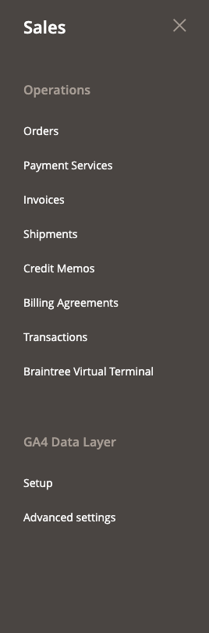
- Figure 1. The Sales menu with GA4 Data Layer › Setup
- From the settings page: Stores › Configuration › Sales › GA4 Data Layer, group General, button Open setup wizard. The wizard opens at the scope the settings page was showing.
Permissions (System › Permissions › User Roles › Role Resources):
- Stores › Settings › Configuration › GA4 Data Layer (Hryvinskyi_DataLayerAdminUi::config) opens the wizard and the settings page and allows saving.
- Server-side delivery actions (Hryvinskyi_DataLayerServerSideAdminUi::delivery), below it, is needed for Send test event and Retry failed in step 5. Without it the step shows the settings and the delivery status, and says why the tools are not offered.
- The purchase preview in step 4 shows a real order, so it also needs Sales › Operations › Orders › Actions › View (Magento_Sales::actions_view). Without it the purchase tab says it is not available.

The page
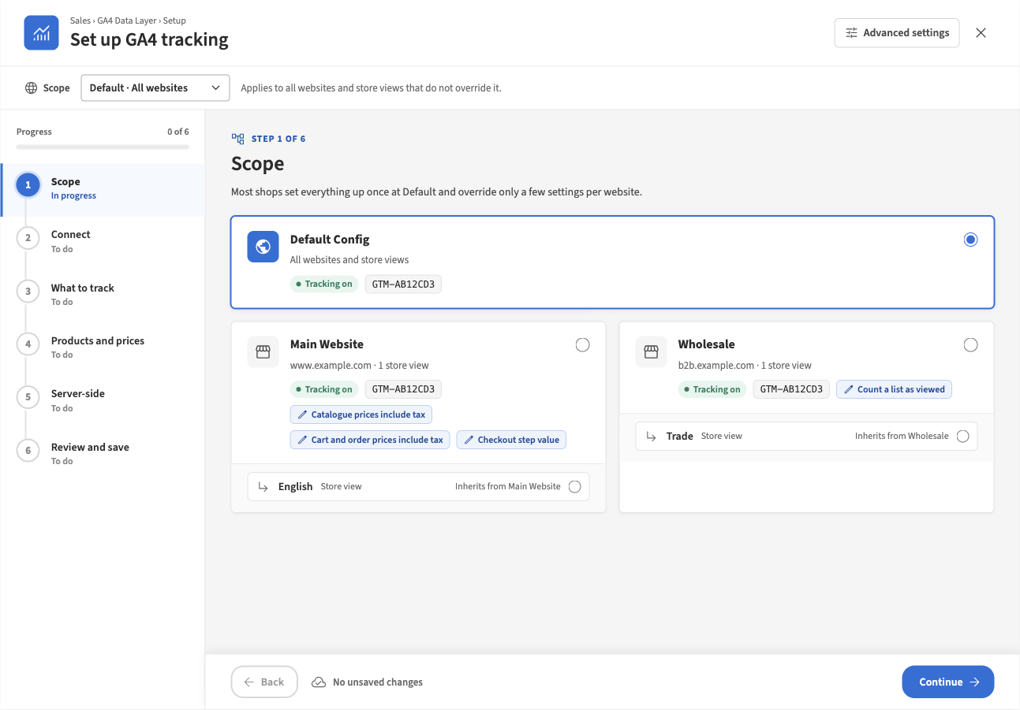
Figure 2. Step 1: Scope
- Header: Advanced settings opens the settings page at the wizard’s current scope; × (Close) leaves the wizard. If you have unsaved changes, both ask before leaving, and so does the browser when you close the tab.
- Scope bar: the scope you are editing, with a line saying who it applies to: “Applies to all websites and store views that do not override it.”, “Applies to the Wholesale website and its store views that do not override it.” or “Applies to the English store view only. Nothing inherits from it.”. You can change scope at any time; your unsaved changes at every scope are kept.
- Steps: each step shows its state: To do, In progress, Needs attention, Done or Skipped, and once done a one-line summary (for example Default · All websites). Progress counts the completed steps. You can open any step directly.
- Footer: Back, the number of unsaved changes (“3 unsaved changes · saved with Save all in the last step”) and Continue. In the last step Continue becomes Save all.
Continue does not save. It checks the step and moves on. If a field has a problem, it stays on the step and moves the focus to that field.

Scopes and inheritance
Settings follow Magento’s scopes: Default (every website), website and store view. A store view uses its own value if it has one, else its website’s, else Default’s, else the built-in default. Under every field a line says where the value comes from:
Line under the field | Meaning | Action offered
Built-in default · used by every website | Nothing is stored; the module’s default applies. | —
Default · used by every website | Set at Default, and no website or store view overrides it. | —
Default · Main Website overrides | Set at Default; the scopes named set their own value. | —
Set for this website / Set for this store view | This scope has its own value. | Use inherited value removes it, so the scope inherits again.
Inherited from Main Website / Inherited from Default Config / Inherited from the built-in default | This scope uses its parent’s value. The field is read-only. | Override here gives the scope its own value, starting from the inherited one.
Website setting — switch scope to Main Website | The setting exists only at website level (for example every server-side setting), so it cannot be set for a store view. | —
A lock with a reason | The value is fixed in the deployment configuration (app/etc/env.php, config.php or an environment variable). The field shows the value the store uses and cannot be changed here. | —
Each field also carries a badge with the narrowest scope it can be set at: Store view, Website or Default.

Step 1: Scope
“Most shops set everything up once at Default and override only a few settings per website.”
Pick the scope to configure from the cards. Default Config covers all websites and store views. Each website card shows its domain, the number of store views, whether tracking is on, the container in use, and an override badge for every setting the website sets itself (above: Main Website sends prices with tax and uses a different checkout step value; Wholesale counts lists when they scroll into view). Store views are listed under their website with “Inherits from …” when they set nothing themselves.
A shop with one website and one store view sees “Your shop has one website, so Default is selected. You can skip this step.” with Skip to Connect.

Step 2: Connect
“Choose how your store loads Google’s script.”
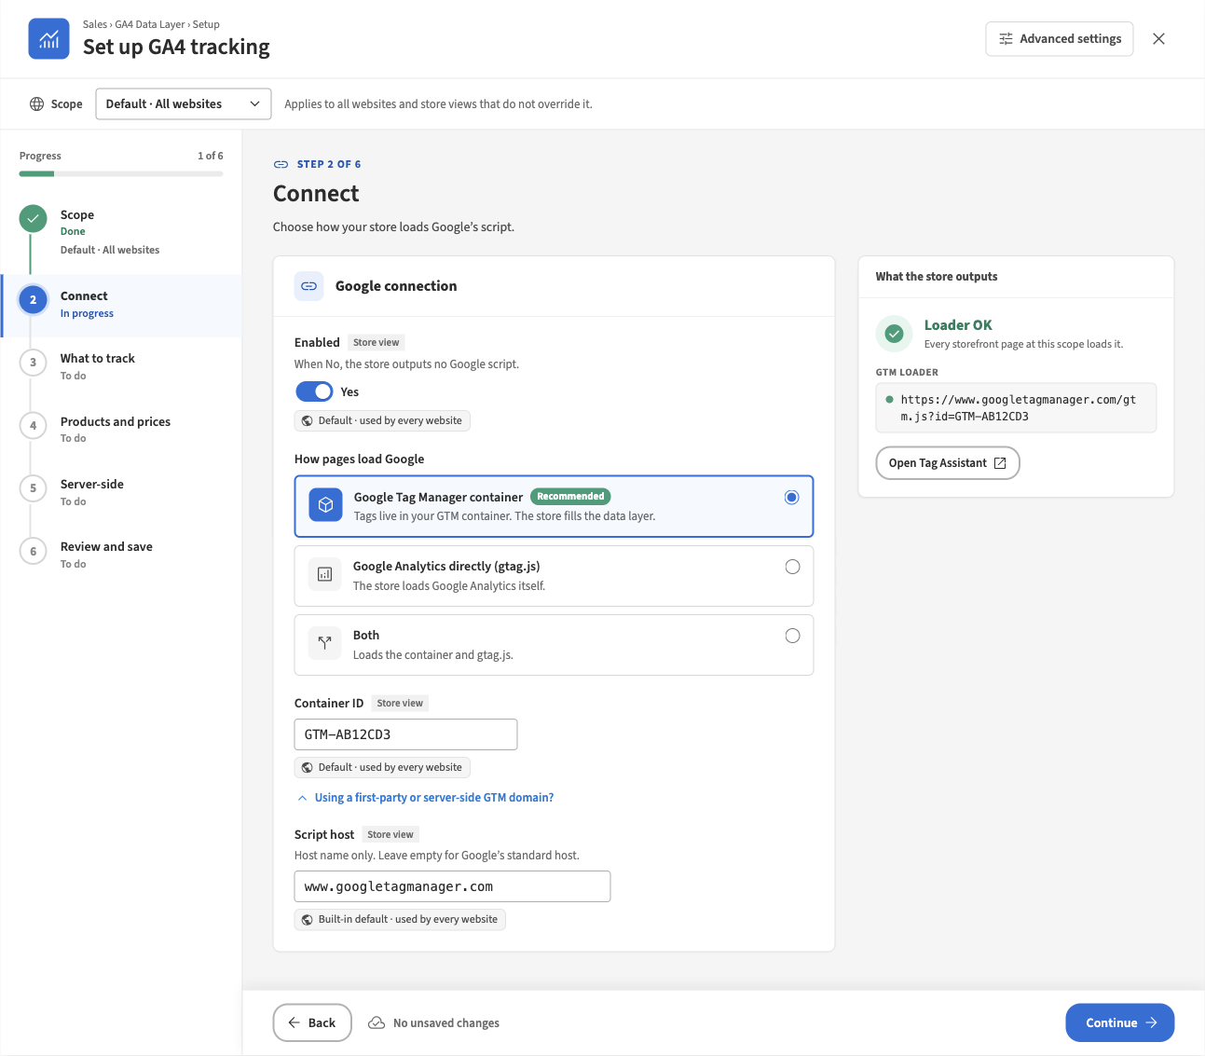
Figure 3. Step 2: Connect, with a valid container
Setting | What it does
Enabled | When No, the store outputs no Google script and sends no events.
How pages load Google | Google Tag Manager container (recommended): tags live in your GTM container and the store fills the data layer. Google Analytics directly (gtag.js): the store loads Google Analytics itself. Both: loads the container and gtag.js.
Container ID | Your GTM container, GTM- followed by letters and digits. Shown for GTM and Both.
Measurement ID | Your GA4 web data stream, G- followed by letters and digits. Shown for gtag.js and Both.
Script host | Under Using a first-party or server-side GTM domain?. Host name only; leave empty for Google’s standard host.
The mode is not a setting of its own: it follows from which IDs are filled in. Choosing a mode clears the ID the mode does not use, at the current scope only. If one of the IDs is locked or cannot be changed at this scope, the modes are disabled with “Choosing a mode changes …, which cannot be changed at this scope.”. Choosing Both shows the warning “GA4 counts events twice if the container also has a GA4 tag for the same stream.”
What the store outputs shows the result at this scope: Loader OK (Every storefront page at this scope loads it.) with the script address and Open Tag Assistant; Waiting for an ID; Invalid ID (Nothing is output until it’s fixed.); or Sending is off.
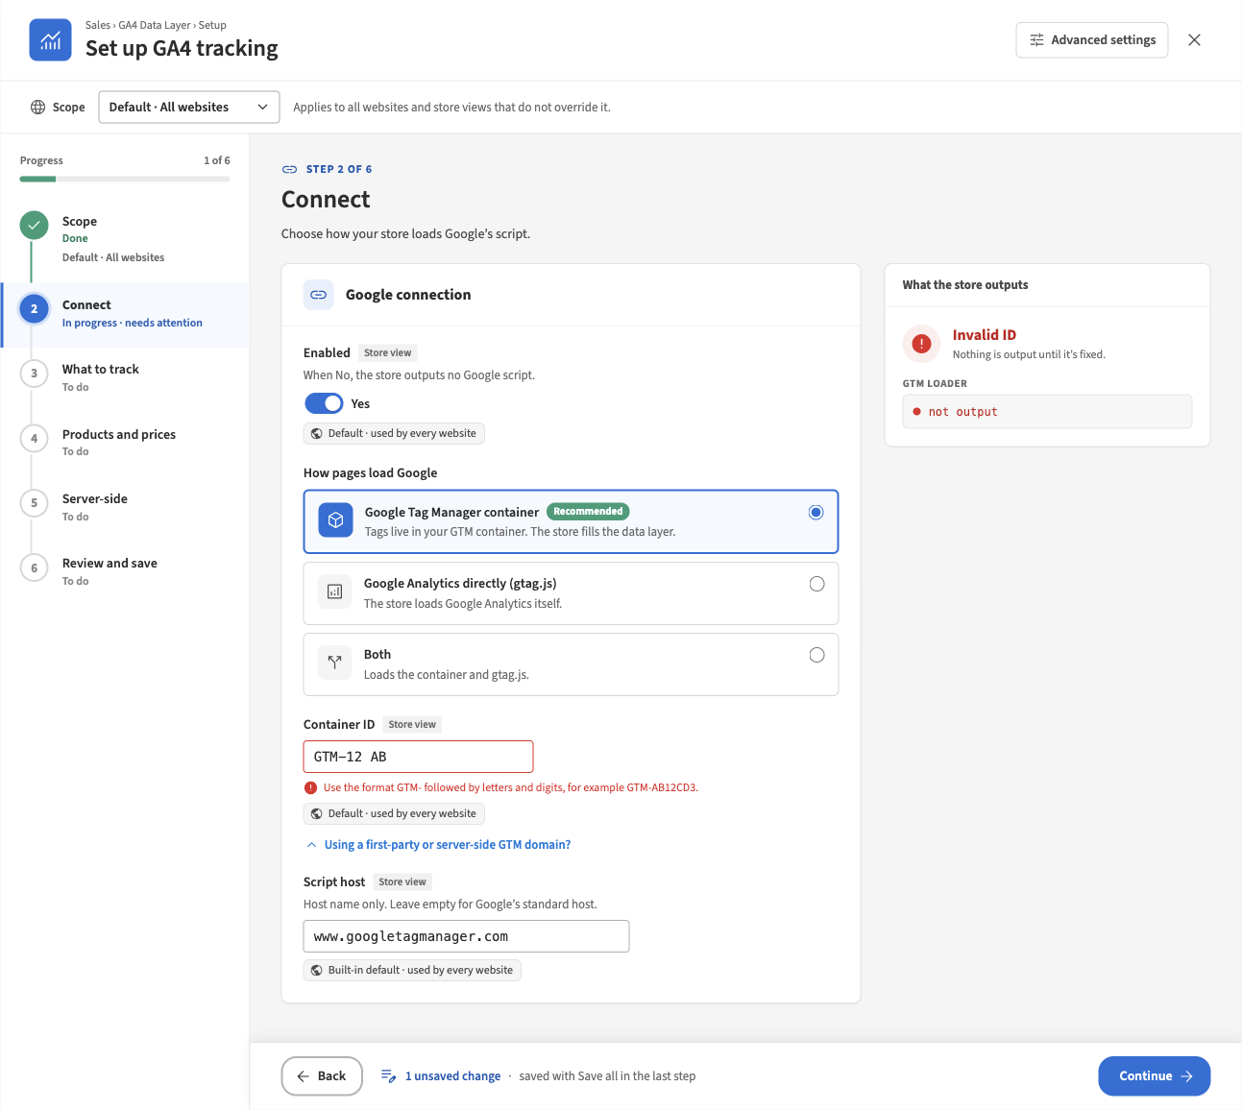
Figure 4. Step 2: an invalid container ID
An ID with the wrong format is marked as you leave the field, and the step shows Needs attention. A container ID is required unless the mode is gtag.js; a measurement ID is required unless the mode is GTM.

Step 3: What to track
“Pick the closest preset, then fine-tune single events.”
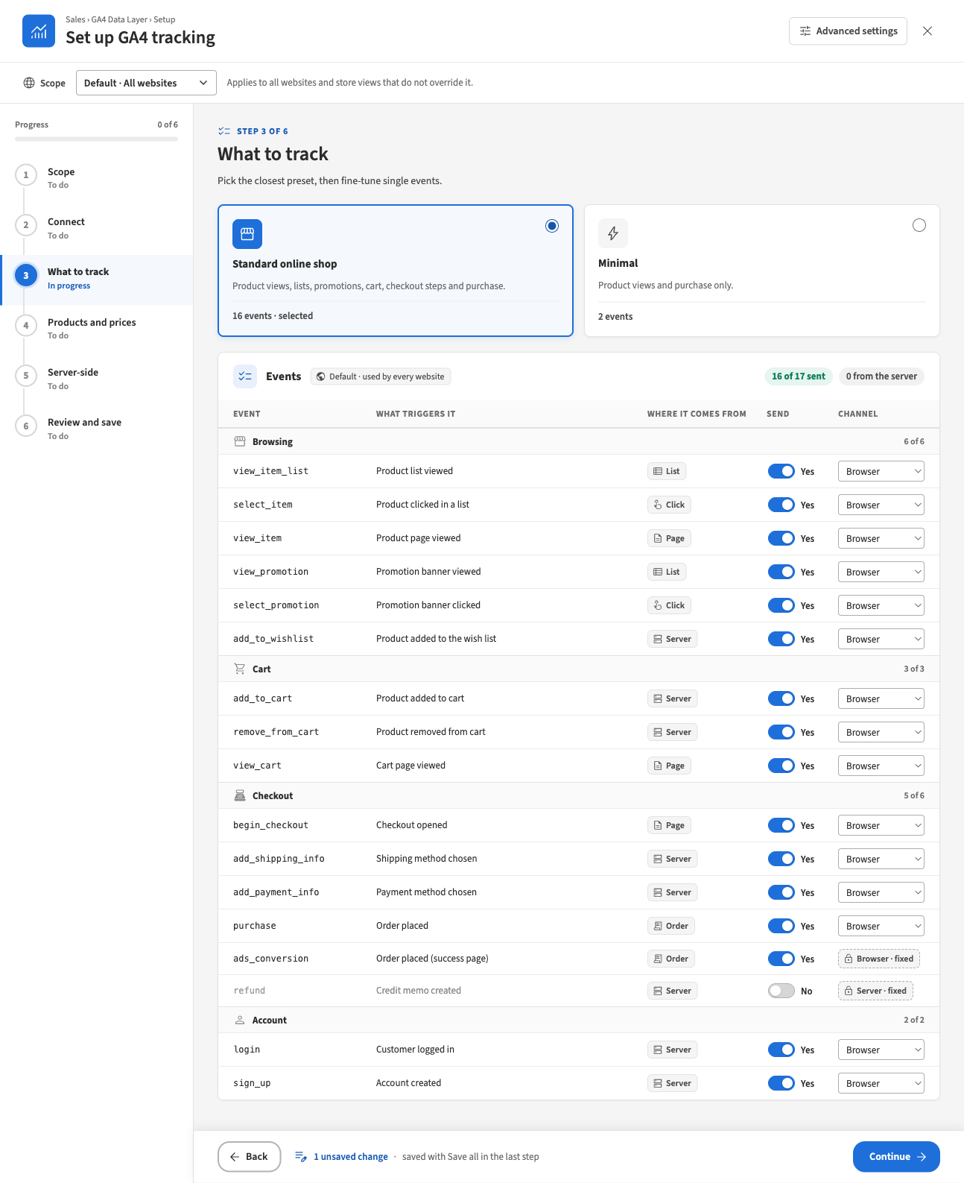
Figure 5. Step 3: the Standard online shop preset applied at Default
- Presets. Choosing a preset switches its events on and every other event off, and resets the channels of non-fixed events to Browser. Each card shows how many events it sends. When the table matches no preset, Custom is selected automatically (“Selected automatically: the table differs from every preset.”).
- The events table. One row per known event, grouped (Browsing, Cart, Checkout, Account, and groups added by other modules), with what triggers it, where it comes from, a Send switch and a Channel choice. Fixed channels show as Browser · fixed or Server · fixed. The header counts “16 of 17 sent” and how many go from the server.
- The events table is one setting at each scope: when you override it at a website or store view, the whole selection and its channels are overridden together. Entries for events of modules that are no longer installed are kept when you save.
Warnings appear under the table and the step shows Needs attention:
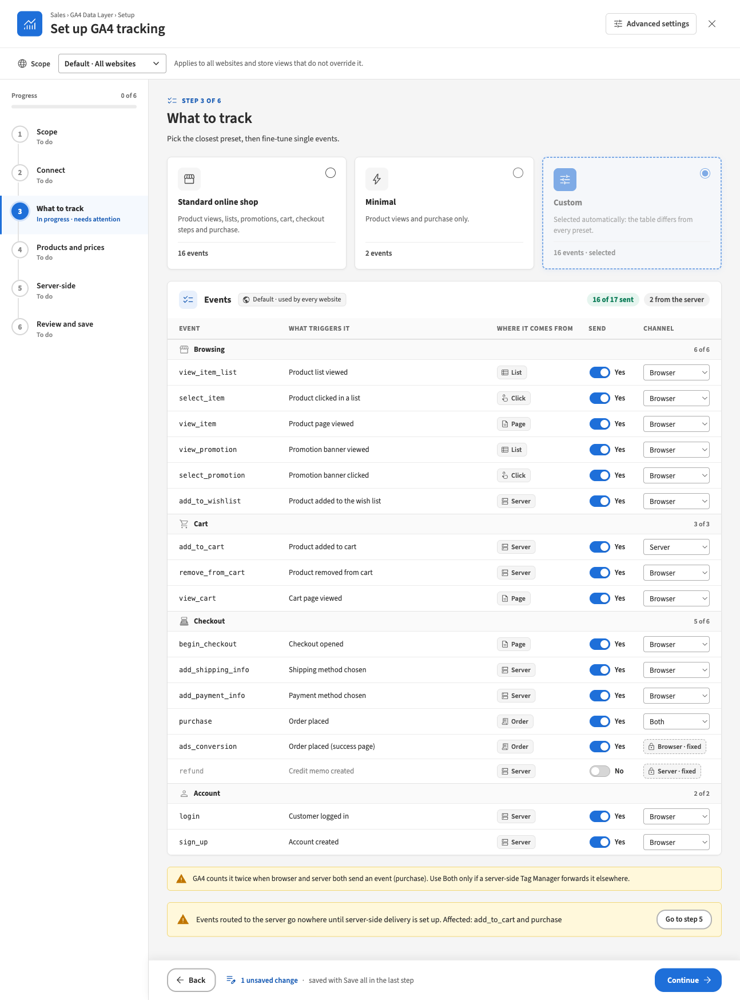
Figure 6. Step 3: warnings for double counting and for server routes without delivery
- “GA4 counts it twice when browser and server both send an event (purchase). Use Both only if a server-side Tag Manager forwards it elsewhere.”
- “Events routed to the server go nowhere until server-side delivery is set up. Affected: add_to_cart and purchase”, with Go to step 5 when the server-side step is installed.
At a scope that inherits the events, the reason is shown above the presets and the table is greyed out until you press Override here:
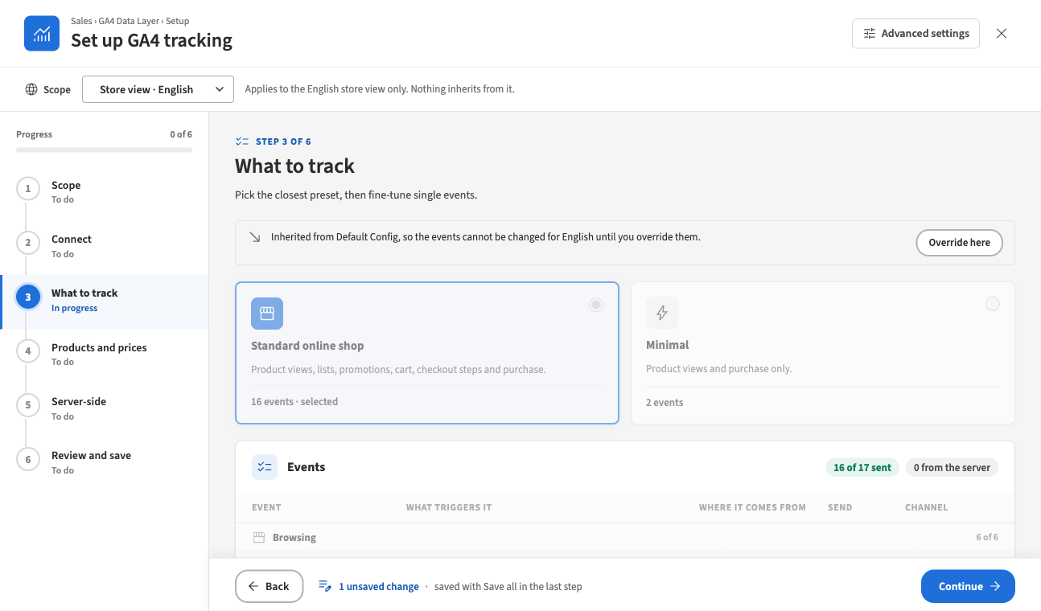
Figure 7. Step 3: a store view that inherits the events

Step 4: Products and prices
“Choose which product data and prices GA4 receives.”
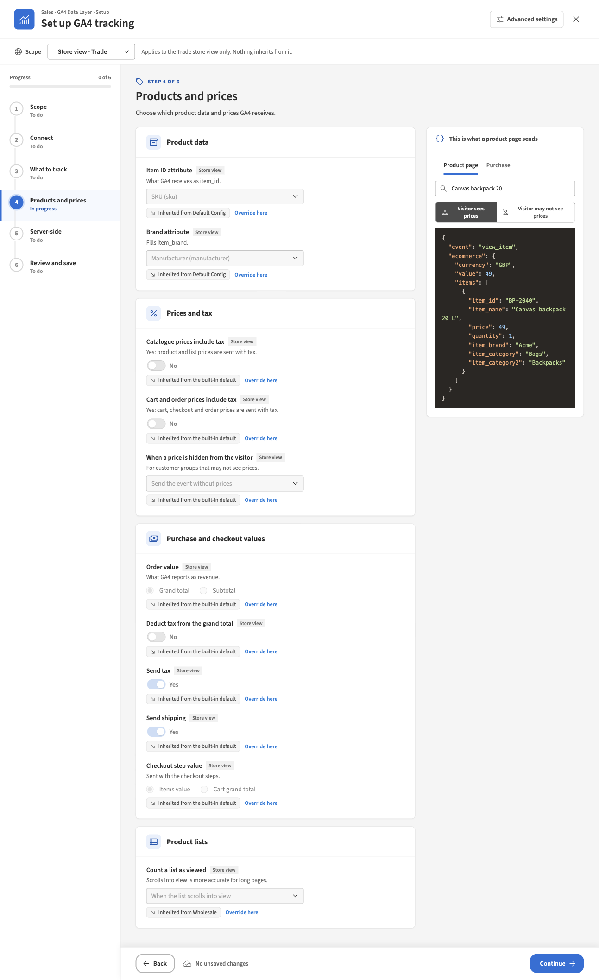
Figure 8. Step 4: Products and prices with the preview card (store view Trade)
Card | Setting | What it does
Product data | Item ID attribute | What GA4 receives as item_id: Product ID, SKU or another text attribute.
 | Brand attribute | Fills item_brand from a dropdown or multiselect attribute; — Not sent — by default.
Prices and tax | Catalogue prices include tax | Yes: product and list prices are sent with tax.
 | Cart and order prices include tax | Yes: cart, checkout and order prices are sent with tax.
 | When a price is hidden from the visitor | Send the event without prices or Do not send ecommerce events, for customer groups that may not see prices.
Purchase and checkout values | Order value | What GA4 reports as revenue: Grand total or Subtotal.
 | Deduct tax from the grand total | Shown only for Grand total. Yes reports revenue excluding tax.
 | Send tax / Send shipping | Fill tax and shipping in the purchase event.
 | Checkout step value | Sent with the checkout steps: Items value or Cart grand total.
Product lists | Count a list as viewed | When the page loads or When the list scrolls into view; scrolling into view is more accurate for long pages.
The preview card shows the exact event the store would build with the values on screen, including changes you have not saved. Nothing is saved and nothing is sent to Google.
- It previews a store view: the current scope if it is a store view, otherwise the first store view under it (“Previewing English, the first store view under this scope.”). At Default with no store view there is nothing to preview.
- Product page: search a product by name or SKU (at least two characters; enabled products visible in that store view; up to ten results). The toggle Visitor sees prices / Visitor may not see prices shows what the store sends to someone who may not see the price, following When a price is hidden from the visitor:
- 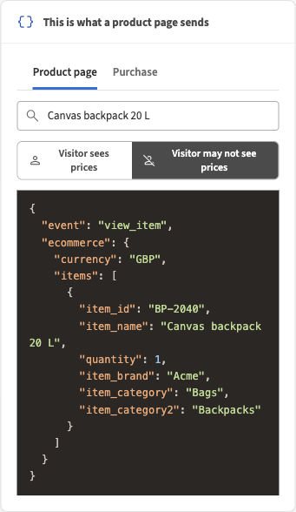
- Figure 9. Preview for a visitor who may not see prices: no price and no value
- Purchase: built from the latest real order of the store view (“Built from the latest order of Trade.”). It needs permission to view orders. A store view without orders shows “No orders in this store view yet.”
- 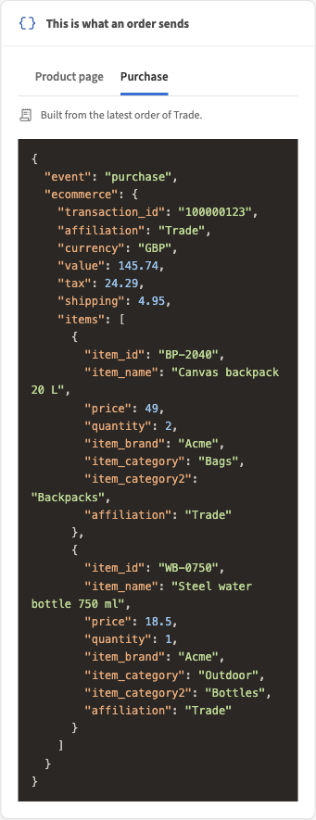
- Figure 10. Preview of the purchase event
- When the event would not be sent (tracking off, the event switched off, prices hidden with Do not send ecommerce events, nothing reportable), the card says why instead of showing JSON.

Step 5: Server-side
This step is present when the server-side modules are installed. “Sends selected events, such as purchase, from Magento straight to Google, so ad blockers and closed tabs don’t lose them. Optional: browser tracking keeps working without it.” It can be skipped with Skip this step. While delivery is off, only the Enabled switch is shown.
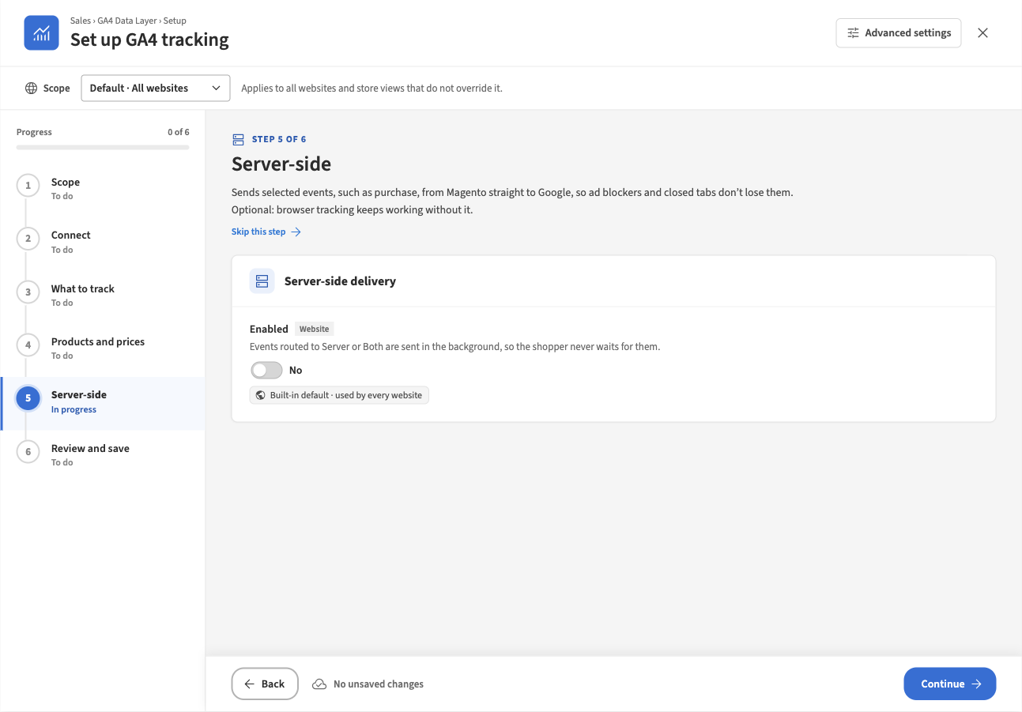
Figure 11. Step 5: server-side delivery switched off
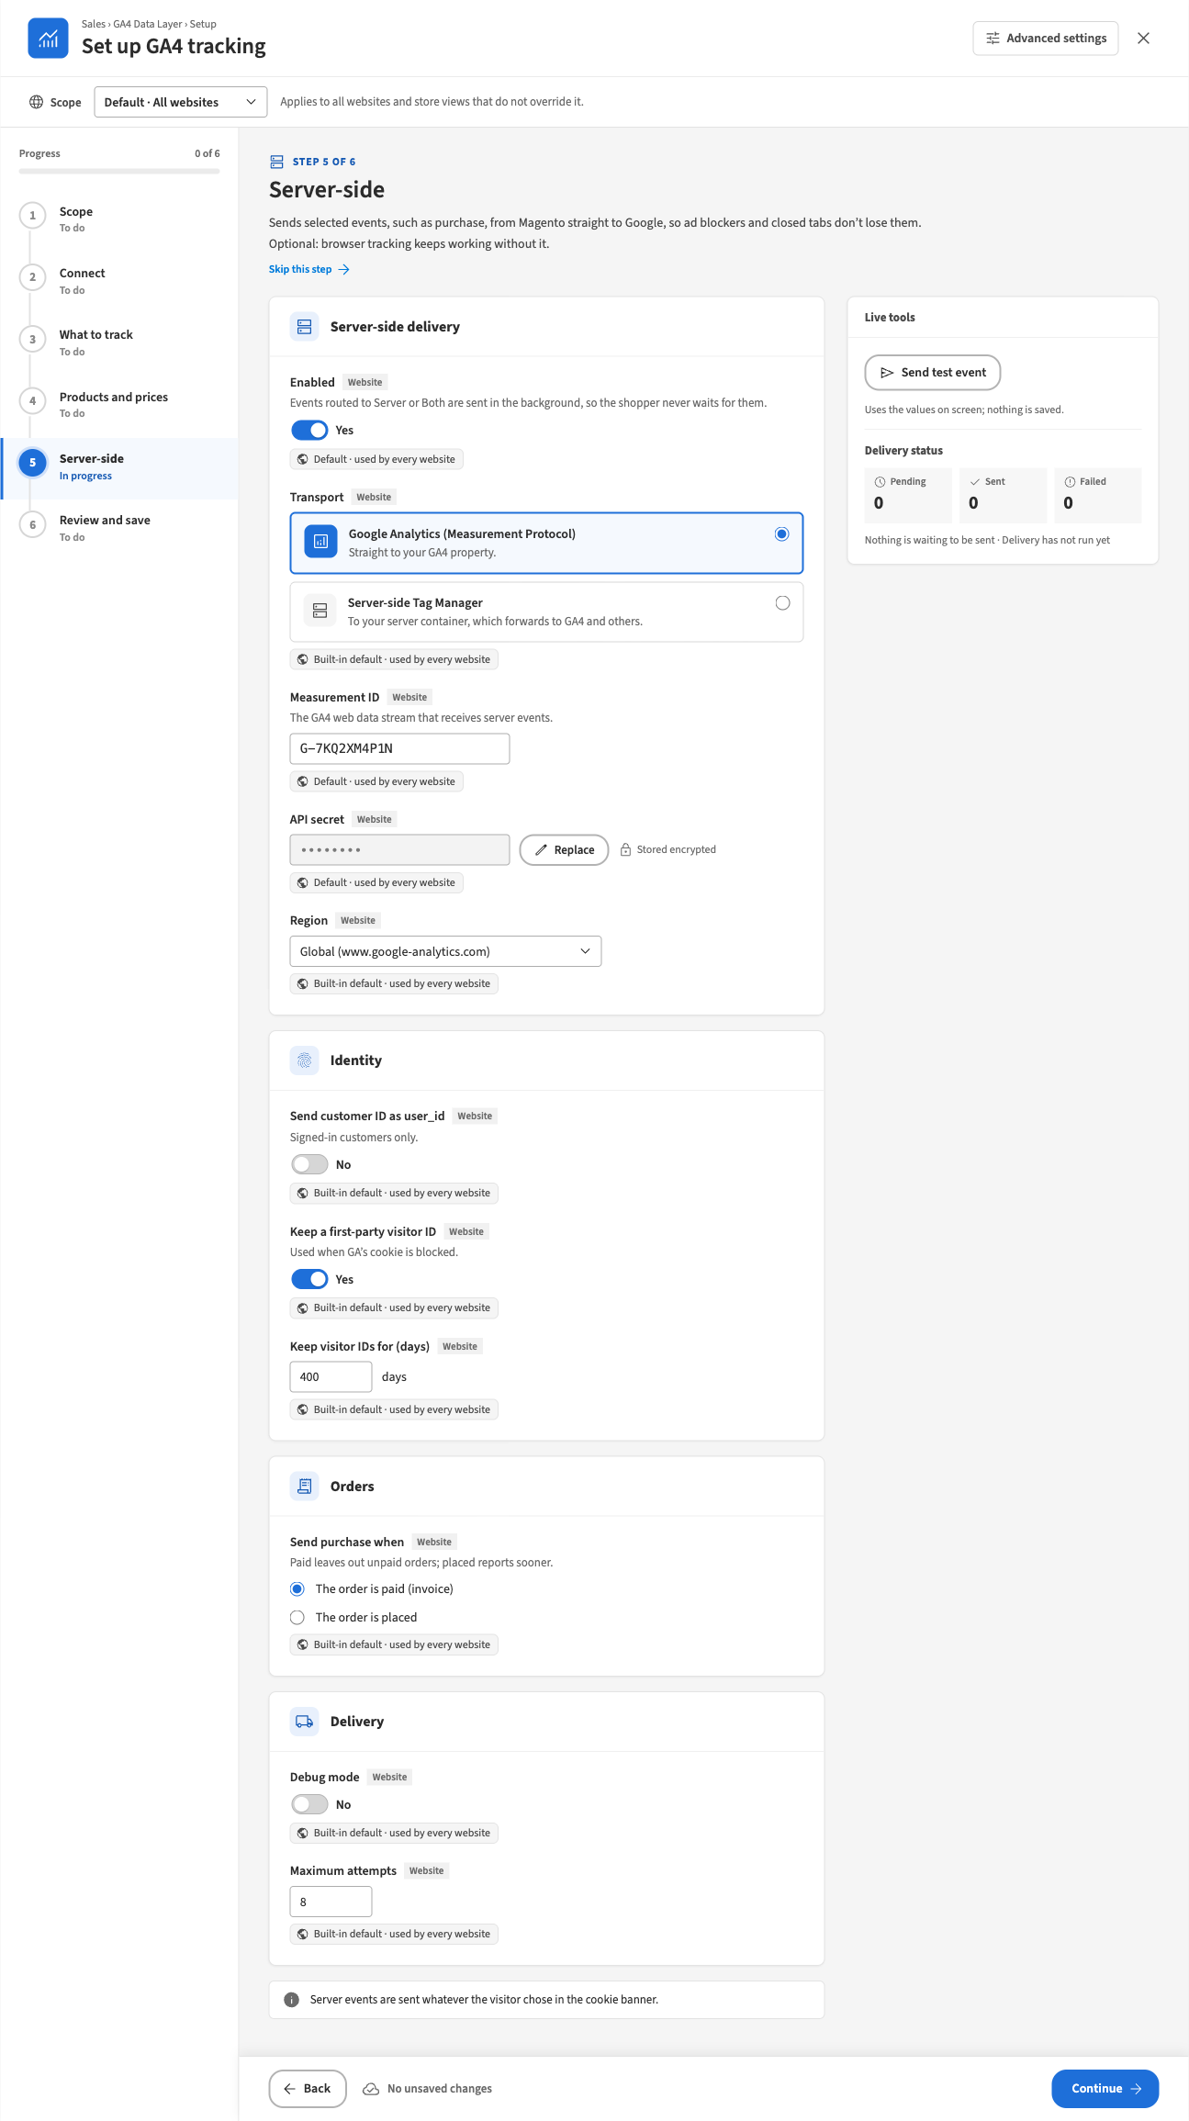
Figure 12. Step 5: server-side delivery through the Measurement Protocol
Card | Setting | What it does
Server-side delivery | Enabled | Events routed to Server or Both are sent in the background, so the shopper never waits for them.
 | Transport | Google Analytics (Measurement Protocol): straight to your GA4 property. Server-side Tag Manager: to your server container, which forwards to GA4 and others.
 | Measurement ID | The GA4 web data stream that receives server events. Required for the Measurement Protocol.
 | API secret | Measurement Protocol only. Required. Stored encrypted; the wizard shows only Stored encrypted and offers Replace.
 | Region | Measurement Protocol only: Global or EU only.
 | Endpoint / API secret (optional) | Server-side Tag Manager only: the container’s https address with no path, and its own secret if it asks for one.
Identity | Send customer ID as user_id | Signed-in customers only.
 | Keep a first-party visitor ID | Used when GA’s cookie is blocked. See section 7.
 | Keep visitor IDs for (days) | 30 to 1000.
Orders | Send purchase when | The order is paid (invoice) or The order is placed. Paid leaves out unpaid orders; placed reports sooner.
Delivery | Debug mode | When on: “Debug mode is on: events go to Google’s validation endpoint and are NOT recorded in GA4.”
 | Maximum attempts | How often a failed send is retried.
The step ends with “Server events are sent whatever the visitor chose in the cookie banner.”
Live tools (right):
- Send test event sends one test event with the values on screen, including unsaved ones (“Uses the values on screen; nothing is saved.”). A stored API secret is used unless you typed a new one. The result is Valid. Google returned no messages., a list of Google’s validation messages, or the reason it could not be checked. Only the Measurement Protocol can be tested: a server container has no validation endpoint and would record the test.
- Delivery status: pending, sent and failed counts for the scope’s website (all websites together at Default), with the oldest pending event and the last run. Retry failed appears while there are failed events.
Server-side settings are per website. At a store view they are shown read-only with “Website setting — switch scope to Main Website”; the tools work for that store view’s website.
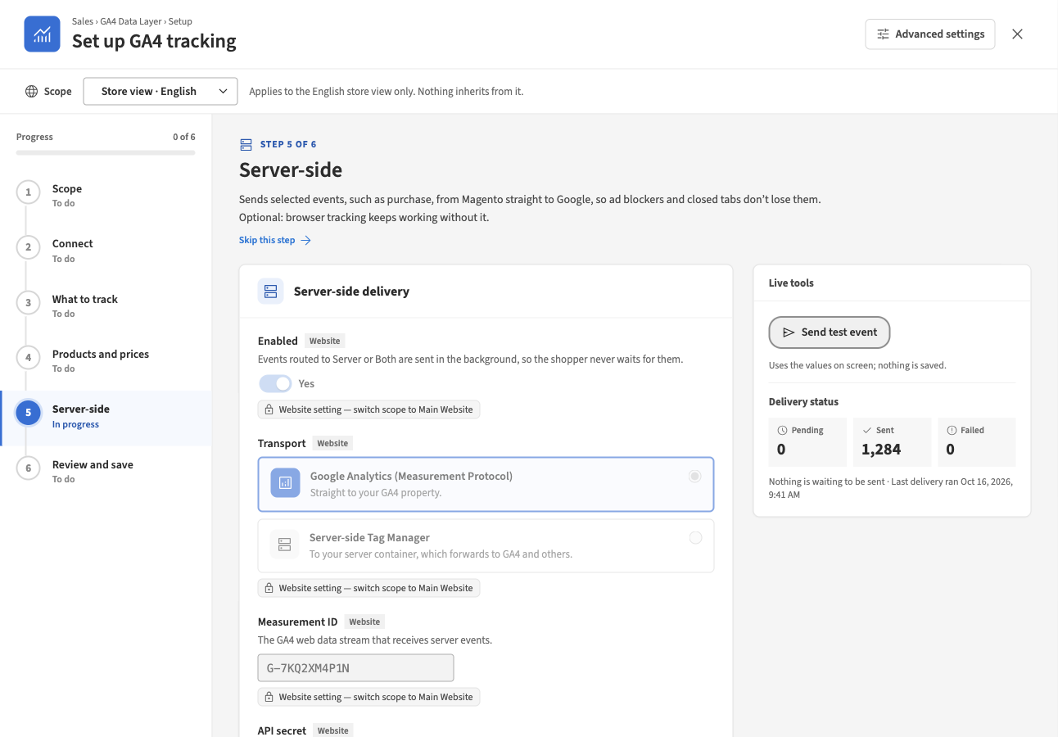
Figure 13. Step 5 at a store view: website settings are read-only

Step 6: Review and save
“Nothing reaches the store until you click Save all.”
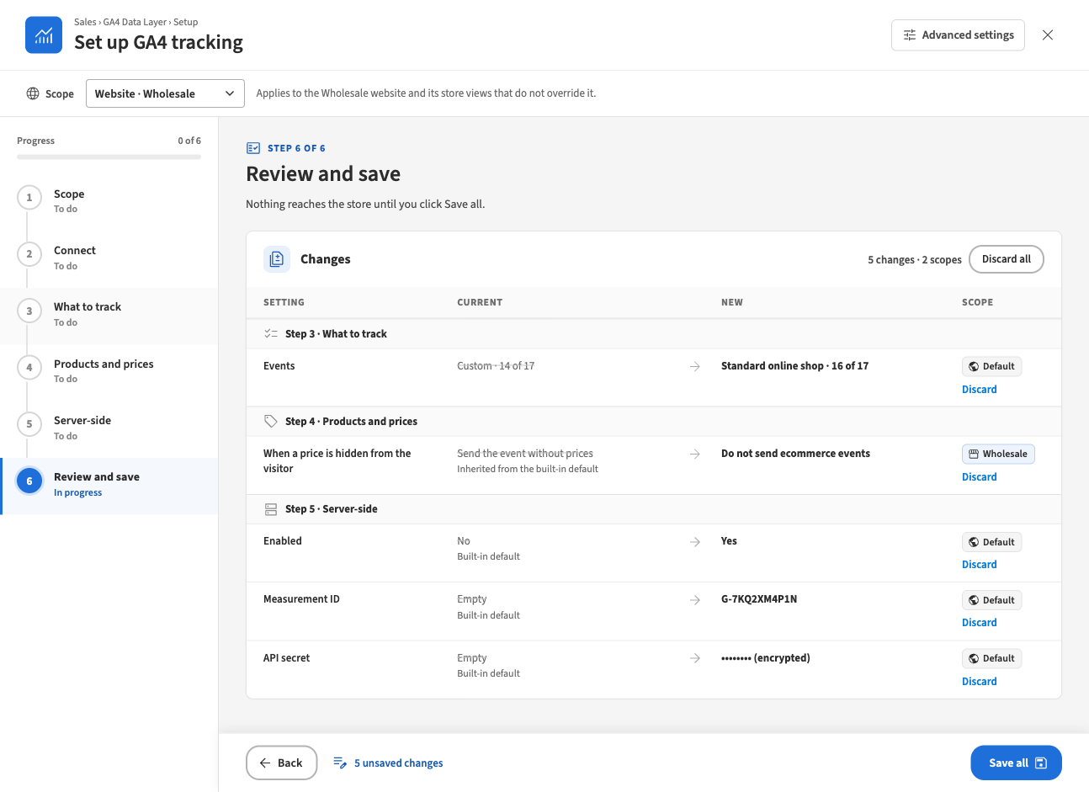
Figure 14. Step 6: the changes to be saved
- The table lists every change against what is stored, grouped by step: the setting, its current value (with where it comes from), the new value and the scope. Secrets are never shown. The events setting is summarised as the preset name and the number of events sent.
- Discard removes one change; Discard all asks “Discard every unsaved change?”.
- Save all is held back while a step has a problem at a scope you changed: the step lists “Fix these steps before saving:” with each step and scope, and leads to it.
- Save all writes the changes as ordinary Magento configuration values, exactly as the settings page does: the same validation, the same events and the same cache handling. While it saves, the wizard cannot be edited, so what is saved is what you see.
When everything is saved, the step shows what was saved per scope and what to do next:
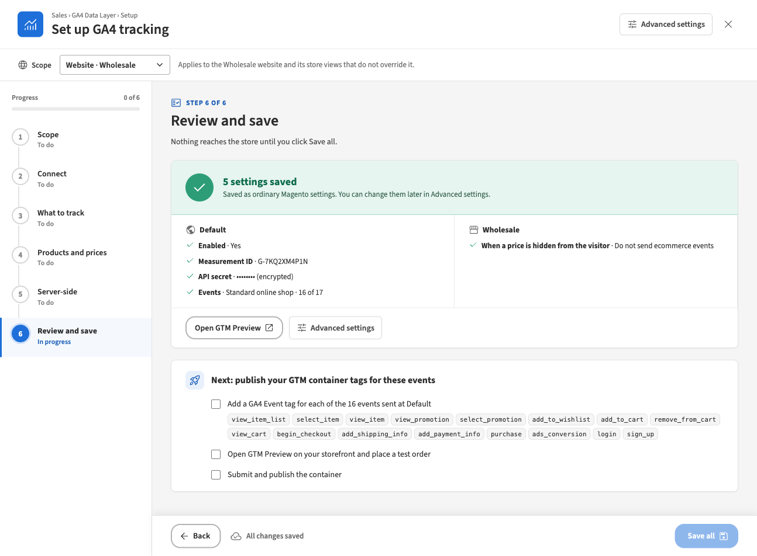
Figure 15. After Save all: the saved settings and the GTM checklist
- “Saved as ordinary Magento settings. You can change them later in Advanced settings.”
- Next: publish your GTM container tags for these events: a checklist with the events sent at each scope, Open GTM Preview on your storefront and place a test order, and Submit and publish the container. The ticks are a personal checklist and are not stored.
When some changes fail. Each change is reported on its own. If a change is refused (for example a value the store rejects, or a value locked in the deployment configuration), the step shows “4 of 5 changes were saved. 1 could not be saved — see the marked rows.”; the saved changes are no longer pending and the failed ones stay, marked, for you to correct and save again. Sending the same changes again is harmless.
When the request fails. A red strip above the step explains it and every edit is kept:
Message | What to do
Your admin session has ended. Sign in again in another tab, then retry; your changes are kept. | Sign in to the admin in another browser tab, come back and press Retry.
Your role may not change these settings. | Ask for the GA4 Data Layer permission.
The store took too long to answer. / could not be reached. / could not complete the request. | Try again.

Narrow windows
Below 1000 pixels of width the wizard switches to a single column: the steps become a row of chips under the scope bar and the side panels move under the settings.
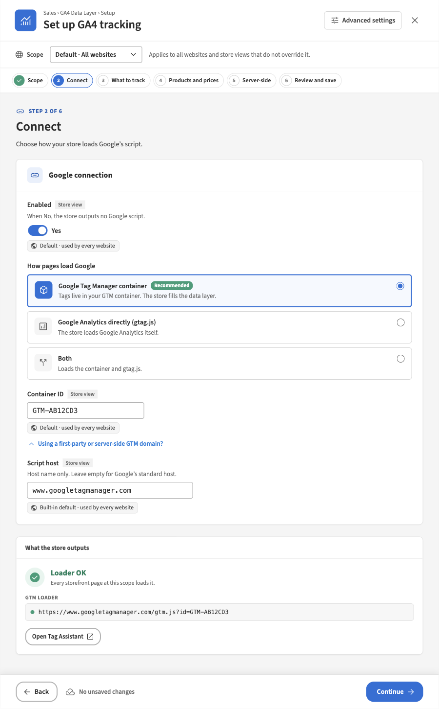
Figure 16. The wizard in a narrow window

The wizard and the settings page
The wizard and Stores › Configuration › Sales › GA4 Data Layer edit the same settings. The settings page remains the complete reference: it also has the Google Ads conversion settings, which the wizard does not show. A value saved in one appears in the other. Use Advanced settings in the wizard to jump to the settings page at the same scope.

6 Settings reference
Stores › Configuration › Sales › GA4 Data Layer. All settings in the core groups can be set at default, website and store view scope; the Server-side group at default and website only. Paths are relative to core_config_data and can be used in app/etc/config.php or env.php to lock a value.

General, Google Tag Manager, Google Analytics (gtag.js)
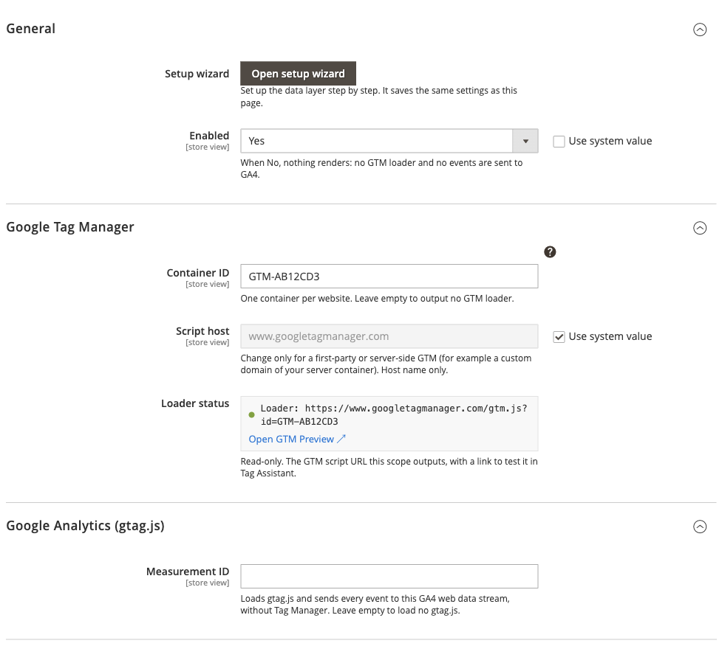
Figure 17. Settings page: General, Google Tag Manager and Google Analytics
Setting | Path | Default | Description
Setup wizard | — | — | Opens the setup wizard at the scope shown. Stores nothing.
Enabled | hryvinskyi_datalayer/general/enabled | No | When No, nothing renders: no GTM loader and no events are sent to GA4.
Container ID | hryvinskyi_datalayer/gtm/container_id | (empty) | GTM- followed by capital letters and digits. One container per website. Empty = no GTM loader.
Script host | hryvinskyi_datalayer/gtm/script_host | www.googletagmanager.com | Change only for a first-party or server-side GTM domain. Host name only, no https:// or path.
Loader status | — | — | Read-only: the GTM script address this scope outputs, or why none, with Open GTM Preview.
Measurement ID | hryvinskyi_datalayer/gtag/measurement_id | (empty) | Loads gtag.js and sends every event to this GA4 web data stream. Upper-cased on save. Empty = no gtag.js. When the scope loads both a container and gtag.js, an amber warning about double counting appears.

Events
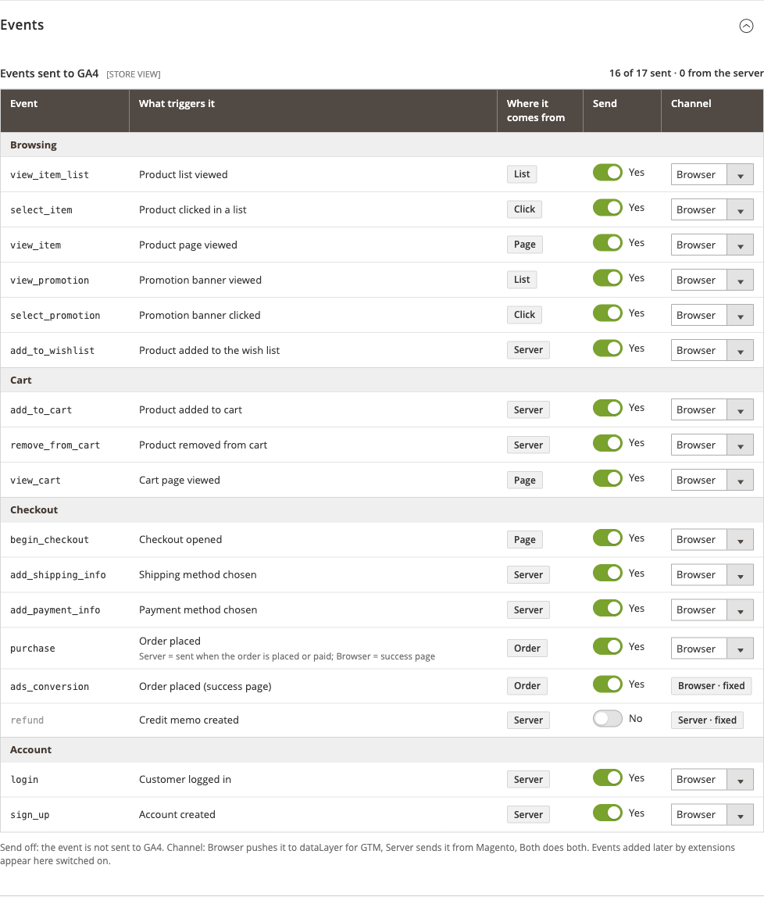
Figure 18. Settings page: the events table
Setting | Path | Default | Description
Events sent to GA4 | hryvinskyi_datalayer/events/disabled | refund off | The events table: one row per known event with Send and Channel. Stored as the list of events switched off.
(event routing) | hryvinskyi_datalayer/channels/routing | All Browser | Saved by the same table: the events routed to Server or Both.
One Use Default / Use Website checkbox covers both paths. The table warns when an event is routed to Both, and when server routes exist while server delivery is off for the website (with a link to the server-side settings).

Items, Checkout steps, Purchase
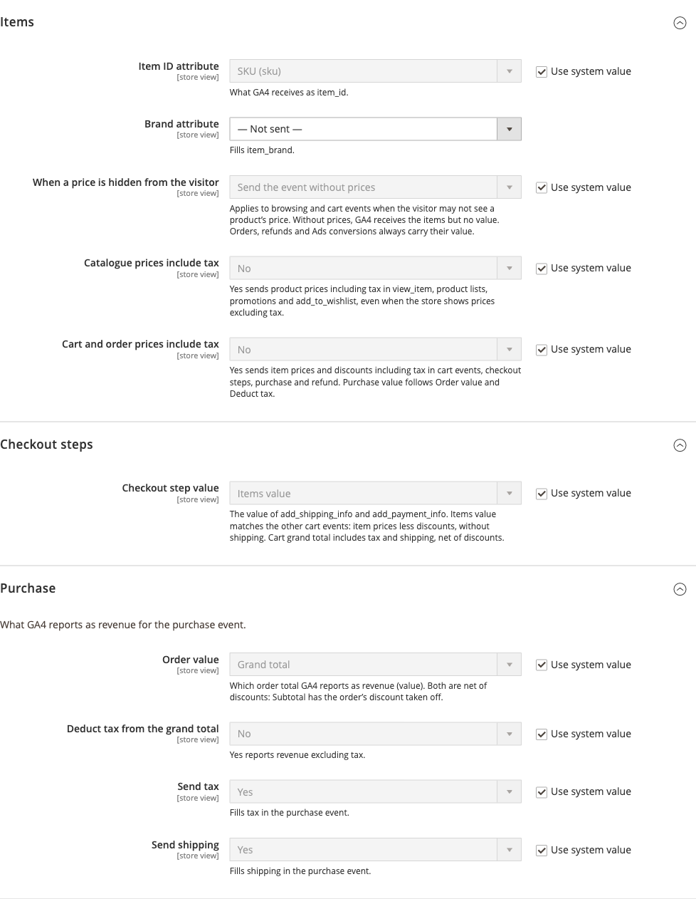
Figure 19. Settings page: Items, Checkout steps and Purchase
Setting | Path | Default | Options
Item ID attribute | hryvinskyi_datalayer/item/identifier_attribute | sku | Product ID, or any text attribute
Brand attribute | hryvinskyi_datalayer/item/brand_attribute | (not sent) | Any dropdown or multiselect attribute
When a price is hidden from the visitor | hryvinskyi_datalayer/item/hidden_price_handling | omit_price | Send the event without prices · Do not send ecommerce events
Catalogue prices include tax | hryvinskyi_datalayer/item/catalogue_price_includes_tax | No | Yes / No
Cart and order prices include tax | hryvinskyi_datalayer/item/line_price_includes_tax | No | Yes / No
Checkout step value | hryvinskyi_datalayer/checkout/step_value_basis | items | Items value · Cart grand total
Order value | hryvinskyi_datalayer/purchase/value_basis | grand_total | Grand total · Subtotal (both net of discounts)
Deduct tax from the grand total | hryvinskyi_datalayer/purchase/deduct_tax | No | Shown for Grand total only
Send tax | hryvinskyi_datalayer/purchase/include_tax | Yes | Fills tax in purchase
Send shipping | hryvinskyi_datalayer/purchase/include_shipping | Yes | Fills shipping in purchase

Google Ads conversion, Product lists
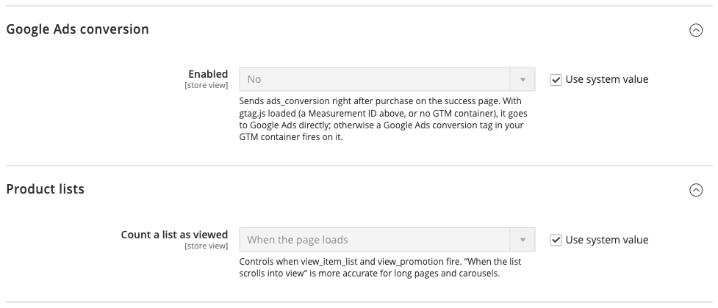
Figure 20. Settings page: Google Ads conversion and Product lists
Setting | Path | Default | Description
Enabled | hryvinskyi_datalayer/ads/enabled | No | Sends ads_conversion right after purchase on the success page (see section 3).
Conversion ID | hryvinskyi_datalayer/ads/conversion_id | (empty) | The Google Ads account, for example AW-123456789.
Conversion label | hryvinskyi_datalayer/ads/conversion_label | (empty) | The part after the slash in the conversion action’s send_to.
Conversion value | hryvinskyi_datalayer/ads/value_source | purchase | Purchase value (same value and currency as purchase) · Fixed value
Fixed value | hryvinskyi_datalayer/ads/fixed_value | (empty) | Sent for every order, in the order’s currency. Shown for Fixed value.
Count a list as viewed | hryvinskyi_datalayer/lists/impression_trigger | load | When the page loads · When the list scrolls into view. Applies to view_item_list and view_promotion.

Server-side
Added by the server-side modules. Default and website scope only.
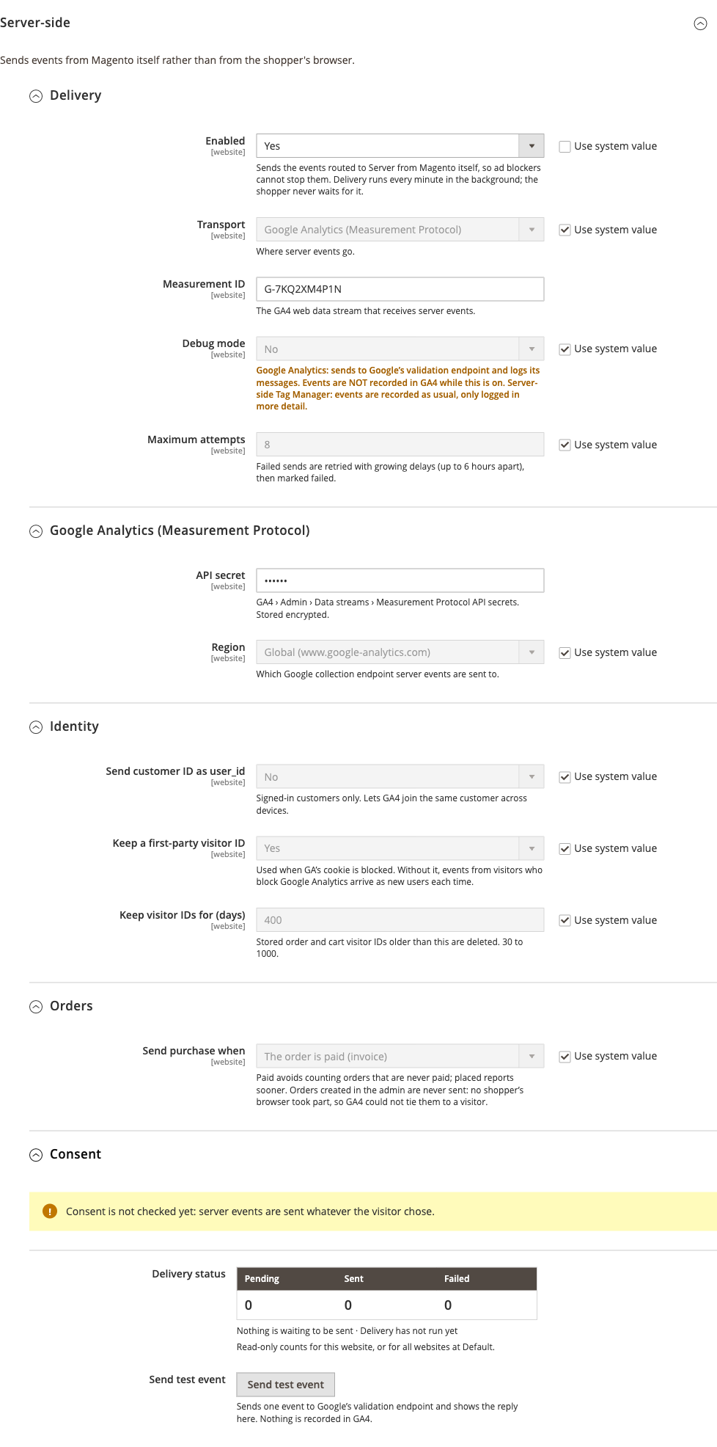
Figure 21. Settings page: the Server-side group
Group | Setting | Path | Default | Description
Delivery | Enabled | hryvinskyi_datalayer_server/general/enabled | No | Sends the events routed to Server from Magento. Delivery runs every minute in the background.
 | Transport | hryvinskyi_datalayer_server/general/transport | ga4 | Google Analytics (Measurement Protocol) · Server-side Tag Manager
 | Measurement ID | hryvinskyi_datalayer_server/ga4/measurement_id | (empty) | The GA4 web data stream that receives server events.
 | Debug mode | hryvinskyi_datalayer_server/delivery/debug | No | Measurement Protocol: validation only, events are not recorded in GA4. Server-side Tag Manager: recorded as usual, logged in more detail.
 | Maximum attempts | hryvinskyi_datalayer_server/delivery/max_attempts | 8 | 1 to 20. Retries with growing delays, up to 6 hours apart, then marked failed.
Google Analytics (Measurement Protocol) | API secret | hryvinskyi_datalayer_server/ga4/api_secret | (empty) | From GA4 › Admin › Data streams › Measurement Protocol API secrets. Encrypted; never written by app:config:dump.
 | Region | hryvinskyi_datalayer_server/ga4/region | global | Global (www.google-analytics.com) · EU only (region1.google-analytics.com)
Server-side Tag Manager | Endpoint | hryvinskyi_datalayer_server/sgtm/endpoint | (empty) | https://host[:port], no path or query, a public address.
 | API secret (optional) | hryvinskyi_datalayer_server/sgtm/api_secret | (empty) | Only when your server container asks for one. Never the GA4 secret.
Identity | Send customer ID as user_id | hryvinskyi_datalayer_server/identity/send_user_id | No | Signed-in customers only.
 | Keep a first-party visitor ID | hryvinskyi_datalayer_server/identity/fallback_cookie | Yes | Without it, visitors who block Google Analytics arrive as new users each time.
 | Keep visitor IDs for (days) | hryvinskyi_datalayer_server/identity/retention_days | 400 | 30 to 1000.
Orders | Send purchase when | hryvinskyi_datalayer_server/orders/purchase_trigger | paid | The order is paid (invoice) · The order is placed
Consent | (notice) | — | — | Consent is not checked yet: server events are sent whatever the visitor chose.
 | Delivery status | — | — | Read-only counts for the website (all websites at default), oldest pending event, last run, latest failure and Retry failed.
 | Send test event | — | — | Sends one event to Google’s validation endpoint and shows the reply. Nothing is recorded.

7 Server-side delivery
Server delivery sends events from Magento to Google instead of, or as well as, from the shopper’s browser. Ad blockers cannot stop it, and an order is reported even when the shopper closes the tab before the success page.

Transports
Transport | Where events go | What it needs
Google Analytics (Measurement Protocol) | https://www.google-analytics.com/mp/collect (or the EU endpoint) | Measurement ID and API secret.
Server-side Tag Manager | <endpoint>/mp/collect on your server container, which forwards to GA4 and other platforms | Endpoint; the measurement ID is passed on; an optional container secret.
Secrets are never sent in the request body and are removed from every log line and error message. For security, the endpoint must be a public https address: local and private network addresses are refused.

How delivery works
- An event routed to Server or Both is written to an outbox (table hryvinskyi_datalayer_server_event) instead of being sent during the shopper’s request. Events from the browser routed to the server reach the store’s collector by sendBeacon and are stored the same way.
- A cron job in its own group (hryvinskyi_datalayer) runs every minute, sends pending events in batches (up to 25 events per request for the same visitor) and records the outcome.
- A failed send is retried with growing delays, at most 6 hours apart, until Maximum attempts is reached; then the event is marked failed. Events older than 72 hours are not sent (a Measurement Protocol limit).
- An event is stored only once: a second purchase for the same order or refund for the same credit memo is ignored.
Sent events are kept 7 days and failed events 30 days; visitor IDs for Keep visitor IDs for (days).

Status, retry and test
- Delivery status (settings page and wizard step 5): pending, sent and failed counts, the oldest pending event, the last run and the latest error.
- Retry failed puts failed events of the last 72 hours back in the queue with fresh attempts.
- Send test event sends one fixed test event through the Measurement Protocol’s validation endpoint and shows Google’s reply. Nothing is recorded in GA4 and nothing goes through the outbox.
- Command line: bin/magento hryvinskyi:datalayer:server:status and bin/magento hryvinskyi:datalayer:server:retry-failed [--website=<id>].

Identity
- The GA4 client ID and session are read from the visitor’s _ga cookies.
- First-party visitor ID. When Google Analytics’ cookie is blocked, the store can keep its own visitor ID in a first-party cookie (hdl_cid, two years), set when the cart is saved. Without it those visitors arrive in GA4 as new users each time, and their events cannot be stored, because the Measurement Protocol requires a client ID.
- user_id is the customer ID of a signed-in customer when Send customer ID as user_id is on.
- The visitor is recorded with the cart and copied to the order, so order events sent later (when the order is paid, or as a refund) are tied to the shopper who placed it.

Purchase: paid or placed
- The order is paid (invoice) (default) avoids counting orders that are never paid. Payment methods that are invoiced late are reported late, and orders that are never invoiced are not reported.
- The order is placed reports sooner, but also counts orders whose payment is later abandoned.
- Orders created in the admin are never sent: no shopper’s browser took part, so GA4 could not tie them to a visitor. A storefront order invoiced in the admin is sent.

Consent
Consent is not checked by server delivery today: server events are sent whatever the visitor chose in the cookie banner. In the browser, consent is handled by Google Tag Manager (Consent Mode); the module always pushes to dataLayer, and your tags decide what to send. Take this into account before routing events to the server.

Debug mode
With the Measurement Protocol, debug mode sends to Google’s validation endpoint and logs its messages: events are not recorded in GA4. Switch it off after testing. With a server-side Tag Manager, events are recorded as usual and only logged in more detail.

8 Permissions
System › Permissions › User Roles › Role Resources:
Resource | Grants
Stores › Settings › Configuration › GA4 Data Layer (Hryvinskyi_DataLayerAdminUi::config) | The whole settings section (including Server-side), the menu Sales › GA4 Data Layer › Setup and every wizard action.
… › Server-side delivery actions (Hryvinskyi_DataLayerServerSideAdminUi::delivery) | Retry failed and Send test event, on the settings page and in the wizard.
Sales › Operations › Orders › Actions › View (Magento_Sales::actions_view) | Needed in addition for the purchase preview in the wizard, because it shows a real order.
A setting that a module places in another configuration section is shown and saved in the wizard only for users allowed to open that section.

9 Going-live checklist
- Disable or remove Magento’s own Google modules if they are still installed, and check that the migrated Measurement ID and Google Ads settings are what you expect.
- Decide how pages load Google per website: a GTM container (recommended) or gtag.js. Avoid loading both for the same GA4 stream.
- Choose the events (a preset, then single events) and keep every event on the Browser channel unless server delivery is set up.
- Set item and price options: item ID attribute, brand attribute, tax bases, order value, and the behaviour for hidden prices if some customers cannot see prices. Check the result in the wizard’s preview.
- In your GTM container:
  - add a GA4 Configuration (Google tag) for your measurement ID;
  - add a GA4 Event tag for each event the store sends, triggered by a Custom Event trigger with the event’s name, with Send Ecommerce data from the data layer;
  - add a Google Ads Conversion Tracking tag on ads_conversion if you use Ads conversions in GTM mode.
- Test with GTM Preview (Tag Assistant): browse a category, open a product, add to cart, go through checkout and place a test order. Check each event and its ecommerce object.
- Submit and publish the container.
- Server delivery (optional): create a Measurement Protocol API secret, enter it with the measurement ID per website, press Send test event, then route the chosen events (typically purchase) to Server. Check the delivery status after the first orders. Make sure debug mode is off.
- Switch tracking on (General › Enabled) and refresh Page Cache.
- Grant permissions: the GA4 Data Layer resource to whoever maintains tracking, and Server-side delivery actions only to those who should send test events or retry deliveries.

10 Troubleshooting and FAQ
Nothing appears in dataLayer or in GA4. - Enabled is No at that store view (the wizard’s scope cards show Tracking off). - Neither a container ID nor a measurement ID is set: events are pushed, but no Google script loads. - The container ID is lower-case or has spaces: it must be GTM- followed by capital letters and digits. - The theme does not render Head Tag Manager’s head output, so nothing reaches <head>. - Page Cache was not refreshed after installing or changing settings. - The event is switched off in the events table.
Every event is counted twice. - The scope loads gtag.js with a measurement ID and a container with a GA4 tag for the same stream (the settings page and the wizard warn about this). Keep one. - An event is routed to Both while both copies reach GA4. - The container fires its own GA4 purchase from the browser while purchase is also routed to Server.
Cart events are missing. - On a headless (GraphQL) storefront, use the Server channel. - A checkout page built without Magento’s standard page layout does not load the scripts; the queued events are pushed on the next page that does. - Requests from another domain than the store’s base URL are refused by the queue endpoints.
purchase is missing on the success page. It is routed to Server, which sends it from Magento instead; check the delivery status. With the Browser channel, it is sent once per order per session, so reloading the success page does not send it again.
Server events do not arrive. - The hryvinskyi_datalayer cron group is not running: check bin/magento hryvinskyi:datalayer:server:status for the last run and the oldest pending event. - Wrong measurement ID or API secret: use Send test event. - Debug mode is on: events are validated but not recorded. - The order was created in the admin (never sent), or the trigger is paid and the order was never invoiced. - The visitor had no Google Analytics cookie and the first-party visitor ID is switched off. - After correcting the settings, use Retry failed (events of the last 72 hours).
Events routed to Server go nowhere. Server delivery is off for that website. Switch it on (wizard step 5) or route the events back to Browser.
Prices are missing from events. A module has declared that the visitor may not see the price, and When a price is hidden from the visitor is Send the event without prices. Orders always carry their value.
The wizard says my session has ended. Your admin session expired while the wizard was open. Sign in again in another tab and press Retry; your changes are kept.
Save all is greyed out or refuses to save. Either there is nothing to save, or a step has a problem at a scope you changed: the review step lists which steps to fix.
I changed something in the wizard but the storefront did not change. Nothing is stored until Save all. After saving, refresh Page Cache.
Can I use the settings page and the wizard together? Yes. They read and write the same settings. Saving in one is visible in the other on its next load.
Known limitations. - An http:// product link on an https:// page counts as another origin, so it sends no select_item. - Search widgets that render results outside Magento’s product list blocks are not tracked as lists. - The store’s Content Security Policy covers Google’s tag, analytics and ads hosts. Other tags loaded by your container need their own policy entries. - Measurement Protocol events are not bot-filtered by Google; only known crawlers are refused by the collector.

11 For developers

How it works (in brief)
- One pipeline for every event. Event builders create events from the page, the cart or the order; the item builder fills items through field providers; event modifiers can change or drop an event; the dispatcher routes it to the browser queue, the page or the server outbox according to the event’s channel.
- Settings drafts for previews. The wizard’s preview and test event run the real builders under a request-scoped overlay of the unsaved values, which is always cleared afterwards. Nothing is written to show what saving would do.
- The wizard writes through Magento’s configuration model, one save per scope, so backend models, the section-changed event and cache cleaning run exactly as on the settings page.
- Browser code is plain ES modules loaded through an import map; the wizard is a Preact application built from TypeScript sources shipped with the module.

Extension points
Except where a row says otherwise, each is registered in di.xml as an item of the named argument.
To… | Implement / register
Change, replace or drop an event | Hryvinskyi\DataLayerApi\Api\EventModifierInterface in modifiers of Hryvinskyi\DataLayer\Model\EventModifierPipeline
Add item fields | Hryvinskyi\DataLayerApi\Api\ItemFieldProviderInterface in providers of Hryvinskyi\DataLayer\Model\ItemBuilder (sort order; core providers use 10–80)
Hide prices from some visitors | Hryvinskyi\DataLayerApi\Api\PriceVisibilityInterface in contributions of Hryvinskyi\DataLayer\Model\PriceVisibility
Stop tracking some carts | Hryvinskyi\DataLayerApi\Api\CartTrackingPolicyInterface in rules of Hryvinskyi\DataLayer\Model\CartTrackingPolicy
Give a special cart its own event names | Hryvinskyi\DataLayerApi\Api\CartKindInterface in kinds of Hryvinskyi\DataLayer\Model\Cart\CartEventNaming
Register a new event | An item in events of Hryvinskyi\DataLayer\Model\KnownEvents (label, group, groupCode, trigger, source, sourceCode, browserOriginated); it then appears in the events table, the wizard and the routing
Fix an event’s channel | channels of Hryvinskyi\DataLayer\Model\FixedChannels
Add or extend a preset | presets of Hryvinskyi\DataLayer\Model\EventPresets (label, description, sortOrder, icon, extends, events)
Add page events | Hryvinskyi\DataLayer\Api\PageEventSourceInterface in the page_event_sources argument of the hryvinskyi.datalayer.bootstrap block
Track another product list block | Hryvinskyi\DataLayerFrontendUi\Api\Lists\ListContextInterface in listContexts, keyed by block name
Send a list or promotions from your own block | Call Hryvinskyi\DataLayerApi\Api\ListDataRendererInterface::renderProductList() (an item_list_id, an item_list_name and the products in display order) or renderPromotions() (a list of Hryvinskyi\DataLayerApi\Api\Data\PromotionInterface, created through its generated factory), and append the result to the block’s HTML. In an after-plugin on a cached block, append it through Hryvinskyi\DataLayerApi\Api\BlockListDataInterface::append() so it survives the block cache. The storefront then sends view_item_list / select_item or view_promotion / select_promotion as for core lists.
Add browser settings | Hryvinskyi\DataLayerApi\Api\BrowserConfigProviderInterface in providers of Hryvinskyi\DataLayerFrontendUi\Model\Browser\BrowserConfig
Hook every push in the browser | An ES module exporting default function (api) (api.config, api.push, api.beforePush, api.onPush), listed in plugins of Hryvinskyi\DataLayerFrontendUi\Model\Browser\PluginUrls
Receive server-channel events | Hryvinskyi\DataLayerApi\Api\ServerEventSinkInterface in sinks of Hryvinskyi\DataLayer\Model\EventDispatcher
Add a server transport | Hryvinskyi\DataLayerServerSide\Api\TransportInterface in transports of Hryvinskyi\DataLayerServerSide\Model\Transport\TransportPool, plus its label in the admin’s Transports source

Adding settings or a step to the wizard
A module joins the wizard without the wizard naming it:
- Settings. Add items to descriptors of Hryvinskyi\DataLayerAdminUi\Model\Setup\SettingDescriptors: a key with path, kind (flag, choice, text, number or secret), step, and optionally pattern (the PHP constant your backend model validates with), caseInsensitive, min and max. Labels, options and scope come from the field in system.xml.
- Wording, data and browser code. Add a Hryvinskyi\DataLayerAdminUi\Api\Setup\SetupContributionInterface to contributions of Hryvinskyi\DataLayerAdminUi\Model\Setup\SetupContributions. It returns its phrases (translated when read), its plugin (an id and a browser module specifier), the import that maps the specifier to Vendor_Module::js/…, and any page data the step needs.
- A step. The plugin module’s default export receives the wizard’s SDK:
- export default function register(sdk) {
sdk.registerStep({ id: 'my_step', after: 'products', icon: 'tune',
title: 'my.step.title', intro: 'my.step.intro', skippable: true,
component: MyStep, summary: mySummary });
sdk.registerRequirement(/* a required-field rule */);
const data = sdk.extensionData('my_plugin');
}
- A plugin that fails to register is logged and left out; the rest of the wizard keeps working. A setting that cannot be saved the generic way can provide its own Hryvinskyi\DataLayerAdminUi\Api\Setup\SettingFieldsInterface in fields of Hryvinskyi\DataLayerAdminUi\Model\Setup\SettingFieldsPool.

Modules: Hryvinskyi_DataLayerApi, Hryvinskyi_DataLayer, Hryvinskyi_DataLayerFrontendUi, Hryvinskyi_DataLayerAdminUi, Hryvinskyi_DataLayerServerSide, Hryvinskyi_DataLayerServerSideFrontendUi, Hryvinskyi_DataLayerServerSideAdminUi.

