MCP Server
Hryvinskyi_McpServer
Connect an AI assistant such as Claude to your store, and decide what it may read and change.
Module version 1.5.0 · Magento 2.4.6 – 2.4.9 · PHP 8.1 – 8.5 · Published 2026-11-11
Magento Open Source and Adobe Commerce · © 2026 Hryvinskyi

Contents

1 Start here
MCP Server connects an AI assistant, such as Claude, to your Magento Open Source or Adobe Commerce store. You ask the assistant a question in your own words, for example which products changed this week, and it looks the answer up in your store. You decide what the assistant may see, and whether it may change anything.
This guide is for store owners and the people who run the store in the Magento admin. It needs no programming. Installing the module is a developer’s task, described in the Developer Guide that comes with it.
Before you start, you need:
- The module, installed. If Stores > Settings has no MCP Server entry, ask your administrator for access to it, or your developer to install the module.
- An admin account that may change the configuration, create integrations and open the MCP Server page. The Administrators role has all of this. Give a colleague access to the MCP Server page lists the permissions one by one.
- Claude Desktop on your computer. Cursor and VS Code work too (see Connect Cursor or VS Code).
Table 1. Where to go
You want to | Read
Connect Claude for the first time | Getting started
Do one particular thing, such as letting the assistant change data | How-to guides
Understand why the assistant may or may not do something | How it works
Look up a screen or a setting | Screens and settings
Fix something that does not work | Troubleshooting and FAQ

2 Getting started
In this chapter you connect Claude Desktop to your store and ask it your first question. Claude will be able to read your products and nothing else. It takes about ten minutes.

2.1 Turn on the server
Stores > Settings > Configuration > MCP Server > MCP Server
- Go to Stores > Settings > Configuration.
- In the list on the left, click MCP Server, then MCP Server below it.
- Expand General.
- Next to Enable MCP Server, clear Use system value, then select Yes.
- Leave Read-only Mode at Yes. While it is on, the assistant can read but not change anything.
- Click Save Config.
The message You saved the configuration. appears.
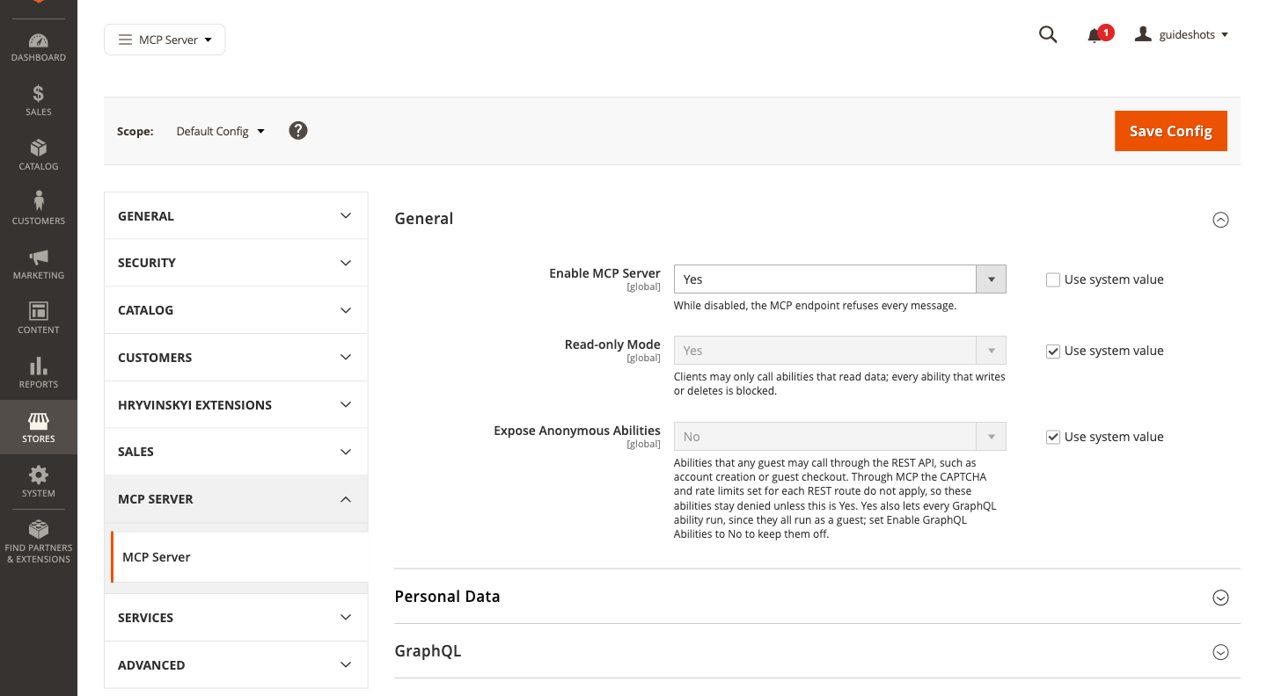
Figure 1. The General settings of MCP Server, with Enable MCP Server set to Yes
Note
If the top of the page then says One or more of the Cache Types are invalidated, refresh the cache as described in Refresh the cache after a change.

2.2 Let the store accept integration keys
Claude signs in to your store with the key of an integration. Magento refuses such keys until this setting is on. You change it once.
Stores > Settings > Configuration > Services > OAuth
- Go to Stores > Settings > Configuration.
- In the list on the left, click Services, then OAuth.
- Expand Consumer Settings.
- In Allow OAuth Access Tokens to be used as standalone Bearer tokens, select Yes.
- Click Save Config.

2.3 Create an integration for Claude
An integration is a key to your store with its own permissions. Claude signs in with it and can do only what its permissions allow. Here it gets one permission to connect and one to read products.
System > Extensions > Integrations
- Go to System > Extensions > Integrations and click Add New Integration.
- In Name, enter Claude.
- In Your Password, enter the password you use to sign in to the admin.
- In the list on the left, click API. Resource Access already shows Custom; leave it.
- In Resources, expand Stores > MCP Server and select Use the MCP endpoint.
- Expand Catalog > Inventory and select Products.
- Click the arrow next to Save, then Save & Activate.
- Magento lists the access you chose. Click Allow.
- Magento shows the integration’s keys. Copy the Access Token: you paste it into Claude Desktop in the next step. Then click Done.
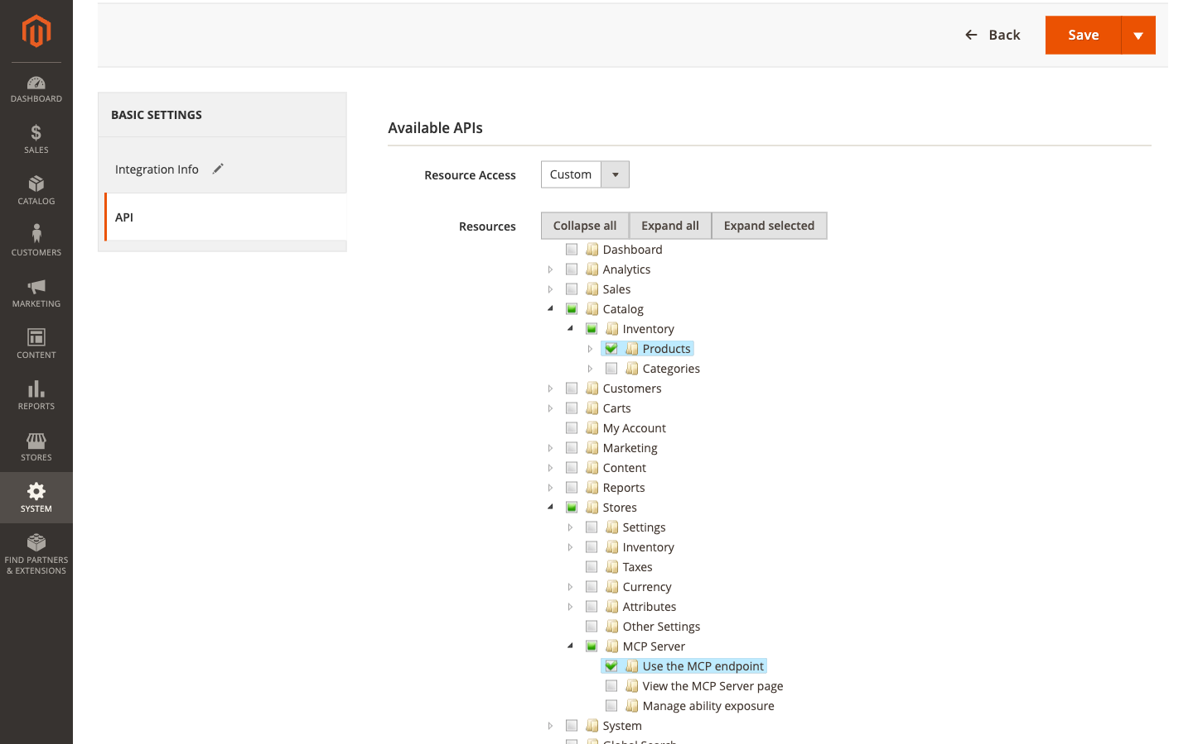
Figure 2. The API tab of the new integration, with Use the MCP endpoint and Products selected
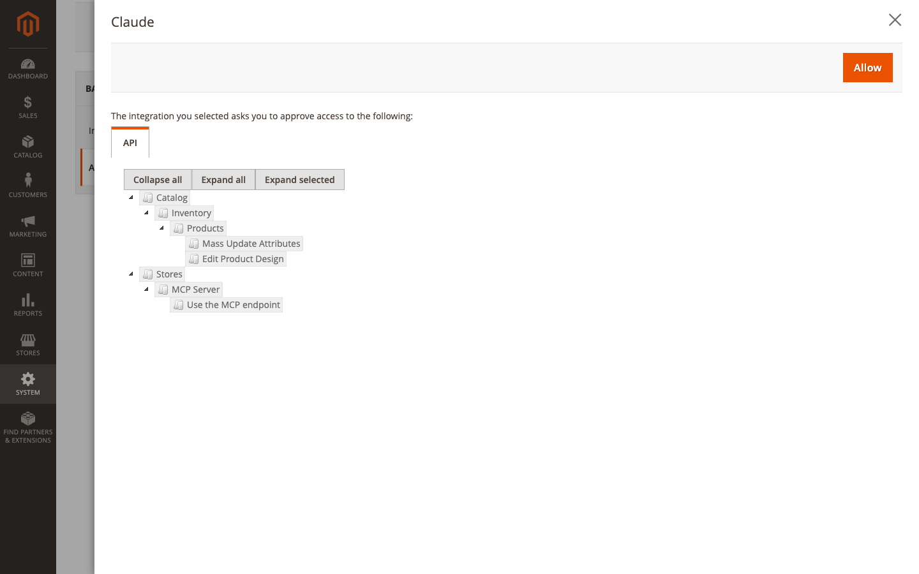
Figure 3. Magento asks you to approve the access the integration asks for
Important
The access token is a key to your store. Keep it like a password: do not send it by e-mail or paste it into a chat.
Tip
You can copy the access token again later. In System > Extensions > Integrations, click the pencil icon in the Edit column of the integration: Integration Details shows the Access Token.

2.4 Connect Claude Desktop
Stores > Settings > MCP Server
- Go to Stores > Settings > MCP Server.
- In the Install card, click Download for Claude Desktop (.mcpb).
- Open the downloaded file with Claude Desktop and install the extension.
- When Claude Desktop asks for the extension’s settings, leave Store endpoint as it is, and paste the access token you copied into Access token.
Claude Desktop keeps the token in your computer’s keychain, the place where your computer keeps passwords.
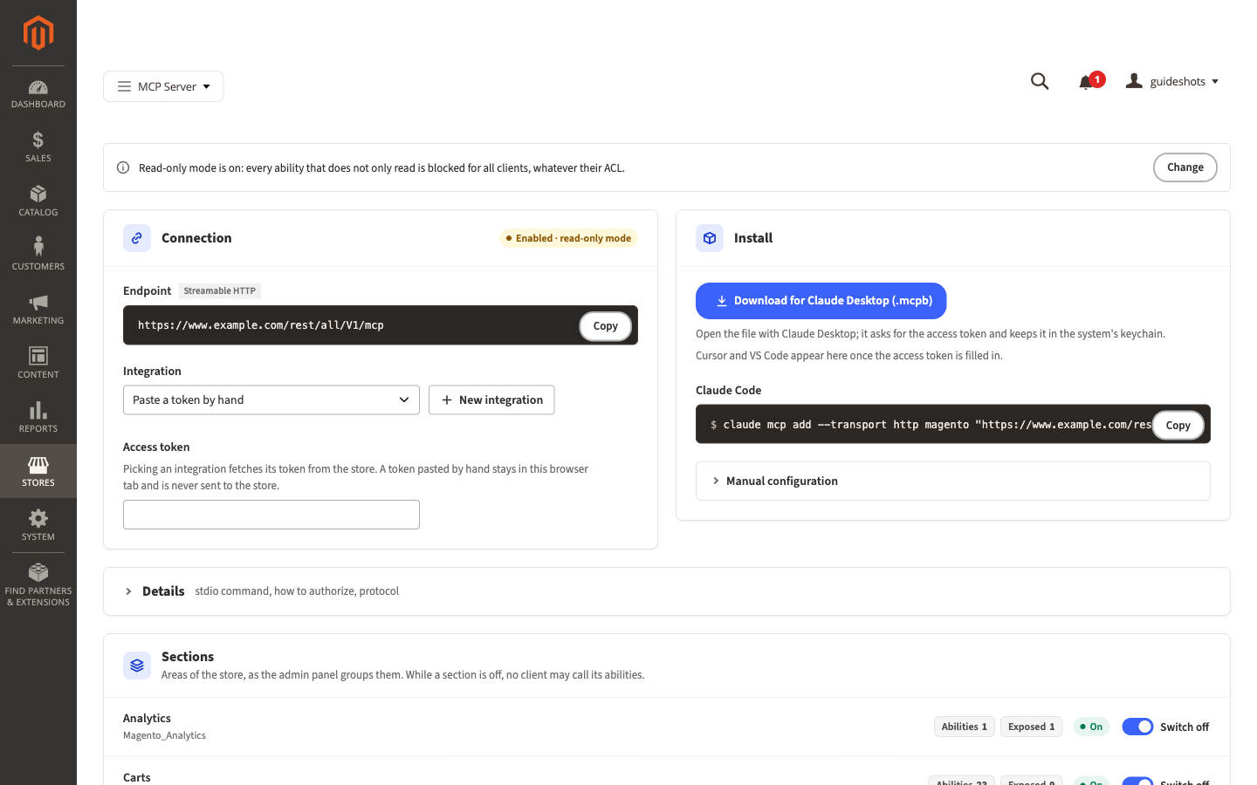
Figure 4. The MCP Server page: the Connection card with your store’s address, and the Install card with the download for Claude Desktop

2.5 Ask your first question
In Claude Desktop, start a new chat and ask:
Note
Show me the five products in my store that were changed most recently.
Claude looks through the actions your store offers, finds the one that lists products, runs it, and answers with the names and SKUs of five products. Your assistant is connected.
If Claude says that the store refused it, find its answer in Troubleshooting and FAQ.

3 How-to guides

3.1 Refresh the cache after a change
Magento sometimes asks you to refresh its cache after you save a setting: the top of the page says One or more of the Cache Types are invalidated.
System > Tools > Cache Management
- Go to System > Tools > Cache Management.
- Select the row of every cache type whose Status reads INVALIDATED.
- In Actions, select Refresh.
- Click Submit.
Magento confirms how many cache types it refreshed, for example 2 cache type(s) refreshed.
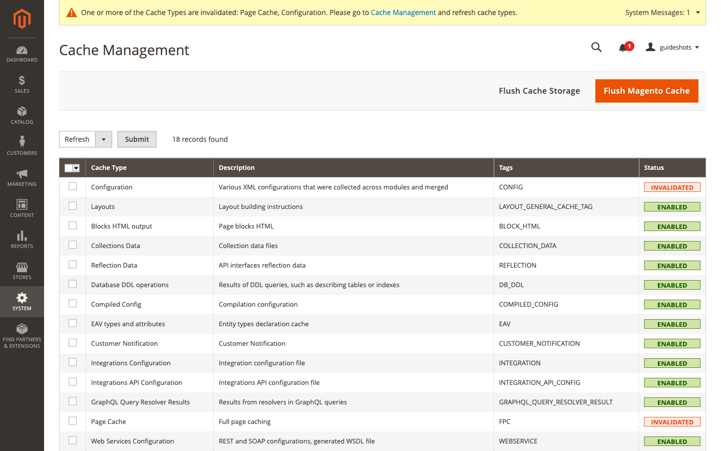
Figure 5. Cache Management with two cache types marked INVALIDATED

3.2 Give each person or app its own integration
Create one integration for each person or app that connects, named after them. You can then take access away from one without touching the others, and give each only the permissions it needs.
- Create the integration as in Create an integration for Claude, with the person’s or the app’s name.
- In Resources, select Use the MCP endpoint and only the areas this person or app needs (see Choose what the assistant may read).

3.3 Connect Cursor or VS Code
Stores > Settings > MCP Server
- Go to Stores > Settings > MCP Server.
- In the Connection card, in Integration, select the integration for this app. Its access token fills the Access token field, shown as dots. If the integration is not in the list, paste its access token into Access token instead.
- In the Install card, click Add to Cursor or Install in VS Code.
- Confirm the installation in the app that opens.
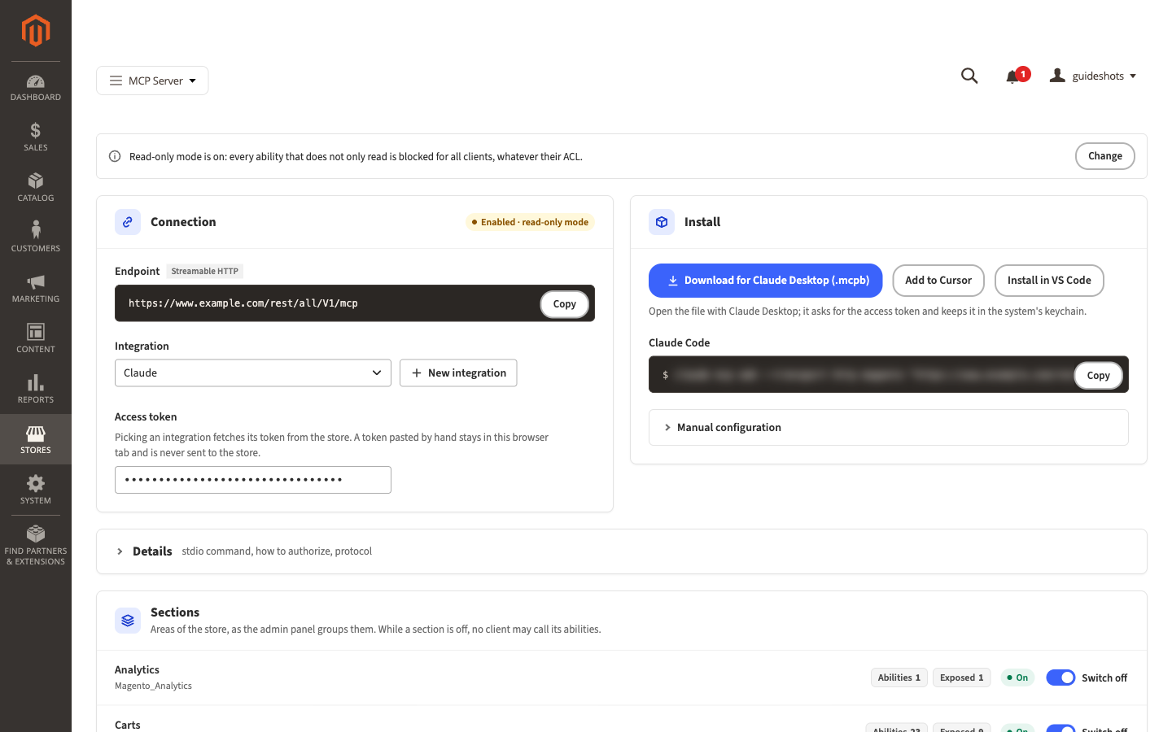
Figure 6. The Connection card with the Claude integration selected; Add to Cursor and Install in VS Code have appeared. The Claude Code command is blurred in this picture because it shows the access token.
Note
Add to Cursor and Install in VS Code appear only once Access token holds a token. Cursor and VS Code keep the token in their own settings file, readable by anyone who can open that file on the computer.
The Integration list appears only if your admin account may manage integrations. A token you paste by hand stays in your browser tab and is never sent to the store.

3.4 Choose what the assistant may read
The integration’s permissions decide what the assistant may do: what the integration may not do, the assistant cannot do either.
System > Extensions > Integrations
- Go to System > Extensions > Integrations.
- Click the pencil icon in the Edit column of the integration.
- In Your Password, enter your admin password.
- In the list on the left, click API.
- Select the areas from the table below, and clear the ones the assistant should not use.
- Click Save.
The change applies to the assistant’s next action.
Table 2. Common permissions
To let the assistant read | Select in Resources
Products | Catalog > Inventory > Products
Categories | Catalog > Inventory > Categories
Orders | Sales > Operations > Orders > Actions > View
Customers | Customers
CMS pages | Content > Elements > Pages
CMS blocks | Content > Elements > Blocks
Keep Use the MCP endpoint selected: without it, the assistant cannot connect at all.

3.5 Let the assistant change data
Read-only mode is on after installation, so the assistant can only read. Turn it off when you want the assistant to change things, for example to update product descriptions.
Warning
With read-only mode off, the assistant can change and delete anything its integration’s permissions allow. Give the integration only the areas it should change, and consider Make the assistant ask you first for actions that change data.
Stores > Settings > Configuration > MCP Server > MCP Server
- Go to Stores > Settings > Configuration, then MCP Server > MCP Server in the list on the left.
- Expand General.
- Next to Read-only Mode, clear Use system value, then select No.
- Click Save Config.
To turn read-only mode back on, select Yes again, or select Use system value, and click Save Config. The Change button in the read-only notice at the top of the MCP Server page opens these settings too.

3.6 Switch off a whole area of the store
The Sections card lists the areas of your store, as the admin menu groups them: Catalog, Sales, Customers and so on. While an area is switched off, no assistant may use any of its actions, whatever its permissions.
- Go to Stores > Settings > MCP Server.
- In the Sections card, find the area and click Switch off.
The message The section Customers is switched off: no client may call its abilities. appears, the area shows Off, and its Exposed count drops to 0. To undo, click Switch on.
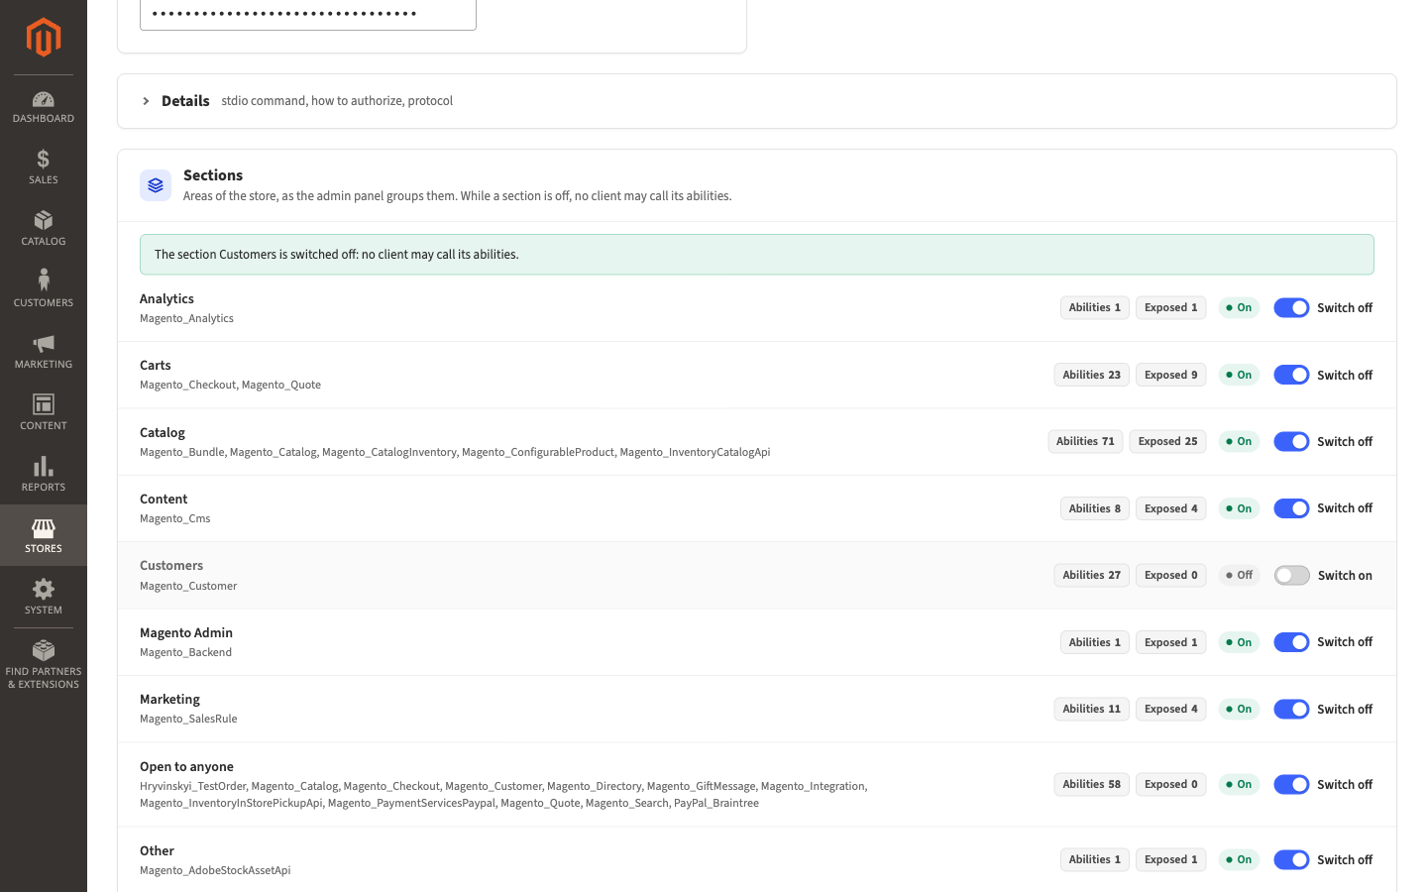
Figure 7. The Sections card with Customers switched off

3.7 Stop the assistant from using one action
Put the action on the deny-list. Find it first in the Ability catalog at the bottom of the MCP Server page.
- Go to Stores > Settings > MCP Server and scroll to Ability catalog.
- In Search by keyword, enter part of the action’s name, for example customer_repository, and press Enter.
- Select the row of the action.
- In Actions, select Add to deny-list.
- In the Add to deny-list? dialog, click OK.
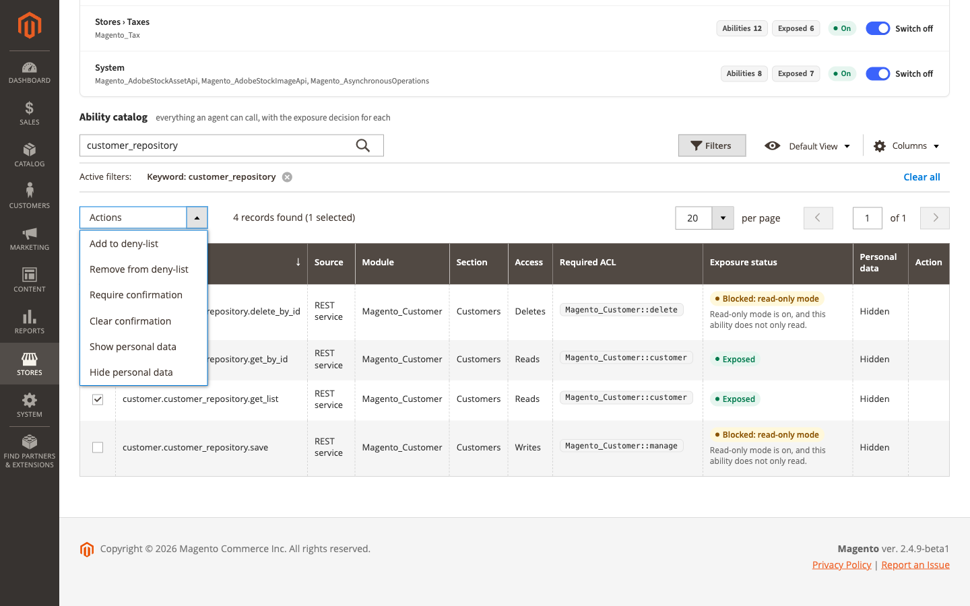
Figure 8. Add to deny-list in the Actions menu of the Ability catalog
The action’s Exposure status now reads Denied: deny-list. To undo, click Remove from deny-list in the Action column of its row, and click OK in the Remove from deny-list? dialog.
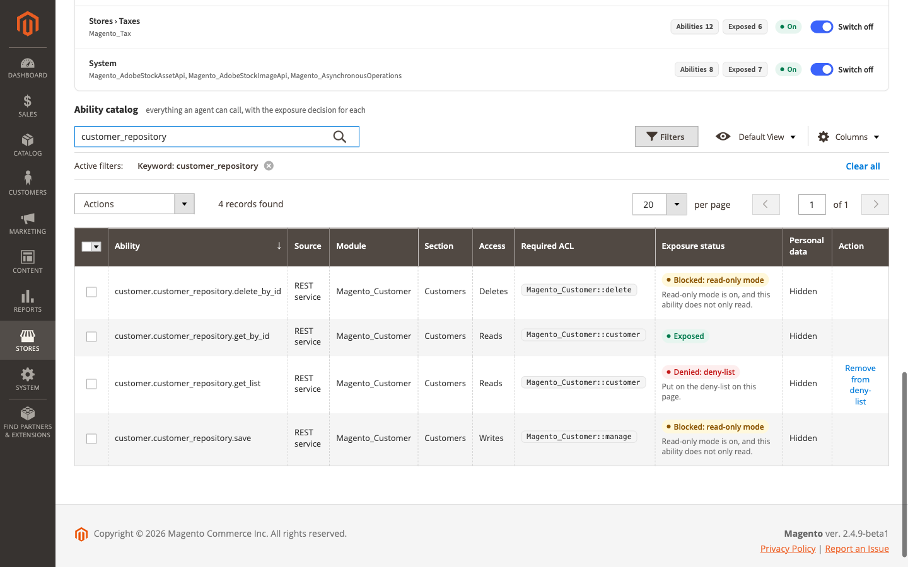
Figure 9. An action on the deny-list, with Remove from deny-list in the Action column

3.8 Make the assistant ask you first
Mark an action as needing confirmation. The assistant then asks you in the chat before each use, and goes ahead only after you agree.
- Go to Stores > Settings > MCP Server and scroll to Ability catalog.
- Search for the action and select its row.
- In Actions, select Require confirmation. It applies at once.
The action’s Exposure status now reads Needs confirmation. To undo, select its row and choose Clear confirmation in Actions.
Warning
Confirmation relies on the assistant asking you, and well-behaved assistants such as Claude do. It is not a lock: for anything that must never happen without you, use the deny-list or read-only mode instead.

3.9 Let the assistant see customer details for one action
Names, e-mail addresses, phone numbers, addresses and similar details are hidden from the assistant: they reach it as [personal data]. You can show them for chosen actions, for example when the assistant should write to customers about their orders.
Important
What the assistant receives goes to the company that runs the AI (for Claude, Anthropic). Show personal data only when your data processing agreement with that company covers it.
- Go to Stores > Settings > MCP Server and scroll to Ability catalog.
- Search for the action and select its row.
- In Actions, select Show personal data.
- In the Show personal data? dialog, click OK.
The action’s Personal data column now reads Shown, and a notice at the top of the page reminds you that a data processing agreement must cover it. To undo, select the row and choose Hide personal data.

3.10 Give a colleague access to the MCP Server page
System > Permissions > User Roles
What a colleague may do in the admin depends on the role of their admin account. Add the MCP Server permissions to that role.
- Go to System > Permissions > User Roles and click your colleague’s role.
- Click Role Resources. If Resource Access reads All, the role already has every permission, and you are done.
- Under Stores > MCP Server, select View the MCP Server page, and Manage ability exposure if your colleague should change what assistants may do.
- Under Stores > Settings > Configuration, select MCP Server Settings if your colleague should change the settings.
- Under System > System Extensions, select System Integrations if your colleague should create integrations and pick them on the MCP Server page.
- Click Role Info, and in Your Password, enter your admin password.
- Click Save Role.
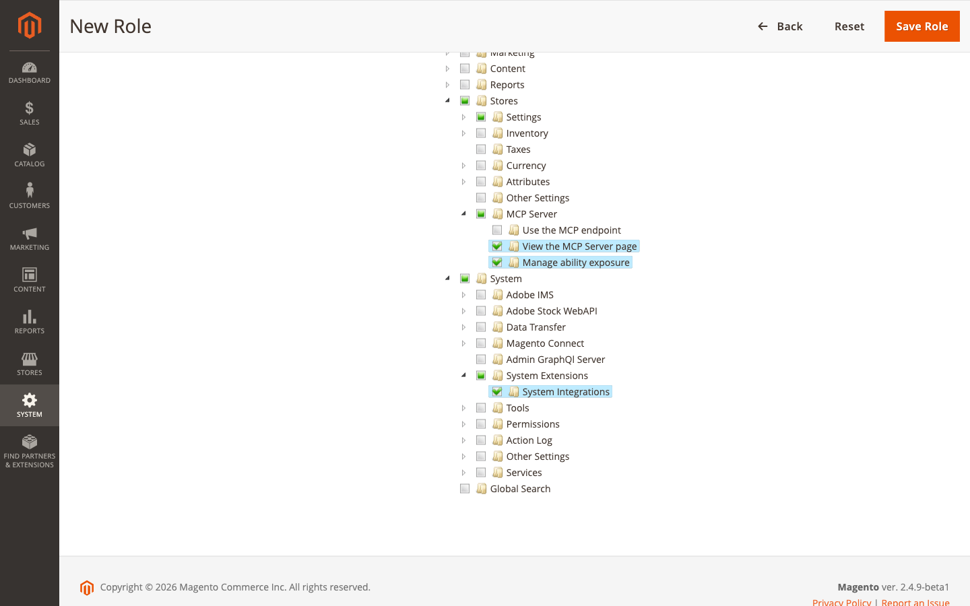
Figure 10. Role Resources with the MCP Server permissions selected
Every admin account with this role gets the permissions. An account has one role only: moving your colleague to another role takes away the permissions of their current one.
Use the MCP endpoint is for integrations: your colleague does not need it to work on the page.

3.11 Take access away
Delete the integration. The assistant that uses it is refused from its next action on, and its access token stops working for good.
System > Extensions > Integrations
- Go to System > Extensions > Integrations.
- In the row of the integration, click the trash icon in the Delete column.
- In the dialog, click OK.
The message The integration ‘Claude’ has been deleted. appears, with your integration’s name.
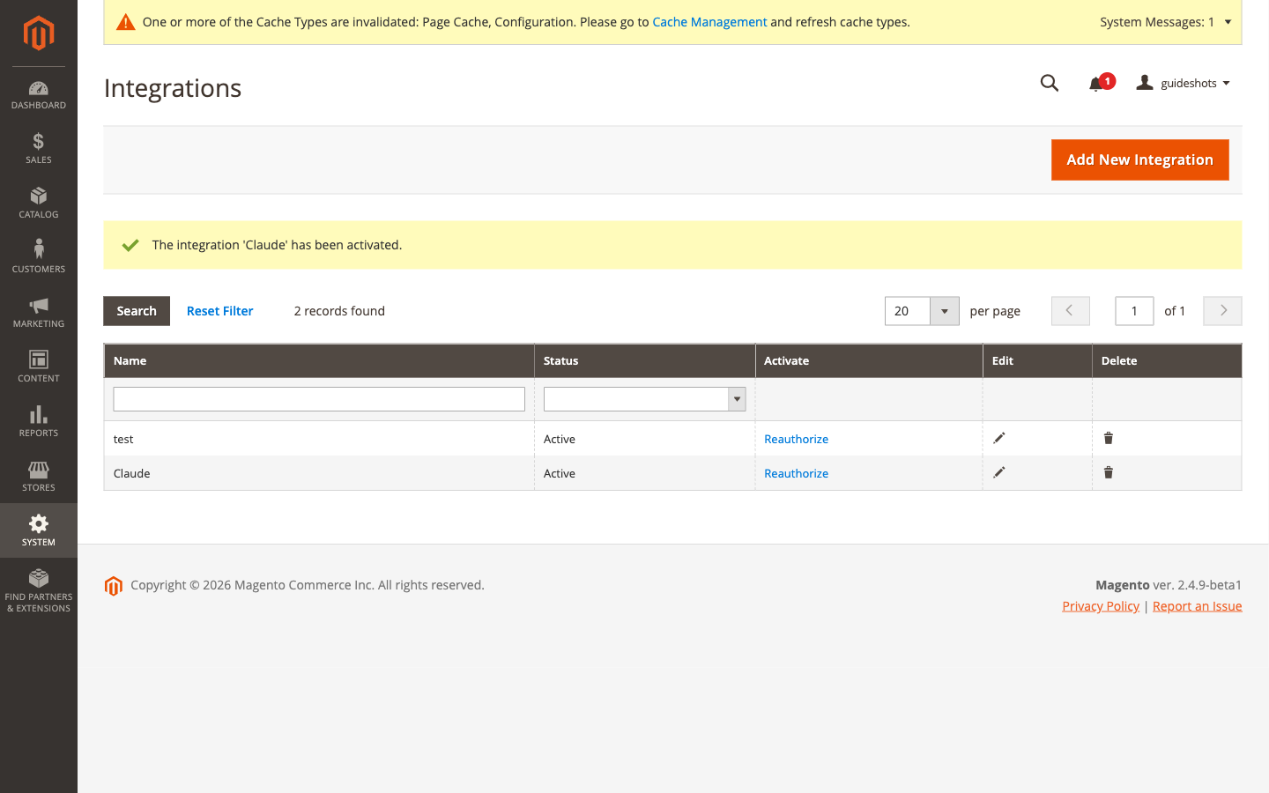
Figure 11. The Integrations list

3.12 Give an assistant a new access token
Replace the token when someone else may have seen it. The integration keeps its permissions, and the old token stops working.
System > Extensions > Integrations
- Go to System > Extensions > Integrations.
- In the row of the integration, click Reauthorize.
- In the dialog, click Reauthorize.
- Copy the new Access Token, then click Done.
Then give the new token to every app that used the old one:
Table 3. Where the new token goes
App | What to do
Claude Desktop | Open the store’s extension in Claude Desktop’s settings, and paste the new token into Access token.
Cursor, VS Code | On the MCP Server page, select the integration in Integration, click Add to Cursor or Install in VS Code again, and confirm in the app.

3.13 Find out what the assistant can do
The Ability catalog at the bottom of the MCP Server page lists every action an assistant may ask your store to run, and says for each whether it may.
- Go to Stores > Settings > MCP Server and scroll to Ability catalog.
- In Search by keyword, enter a word from the action’s name, for example product, and press Enter. Or click Filters to narrow the list by section, access or exposure.
- Read Exposure status: Exposed means an assistant may use the action, as far as its integration’s permissions allow.
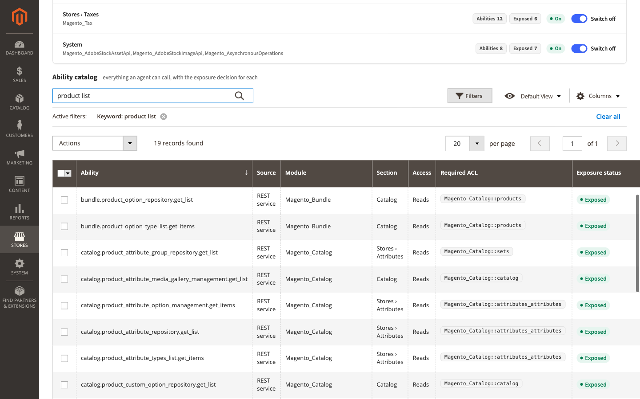
Figure 12. The Ability catalog, searched for “product list”
Screens and settings explains every column.

3.14 Turn the server off
Stores > Settings > Configuration > MCP Server > MCP Server
- Go to Stores > Settings > Configuration, then MCP Server > MCP Server in the list on the left.
- Expand General.
- In Enable MCP Server, select No.
- Click Save Config.
Every assistant is refused until you turn the server on again, and is told The MCP server is disabled. Your integrations and the choices on the MCP Server page stay as they are.

4 How it works

4.1 What the assistant does in your store
The assistant does not receive a copy of your store. It asks your store to run an action, such as list products, and receives the answer. The actions are the same operations Magento already offers to other programs, for example to a warehouse system. MCP Server calls them abilities and gives each a name, such as catalog.product_repository.get_list for listing products. The Ability catalog lists them all.
Your store keeps the time of every order and change in UTC, while you count days in your store’s own time zone. The assistant is told your store’s time zone, from Stores › Configuration › General › Locale Options › Timezone, so orders of yesterday means yesterday in your store. If that setting is wrong, the assistant counts the wrong days.

4.2 Who the assistant acts as
The assistant signs in with an integration’s access token and acts as that integration. Magento checks the integration’s permissions before every action, as it does for any program that connects to the store. What the integration may not do, the assistant cannot do either.

4.3 The rules on top of permissions
The MCP Server page adds rules that apply to every assistant, whatever its integration may do. When several apply to an action, the strictest wins.
Table 4. Rules, from the strictest
Rule | Effect
Server turned off | Every assistant is refused.
Built-in deny-list | Some actions are never allowed: anything about integrations and access tokens, passwords, two-factor authentication, and logging in as a customer. You cannot change this.
Deny-list | Actions you put on it are refused.
Section switched off | Every action of that area is refused.
Open to anyone | Actions any visitor of your store may use without signing in, such as creating a customer account, are refused while Expose Anonymous Abilities is No.
Read-only mode | Actions that change or delete data are refused.
Confirmation | The assistant asks you before the action runs.
Expose Anonymous Abilities stays No for a reason. In the storefront, those actions are protected against abuse, for example by CAPTCHA and by limits on repeated requests. Through the assistant, these protections do not apply. Change it only on your developer’s advice.

4.4 Personal data
What an action returns goes to the assistant, and from there to the company that runs the AI, often outside the European Union. That is why personal details are hidden after installation: names, e-mail addresses, phone numbers, street addresses, dates of birth, tax and VAT numbers and similar fields reach the assistant as [personal data]. The assistant is told so, and does not ask for them.
Text written freely, such as order comments, is not hidden. If your order comments hold personal details, ask your developer to add the comment fields to Personal Data Fields.

5 Screens and settings

5.1 MCP Server settings
Stores > Settings > Configuration > MCP Server > MCP Server
Every setting here applies to the whole store, which the admin shows as [global] under the setting’s name.
Table 5. General and Personal Data
Setting | What it does | After installation
Enable MCP Server | While No, every assistant is refused. | No
Read-only Mode | While Yes, assistants may only use actions that read. | Yes
Expose Anonymous Abilities | Whether assistants may use actions open to any visitor of the store (see How it works). Yes also lets every GraphQL lookup run (see the GraphQL settings below); set Enable GraphQL Abilities to No to keep those off. | No
Hide Personal Data | While Yes, personal details reach assistants as [personal data]. No sends them to every action. | Yes
Personal Data Fields | The kinds of details to hide, one per line. Shown only while Hide Personal Data is Yes. Change it only with your developer. | E-mail, names, phone, address, date of birth and similar
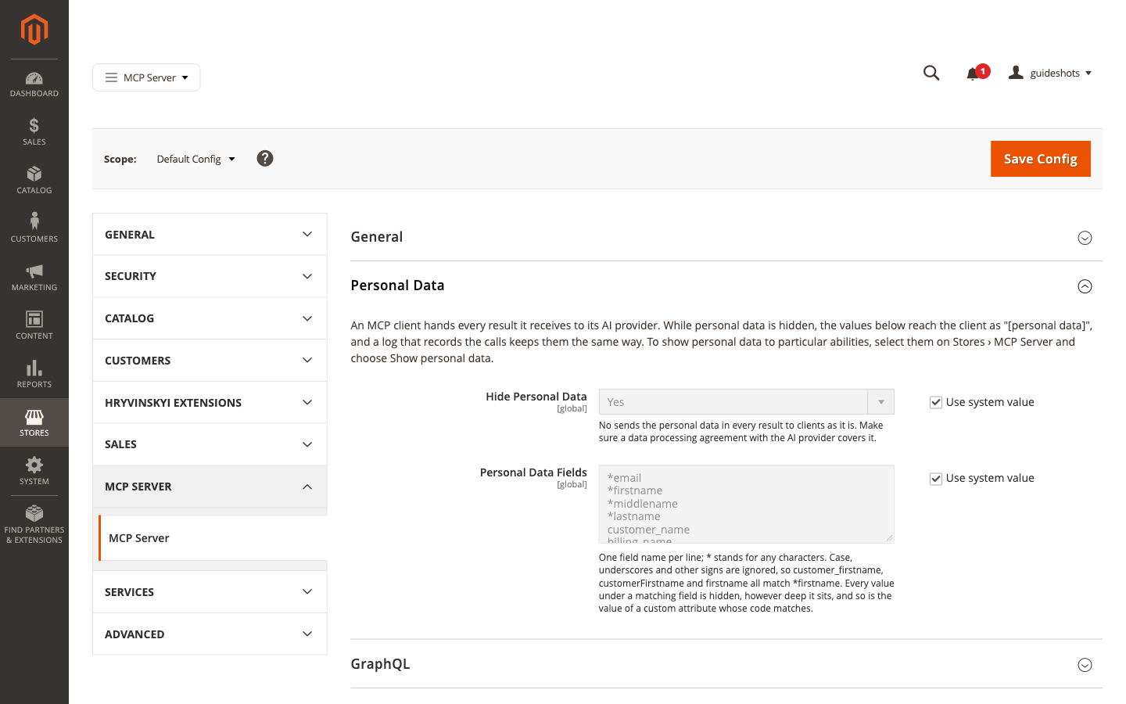
Figure 13. The Personal Data settings
GraphQL is the interface your storefront and apps use to look up products, categories and pages. The GraphQL group decides whether assistants may use it too.
Table 6. GraphQL
Setting | What it does | After installation
Enable GraphQL Abilities | While Yes, the lookups of this interface are actions too. They run as a visitor who is not signed in, so they stay refused while Expose Anonymous Abilities is No. | Yes
Expose GraphQL Mutations | While Yes, the interface’s actions that change data are offered as well. Read-only mode blocks them. | No
GraphQL Endpoint URL | The address of the interface. Leave it empty unless your developer gives you one: empty means your store’s own address. | Empty
Store View | The store view the lookups run in. | Default Store View

5.2 The MCP Server page
Stores > Settings > MCP Server
Notices at the top of the page: while the server is turned off, one notice says so, with an Enable in configuration button. While it is on, notices tell you when read-only mode is on and when some action shows personal data, each with a Change button. The buttons open the MCP Server settings, and appear only if your account may change them.
Connection card
Table 7. The Connection card
Item | What it is
Status badge | Enabled · read-only mode, Enabled or Disabled.
Endpoint | Your store’s address for assistants, with a Copy button.
Integration | Pick an integration to fill its access token into Access token. Paste a token by hand clears the pick. Shown only if your account may manage integrations.
New integration | Opens Magento’s form for a new integration in a new tab.
Access token | The token the install buttons use, shown as dots. A token you paste here never leaves your browser tab.
OAuth warning | Integration tokens are not accepted as Bearer tokens…, while the store refuses integration keys. Its Open the OAuth settings button opens the setting (see Let the store accept integration keys).
Install card
Table 8. The Install card
Item | What it is
Download for Claude Desktop (.mcpb) | The file that connects Claude Desktop to this store.
Add to Cursor, Install in VS Code | Add the store to these apps. They appear once Access token holds a token.
Claude Code, Manual configuration | For developers; see the Developer Guide.
Details (folded) holds technical information for developers.
Sections card: each area of the store with the modules in it, Abilities (how many actions it has), Exposed (how many an assistant may use now), On or Off, and the Switch off or Switch on button. Two areas are not part of the admin menu: Open to anyone holds actions any visitor may use, and Other holds actions that fit no area.
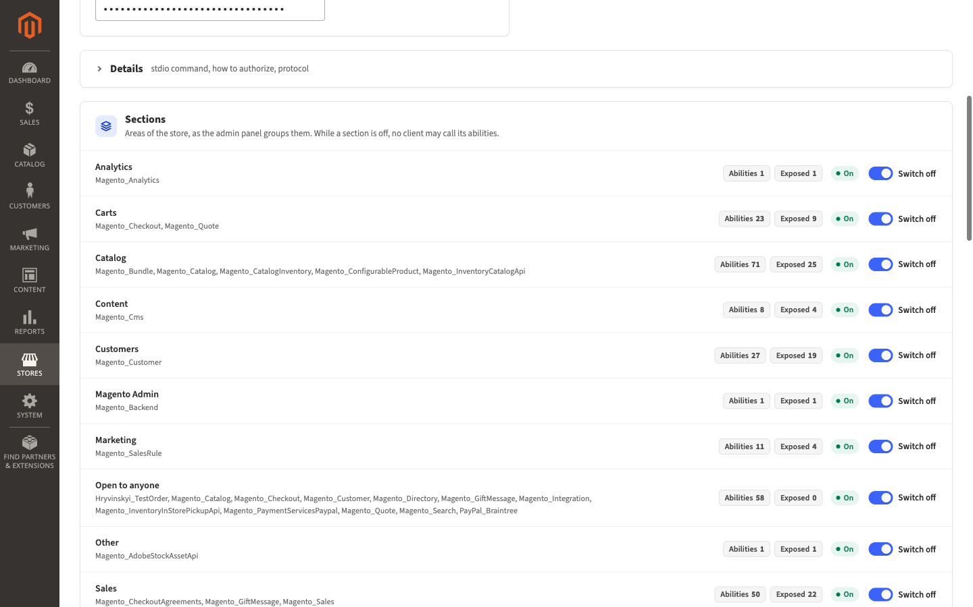
Figure 14. The Sections card
Ability catalog
Table 9. Columns of the Ability catalog
Column | What it shows
Ability | The action’s name.
Source | Where the action comes from, for example REST service: one of the store’s own operations.
Module | The part of Magento that provides it.
Section | The area of the store it belongs to.
Access | Reads, Writes or Deletes.
Required ACL | The permission the integration needs, as Magento names it internally. The Section column tells you where to find it in the Resources tree.
Exposure status | Whether an assistant may use it, and if not, why.
Personal data | Hidden or Shown.
Action | A change you can make to this one row, such as Remove from deny-list.

Table 10. Exposure statuses
Exposure status | Meaning
Exposed | Assistants may use it, within their integration’s permissions.
Needs confirmation | The assistant asks you before each use.
Blocked: read-only mode | It changes data, and read-only mode is on.
Denied: deny-list | You put it on the deny-list.
Denied: built-in deny-list | It is never allowed.
Denied: section off | Its area is switched off.
Denied: open to anyone | It is open to any visitor, and Expose Anonymous Abilities is No.

Table 11. Actions of the Ability catalog
In Actions | Effect
Add to deny-list | Assistants may not use the selected actions. Asks you to confirm.
Remove from deny-list | Takes them off the deny-list.
Require confirmation | The assistant asks you before each use.
Clear confirmation | Removes that.
Show personal data | The selected actions send personal details. Asks you to confirm.
Hide personal data | They hide personal details again.
An action that is always denied, or blocked by read-only mode, offers no change: its status does not depend on this page.

5.3 Permissions
The module adds these entries to the Resources tree of user roles and integrations.
Table 12. Permissions of MCP Server
Entry | Lets you or an integration
Stores > MCP Server > Use the MCP endpoint | Connect an assistant. Every integration for an assistant needs it.
Stores > MCP Server > View the MCP Server page | Open the MCP Server page and download the Claude Desktop file.
Stores > MCP Server > Manage ability exposure | Change sections, the deny-list, confirmations and personal data on the page.
Stores > Settings > Configuration > MCP Server Settings | Change the MCP Server settings.

6 Troubleshooting and FAQ

6.1 Claude says the MCP server is disabled
The server is turned off. Turn it on as in Turn on the server. If Claude still says so after you saved, refresh the cache (Refresh the cache after a change).

6.2 Claude cannot connect to the store at all
Check, in this order:
- Stores > Settings > Configuration > Services > OAuth > Consumer Settings: Allow OAuth Access Tokens to be used as standalone Bearer tokens must be Yes. The MCP Server page warns you while it is not.
- System > Extensions > Integrations: the integration is still there, and its Status is Active.
- The integration’s API tab has Use the MCP endpoint selected.
- The token you pasted into Claude Desktop is complete. Copy it again from Integration Details if in doubt.

6.3 The MCP Server page says integration tokens are not accepted
The page says Integration tokens are not accepted as Bearer tokens, so the store refuses every MCP client that sends one. Click Open the OAuth settings in the warning, and set Allow OAuth Access Tokens to be used as standalone Bearer tokens to Yes, as in Let the store accept integration keys.

6.4 Picking an integration shows a note instead of filling the token
The note says why the integration cannot be used. Its Edit integration button opens the integration in a new tab. The fixes in System > Extensions > Integrations:
Table 13. Notes of the Integration list
Note | What to do
Not activated yet. | Click Activate in its row, then Allow, then Done.
Its settings changed. | Click Activate in its row, then Reauthorize. The integration gets a new access token: give it to every app that used the old one (see Give an assistant a new access token).
Its API resources leave out “Use the MCP endpoint”. | Edit the integration, enter your admin password in Your Password, select Use the MCP endpoint in its API tab, and click Save.
It has no usable access token. | Give it a new token as in Give an assistant a new access token.
The token could not be fetched. | Reload the page and pick again, or paste the token by hand. If it keeps happening, ask your developer.
After a fix, reload the MCP Server page and pick the integration again.

6.5 A button or the MCP Server menu entry is missing
Each part of the page needs a permission in the role of your admin account:
Table 14. Permissions behind the page
Missing | Permission your role needs
MCP Server in Stores > Settings | Stores > MCP Server > View the MCP Server page
The Actions menu and the Action column of the Ability catalog, Switch off and Switch on | Stores > MCP Server > Manage ability exposure
Enable in configuration and Change in the notices | Stores > Settings > Configuration > MCP Server Settings
Integration and New integration in the Connection card | System > System Extensions > System Integrations
Open the OAuth settings | Stores > Settings > Configuration > OAuth Configuration
Ask an administrator to add the permission to your role, as in Give a colleague access to the MCP Server page.

6.6 Claude says read-only mode is on
Claude reports something like Read-only mode is on, and the ability “catalog.product_repository.save” changes data. This is expected while read-only mode is on. If the assistant should change data, see Let the assistant change data.

6.7 Claude says its role lacks a permission
Claude reports something like The ability “sales.order_repository.get_list” needs ACL resources your role lacks: Magento_Sales::actions_view. The integration does not have the permission this action needs. Add it as in Choose what the assistant may read; the table there covers the common cases, and the action’s Section in the Ability catalog tells you which part of the Resources tree to look in.

6.8 Claude says an action is on the deny-list
Claude reports The ability “…” is on the deny-list of this store. Someone put it on the deny-list. To allow it again, see Stop the assistant from using one action. If the Ability catalog shows Denied: built-in deny-list, the action is never allowed.

6.9 Claude says an action is not exposed (section_off)
Claude reports The ability “…” is not exposed to MCP clients (section_off). Its area is switched off in the Sections card. Click Switch on to allow it.

6.10 Claude says an action is open to anonymous callers
Claude reports The ability “…” is open to anonymous callers, and this store does not expose such abilities. This is expected; How it works explains why.

6.11 Names and e-mail addresses arrive as [personal data]
This is expected while personal data is hidden. To show it for particular actions, see Let the assistant see customer details for one action.

6.12 Claude asks me to confirm before it does something
The action is marked Needs confirmation. Answer Claude in the chat. To stop the question, see Make the assistant ask you first.

6.13 Add to Cursor and Install in VS Code do not appear
They appear only once Access token holds a token. Pick the integration in Integration, or paste its token.

6.14 Download for Claude Desktop shows an error instead of a file
The MCP Server page shows a message about the store’s address instead of the file, for example The store’s endpoint … uses plain http to a host other than this computer, so the extension would send the access token unencrypted and refuses to start. The extension sends the access token only to an address that starts with https://, unless the store runs on your own computer. Ask your developer to give the store a secure address; the message tells them what to change.

6.15 Questions
Does the assistant see everything in my store? No. It sees only what its integration’s permissions allow, minus switched-off areas and denied actions, and personal details stay hidden unless you show them.
Can the assistant change prices or delete products? Only after you turn read-only mode off, and only if its integration has the permission to change products.
Does the access token expire? No. It works until you delete the integration or give it a new token (see Take access away and Give an assistant a new access token).
Where does Claude Desktop keep the token? In your computer’s keychain.
Does turning the server off delete my integrations or settings? No. They stay as they are and apply again when you turn the server on.
Where do I get more help? Ask your developer, or open an issue at https://github.com/hryvinskyi/magento2-mcp-server/issues.

7 Glossary
Table 15. Glossary
Term | Meaning
AI assistant | A program you talk to in your own words, such as Claude, that can use your store’s actions.
MCP | Model Context Protocol: the common language AI assistants use to connect to other programs. MCP Server makes your store speak it.
Ability | One action the assistant can ask your store to run, such as listing products.
Integration | A key to your store with its own permissions, made in System > Extensions > Integrations.
Access token | The secret text of an integration’s key. Whoever holds it acts as the integration.
Endpoint | Your store’s address for assistants, shown on the MCP Server page.
Read-only mode | A setting that lets assistants read but not change anything.
Section | An area of the store, such as Catalog or Sales, that you can switch off for assistants.
Deny-list | The list of actions no assistant may use.
Confirmation | A mark that makes the assistant ask you before an action.
Personal data | Details that identify a person, such as a name or an e-mail address.
GraphQL | The interface your storefront and apps use to look up products, categories and pages.
Permission | A right in the Resources tree of a role or an integration, such as Products. Magento calls them ACL resources.
Cache | Stored copies Magento keeps to be fast. After some changes, Magento asks you to refresh them.
Data processing agreement | A contract with a company that handles personal data for you, required under the GDPR.

Appendix A — Document history
Table 16. Document history
Version | Date | Changes
1.0 | 2026-11-09 | First version, for MCP Server 1.4.2.
1.1 | 2026-11-11 | For MCP Server 1.5.0: the assistant is told your store’s time zone.

Open questions
Not yet tried on a computer with these apps. Remove each item once it is checked.
- Connect Claude Desktop, steps 3 and 4: how Claude Desktop installs the file and asks for its settings. Written from the MCP Server page’s own hint and the extension’s two settings, Store endpoint and Access token.
- Connect Cursor or VS Code, step 4: what Cursor and VS Code ask before they add the store.
- Give an assistant a new access token: where Claude Desktop keeps an installed extension’s settings, and whether Add to Cursor and Install in VS Code replace the store’s earlier entry or add a second one.

