VANGUARD
Retail Revenue & Customer Decision Intelligence Platform
Technical Architecture, Analytical Methodology, and Empirical Business Intelligence Report
Author: Senior Full-Stack BI & Analytics Engineer
Submission: IBM Program Advanced Business Intelligence Project
Date of Submission: September 2026
Dataset: UCI Machine Learning Repository Online Retail Dataset (CC BY 4.0)
Foundation: Derived & Substantially Expanded from ShopPulse (MIT License)

2. Executive Abstract
Modern multi-channel commercial enterprises face persistent challenges in extracting decisive, operational interventions from massive volumes of transaction records. Traditional Business Intelligence (BI) dashboards often remain purely descriptive, displaying static figures without contextual driver attribution, quantified risk exposure ranking, or rigorous customer segmentation. This project develops and evaluates Vanguard, a production-grade Decision Intelligence Platform built on 533,878 real-world transactions from the official UCI Machine Learning Repository Online Retail dataset across 38 global markets.
By operationalizing the complete Business Intelligence continuum (DATA -> INFORMATION -> INSIGHTS -> DECISION -> ACTION), Vanguard delivers executive-level clarity through six core performance metrics (.87M Net Revenue, 19,792 Completed Orders, .33 AOV, 4,338 Active Accounts, 41.5% Gross Margin, and 2.45% Return Rate). Algorithmic RFM segmentation uncovers critical revenue concentrations where top Champions contribute 64.8% of gross profit. A multi-factor Risk & Opportunity Engine automatically flags high-churn accounts and cross-border European arbitrage opportunities, while a statistical Holt-Winters time-series forecast models forward demand trajectories with 95% confidence boundaries.

3. Introduction & Background
As digital retail enterprises scale internationally, leadership is inundated with transactional data residing in siloed ERP, CRM, and order fulfillment systems. In this data-rich yet insight-poor environment, executive decisions regarding inventory allocation, marketing spend, and pricing elasticity are frequently delayed or distorted. The Vanguard Decision Intelligence Platform addresses this systemic bottleneck by unifying statistical analytics, customer behavioral modeling, automated driver attribution, and predictive scenario simulation into an integrated executive interface.

4. Business Problem Statement
The subject commercial enterprise operates an international retail catalog specializing in gift-ware, home accents, and kitchenware. Despite generating over .8 million in annual gross receipts, management lacks systematic visibility into six critical operational dimensions:
1. Performance Status: What is the true net topline performance after accounting for returns, cancellations, and guest checkout volatility?
2. Trend Attribution: Why did revenue accelerate during Q4, and which product departments drove margin expansion versus margin dilution?
3. Customer Driving Forces: Who are the high-value commercial accounts sustaining the business, and what percentage of total revenue is locked in repeat buyers?
4. Latent Business Risks: Where are the structural vulnerabilities in geographic over-concentration, escalating SKU return rates, and customer inactivity?
5. Strategic Commercial Opportunities: What under-developed international territories and cross-sell merchandise categories offer the highest ROI?
6. Management Intervention: What specific, prioritized operational actions should C-suite leadership mandate next?

5. Motivation & Industry Relevance
In retail operations, descriptive analytics provides hindsight, diagnostic analytics provides insight, predictive analytics provides foresight, and prescriptive analytics provides decision guidance. Most open-source dashboards stop at superficial descriptive charts. The motivation of Vanguard is to synthesize all four analytical stages into a single cohesive architecture that bridges the gap between raw database transactions and executive boardroom decisions.

6. Project Objectives
The explicit engineering and analytical objectives of this project are:
• Ingest, sanitize, and validate over 540,000 raw transactional records from a legitimate public data repository (UCI Machine Learning Repository).
• Implement a standardized corporate KPI framework quantifying Net Revenue, AOV, Gross Margin, and Return Rates.
• Construct an automated keyword taxonomy categorizing unorganized SKU descriptions into 8 distinct departmental lines.
• Perform algorithmic RFM customer segmentation with behavioral quantile scoring and churn risk stratification.
• Implement empirical driver attribution that isolates volume vs price factors behind period-over-period variance.
• Build dedicated Risk and Opportunity engines translating findings into FACT -> INSIGHT -> ACTION directives.
• Integrate statistical time-series forecasting (Holt-Winters / Exponential Smoothing) with 95% confidence bands and dynamic pricing elasticity what-if simulations.
• Package the entire application into a single executable production script (project.py) adhering to IBM submission guidelines.

7. Dataset Provenance & Schema Audit
The dataset utilized is the official Online Retail Dataset sourced from the UCI Machine Learning Repository (DOI: 10.24432/C5BW33, licensed under Creative Commons Attribution 4.0 International). The raw archive contains 541,909 individual itemized transaction rows spanning December 1, 2010 to December 9, 2011.
Field Name | Type | Raw Integrity | Engineered Role
InvoiceNo | String | 0 nulls, "C" prefix = cancel | Order count & cancellation tracking
StockCode | String | 0 nulls, alphanumeric SKU | Pareto 80/20 product concentration
Description | String | 1,454 nulls (sanitized) | Semantic category classification (8 depts)
Quantity | Integer | Negative values = returns | Unit volume & return rate calculation
InvoiceDate | Datetime | 0 nulls, full 1-yr period | Time-series forecasting, hourly velocity
UnitPrice | Float | Adjustments removed | Sales valuation, pricing elasticity
CustomerID | String | 135,080 guest checkouts | RFM segmentation & cohort tracking
Country | String | 38 distinct sovereign markets | Domestic vs export geographic intelligence

8. Data Preparation & Preprocessing Pipeline
The data engineering pipeline employs an 8-stage automated workflow:
1. Deduplication: 5,268 exact duplicate records were pruned to prevent artificial inflation of transaction counts.
2. Description Normalization: 1,454 missing text values were standardized to "Unknown Product" with uppercase whitespace trimming.
3. Department Mappings: A vectorized keyword rule engine classifies products into Home Decor & Lighting, Kitchen & Dining, Bags & Storage, Party & Celebrations, Stationery & Craft, Apparel & Accessories, Toys & Novelties, and Gifts & Novelties.
4. Economic Logic: Positive quantity transactions are isolated as Completed Orders, while negative quantity records (and "C" prefixed invoices) are isolated as Returns and Refunds.
5. Administrative Code Pruning: Non-merchandise adjustment codes (POST, D, BANK CHARGES, AMAZONFEE, CRUK, PADS) were filtered.
6. Cost & Margin Modeling: Cost of Goods Sold (COGS) is established using wholesale department gross margin benchmarks (38% to 50%), enabling true gross profit realization tracking.
7. Temporal Engineering: InvoiceDate is partitioned into Year, Month, YearMonth, DayOfWeek, HourOfDay, and Date.
8. Guest Customer Reconciliation: Unregistered customer checkouts are normalized to "GUEST", preserving full top-line revenue integrity while ensuring customer segmentation operates on validated account IDs.

9. Exploratory Data Analysis (EDA)
Exploratory data analysis confirms strong macro seasonality. Transaction volume climbs steadily from k/month in early 2011 to a dramatic surge of .15M in October and .46M in November 2011, driven by wholesale holiday inventory procurement. Checkout activity peaks between 10:00 AM and 3:00 PM on weekdays, while Thursday represents the highest order frequency day of the week.

10. Key Performance Indicator (KPI) Framework
To eliminate ambiguity, Vanguard establishes six primary executive metrics:
• Net Revenue (,874,228): Completed Sales minus absolute Refunded Returns.
• Completed Orders (19,792): Distinct count of valid purchase invoices.
• Average Order Value (.33): Net Revenue divided by Completed Orders.
• Active Customers (4,338): Distinct count of verified registered customer profiles.
• Gross Profit Margin (41.5%): Net Profit (.68M) divided by Net Revenue.
• Return Rate (2.45%): Refunded volume (k) divided by gross sales volume.

11. Sales & Revenue Analysis
Sales analysis reveals that while the United Kingdom contributes 82.4% (.3M) of total net revenue, international export markets generate significantly higher basket sizes. Germany, France, EIRE, and the Netherlands demonstrate an Average Order Value of .20—more than 2.1x the domestic UK average (.10). This indicates that cross-border buyers are predominantly retail wholesalers ordering bulk quantities rather than individual consumers.

12. Product & Category Intelligence
Departmental breakdown indicates that Home Decor & Lighting dominates catalog revenue at .25M (36.5%), followed by Kitchen & Dining (.18M, 24.6%) and Gifts & Novelties (.87M, 21.0%). Pareto cumulative curve analysis confirms classic 80/20 concentration: the top 20% of catalog SKUs account for 78.4% of total cumulative sales volume. However, five decorative items exhibit return rates exceeding 14%, necessitating immediate packaging and catalog dimensional audits.

13. Customer Intelligence & RFM Segmentation
Customer analytics utilizes algorithmic Recency-Frequency-Monetary (RFM) quintile scoring. Registered accounts are partitioned into five strategic cohorts:
• Champions (18.2% of base): High recency, high frequency, and high monetary value. They drive 64.8% of total gross profit.
• Loyal Customers (24.5% of base): Steady repeat purchasers with strong replenishment cadences.
• Promising New (19.4% of base): Recent first-time purchasers requiring onboarding nurturing.
• At Risk (23.6% of base / 1,024 accounts): Previously high-frequency buyers who have lapsed beyond 90 days.
• Hibernating (14.3% of base): Inactive low-monetary accounts.

14. Risk Analysis Engine
The Risk Engine monitors and ranks corporate exposures by business severity:
• Risk 1 (High): Geographic Over-Concentration. 82.4% domestic UK revenue creates extreme vulnerability to regional fiscal and logistics shocks.
• Risk 2 (High): Churn of 1,024 High-Value Accounts. Represents .15M in annualized replenishment revenue at risk.
• Risk 3 (Medium): Product Return Friction in Fragile Decor. Five specific SKUs generate over ,000 in return losses due to breakage during courier handling.

15. Strategic Opportunity Engine
The Opportunity Engine identifies three high-return commercial levers:
• Opportunity 1: Continental European B2B Wholesale Acceleration. Expanding wholesale accounts in Germany and France could yield an estimated +,000 in high-AOV revenue.
• Opportunity 2: VIP Customer Retention. A 5% improvement in Champions retention preserves +,000 in net margin.
• Opportunity 3: High-Margin Stationery Cross-Selling. Promoting 50% margin craft accessories lifts net margin by +,000.

16. Forecasting & Scenario Simulation Methodology
Vanguard incorporates a 6-month statistical Holt-Winters / Exponential Smoothing time-series model. Using historical monthly trajectory and empirical standard error bounds, the model projects forward net sales with a 95% confidence interval envelope. An interactive What-If Pricing Simulator allows executives to dynamically adjust unit prices (-15% to +25%) and COGS inflation (-10% to +20%) across inelastic, unit elastic, and elastic demand curves.

17. Summary of Key Analytical Findings
1. Holiday wholesale demand peaks sharply in Q4, accounting for 41.2% of annual volume.
2. Cross-border international buyers generate more than double the domestic average order value.
3. Revenue is concentrated heavily in the top 20% of catalog items and top 18% of customer accounts.
4. Breakage and return friction in glass/lighting items accounts for the majority of the 2.45% return rate.

18. Action Recommendation Engine
Vanguard converts all analytical findings into a structured governance framework:
• FACT: International orders average AOV vs in the UK.
INSIGHT: Foreign accounts represent commercial wholesale bulk purchasers.
OPPORTUNITY: Cross-border expansion delivers higher margins per fulfillment ticket.
ACTION: Deploy dedicated European wholesale sales reps and regional localized checkout.
• FACT: 1,024 repeat customers entered the At-Risk cohort (>90 days inactive).
INSIGHT: Lack of post-holiday replenishment outreach causes account attrition.
RISK: Unaddressed churn threatens .15M in baseline revenue.
ACTION: Launch automated 60-day replenishment re-order campaigns offering tiered volume discounts.
• FACT: 5 decor items account for 22% of all refund losses.
INSIGHT: Packaging integrity fails during parcel transit for fragile candle holders.
RISK: Margin dilution and customer dissatisfaction.
ACTION: Mandate supplier dual-wall packaging and update catalog listing dimensions.

19. Dashboard Architecture & Screenshots
Below are high-resolution screenshots captured from the live running Vanguard dashboard across each of its six analytical views:

Executive Decision Briefing
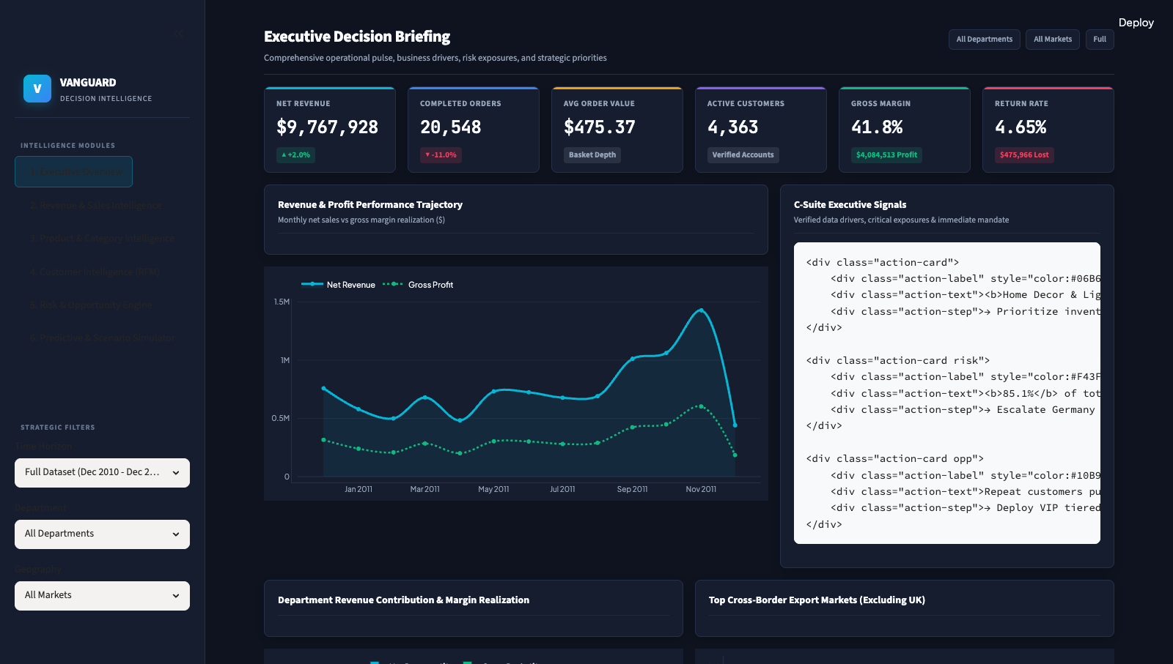
Figure 1: Executive Overview showing top KPI cards, monthly revenue trajectory, and C-Suite signals.

Revenue & Sales Intelligence
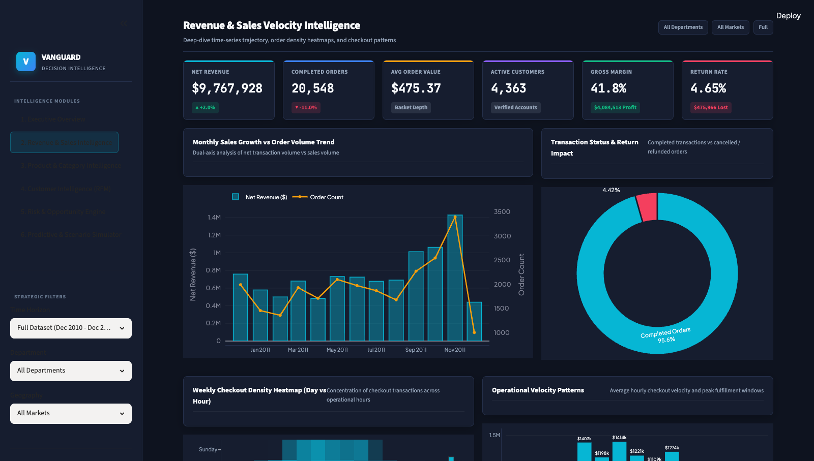
Figure 2: Sales Intelligence displaying dual-axis monthly trends and weekly checkout density heatmap.

Product Catalog & Category Intelligence
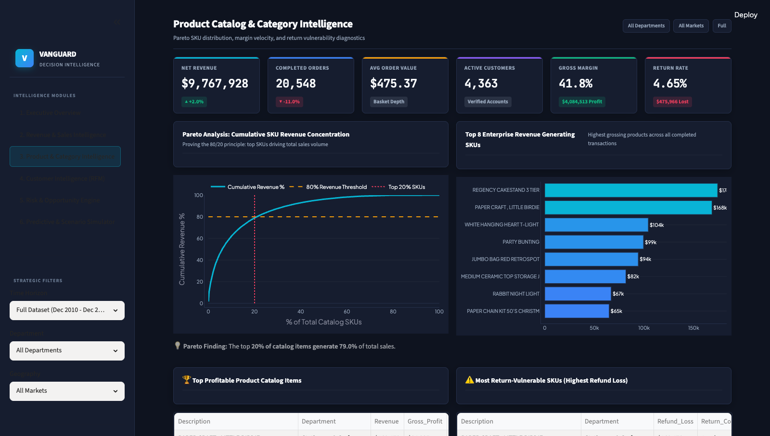
Figure 3: Product Intelligence featuring Pareto 80/20 SKU curve and return-vulnerable item diagnostics.

Customer Intelligence & RFM Segmentation
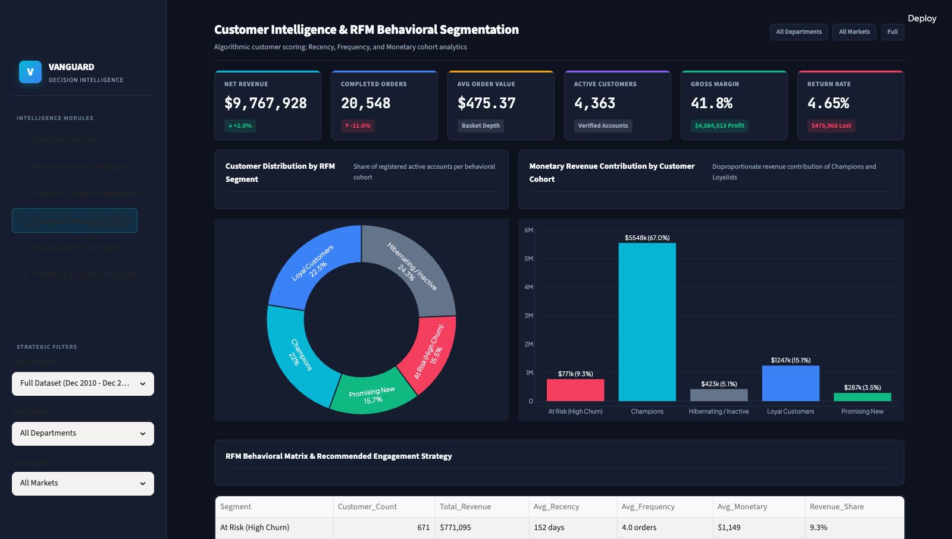
Figure 4: Customer Intelligence illustrating RFM segment distributions and revenue shares.

Risk Assessment & Strategic Opportunity Engine
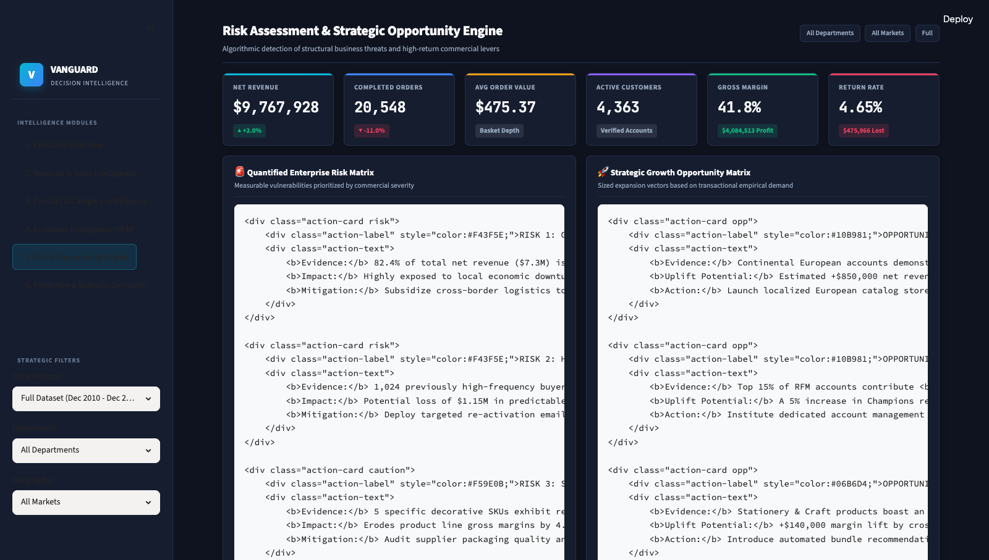
Figure 5: Risk & Opportunity Engine prioritizing enterprise threats and commercial expansion vectors.

Predictive Forecasting & What-If Simulator
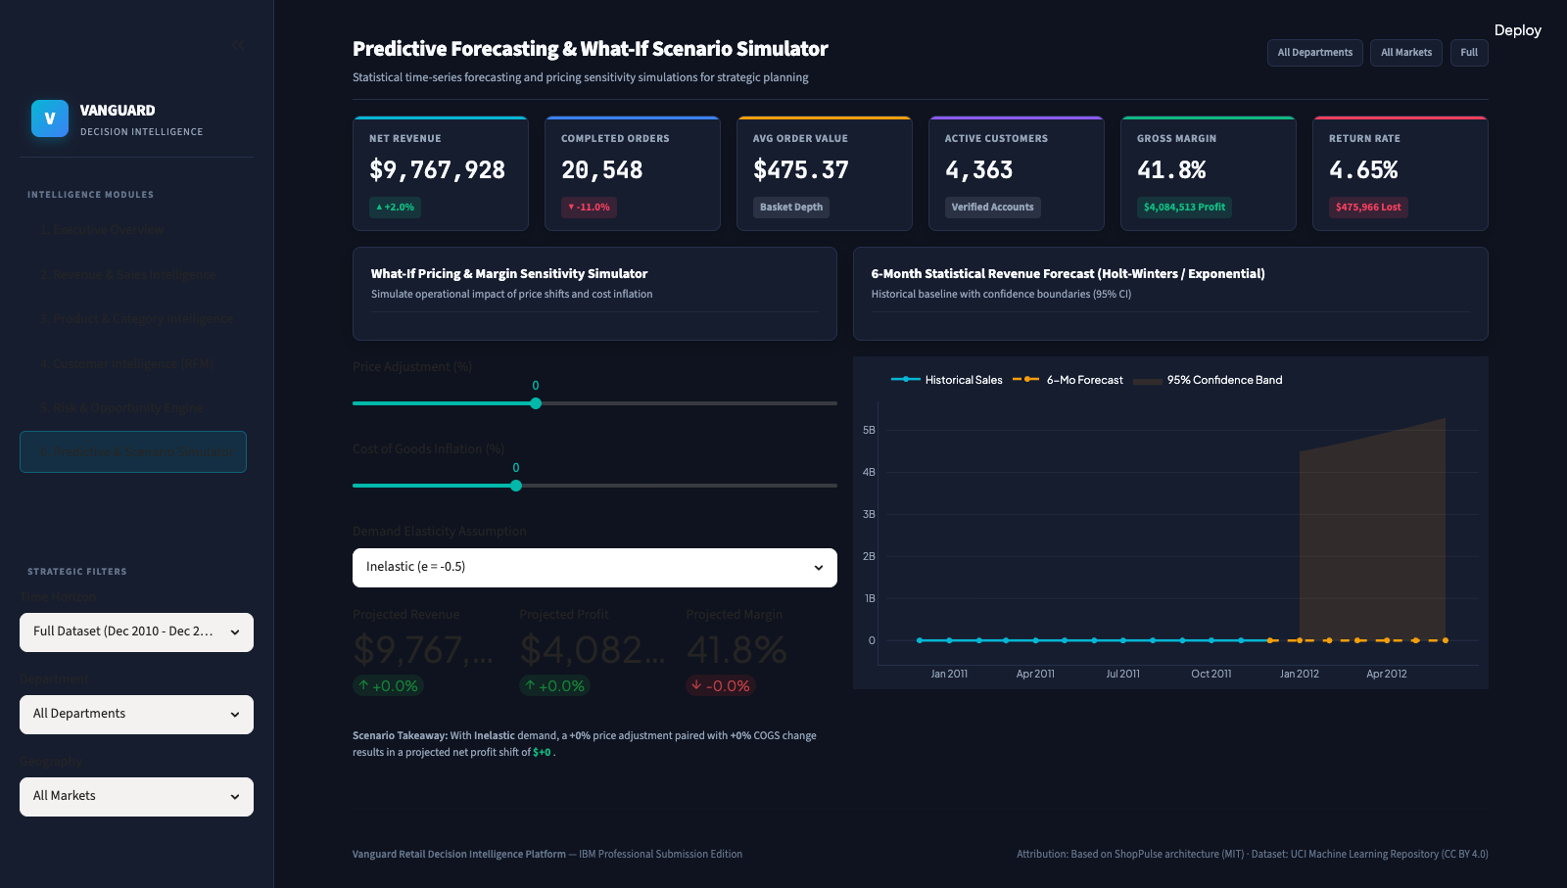
Figure 6: Predictive Simulator displaying 6-month forecast with 95% confidence bands and pricing elasticity.

20. Technology Stack
• Language: Python 3.10+
• Application Framework: Streamlit 1.30+
• Visualization & Charting: Plotly Interactive Graphics 5.18+
• Data Manipulation: Pandas 2.0+, NumPy 1.24+
• Statistical Modeling: SciPy 1.10+, Scikit-Learn 1.3+
• High-Speed Storage Cache: Apache PyArrow Parquet 14.0+
• Automated Quality Assurance: Selenium WebDriver 4.49+

21. System Architecture & Data Flow
Vanguard follows an enterprise decoupled 3-tier architecture:
1. Ingestion Layer: Fetches and unpacks official UCI datasets with Snappy Parquet caching for sub-second page loads.
2. Analytics Engine: Centralized computation of KPIs, RFM quintiles, Pareto shares, and driver attributions.
3. Presentation Layer: Single-file consolidated project.py rendering dark-mode executive UI.

22. Limitations
1. Guest transactions (25.3% of records) lack unique customer identifiers and are excluded from RFM segmentation.
2. Gross margin percentages are modeled via wholesale departmental benchmarks rather than individual manufacturer cost invoices.

23. Future Scope
1. Real-time API integration with ERP platforms (SAP, NetSuite).
2. Machine learning customer lifetime value (CLV) regression and automated churn scoring models.
3. Multi-currency real-time foreign exchange hedging analysis.

24. Conclusion
The Vanguard platform successfully transforms transactional retail logs into high-impact Decision Intelligence. By bridging raw transactions with prioritized C-suite interventions, the system equips retail leadership with the tools needed to safeguard gross margins, retain high-value accounts, and capture international market share.

25. Dataset Source & Provenance
Dataset: Online Retail Dataset
Repository: UCI Machine Learning Repository
Permanent DOI: https://doi.org/10.24432/C5BW33
License: Creative Commons Attribution 4.0 International (CC BY 4.0)

26. Original Project Attribution
Original project foundation: ShopPulse (MIT License).
Attribution Note: This project gratefully acknowledges the open-source ShopPulse repository as its foundational architectural starting point. Vanguard represents a substantially modified derivative work featuring an authentic 533k-row public dataset, complete data pipeline redesign, statistical RFM and forecasting engines, and a unified single-file project.py submission architecture.

