***Assignment-5***

***Name- Harsh Kumar***

***Email-*** [***hs150harsh@gmail.com***](mailto:hs150harsh@gmail.com)

***Module Cmdlet Commands Practice***

1. ***Get-NetIPConfiguration | Out-File D:\Wipro\Example\datafiles.txt -Append***

*This Command will append a file which contains details about the computers Ip configurations and store it in the desired locations.*

* *Retrieves current IP configuration.*
* ***Appends*** *the output to the end of the file.*
* *Useful for* ***logging over time*** *or* ***aggregating data*** *from multiple runs.*
* *This is better if you want to store data over a longer period of time.*

*The output which it will create is showed below*

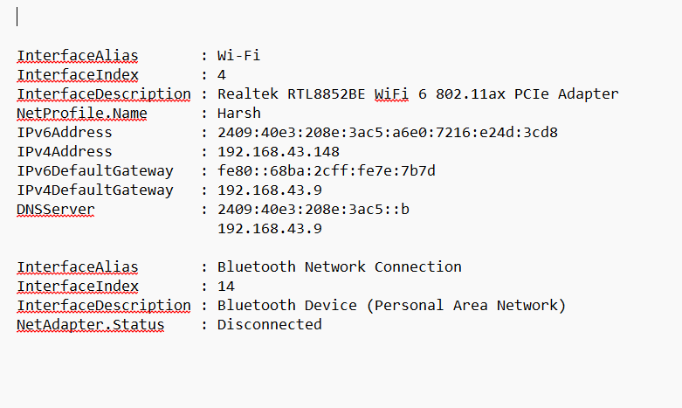

1. ***Get-NetIPConfiguration | Out-File -FilePath D:\Wipro\Example\netfileconfigs***

*This Command will overwrite a file which contains details about the computers Ip configurations and store it in the desired locations*

* *Retrieves current IP configuration.*
* *Writes the output to the specified file.*
* ***Overwrites*** *any* ***existing******content*** *in that file.*

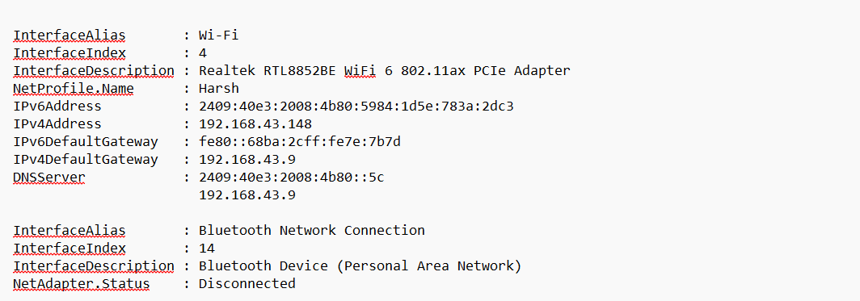

1. ***Get-Service| Out-File D:\Wipro\Example\processfile -Append***

*This will log service status into the process file and append all the data in it*

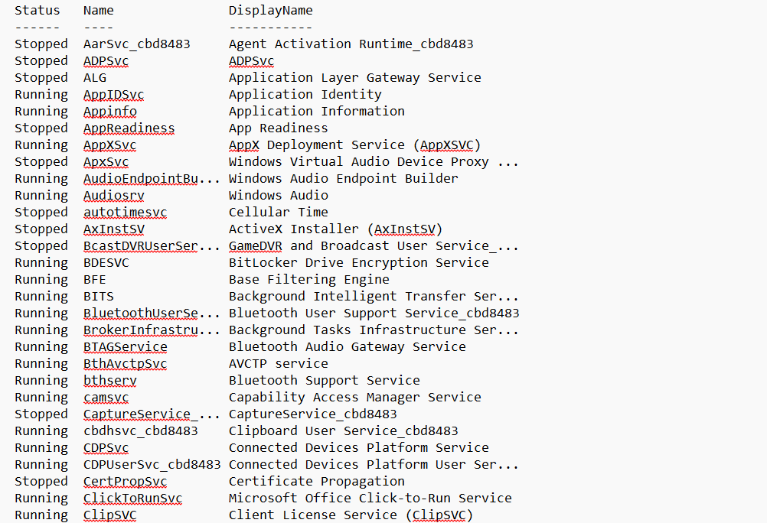

1. ***Get-PSDrive -PSProvider FileSystem | Out-File D:\Wipro\Example\datefile.txt -Append***

*This will log the file system drives into the computer.*

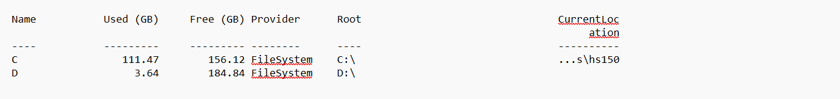

1. ***Get-Command | Out-File D:\Wipro\Example\datefile.txt -Append***

*This will log all available commands into the file*

*The existing data will not be deleted*

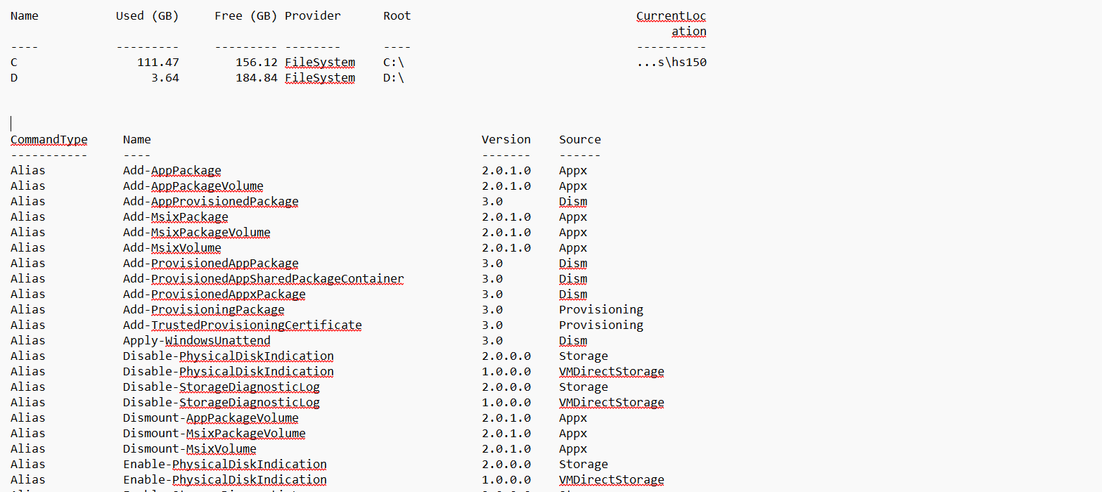

1. ***Get-PSDrive -PSProvider FileSystem | Out-File D:\Wipro\Example\datefile.txt -Append***

*This will log system file again into the file*

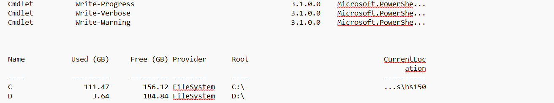

1. ***Get-ChildItem | Out-File D:\Wipro\Example\datefile.txt -Append***

*This will log all the directory content in the available command*

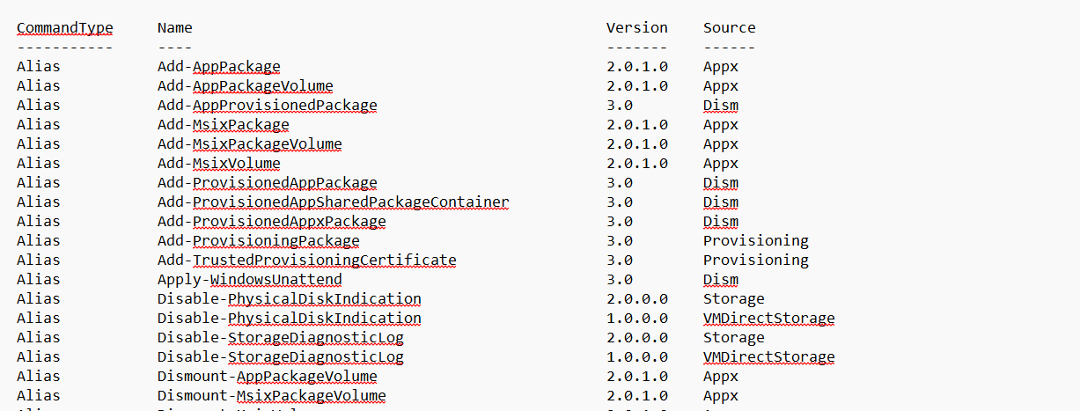

1. ***Get-Service | Out-File D:\Wipro\Example\opfilecommands.txt -Append***

*This will log all the service status into the file*

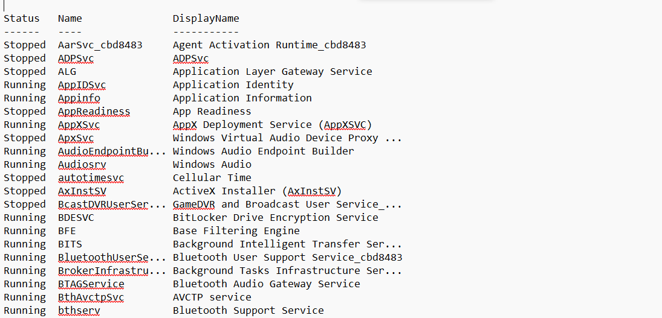

1. ***Get-CimInstance Win32_OperatingSystem***

*Retrieves OS details like serialNumber version architecture etc.*

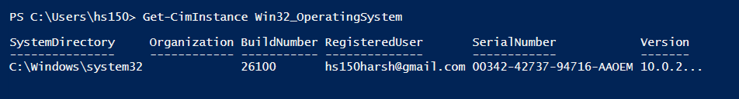

1. ***Get-Command Get-CimInstance***

*Display Metadata about the Get-CimInstance Command*

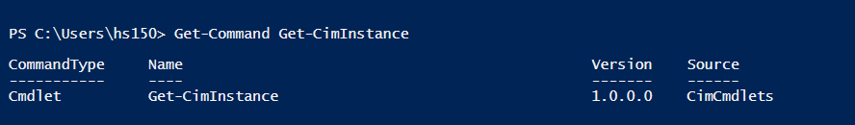

1. ***Get-Help Get-CimInstance***

*It will show help documentations about the Get-CimInstance*

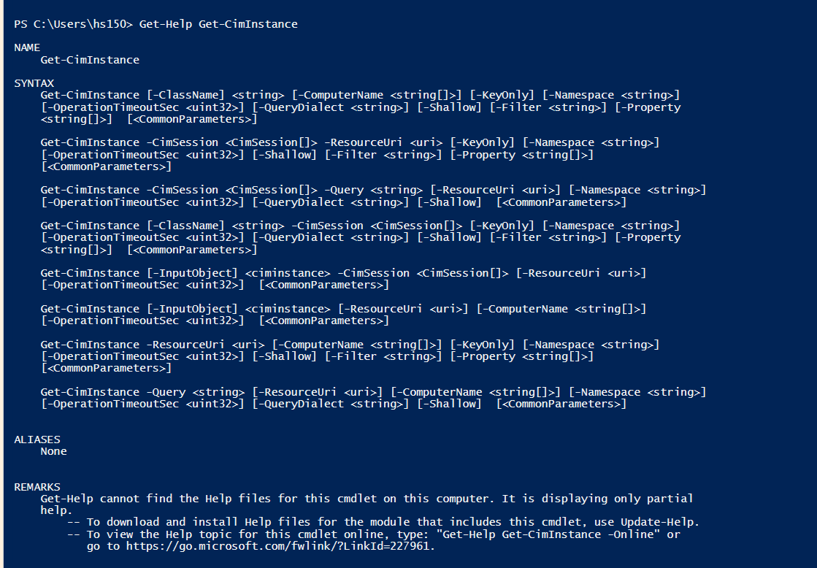

1. ***Import-Module BitsTransfer***

*Load BitsTransfer module into the system*

1. ***Get-Command Install-Module, Install-PSResource***

*Displays metadata for PowerShell package installation commands*

**

1. ***Get-Module***

*Lists currently loaded modules*

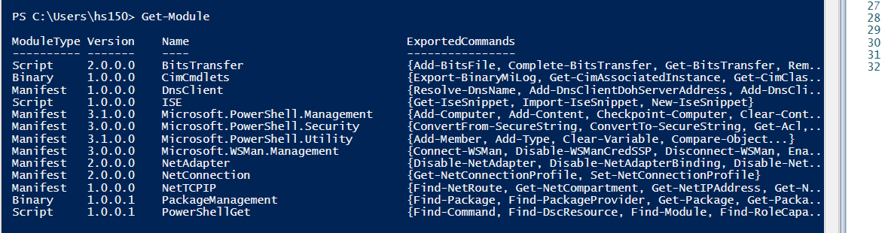

1. ***Get-Module -ListAvailable***

*Lists all modules installed and available*

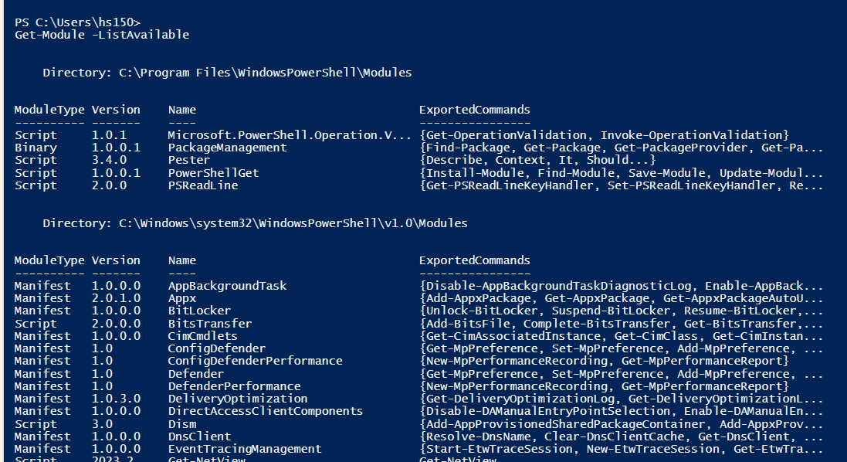

1. ***Get-Command -Module Appx***

*Lists commands for a specific module in this case (Appx)*

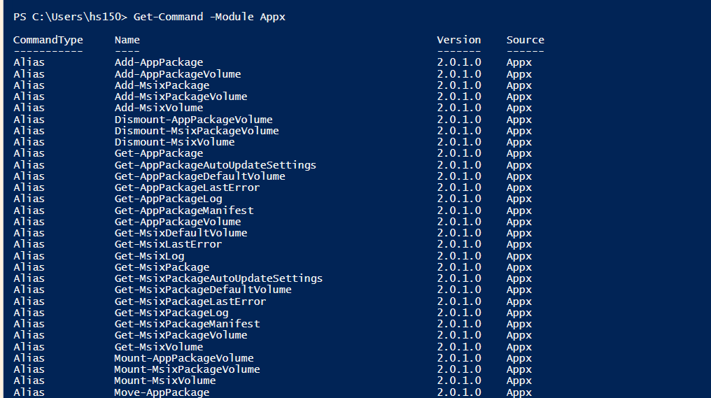

1. ***Remove-Module BitsTransfer***

*Remove Module BitsTransfer from the memory.*

1. ***Get-Command Get-Date, Get-Help -All | Select-Object -Property Name, CommandType, Module ,PSSnapIn***

*This command retrieves metadata about the Get-Date and Get-Help commands, including all variants of Get-Help, and then filters the output to show only selected properties.*

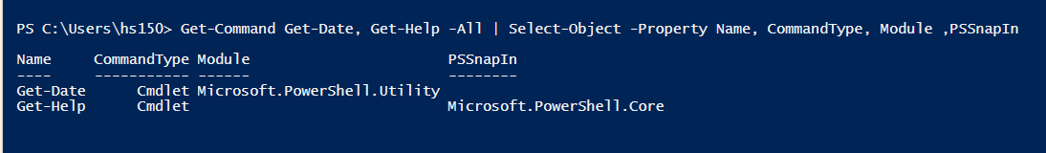

1. ***Remove-Item Function:Get-Date***

*Deletes the Get-Date function (only if it's user-defined)*

*We didn’t defined anything*

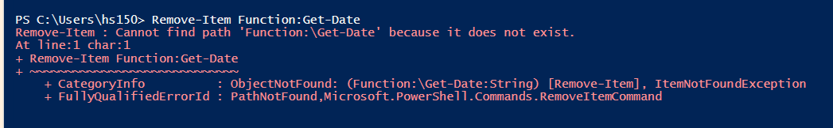

1. ***Get-CimClass *network* | Sort CimClassName***

*Finds CimClasses related to networks and sorts them by name*

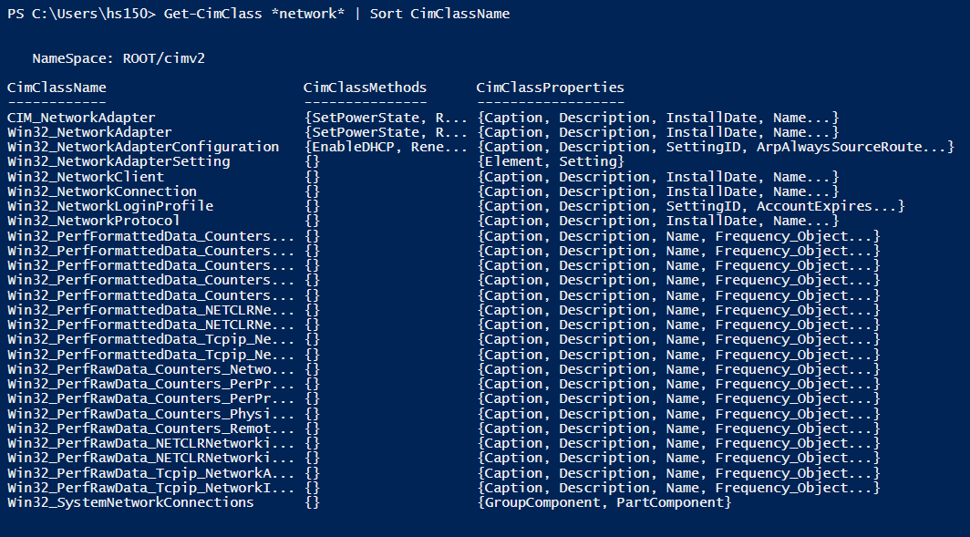

1. ***Get-WmiObject -Class Win32_Keyboard***

*Retrieves keyboard hardware info*

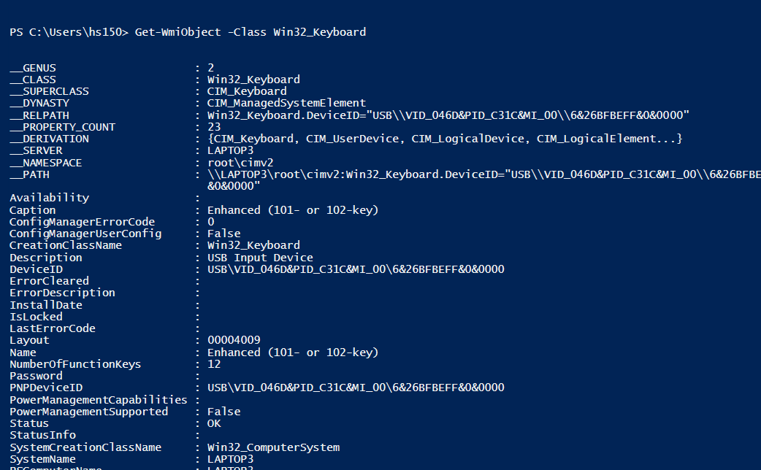

1. ***Get-WmiObject -Namespace root -List | Out-File D:\Wipro\Example\Namespace.txt -Append***

*Saves WMI class list from root namespace to a file.*

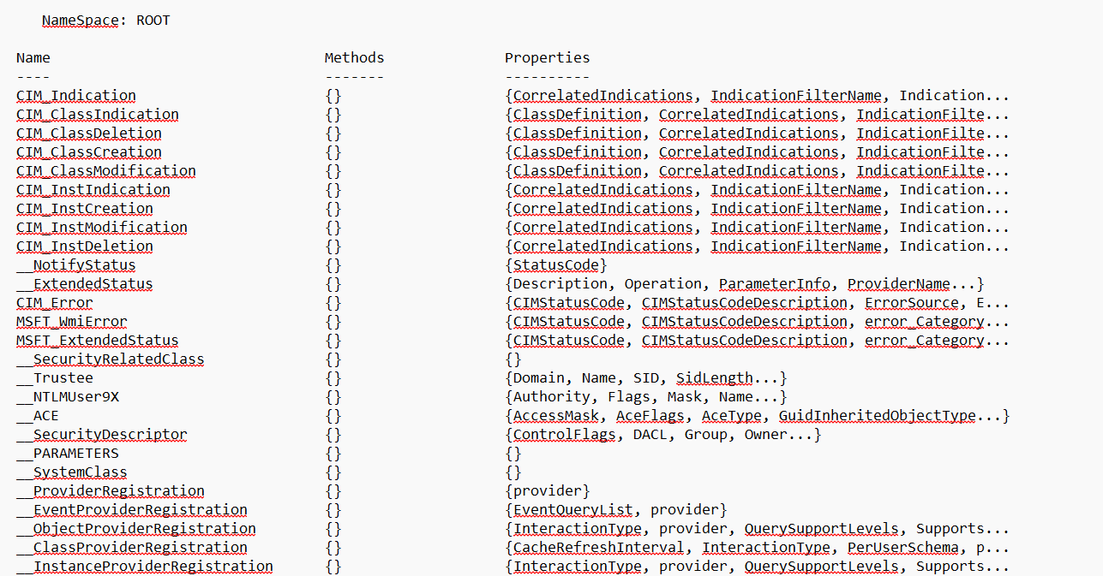

1. ***Get-WmiObject -Namespace root\cimv2 -List | Sort Name***

*Lists all CIM classes in root\CIMv2 and sorts alphabetically*

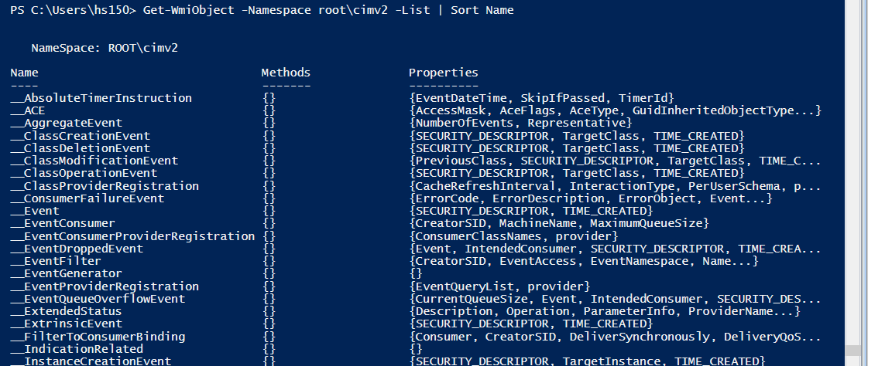

1. ***Get-WmiObject -Namespace root\CIMv2 -List | Out-File D:\Wipro\Example\cimv2.txt -Append***

*Saves WMI class list from root\CIMv2 to a file*

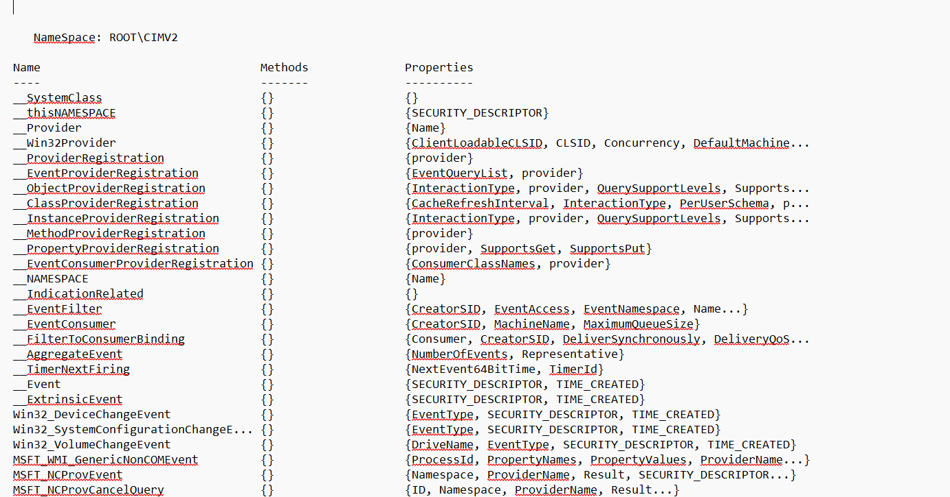

1. ***Get-WmiObject -Namespace root\cimv2 -List | Sort Name | Out-File D:\Wipro\Example\sortcimv2.txt -Append***

*Saves sorted WMI class list from root\cimv2 to a file.*

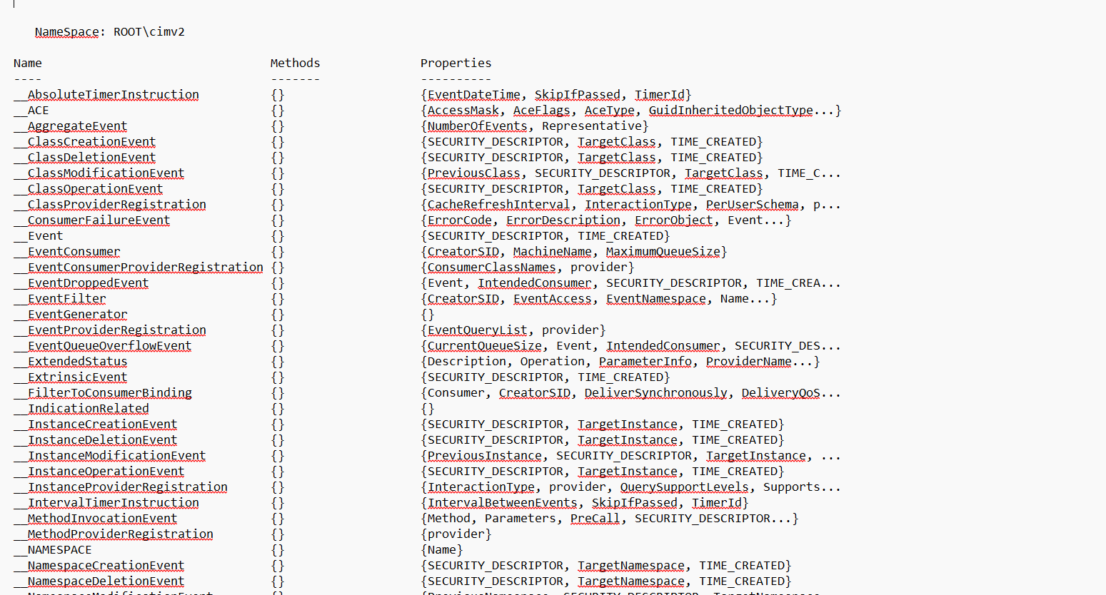

1. ***Get-CimClass -Namespace root\CIMv2 | Sort CimClassName***

*Lists all CIM classes in root\CIMv2 and sorts alphabetically According to their CimClassName*

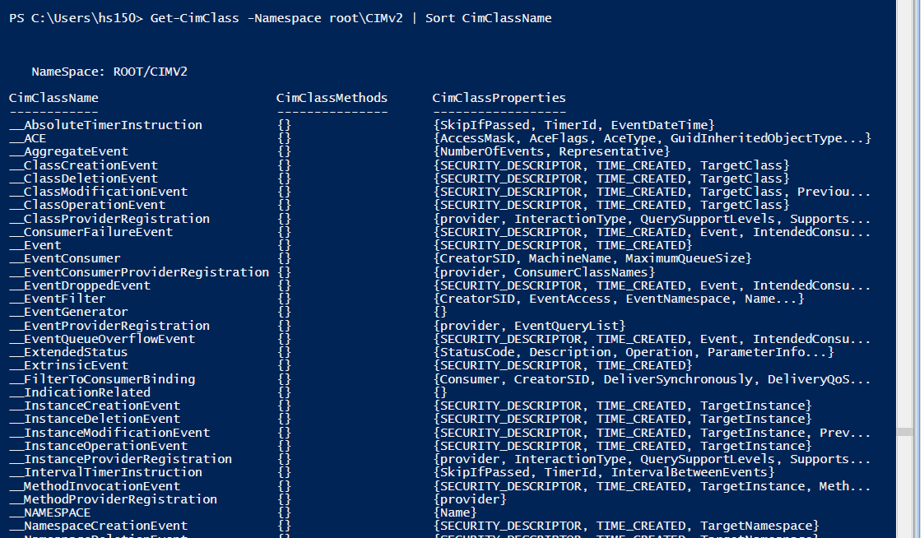

1. ***Get-WmiObject -Class CIM_Chip***

*Retrieves chip level Hardware info*

1. ***Get-WmiObject -ClassName CIM_InstalledOS***

*Retrieves installed OS info (may return nothing if unsupported)*

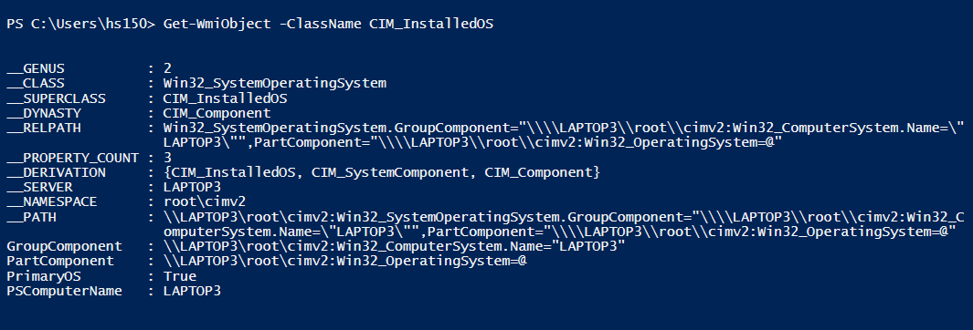

1. ***Get-CimInstance -Class Win32_LogicalDisk***

*Retrieves logical Disk info using CIM*

1. ***Get-WmiObject -Class Win32_LogicalDisk***

*Retrieves all logical disk without any info*

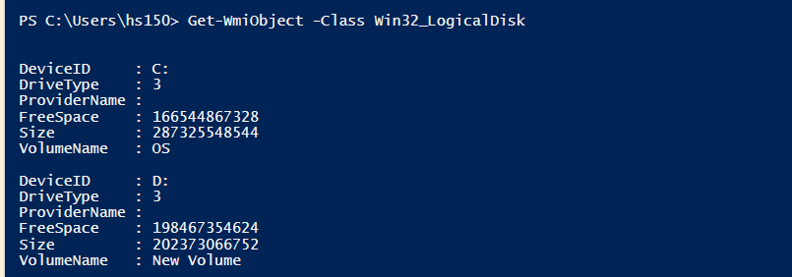

1. ***Get-WmiObject Win32_LogicalDisk***

*It will do the same as above but it is a short form (same syntax)*

1. ***Get-WmiObject -Class Win32_LogicalDisk -Filter "DriveType=3"***

*It will Retrieve only local hard drives. With WMI Filter*

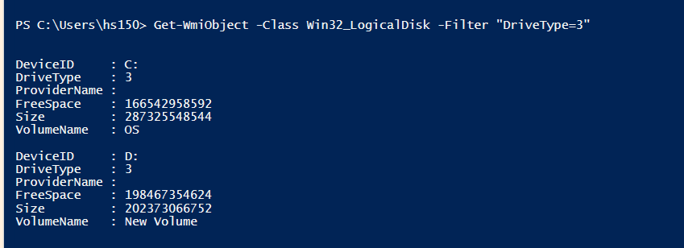

*This PC has only local drive so the results are same if it has external drives then there might be some other results.*

1. ***Get-CimInstance -ClassName Win32_LogicalDisk -Filter "DriveType=3"***

*It will Retrieve only local drive but with CIM filter.*

1. ***Get-WmiObject -Query "SELECT * FROM Win32_LogicalDisk WHERE DriveType = 3"***

*It uses WQL Query to get local drives via the WMI cmdlet*

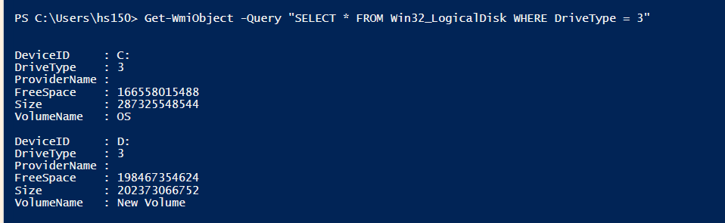

1. ***Get-CimInstance -Query "SELECT * FROM Win32_LogicalDisk WHERE DriveType = 3"***

*It uses WQL query to get local drives via the CIM cmdlet*

