Hamza Salman
Proposal Document

Rubik’s Cube Solver (In C#):

Problem situation  Describe the problem situation / context, what your solution will do eg how it works, whats involved, why needed | - Rubik’s Cube Solver  - The purpose of the program:  - To provide people who do not know how to solve a Rubik’s Cube, easy to follow steps, to allow them to solve their (shuffled) Rubik’s Cube, based on an easy method for solving a cube: The Layer By Layer Method (which I already can do)  - I might implement two modes (I’ll definitely implement the first, the second may require more GUI work):  - One with more optimized steps, to allow people to solve Rubik’s Cubes quickly  - Another mode with little to no optimized steps to help teach beginners how to solve a Rubik’s Cube  - I also might implement a way to save the cube’s state (in case somebody wishes to come back to their cube later; Loading a saved cube will be much quicker than setting a new cube to solve)
Describe the stakeholders (eg the users, owners) | Stakeholders:  - Common Public (who have a Rubik’s Cube they wish to solve without learning algorithms)  - Beginners who want to learn how to solve the Rubik’s Cube
How will solution provide an improved / alternative solution to current methods? | The best current method to learn how solve a Rubik’s Cube, is to go onto YouTube and to learn how to solve the Rubik’s Cube from observing what the people do to solve the Rubik’s Cube.  Even though this is largely effective, it is still extremely difficult to account for all issues and situations that beginners may run into, in just a video tutorial, to solve the cube…  So, my program will expand on what the YouTube videos cover, by showing graphically, step by step, how to solve the Rubik’s Cube, which may allow learners to better understand how to use this algorithm to solve the cube,  My program will also simply allow user’s to take the required steps to instantly solve a Rubik’s Cube, so for people who wish to be able to solve the cube, while not wishing to learn the algorithms, can still hold a solved Rubik’s Cube
What features make the problem solveable by a computer?  Eg:  Sequence, selection & iteration?  Repetitive processing?  Concurrency?  Preconditions?  Clearly defined procedures?  Nature of the data | - The 3D graphical design for the cube will allow the cube to be seen from all sides, improving on the YouTube video tutorials’ problems of not being able to freely see all sides of the cube.  - Completing set algorithms are a big strength of computers, and algorithms are an integral part of solving Rubik’s Cubes. Also, computers will be able to spot optimizations in the steps required to solve the Rubik’s Cube, and be able to shorten the required steps to solve the cube (, for people who wish to solve the cube without learning any algorithms)

Stakeholder details  (name, job title, email/phone numbers)  Secondary stakeholders  Who else uses / will use the system  Eg  Users & audience | Main Stakeholders:  - My family members can be Stakeholders  - Mum:  - Name: Hummera Salman  - Job: Preschool Teacher  - Email: hummeras@yahoo.com  - Phone Number: 07980271758  - Sister:  - Name: Amal Salman  - School: Archbishop Holgates Secondary  - Email: amal.york@yahoo.com  - Phone Number: 07456579335  Secondary Stakeholders:  - Common Public (who have a Rubik’s Cube they wish to solve without learning algorithms)  - Beginners who want to learn how to solve the Rubik’s Cube
Describe how each stakeholder will use the system or the outputs of the system | - Common Public (who have a Rubik’s Cube they wish to solve without learning algorithms)  - They would use the program to show them the steps, so they can follow each step accordingly, and solve their Rubik’s Cube  - Beginners who want to learn how to solve the Rubik’s Cube:  - They would also use the program to see the steps to solve their Rubik’s Cube, but they may also wish to see the algorithms being completed as they solve their cube, so that they can learn how to solve it.
What existing solutions are there? (urls and screenshots)  Which features of these would you like to use in your work?  What benefits & drawbacks are there to other solutions? | On YouTube, there is somebody who also made a Rubik’s Cube Solver for his A-Level project, and he showed what his program is capable of doing, and he also showed that he used a free library OpenTK, in C#, to make the program (he hasn’t disclosed the source code, but showed what his program was cable of, which shows me ideas how to go about making a GUI).  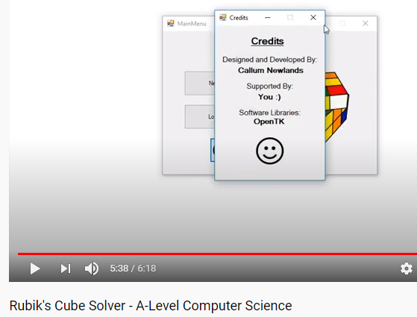  Another person in another YouTube video also showcases what their program can do and has disclosed the source code too, though I doubt I will be looking much into that.  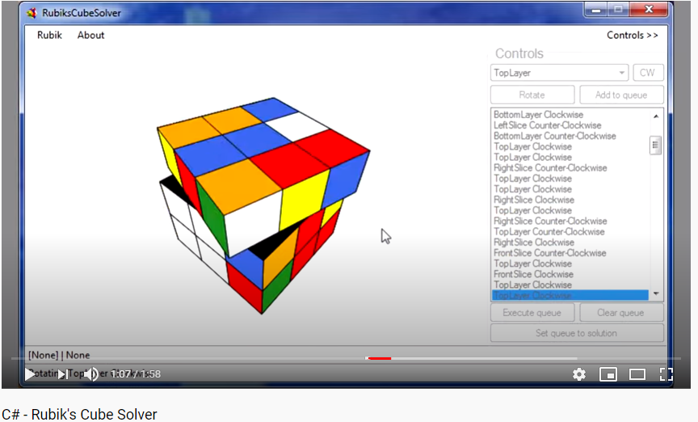  Plus, there are many various tutorials on YouTube on how to use OpenTK too, as well as some instructions on how to use OpenTK on their website too.  
What limitations might you set to the solution  Eg  Platforms?  No. of users?  Size of data? | - The program is best used on a desktop only (not really for mobile use)  - The program must be optimized, so that the program can run as smoothly as possible  - The data saved must also be optimized (if there is any)
Numbered list of requirements  See requirements task, mark scheme and sample projects for guidance  Provide reasons for each | - Have a UI for the user to interact with the program, having a Start Menu  - So, users can easily use and interact with the program  - Create a 3D cube on-screen that can be viewed from all sides in C# using OpenTK  - So that users can easily see what their Rubik’s Cubes should look like  - So, users can easier observe the effects on the location of the colours, while turning the Rubik’s cube  - Create a 3x3 Rubik’s Cube out of the 3D cube on screen  - This must be 3D so users can easily see how the digital cube maps onto their cube  - 3x3 Rubik’s Cube is by far the most common and most famous of the variants  - Create the controls for the cube, so the cube can be interacted with  - This is mainly for programming purposes, so it will become much easier to implement an algorithm, by simply using these controls, rather than hard coding each control  - Create the algorithm that will solve the cube.  - This is the main purpose of the program, and goal for the user too  - Add a GUI that will allow the user to scroll through the steps, and change some settings  - Since different users have different requirements, and learn differently, or wish to do different things with the program, the settings should allow for as many of these different things as possible (while still being clear to use)  - Adding a clear way to scroll through the steps makes the goal of the program mush easier to achieve, since users will have less trouble understanding how to use the program and will thus find it easier to solve their cube.
Numbered list of measurable success criteria  See requirements task, mark scheme and sample projects for guidance  Provide reasons for each | - Have a UI for the user to interact with the program, having a Start Menu  - Make clear, easy to see buttons  - Make buttons brighter in colour when hovered over.  - Make buttons to open settings  - Create a 3D cube on-screen that can be viewed from all sides in C# using OpenTK  - Must be able to scroll around cube, so the user can look at all sides of the cube, as they wish  - Create a 3x3 Rubik’s Cube out of the 3D cube on screen  - It must have 6 different colours, with 9 tiles for each colour  - Most likely data for the cube will be stored in a 2D Array  - Create the controls for the cube, so the cube can be interacted with  - There must be a way to turn every part of the cube, even if this control is hidden from the user and solely used by the cube solving algorithm  - Create the algorithm that will solve the cube.  - The algorithm should be based on The Layer by Layer Method  - The algorithm should still be able to solve the cube in a reasonable number of steps, even if this means making slight changes to the original algorithm whenever this does not occur  - Add a GUI that will allow the user to scroll through the steps, and change some settings  - The buttons to scroll through the steps should be at the bottom of the window  - Some possible settings (that I have seen in other people’s versions and would like to implement):  - Animation Speed  - Cube Brightness  - Other settings I might add, for those people who wish to learn the algorithms as well as solve the cube  - How to display algorithm, e.g. F, R, U, …

.

