None of this design is final, and this design is a combination of many different images put together from Google Images, and Microsoft Word shapes and text boxes. Despite that, this GUI does show how I would implement some of the features of my program. It is highly likely that the colours and actual look / way some of the features are presented, will be different, e.g. Slider will be look different.

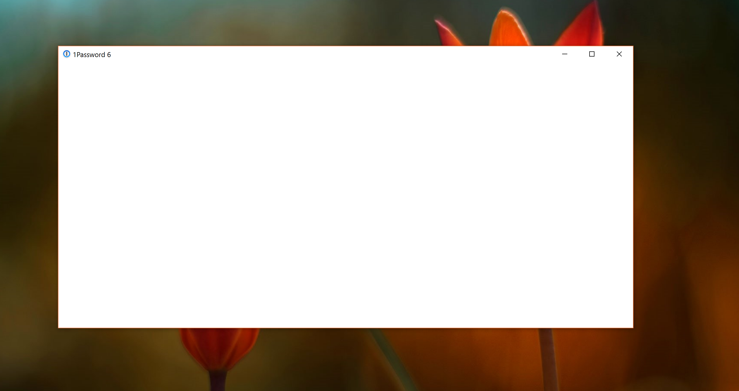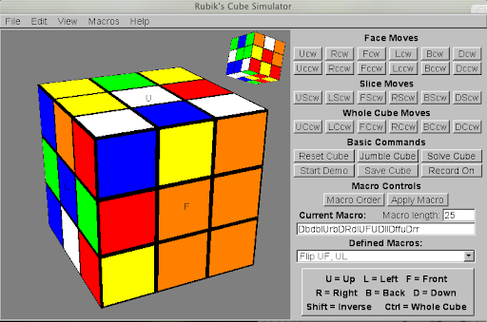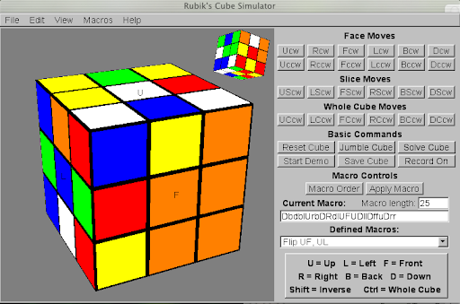

>>

>

<

<<

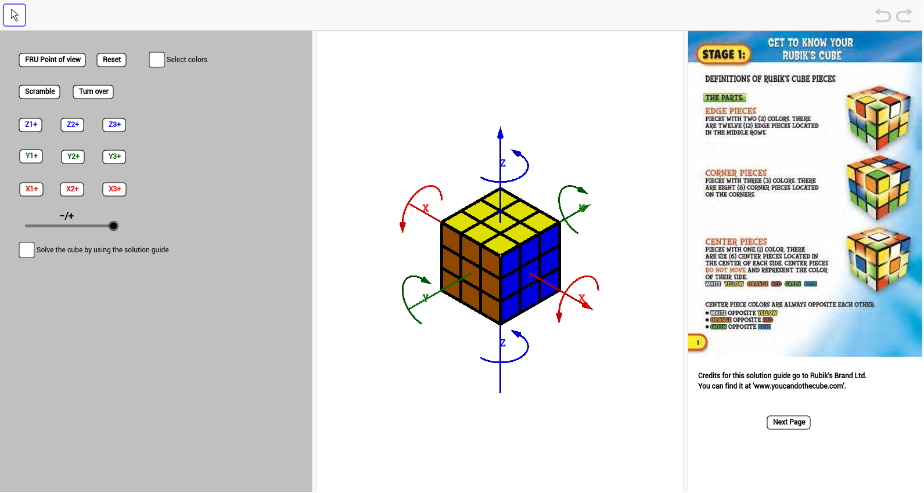

Settings

**STEP 22: F, R, U, R’, U’, F’**

**STEP 23: F, R, U, R’, U’, F’**

**STEP 24: F, R, U, R’, U’, F’**

How to Solve

File contains:

* New Cube
* Load Cube
* Save Cube
* Quit Run Through

Animation Speed

Scroll through Steps Speed

Visual Representation of each step of the algorithm – (where each of those letters represents a way of turning a face)

View contains:

* Reset Camera
* View:
  + Front Face
  + Right Face
  + Left Face
  + Top Face
  + Bottom Face
  + Back Face

Edit contains:

* Edit Cube Faces

Scroll through steps automatically

Scroll through steps

Help contains:

* Instructions on how to use the program
* A guide to the purpose of each algorithm used in the program

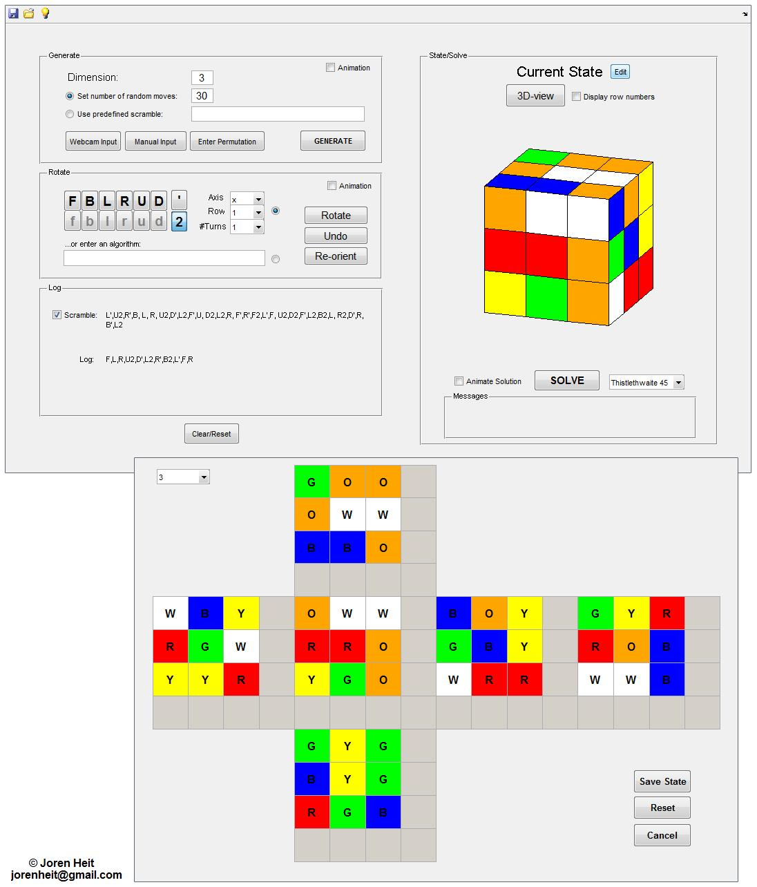

I would also have a simple button window for when the program starts, and for when the user quits a simulation of solving the cube.

The menu to edit the cube faces, would look something like this (again, this is from google images, and so the final design is highly likely to be different)