Q1. For 14 July 2021 find the required details-

• Most frequently used payment type

• Merchant ID with highest transaction value

• % transactions which were settled by 15th July

Solution>

There are total 8023 transaction taking place on 14 July 2021

DC is the most frequently used payment type on this day as it can be seen from the graph

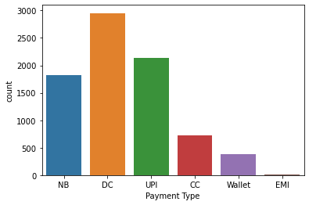

Merchant id with highest Transaction amount=11508728

Total No. of transaction that were settled on 15-july-2021=4534

Total No. of transaction that were settled on 14-july-2021=00

Total transaction that began on 14-july-2021=8023

% transaction which were settled by 15-july-2021= ((4534+0)/8023) \* 100

= 56.51 %

Q2. Which payment type has the highest transaction fee %

Solution>

There are total 6 types of payment type

1. EMI
2. UPI
3. Wallet
4. CC
5. NB
6. DC

EMI>% transaction fees for EMI is 0.8204 ,but for most cases % transaction fee is between 1%-2%.

UPI>% Transaction fees for UPI is 0% for more than 90% transactions.

But on an average it is 0.0115%.

WALLET> On an average the transaction fees is 1.798,but for most of the cases % transaction fee is greater than 2%

CC>On an average transaction fees is 1.71%.But the Transaction fees % does not follow a particular trend.

NB> On an average transaction fee % is 0.147%.But for most of the case transaction fees is between 20-25.

DC> On an average transaction fee % is 0.855%

Wallet has the highest % of Transaction fees.

Q3. What percentage of transactions were settled within 1-day?

Solutions>

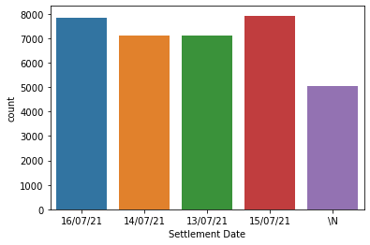

Solution>

As we can see from the above plot there are 4 settlement dates and for some

Transaction settlement date is not given.29981 transaction have settlement dates so only they will be considerd.

For each settlement date we count the no. of transaction that were

Initiated one day before and were settled on that particular settlement day.

That is,

5026 transaction settled in 1 day which had settlement day on 16/07/21

4534 transaction settled in 1 day which had settlement day on 15/07/21

3706 transaction settled in 1 day which had settlement day on 14/07/21

3334 transaction settled in 1 day which had settlement day on 13/07/21

Total transaction settled in 1 day=16600

percentage of transaction settled in 1 day = (16600/29981)\*100

= 55.36%

Q4. What is the average time taken between transaction & settlement (assume every day settlement happens at 12 noon)

Solution>

For calculating the average time taken,

We remove all the transactions from the database which do not contain settlement date.

We get 29981 transactions which have settlement date mentioned.

As time is not given in the settlement date we add time to the entire Settlement date column.

We convert both ‘Date of transaction’ and ‘Settlement date’ to standard date time format

We convert the difference between both the date time to hours and calculate the average

Total hours=968074.36 hrs

Average time=968074.36/29981

=32.28 hrs

Q5. Provide hourly trend for transactions for all days together. And find out the peak/highest hours of transactions?

Solution>

We have to Convert the ‘Date of Transaction’ to standard date time format

Add a new column which contains the hour from the ‘Date of Transaction’

The new column contains hour in which most of the transaction took place.

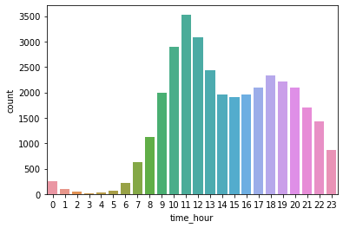

The graph shows that 11:00-12:00 is the time when most no. of transaction take place.

The same can be observed from the table below 11:00-12:00 has most frequency of transaction.

00:00-1:00 252

01:00-2:00 98

02:00-3:00 42

03:00-4:00 17

04:00-5:00 32

05:00-6:00 60

06:00-7:00 221

07:00-8:00 635

08:00-9:00 1124

09:00-10:00 2000

10:00-11:00 2903

11:00-12:00 3533

12:00-13:00 3083

13:00-14:00 2435

14:00-15:00 1968

15:00-16:00 1903

16:00-17:00 1968

17:00-18:00 2100

18:00-19:00 2341

19:00-20:00 2221

20:00-21:00 2103

21:00-22:00 1707

22:00-23:00 1430

23:00-00:00 864

Q6 Any other interesting insight you can derive from this data

Solution>

If we analyse the Status column of all the transactions

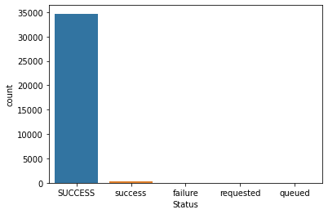

We can see that more than 99% payments are success

Only 4 transaction have ‘failure’ as Status and all 4 transaction have Payment type as UPI.

Out of 18 transaction which has ‘requested’ as Status 17 have Payment type as NB and 1 has

Payment type as UPI

Some transaction have ‘queued’ as Status ,all payment type except ‘WALLET’ has this Status.

Wallet is the Payment mode which has 100% success, NB is the Payment mode which has given maximum no. of error and UPI is the payment mode which has given all kinds of error.