**Chapter 1: Introduction**

* 1. **. Definition**

Web based portal for **Project Monitoring and Management System (PMMS)**.

* 1. **. Objective**

The objective of the PMMS portal is to develop a system for helping students to get appropriate help and mentoring online and to help them work more systematically on their project.

This platform will help the students to remain in active contact with their team members, their faculty guide. On the site, the students will be able to update their progress in the project and on which the guide can comment on the status, progress and problems. This will increase collaboration and co-creation while improving novelty of their work.

**1.3. Scope**

This portal will be helpful in monitoring student’s progress periodically. Also it will be helpful to the faculty guide in managing his/her assigned groups progress and approving the task done by the students. Students will get the feedback to the work uploaded quicker and at any time anywhere. Task approval and maintaining student’s reports will be easy and manageable. Student have to give final project presentation physically.

**1.4. Modules**

There will basically be Four modules:

* Registration
* Project Details
* Notification
* FAQ
  1. **Project basic requirements**
     1. **Software requirements**:
* PHP
* HTML
* CSS / Bootstrap
* JavaScript / AngularJS
* AJAX
* MySQL
* XAMPP server
  + 1. **Hardware requirements:**
* Server for web hosting
* Database server
* Computer / Laptop / Mobile phone

**Chapter 2: Analysis, Design Methodology and Implementation Strategy**

**2.1. Comparison of existing application with your project:**

In the existing system all the work is done manually and there is lot of information gap between faculty, students and coordinator. There is lot of paperwork to be submitted manually.

While in the project all the work is done online on the portal. Faculty is notified whenever its respective group of students uploads a report and vice-versa. Similarly, for the relationship between coordinator and student.

**2.2. Project feasibility**

* + 1. **Technical feasibility**

­It would be feasible to implement the portal on PHP & MySQL for server side scripting and database server and for client side scripting and designing we will use JavaScript and Cascading style sheet libraries like AngularJS and Bootstrap.

* + 1. **Economic feasibility**

The expense of building the portal will be less it will just need server for hosting the website and creating database.

* + 1. **Operational feasibility**

The operation of the portal will be easy for the both faculty and student as it will increase the efficiency of the project in terms of approving the task and maintaining records.

* + 1. **Time feasibility**

The building of portal will be completed within specified time.

* 1. **Project Timeline chart:**

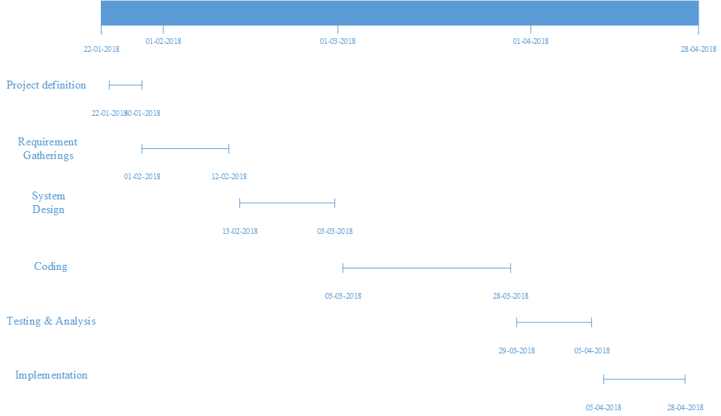

* 1. **Detailed Module Description:**
     1. **Registration**

This module will contain three types of user:

* + - 1. **Admin**

Course coordinator will form the groups of students and assign faculty guide to each of the group. He / she can monitor the progress of each and every group and also he can add notice on the common dashboard. He / she can retrieve a consolidated report of the student.

* + - 1. **Student**

Student will be given a login id & a password and he/she can login and upload the document as per requirement and it will be sent to the respective faculty guide and he/she will be notified whether the task is approved or not by the faculty guide.

* + - 1. **Faculty**

Faculty will also be given a login id and a password and he / she can view the progress of the groups assigned to him / her. Faculty can also view the uploaded report and approve or reject the report and progress.

**NOTE:** Here both student and faculty will be notified when the student uploads a document or faculty approves a document.

* + 1. **Project Details**

This module will contain mainly functionalities such as,

* Definition approval
* Periodic report /Term work upload
* Final report upload

Here, there will be comment box, On the faculty side, faculty can comment for the report/work uploaded by the student and approve the work done by student and at the student can view the comments.

Faculty will download the report/work and the student will upload the report/work.

* + 1. **Notification**

In this module the user will able to view important notification by the admin or other user.

* + 1. **FAQ**

This module will contain Frequently Asked Questions by the students to the faculty guide and also some basic questions.

* 1. **Project SRS**
     1. **Use Case Diagram**

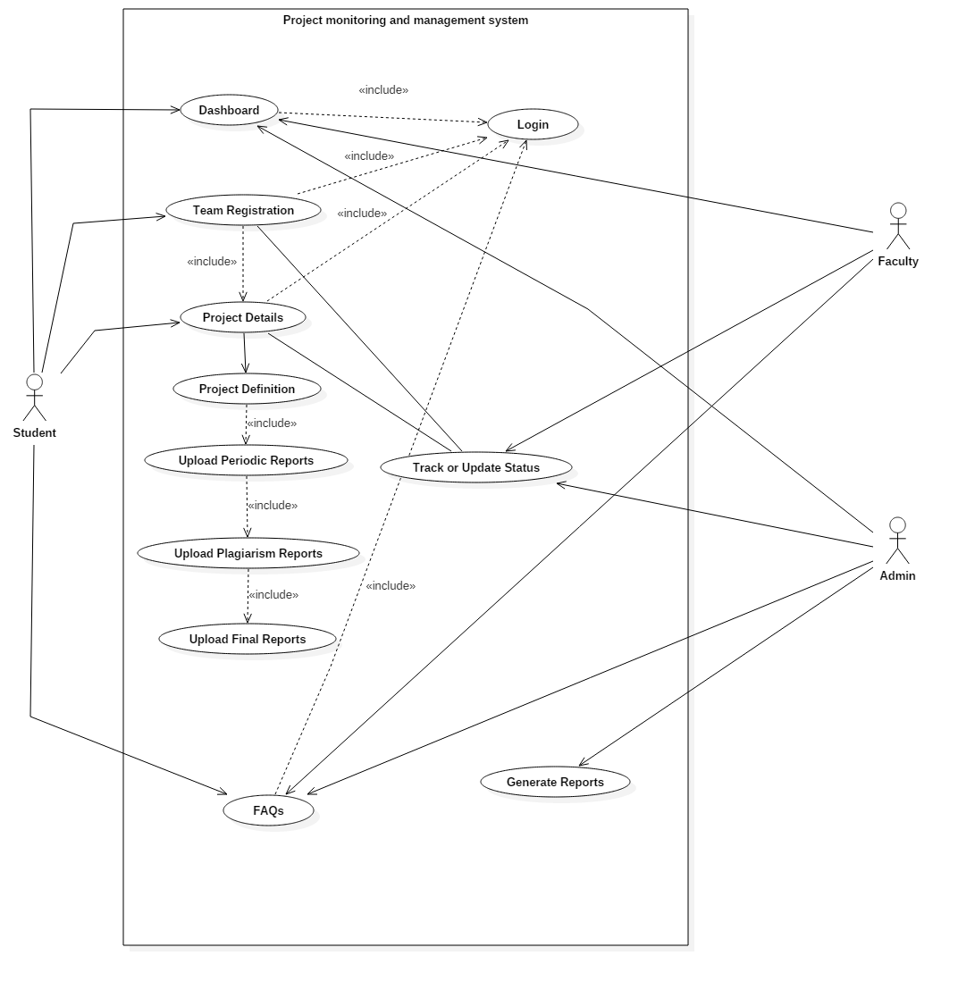

**Figure 2.5.1.1. Use Case Diagram**

* + 1. **Data Flow Diagram**

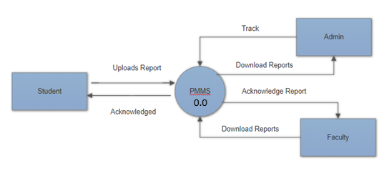

**Figure 2.5.2.1 Level 0**

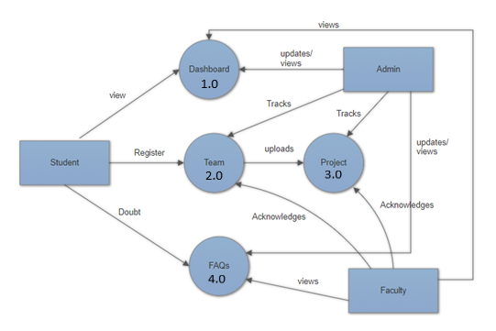

**Figure 2.5.2.2 Level 1**

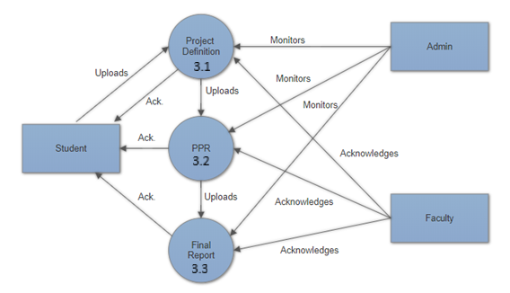

**Figure 2.5.2.3 Level 2 (Extension of Project (3.0))**

* + 1. **Entity Relation Diagram**

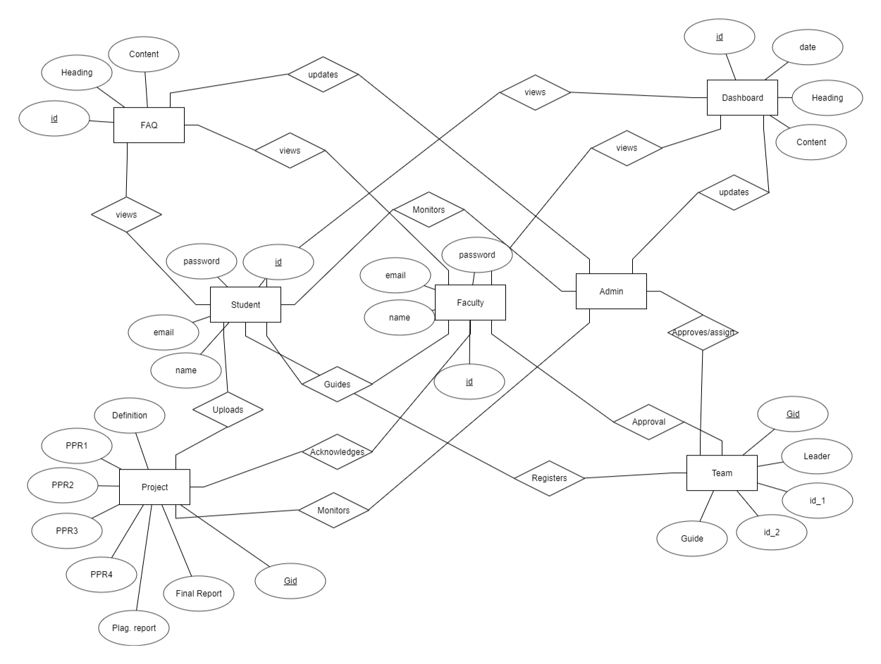

**Figure 2.5.3.1 ER Diagram**