**IT341: Mini Project**

**Progress Report – II**

|  |  |  |
| --- | --- | --- |
| **Name** | **ID** | **Faculty Guide** |
| Harshil Shah | 15IT069 | Zankhana Shah |
| Jay Patel | 16IT603 |

**1. Project Requirement Gathering:**

**1.1 Requirement Gathering Techniques for project:**

**1.1.1 Brainstorming:**

We have used this technique in requirement gathering to get good numbers of ideas from group of people. This technique has provided broad view to get creative ideas for project definition.

**1.1.2 Focus Group:**

It involves synergistic discussion among group members. We have used this technique so that each group member must know the user’s expectations and work according to it.

**1.1.3 Prototyping:**

This technique involves primary requirements gathering which is used to build an initial version of our project. This will continue until the final project is done

**1.1.4 Interview:**

It involves interviewing the faculties, coordinator and students in order to make the portal more user friendly and interactive.

**1.2 Comparison of existing application with your project:**

In the existing system all the work is done manually and there is lot of information gap between faculty, students and coordinator. There is lot of paperwork to be submitted manually.

While in the project all the work is done online on the portal. Faculty is notified whenever its respective group of students uploads a report and vice-versa. Similarly, for the relationship between coordinator and student.

**2. Project Timeline Chart**

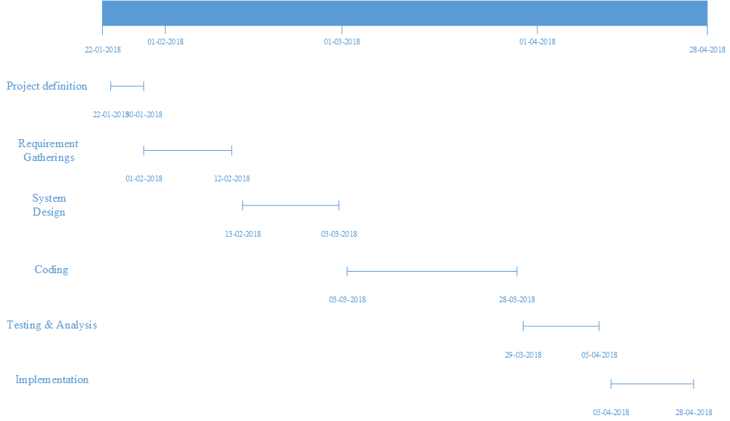

**3. Project SRS**

**3.1 Designing:**

**3.1.1 Data Flow Diagram**

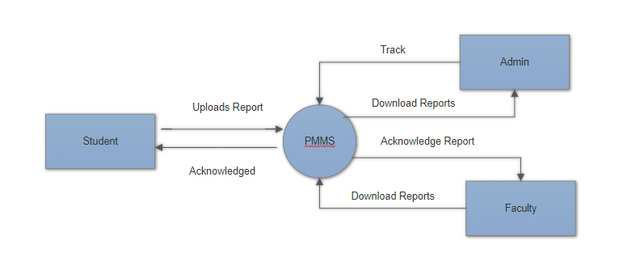**Figure 3.1 Level 0**

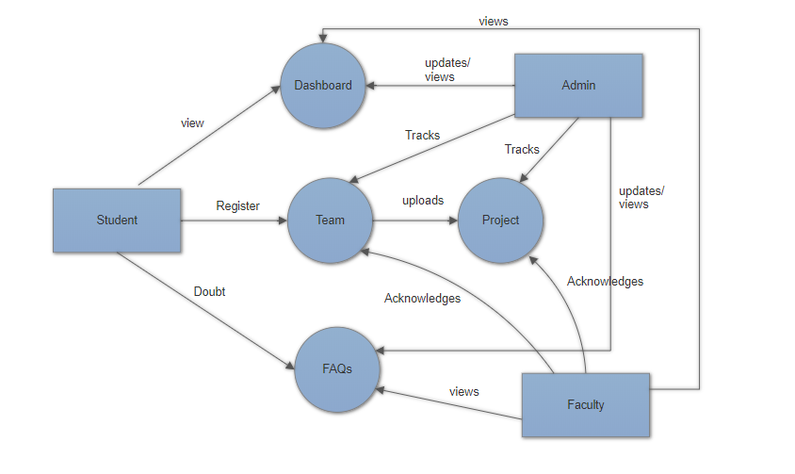

**Figure 3.2 Level 1**

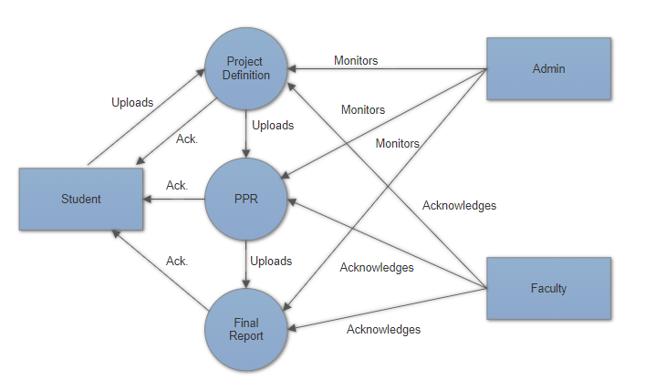

**Figure 3.3 Level 2**

**3.1.2 ER Diagram**

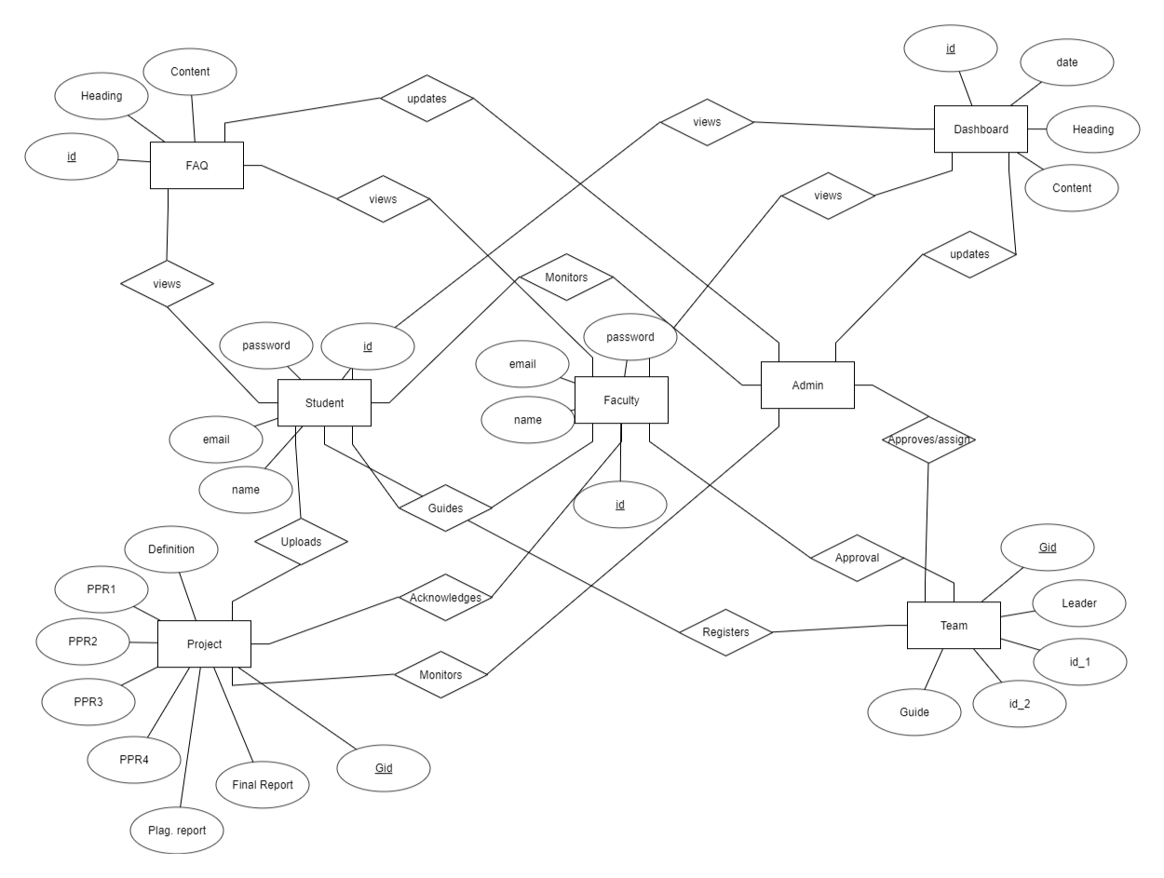

**Figure 3.4 ER DIAGRAM**

**3.1.3 Use Case Diagram**

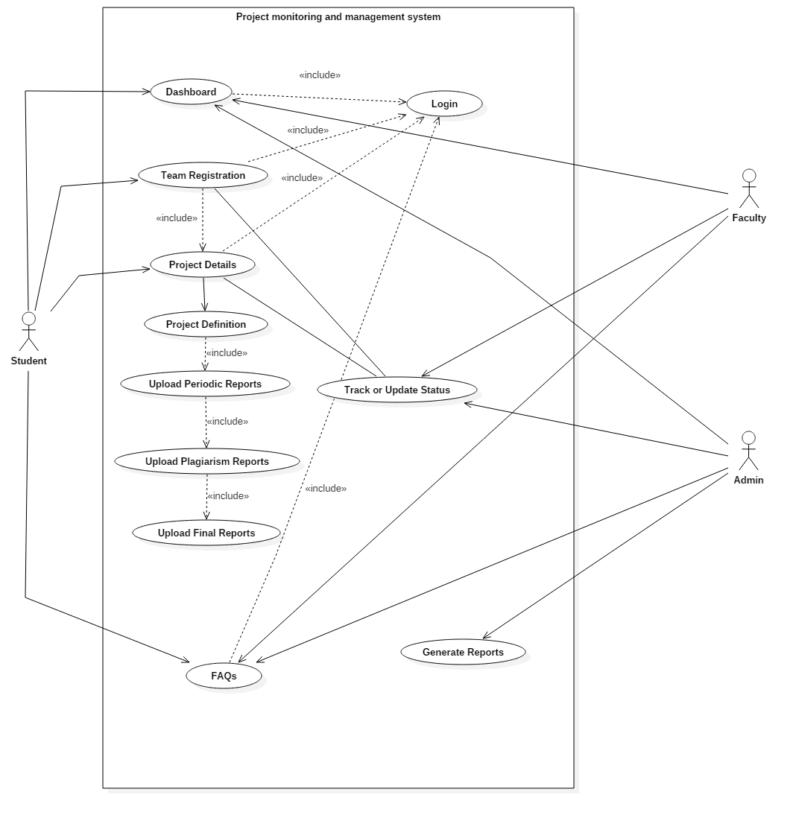**Figure 3.5 Use Case Diagram**

**3.2. Data Dictionary**

Table Name: Student

Primary Key:

Description:-It Stores Student information.

|  |  |  |  |  |  |
| --- | --- | --- | --- | --- | --- |
| Sr.no. | Column name | Data Type | Size | Constraint | Description |
| 1 | ID | Integer | 10 | Primary Key | It identifies a student uniquely |
| 2 | Name | Varchar | 20 | Not Null | Student’s Name |
| 3 | Email | Varchar | 20 | Not Null | Student’s email |
| 4 | Password | Varchar | 10 | Not Null | Students password |

**Table 3.2.1**

Table Name: Faculty

Primary Key: ID

Description: It Stores faculties information.

|  |  |  |  |  |  |
| --- | --- | --- | --- | --- | --- |
| Sr.no. | Column name | Data Type | Size | Constraint | Description |
| 1 | ID | Integer | 10 | Primary Key | It identifies a faculty uniquely |
| 2 | Name | Varchar | 20 | Not Null | Faculty’s Name |
| 3 | Email | Varchar | 20 | Not Null | Faculty’s email |
| 4 | Password | Integer | 10 | Not Null | Faculty’s password |

**Table 3.2.2**

Table Name: Admin

Primary Key: ID

Description:-It Stores Admin details.

|  |  |  |  |  |  |
| --- | --- | --- | --- | --- | --- |
| Sr.no. | Column name | Data Type | Size | Constraint | Description |
| 1 | ID | Integer | 10 | Primary Key | It identifies admin uniquely |
| 2 | Email | Varchar | 20 | Not Null | Admin’s Email |
| 3 | Password | Integer | 10 | Not Null | Admin’s password |

**Table 3.2.3**

Table Name: Team

Primary Key: Gid

Description:-It Stores groups information.

|  |  |  |  |  |  |
| --- | --- | --- | --- | --- | --- |
| Sr.no. | Column name | Data Type | Size | Constraint | Description |
| 1 | Gid | Integer | 10 | Primary Key | It identifies a group uniquely |
| 2 | Guide | Varchar | 10 | Not Null | Faculty’s ID |
| 3 | Id_1 | Varchar | 10 | Not Null | Leader’s ID |
| 4 | Id_2 | Varchar | 10 | Not Null | Partner’s ID |
| 5 | Id_3 | Integer | 10 | Null | Partner’s ID |

**Table 3.2.4**

Table Name: Project

Primary Key: Gid

Description:-It Stores status related to the group’s report upload.

|  |  |  |  |  |  |
| --- | --- | --- | --- | --- | --- |
| Sr.no. | Column name | Data Type | Size | Constraint | Description |
| 1 | Gid | Integer | 10 | Primary key | Group’s ID |
| 2 | Project Definition | Boolean | - | Not Null | Project’s Definition |
| 3 | Ppr1 | Boolean | - | Not Null | Status of PPR1 |
| 4 | Ppr2 | Boolean | - | Not Null | Status of PPR2 |
| 5 | Ppr3 | Boolean | - | Not Null | Status of PPR3 |
| 6 | Ppr4 | Boolean | - | Not Null | Status of PPR4 |
| 7 | Plagiarism report | Boolean | - | Not Null | Status of Plagiarism report |
| 8 | Final Report | Boolean | - | Not Null | Status of Final Report. |

**Table 3.2.5**

Table Name: FAQ

Primary Key: ID

Description: It Store FAQs uploaded by the admin.

|  |  |  |  |  |  |
| --- | --- | --- | --- | --- | --- |
| Sr.no. | Column name | Data Type | Size | Constraint | Description |
| 1 | ID* | Integer | 10 | Primary Key | It identifies a unique FAQ |
| 2 | Heading | Varchar | 50 | Not Null | Question |
| 3 | Content | Varchar | 1000 | Not Null | Answer |

**Table 3.2.6**

Table Name: Dashboard

Primary Key: ID

Description: It Store Notice uploaded by the Admin.

|  |  |  |  |  |  |
| --- | --- | --- | --- | --- | --- |
| Sr.no. | Column name | Data Type | Size | Constraint | Description |
| 1 | ID* | Integer | 10 | Primary Key | It identifies a unique |
| 2 | Heading | Varchar | 50 | Not Null | Notice |
| 3 | Content | Varchar | 1000 | Not Null | More information |

**Table 3.2.7**

NOTE: Here ‘*’ means AUTO INCREMENT.

**3.3 Template Design**

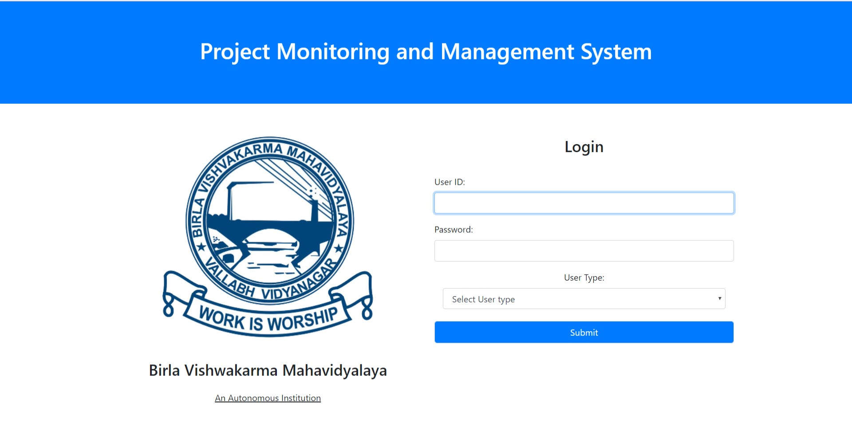

**Figure 3.6 Login page**

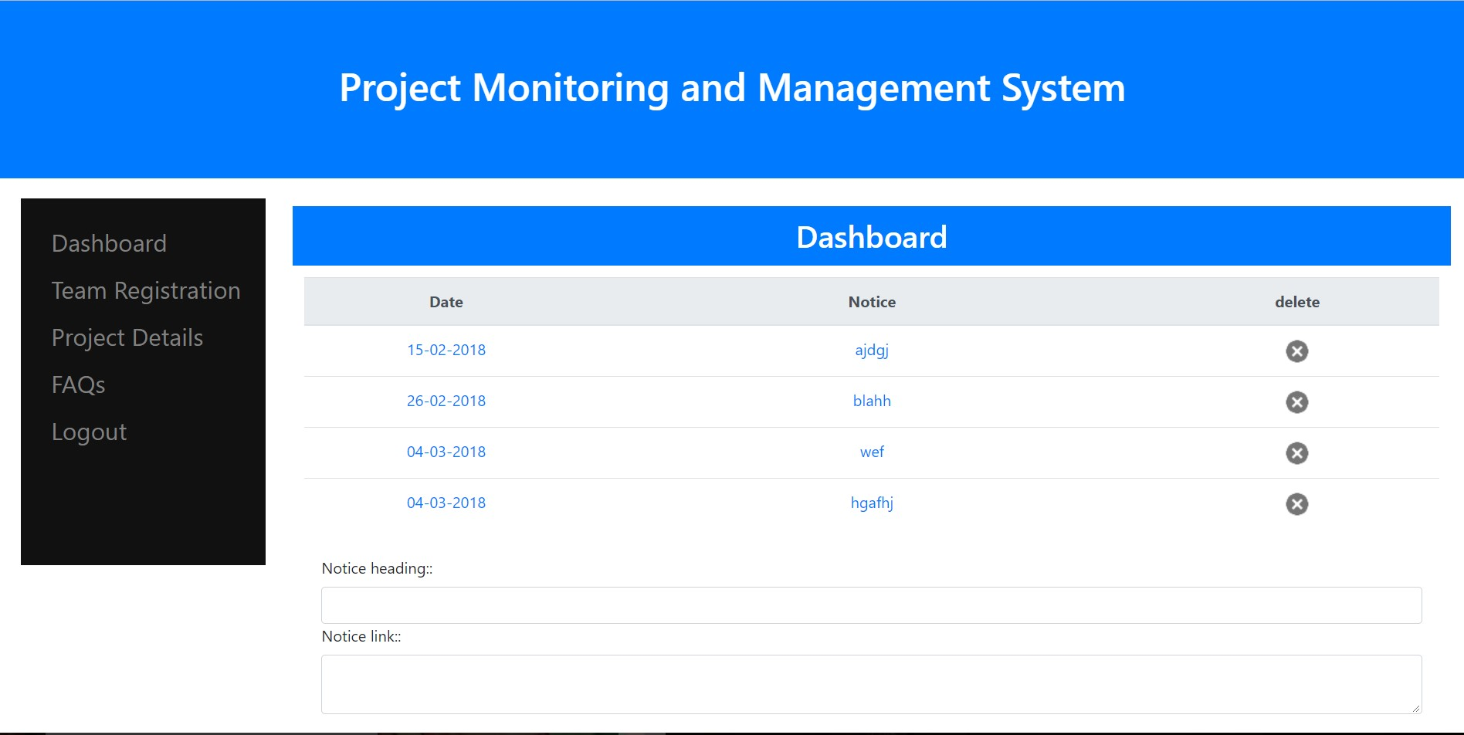

**Figure 3.7 Dashboard page**

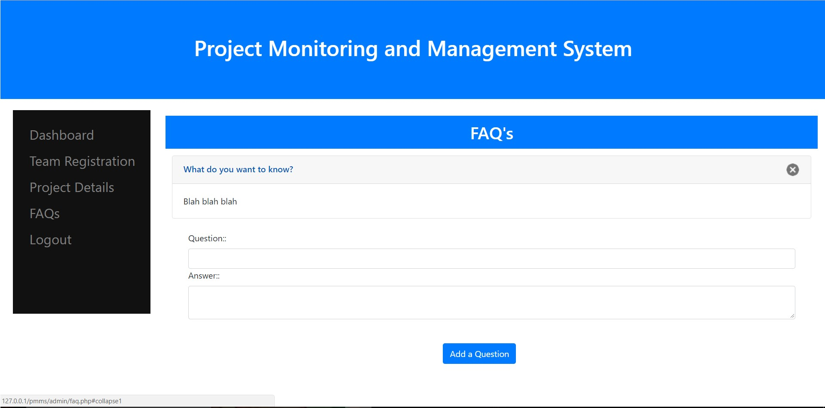

**Figure 3.8 FAQs page**

**4. Project work distribution among team members**

We have opted for pair programming, each member in our team has done equal amount of work. Every member of our team has participated for implementing the modules and generating reports.

**Remarks/Suggestions:**

**Faculty Guide’s Signature:**