**A**

**MINI PROJECT REPORT**

**ON**

**“Project Monitoring**

**And**

**Management System”**

**Submitted by**

**Harshil Shah (15IT069)**

**Jay Patel (16IT603)**

**Prof. Zankhana Shah**

**Faculty Guide**



**Information Technology Department**

**Birla Vishvakarma Mahavidyalaya Engineering College**

**(An Autonomous Institution)**

**A Y: 2017-18, Semester II**



**Birla Vishvakarma Mahavidyalaya Engineering College**

**(An Autonomous Institution)**

**Information Technology Department**

**AY: 2017-18, Semester II**

**CERTIFICATE**

This is to certify that project entitled with **“Project Monitoring and Management System”** has been successfully carried out by **Harshil Shah (15IT069) & Jay Patel (16IT603)** for the subject of **IT341- Mini Project** under my guidance during the academic year 2017-18,Semester II. The Mini Project work carried out by the students of 6th semester is satisfactory.

|  |  |  |
| --- | --- | --- |
| **Date:** |  |  |
| **Prof. Zankhana Shah** | **Prof. Nilesh Prajapati** | **Dr. Keyur Brahmbhatt** |
| IT Department | IT Department | IT Department |
| BVM | BVM | BVM |

**ACKNOWLEDGEMENT**

We have taken efforts in this project. However, it would not have been possible without the kind support and help of many individuals and organizations. I would like to extend my sincere thanks to all of them. I am highly indebted to Prof. Zankhana Shah, Prof. Nilesh Prajapati and Prof. Bijal Dalwadi for their guidance and constant supervision as well as for providing necessary information regarding the project & also for their support in completing the project.

**ABSTRACT**

**“Project Monitoring and Management System”** is a web portal that is used to monitor and manage the projects made by the students of pre-final year and final year. This system mainly takes periodic report from the teams formed by the students as an input and faculty guide keeps the record of the reports which would be helpful in monitoring the project made by the students and accordingly mentor the students. Also the course coordinator manages and tracks the teams.

**INDEX**

**Chapter 1: Introduction**

1.1 Aim of the Project

1.2 Project Scope

1.3 Project Objective

1.4 Project Modules

1.5 Project basic requirements

**Chapter 2: Analysis, Design Methodology and Implementation Strategy**

2.1 Comparison of Existing Applications with your Project

2.2 Project Feasibility Study

2.3 Project Timeline chart

2.4 Detailed Modules Description

2.5 Project SRS

2.5.1 Use Case Diagrams

2.5.2 Data Flow Diagrams

2.5.3 Entity Relationship Diagrams

2.6 Database design and Normalization

2.7 Template Design

**Chapter 3: Implementation and Testing**

3.1 Software and Tools

3.2 User Interface and Snapshot

3.3 Testing using Use Cases

**Chapter 4: Conclusion and Future work**

4.1 Conclusion

4.2 Future work

**References**

**Chapter 1. Introduction**

**1.1 Aim of the Project:**

Web based portal for Project Monitoring and Management System (PMMS).

**1.2 Project Scope:**

This portal will be helpful in monitoring student’s project’s progress periodically. Also it will be helpful to the faculty guide in managing his/her assigned groups progress and approving the task done by the students. Students will get the feedback to the work uploaded quicker and at any time anywhere. Task approval and maintaining student’s reports will be easy and manageable. Student have to give final project presentation physically.

**1.3 Project Objective:**

The objective of the PMMS portal is to develop a system for helping students to get appropriate help and mentoring online and to help them work more systematically on their project.

**1.4 Project Modules:**

* **Dashboard**
* **Team Registration**
* **Project Details**
* **FAQs**

**1.5 Project basic requirements:**

**1.5.1 Hardware Interfaces**

* Server for web hosting
* Database server
* Computer / Laptop / Mobile phone

**1.5.2 Software Interface**

* PHP
* PHPExcel
* HTML
* CSS / Bootstrap
* JavaScript / JQuery
* AJAX
* MySQL
* XAMPP server

**Chapter 2: Analysis, Design Methodology and Implementation Strategy:**

**2.1 Comparison of Existing Applications with your Project:**

In the existing system all the work is done manually and there is lot of information gap between faculty, students and coordinator. There is lot of paperwork to be submitted manually.

While in the project all the work is done online on the portal. Faculty is notified whenever its respective group of students uploads a report and vice-versa. Similarly, for the relationship between coordinator and student.

**2.2 Project Feasibility Study:**

* **Technical feasibility**

It would be feasible to implement the portal on PHP & MySQL for server side scripting and database server and for client side scripting and designing we will use JavaScript and Cascading style sheet libraries like AngularJS and Bootstrap.

* **Economic feasibility**

The expense of building the portal will be less it will just need server for hosting the website and creating database.

* **Operational feasibility**

The operation of the portal will be easy for the both faculty and student as it will increase the efficiency of the project in terms of approving the task and maintaining records.

* **Time feasibility**

The building of portal will be completed within specified time.

**2.3 Project Timeline chart:**

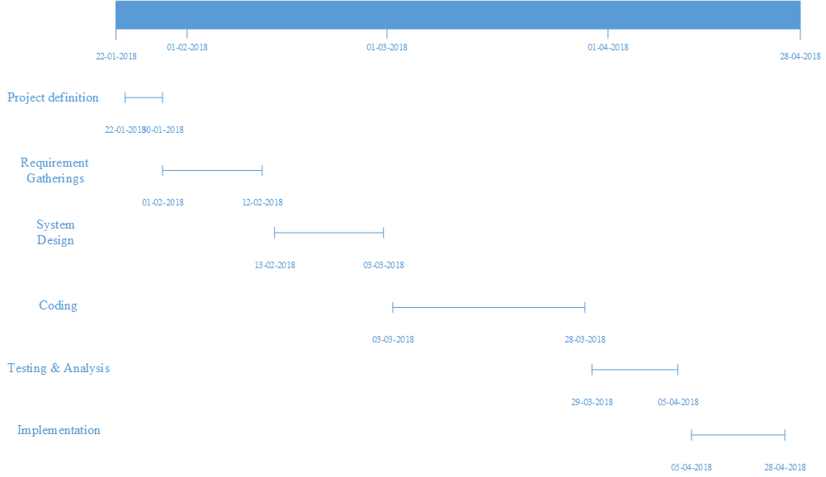

**Figure 2.3.1 Project Timeline chart**

**2.4 Detailed Modules Description:**

There will basically be Four modules:

**2.4.1 Login**

This module will contain three types of user:

* + - 1. **Admin**

Course coordinator will track the groups formed by the students. He/she can monitor the progress of each and every group and also he can add notice on the common dashboard. He / she can retrieve a consolidated report of the student.

* + - 1. **Student**

Student will be given a login id & a password and he/she can login, form a team with faculty guide of his/her choice and upload the document as per requirement and it will be sent to the respective faculty guide and he/she will be notified whether the task is approved or not by the faculty guide.

**2.4.1.3 Faculty**

Faculty will also be given a login id and a password and he / she can view the progress of the groups assigned to him / her. Faculty can also view the uploaded report and approve or reject the report and progress.

**NOTE:** Here both student and faculty will be notified when the student uploads a document or faculty approves a document.

**2.4.2 Project Details**

This module will contain mainly functionalities such as,

* Definition approval
* Periodic report /Term work upload
* Final report upload

Here, there will be comment box, On the faculty side, faculty can comment for the report/work uploaded by the student and approve the work done by student and at the student can view the comments.

Faculty will download the report/work and the student will upload the report/work.

* + 1. **Notifications**

In this module the user will able to view important notification by the admin or other user.

* + 1. **FAQ**

This module will contain Frequently Asked Questions by the students to the faculty guide and also some basic questions.

**2.5 Project SRS:**

**2.5.1 Use Case Diagram**

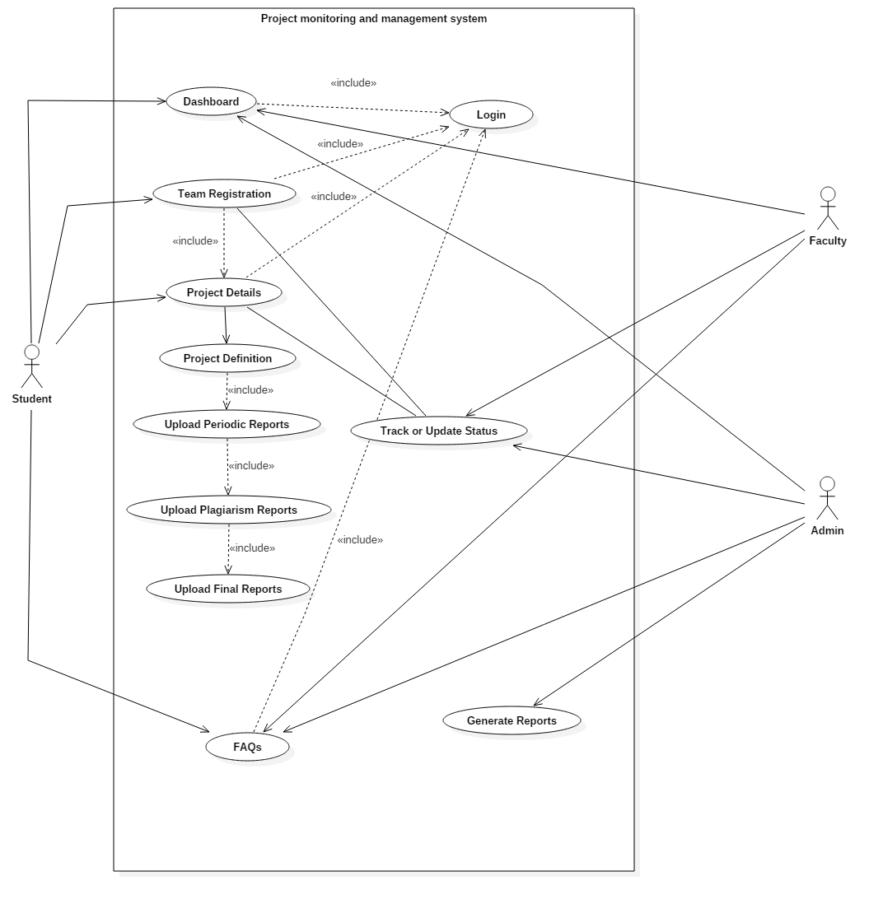

**Figure 2.5.1.1 Use Case Diagram**

**2.5.2 Data Flow Diagrams:**

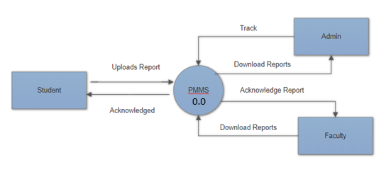

**Figure 2.5.2.1 PMMS Level 0**

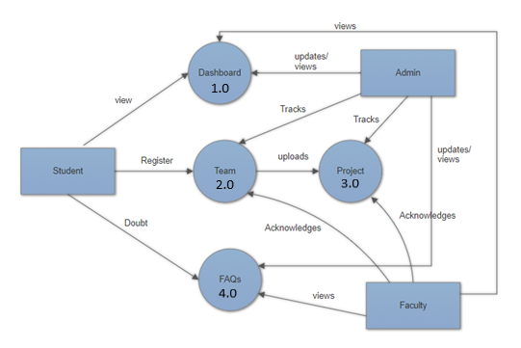

**Figure 2.5.2.2 PMMS Level 1**

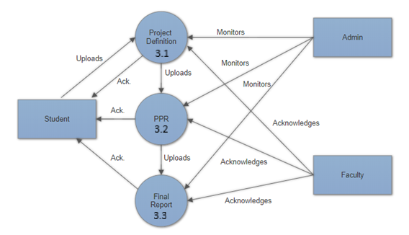

**Figure 2.5.2.3 PMMS Level 2**

**2.5.3 Entity Relationship Diagrams:**



**Figure 2.5.3.1 Entity Relationship Diagrams**

**2.6 Database design and Normalization:**

Table Name: Student

Primary Key:

Description:-It Stores Student information.

|  |  |  |  |  |  |
| --- | --- | --- | --- | --- | --- |
| Sr no | Column name | Data Type | Size | Constraint | Description |
| 1 | ID | Integer | 10 | Primary Key | It identifies a student uniquely |
| 2 | Name | Varchar | 20 | Not Null | Student’s Name |
| 3 | Email | Varchar | 20 | Not Null | Student’s email |
| 4 | Password | Varchar | 10 | Not Null | Students password |

**Table 2.6.1**

Table Name: Faculty

Primary Key: ID

Description: It Stores faculties information.

|  |  |  |  |  |  |
| --- | --- | --- | --- | --- | --- |
| Sr no | Column name | Data Type | Size | Constraint | Description |
| 1 | ID | Integer | 10 | Primary Key | It identifies a faculty uniquely |
| 2 | Name | Varchar | 20 | Not Null | Faculty’s Name |
| 3 | Email | Varchar | 20 | Not Null | Faculty’s email |
| 4 | Password | Integer | 10 | Not Null | Faculty’s password |

**Table 2.6.2**

Table Name: Admin

Primary Key: ID

Description:-It Stores Admin details.

|  |  |  |  |  |  |
| --- | --- | --- | --- | --- | --- |
| Sr no | Column name | Data Type | Size | Constraint | Description |
| 1 | ID | Integer | 10 | Primary Key | It identifies admin uniquely |
| 2 | Email | Varchar | 20 | Not Null | Admin’s Email |
| 3 | Password | Integer | 10 | Not Null | Admin’s password |

**Table 2.6.3**

Table Name: Team

Primary Key: Gid

Description:-It Stores groups information.

|  |  |  |  |  |  |
| --- | --- | --- | --- | --- | --- |
| Sr no | Column name | Data Type | Size | Constraint | Description |
| 1 | Gid | Integer | 10 | Primary Key | It identifies a group uniquely |
| 2 | Guide | Varchar | 10 | Not Null | Faculty’s ID |
| 3 | Leader | Varchar | 10 | Not Null | Leader’s ID |
| 4 | Id_1 | Varchar | 10 | Not Null | Partner’s ID |
| 5 | Id_2 | Integer | 10 | Null | Partner’s ID |

**Table 2.6.4**

Table Name: Project

Primary Key: Gid

Description:-It Stores status related to the group’s report upload.

|  |  |  |  |  |  |
| --- | --- | --- | --- | --- | --- |
| Sr no | Column name | Data Type | Size | Constraint | Description |
| 1 | Gid | Integer | 10 | Primary key | Group’s ID |
| 2 | Project Definition | Boolean | - | Not Null | Project’s Definition |
| 3 | Ppr1 | Boolean | - | Not Null | Status of PPR1 |
| 4 | Ppr2 | Boolean | - | Not Null | Status of PPR2 |
| 5 | Ppr3 | Boolean | - | Not Null | Status of PPR3 |
| 6 | Ppr4 | Boolean | - | Not Null | Status of PPR4 |
| 7 | Plagiarism report | Boolean | - | Not Null | Status of Plagiarism report |
| 8 | Final Report | Boolean | - | Not Null | Status of Final Report. |

**Table 2.6.5**

Table Name: FAQ

Primary Key: ID

Description: It Store FAQs uploaded by the admin.

|  |  |  |  |  |  |
| --- | --- | --- | --- | --- | --- |
| Sr no | Column name | Data Type | Size | Constraint | Description |
| 1 | ID* | Integer | 10 | Primary Key | It identifies a unique FAQ |
| 2 | Heading | Varchar | 20 | Not Null | Question |
| 3 | Context | Varchar | 20 | Not Null | Answer |

**Table 2.6.6**

Table Name: Dashboard

Primary Key: ID

Description: It Store Notice uploaded by the Admin.

|  |  |  |  |  |  |
| --- | --- | --- | --- | --- | --- |
| Sr no | Column name | Data Type | Size | Constraint | Description |
| 1 | ID* | Integer | 10 | Primary Key | It identifies a unique |
| 2 | Heading | Varchar | 20 | Not Null | Notice |
| 3 | Context | Varchar | 20 | Not Null | More information |

**Table 2.6.7**

NOTE: Here ‘*’ means AUTO INCREMENT.

**2.7 Template Design:**

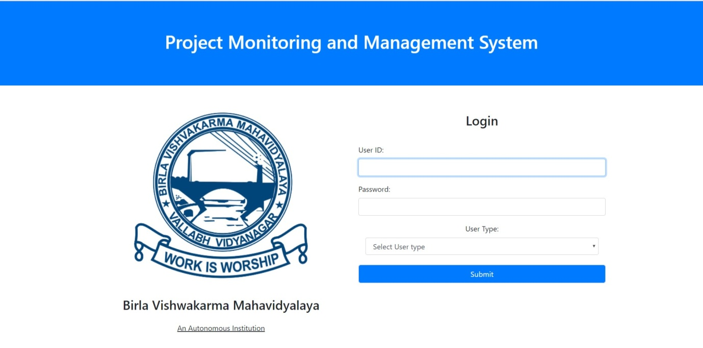

**Figure 2.7.1 Login page**

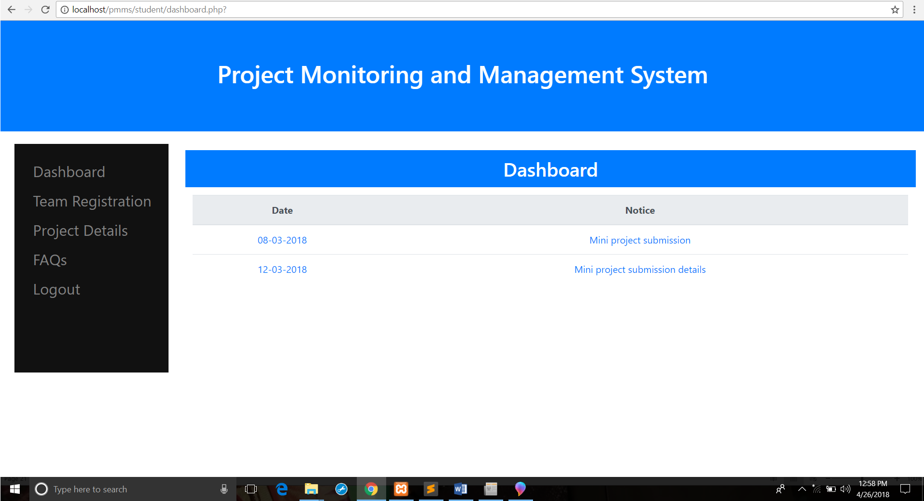

**Figure 2.7.2 Dashboard page**

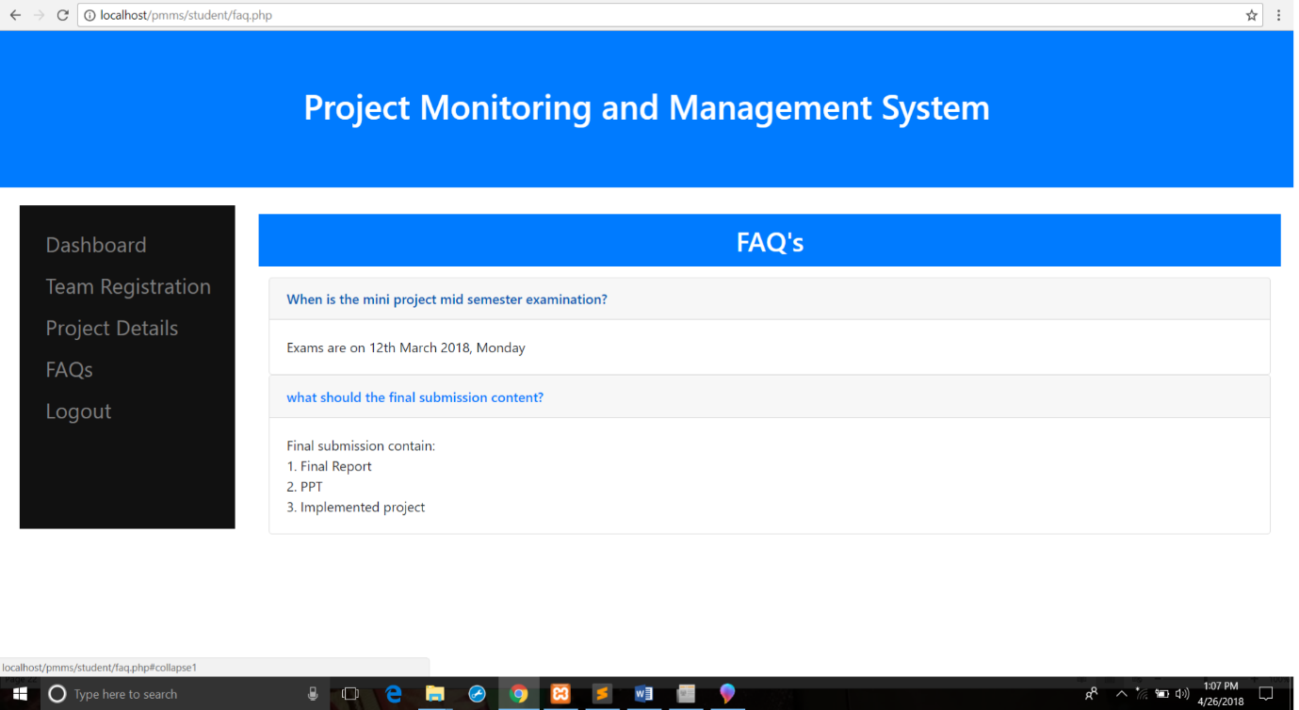

**Figure 2.7.3 FAQs page**

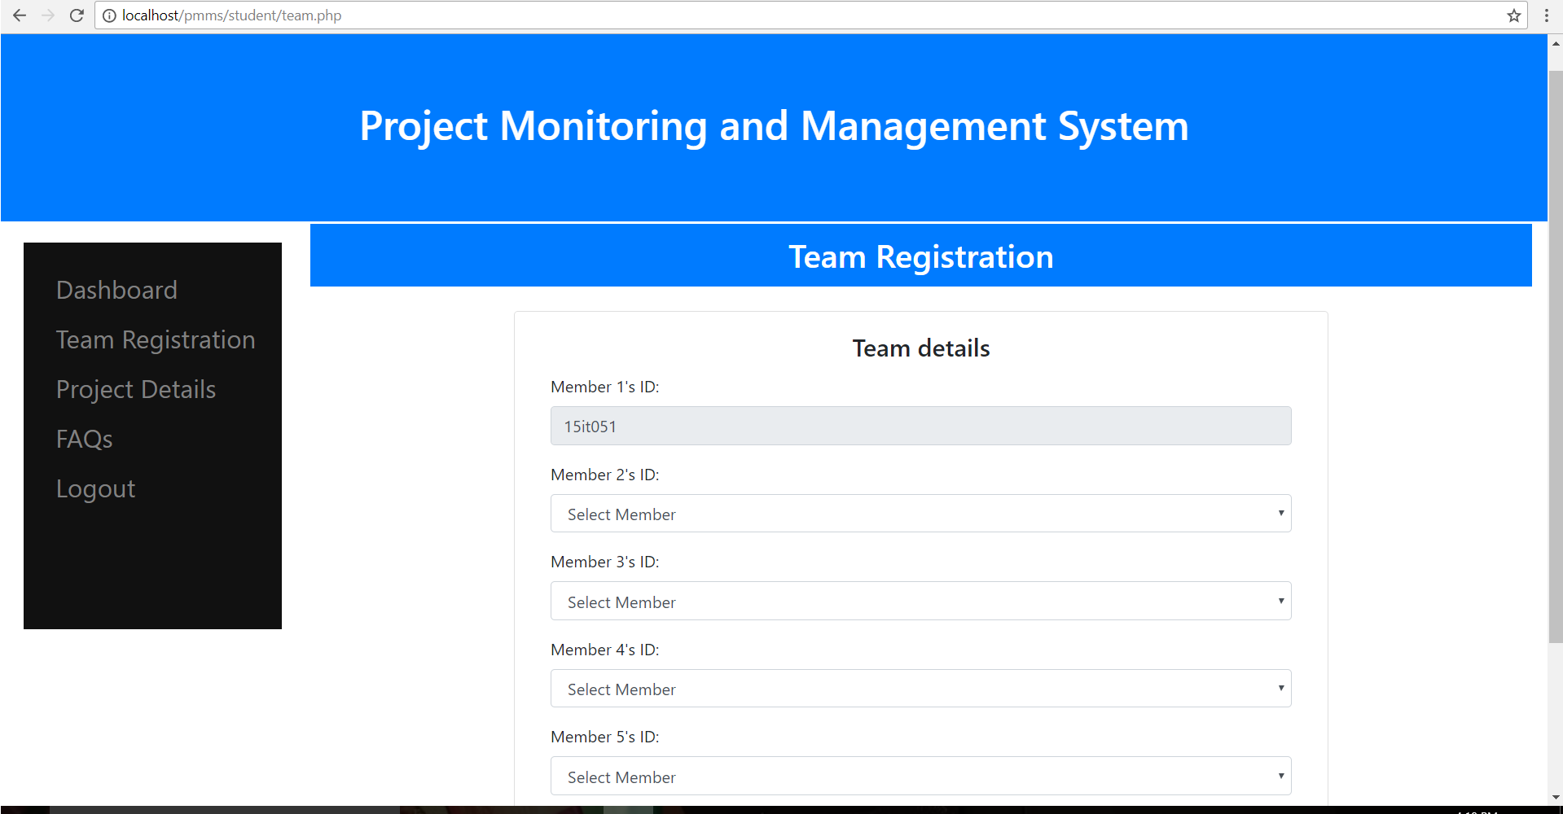

**Figure 2.7.4 Team Registration page**

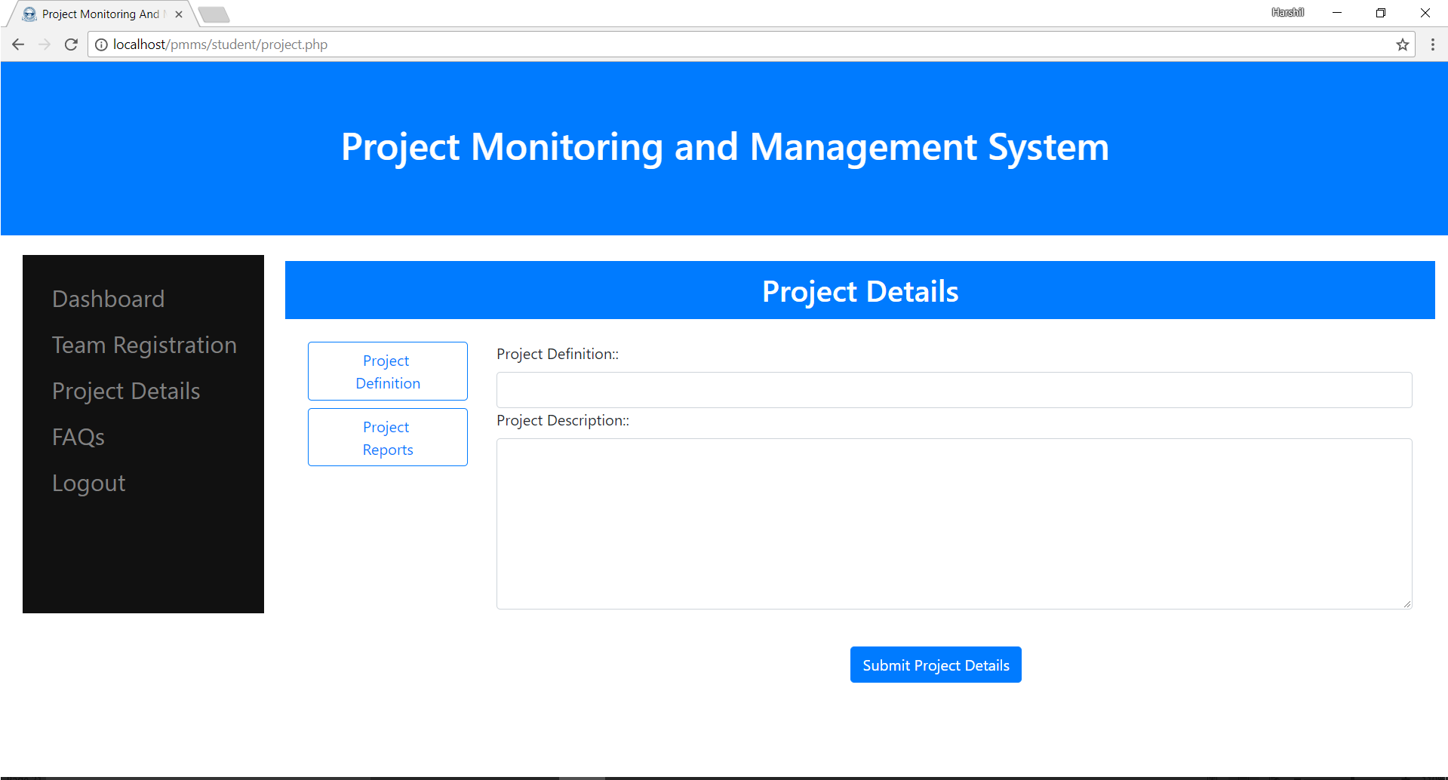

**Figure 2.7.5 Project Definition page**

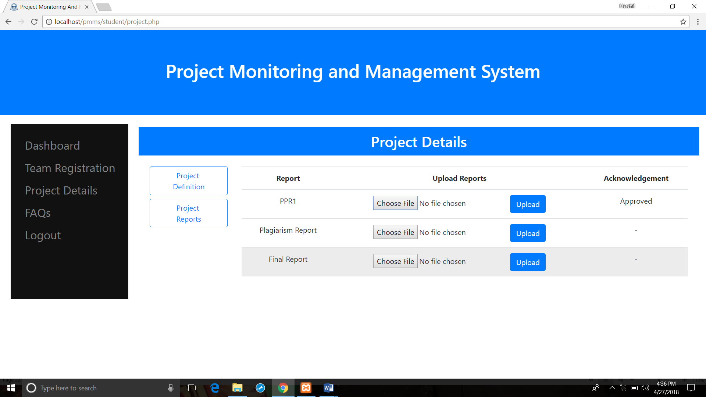

**Figure 2.7.6 Report Upload page**

**Chapter 3: Implementation and Testing**

**3.1 Software and Tools**

**3.1.1 Hardware Interface**

* Server for web hosting
* Database server
* Computer / Laptop / Mobile phone

**3.1.2 Software Interface**

* PHP
* HTML
* CSS / Bootstrap
* JavaScript / JQuery
* AJAX
* MySQL
* XAMPP server

**3.2 User Interface and Snapshot**

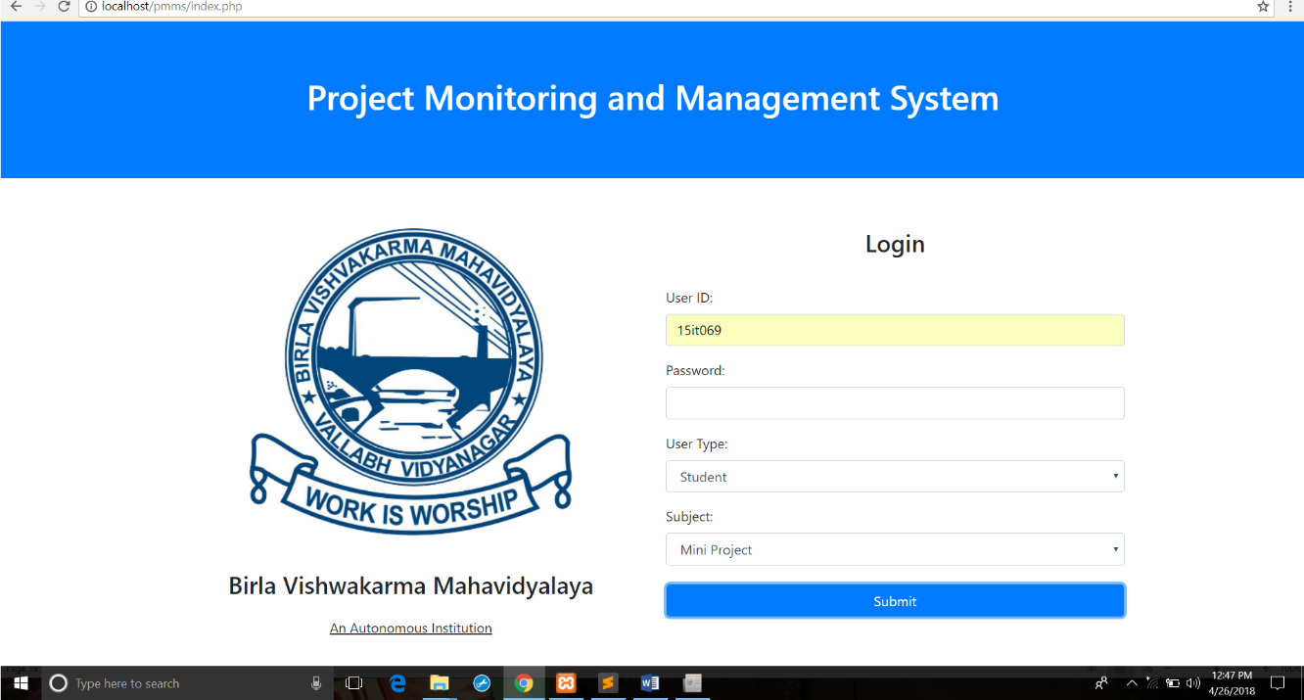

**Figure 3.2.1 student login**

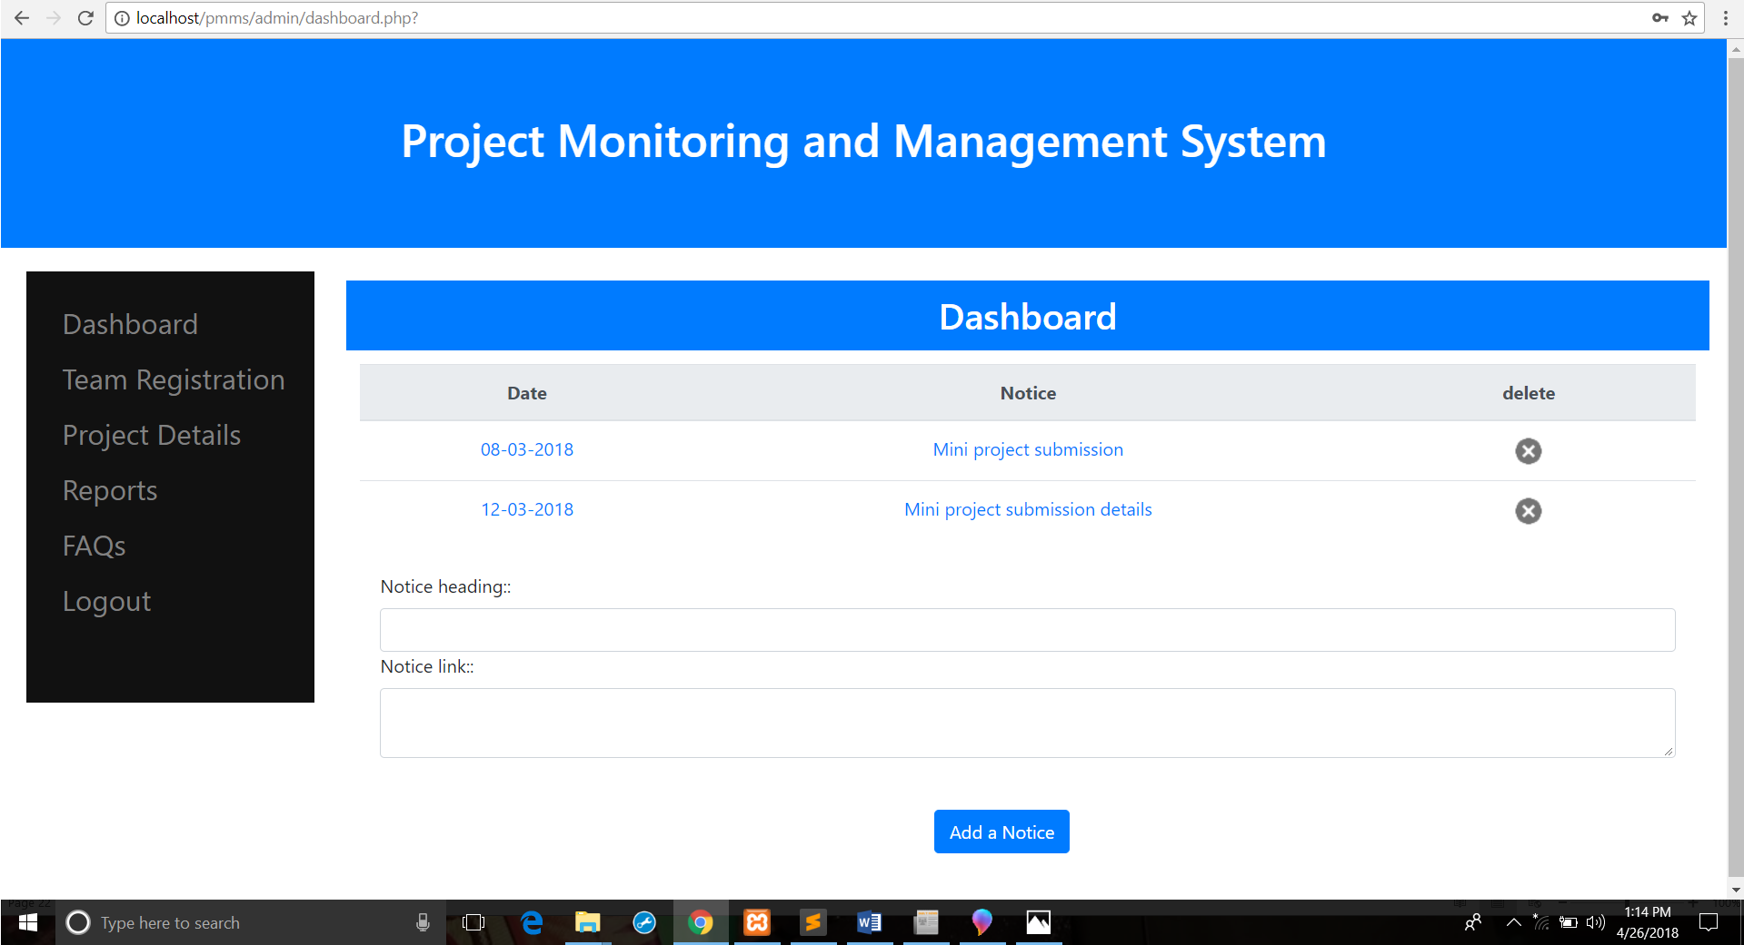

**Figure 3.2.2 Dashboard page**

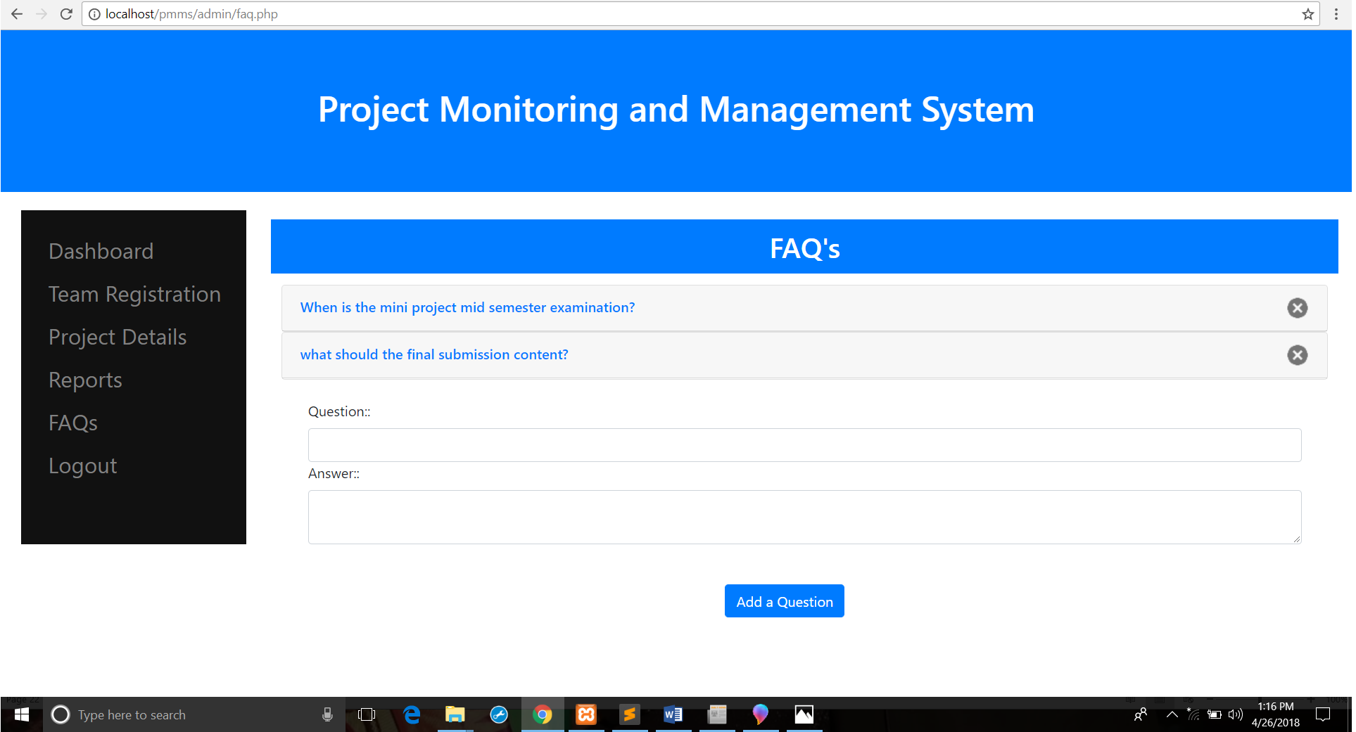

**Figure 3.2.3 FAQs page**

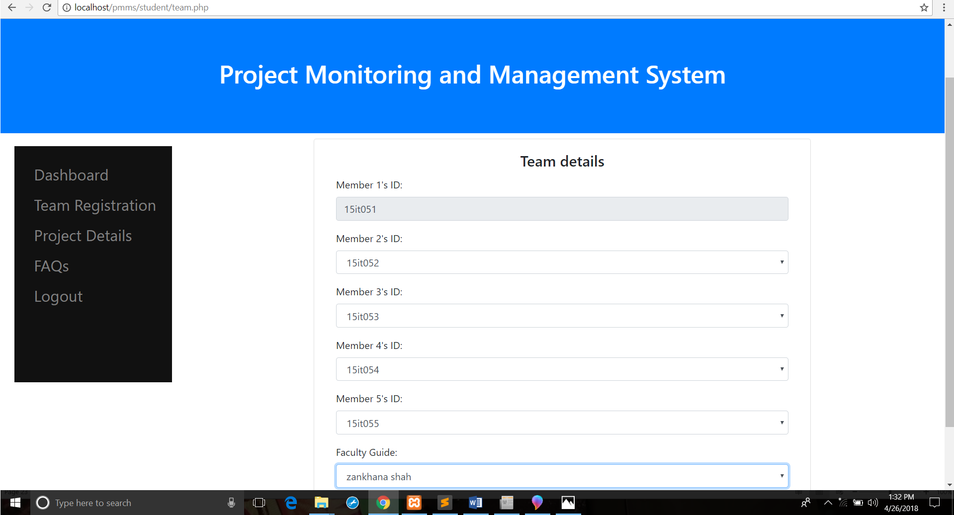

**Figure 3.2.4 Team registration page**

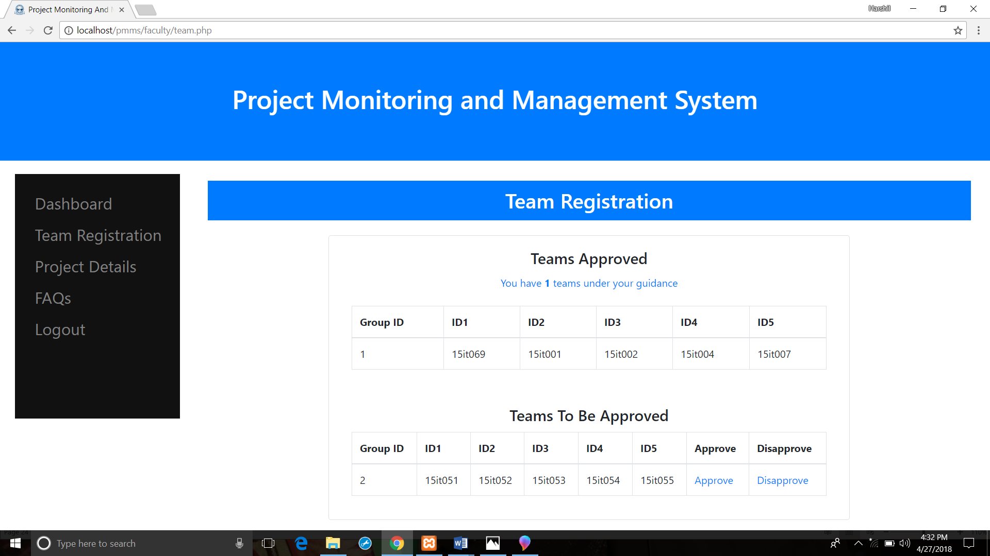

**Figure 3.2.5 Team Approval page**

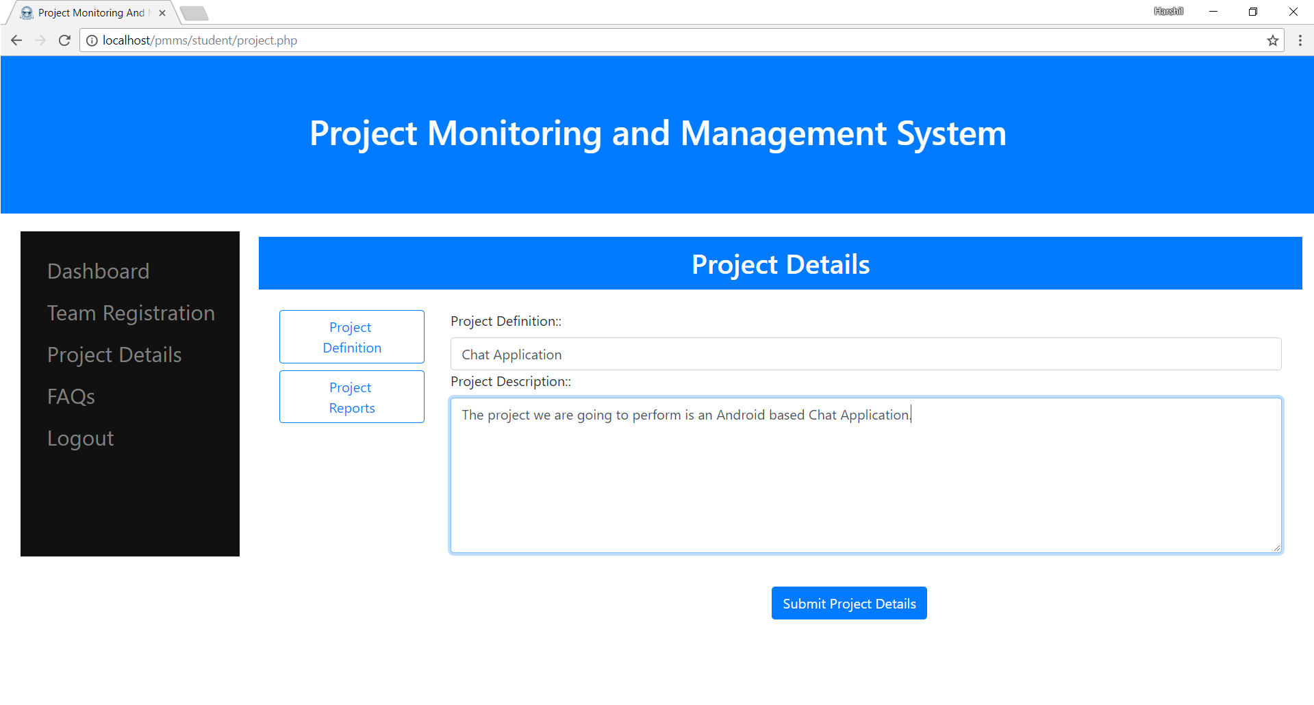

**Figure 3.2.6 Project Definition page**

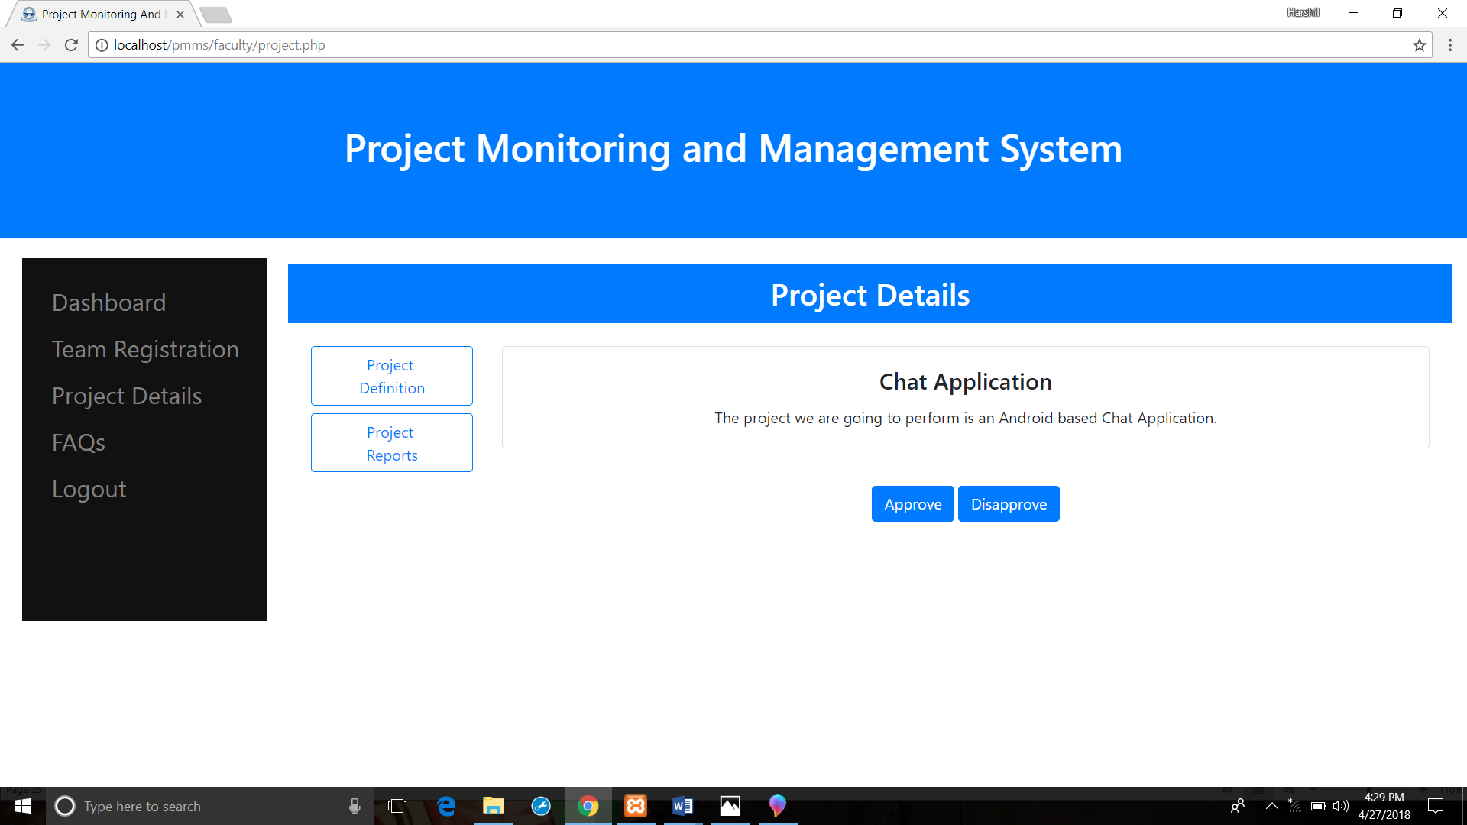

**Figure 3.2.7 Project Definition Approval page**



**Figure 3.2.8 Report Upload page**

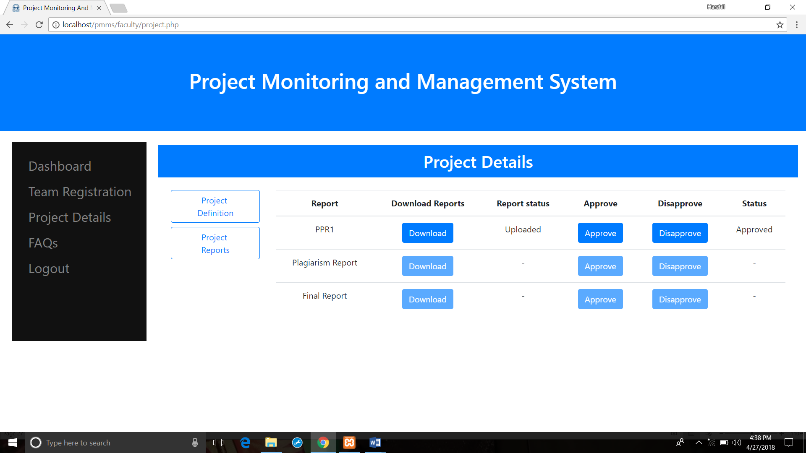

**Figure 3.2.9 Report Approval page**

**3.3 Testing using Use Cases**

|  |  |  |  |  |  |
| --- | --- | --- | --- | --- | --- |
| **Test case ID** | **Test Scenario** | **Test Steps** | **Test Data** | **Expected Results** | **Actual Results** |
| TU01 | Check student login with valid input for a subject | 1. Go to index.php  2. Enter User id  3. Enter Password  4. Select User Type  5. Select Subject | UserId = 15IT069  Password =  “”  User Type = student  Subject = Mini project | Student should login into the portal | As expected |
| TU02 | Check student login with invalid input for subject | 1. Go to index.php  2. Enter User id  3. Enter Password  4. Select User Type  5. Select Subject | UserId = 15IT069  Password =  “12”  User Type = student  Subject = Mini project | Student should not login into the portal | As expected |
| TU03 | Check faculty login with valid input for suject | 1. Go to index.php  2. Enter User id  3. Enter Password  4. Select User Type  5. Select Subject | UserId = pks  Password =  “pks”  User Type = faculty  Subject = Mini project | Student should login into the portal | As expected |
| TU04 | Check faculty login with invalid input for subject | 1. Go to index.php  2. Enter User id  3. Enter Password  4. Select User Type  5. Select Subject | UserId = pks  Password =  “pks1”  User Type = faculty  Subject = Mini project | Student should not login into the portal | As expected |
| TU05 | Check admin login with valid input for subject | 1. Go to index.php  2. Enter User id  3. Enter Password  4. Select User Type  5. Select Subject | UserId = admin_mini  Password =  “admin”  User Type = admin  Subject = Mini project | Student should login into the portal | As expected |

|  |  |  |  |  |  |
| --- | --- | --- | --- | --- | --- |
| **Test Case Id** | **Test Scenarios** | **Test Steps** | **Test Data** | **Expected Resuts** | **Actual Results** |
| TU06 | Check admin login with invalid input for subject | 1. Go to index.php  2. Enter User id  3. Enter Password  4. Select User Type  5. Select Subject | UserId = admin_mini  Password =  “pks”  User Type = admin  Subject = Mini project | Student should not login into the portal | As expected |

**­­­­­­­­­­­­­­­­­­­­­­­­­­­­­**

**Chapter 4: Conclusion and Future work**

**4.1 Conclusion:**

Thus We have created a web portal for Project Monitoring and Management System (PMMS) with functionality such as to team registration, report tracking, project monitoring, etc.

**4.2 Future work:**

* Faculty can send a request to the course coordinator to change the member of team on student’s request for eligible reason and course coordinator can change the student id requested in the team specified by faculty guide.
* To make the system more dynamic by dividing the system based on department.

Presently, the system cannot differentiate between the student of other branches.

It is limited to single branch/department.

Eg: IT student and ME student can form a team and select faculty from another department.

* Make the web portal Mobile-Friendly.

**References:**

* [www.w3school.com](http://www.w3school.com)
* [www.stackoverflow.com](http://www.stackoverflow.com)
* [www.javatpoint.com](http://www.javatpoint.com)
* [www.tutorialspoint.com](http://www.tutorialspoint.com)