# 

# 

# Assignment 2a

### Course: CS4610

### Name: Han Song

### Pawprint: hs267

### Student ID:14253499

# 

# 

# 

# 

# 

# 

# 

# 

# 

# Report of Assignment 2a

Part A:

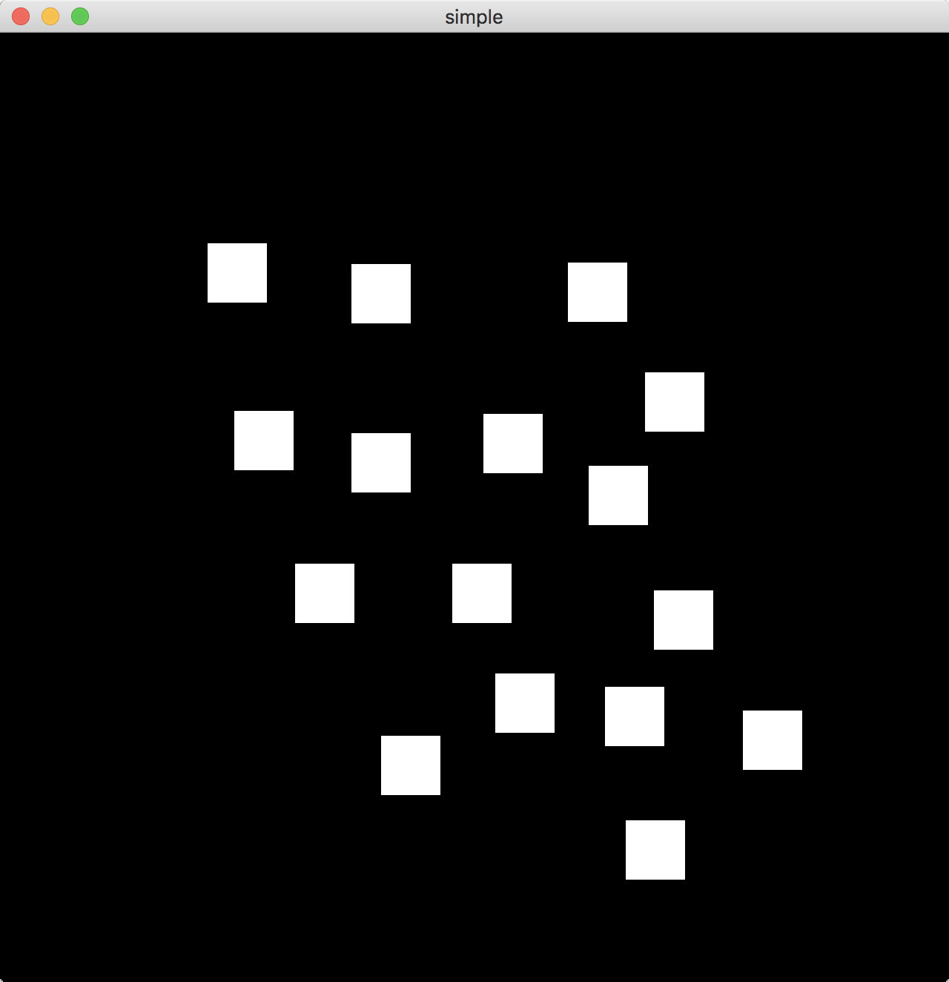

This is to run the DrawSquare file provided on the website. The final result is to get the square by click the screen.

Part B:

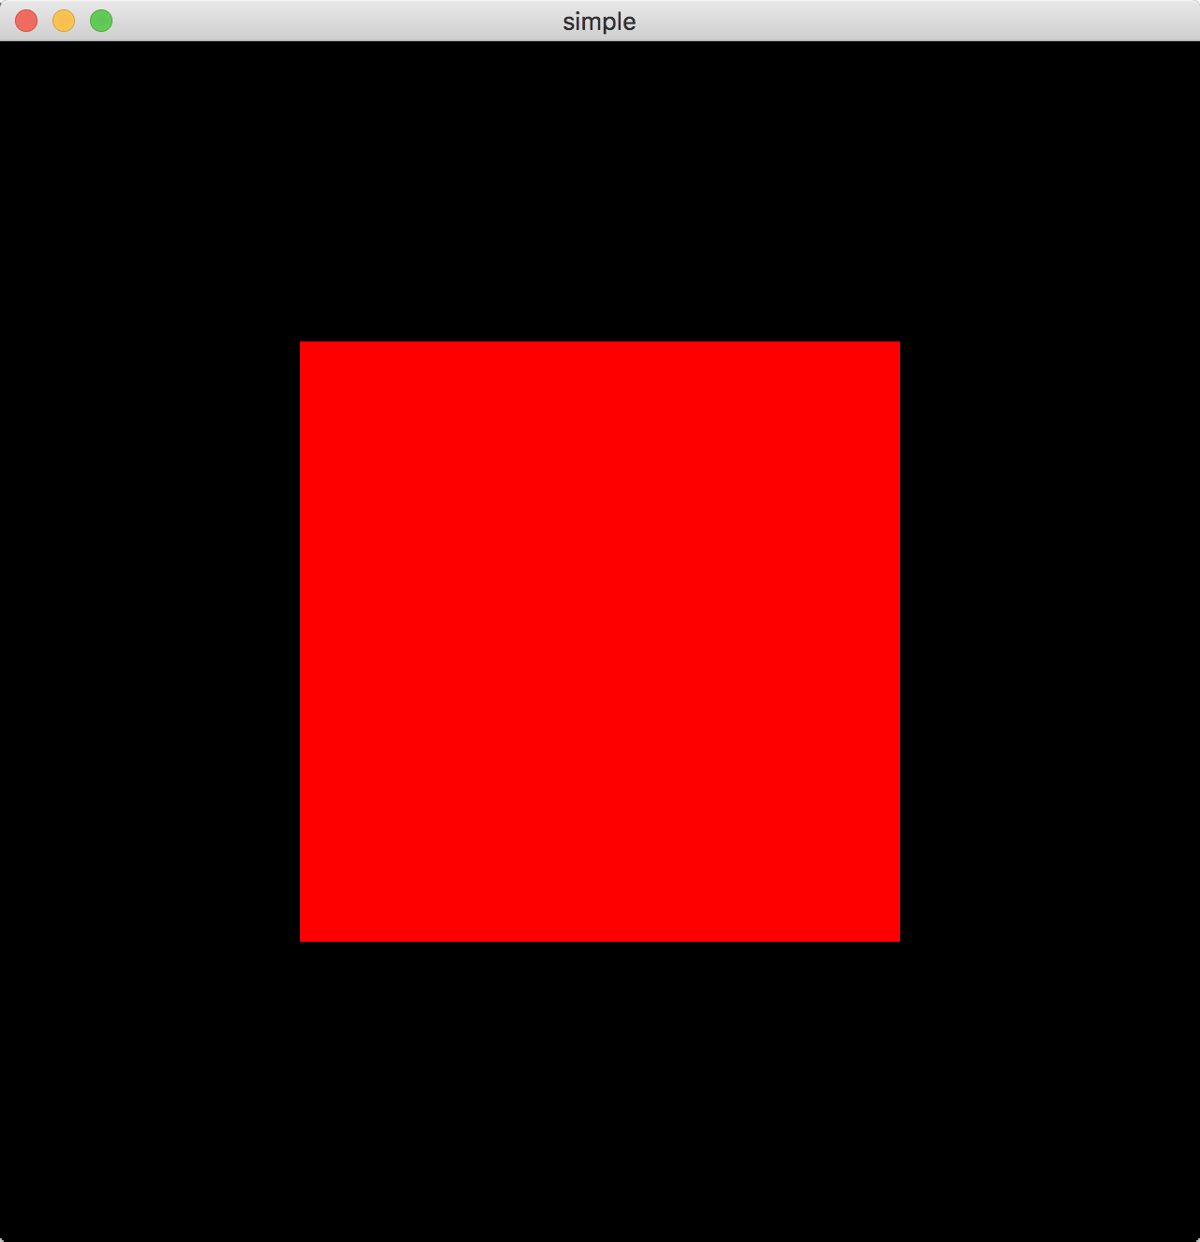

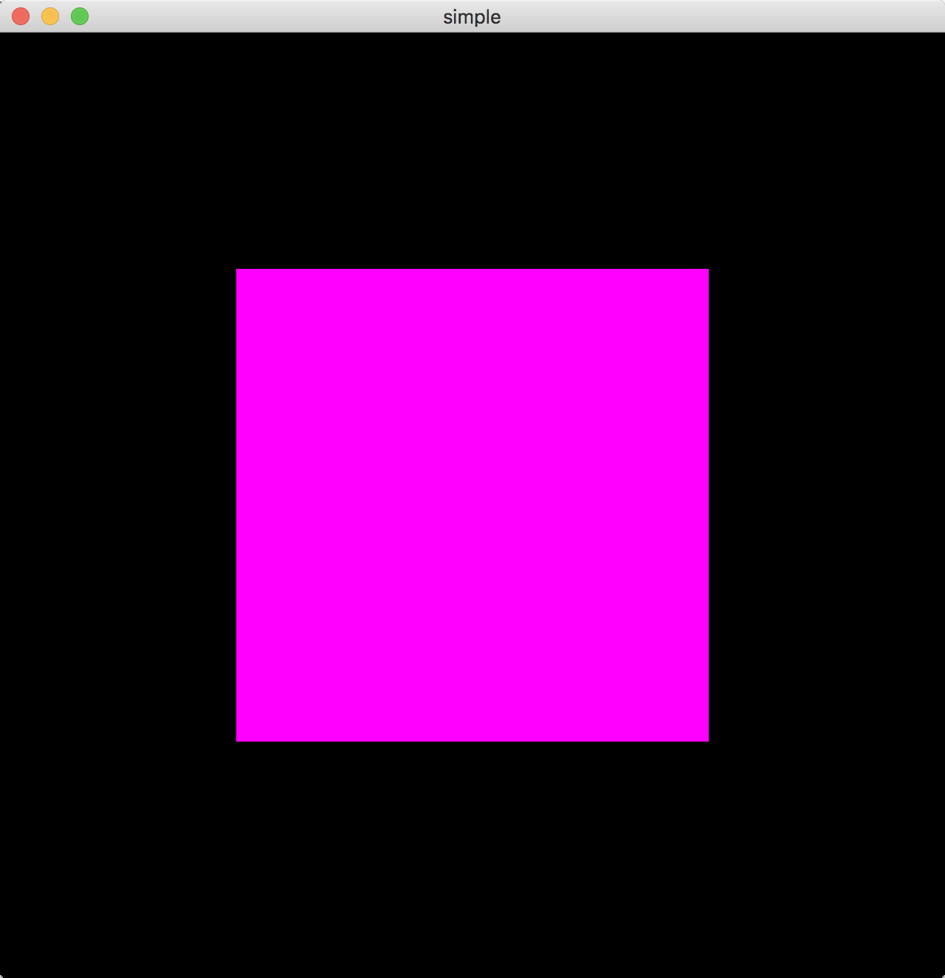

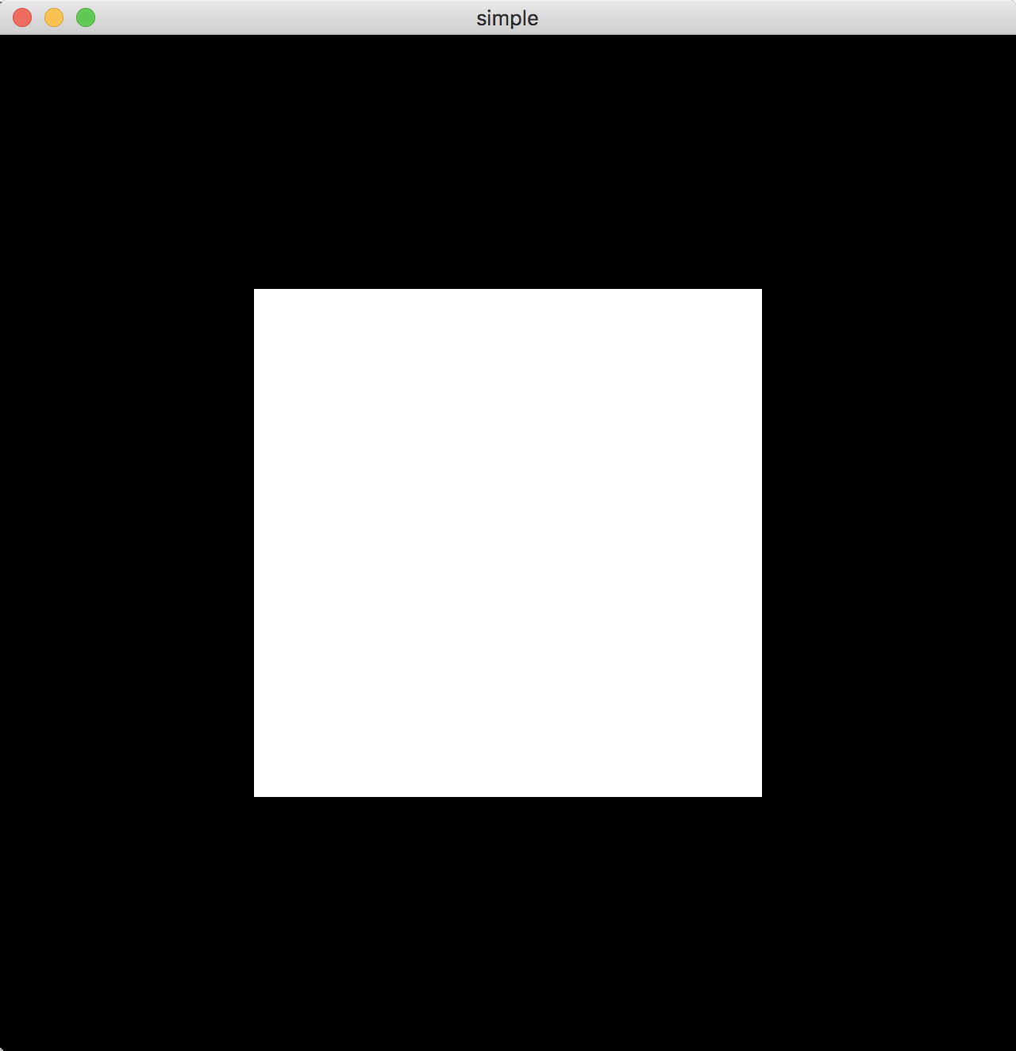

Click the keys on the keyboard to change the color of the cube.

Right click the screen to exit the program.

Method:

void myKeyboard(GLFWwindow* window, int button, int scancode, int action, int mods){

if (action == GLFW_PRESS) switch (button){

case GLFW_KEY_LEFT:{

glUseProgram(shader_programme);

if(color > 0)

color = color-1;

else

color += 8;

vec4 left = vertex_colors[color%8];

glUniform4fv(vertexColorLocation, 1, left);

break;

}

case GLFW_KEY_RIGHT:{

glUseProgram(shader_programme);

color = color+1;

vec4 right = vertex_colors[color%8];

glUniform4fv(vertexColorLocation, 1, right);

break;

}

}

}

void myMouse(GLFWwindow* window, int button, int action, int mods){

if (action == GLFW_PRESS && button == GLFW_MOUSE_BUTTON_RIGHT){

glfwSetWindowShouldClose(window, GL_TRUE);

}

}