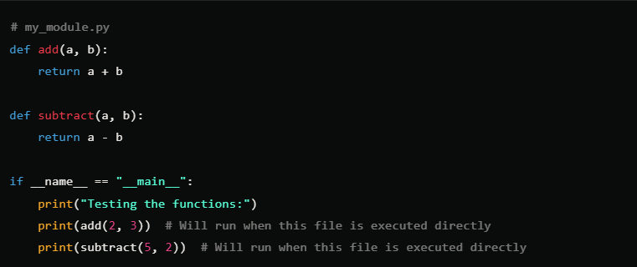

Now, if you import my_module.py into another script, the tests won't run:

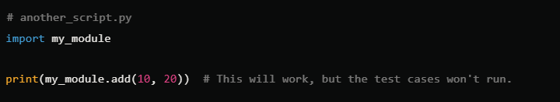

This way, you can avoid executing the testing block when you're importing the module into other scripts, making your code more modular and reusable.

What exactly--🡪 if __name__ == __main__ is ?

