INTERNSHIP PROJECT REPORT
STUDENT PERFORMANCE ANALYSIS AND
PREDICTION USING DATA ANALYTICS
AND MACHINE LEARNING
Submitted as part of the IBM SkillsBuild Data Analytics with AI
Academic Internship Program conducted by BharatCares in association with AICTE
SUBMITTED BY
Hemant Sharma
Father’s Name: Ashok
Roll Number: 24202855
Enrollment Number: 23/133726
SUBMITTED TO
Govt. P.G. College, Dholpur
Maharaja Surajmal Brij University
Academic Session: ____________________
Project Mentor: ____________________

CERTIFICATE
This is to certify that the project report entitled “Student Performance Analysis and Prediction Using Data Analytics and Machine Learning” has been prepared by Hemant Sharma (Roll Number: 24202855; Enrollment Number: 23/133726), a student of Govt. P.G. College, Dholpur, under Maharaja Surajmal Brij University, as an academic project associated with the IBM SkillsBuild Data Analytics with AI Academic Internship Program conducted by BharatCares in association with AICTE.
The report presents a structured demonstration of data preparation, exploratory analysis, visualization, regression modelling, model evaluation and responsible interpretation. The dataset used in the included demonstration is synthetic. The report is submitted for academic review, subject to verification and approval by the designated project mentor and institution.
The project has been prepared for educational purposes. Any institutional certification, approval, date or signature should be completed only by the authorized mentor or college official.
Project Mentor: ______________________________
Department / Institution: _____________________
Signature: __________________________________
Date: ______________________________________

DECLARATION
I, Hemant Sharma, hereby declare that this report titled “Student Performance Analysis and Prediction Using Data Analytics and Machine Learning” has been compiled for academic learning and project submission. The descriptions of the workflow, analysis and code are provided to explain the methods used in the demonstration.
I acknowledge that the included dataset is synthetic and was created for learning and reproducibility; it was not collected from the students or records of Govt. P.G. College, Dholpur or any other institution. Numerical findings in this report therefore describe only this artificial dataset and must not be represented as findings about real students.
References to software libraries and learning resources are listed at the end of this report. Any future change to a real-data version of the project should clearly identify the source, confirm appropriate permission, protect privacy and re-run the analysis rather than reusing the demonstration metrics.
Student Name: Hemant Sharma
Roll Number: 24202855
Enrollment Number: 23/133726
Signature: ____________________________ Date: __________________

ACKNOWLEDGEMENT
I express my sincere gratitude to the organizers and learning resources of the IBM SkillsBuild Data Analytics with AI Academic Internship Program, conducted by BharatCares in association with AICTE, for providing an opportunity to strengthen my understanding of data analytics and introductory machine learning.
I am thankful to Maharaja Surajmal Brij University and Govt. P.G. College, Dholpur, for the academic environment in which this project is being submitted. I also acknowledge the guidance that a project mentor and faculty members provide in helping students connect theoretical concepts with practical problem-solving. The mentor name has been left blank for completion by the institution.
I acknowledge the open-source Python ecosystem, including pandas, NumPy, scikit-learn, Matplotlib and Jupyter, which makes data cleaning, exploratory analysis, model building and reproducible experimentation accessible to students.
Finally, I thank my family, including my father, Ashok, for their encouragement and support during my studies. This report represents an educational exercise and an effort to develop careful, ethical and evidence-aware analytical habits.
Hemant Sharma

ABSTRACT
This project demonstrates how data analytics and introductory machine learning can be used to examine relationships among learning-related indicators and estimate a numerical final score. It is designed to help a student practise a complete analytical workflow: defining the question, understanding a dataset, validating data quality, computing descriptive statistics, visualizing patterns, encoding categorical features, splitting data into training and test sets, training regression models and evaluating their predictions.
The project uses a synthetic dataset of 600 records. Fields include attendance percentage, study hours per day, assignment completion, previous score, sleep hours, internet access, extracurricular hours, parental support and final score. Synthetic data was chosen so the exercise is reproducible and does not expose real students’ personal or academic records. It is also an important limitation: the patterns are generated for demonstration and are not evidence about any real school, college or population.
Two regression methods are compared: Linear Regression and Random Forest Regression. On a fixed 80/20 train-test split (random state 42), the model with the lower RMSE is Linear Regression. Its test-set MAE is 5.05 score points, RMSE is 6.47 points, and R-squared is 0.546. These metrics are descriptive of this synthetic benchmark only. They do not establish that the model will work on real data.
The report concludes that a reproducible analysis can support structured exploration, but model outputs must be interpreted cautiously. Correlation and feature importance do not imply causation. Real-world use would require permission to use data, privacy protections, representative sampling, fairness evaluation, domain oversight, monitoring and human review. The project is intended for learning rather than for ranking or making consequential decisions about students.
Keywords: Data Analytics, Exploratory Data Analysis, Python, Machine Learning, Regression, Student Performance, Model Evaluation, Responsible AI.

TABLE OF CONTENTS
Section | Title | Page
1 | Introduction | 8
2 | Background and Literature Review | 9
3 | Problem Statement, Aim and Objectives | 10
4 | Scope, Significance and Limitations | 11
5 | Tools and Technologies | 12
6 | Dataset Description and Data Dictionary | 13
7 | Methodology and Workflow | 14
8 | Data Quality and Preprocessing | 15
9 | Exploratory Data Analysis | 16
10 | Model Development | 18
11 | Evaluation and Results | 19
12 | Discussion and Interpretation | 21
13 | Ethical, Privacy and Responsible AI Considerations | 22
14 | Conclusion and Recommendations | 23
15 | Future Scope | 24
16 | Learning Outcomes | 25
17 | References | 27
Appendix A | Project execution guide | 28
Appendix B | Sample code and supplementary details | 29

Note: Page numbers may change if this report is edited or rendered in a different version of Microsoft Word or LibreOffice. Use the heading structure and navigation pane to locate sections.

LIST OF TABLES AND FIGURES

Tables
- Table 1. Project overview
- Table 2. Dataset fields and meanings
- Table 3. Tools and their functions
- Table 4. Data validation checklist
- Table 5. Model evaluation metrics
- Table 6. Strengths and limitations
- Table 7. Suggested future improvements

Figures
- Figure 1. Overall analytical workflow
- Figure 2. Distribution of final scores
- Figure 3. Study time and final score
- Figure 4. Actual versus predicted scores
- Figure 5. Top predictive features of the selected model
All graphs in this project are generated from the included synthetic dataset. They are illustrative visual summaries and should not be interpreted as findings about real students.

CHAPTER 1: INTRODUCTION

1.1 Introduction to Data Analytics
Data analytics is the systematic process of collecting, checking, organizing, exploring and interpreting data to answer questions. It combines domain understanding with statistical reasoning, visualization and computing. An analysis is most useful when the question is clear, the data is appropriate, the methods are reproducible, and the limitations are communicated honestly.
In education, data may describe attendance, assignment completion, study time, prior assessment performance and other learning conditions. Descriptive analytics can summarize these indicators and display patterns that deserve further investigation. Predictive modelling goes a step further by estimating an outcome from available inputs. A prediction, however, is not a fact and should not replace the judgment of teachers, learners or qualified professionals.

1.2 Project overview
This project is a compact end-to-end data analytics exercise. It demonstrates descriptive summaries, basic data validation, visual exploration and two regression approaches. The target is a numerical final score on a 0–100 scale. Inputs are selected as plausible educational indicators for demonstration, but their relationships are simulated. No real student records are used.
Item | Description
Project title | Student Performance Analysis and Prediction Using Data Analytics and Machine Learning
Student | Hemant Sharma
Father’s name | Ashok
Roll number | 24202855
Enrollment number | 23/133726
College | Govt. P.G. College, Dholpur
University | Maharaja Surajmal Brij University
Program context | IBM SkillsBuild Data Analytics with AI Academic Internship Program
Dataset | 600 synthetic records; 9 analytical attributes plus ID and target
Primary task | Estimate a numeric final score and compare models

1.3 Why this project matters
The project provides a safe environment for practising core analytics skills before working with sensitive real-world records. It also emphasizes that sound analysis requires more than code: the dataset’s origin, assumptions, evaluation design, uncertainty and intended use are equally important.

CHAPTER 2: BACKGROUND AND LITERATURE REVIEW

2.1 Descriptive and exploratory analytics
Descriptive analytics summarizes what is present in a dataset through counts, averages, medians, ranges and visual summaries. Exploratory Data Analysis (EDA) builds on those summaries to reveal unusual values, distributions, possible associations and questions that merit verification. EDA is not a final causal explanation; it is a disciplined way to understand data before modelling.

2.2 Regression as a prediction technique
Regression estimates a continuous outcome from one or more input variables. Linear Regression provides a transparent baseline and assumes a linear relationship between predictors and the expected outcome, conditional on the model. Random Forest Regression combines many decision trees and can capture nonlinear patterns and interactions. The more complex method is not automatically superior; both should be evaluated on held-out data and compared against appropriate baselines.

2.3 Model evaluation
Mean Absolute Error (MAE) is the average absolute difference between observed and predicted values. Root Mean Squared Error (RMSE) squares the errors before averaging and taking a square root, so larger errors receive greater weight. R-squared compares the model against a mean-only baseline on the test data. No single score proves suitability: metrics should be paired with residual inspection, context and validation on data representative of the intended use.

2.4 Responsible interpretation
Educational outcomes are influenced by many complex factors, some unmeasured and some outside a learner’s control. Using data to label or rank students may amplify existing disadvantage, especially if records are incomplete, biased or collected without a legitimate purpose. A model built on synthetic data is useful as a programming demonstration but cannot justify educational policy or action.

2.5 Review summary
The methods selected in this report reflect common introductory practices in the Python analytics ecosystem: tabular processing with pandas, numerical operations with NumPy, plots with Matplotlib, and model training and evaluation with scikit-learn. Official documentation for these tools is listed in the References section and should be consulted when adapting the project.

CHAPTER 3: PROBLEM STATEMENT, AIM AND OBJECTIVES

3.1 Problem statement
Learners beginning data analytics need a practical, reproducible example that demonstrates how structured indicators can be examined and used in a prediction workflow. The project addresses this learning need by creating a synthetic dataset and applying a transparent process to summarize the data, visualize relationships and compare regression models.

3.2 Aim
The main aim is to demonstrate an end-to-end data analytics and introductory machine learning workflow for a synthetic student-performance dataset, while communicating the limits of model-based conclusions.

3.3 Objectives
- Describe the structure, variables and intended meaning of the dataset.
- Check data types, missing values, duplicate rows and plausible value ranges.
- Use summary statistics and charts to explore score distributions and relationships.
- Prepare modelling features through categorical encoding and a fixed train-test split.
- Fit and compare Linear Regression and Random Forest Regression.
- Report MAE, RMSE and R-squared transparently.
- Explain why synthetic results cannot be generalized to real student populations.
- Document reproducibility steps, references and responsible-use safeguards.

3.4 Research questions
- What does the synthetic dataset contain, and does it pass basic structural checks?
- How are synthetic scores distributed across the generated records?
- What pattern is visible between study hours and final score?
- Which of the two selected regressors yields the lower test-set RMSE?
- What limitations must be addressed before any application to real data?

3.5 Expected outputs
Expected outputs are a cleaned and documented example dataset, a runnable Jupyter notebook, visualizations, a comparison of two baseline models, a written discussion of results, and a README file describing how to run the project. The deliverables are intended to be easy for a reviewer to inspect and reproduce.

CHAPTER 4: SCOPE, SIGNIFICANCE AND LIMITATIONS

4.1 Scope
The project covers basic data quality checks, descriptive statistics, visual exploration, simple preprocessing, supervised regression and metric-based comparison. It focuses on one numerical target and a small set of accessible predictors. The included workflow runs locally in Python using commonly used open-source libraries.

4.2 Significance
The exercise illustrates the value of a repeatable sequence of steps. It gives the student an opportunity to connect programming with data interpretation, produce understandable charts, compare modelling approaches and present the results in an academic report. It also models good documentation by including a data dictionary, requirements list and explicit limitations.

4.3 Project boundaries
The project does not perform a real-world evaluation of student performance, does not identify causes of achievement, and does not provide an educational intervention. The generated records are not drawn from the university, college, internship organizer or a public educational dataset. The model metrics are therefore not externally validated evidence.

4.4 Limitations
- Synthetic data generation may encode patterns that differ from real educational settings.
- Only a limited number of features are included; important contextual variables are unobserved.
- The 80/20 holdout split measures performance on one sample split and may vary on another split.
- Hyperparameters are instructional choices and have not been exhaustively tuned.
- There is no independent external dataset, temporal validation or fairness audit.
- Feature importance and correlation do not establish causal influence.
- No confidence interval or prediction interval is included in this beginner-level demonstration.

4.5 Assumptions
For the demonstration, each row represents one generated student-like record, final scores range from 0 to 100, and input fields are treated as available before the target score. A fixed random seed is used for reproducibility. These assumptions are conveniences of the exercise, not statements about actual institutional data collection.

CHAPTER 5: TOOLS AND TECHNOLOGIES
The implementation uses Python and its analytics ecosystem. The tools below each play a limited role in making the workflow readable and repeatable.
Tool / library | Purpose in this project
Python | General-purpose language for data processing, modelling and automation.
Jupyter Notebook | Interactive document that combines explanations, code, outputs and charts.
pandas | Reads CSV data, inspects columns, summarizes values and prepares tables.
NumPy | Supports numerical operations and reproducible synthetic-data generation.
Matplotlib | Creates score histograms, scatter plots and feature-importance charts.
scikit-learn | Provides train-test split utilities, regressors and evaluation metrics.
CSV | Simple portable file format for the example dataset.
Microsoft Word / DOCX | Used to prepare the academic report.

5.1 Why Python?
Python is widely used for introductory analytics because its syntax is readable and many standard operations are provided through well-documented libraries. Separating the code into cells allows a reviewer to inspect the process in small steps and rerun the analysis after an input or method changes.

5.2 Hardware and software requirements
A standard laptop or desktop with a supported Python installation, several hundred megabytes of free storage, and an internet connection for initial package installation is sufficient. After the packages and files are available locally, the notebook and dataset can be processed offline. Requirements are listed in the accompanying requirements.txt file.

5.3 Reproducibility
The train-test split and Random Forest model use random_state=42. A deterministic synthetic-data generator uses the same seed to create the CSV file shipped with the project. Keeping the dataset, notebook and requirements file together helps avoid path and dependency errors. Results can still change if package versions, code or inputs are changed.

CHAPTER 6: DATASET DESCRIPTION AND DATA DICTIONARY
The included CSV has 600 rows. It is generated by a deterministic process using random distributions and deliberately constructed relationships. Each row has a synthetic ID, explanatory fields and a final-score target. No personal identity data, real names, addresses or student records are present.
Field | Meaning | Expected values | Role
student_id | Synthetic identifier | Text; S0001 etc. | Excluded from model features
attendance_pct | Attendance percentage | Numeric; approximately 45–100 | Input feature
study_hours_per_day | Study time per day | Numeric; approximately 0.2–7 hours | Input feature
assignment_completion_pct | Assignment completion percentage | Numeric; approximately 20–100 | Input feature
previous_score | Previous assessment score | Numeric; 0–100 range in generator | Input feature
sleep_hours | Hours of sleep | Numeric; approximately 4–10 hours | Input feature
internet_access | Access category | Yes / No | One-hot encoded input
extracurricular_hours_per_week | Extracurricular time per week | Numeric; approximately 0–4 hours | Input feature
parental_support | Support category | Low / Medium / High | One-hot encoded input
final_score | Synthetic final score | Numeric; 0–100 | Prediction target

6.1 Size and composition
The file contains 600 rows and 10 columns, including the identifier and prediction target. The modelling table excludes the identifier and target from the predictor matrix, then converts the two categorical attributes into numeric dummy variables. Because the dataset is fully synthetic, every data point should be treated as illustrative.

6.2 Target variable
The target is final_score, a number clipped to the 0–100 range by the generator. The value is constructed from several input fields and a random noise component. This construction gives the models a learnable pattern for demonstration, but it also means that the benchmark is not an independent test of educational theory or actual student performance.

CHAPTER 7: METHODOLOGY AND WORKFLOW
The project follows a sequential workflow. Each stage creates an output or decision needed by the next stage. The order reduces the chance of modelling before understanding the data and makes the work easier to audit.
Stage | Activity | Output
1. Define | Set the question, target, scope and limitations. | Project objectives and boundaries
2. Load | Read the CSV into a DataFrame. | Structured table
3. Inspect | Check dimensions, types, missingness and duplicates. | Data-quality summary
4. Explore | Review descriptive statistics and plots. | Initial patterns and questions
5. Prepare | Separate target, encode categories, split data. | Model-ready training and test sets
6. Train | Fit Linear Regression and Random Forest Regression. | Trained models
7. Evaluate | Compute MAE, RMSE and R² on holdout data. | Comparable metrics
8. Interpret | Review metrics, charts and limitations. | Evidence-aware findings
9. Document | Package code, dependencies, dataset and report. | Reproducible project files

7.1 High-level workflow
- Question and scope → dataset generation → quality checks
- Quality checks → descriptive summaries → visual exploration
- Exploration → feature encoding → train/test split
- Training data → candidate regressors → trained models
- Test data → MAE / RMSE / R² → comparison
- Interpretation → limitations → report and deliverables

7.2 Train-test separation
Twenty percent of the records are reserved as a test set, and the remaining eighty percent are used for model fitting. The random state is fixed so the split can be repeated. The test set is kept separate from the model-fitting calls, which makes the reported metrics a clearer estimate of performance on unseen generated records. It still does not replace validation on real or external data.

7.3 Model selection rule
The primary selection rule is the lower RMSE on the held-out test set. MAE and R² are also reported so the decision is not based on a single metric without context. Since this project is educational, the selected model should be understood as the better performer on this particular synthetic split rather than as a universally best model.

CHAPTER 8: DATA QUALITY AND PREPROCESSING

8.1 Structural checks
The initial inspection checks the dataset shape and data types. Missing-value counts reveal whether any columns require imputation or exclusion. Duplicate-row checks help detect accidental repetition. Numeric summaries provide minimum, maximum, mean, median and standard deviation values that can be compared with expected ranges.
Check | Expected observation / action
Dataset shape | 600 rows and 10 columns in the CSV
Data types | Identifier and categories are text; measured attributes and scores are numeric
Missing values | Expected: none in the generated file
Duplicate rows | Expected: none in the generated file
Range checks | Percentages and scores stay within generator bounds
Identifier usage | student_id is removed before modelling
Categorical encoding | internet_access and parental_support use one-hot encoding
Target leakage | final_score is separated from the predictors

8.2 Missing values and duplicates
The synthetic generator deliberately creates complete rows, so no imputation is required in the supplied file. In a real dataset, missingness should be assessed before deciding whether to impute, remove rows or investigate data collection. A missing value may be informative, and deletion may introduce bias when missingness is systematic. Duplicate records should be assessed in context before removal.

8.3 Encoding categorical values
The modelling algorithms require numeric input, so the categorical fields are converted using one-hot encoding. The `drop_first=True` option omits one reference category from each encoded group, preventing redundant dummy columns for a simple linear model. The same encoded feature columns are then used when preparing a hypothetical example prediction.

8.4 Leakage and model readiness
The target `final_score` is excluded from the predictors before the split. The identifier `student_id` is also excluded because it has no intended substantive meaning. Preprocessing choices are kept simple and are appropriate for this small demonstration. With a production dataset, preprocessing should be fitted inside cross-validation pipelines to prevent information from validation folds leaking into training.

CHAPTER 9: EXPLORATORY DATA ANALYSIS

9.1 Descriptive summary
Exploratory Data Analysis (EDA) is used to understand the distribution of numeric indicators and inspect relationships before interpreting model outputs. The notebook reports averages, medians, standard deviations and value ranges. These statistics help identify the scale and variability of each field and provide a basis for checking the generated values.

9.2 Distribution of final scores
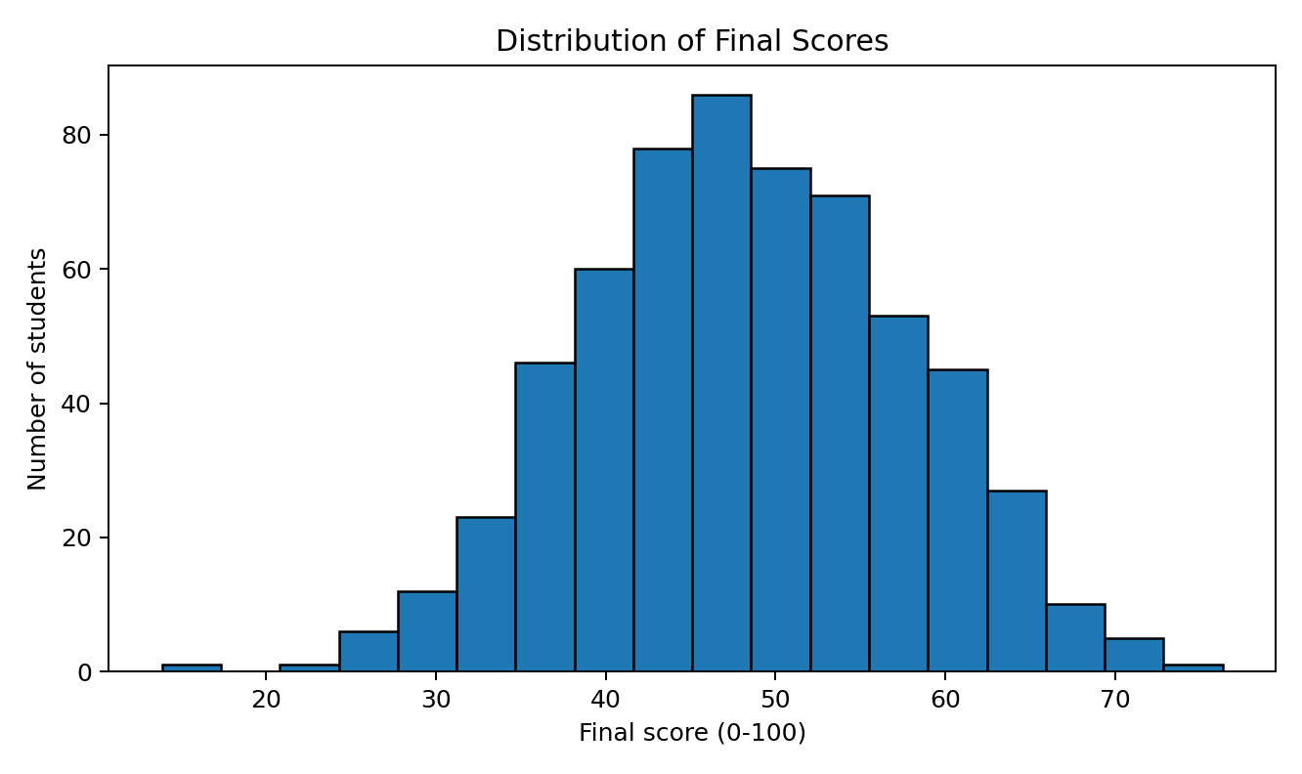
Figure 2. Distribution of final scores across the synthetic records.
The mean generated final score is 48.27, the median is 48.30, and the standard deviation is 9.46. The histogram summarizes the distribution, including where records are concentrated and whether the score range is broad. The shape reflects the generator design and must not be generalized to real academic outcomes.

9.3 Study time and score
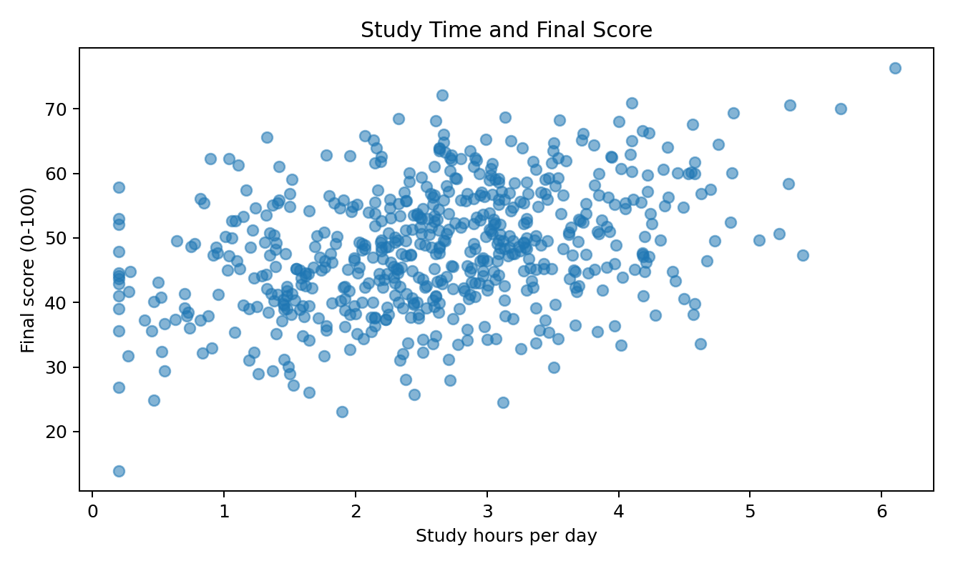
Figure 3. Study hours per day versus generated final score.
The scatter plot is a visual inspection of a possible association between study time and the final score. A broad upward pattern would be consistent with the way the synthetic values were generated; individual points still vary because several inputs and a noise term also affect the target. The chart is descriptive and does not establish that increasing study time alone causes a particular score increase.

9.4 Categories and further analysis
The categorical fields can be summarized using counts and groupwise statistics. Such comparisons are helpful for learning EDA, but any apparent group differences in artificial data are predetermined by the generator. For genuine data, category sizes, representativeness, confounding, measurement quality and privacy would need to be considered before interpretation.

CHAPTER 10: MODEL DEVELOPMENT

10.1 Linear Regression
Linear Regression is included as a transparent baseline. It estimates coefficients that minimize squared residuals in the training data. Its simplicity supports discussion of relationships between each input and the expected outcome, but coefficient interpretation requires care when variables are correlated or measured on different scales. Coefficients in this report are not causal effects.

10.2 Random Forest Regression
Random Forest Regression fits an ensemble of decision trees and combines their predictions. It can represent nonlinear relationships without specifying each one in advance. The model is configured with 250 trees, maximum tree depth of 8, minimum leaf size of 3 and a fixed random state. These are reasonable instructional settings, not the result of a full hyperparameter search.

10.3 Training process
The feature matrix contains numeric variables and encoded categorical fields. The data are split before training. Each candidate model is fitted on the training portion and generates predictions for the holdout records. The same holdout target and feature matrix are used to calculate evaluation metrics for both methods, making the comparison consistent.

10.4 Evaluation metrics
Metric | Interpretation | Direction
MAE | Average absolute prediction error, in score points. | Lower is better
RMSE | Square root of average squared error, in score points; emphasizes larger errors. | Lower is better
R² | Relative fit compared with predicting the test-set mean. | Higher is generally better; may be negative

10.5 Reproducibility
The notebook contains code cells for loading data, producing summary tables, drawing charts, preparing features, fitting models and reporting metrics. A README provides setup instructions and the requirements file lists software dependencies. A reviewer can execute the notebook from top to bottom to reproduce the analysis from the included CSV.

CHAPTER 11: EVALUATION AND RESULTS

11.1 Model comparison
Model | MAE | RMSE | R²
Linear Regression | 5.053 | 6.474 | 0.546
Random Forest Regressor | 5.706 | 7.446 | 0.400

Using RMSE as the primary selection metric, Linear Regression is selected for the demonstration because it gives the lower RMSE on the fixed test split. Its MAE is 5.053 score points, RMSE is 6.474 score points and R² is 0.546.

11.2 Actual versus predicted scores
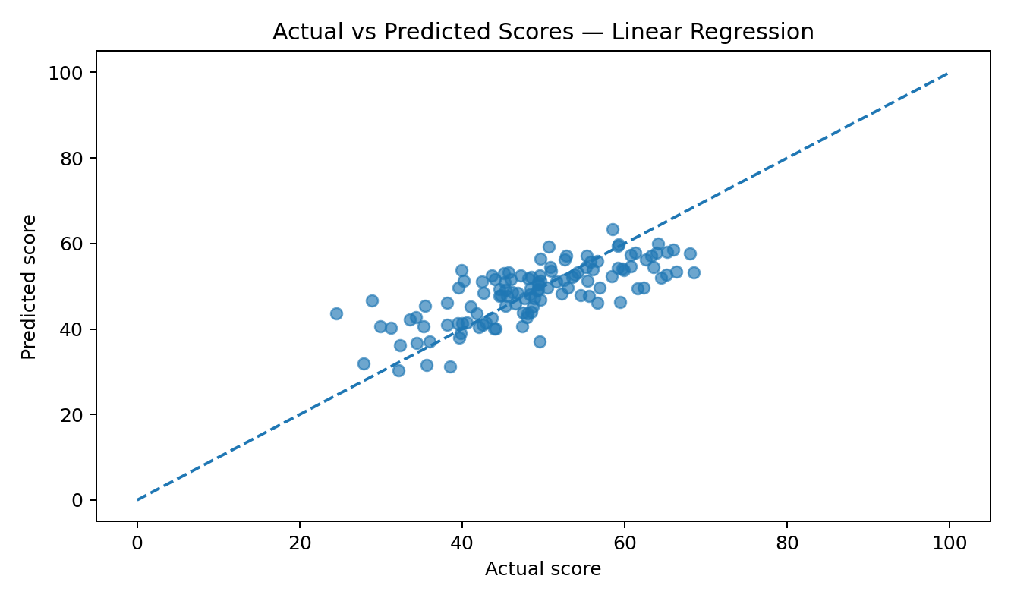
Figure 4. Actual versus predicted score values for Linear Regression.
Points close to the diagonal reference line represent predictions close to observed synthetic values. Distance from the line indicates prediction error. The plot makes patterns and outliers easier to inspect than a single metric. Because the target is generated with random noise, perfect predictions should not be expected.

11.3 Feature summary
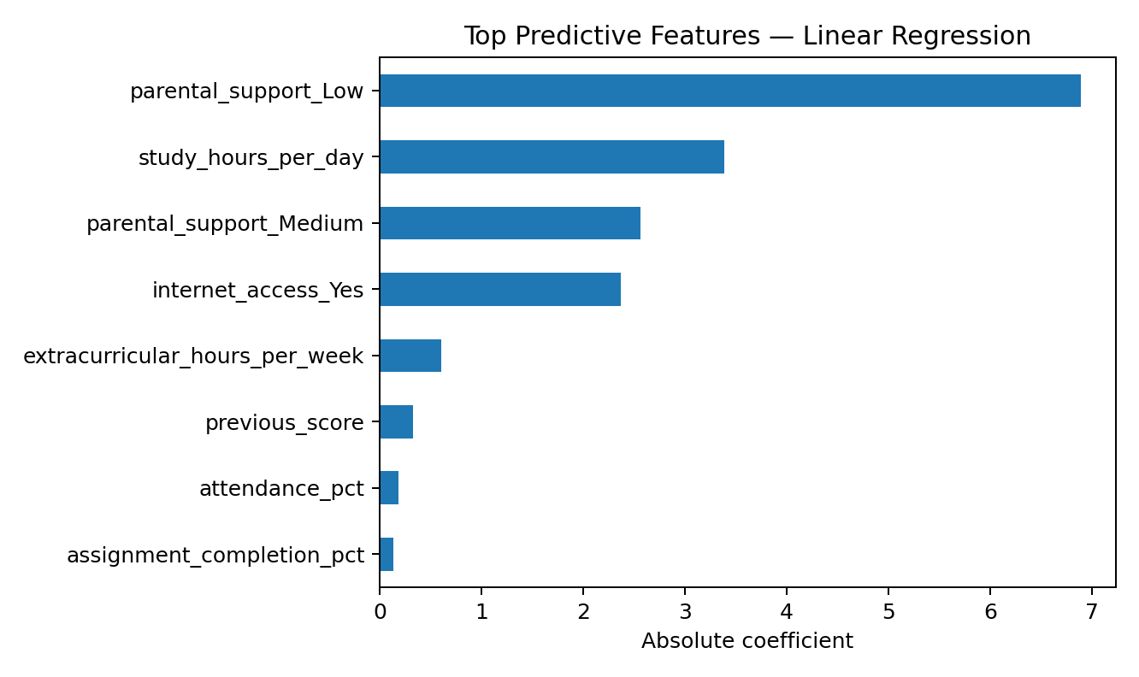
Figure 5. The top features according to Linear Regression.
For Random Forest, the chart reports impurity-based feature importance; for Linear Regression, it shows absolute coefficient magnitude. Both are model-specific summaries. They do not show that a feature causes a score difference, and correlated inputs can affect how importance is distributed. For Linear Regression, variables have different scales, so absolute coefficients are only a rough display.

11.4 Result statement
The analysis successfully executes the intended learning workflow: it reads and checks the data, describes the variables, draws visual summaries, trains two regression models and compares their predictions with the same held-out test set. The observed metric values are reproducible for the supplied synthetic data and environment. Any change to data, random state, library version or model parameters should prompt a new run and an updated report.

CHAPTER 12: DISCUSSION AND INTERPRETATION

12.1 What the analysis demonstrates
The project demonstrates how an analytics task can be translated into a clear sequence of code and documentation. Summary tables explain the dataset’s scale; charts reveal visible patterns; a baseline and an ensemble model offer a comparison; and explicit metrics create a common basis for discussion. Combining these elements gives a more complete account than reporting a model score alone.

12.2 Understanding the model difference
The selected method, Linear Regression, achieved the lower RMSE on this particular generated test set. The advantage, if any, may reflect the relationship structure built into the synthetic generator, the chosen train/test split or the model settings. It does not prove that this method is always better for educational data. In a new dataset, model ranking may change.

12.3 Interpreting a feature ranking
The feature chart should be read as a description of how one fitted model uses the inputs, not as a policy guide. For example, a high importance score does not prove that changing the variable will change a student’s achievement. Inputs may act as proxies for other factors, and a ranking can be unstable when predictors overlap. Causal claims require an appropriate study design beyond this demonstration.

12.4 From demonstration to a responsible study
A real institutional study would begin with a specific decision-support question and a lawful, documented data-governance process. The data would need clear definitions, representative coverage and checks for missingness and measurement error. Validation should be performed on data separated by time, institution or other meaningful unit when appropriate. Results should be reviewed with educators and learners, and the model should not be deployed without clear safeguards.

12.5 Strengths and limitations summary
Strengths | Limitations
Reproducible synthetic dataset and fixed random seeds. | No real or public-source student data are used.
Readable notebook and complete setup instructions. | Metrics only describe a synthetic holdout split.
Two model families and multiple evaluation metrics. | No external validation or full tuning procedure.
Includes responsible-use cautions. | No causal analysis or formal fairness audit.

CHAPTER 13: ETHICAL, PRIVACY AND RESPONSIBLE AI CONSIDERATIONS

13.1 Data minimization and consent
This demonstration avoids collecting personal data. If a future version uses actual student records, the project owner should confirm a valid purpose and applicable permissions before access or processing. Only fields necessary for that purpose should be collected, and identifiable records should be protected through suitable access controls, retention limits and secure storage. Consent and institutional approval requirements should be reviewed with the relevant authority.

13.2 Fairness and representation
Educational datasets may reflect unequal access to resources, differences in teaching environments or historic measurement practices. A model can reproduce or amplify those patterns. Evaluation should examine errors across relevant groups when appropriate and lawful, while preventing inappropriate disclosure of sensitive information. Group-level metrics do not automatically resolve fairness questions; context and stakeholder input remain necessary.

13.3 Transparency and human oversight
People affected by a data-informed process should receive a clear explanation of what the system does, what information it uses and what its limitations are. Predictions should not be treated as the final authority in high-impact decisions. A responsible process needs human review, a way to challenge errors and a clear line of accountability.

13.4 Avoiding harmful use
The model in this report is not appropriate for student ranking, admissions, discipline, scholarship eligibility or other consequential decisions. It was trained on generated records and has no evidence of real-world validity. Even a well-performing model can be harmful if used for a purpose it was not designed and evaluated to support.

13.5 Responsible AI checklist for future work
- Define the intended use and prohibited uses before collecting data.
- Obtain institutional and legal review where required.
- Minimize personal data and apply access and retention controls.
- Document provenance, definitions, known gaps and transformations.
- Validate with representative data not used in training.
- Inspect errors and possible disparities; involve relevant stakeholders.
- Provide human oversight, transparency and a way to correct records.
- Monitor performance over time and stop use if risks cannot be controlled.

CHAPTER 14: CONCLUSION AND RECOMMENDATIONS

14.1 Conclusion
The project has demonstrated the core stages of a beginner-friendly analytics and machine learning workflow. It created a synthetic dataset, checked its structure, described numeric attributes, visualized the score distribution and study-time relationship, prepared the predictors, trained Linear Regression and Random Forest Regression, and compared models using MAE, RMSE and R-squared.
On the fixed test split, Linear Regression achieved the lower RMSE, with an MAE of 5.05, RMSE of 6.47 and R² of 0.546. These findings satisfy the technical goals of the demonstration but are not evidence about real students because the dataset was generated artificially. The central result is the reproducible workflow and the disciplined interpretation of model outputs.

14.2 Recommendations
- Keep the dataset, code, environment requirements and report together so another reviewer can reproduce the work.
- Record the provenance and limitations of every dataset explicitly.
- Use a baseline model before trying more complex algorithms.
- Report multiple metrics and visually inspect prediction errors.
- Avoid presenting association or feature importance as causal evidence.
- Do not move to real student data without permission, privacy safeguards, suitable validation and mentor review.
- Treat algorithmic output as supplementary information rather than a replacement for informed human judgment.

14.3 Achievement of objectives
Objective | Status in this demonstration
Describe the dataset | Completed: field dictionary and dimensions documented.
Check basic quality | Completed: notebook checks types, missingness and duplicates.
Explore patterns | Completed: summary statistics and figures included.
Compare models | Completed: two regressors trained and evaluated.
Communicate limits | Completed: synthetic-data and responsible-use limitations explained.
Support reproduction | Completed: notebook, CSV, requirements and README supplied.

CHAPTER 15: FUTURE SCOPE
Several extensions could improve the technical depth of the project, but they should be added only where they answer a clear question and remain appropriate for the data available.

15.1 Improve evaluation design
Future work could use cross-validation on the training data and reserve a final test set for one-time evaluation. Hyperparameter tuning should be performed only within the training process. If real records are collected over time, a time-based split may offer a more realistic test of future predictions than a fully random split.

15.2 Add diagnostic analysis
A more advanced version could plot residuals against predicted values, calculate subgroup error measures where appropriate, assess prediction intervals and compare performance with a simple mean-only baseline. These checks can reveal weaknesses that a single headline metric does not show.

15.3 Extend visual analysis
Further charts could include correlation heatmaps for numeric fields, boxplots for score distributions by category and pairwise comparisons among selected features. Interpretation should remain descriptive and recognize that correlations may be driven by the data-generation process or hidden factors.

15.4 Use an external dataset responsibly
A later version could use a reputable public dataset with clear licensing and documentation. The analyst should verify the source, variables, collection context, permitted uses and known limitations. If institutional data are contemplated, the appropriate authorities must review access, privacy and consent requirements. No public or institutional dataset should be represented as used unless it is actually obtained and analyzed.

15.5 Responsible deployment
This prototype is not ready for operational use. Any real deployment would require a defined purpose, stakeholder review, legal and ethical checks, adequate validation, security controls, ongoing monitoring, human oversight and a plan to respond to errors or unintended impacts. It may be appropriate to stop at descriptive analysis if predictive modelling adds no justified benefit.

CHAPTER 16: LEARNING OUTCOMES
Completing the project provides an opportunity to practise several technical and professional skills.

Conceptual understanding
The project connects data analytics concepts with an applied question, clarifying the differences between descriptive statistics, exploratory analysis and prediction.

Practical participation
The notebook gives hands-on practice in loading CSV files, inspecting columns, summarizing values, creating charts and training models.

Logical and mathematical thinking
Model evaluation uses defined error measures and a fixed comparison procedure instead of relying only on intuition.

Analytical ability
The student learns to inspect data quality, look for patterns, compare model outputs and recognize where evidence is insufficient.

Application awareness
The report explains why a synthetic dataset can teach a method but cannot support claims about real people or institutions.

Research and communication
The deliverables combine code, figures, technical descriptions, citations, limitations and a clear run guide.

Reproducibility and collaboration
A notebook, requirements file, CSV and README allow a reviewer to repeat the steps and identify differences in environment or output.

16.1 Overall reflection
The most important learning is that a successful analytics project is not simply a model that produces predictions. It is a traceable process that starts from a well-defined question, uses data responsibly, makes assumptions visible, evaluates results appropriately and communicates limitations. These habits are fundamental to further study in analytics and AI.

REFERENCES
- Project dataset: Synthetic dataset generated by the accompanying Python script for academic demonstration; no external dataset was used.
- pandas development team. pandas documentation. https://pandas.pydata.org/docs/ (accessed for library reference; consult current documentation when running the project).
- NumPy developers. NumPy documentation. https://numpy.org/doc/ .
- scikit-learn developers. scikit-learn User Guide and API Reference. https://scikit-learn.org/stable/ .
- Matplotlib developers. Matplotlib documentation. https://matplotlib.org/stable/ .
- Project Jupyter. Jupyter documentation. https://docs.jupyter.org/ .
- Python Software Foundation. Python documentation. https://docs.python.org/3/ .
- IBM SkillsBuild. SkillsBuild learning platform. https://skillsbuild.org/ .
- All websites are provided as official documentation or programme context references. The report does not claim that any metric or result was drawn from those websites.
Referencing note: Links are supplied so that the reader can check tool functionality and relevant technical descriptions. The results in this report are produced locally from the packaged synthetic dataset and notebook; they are not quoted from external publications.

APPENDIX A: PROJECT EXECUTION GUIDE

A.1 Folder contents
File | Purpose
HemantSharma_StudentPerformanceAnalysis.ipynb | Executable notebook with code, explanations and plots.
HemantSharma_ProjectReport.docx | Full formatted academic report.
requirements.txt | Python library dependencies.
README.md | Project overview and execution instructions.
student_performance_dataset.csv | Synthetic example dataset used by the notebook.
PNG image files | Figures included in the report and available for review.

A.2 Run instructions
- Install Python 3.10 or later.
- Open a terminal in the extracted project folder.
- Install libraries with: pip install -r requirements.txt
- Launch Jupyter with: jupyter notebook HemantSharma_StudentPerformanceAnalysis.ipynb
- Run the notebook cells in order and confirm that the CSV remains in the same folder.
- Compare displayed metrics with the report; small differences may result from package versions or modifications.

A.3 Troubleshooting
If the notebook reports that the CSV file cannot be found, confirm that the notebook and CSV are in the same directory and that the filename matches exactly. If a Python package is missing, rerun the installation command in the environment used to launch Jupyter. If results differ, verify that the supplied CSV and notebook have not been modified and that the random state and model parameters remain as documented.

APPENDIX B: SAMPLE CODE AND SUPPLEMENTARY DETAILS

B.1 Core model-evaluation logic
from sklearn.model_selection import train_test_split
from sklearn.linear_model import LinearRegression
from sklearn.ensemble import RandomForestRegressor
from sklearn.metrics import mean_absolute_error, mean_squared_error, r2_score
X_train, X_test, y_train, y_test = train_test_split(
X, y, test_size=0.20, random_state=42
)
for model in [LinearRegression(), RandomForestRegressor(
n_estimators=250, max_depth=8, min_samples_leaf=3, random_state=42
)]:
model.fit(X_train, y_train)
prediction = model.predict(X_test)
mae = mean_absolute_error(y_test, prediction)
rmse = mean_squared_error(y_test, prediction) ** 0.5
r2 = r2_score(y_test, prediction)
print(type(model).__name__, mae, rmse, r2)

B.2 Important interpretation notes
- MAE and RMSE are expressed in the score units of the target variable.
- R-squared describes fit relative to a mean-only baseline and can be negative on a test set.
- A fixed random seed makes the example repeatable but does not make the synthetic dataset representative.
- Feature importance is descriptive and not a proof of causal effects.
- Do not use the demonstration model to make real decisions about students.

B.3 Final submission checklist
- Confirm the student identity fields and institutional spelling.
- Add the official mentor name, date and signatures only after confirmation by the institution.
- Open the notebook and execute all cells successfully.
- Include the DOCX report, notebook, requirements file and README in the final submission.
- Retain the explicit note that the packaged dataset is synthetic.

