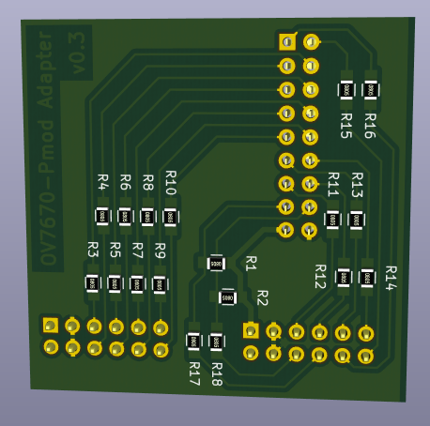
Pmod-Adapter-Board
for OV7670 camera module
Version: 0.3
Changes to previous version:
- Pinout redesign to allow (one layer) PCB design.
- All signal lines contain resistors to protect against short circuits

Pmod Connectors used for OV7670 sensor connection:
Pin | 6 | 5 | 4 | 3 | 2 | 1 |  | Pin | 6 | 5 | 4 | 3 | 2 | 1
Zybo  (JC) |  |  | T10 | T11 | W15 | V15 |  | Zybo  (JB) |  |  | W20 | V20 | U20 | T20
uZed  (JB) |  |  | Y14 | W14 | Y17 | Y16 |  | uZed  (JA) |  |  | U12 | T12 | T10 | T11
 | 3V3 | GND | D0 | D2 | D4 | D6 |  |  | 3V3 | GND | VSYNC | HREF | PCLK | XCLK
 | 3V3 | GND | D1 | D3 | D5 | D7 |  |  | 3V3 | GND | SIOD | SIOC | RESET | PWDN
Pin | 12 | 11 | 10 | 9 | 8 | 7 |  | Pin | 12 | 11 | 10 | 9 | 8 | 7
Zybo  (JC) |  |  | U12 | T12 | Y14 | W14 |  | Zybo  (JB) |  |  | W19 | W18 | Y19 | Y18
uZed  (JB) |  |  | W15 | V15 | U17 | T16 |  | uZed  (JA) |  |  | T15 | T14 | W13 | V12

Caution: For I2C communication with the sensor, make sure to properly pull-up SIOD and SIOC with 4.7kOhm resistors (here R1 and R2).

BOM:
2x (R1, R2): SMD resistor, 0805, 4,7 kOhm, 125 mW
14x (R3-R16): SMD resistor, 0805, 100 Ohm, 125 mW
2x (R17, R18): SMD resistor, 0805, 100 Ohm, 125 mW
1x Female pin header, 2x9 pin, 2,54mm
2x Male pin header, 2x6 pin, 2,54mm

