**系統程式設計**

**Lab5 Stdio Compare**

**學號:408410035**

**姓名:鄭宇辰**

1. **Where is the counter you add?   
   5.4:Line15**

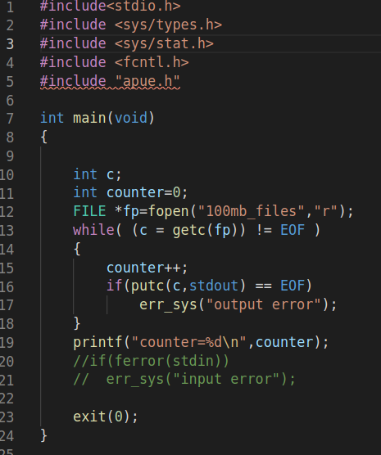

**5.5:Line12**

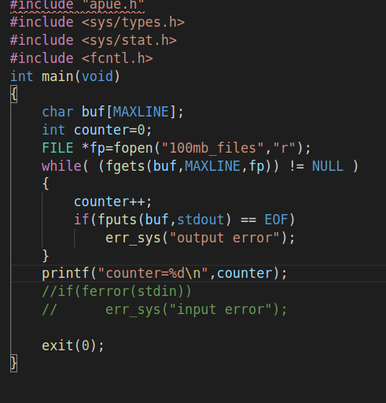

1. **Screen shot for Table1  
   5.4:putc&getc**

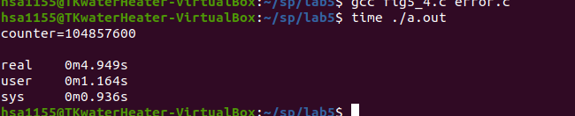

**5.5:fgets&fputs**

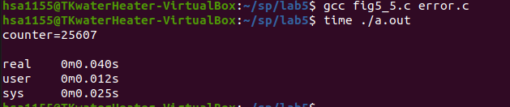

1. **Screen shot for Table2  
   full buffer:**

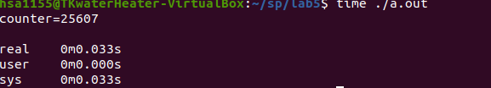

**Line buffer:**

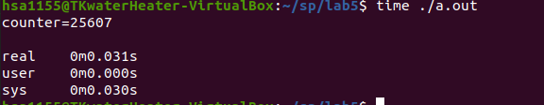

**Unbuffer:**

