SWDV 691- Capstone Project

**Movie Time**

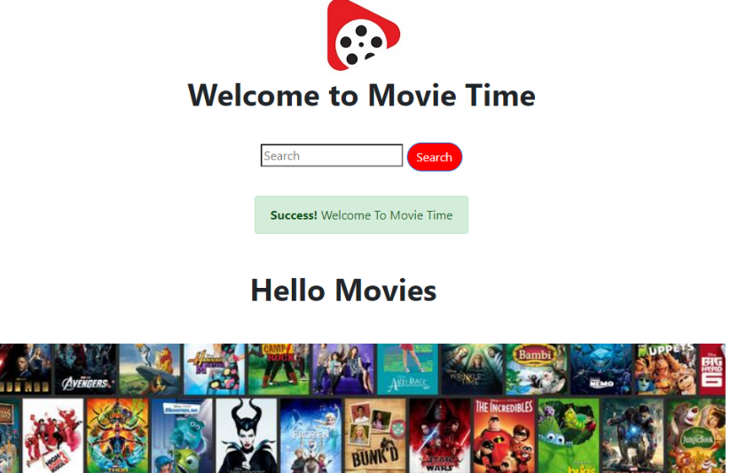

Movie Time is an entertaining app, that has a variety of movies for all ages. It has many movie categories and one special category of family movies which is good and safe for kids to watch. Also, the user should be able to search for movies instead of looking into the categories.

* Movies have six categories (Trending, top, Family, Star Wars, popular, upcoming).
* Clicking on an item opens detail screen for that item.
* Items are obtained from API.
* Movies can be searched by name.
* Logging in and registration saved in database.