KKB Redemption Arc

Documentation

Project members:

Anton Slavov [asslavov@18@codignburgas.bg](mailto:asslavov@18@codignburgas.bg)

Bozhidar Dimitrov [bddimitrov18@codingburgas.bg](mailto:bddimitrov18@codingburgas.bg)

Volen Mateev [vpmateev18@codingburgas.bg](mailto:vpmateev18@codingburgas.bg)

Jacqueline Yordanova [zoyordanova18@codingburgas.bg](mailto:zoyordanova18@codingburgas.bg)

Kaloyan Yordanov [kyayordanov18@codingburgas.bg](mailto:kyayordanov18@codingburgas.bg)

Hussein Abumelih [hsabumelih18@codingburgas.bg](mailto:hsabumelih18@codingburgas.bg)

Table of contents

Purpose of the project 3

Diagram 4

Most important functions 5

# Project: The Bletchley code breaker

# Purpose of the project

Everyone knows that cryptography is the practice and study of techniques for secure communication in the presence of third parties called [adversaries](https://en.wikipedia.org/wiki/Adversary_(cryptography)). Modern cryptography exists at the intersection of the disciplines of mathematics, computer science, electrical engineering, communication science, and physics. Applications of cryptography include electronic commerce, chip-based payment cards, digital currencies, computer passwords, and military communications. Cryptography was used extensively during World War II, with a plethora of code and cipher systems fielded by the nations involved. Probably the most important codebreaking event of the war was the successful decryption by the Allies of the German "Enigma" Cipher.  They were substantially improved by British efforts at the [Bletchley Park](https://en.wikipedia.org/wiki/Bletchley_Park) research station during the war. In addition, the theoretical and practical aspects of cryptanalysis, or codebreaking, were much advanced. The player chooses to play with the computer or some other player. The program asks for a combination until it’s correct. After the combination the code breaker should guess a number and its position. If the code breaker guesses right in 13 choices, he wins. If he doesn’t guess right till the 13th choice, the player loses.

# Diagram

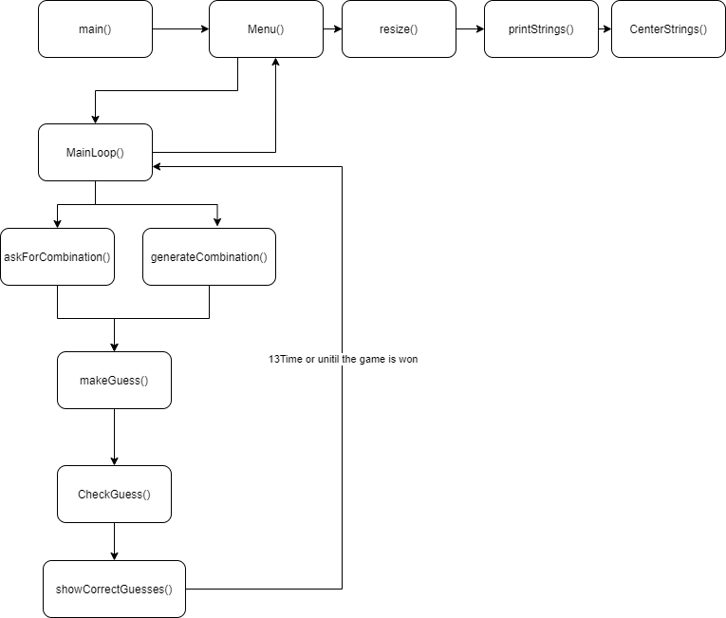

# Most important functions

|  |  |  |  |
| --- | --- | --- | --- |
| **Function name** | **Usage** | **Arguments** | **Return type** |
| askForCombination | ask the player for the coordinates | - | vector <int>, because the coordinates should be 4 numbers between 0 and 7 |
| generateCoord | generates coordinates | bool* used | int, because returns coordinates that are integers |
| centerstring | centers the text verses the screen | string s | string, because returns text |
| makeGuess | ask the player to make a guess | vector<int> combination | vector<int>, because the coordinates should be 4 numbers between 0 and 7 |
| showCorrectGuess | shows the player is his guess is right | int guessedCount, int guessedPositionCount | void, because it is not needed |
| checkWinner | displays if the player wins | int guessedCount | void, because it is not needed |
| checkBetween | check if the number that the player input is correct | int number | int, because return the number that the player has chosen |
| checkGuess | checks if the the guessed coordinates are correct | vector<int> guess, vector<int> combination | bool, because checks if it is correct or not |