Website Project

Haroon Sadiq

2021

Table of Contents

Design 2

Identification of need 2

Website Hierarchy 2

Wireframes 3

6

Written evaluation 7

# Design

## Identification of need

I am making this website to portray my work and portfolio in a contemporary design, with this the site must be catered towards a factual yet compositionally modern layout. Therefore, I want the site itself to portray my abilities and interests with the information displayed being a by-product of this.

The primary demographic will most likely employers looking to see my skillset so having a well structed website is a must. First impressions are key so focusing on a clear and consistent user interface is essential – this means I will have to be proficient in all areas of web development;

* HTML - Importing and placing all data need for the website to function while declaring data types and arranging the basic location of elements.
* CSS – Use inherent values across the website to create a uniform design scheme while formatting specific pages to make the website look less generic.
* JavaScript – Adding JavaScript roots the possibilities to amalgamate computational tasks which could range from user input to routine commands.

The colour scheme of my website will be minimal with faded colours hinting a retro look.

## Website Hierarchy

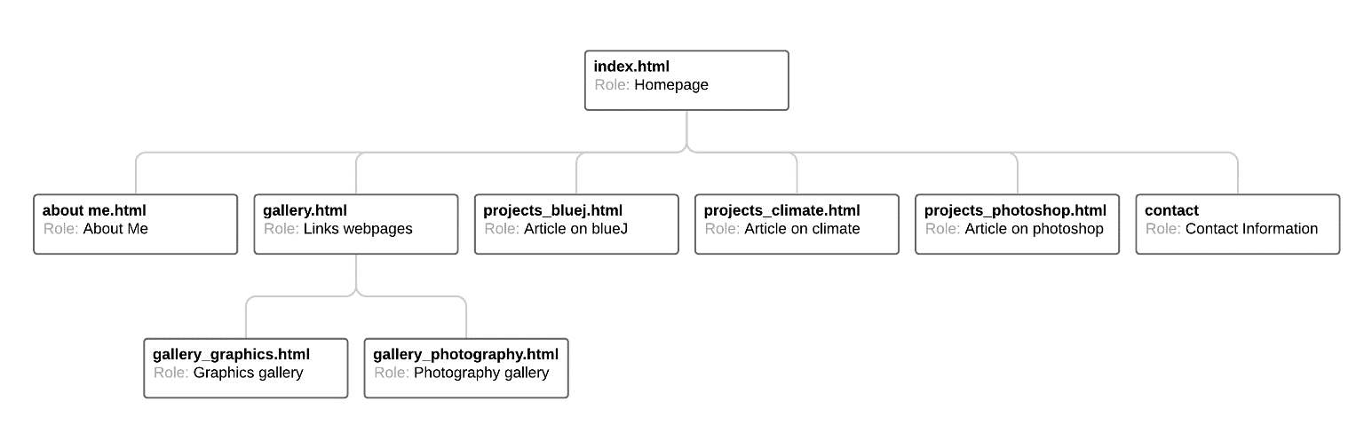

## Wireframes

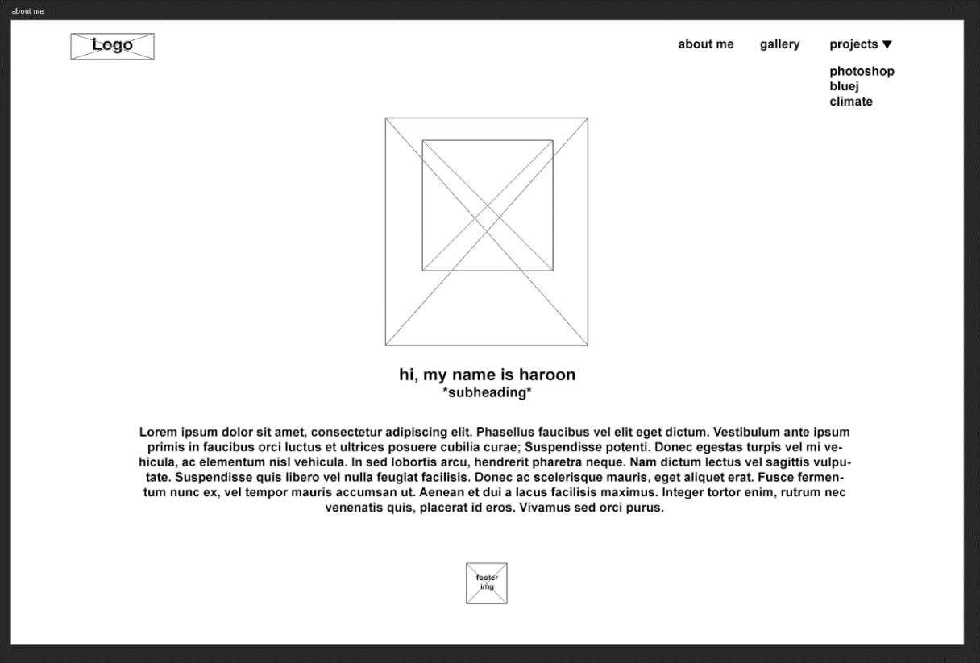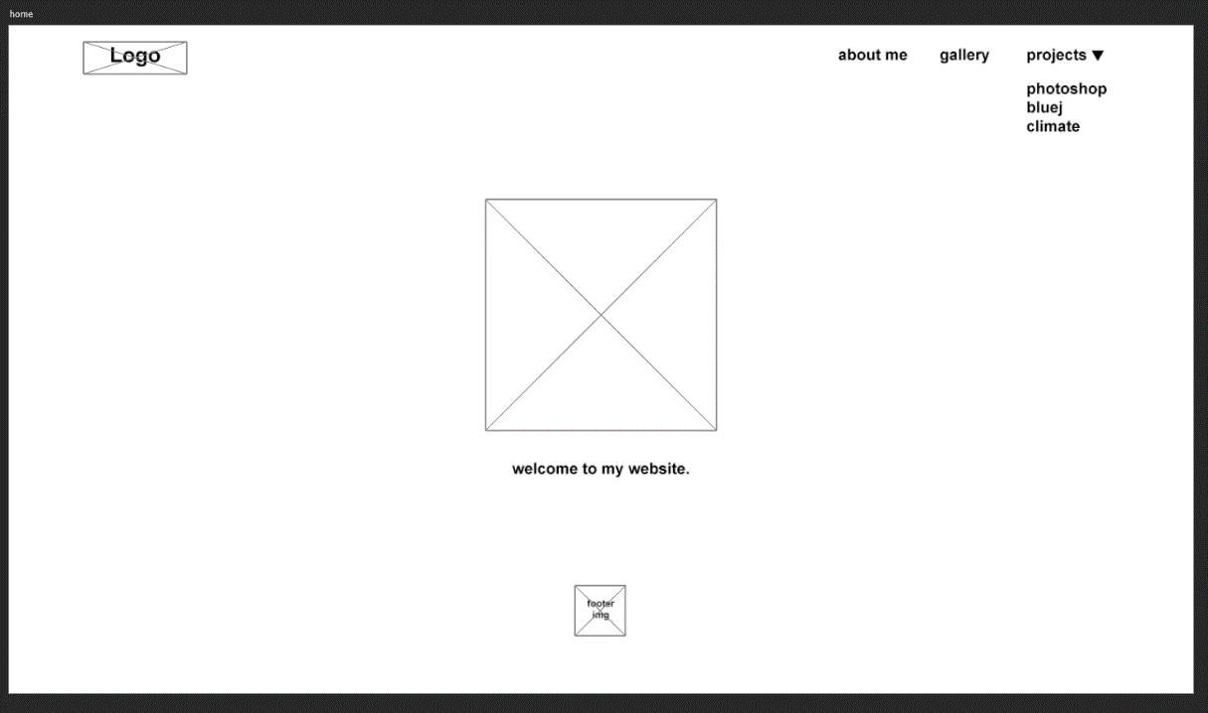

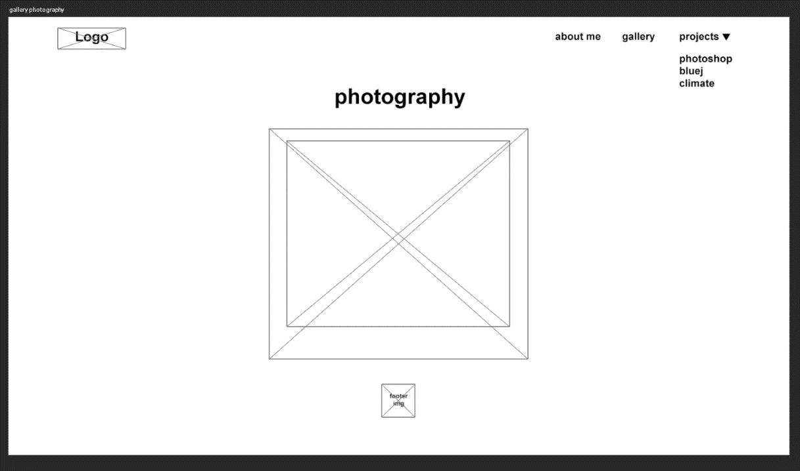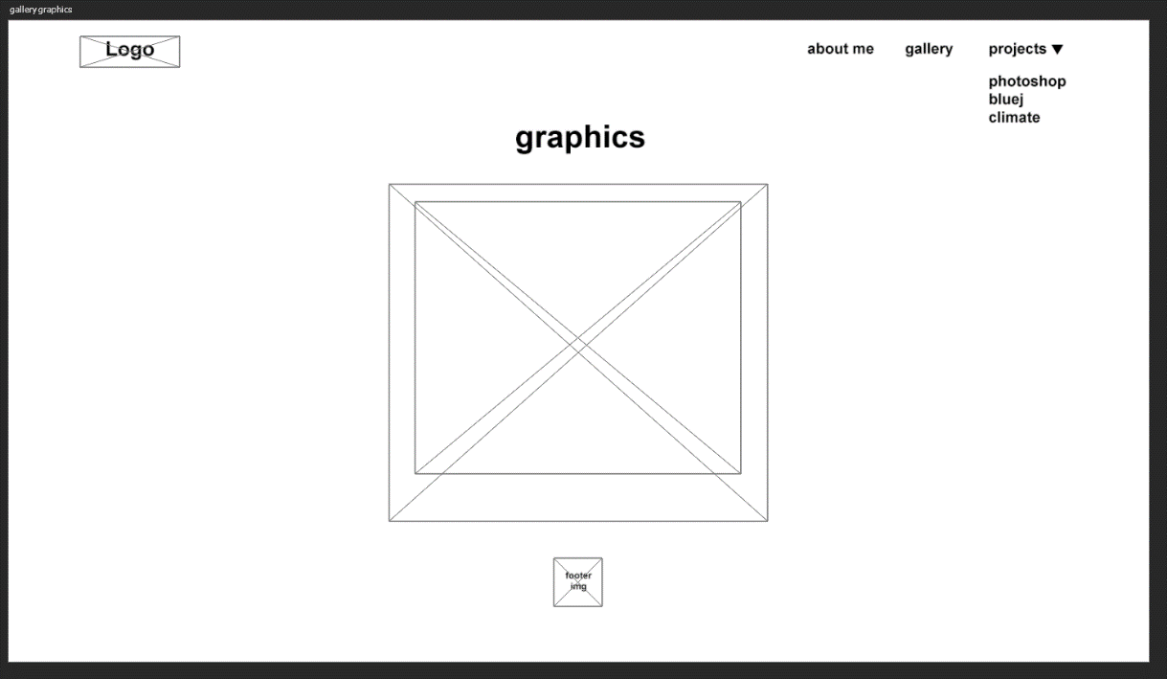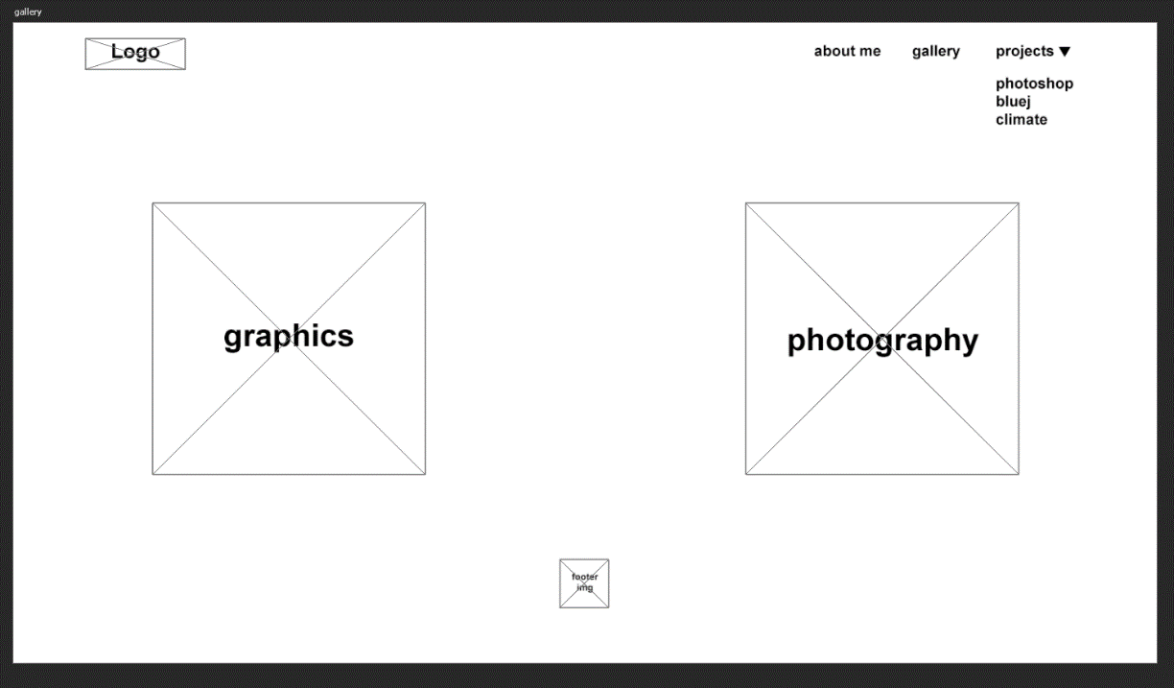

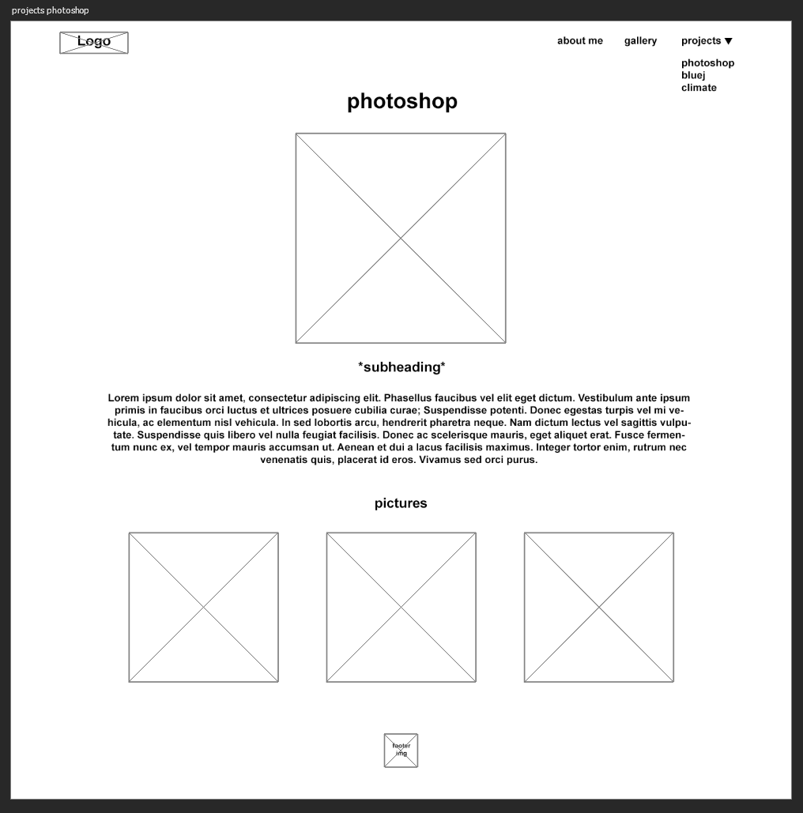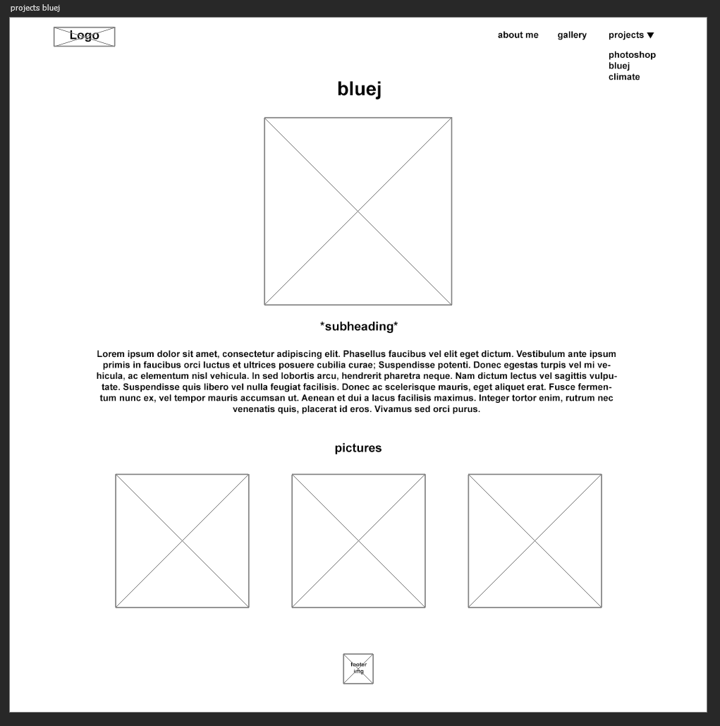

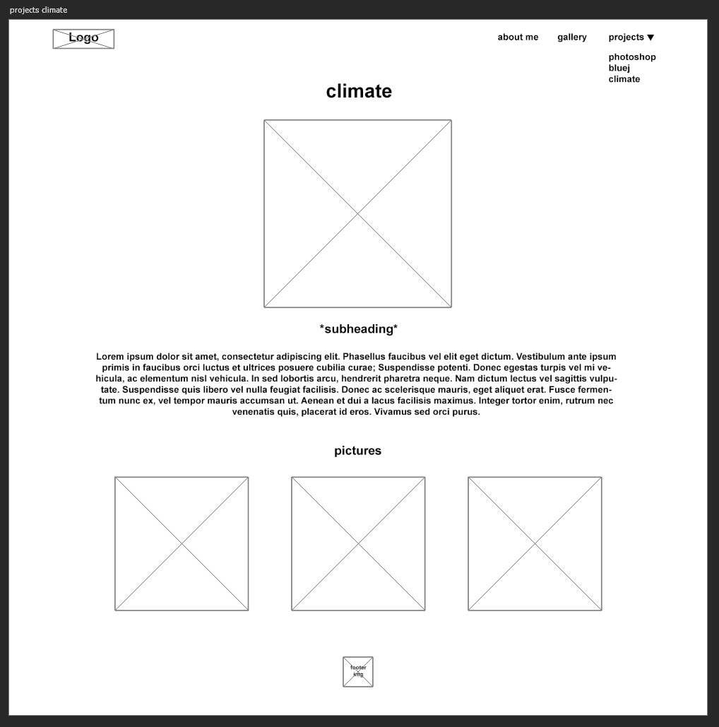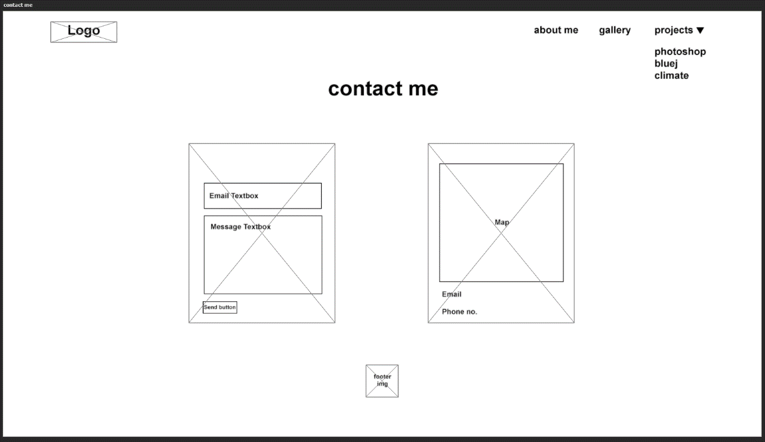

## Written evaluation

Creating the final product was a process