MS Project Deliverable #4 – IT 343
Name: Huma Safdar
Course: IT 343 – IT Project Management
Professor: Professor Nelson

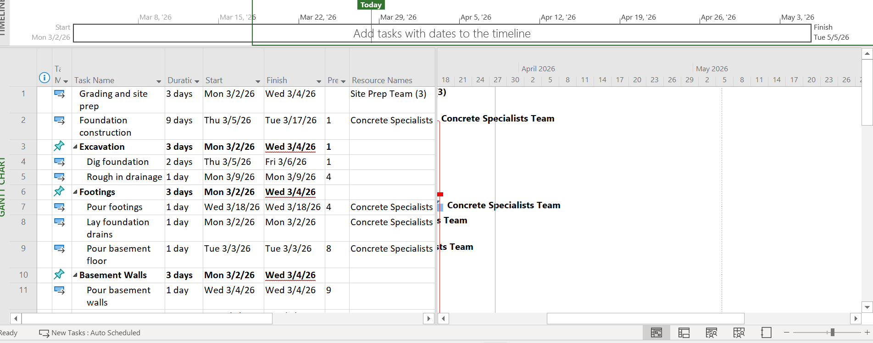

In this assignment, I made up a resource sheet and included various teams such as site prep, concrete, framing, roofing, plumbing, and HVAC. I also added other jobs such as insulation, drywall, flooring and finishing work. I had to give an hourly rate on each resource depending on the nature of work, hence it appeared more realistic rather than leaving it blank.
Then I distributed the resources to activities as it made the most sense to the activity. As an example, framing workers were tasked with framing work and structure work, plumbing and HVAC work were tasked with their respective work on installation. I also included material resources such as concrete mix where necessary particularly when carrying out certain tasks such as pouring footing and basement work.
The resources were initially overlapping due to the simultaneous occurrence of several tasks. This resulted in overallocation and made the schedule appear a bit messy and unrealistic. To correct that, I applied the Level All option of MS Project which automatically adjusted the schedule and distributed the work more equally.
These changes helped the project to appear more structured and comprehensible. The resources were no longer overworked, and the tasks were planned in a more sensible manner. All in all, it made me understand the importance of resource planning as much as the tasks are organized in the right way, the project may still have problems in case resources are not managed in the right way.

