DOCUMENTATION FILE

-HIMANSHU NANDA(2017237)

-HARKISHAN SINGH(2017233)

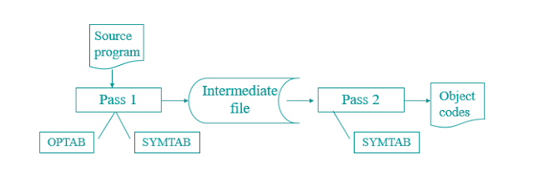

Assembler is a system sotware which converts an assembly language program to its equivalent object code.

* Input to the assembler is a source code written in assembly language(using mnemonics) and the output is an object code.

# BASIC ASSEMBLER FUNCTIONS

* Translating mnemonic language to its equivalent object code.
* Assigning machine addresses to symbolic labels.

# TWO PASSES OF AN ASSEMBLER

First Pass(define symbols and literals)

* Input the source program.
* Build a symbol table-contains the values of all the symbols where symbol is a label.
* Build the Literal table- Literal is a constant for which the assembler reserves memory.
* keep the track of location counter.

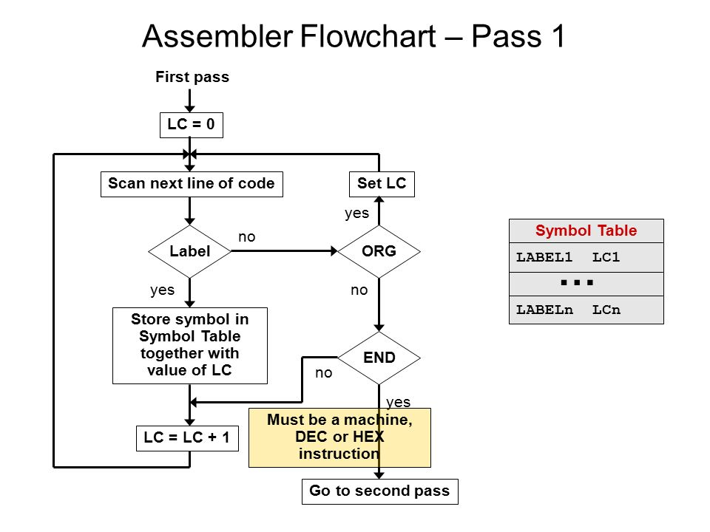

Second Pass

* Look up values of symbols.
* Generate instructions.
* Generate data for DC,DS and literals.
* Determining values of opcodes.
* Finally generates the object program.

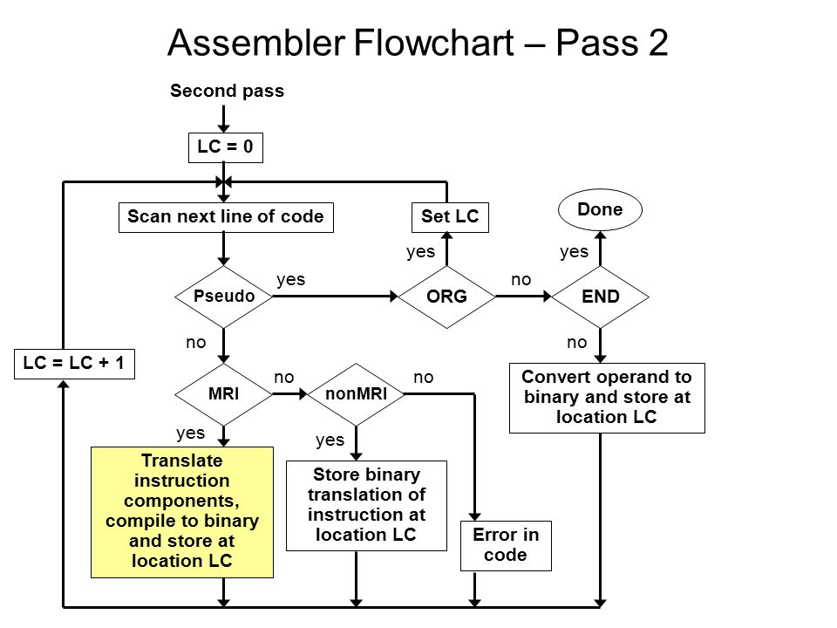

# ERRORS REPORTED DURING JAVA CODE

* File Not Found Exception-occurs when you read the file which does not exist.
* Symbol used but not defined error occurs when we use a symbol which is not declared.
* Symbol defined more than once error occurs when a symbol is declared many times.
* Opcode is not supplied with enough operands error when no of operands are not present as much operation demands.