**PROJECT TOPIC: Predict Tinder Matches using ML**

**CSE-AIML Group No.:** 20

**Project Group Members:**

1. Himanshu Sharma (M-/201550062)
2. Trapti Goyal (M-/201550140)
3. Preeti Yadav (M-/201550105)
4. Akshat Saxena (M-/201550016)

**Project Supervisor:** Mr. Aditya Upadhyay, Assistant Professor

**Objective:** Our project aims to revolutionize the online dating landscape through the strategic integration of machine learning algorithms. By enhancing matchmaking efficiency and delivering personalized match recommendations, we strive to simplify the search for meaningful connections. Through meticulous analysis of user profiles and activity metrics, we seek to streamline the matchmaking process while providing valuable insights to platform operators. Ultimately, our goal is to cultivate a user-centric online dating environment that prioritizes simplicity, satisfaction, and genuine connections.

**Tools required:**

* **Hardware Requirements:**
* Devices with internet connectivity for accessing the web application.
* Firebase Hosting for deploying the web-based interface.
* **Software Requirements:**
* Web browser for user interaction.
* Integration with Firebase or similar database management system.
* Python for backend development.
* Optional: Jupyter Notebooks for data exploration.
* Optional: Machine learning libraries like NumPy and pandas for data manipulation.
* Optional: Web development frameworks such as Flask or Django for building the interface.

**Abstract:** In the rapidly evolving realm of modern dating applications, our project, "Predicting Tinder Matches with Machine Learning," stands as a beacon of innovation. By harnessing advanced machine learning algorithms, notably cosine similarity, we endeavour to predict potential matches with unprecedented accuracy. Upholding stringent privacy and ethical standards, we place paramount importance on user consent and data protection. However, our focus extends beyond mere algorithmic precision; we are committed to elevating user satisfaction and fostering meaningful connections in the dynamic digital dating sphere. Through this transformative journey, we redefine the online dating experience, harnessing the immense potential of technology to forge genuine relationships.

**Outcome:**

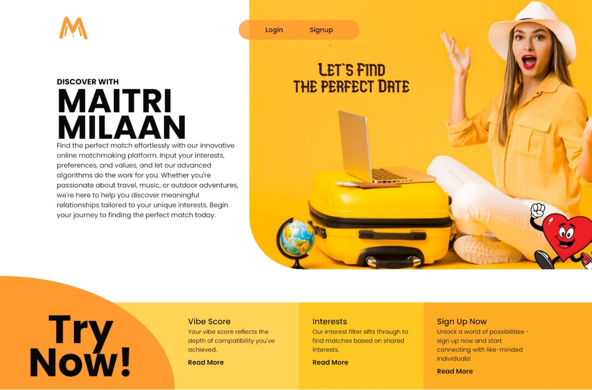



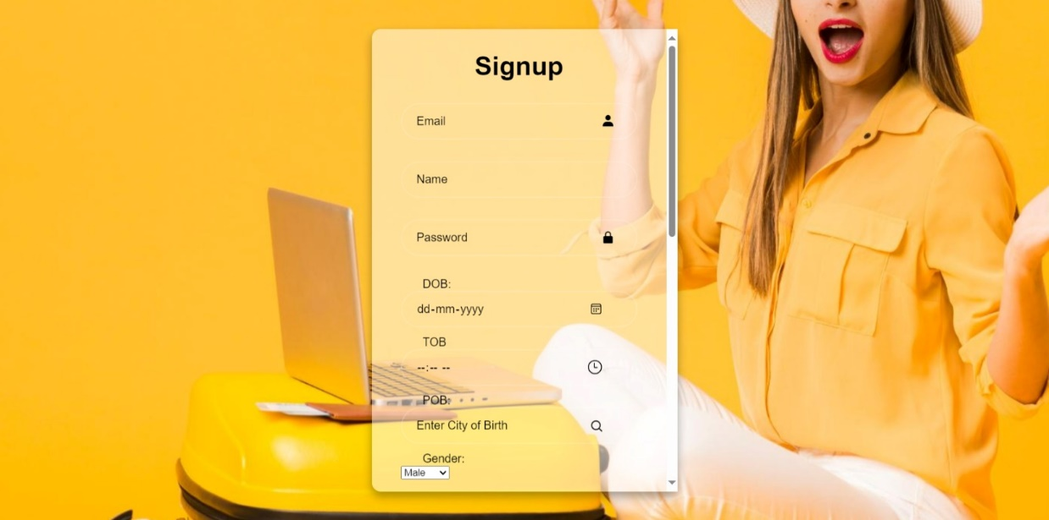

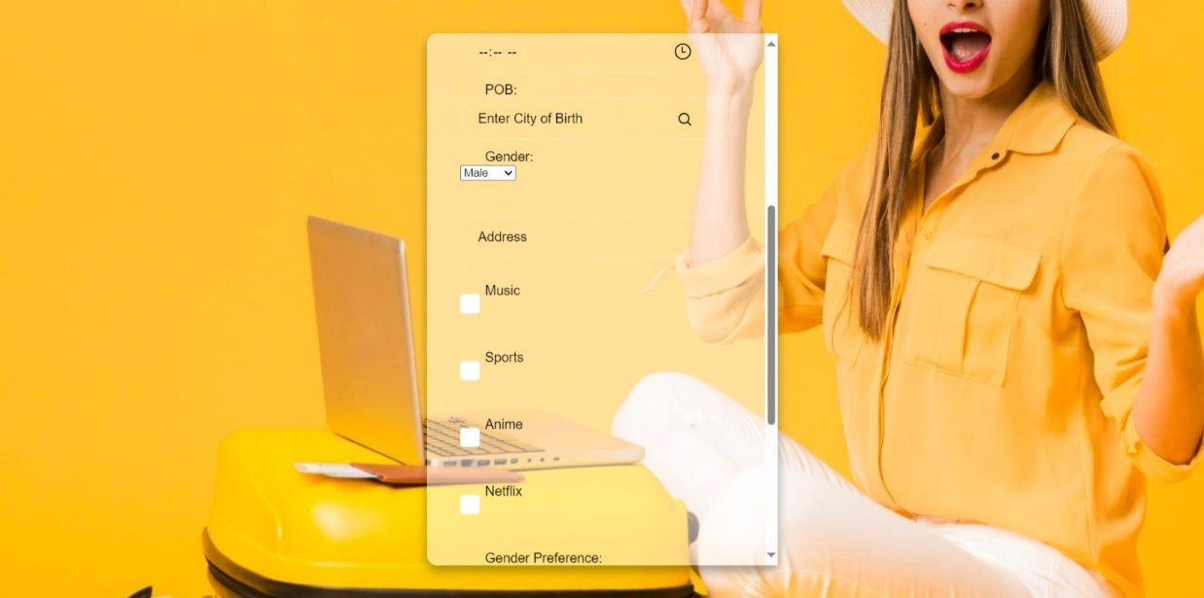



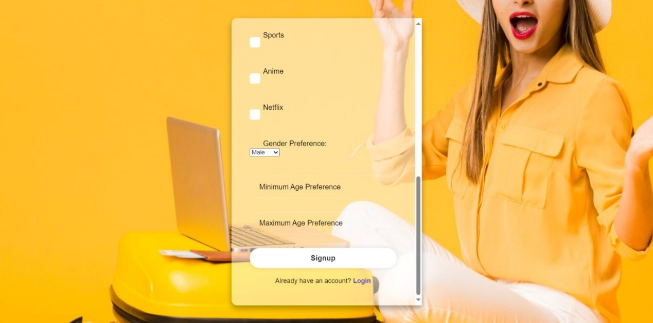



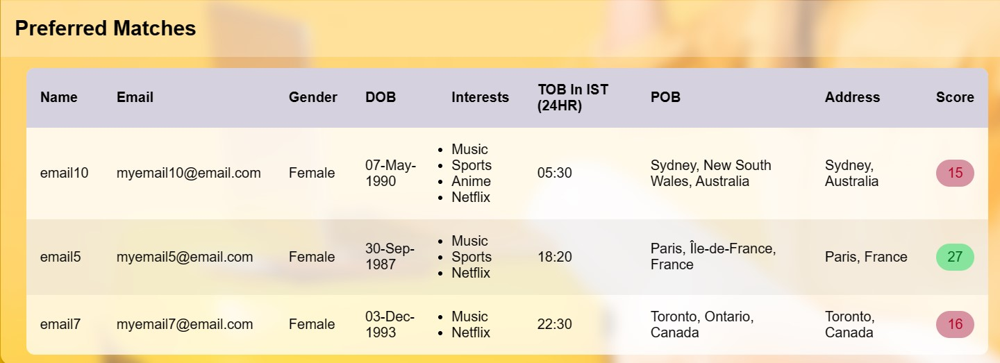

Visual representation is integral to our project, offering a clear glimpse into the functionality and user interface of our web application. These outcome images serve as invaluable visual aids, providing stakeholders with a comprehensive understanding of our system's features and design. From the captivating landing page to the intuitive sign-up and login interfaces, each image encapsulates the user journey, highlighting key elements such as form fields, buttons, and navigation options. Moreover, the dashboard screenshots offer insights into the personalized matchmaking experience, showcasing users' ability to explore preferred matches based on filtered criteria and cosine similarity scores. By incorporating these outcome images, we enhance the readability of our project documentation and offer stakeholders a tangible illustration of the user experience and system functionality.