 | 
EUROMED UNIVERSITY OF FES (UEMF)
Cybersecurity Engineering Cycle, 1st Year

TECHNICAL INTERNSHIP REPORT
Court Digitalization Suite
Web-Based and Desktop
(Mahkama Dossier & Intern Management Systems)
Host Institution | Administrative Court of Appeal of Fès — IT Department
Internship Period | 29/06/2026 – 29/07/2026 (1 month)
Academic Year | 2025 / 2026
Prepared by
Hatim SAMI
Under the supervision of
Mr. El Gouarti Monsif
Mr. El Issaoui Naoufal

Administrative Court of Appeal of Fès • Academic Year 2025 / 2026

Acknowledgements

I would like to express my deepest gratitude to the Euromed University of Fes (UEMF) for giving me the opportunity to acquire the essential theoretical and practical engineering skills required to carry out this project. I particularly appreciate the quality of the academic supervision and the richness of the training received within the Cybersecurity and Information Protection major.

I also sincerely thank the Administrative Court of Appeal of Fes for welcoming me as an intern. The entire staff was welcoming and highly cooperative, sharing with me their knowledge of internal processes and identifying the real needs in terms of digitalization.

My special thanks go to my professional supervisors:
• Mr. El Gouarti Monsif — for his constant availability, technical expertise, and valuable advice that structured my work and helped me overcome numerous technical difficulties.
• Mr. El Issaoui Naoufal — for his guidance, constructive feedback, and commitment to ensuring that the project met the institution's expectations.

I also thank all my professors at UEMF for providing me with the foundational knowledge needed to successfully complete this project.

Abstract
This Technical Internship Report presents the design and implementation of a court digitalization software suite developed during a one-month internship at the IT Department of the Administrative Court of Appeal of Fes (Cour d'Appel Administrative de Fès). The suite consists of two distinct but complementary applications:

1. Mahkama Dossier Manager — a desktop application (Python + Flask + PyWebView) that automates judicial deadline monitoring, the synchronization of case data from the official Ministry of Justice portal (www.mahakim.ma), the computation of activity statistics, and a global search across downloaded dossiers. It employs a color-coded urgency system (red/orange/green), smart case-number matching (including reversed formats), and exports to Excel and PDF. It has been in daily use by court staff since its deployment in June 2026.
2. Mahkama Intern Manager — a secure web application (React 19 + TypeScript 5.7 + Flask REST API) with role-based access control (RBAC), which digitizes and automates the complete intern lifecycle: from application submission (with Google Forms integration and bilingual Arabic/French public forms) to certificate generation and archival, including document validation, daily attendance tracking, supervisor assignment, and performance evaluation (5 criteria, 20 points maximum).

The technical architecture employs Python 3.10+ with Flask for REST API endpoints, Playwright for headless browser automation, SQLAlchemy ORM for SQLite database operations, React 19 with TypeScript 5.7 for the Intern Manager frontend, PyWebView for the Dossier Manager desktop wrapper, and Docker for containerized deployment. Both applications are designed for local deployment on the court's internal network, with no external exposure, ensuring the confidentiality of sensitive judicial and personal data.

Keywords: Judicial digitalization — Case management — Legal deadlines — Playwright — Flask — PyWebView — React — TypeScript — RBAC — SQLite — WAL mode — Docker — Electron — Administrative Court of Appeal of Fes.

Table of Contents
Acknowledgements 2
Abstract 3
List of Figures 5
List of Abbreviations and Acronyms 6
Chapter 1: Project Framework & Organizational Context 7
1.1 Introduction 7
1.2 Host Institution: Administrative Court of Appeal of Fes 7
1.2.1 Court History and Jurisdiction 7
1.2.2 Functional Organization and Administrative Departments 8
1.2.3 Detailed Organizational Structure — Official Court Organigram 8
1.3 Internship Mission and Context of Insertion 9
1.4 Field Observations and Problem Statement 10
1.4.1 Gaps in Court Case Tracking and Deadline Monitoring 10
1.4.2 Administrative Difficulties in Managing Student Placements 11
1.5 Proposed Solution — Court Digitalization Suite 11
1.6 Summary Table of Identified Pain Points and Needs 12
1.7 Chapter Conclusion 13
Chapter 2: Requirements Analysis & Technology Architecture 14
2.1 Introduction 14
2.2 Agile/Scrum Engineering Methodology 14
2.3 Requirements Engineering 15
2.3.1 Functional Requirements (FR) by Actor 15
2.3.2 Non-Functional Requirements (NFR) — ISO/IEC 25010 Alignment 15
2.4 Technology Stack Architecture & Rationale 16
Chapter 3: System Design & Implementation 17
3.1 UML Use Case Specifications 17
3.2 Class Diagrams & SQLite Data Schema 18
3.3 Implementation — Mahkama Dossier Manager 18
3.4 Implementation — Mahkama Intern Manager 20
3.5 Technical Difficulties & Resolved Solutions 21
3.6 Test Scenarios & Validation Results 22
Chapter 4: User Interface Walkthrough — Mahkama Dossier Manager 23
4.1 Mahkama Dossier Manager Interfaces 23
Chapter 5: User Interface Walkthrough — Mahkama Intern Manager 31
5.1 Mahkama Intern Manager Interfaces 31
General Conclusion & Future Perspectives 38
Context and Project Recall 38
Personal Contributions and Developed Competencies 39
Difficulties Overcome 39
Future Perspectives 39
Bibliography and Webography 40
Official Technical Documentation 40
Additional Resources and Tools 40
Institutional and Contextual References 41
Articles and Web Resources Consulted 41
Project Source Code (Internal References) 41
Annexes 42
Annexe A — Code Extract: Dossier Manager Launch (launcher.py) 42
Annexe B — Code Extract: Configuration & Urgency Calculation (engine.py) 43
Annexe C — Code Extract: Intern Manager Data Model (models.py) 45
Annexe D — Complete RBAC Permission Matrix (DEFAULT_PERMISSIONS) 46
Annexe E — Critical Backend Code Extracts (backend/app.py) 46

List of Figures
- Figure 1: Official Organizational Hierarchy of the Administrative Court of Appeal of Fes
- Figure 2: Global System Use Case Diagram — Court Digitalization Suite
- Figure 3: Relational Class Diagram & SQLite Data Structure
- Figure 4: Sequence Diagram — Asynchronous Scraping & Log Streaming Pipeline
- Figure 5: Sequence Diagram — JWT Authentication & RBAC Authorization Interceptor
- Figure 4.1: Scraper Orchestration Dashboard (Top Controls & Bottom Search)
- Figure 4.2: Scraper Execution & Real-Time Log Streaming Pipeline
- Figure 4.3: Caseload Statistics Computation & Multi-Format Output Flow
- Figure 4.4: Multi-Format Data Export & Spreadsheet Validation Suite
- Figure 4.5: Color-Coded Judicial Deadline Alert Monitor
- Figure 5.1: Admin Executive Command Center & Dashboard
- Figure 5.2: Central Intern Directory & Dynamic Status Filters
- Figure 5.3: 360-Degree Intern Profile & Competency Evaluation Matrix
- Figure 5.4: Form Builder & Google Forms Synchronization Module
- Figure 5.5: Centralized Digital Document Vault
- Figure 5.6: Interactive Monthly Attendance Register
- Figure 5.7: Gantt Timeline & Department Capacity Planner
- Figure 5.8: Secure Authentication & Access Control Interface
- Figure 5.9: Users & RBAC Permissions Control Console
- Figure 5.10: Admin System Settings
- Figure 5.11: Intern Portal Dashboard

List of Abbreviations and Acronyms
API — Application Programming Interface
CIN — Carte d'Identification Nationale (National Identity Card)
CRUD — Create, Read, Update, Delete
DB — Database
DM — Dossier Manager (Mahkama Dossier Manager)
Docker — Software containerization platform
Electron — Desktop framework based on Chromium/Node.js
HTTP — HyperText Transfer Protocol
IM — Intern Manager (Mahkama Intern Manager)
JWT — JSON Web Token
ORM — Object-Relational Mapping
PFA — Projet de Fin d'Année (Final Year Project)
RBAC — Role-Based Access Control
REST — Representational State Transfer
RTL — Right-To-Left (text direction)
SMTP — Simple Mail Transfer Protocol
SQL — Structured Query Language
SQLAlchemy — Python ORM for relational databases
UI — User Interface
WAL — Write-Ahead Logging (SQLite mode)
WSGI — Web Server Gateway Interface

General Introduction
In public administration, modernizing judicial and operational workflows is a key driver of efficiency, transparency, and institutional trust. Moroccan judicial institutions are undergoing digital modernization under the Ministry of Justice's strategic transition programs. However, daily operations in regional appellate jurisdictions often rely on legacy manual registers, physical case logs, and uncoordinated spreadsheets. This creates administrative bottlenecks, delays, and compliance risks.
During an engineering internship at the Administrative Court of Appeal of Fes (Cour d'Appel Administrative de Fès), two operational bottlenecks requiring immediate digital transformation were identified:
- Judicial Dossier Tracking & Legal Deadline Calculation: Active dossiers move constantly between the mail desk, registry clerks, reporting counselors, and external experts. Legal response windows—such as expert appraisal filings—are tracked manually from paper registers or individual lookup queries on the Ministry's portal (www.mahakim.ma). Delays in reporting or missed response dates compromise judicial calendars and can result in default judgments.
- Student Placement Coordination & Lifecycle Tracking: The court manages dozens of students and professional placements across various registry units. Managing placement applications, credential verification, daily attendance, department capacity, and evaluations via physical paperwork creates substantial administrative overhead.
To solve these challenges, we engineered the Mahkama Court Digitalization Suite—a unified software ecosystem comprising two dedicated applications: Mahkama Dossier Manager and Mahkama Intern Manager.
This report outlines the project framework, software specifications, cybersecurity architecture, system design models, implementation walkthroughs, and institutional impact of the deployed suite.

Chapter 1: Project Framework & Organizational Context

1.1 Introduction
The judicial system guarantees the rule of law and balances administrative authority with citizen rights. Under Moroccan administrative law, specialized administrative jurisdictions evaluate disputes involving state entities, local municipalities, public contracts, and administrative liabilities. Digitizing regional court workflows improves case processing speeds and secures internal records

1.2 Host Institution: Administrative Court of Appeal of Fes

1.2.1 Court History and Jurisdiction
The Administrative Court of Appeal of Fes operates as a second-degree administrative court established under Moroccan judicial framework reforms. Its territorial jurisdiction covers the Fes-Meknes region and adjacent provinces. The court evaluates appeals lodged against initial rulings rendered by administrative courts of first instance regarding:
- Public procurement and administrative contract disputes.
- Civil service administrative decisions and disciplinary litigation.
- Municipal tax assessments and expropriation indemnities.
- Direct state liability claims arising from public service execution.

The court's jurisdiction extends over the territory of the Fes-Meknès region and surrounding areas. The cases handled include disputes between administrative authorities and citizens, civil service career disputes, municipal and tax litigation, expropriation for public utility, and administrative liabilities. The volume of cases handled by the court is significant: hundreds of dossiers transit each year through the different sections of the registry, sustaining a sustained judicial activity that requires rigorous organization and precise tracking of legal deadlines.

1.2.2 Functional Organization and Administrative Departments
The operational structure of the court is designed to handle high volumes of legal transactions while preserving the necessary control and validation steps. The main departments are:

• The Bureau d'Ordre (Mail Reception Desk): handles the reception, initial registration, and sorting of incoming and outgoing correspondence. It is the entry point for all official correspondence; it must classify, index, and direct each document to the competent service.
• The Registry (Greffe): the central service of the court, divided into specialized sections (Judgments Registry, Hearings Registry, Expertise Registry). The registry records dossiers, tracks hearing dates, registers judgments, and maintains procedure registers. This is where most of the manual dossier tracking work is performed.
• The Archives Department: responsible for the classification and conservation of closed dossiers. It manages loans of active dossiers to judges or experts, and monitors return dates to prevent any loss or document delay.
• The IT Department: maintains local infrastructure, manages workstations, monitors network security, and provides technical support to users. This is the department where the internship was carried out, under the supervision of Mr. El Gouarti Monsif and Mr. El Issaoui Naoufal.

1.2.3 Detailed Organizational Structure — Official Court Organigram
The court's organizational chart combines judicial responsibilities (exercised by the First President) and administrative management (under the authority of the First Clerk/Principal Greffier). The following official organigram, observed on-site during the internship, illustrates the complete hierarchical and functional structure of the Administrative Court of Appeal of Fes.

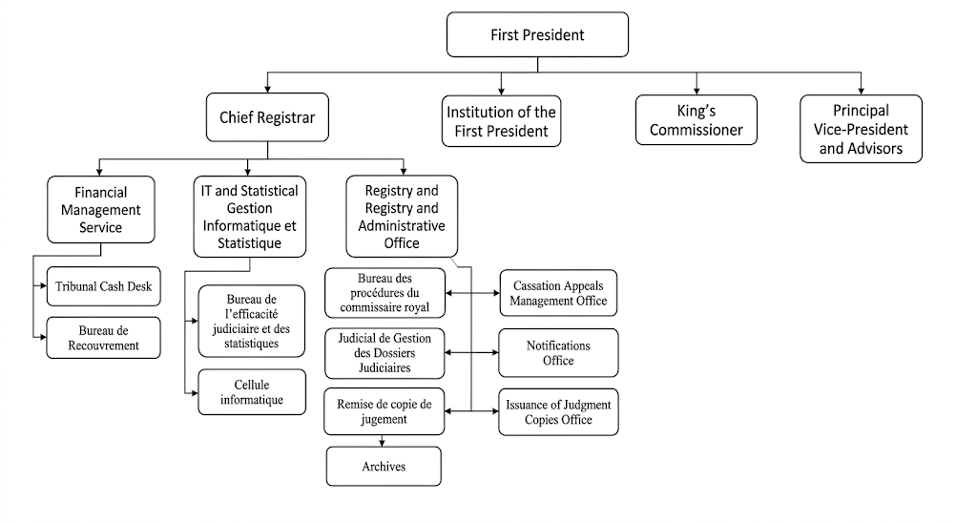
Figure 1: Official Court Organigram — Administrative Court of Appeal of Fes

Under the authority of the First Clerk, several registry units coordinate the registration, processing, and retrieval of active dossiers. This configuration imposes smooth collaboration between services — collaboration that is often slowed down by the use of manual registers and scattered Excel files, motivating the need for the digital tools presented in this report.

1.3 Internship Mission and Context of Insertion
The internship took place within the IT Department of the Administrative Court of Appeal of Fes, from 29 June 2026 to 29 July 2026. It was part of the Final Year Project (PFA) of the Cybersecurity major, 3rd year of the Engineering Cycle at the Euromed University of Fes (UEMF).

The overall mission assigned was the design and development of a court digitalization software suite, intended to respond to the concrete needs identified by the registry services and the IT department. The objective was to propose operational tools, adapted to the local context (Windows environment, internal network, access to the Ministry of Justice portal), and capable of being deployed and used directly by court staff.

The main constraints were as follows:
• Operation on a local network, with no external exposure, for confidentiality of judicial data .
• Authenticated access to the www.mahakim.ma portal for case data retrieval.
• Compatibility with existing court accounts (case monitoring account, statistics access account).
• Simple deployment, with no dependency on additional servers or heavy infrastructure.
• Interface in Arabic (RTL) and/or French, in line with internal usage.

The work was carried out autonomously, with regular supervision from the professional supervisors. Exchanges with the registry and mail desk staff were essential to understand the real processes and adjust the functionalities iteratively throughout the development.

1.4 Field Observations and Problem Statement

1.4.1 Gaps in Court Case Tracking and Deadline Monitoring
Field analysis across registry units identified specific operational bottlenecks:
- Manual Portal Lookups: Clerks spent an estimated 2 to 3 hours daily manually searching case reference numbers on the national Mahakim portal to transcribe hearing postponements, expertise dates, and counselor notes into local spreadsheets.
- Unmonitored Expertise Deadlines: Dossiers requiring expert reports regularly experienced delays. Without automated calculation tools, tracking remaining response windows (Article 48 of the Administrative Procedure Code) across 500+ active cases was prone to human error.
- Disorganized Placement Coordination: Tracking 20+ university interns across different units relied on paper sign-in rosters and physical document folders, leading to attendance calculation errors and scheduling conflicts.

In current practice, staff rely on paper registers or scattered Excel files to track dossier progress. When a deadline must be verified, the responsible person must manually consult the Ministry of Justice website (www.mahakim.ma) for each dossier concerned — a time-consuming operation that cannot be automated in the current state of affairs.

The absence of an alert system that immediately visualizes dossiers whose deadline is approaching or has expired generates several risks:
• Delays in producing expert reports and complementary documents.
• Risks of procedural default or non-respect of procedural deadlines.
• Multiplication of back-and-forth trips to the mahakim.ma portal for each verification.
• Inability to visually prioritize the most urgent dossiers in the daily workflow.

It is from these observations that the need for a deadline monitoring tool emerged, capable of automatically calculating deadlines, classifying dossiers by urgency level, and alerting staff on critical cases — which imposed itself as a priority.

1.4.2 Administrative Difficulties in Managing Student Placements
The court hosts a significant number of engineering and administrative interns each year. The coordination of these placements is currently managed informally and on paper, which generates several difficulties:

• Overbooking: several departments may simultaneously receive too many interns, creating training capacity and supervision problems.
• Absence tracking: attendance sheets are kept in physical files, making monthly calculation of attendance hours slow, error-prone, and impossible to exploit quickly.
• Document management: intern documents (national ID cards, insurance certificates, internship agreements) are kept in physical binders, complicating verification, location, and archiving.
• Evaluation and certification: evaluation forms are filled manually, and internship certificates must be typed and signed individually, adding to the administrative workload at the end of the internship.

These observations motivated the design of an intern management application capable of centralizing information, digitizing documents, tracking attendance, and automating certificate generation.

1.5 Proposed Solution — Court Digitalization Suite
In response to the identified needs, a two-application suite was designed and developed:

1. Mahkama Dossier Manager — addresses the judicial dossier tracking and deadline monitoring needs:
• Automatic synchronization of case data from the www.mahakim.ma portal via Playwright.
• Automatic calculation of remaining legal deadlines with color-coded alerts (red/orange/green).
• Activity statistics with Excel and PDF export.
• Global search across all downloaded dossiers with smart number matching.
• Deployable as a single Windows executable (PyInstaller).

2. Mahkama Intern Manager — addresses the intern lifecycle management needs:
• Public bilingual (Arabic/French) application forms with Google Forms integration.
• Role-based access control (RBAC) with granular permissions for Admin, Manager, and Intern roles.
• Digital attendance register with monthly presence logging.
• Document vault with versioning, approval workflows, and centralized storage.
• 5-criteria performance evaluation matrix with visual grading sliders.
• Automated internship certificate generation and archival.
• Gantt timeline planner for department capacity visualization.

Both applications were developed using a pragmatic technology stack: Python 3.10+ with Flask for the backend REST API, SQLAlchemy ORM with SQLite (WAL mode) for data persistence, React 19 with TypeScript 5.7 for the Intern Manager frontend, PyWebView for the Dossier Manager desktop wrapper, and Playwright for headless browser automation. The Intern Manager is containerized via Docker (multi-stage build) and can optionally run in Electron desktop mode. The Dossier Manager is distributed as a standalone Windows executable.

1.6 Summary Table of Identified Pain Points and Needs
Table 1 recapitulates the main dysfunctions observed during the field-observation phase and the corresponding needs that gave rise to the two applications.

Current Situation | Consequence | Need Identified | Target Application
Manual deadline tracking on paper registers / Excel | Delays, risk of procedural default, individual verifications on mahakim.ma | Automatic deadline calculation and visual alerts | Dossier Manager
Repeated back-and-forth to the Ministry portal for each verification | Significant time loss, interruption of workflow | Automatic synchronization of data from the portal | Dossier Manager
No visual alert system for urgent dossiers | Difficult prioritization in daily workflow | Color coding (red/orange/green) by urgency level | Dossier Manager
Activity statistics calculated manually | Long processing time, possible errors | Automated statistics module with Excel/PDF export | Dossier Manager
Historical dossier search by manual file navigation | Difficulty in quick location of specific cases | Global search engine with smart matching | Dossier Manager
Overbooking of departments with interns | Training capacity exceeded, supervision problems | Visual planning of assignments (Gantt) | Intern Manager
Paper attendance sheets | Slow and error-prone monthly calculation | Digital attendance register | Intern Manager
Intern documents in physical files | Slow verification and location of documents | Digitization and centralized document management | Intern Manager
Manual evaluation and certificates | Additional administrative workload at closure | Digital evaluation and automated certificate generation | Intern Manager
No centralized application management tool | Scattered processing of requests | Public form + step-by-step validation + traceable lifecycle | Intern Manager

1.7 Chapter Conclusion
This chapter presented the institutional framework in which the internship took place, the mission assigned, and the problems observed on-site that justified the design of the software suite. The two applications — Mahkama Dossier Manager and Mahkama Intern Manager — respond respectively to the two axes of dysfunction identified: judicial deadline tracking and intern coordination. The next chapter will present the requirements analysis methodology, the detailed functional and non-functional requirements, and the technology stack choices.

Chapter 2: Requirements Analysis & Technology Architecture

2.1 Introduction
This chapter presents the requirements engineering methodology, the detailed functional and non-functional requirements for both applications, and the technology stack architecture with the rationale for each technical choice. The requirements were gathered through direct observation of court operations, interviews with registry staff and IT department personnel, and analysis of existing manual workflows at the Administrative Court of Appeal of Fes.

2.2 Agile/Scrum Engineering Methodology
The project was developed using an Agile/Scrum methodology adapted to the intensive schedule of a one-month technical internship (June 29, 2026 – July 29, 2026). The development cycle was structured into four 1-week sprints, each delivering an integrated set of functional deliverables:

Sprint | Timeline | Focus Area | Key Deliverables | Status
Sprint 1 | Week 1 (29/06 – 05/07) | Inception & Architectural Setup | On-site workflow analysis, UML modeling, database schema design, and repository setup. | Completed
Sprint 2 | Week 2 (06/07 – 12/07) | Mahkama Dossier Manager Core | Playwright scraper engine, Flask backend endpoints, deadline calculation logic, and real-time log streaming. | Completed
Sprint 3 | Week 3 (13/07 – 19/07) | Mahkama Intern Manager Core | React 19 UI, JWT authentication, RBAC permission matrix, attendance logger, and document vault. | Completed
Sprint 4 | Week 4 (20/07 – 29/07) | Packaging, Hardening & Deployment | PyWebView desktop wrapping, Docker multi-stage builds, User Acceptance Testing (UAT) with court staff, and final on-site deployment. | Completed

2.3 Requirements Engineering

2.3.1 Functional Requirements (FR) by Actor
The functional requirements were defined by identifying the main actors interacting with the system:

Actor | Role | Key Functional Requirements
Court Clerk (Greffier) | Daily dossier processing | View and update dossier status, record hearing dates, track deadline alerts, search dossiers by number
Registry Supervisor | Oversight and reporting | View color-coded deadline dashboard, generate activity statistics, export reports to Excel/PDF, monitor sync status
IT Administrator | System maintenance | Configure portal credentials, manage workspace directories, view operations logs, perform backups, update application version
Intern Applicant | Submit application | Fill public bilingual application form (Arabic/French), upload required documents (CIN, transcript, motivation letter)
Department Manager (Encadrant) | Supervise interns | Review and approve/reject intern applications, assign interns to departments, evaluate intern performance, manage document approvals
System Administrator (Admin) | Full system control | Create/manage user accounts, configure RBAC permissions, manage document vault, log attendance, generate Gantt timeline, export all data
Intern (Stagiaire) | Self-service portal | View own status and schedule, upload missing documents, view approved documents, check attendance record, view evaluation results

2.3.2 Non-Functional Requirements (NFR) — ISO/IEC 25010 Alignment
The following non-functional requirements were defined, aligned with the ISO/IEC 25010 quality model:
NFR Category | Requirement | Acceptance Criteria
Performance Efficiency | Dossier synchronization throughput | Automated scraping and parsing completes within 2 minutes for datasets up to 500 cases.
Response Time | Local UI responsiveness | Core UI queries, filter operations, and state transitions respond within 2 seconds on standard court workstations (Intel Core i5, 8GB RAM).
Usability | Bilingual RTL/LTR interface | Native Right-to-Left (Arabic) and Left-to-Right (French) layouts with instant language toggling without reloading application state.
Reliability | Fault-tolerant data synchronization | Network drops during Playwright scraping trigger safe rollback routines, preserving local SQLite state and previously cached files without data corruption.
Security | Authentication, authorization & data protection | Stateless JWT authentication with RBAC bitmask enforcement; passwords cryptographically hashed; zero plain-text storage of credentials.
Maintainability | Modular, containerized distribution | Standalone single-executable packaging for Dossier Manager (PyInstaller) and isolated multi-stage Docker containers for Intern Manager.
Portability | Multi-environment Windows execution | Operates reliably on standard Windows 10/11 court workstations without requiring separate server infrastructure or global Python installations.

2.4 Technology Stack Architecture & Rationale
The technology choices were guided by the project constraints (local deployment, no external server, Windows environment, bilingual Arabic/French interface) and by the competencies acquired during the engineering cycle. Table 5 presents the main technology choices and the alternatives considered.

Component | Choice | Alternatives Considered | Rationale
Backend Framework | Flask (Python) | Django, FastAPI | Lightweight, minimal dependencies, easy single-file deployment, well-suited for REST API + SQLite
Database | SQLite (WAL mode) | PostgreSQL, MySQL | No server required, file-based, sufficient for single-workstation and low-concurrency LAN use, WAL improves concurrency
Desktop Wrapper (DM) | PyWebView | Electron, Tkinter | Native Windows integration, Flask server embedded, WebView2-based, lighter than Electron for desktop app
Frontend (IM) | React 19 + TypeScript 5.7 | Vue.js, Angular, vanilla JS | Component-based architecture, strong typing via TypeScript, rich ecosystem, suitable for complex admin dashboard
Web Scraping | Playwright (Python) | Selenium, requests+BeautifulSoup | Modern browser automation, reliable rendering of JavaScript-heavy portal, headless mode, good error handling
Containerization (IM) | Docker (multi-stage) | Direct deployment, VirtualBox | Isolated Python + Node environments, reproducible builds, simple 1-click deployment script
Desktop (IM optional) | Electron 34 | PyWebView, Tauri | Native-feel desktop window for administrators, connects to Docker backend, consistent with React frontend
PDF Generation | ReportLab | WeasyPrint, FPDF | Programmatic PDF generation from Python, precise layout control for print-ready reports
Excel Export | OpenPyXL / manual XML | pandas, xlwt | OpenPyXL for styled Excel output; manual zipfile+XML parsing for reading existing Excel without dependency
Authentication | JWT (Flask-JWT-Extended) | Session cookies, OAuth2 | Stateless token-based auth suitable for desktop+web hybrid architecture, RBAC integration via claims

Chapter 3: System Design & Implementation
This chapter describes the system architecture, design decisions, and implementation details of both applications. It covers the UML use case specifications, the class diagrams and SQLite data schema, the internal architecture of each application, and the technical difficulties encountered during development and their resolved solutions.

3.1 UML Use Case Specifications
The use case diagram (Figure 2) captures the main interactions between actors and the Court Digitalization Suite. The primary actors are the Court Clerk, Registry Supervisor, IT Administrator, Intern Applicant, Department Manager, System Administrator, and Intern. Each actor interacts with specific functional areas of the two applications.
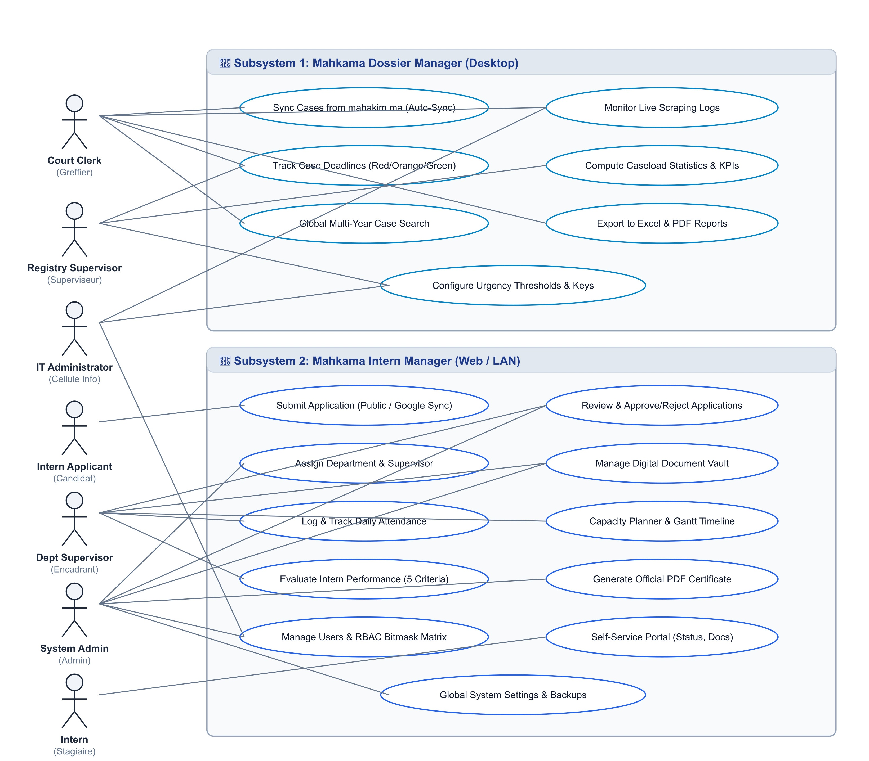
Figure 2: Global System Use Case Diagram

3.2 Class Diagrams & SQLite Data Schema
The class diagrams (Figure 3) represent the data model of both applications. The Dossier Manager uses a lightweight file-based storage approach (JSON configuration, Excel files for dossiers, operations log), while the Intern Manager uses a full SQLAlchemy ORM model with SQLite for users, interns, documents, attendance, evaluations, and permissions.
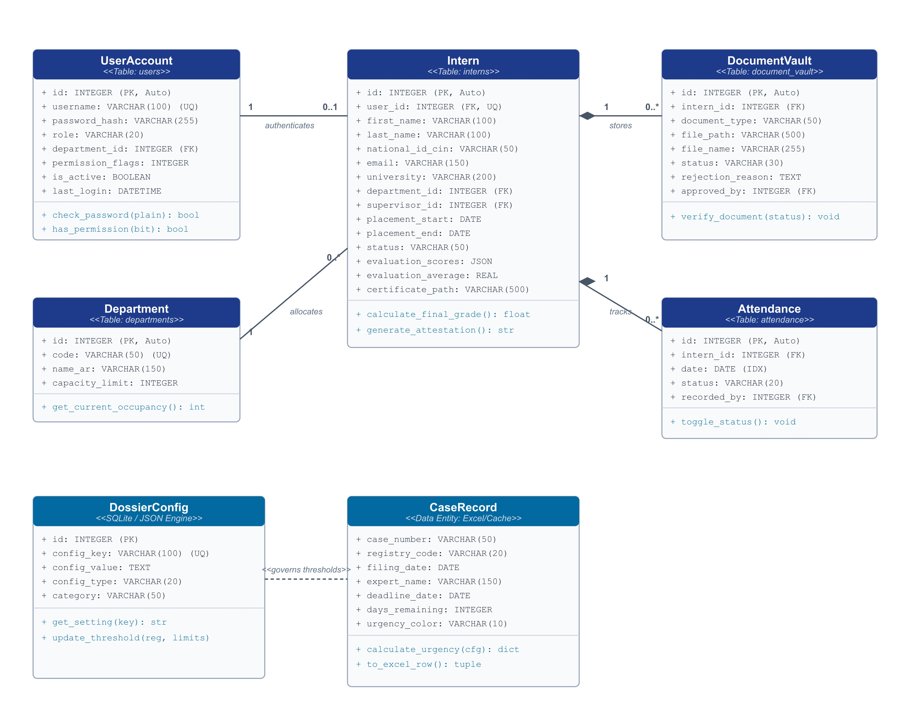
Figure 3: Relational Class Diagram & SQLite Data Structure

3.3 Implementation — Mahkama Dossier Manager
The Dossier Manager is a desktop application built on Flask + PyWebView. Its internal architecture comprises:
• launcher.py — Manages single-instance detection, free port selection, Flask thread startup, PyWebView window creation, and navigation within the existing window (no new windows).
• app.py — Flask backend exposing REST API endpoints for case retrieval, statistics, search, and file management.
• engine.py — Business logic layer: case processing, deadline calculation with configurable thresholds per registry number, urgency classification (red/orange/green), smart number matching with reversed format detection.
• sync_dossiers.py — CLI tool for manual synchronization triggered from the UI; invokes Playwright to authenticate on mahakim.ma and scrape case data.
• sync_stats.py — CLI tool for computing activity statistics from downloaded Excel dossiers; produces summary tables by registry and period.
• static/ — Frontend assets (HTML, CSS, JavaScript) served by Flask and rendered in the PyWebView window.
To ensure the desktop user interface remains fully responsive during long-running scraping operations, the Playwright crawler executes in an asynchronous background worker thread. Live status messages and execution logs are captured and streamed in real time to the frontend Operations Log Modal via the /api/logs endpoint.
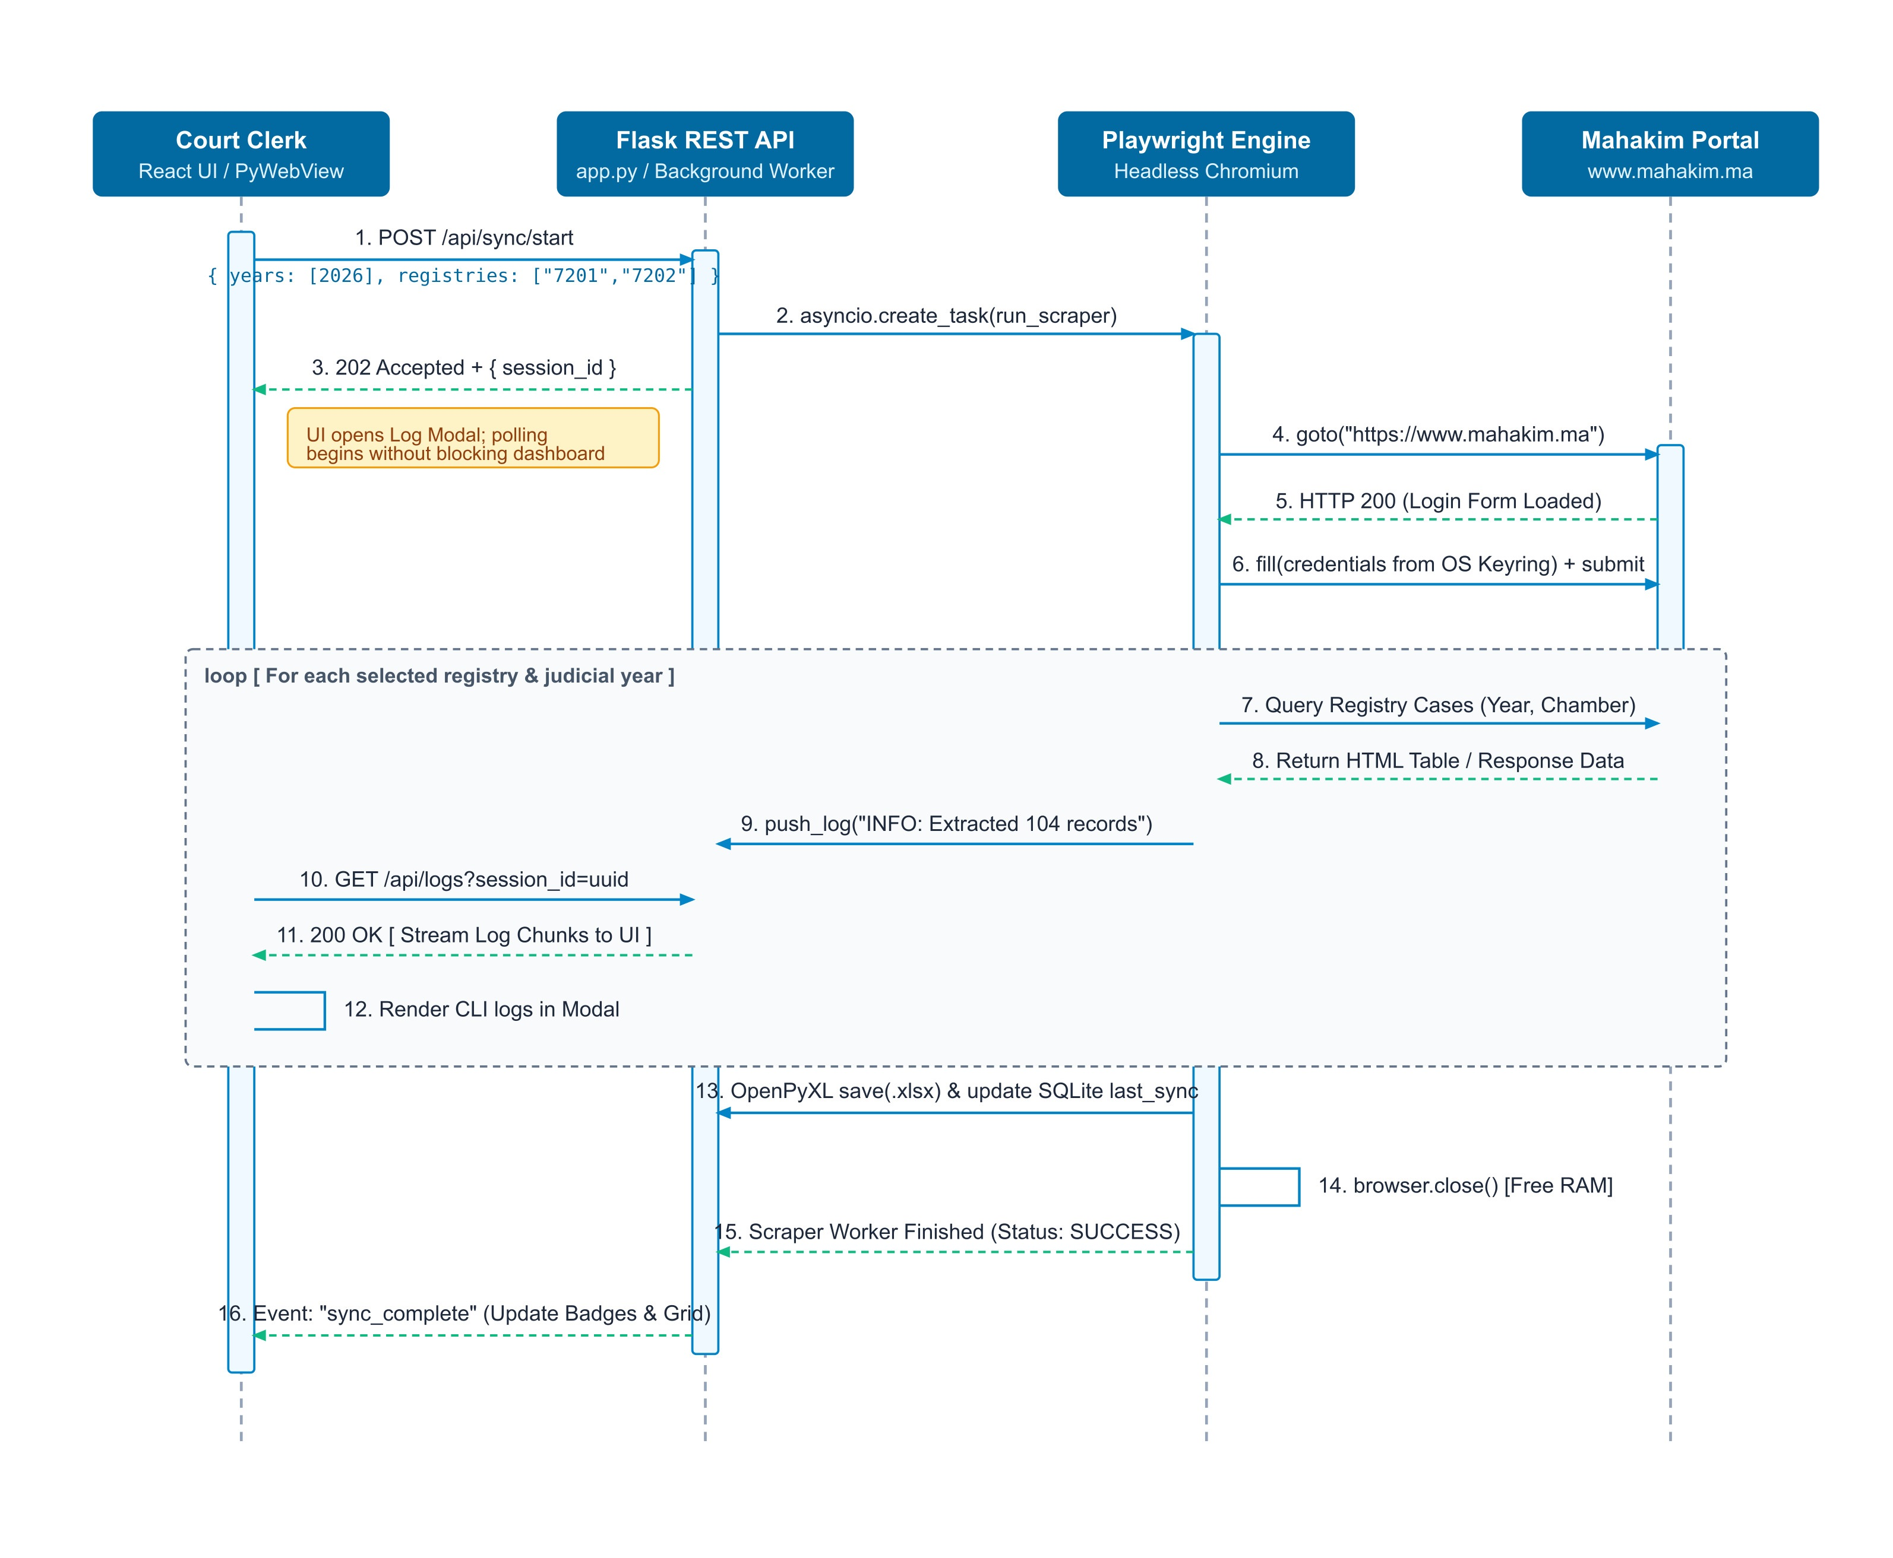
Figure 4: Sequence Diagram — Asynchronous Scraping & Log Streaming Pipeline

3.4 Implementation — Mahkama Intern Manager
The Intern Manager is a web application with a React 19 + TypeScript 5.7 frontend, a Flask REST API backend, and SQLite persistence. Key architectural features include:

• RESTful API design with JWT authentication and role-based access control at the route level.
• RBAC permission matrix (DEFAULT_PERMISSIONS) defining granular access for Admin, Manager, and Intern roles across 15+ modules.
• Document lifecycle management with tracking (MISSING → AWAITING_RETURN → RETURNED → PENDING_REVIEW → REVISION_REQUESTED → APPROVED_AND_SIGNED).
• Google Forms integration for public application submission, with automatic import of submitted applications into the database.
• Bilingual interface supporting Arabic (RTL) and French (LTR) with instant language switching.
• Attendance register with daily presence logging and monthly statistics calculation.
• Gantt timeline planner showing intern placements across departments with capacity visualization.

All client requests sent to the Intern Manager API must provide a valid JSON Web Token (JWT). An incoming request is intercepted by the server-side authentication gateway, which validates the cryptographic signature, checks token expiration, and evaluates the user's RBAC permission bitmask before permitting access to protected database operations.
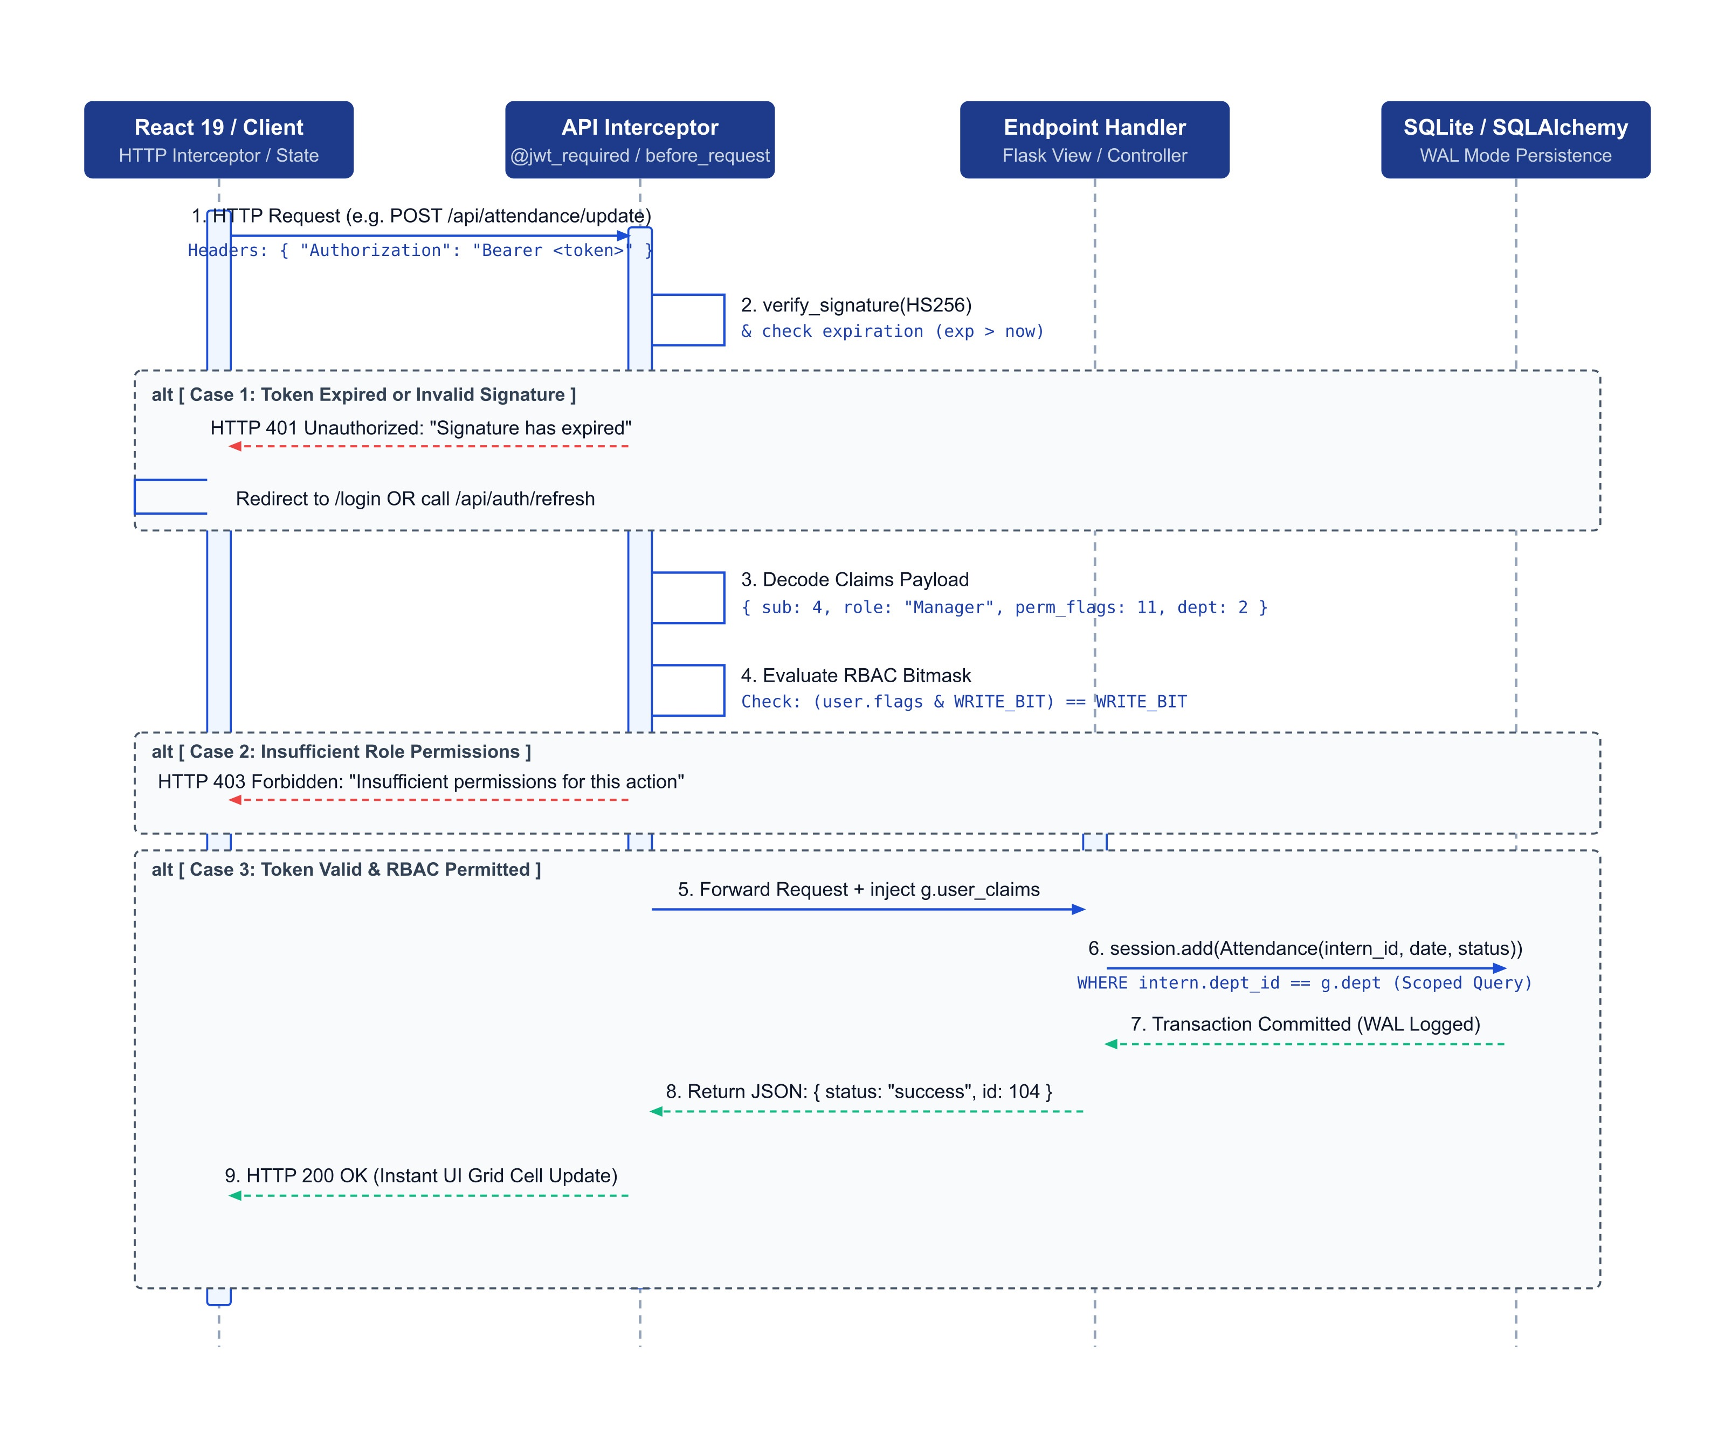
Figure 5: Sequence Diagram — JWT Authentication & RBAC Authorization Interceptor

3.5 Technical Difficulties & Resolved Solutions
During development, several technical difficulties were encountered and resolved:

• Single-instance and launch problems (Dossier Manager): AttributeError on webview.api at module scope, blank UI on launch due to Flask not ready before window creation, and second-instance spawning on feature clicks. Resolved by removing module-level API reference, polling Flask readiness before window creation, and replacing create_window() with evaluate_js() navigation on the existing window.
• Download blockers in PyWebView/WebView2: file download via browser APIs failed due to security restrictions. Resolved by implementing server-side file writing with path return to the frontend, which then opens the file directly.
• Concurrency and threading issues: threading.Lock vs RLock caused deadlocks during simultaneous operations. Resolved by careful lock hierarchy design and operation cancellation mechanisms.
• Build and packaging: PyInstaller spec configuration, handling of hidden imports, and asset bundling required several iterations. The final mahkama.spec produces a reliable single executable.
• Intern Manager Docker deployment on Windows (WSL2): SQLite WAL mode and file locking issues on WSL2 required configuration adjustments. Resolved by enabling WAL mode and configuring appropriate fallback behavior.

3.6 Test Scenarios & Validation Results
Both applications underwent functional testing before deployment. Table 6 present the test scenarios and results for the Dossier Manager and Intern Manager respectively.

Test Scenario | Expected Result | Status
Dossier sync from mahakim.ma portal | Cases downloaded and stored as Excel files; operations log updated | PASS
Deadline calculation for registry 7201 (limit=40, red=5, orange=15) | Correct days_remaining and color classification | PASS
Smart search with reversed case number format | Matches both normal and reversed formats | PASS
Statistics computation from 500+ cases | Accurate counts by registry and period | PASS
Excel export of statistics | Styled Excel file generated and openable | PASS
PDF print layout of case list | A4-formatted PDF with court header | PASS
Single-instance: second launch restores existing window | No duplicate window; existing window brought to front | PASS
Portal credentials stored and reused on next sync | No re-authentication required for subsequent syncs | PASS

Chapter 4: User Interface Walkthrough — Mahkama Dossier Manager
This chapter presents the implemented user interfaces of the Mahkama Dossier Manager, organized as multi-panel figures showing the actual deployed state of each interface. All screenshots were captured during real usage at the Administrative Court of Appeal of Fes in June 2026. Each figure is presented with annotated panels describing the key interface elements and their functionality.

4.1 Mahkama Dossier Manager Interfaces
Mahkama Dossier Manager is a desktop-wrapped web application for court clerks. The following figures present the key interfaces in their final deployed state, organized as multi-panel compositions (a), (b), (c), (d) where applicable. The application supports Arabic (RTL) as the primary interface language with French (LTR) as an alternative.

Figure 4.1: Scraper Orchestration Dashboard
The Home Dashboard is the main entry point of the Dossier Manager. It is divided into two sections: the top section provides card-based controls for configuring and launching the case synchronization process, while the bottom section provides workspace directory selection and the comprehensive file search engine.

Figure 4.1 (a) — Top Section: Card controls for case retrieval configuration.
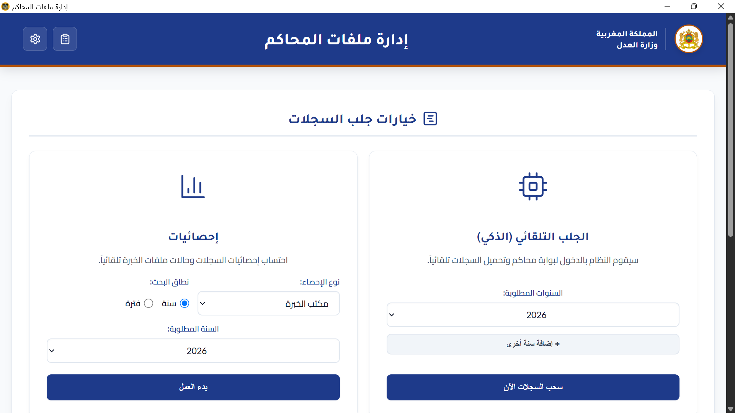
Figure 4.1 (a): Home Dashboard — Top Section

Figure 4.1 (b) — Bottom Section: Workspace directory selector and comprehensive search.
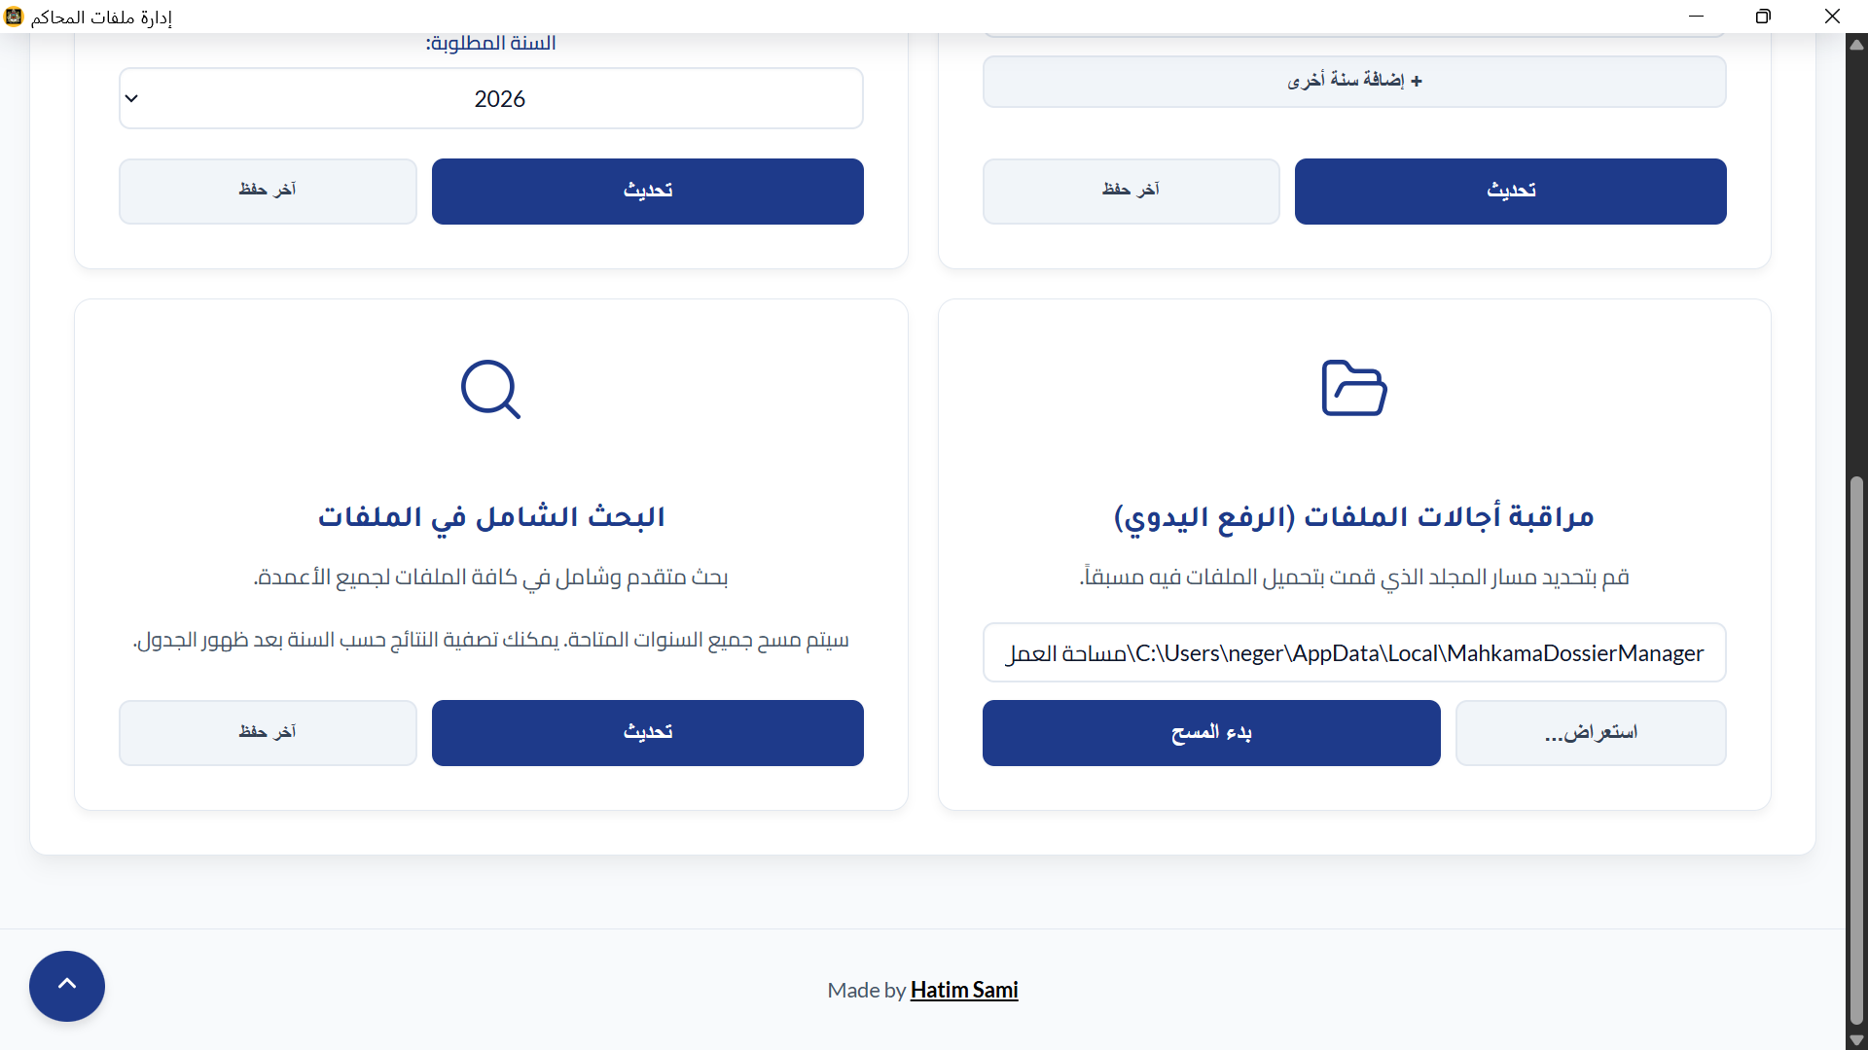
Figure 4.1 (b): Home Dashboard — Bottom Section
Figure 4.2: Operations Log & Smart Auto-Sync Pipeline
The Operations Log Modal provides real-time visibility into the scraping and synchronization process, displaying CLI-style logs with copy-enabled entries. The Smart Auto-Sync Progress overlay shows active synchronization status with a circular progress indicator and detailed terminal information.

Figure 4.2 (a) — Operations Log Modal: Dark terminal-style console showing scraping logs.
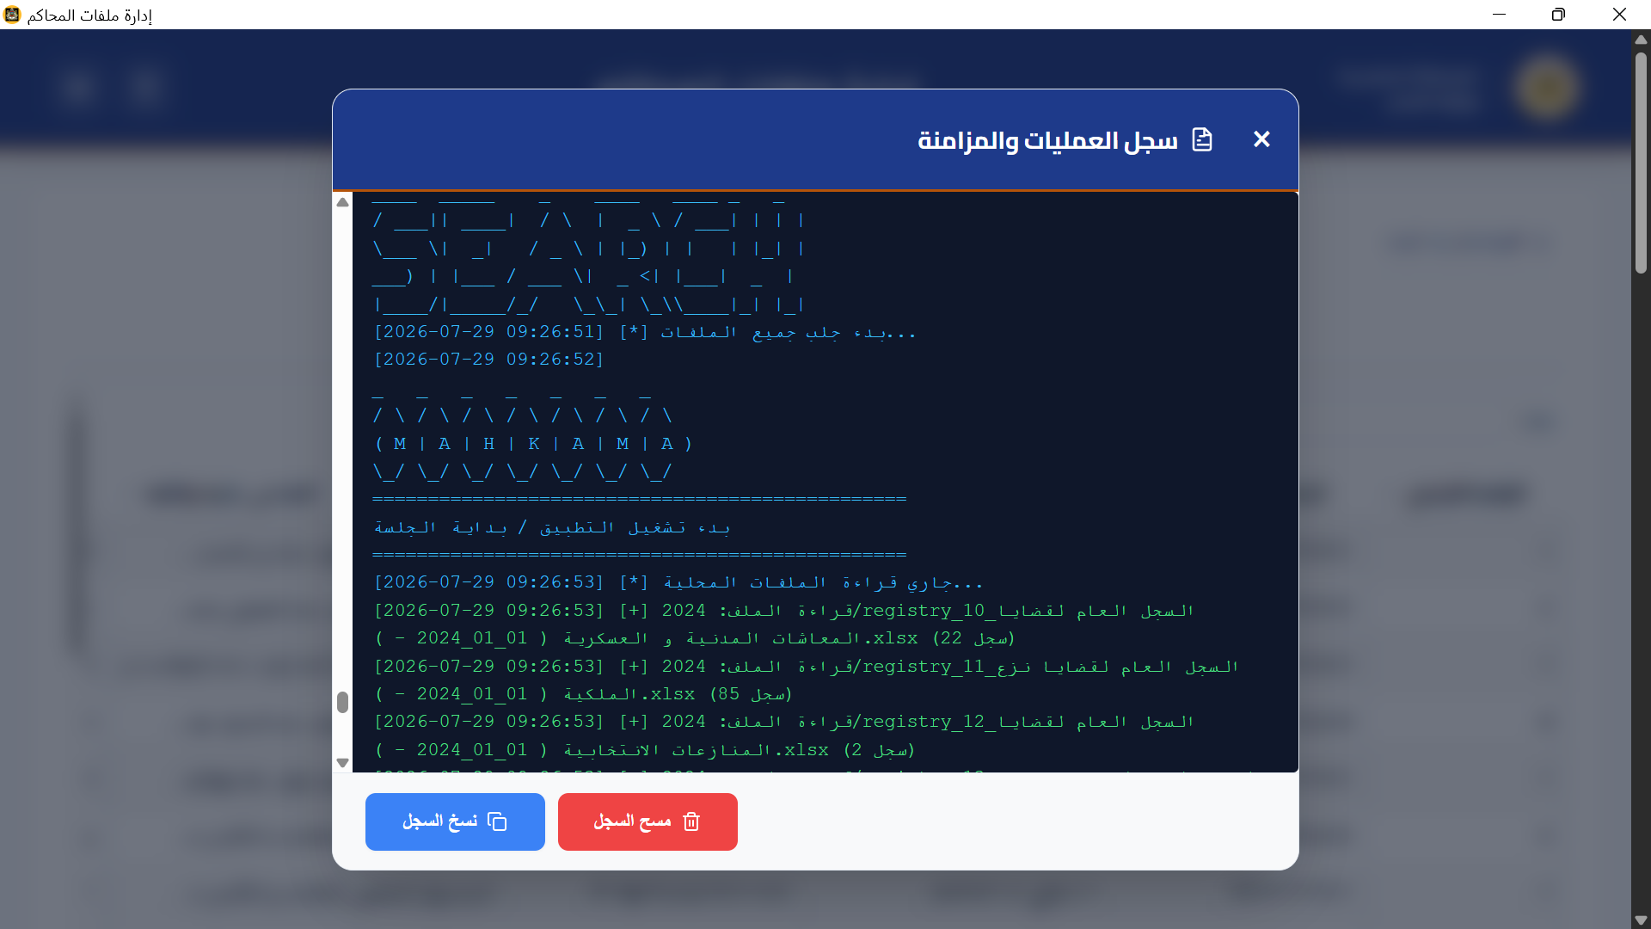
Figure 4.2 (a): Operations Log Modal (Dark terminal console showing CLI scraping logs and copy buttons)

Figure 4.2 (b) — Smart Auto-Sync Progress: Modal overlay with circular spinner.
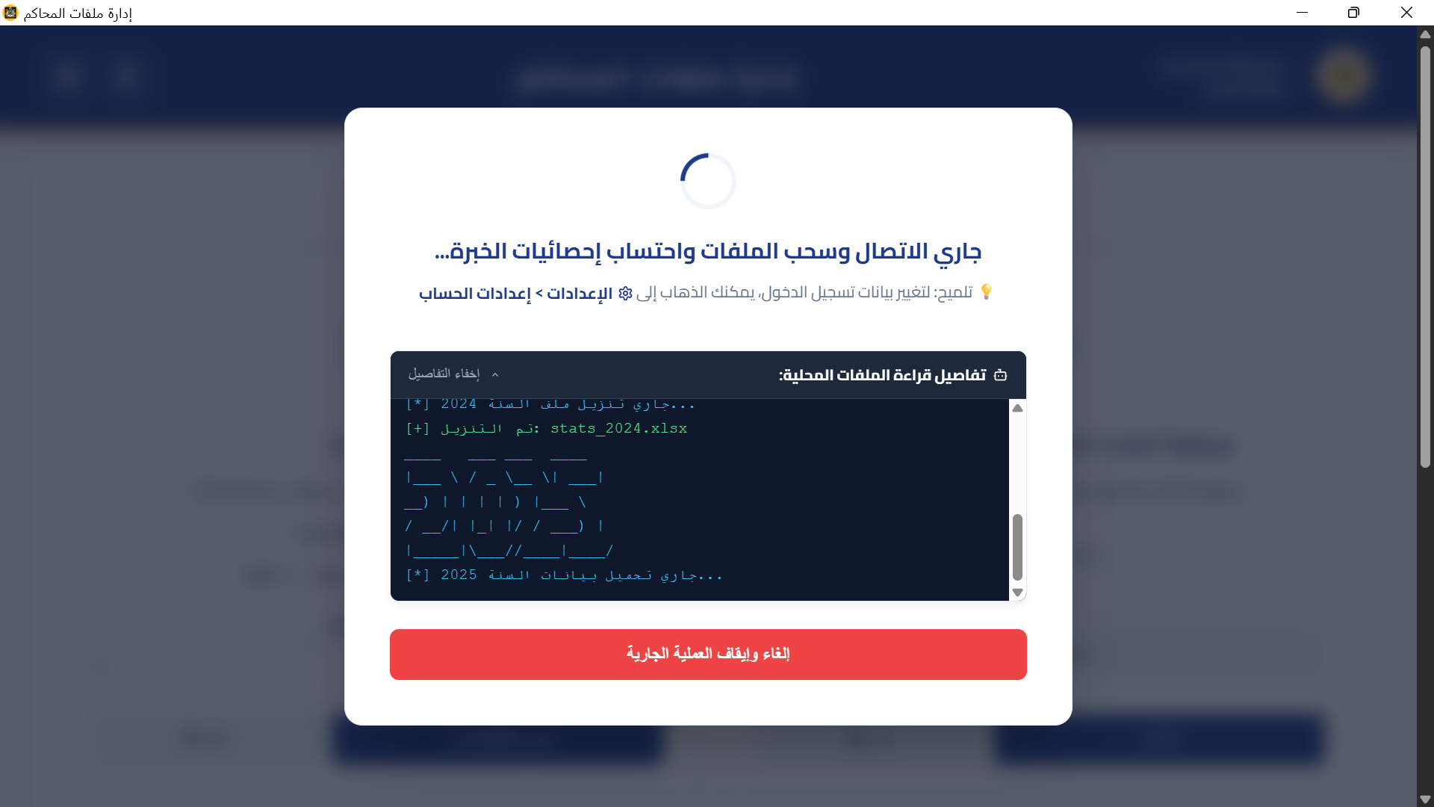
Figure 4.2 (b): Smart Auto-Sync Progress

Figure 4.3: Multi-Format Export Flow
The Statistics module provides a complete workflow from synchronization progress tracking through results visualization, detailed case breakdown, and print-ready PDF export. The following four panels show the complete flow.

Figure 4.3 (a) — Statistics Results Dashboard: 5 KPI metric cards with "93 يوم" average resolution.
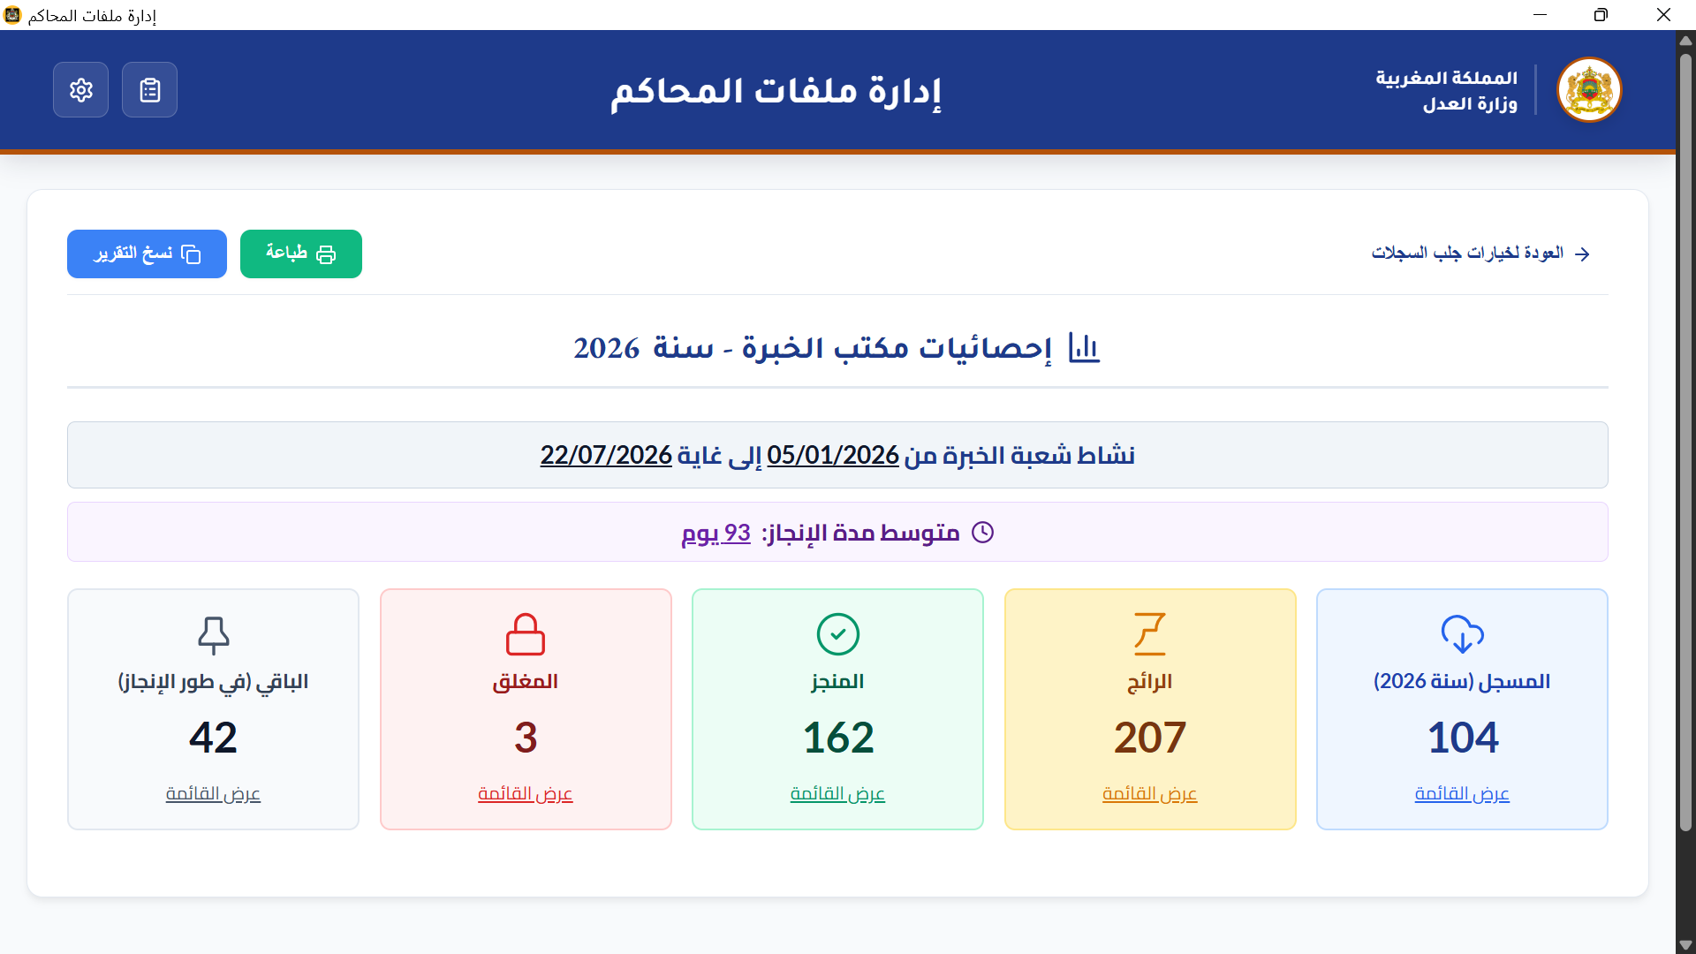
Figure 4.3 (a): Statistics Results Dashboard

Figure 4.3 (b) — Case List Breakdown Grid: Table view with case numbers, judges, and experts.
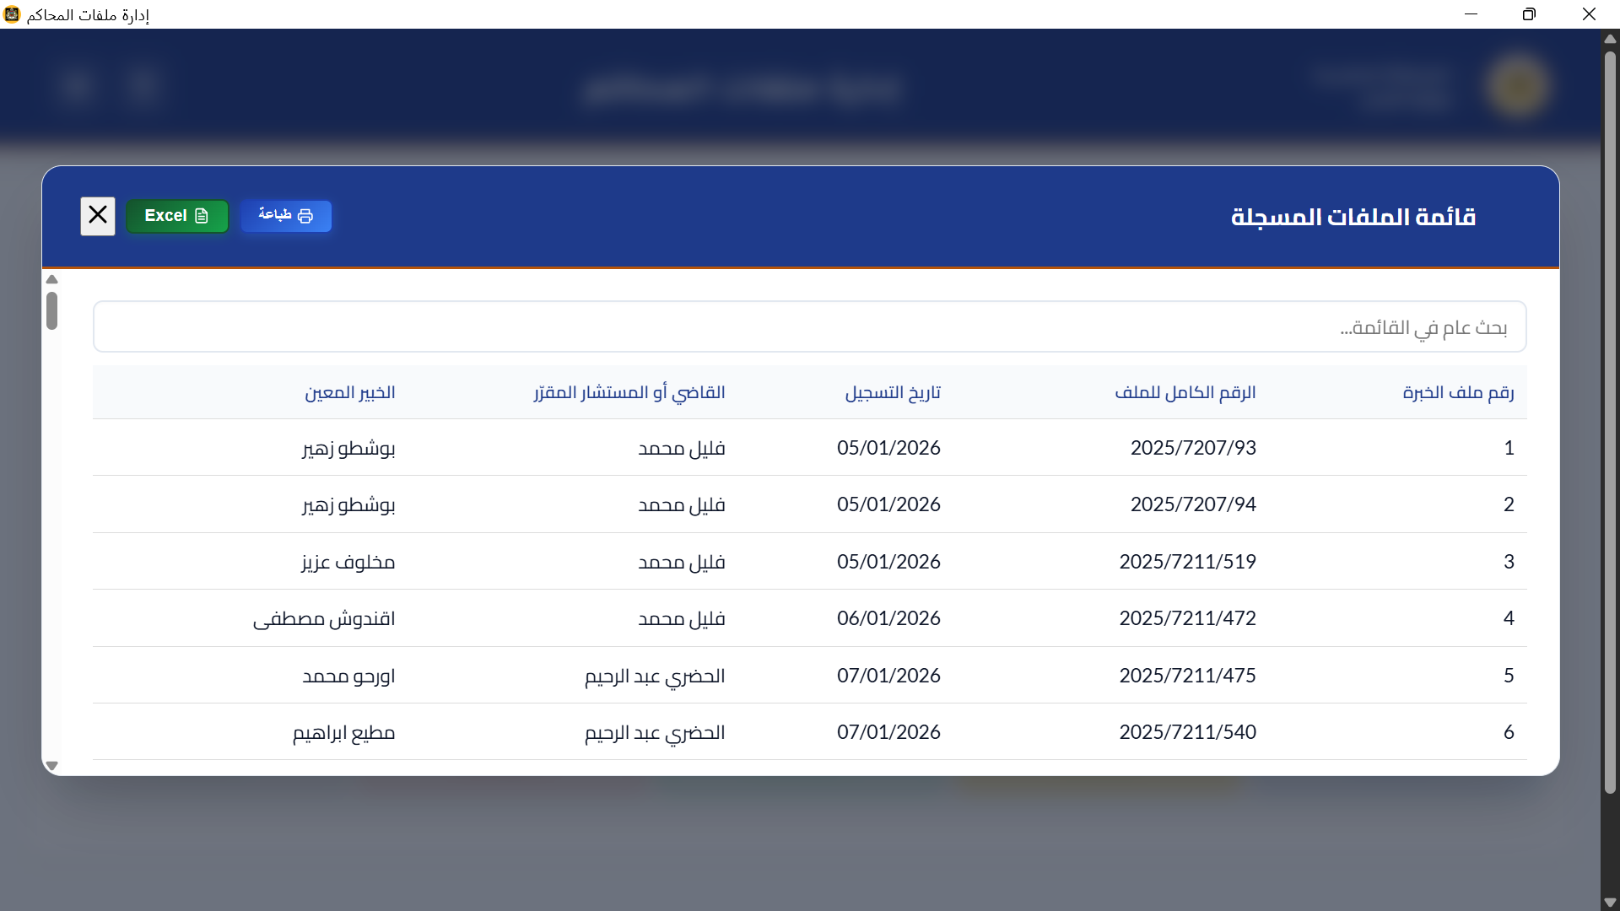
Figure 4.3 (b): Case List Breakdown Grid

Figure 4.3 (c) — Print-Ready PDF Case List Report: A4 layout printer dialog.
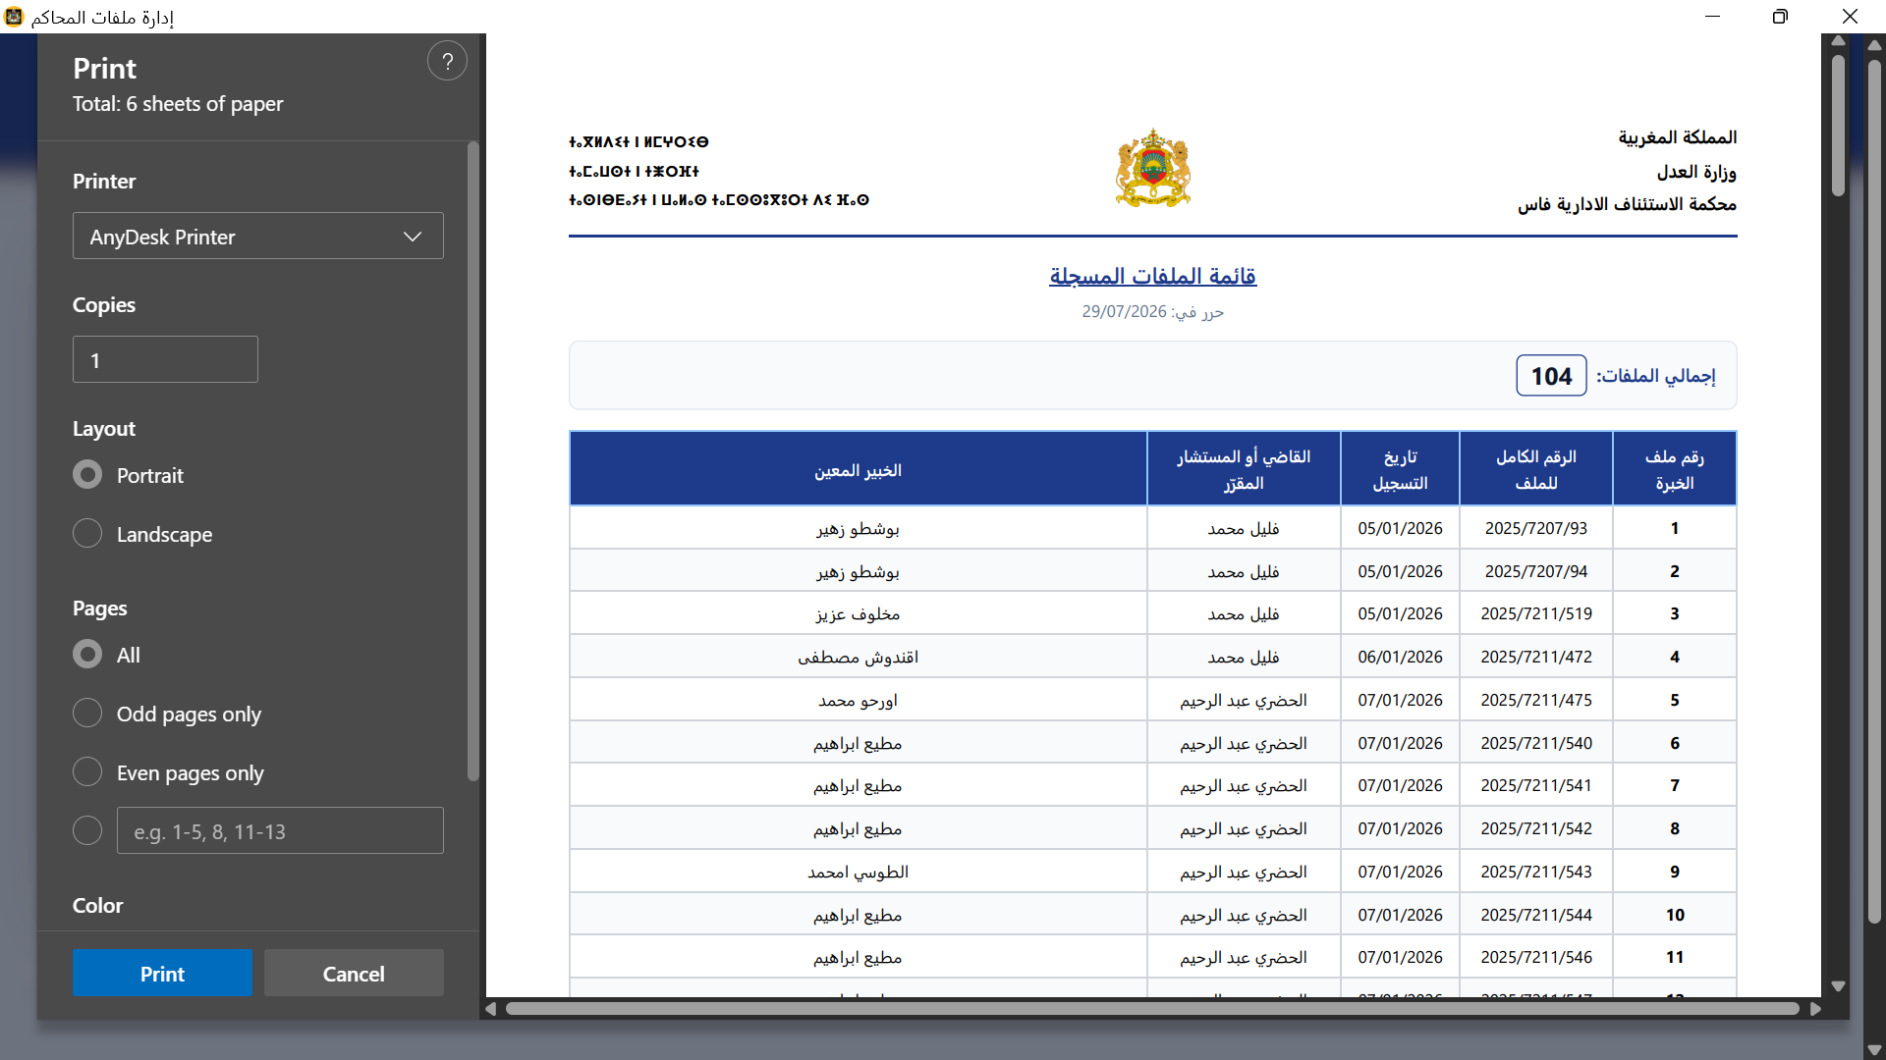
Figure 4.3 (c): Print-Ready PDF Case List
Figure 4.4: Excel & PDF Export Validation Suite
The export functionality is validated through a three-panel sequence: the Excel export saving dialogue with confirmation, the resulting dark-mode Excel worksheet, and the print-ready PDF statistics report.

Figure 4.4 (a) — Excel Export Saving Dialogue: Popup modal with green checkmark.
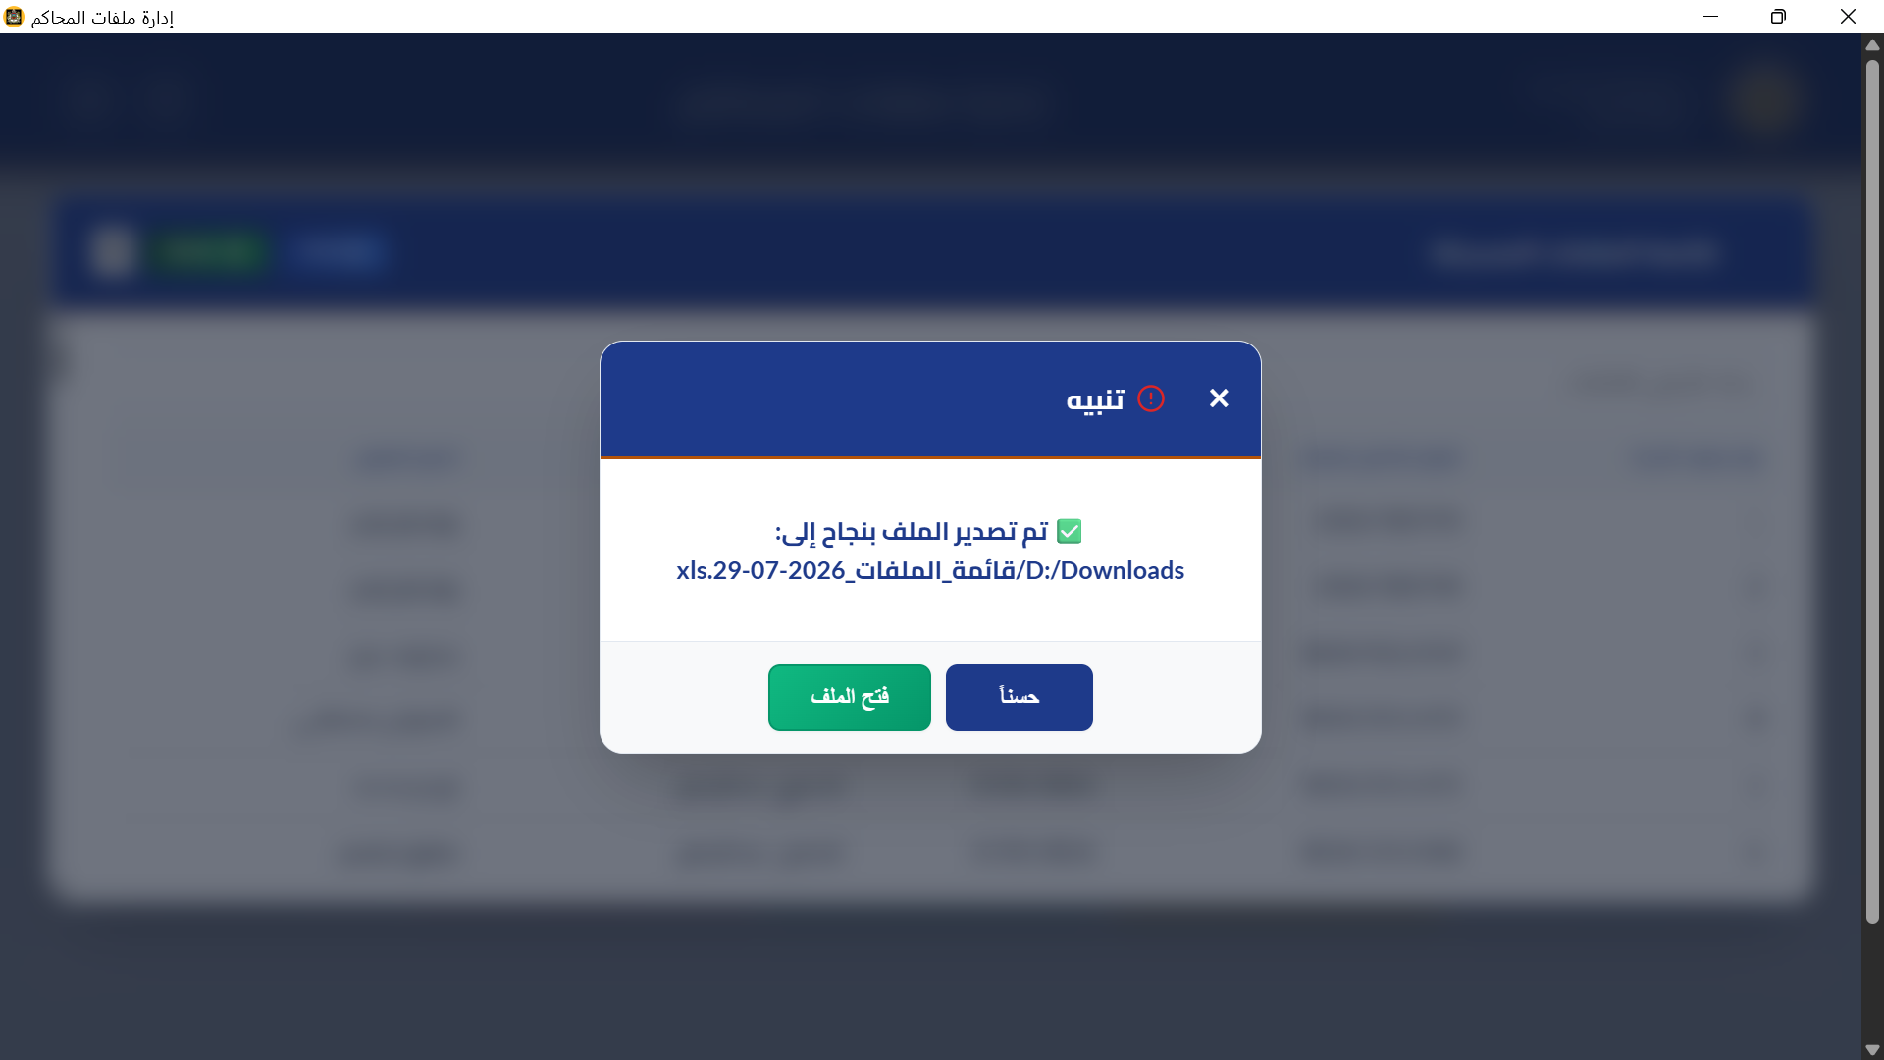
Figure 4.4 (a): Excel Export Saving Dialogue

Figure 4.4 (b) — Exported Excel Worksheet: Dark-mode Microsoft Excel window.
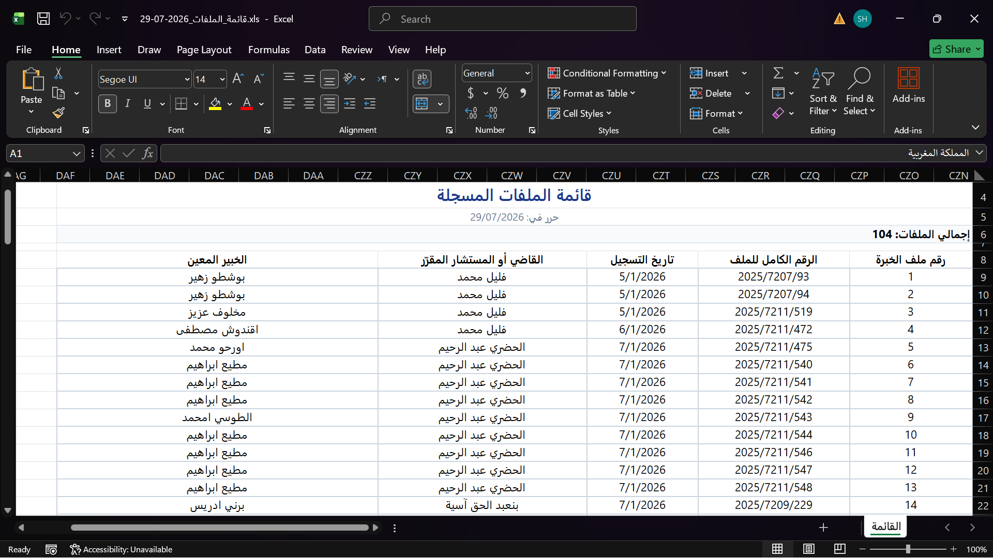
Figure 4.4 (b): Exported Excel Worksheet

Figure 4.4 (c) — Print-Ready PDF Overall Statistics Report.
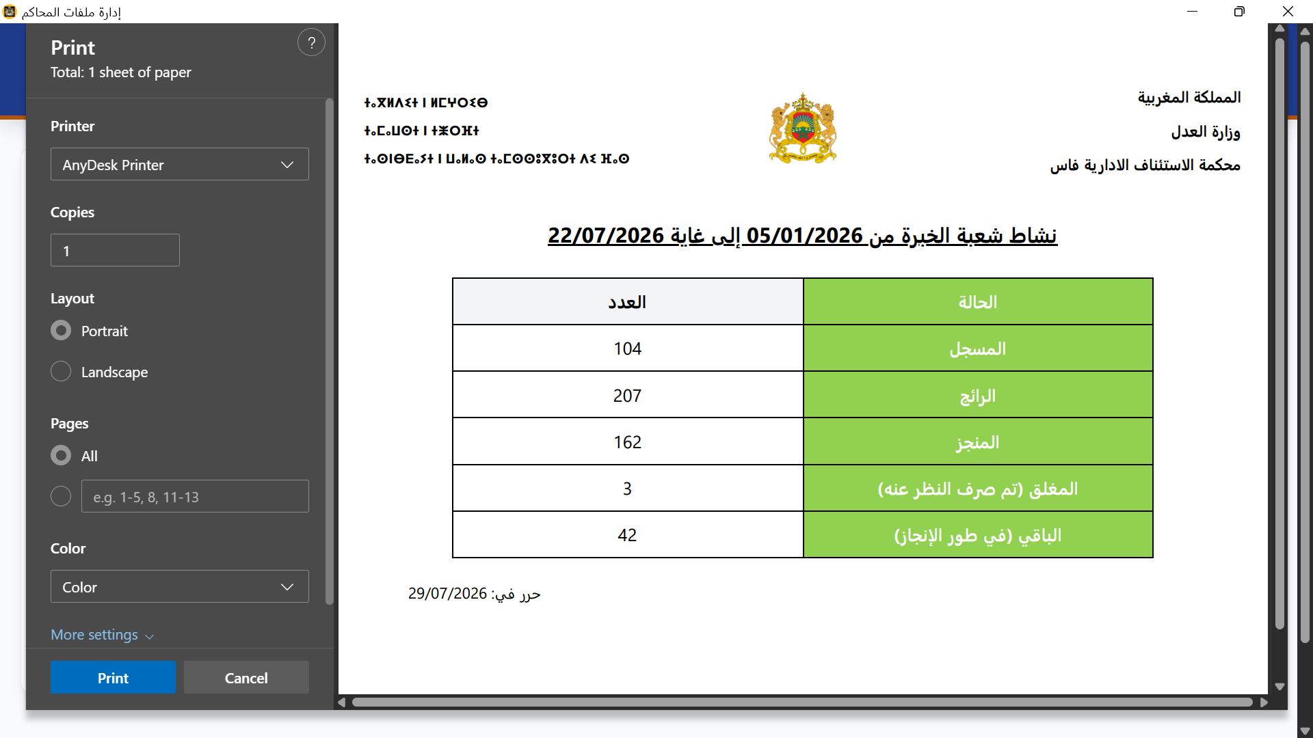
Figure 4.4 (c): Print-Ready PDF Overall Statistics Report

Figure 4.5: Deadline Monitor with Color-Coded Alert System
The Deadline Monitor is the central operational tool for court clerks. It presents all active dossiers in a color-coded table with urgency indicators, checkboxes for selection, and detailed warning states. The following four panels cover the complete deadline monitoring workflow.
Figure 4.5 (a) — Deadline Monitor: General View.
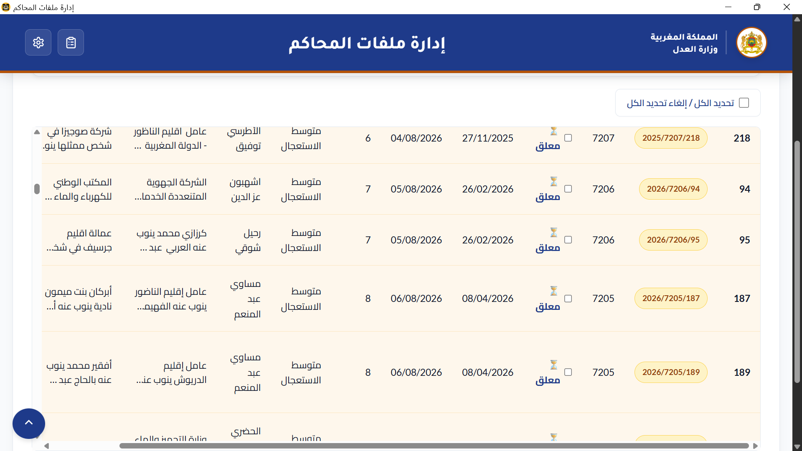
Figure 4.5 (a): Deadline Monitor — General View (Color-coded caseload table with check-boxes)
Figure 4.5 (b) — Critical & Expired Warnings.
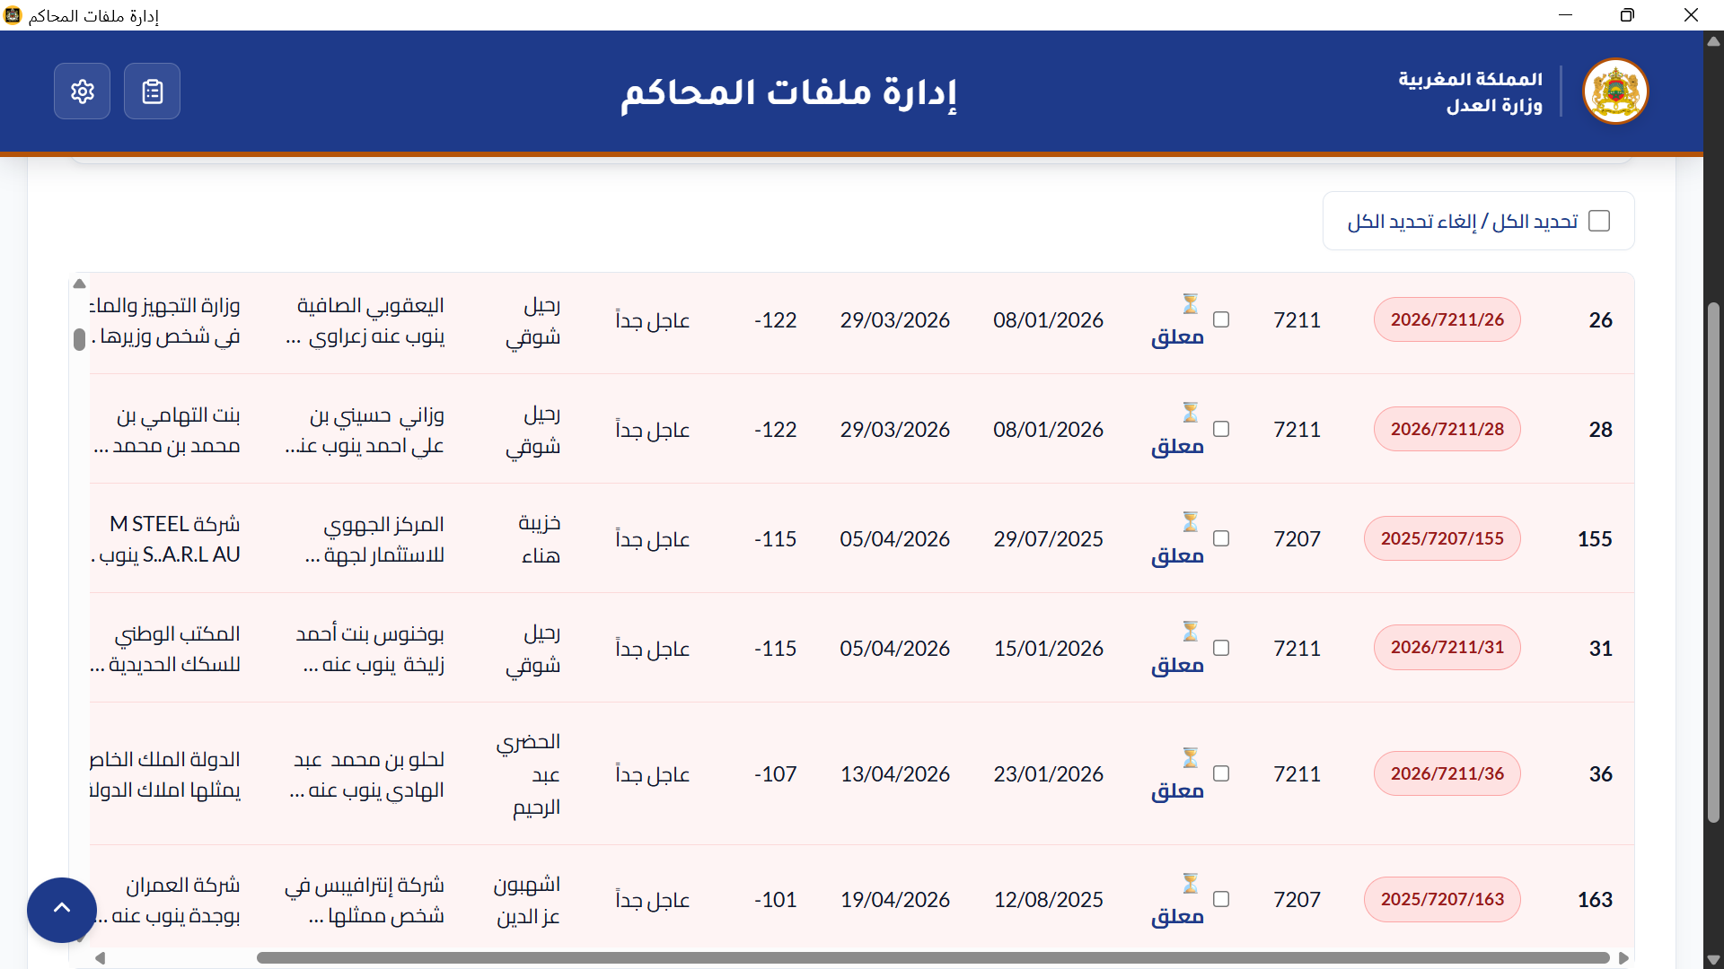
Figure 4.5 (b): Deadline Monitor — Critical & Expired Warnings

Figure 4.5 (c) — Timely & Safe Indicators.
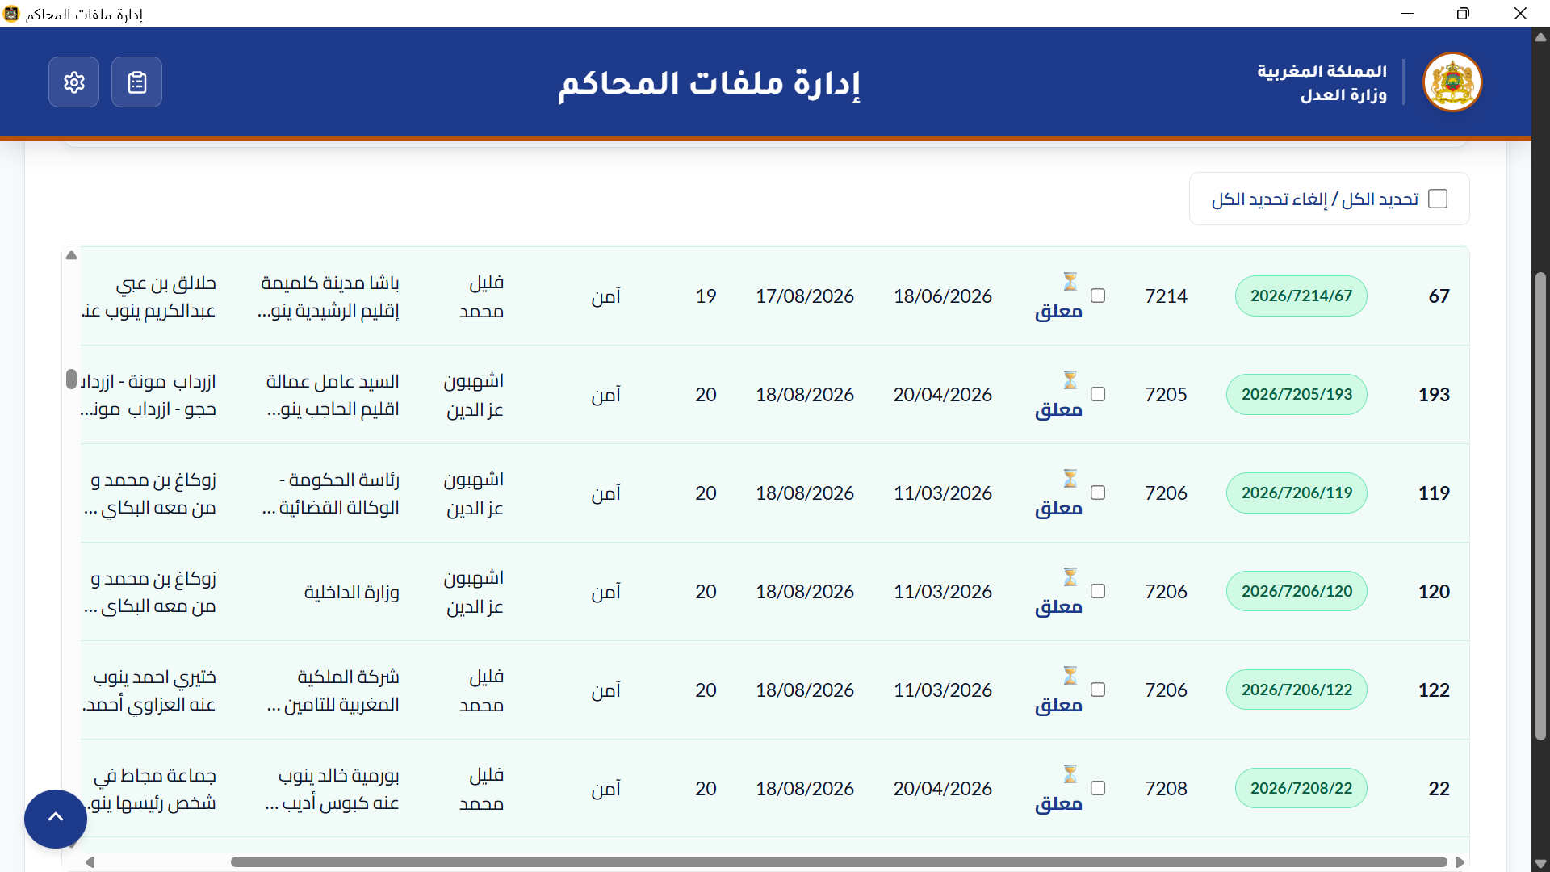
Figure 4.5 (c): Deadline Monitor — Timely & Safe Indicators

Figure 4.5 (d) — Active Dossier Print Report: Print dialog preview .
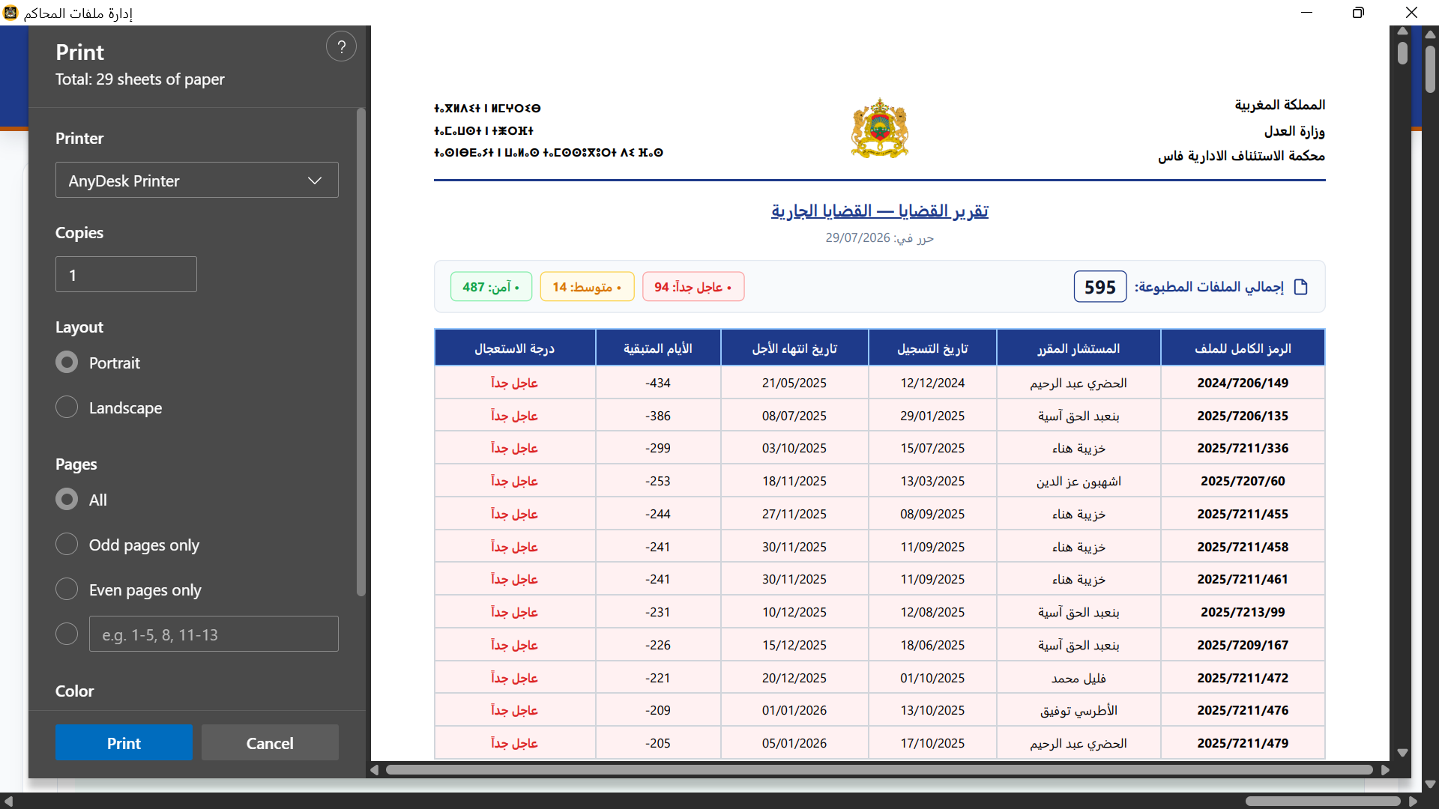
Figure 4.5 (d): Active Dossier Print Report

Chapter 5: User Interface Walkthrough — Mahkama Intern Manager
Mahkama Intern Manager is a secure, role-based web application that manages the complete intern lifecycle. All interfaces support both LTR (French) and RTL (Arabic) layout directions with instant language switching. The following figures present the complete user interface catalog, organized by functional module.

5.1 Mahkama Intern Manager Interfaces
Figure 5.1: Admin Executive Dashboard
The Admin Executive Dashboard is the command center for system administrators. It displays four KPI cards summarizing key metrics and a pending registration requests table ("طلبات التسجيل المعلقة") for review and action.

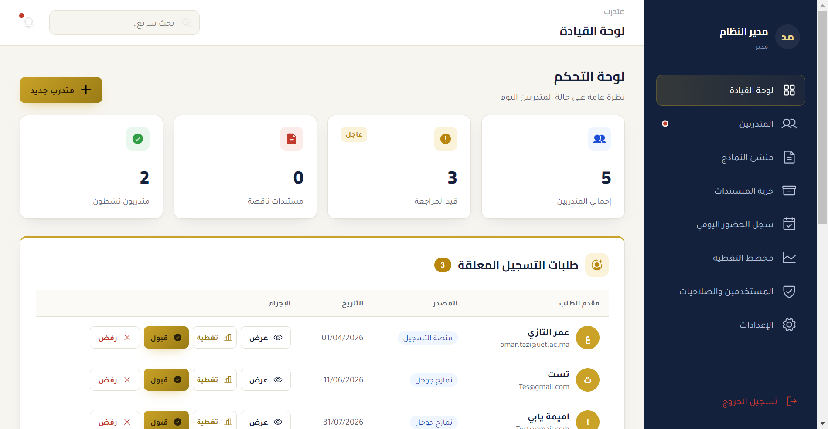
Figure 5.1: Admin Executive Dashboard

Figure 5.2: Intern Directory & Status Filters
The Intern Directory provides a comprehensive grid of intern profile cards with status pills (pending, approved, active, completed) and filters by date range and department. Administrators can quickly locate and manage interns across all departments.

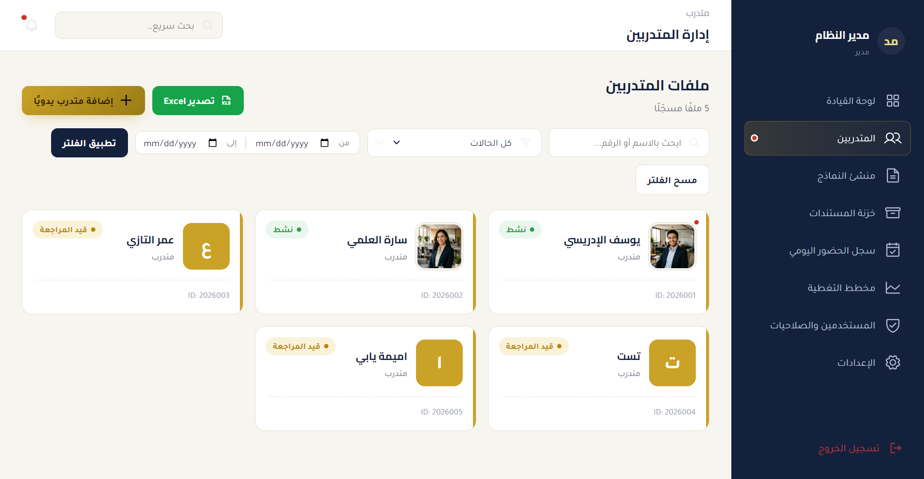
Figure 5.2: Intern Directory & Status Filters

Figure 5.3: Intern Profile & Evaluation Matrix
The Intern Profile view presents a split-panel layout showing the intern's photo and personal details on one side, and a 5-criteria performance evaluation matrix with visual grading sliders on the other. Each criterion is scored out of 4 points, for a maximum total of 20 points.

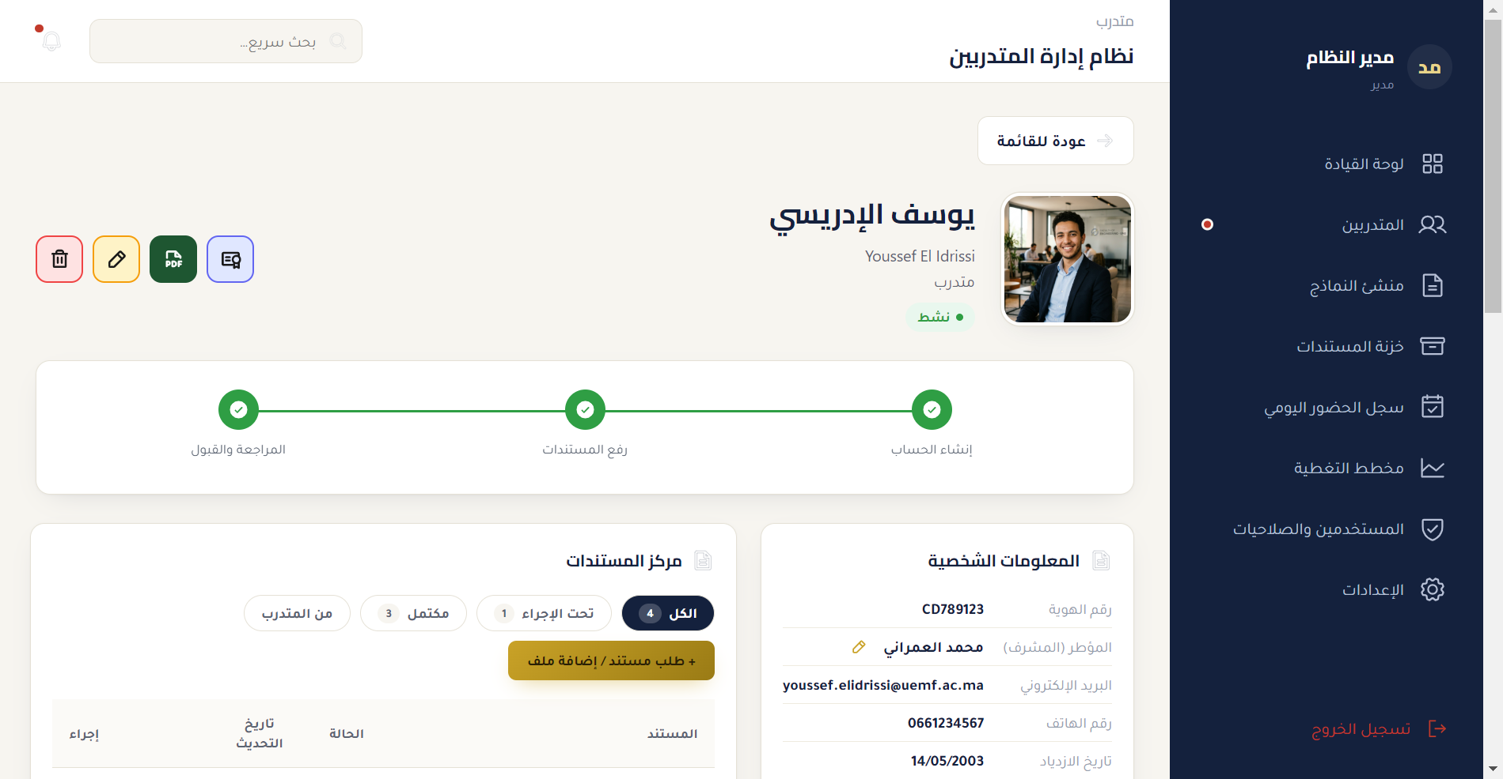
Figure 5.3: Intern Profile & Evaluation Matrix

Figure 5.4: Form Builder & Google Forms Sync
The Form Builder interface allows administrators to create and manage public application forms. Two standard forms are shown: "التسجيل للتدريب المهني" (Professional Training Registration) and "طلب تدريب صيفي" (Summer Training Request). The Google Forms integration synchronizes submitted applications automatically.

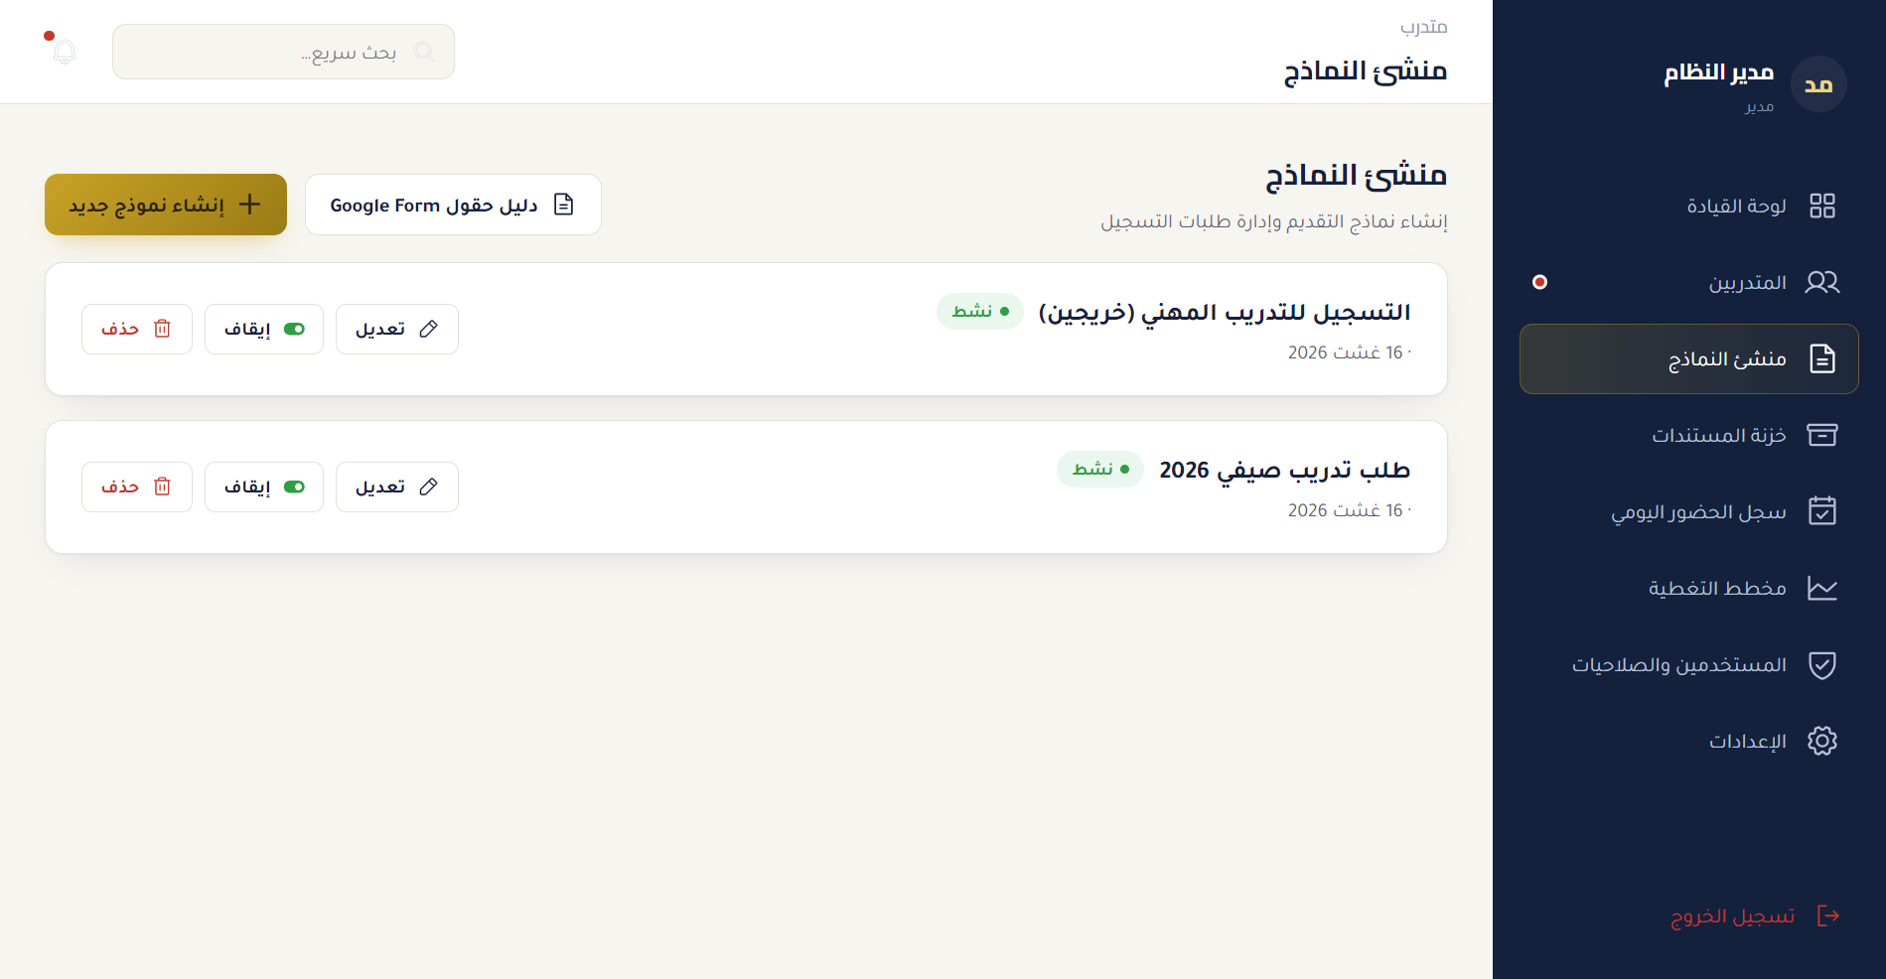
Figure 5.4: Form Builder & Google Forms Sync

Figure 5.5: Document Vault Management
The Document Vault provides a centralized file grid showing uploaded documents with PDF and Word icons. Sample documents include "طلب التدريب" (Training Request), "test_doc", and "Attestation de stage" (Internship Certificate). Documents can be uploaded, versioned, approved, and archived through a complete lifecycle workflow.

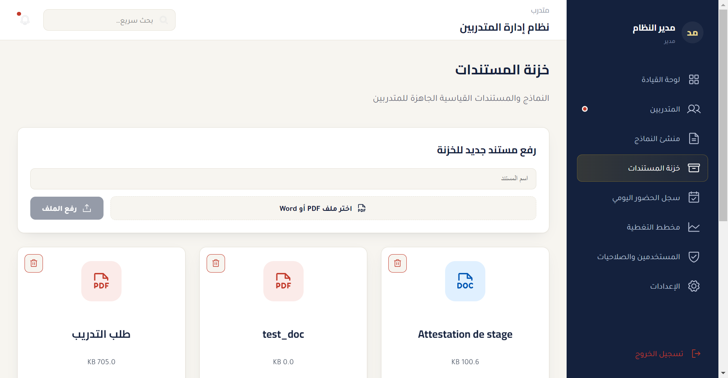
Figure 5.5: Document Vault Management

Figure 5.6: Attendance Register & Calendar Logs
The Attendance Register provides a monthly presence logger showing attendance dates in Arabic format (e.g., "تاريخ الحضور 16/08/2026") and a detailed attendance table. Administrators can record daily presence, absences, and leave for each intern, with automatic monthly hour calculations.

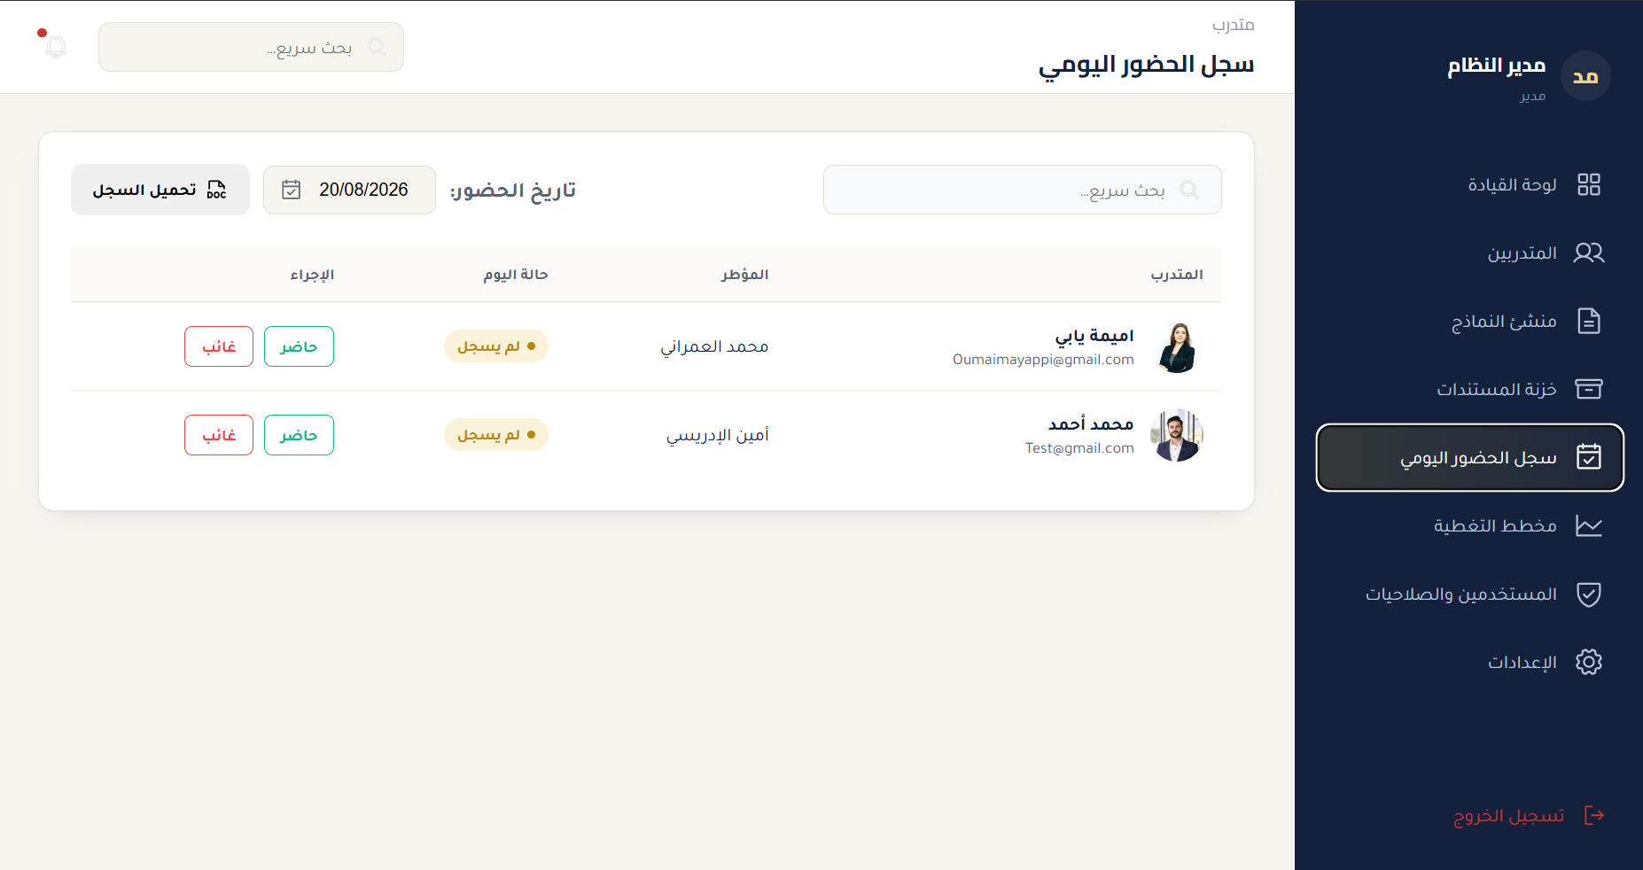
Figure 5.6: Attendance Register & Calendar Logs

Figure 5.7: Timeline & Gantt Capacity Planner
The Timeline & Gantt Capacity Planner displays a dual-month calendar view (August/September 2026) with horizontal timeline bars for each intern placement. The Gantt chart shows X-axis (time timeline in weeks/months, zoomable), Y-axis (departments as rows), and color-coded bars spanning from start date to end date for each intern.

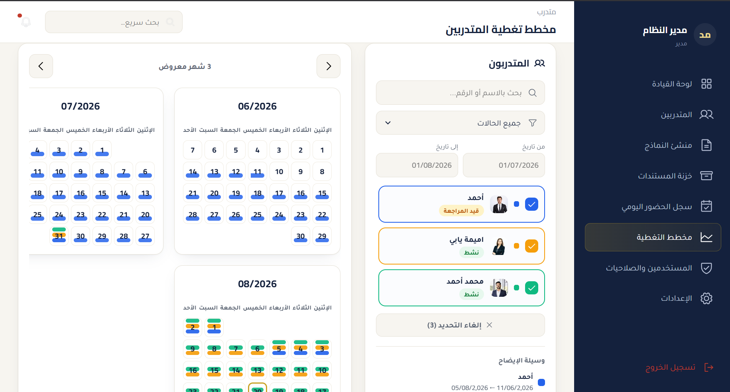
Figure 5.7: Timeline & Gantt Capacity Planner

Figure 5.8: Authentication & Access Control
The Authentication interface presents a RTL login screen for Arabic-first users, with password management capabilities. The login form supports both Arabic and French interface directions and integrates with the JWT-based authentication system. Password management enables administrators to configure and reset user credentials.

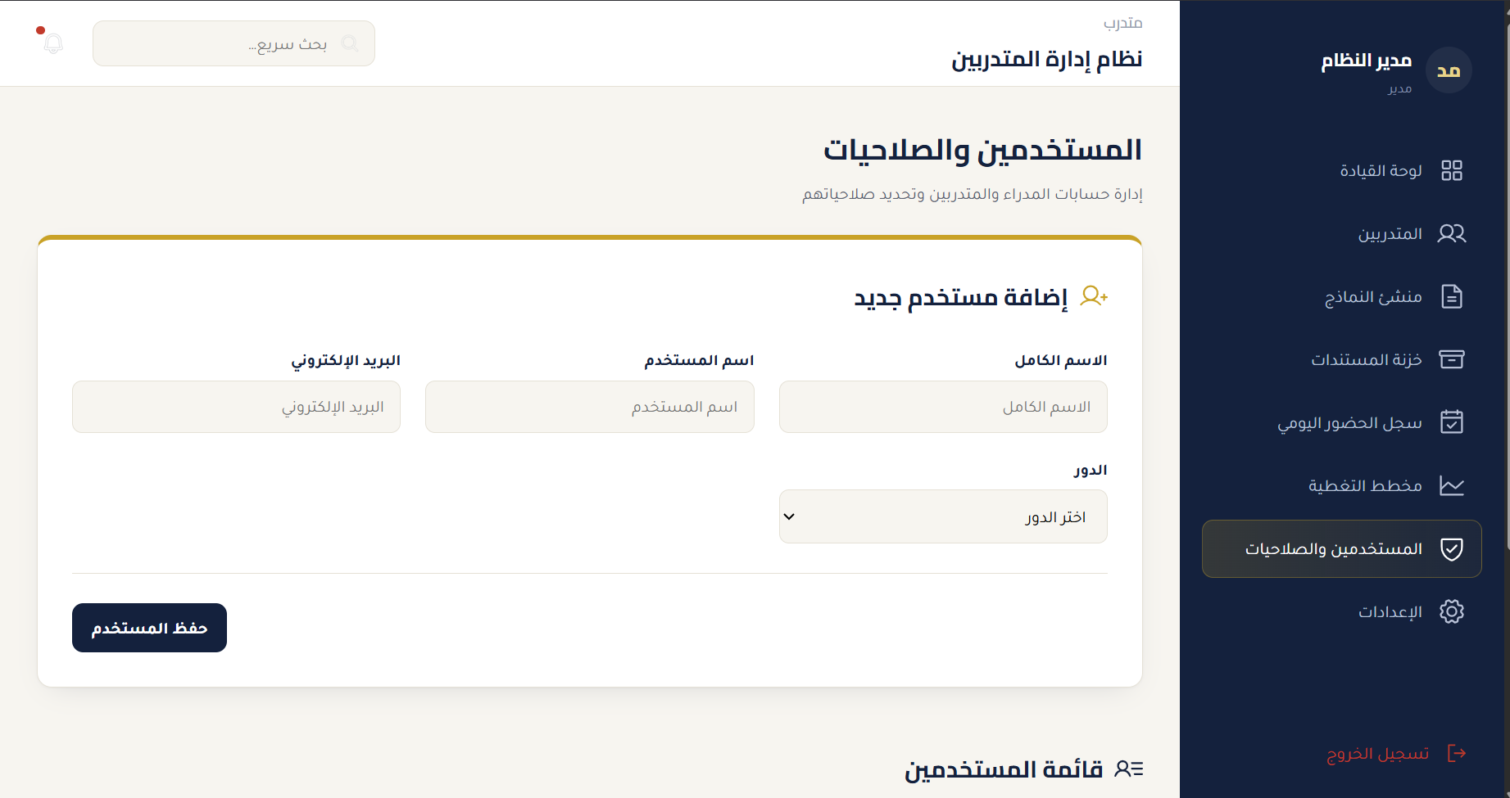
Figure 5.8: Authentication & Access Control

Figure 5.9: Scoped User Portals & Permissions
The Scoped User Portals demonstrate the role-based access control in practice. The figure shows two distinct views: the Department Manager portal with full supervisory capabilities (application review, intern assignment, evaluation, document approval) and the Intern Self-Service portal with limited access to personal status, document uploads, attendance records, and evaluation results. Each role sees only the modules and actions permitted by the RBAC permission matrix.

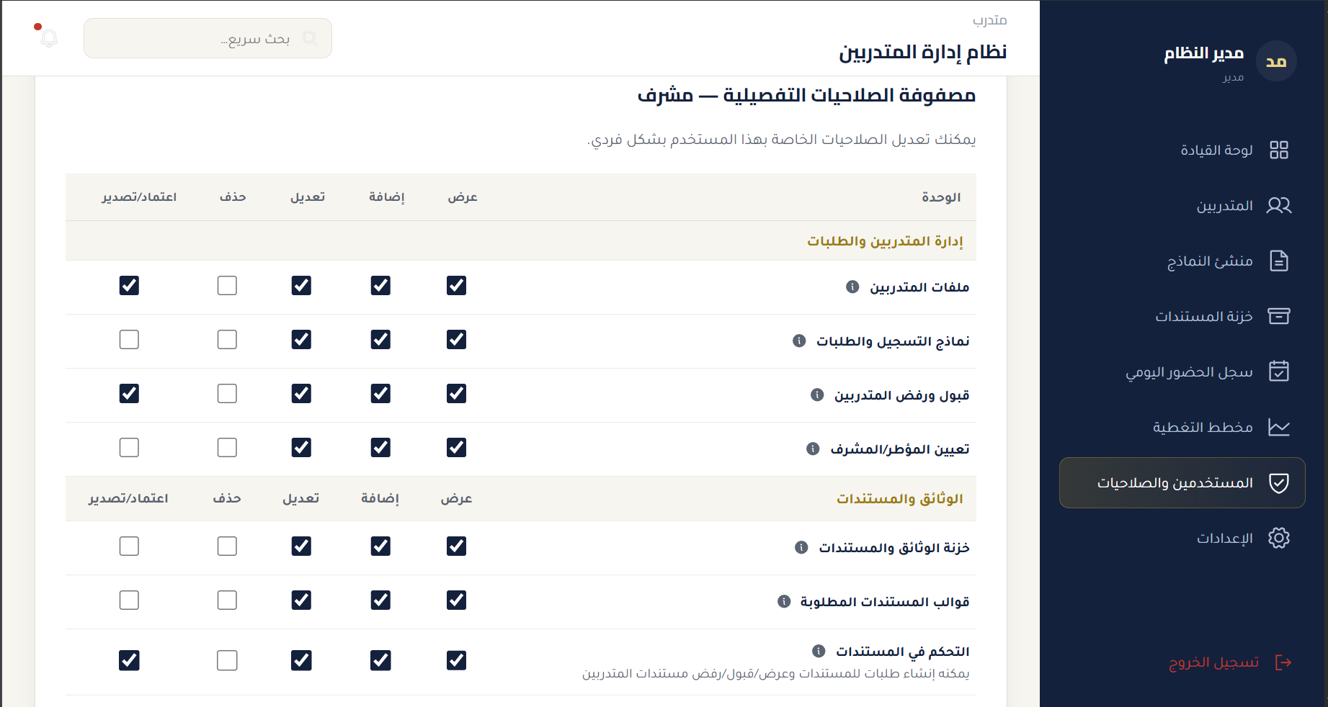
Figure 5.9: Scoped User Portals & Permissions
Figure 5.10: Admin System Settings
Configures external connections, email parameters, and backups.
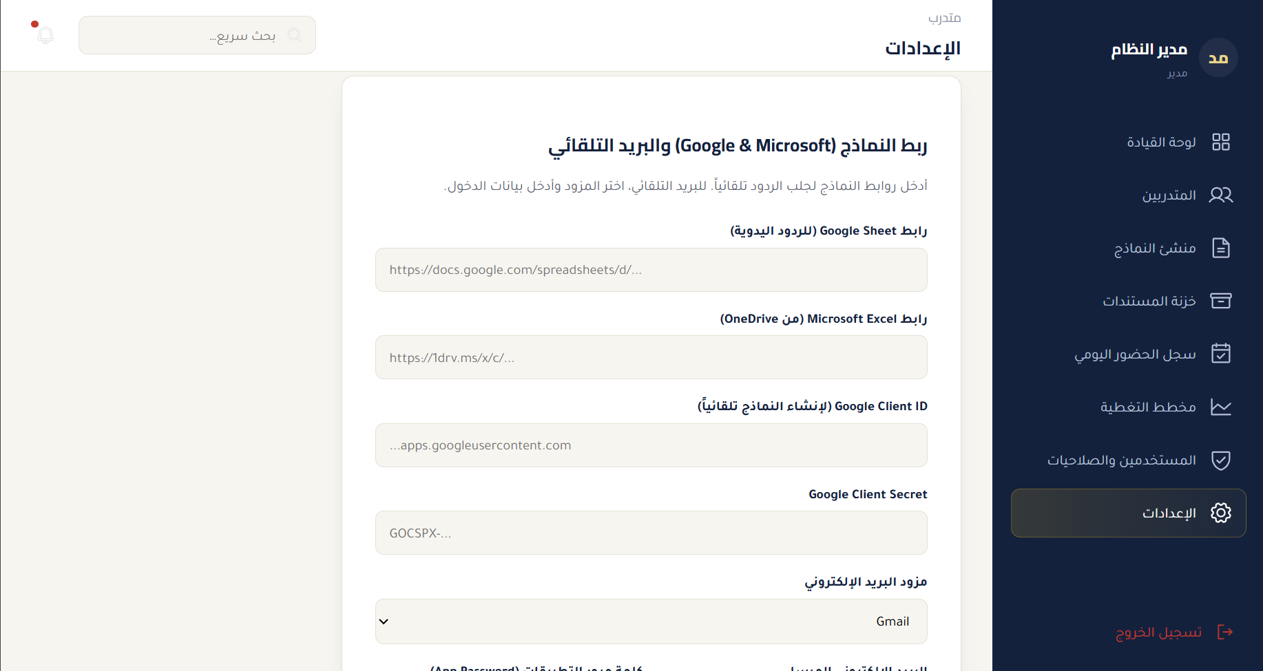
Figure 5.10: Admin System Settings

Figure 5.11: Intern Portal Dashboard
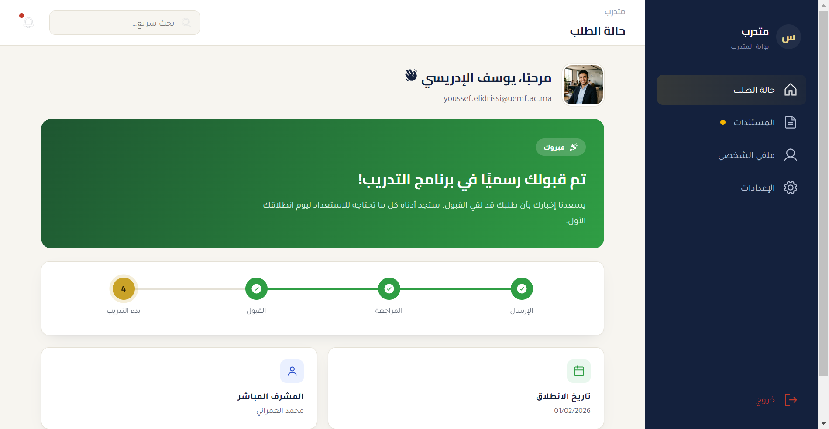
Figure 5.11: Intern Portal Dashboard

General Conclusion & Future Perspectives

Context and Project Recall
This technical internship report presented the design and implementation of a court digitalization software suite, developed during a one month internship (June – July 2026) at the IT Department of the Administrative Court of Appeal of Fes, under the supervision of Mr. El Gouarti Monsif and Mr. El Issaoui Naoufal.

The suite comprises two distinct but complementary applications, each addressing a need identified on-site:

1. Mahkama Dossier Manager: a desktop application (Python Flask + PyWebView) that automates judicial deadline monitoring, synchronization of data from the Ministry of Justice portal (www.mahakim.ma), statistics calculation, and global search in dossiers. It is used daily by court staff and distributed as a single Windows executable.
2. Mahkama Intern Manager: a web application (React 19 + TypeScript 5.7 + Flask REST API) with role-based access control (RBAC), which digitizes and automates the complete intern lifecycle — from application submission via Google Forms integration to certificate generation and archival, including document validation, attendance tracking, supervisor assignment, and performance evaluation. It is containerized via Docker and optionally available in Electron desktop mode.

Personal Contributions and Developed Competencies
This project was an exceptional opportunity to put into practice, in a real context and under constraints, all the competencies acquired during the Cybersecurity and Information Protection engineering cycle at Euromed University of Fes:

• Full-stack development: design and implementation of two complete applications, from user interface to backend, through data storage.
• Automation and web scraping: Playwright for authentication and data retrieval from a complex web portal (mahakim.ma).
• Data processing: Excel parsing without external dependencies, deadline calculation and classification, intelligent search matching, statistical report generation.
• Security: JWT authentication, RBAC with granular permissions, password hashing, token and session management.
• Deployment and containerization: PyInstaller single executable, Docker multi-stage builds, local network configuration.
• Desktop integration: PyWebView and Electron for native desktop experiences.
• Problem solving: diagnosis and correction of numerous real bugs (deadlock, single-instance, blob downloads, WSL2 crashes, SPA routing).
• Technical writing: complete project documentation with coherence between documentation and produced code.

Difficulties Overcome
The main challenges overcome during this project include: understanding and automating access to the mahakim.ma portal; PyWebView/WebView2 limitations for file downloads; concurrency and deadlock problems in Python threading; deployment on Windows and in Docker/WSL2; managing the complete intern lifecycle with precise state modeling; and completing the project within the one-month internship timeframe while leaving sufficient time for testing and validation.

Future Perspectives
- Active Directory / LDAP Integration: Synchronizing court staff authentication with the ministry's enterprise Windows domain accounts.
- PKI Digital Signatures: Integrating cryptographic digital signatures (X.509) for internship completion certificates and official case summaries.
- Predictive Caseload Analytics: Adding statistical forecasting models to estimate average dispute durations based on case category and expert availability.

Bibliography and Webography
The following resources were used for the design, implementation, and writing of this project. They are presented according to a consistent format (author, title, publication/publisher, year, URL link if applicable).

Official Technical Documentation

• Pallets Projects. (2024). Flask Documentation (2.3.x). Available at: https://flask.palletsprojects.com/
• Pallets Projects. (2024). Flask-JWT-Extended Documentation. Available at: https://flask-jwt-extended.readthedocs.io/
• Pallets Projects. (2024). SQLAlchemy Documentation. Available at: https://www.sqlalchemy.org/
• Pallets Projects. (2024). Werkzeug Documentation. Available at: https://werkzeug.palletsprojects.com/
• Romanov, S. (2024). PyWebView Documentation (v5). Available at: https://pywebview.flowrl.com/
• Meta Open Source. (2024). React Documentation (React 19). Available at: https://react.dev/
• Vite Contributors. (2024). Vite Documentation (v8). Available at: https://vite.dev/
• OpenJS Foundation. (2024). Electron Documentation (v34). Available at: https://www.electronjs.org/docs
• Microsoft. (2024). Playwright Python Documentation. Available at: https://playwright.dev/python/docs/intro
• ReportLab. (2024). ReportLab PDF Toolkit Documentation. Available at: https://www.reportlab.com/docs/
• Docker. (2024). Docker Documentation — Multi-stage builds. Available at: https://docs.docker.com/build/building/multi-stage/
• Python Software Foundation. (2024). Python Documentation (3.10+). Available at: https://docs.python.org/3/
• TypeScript. (2024). TypeScript Handbook (5.7). Available at: https://www.typescriptlang.org/docs/

Additional Resources and Tools

• diagrams.net (draw.io). (2024). Diagramming tool. Available at: https://app.diagrams.net/
• GitHub. (2024). GitHub Actions Documentation. Available at: https://docs.github.com/actions/
• Noto Sans Arabic / Arabic Typesetting. Google Fonts. (2024). RTL and Arabic support for web interfaces.
• Inno Setup. (2024). Inno Setup Documentation — Scripting Reference. Available at: https://jrsoftware.org/ishelp/
• PyInstaller. (2024). PyInstaller Documentation. Available at: https://pyinstaller.org/

Institutional and Contextual References

• Ministry of Justice of the Kingdom of Morocco. (2024). Judicial municipalities portal (www.mahakim.ma).
• Administrative Court of Appeal of Fes. (2026). Internal documentation and IT department procedures (unpublished).
• Euromed University of Fes (UEMF). (2026). Cybersecurity and Information Protection stream — Engineering cycle program.

Articles and Web Resources Consulted

• W3C. (2024). CSS Writing Modes Level 3 — RTL support. https://www.w3.org/TR/css-writing-modes-3/
• OWASP. (2024). JWT Security Cheat Sheet. https://cheatsheetseries.owasp.org/cheatsheets/JSON_Web_Token_Cheat_Sheet_for_Java.html
• SQLite. (2024). SQLite Database File Format and Write-Ahead Logging. https://www.sqlite.org/fileformat2.html
• Waitress. (2024). Waitress WSGI Server Documentation. https://docs.pylonsproject.org/projects/waitress/en/latest/

Project Source Code (Internal References)

• hsami7/Mahkama-Dossier-Manager — GitHub repository of the Dossier Manager (292 commits, v1.0.0 to v1.2.10).
• hsami7/mahkama-gestion-des-stagiaire — GitHub repository of the Intern Manager (24 commits, current state).
• ARCHITECTURE.md, INTERNSHIP_REPORT.md, TOUR.md, DEPLOYMENT_GUIDE.md — internal project documentation.

Annexes

Annexe A — Code Extract: Dossier Manager Launch (launcher.py)
The following extracts (simplified and annotated) illustrate the launch mechanism of the Dossier Manager, based on the actual launcher.py file. They show the sequence: single-instance detection → free port selection → Flask startup → readiness polling → window creation → in-window navigation → new-window blocking.

Extract 1 — Free port selection and Flask readiness wait (from launcher.py):
def get_free_port():
s = socket.socket(socket.AF_INET, socket.SOCK_STREAM)
s.bind(('localhost', 0))
port = s.getsockname()[1]
s.close()
return port

def wait_for_flask(port, timeout=15):
deadline = time.time() + timeout
last = None
while time.time() < deadline:
try:
r = urllib.request.urlopen(f'http://127.0.0.1:{port}/', timeout=0.5)
if r.status < 500:
return True
except Exception as e:
last = e
time.sleep(0.2)
raise RuntimeError(f'Flask not ready in {timeout}s: {last}')

Extract 2 — Window creation and navigation (from launcher.py):
port = get_free_port()
t = threading.Thread(target=start_server, args=(port,), daemon=True)
t.start()
wait_for_flask(port, timeout=15)
url = f'http://127.0.0.1:{port}/'
window = webview.create_window(
title='إدارة ملفات المحاكم', url=url, width=1200, height=800,
text_select=True, maximized=True)
webview.start(gui='edge' if os.name == 'nt' else None, http_server=False)

def navigate_to(route): # navigation without new window
if not window: return
if route.startswith('http') or route.startswith('/'):
window.load_url(route)
else:
window.evaluate_js("window.location.href='" + route + "'")

Extract 3 — New-window blocking and second-instance handling (from launcher.py):
def on_new_window(window_id, url): # blocks any new window
return None
def on_second_instance(args): # restores existing window instead of opening new
if window:
window.show()
window.restore()
return []

Annexe B — Code Extract: Configuration & Urgency Calculation (engine.py)
The following extracts illustrate the default threshold configuration for registries 7201–7215 and the urgency calculation logic (from the actual engine.py file).

Extract 1 — DEFAULT_SETTINGS (excerpt):
DEFAULT_SETTINGS = {
"7201": {"limit": 40, "red": 5, "orange": 15},
"7202": {"limit": 60, "red": 5, "orange": 15},
"7203": {"limit": 30, "red": 5, "orange": 15},
... (registries 7204–7215 with same red/orange thresholds but different limits)
}

Extract 2 — calculate_urgency() (excerpt):
def calculate_urgency(reg_date, category_code, settings=None):
if not reg_date:
return {"days_remaining": 9999, "expiry_date": "", "color": "green", "urgency_text": "غير محدد"}
if settings is None:
settings = load_settings()
code_settings = settings.get(str(category_code), {"limit": 30, "red": 5, "orange": 15})
limit_days = code_settings.get("limit", 30)
red_days = code_settings.get("red", 5)
orange_days = code_settings.get("orange", 15)
expiry_date = reg_date + timedelta(days=limit_days)
today = datetime.now().replace(hour=0, minute=0, second=0, microsecond=0)
days_remaining = (expiry_date - today).days
if days_remaining <= red_days:
color = "red"
urgency_text = "عاجل جداً"
elif days_remaining <= orange_days:
color = "orange"
urgency_text = "متوسط الاستعجال"
else:
color = "green"
urgency_text = "آمن"
return {"days_remaining": days_remaining, "expiry_date": expiry_date.strftime('%d/%m/%Y'), "color": color, "urgency_text": urgency_text}

Annexe C — Code Extract: Intern Manager Data Model (models.py)
Excerpt of the main data models of the Intern Manager, based on the actual backend/models.py file (simplified for readability).

class User(db.Model):
__tablename__ = 'users'
id = db.Column(db.Integer, primary_key=True, autoincrement=True)
username = db.Column(db.String(80), unique=True, nullable=False)
name = db.Column(db.String(150), nullable=False)
email = db.Column(db.String(150), unique=True, nullable=True)
password = db.Column(db.String(200), nullable=False) # werkzeug hash
role = db.Column(db.String(50), nullable=False) # Admin / Manager / Intern
permissions = db.Column(db.Text, nullable=True) # JSON
can_manage_documents = db.Column(db.Boolean, default=False)

class Intern(db.Model):
__tablename__ = 'interns'
id = db.Column(db.Integer, primary_key=True, autoincrement=True)
name = db.Column(db.String(150), nullable=False) # Arabic
name_fr = db.Column(db.String(150), nullable=True) # French
email = db.Column(db.String(150), nullable=True)
national_id = db.Column(db.String(50), nullable=True) # CIN
department = db.Column(db.String(100), nullable=True)
encadrant = db.Column(db.String(150), nullable=True)
status = db.Column(db.String(50), default='قيد المراجعة')
source = db.Column(db.String(100), default='إضافة يدوية')
photo_path = db.Column(db.String(255), nullable=True)
... (additional fields for phone, dates, university, specialty, address, documents JSON, evaluation JSON)

class DocumentLifecycle(db.Model):
__tablename__ = 'document_lifecycle'
id = db.Column(db.Integer, primary_key=True, autoincrement=True)
intern_id = db.Column(db.Integer, db.ForeignKey('interns.id'), nullable=False)
doc_type = db.Column(db.String(50), nullable=False)
file_path = db.Column(db.String(255), nullable=True)
status = db.Column(db.String(30), default='MISSING') # MISSING | AWAITING_RETURN | RETURNED | PENDING_REVIEW | REVISION_REQUESTED | APPROVED_AND_SIGNED
... (additional fields for custom_title, requires_return, is_visible_to_intern, timestamps)

Annexe D — Complete RBAC Permission Matrix (DEFAULT_PERMISSIONS)
The complete default permission matrix, used both in the backend (backend/app.py) and the frontend (src/permissions.ts), is as follows:

Module | view | add | edit | delete | approve | Description (Arabic)
interns | ✓ | ✓ | ✓ | ✗ | ✓ | إدارة ملفات المتدربين: بياناتهم الشخصية، متابعة مراحل التدريب، وتصدير ملفاتهم.
forms | ✓ | ✓ | ✓ | ✗ | ✗ | نماذج التسجيل والطلبات: إنشاء وتحرير النماذج العامة التي يملؤها المتقدمون.
approve_interns | ✓ | ✓ | ✓ | ✗ | ✓ | قبول ورفض طلبات المتدربين: مراجعة الطلبات المقدمة واتخاذ قرار القبول أو الرفض.
assign_encadrant | ✓ | ✓ | ✓ | ✗ | ✗ | تعيين المؤطر/المشرف: ربط كل متدرب بمشرف أو مؤطر مسؤول عن متابعته.
vault | ✓ | ✓ | ✓ | ✗ | ✗ | خزنة الوثائق والمستندات: المستودع المركزي للوثائق وقوالب المستندات الجاهزة.
doc_templates | ✓ | ✓ | ✓ | ✗ | ✗ | قوالب المستندات القياسية.
doc_reupload | ✓ | ✓ | ✓ | ✗ | ✓ | إعادة رفع مستند (ré-upload).
attestation | ✓ | ✗ | ✗ | ✗ | ✓ | توليد شهادة التدريب (Attestation de stage).
attendance | ✓ | ✓ | ✓ | ✗ | ✗ | سجل الحضور اليومي: تسجيل الحضور والغياب والإجازات.
evaluate_interns | ✓ | ✓ | ✓ | ✗ | ✗ | تقييم المتدرب: إدخال درجات الأداء وتعليقات المؤطر.
tasks_projects | ✓ | ✓ | ✓ | ✗ | ✗ | تتبع المهام والمشاريع الموكلة للمتدرب.
roles | ✗ | ✗ | ✗ | ✗ | ✗ | مقيد افتراضياً للمشرفين — إدارة الأدوار نظامياً.
system_settings | ✗ | ✗ | ✗ | ✗ | ✗ | مقيد افتراضياً للمشرفين — إعدادات النظام والتكاملات.
activity_logs | ✗ | ✗ | ✗ | ✗ | ✗ | مقيد افتراضياً للمشرفين — سجل الأنشطة والمراقبة.
statistics | ✓ | ✗ | ✗ | ✗ | ✗ | عرض إحصائيات النظام (قراءة فقط للمشرفين).

Annexe E — Critical Backend Code Extracts (backend/app.py)
Extract of the login function and JWT issuance (from backend/app.py):

@app.route('/api/login', methods=['POST'])
def login():
data = request.json
username = data.get('username', data.get('email', '').strip())
password = data.get('password')
... (user lookup, password verification with werkzeug, JWT creation with role and permissions claims)

Extract of the JWT token configuration (from backend/app.py):
app.config['JWT_SECRET_KEY'] = os.environ.get('JWT_SECRET_KEY', 'mahkama-secret-key-2026') # fallback documented as limitation
app.config['JWT_ACCESS_TOKEN_EXPIRES'] = timedelta(hours=24)
jwt = JWTManager(app)

