Hugo Sancen  
HW3 – Part 2 (Individual Submission

#1)

I am exploring the affordability of Chicago rent. Rent appears to be normally distributed with a couple possible outliers.

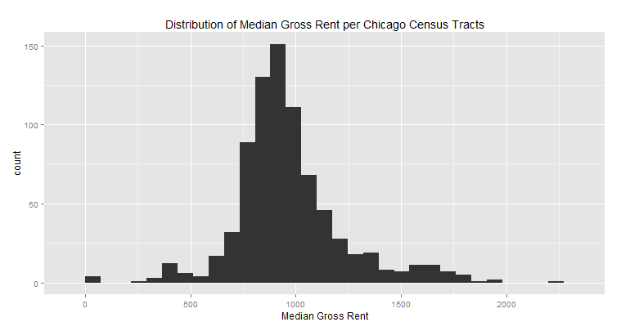

#2)

I am building an interactive choropleth map using leaflet and shiny. So far I have the polygon structures for Chicago Neighborhoods and Census Tracts in place. I am still working on the color palette. The shiny app will allow the user to select an income range, and that will update the choropleth map to determine what areas of the city are more affordable and less affordable. The user will be able to scroll the entire city of Chicago, zoom in and out, and click on Census Tracts to see a popup with additional information about that area. Full code can be found in the zip folder. Also need to add a legend.

**A full working interactive version can be used by opening the ChiAfford.html file in the zip folder.**

