5a) closing price vs date line chart

Changed line thickness so it stands out more; changed the date format to a more traditional format to increase precision; changed the breaks to 2 months to reduce clutter; tried to reduce padding on the x-axis but only partially successful; eliminated padding on the y-axis to reduce wasted space; adj. the y-axis limits to make sure all data was visible in frame; adjusted y-axis breaks to reduce clutter but maintain precision; adjusted y-axis name to "Closing Price" to make more clear

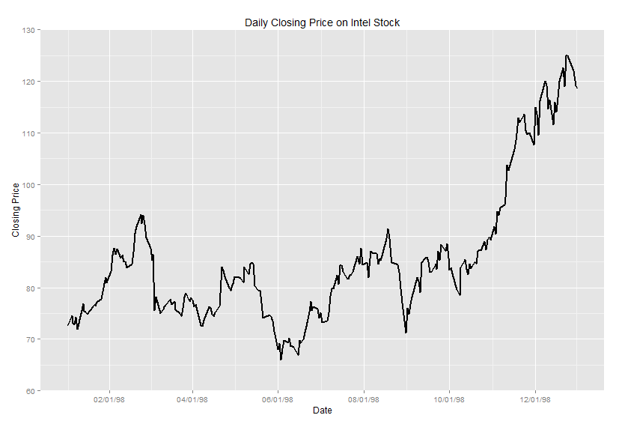

5b) volume vs date bar chart

changed the date format to a more traditional format to increase precision; changed the breaks to 2 months to reduce clutter; tried to reduce padding on the x-axis but only partially successful; eliminated padding on the y-axis to reduce wasted space; adj. the y-axis limits to make sure all data was visible in frame; adjusted y-axis breaks to reduce clutter but maintain precision; adjusted y-axis labels to be shown in millions to save space; change y-axis name to reflect actual scale being used

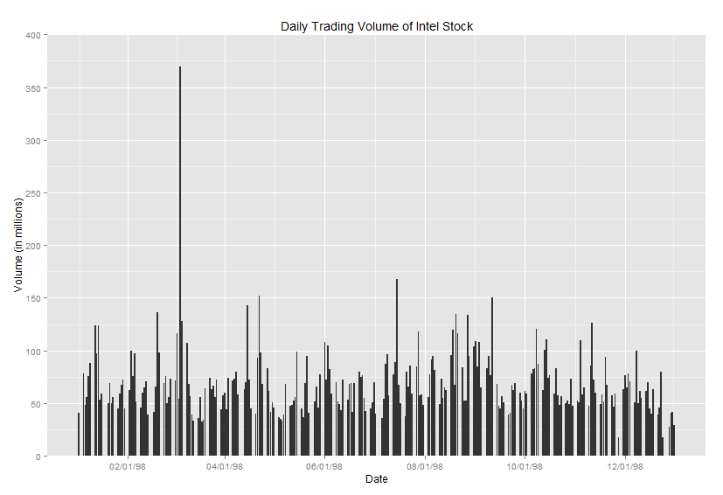

A bar chart is more appropriate for volume data because the data is discrete not continuous. In a line chart, you are measuring the change in a continuous variable over time. In a bar chart you are looking at point-in-time snapshots of the data and comparing them to other point-in-time snapshots that are for the most part independent of each other.

5c) daily stock volume histogram

changed the binwidth to 50mm; changed the scale on the x-labels for easier reading; removed minor breaks b/c they don't add value in a histogram; updated x-axis name to reflect scale change; change y-axis breaks to improve precision; eliminated margin padding on y-axis to reduce wasted space; added white lines to the histogram to make it easier to identify the bins

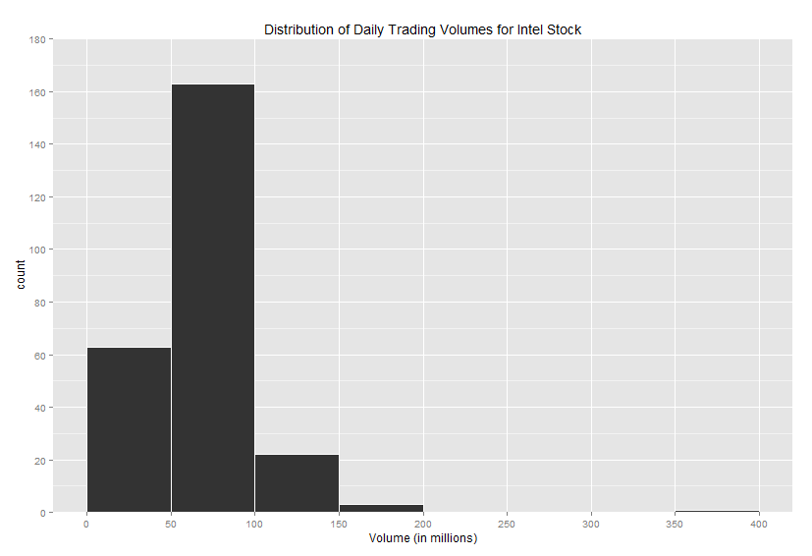

5d)

changed binwidth to 50mm; changed scale on x-labels for easier reading; updated x-axis name to reflect scale change; changed y-axis breaks to improve precision

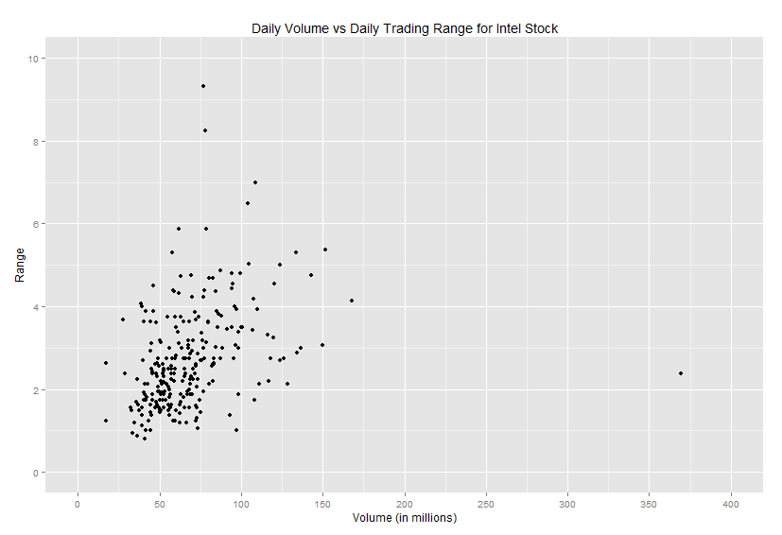

5e)

default line was a polynomial surface, explicitly changed method to "lm" for linear model

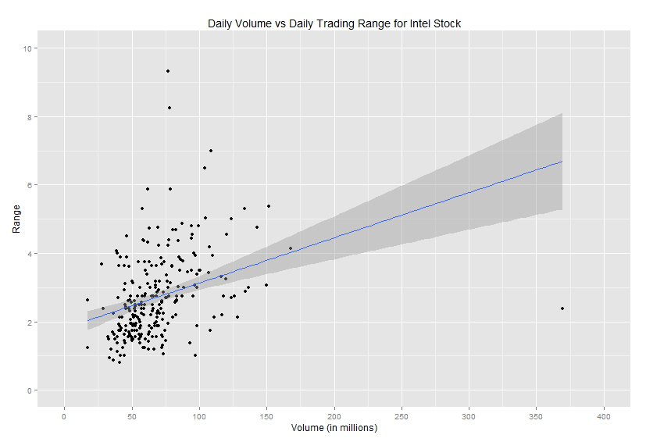

6a)

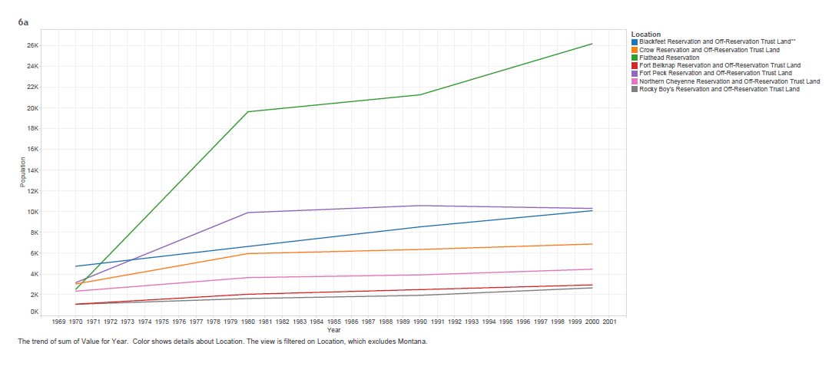

6b)

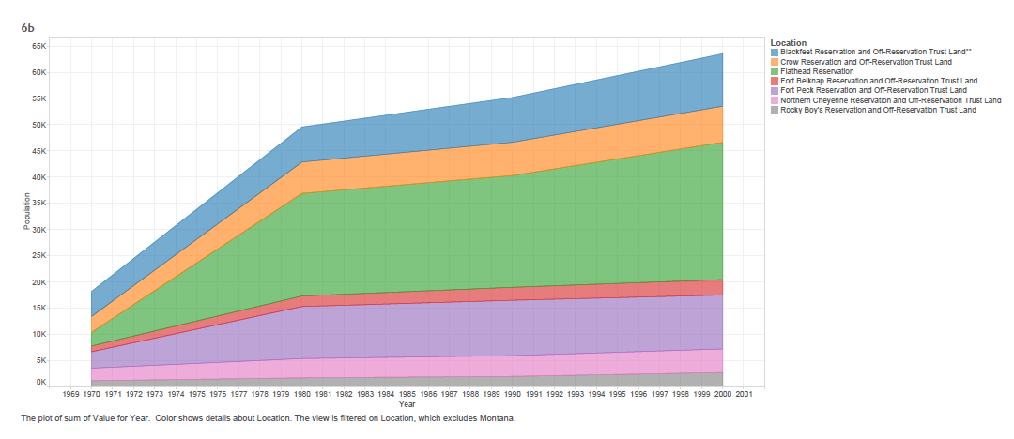

6c)

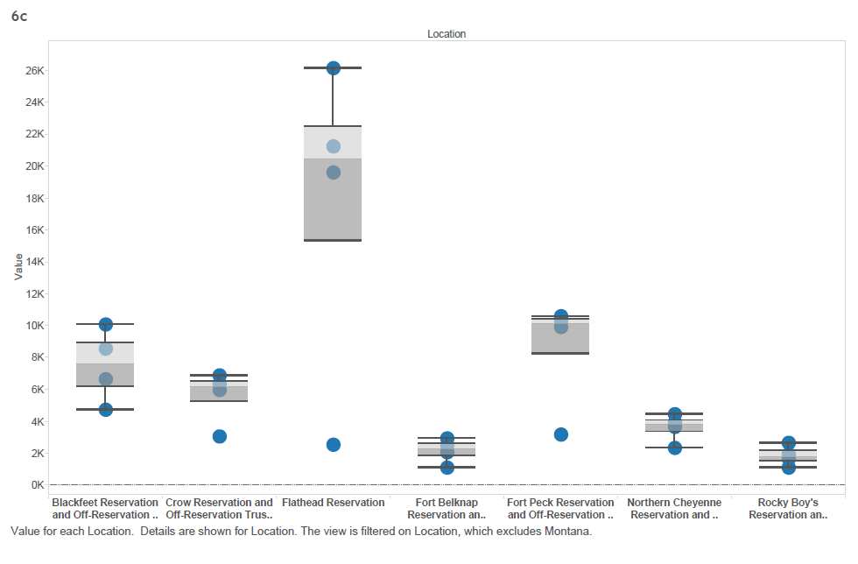

7a) length vs weight scatterplot

changed the axis names to clearer meaning; adjusted x-axis breaks so not on decimal points; increased the size of the data points to better distinguish the color between boy and girl

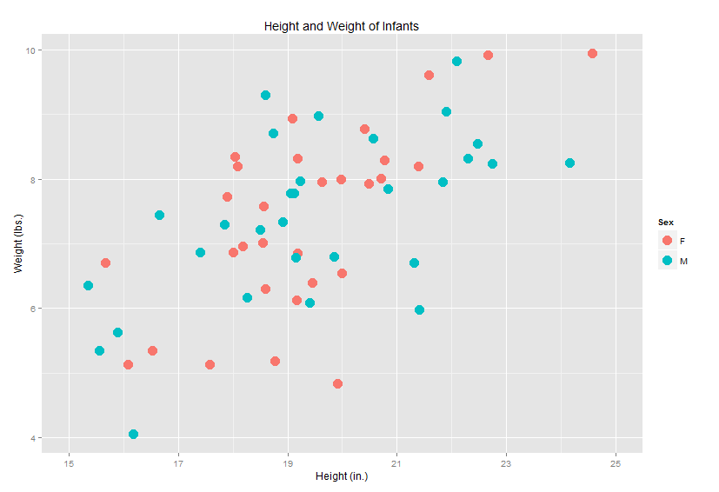

7b,c,d)

I decided I wanted to make the trend lines the focal piece of this chart. Thus, I decided to change the plotting icons to this cross so it doesn’t clutter the graph and compete as much with the trend lines. I also thickened the trend lines and I kept the colors because I thought they did a good job of distinguishing each other.

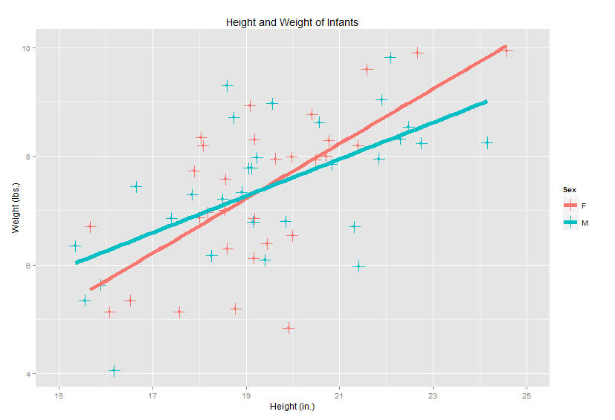

8a) I think the treemap does a much better job of organizing the data. It is easy to see where the makes are distributed and which one is the most expensive. I could not figure out how to control the layout of the bubble chart so that may add to why I don’t like its organization but it does make it pretty easy to see that Cadillac is the biggest sphere. The difference in the orientation of the boxes in the treemap make it harder to compare sizes in my opinion.

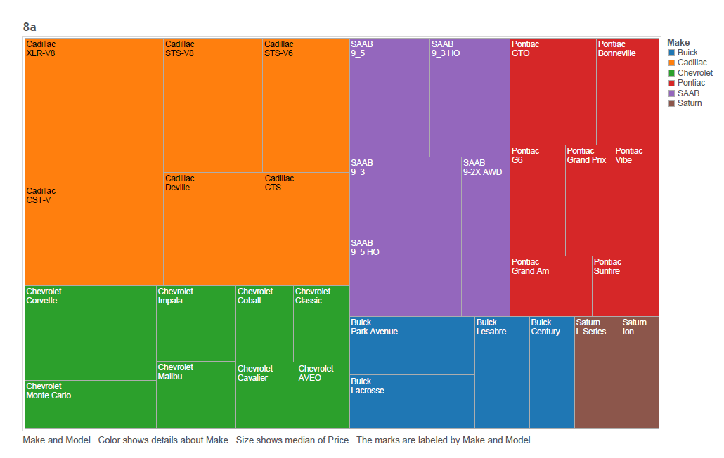

8b)

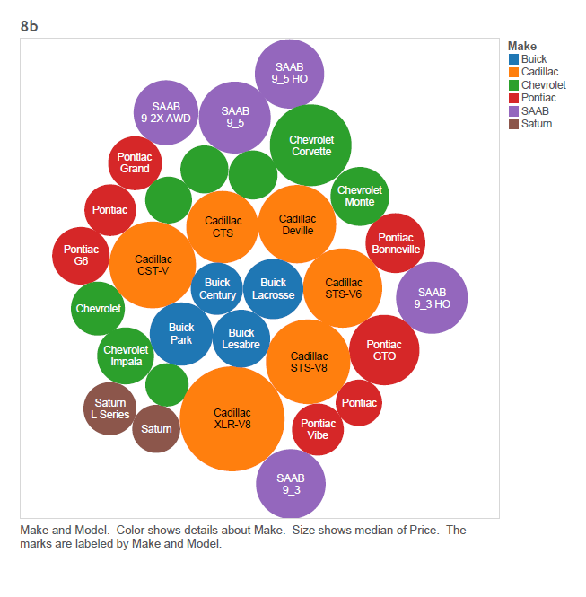

9a) Earthquake Graph

This graph is trying to communicate to the user that there will be another large string of earthquakes in ‘The future’ (i.e., post 2000). The graph is significantly cluttered with unnecessary 3d graphics. The shading of the earthquake bars seems unnecessary because the value is prominently displayed on the bar so the legend is clutter. The color choice to distinguish magnitude makes it hard to distinguish any difference. The purpose of the graph, which is to highlight the increased risk of earthquakes in the future, has this data in the bottom right corner and is being cut off when it should be displayed more prominently. Also there are absolutely no metrics associated with probability of increased earthquakes, it is purely color.

My design below reduces clutter by eliminating the 3d effects and redundant labeling of year and magnitude. It is now clear to see that there is a concentration of earthquakes in the period of time that was forecasted by scientists to be of high earthquake activity. This is denoted by the hashed region of the chart. There is an additional hashed area of the chart in the forecasted period of 2030+ which suggests to the reader that there may an increase in earthquake activity at that point in time.

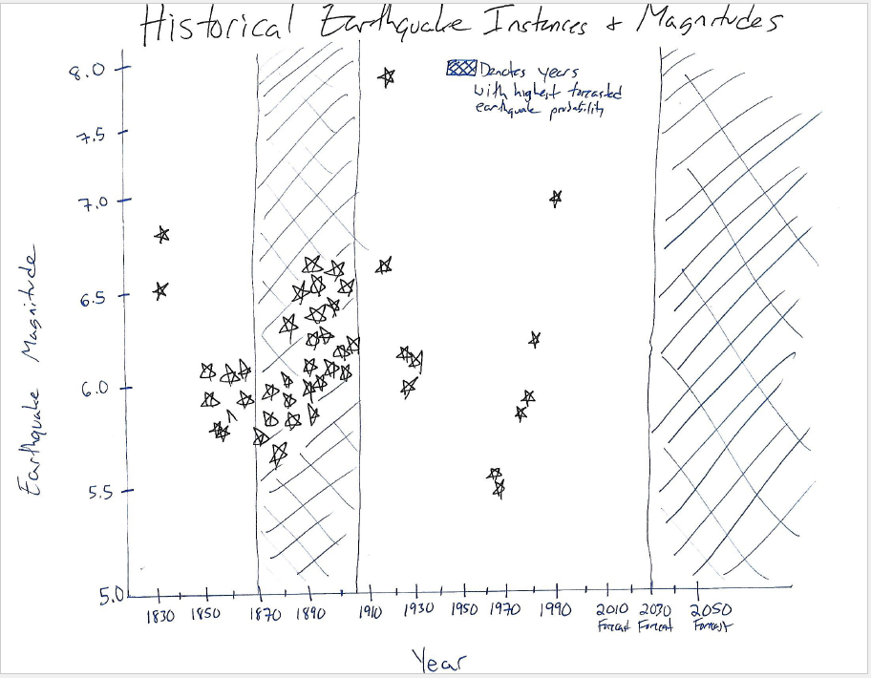

9b) Bush graph

For the major chart, the x-axis doesn’t make any sense because it is labeling an inconsistent range of days (e.g., Feb. 1-4 vs Sept. 14-15). More importantly, the chart is supposed to describe the decline in support for President Bush but from the beginning of the chart to the end of the chart, the % is actually the same. In this case it is open to interpretation whether it is misleading to start the chart at Sept. 2011 to capture only the decline. Also, for the three charts on the left hand side it is not clear whether the percentages represent approval or disapproval. For the column of smaller charts on the right hand side, none of them equal 100%.Holistically, the charts do not paint a clear disapproval for President Bush as the title of the graph suggests.

I improved this chart by toning down the language of the title and letting readers judge the data for themselves. I also made the meaning of the charts clear by adding a description of what the percentages represented for each of the three charts on the left hand side. I also adjusted the x-axis labels to remove the confusing range of days provided in the original.

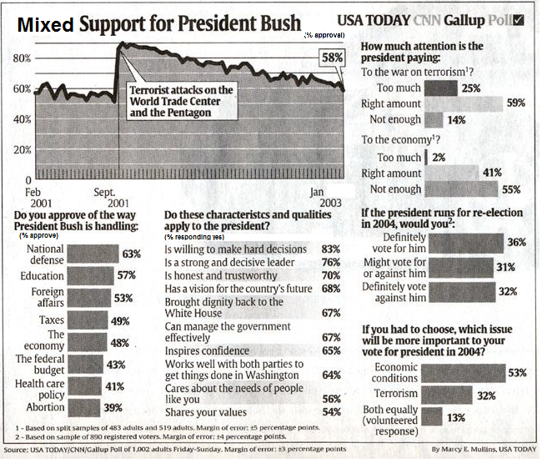

9c) Physics graph

The most egregious error here is that the actual data line surpasses the maximum limit on the y-axis. The x-axis is also poorly scaled – it is much too wide of a range for the narrow set of data. I’m not sure how important the distance is between the lines.

I increased the y limit so that the data fits on the plot. I tried to reduce the x-axis range to fit more of the data on the plot but the curve is too steep. I think this chart may benefit from a different aspect ratio.

