# Part 2 – Perception Test Data

1. Overall the users’ perceptions were normally distributed around the true value, with a roughly equal amount overestimating and underestimating. 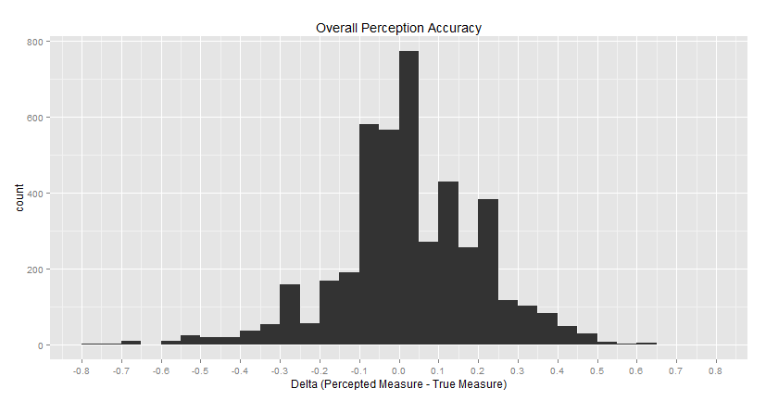
2. The distributions below suggest ‘Length, Non-Aligned’, ‘Vertical Distance, Aligned’, and ‘Vertical Distance, Non-Aligned’ are among the most accurate graph types when it comes to user perception as evidenced by their mean Delta very close to 0. ‘Slope’ and ‘Color Value’ appear to be the least accurate graphic types of user perception given their wide range and median Deltas not close to zero. If we add a jitter to the plot to visualize the actual distribution of data points, we can see that ‘Length, Non-Aligned’ and ‘Vertical Distance, Aligned’ have the most tightly distributed data points around the Delta of 0. 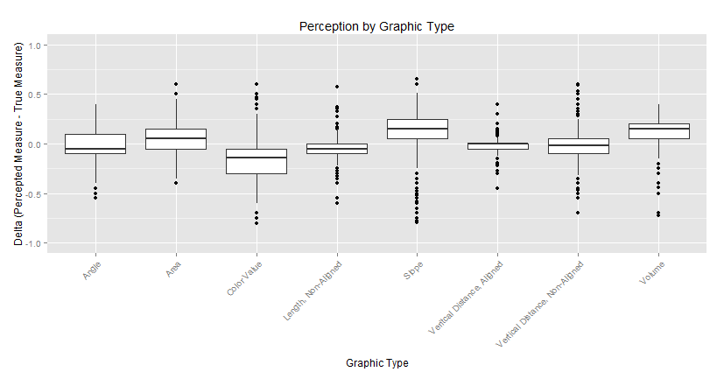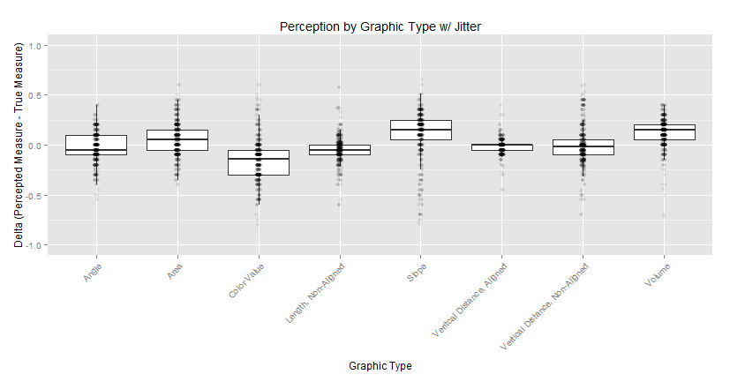
3. TBD
4. Yes, from the chart below which shows the median difference between reported measure and true measure, ‘Color Value’ was a test that was generally underestimated. ‘Slope’ and ‘Volume’ were two tests that were generally overestimate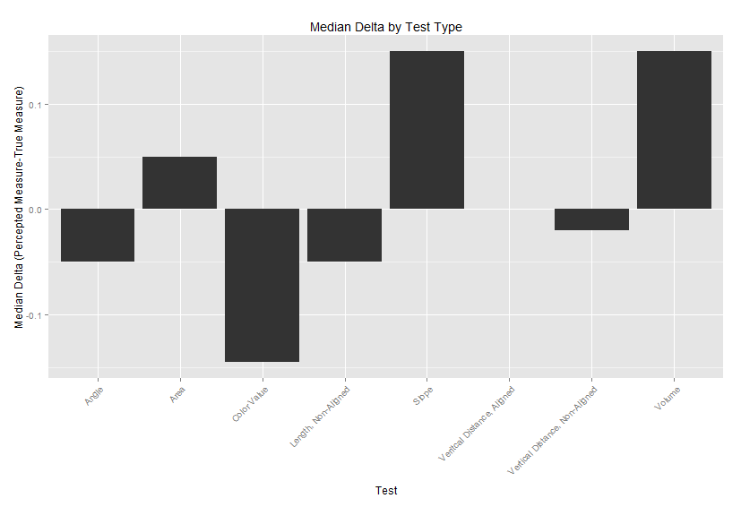
5. There appears to be minimal difference when seeing the first set of displays before the second for subjects 56-73 given that the median is unchanged at 0 Delta. However, the interquartile range for Display 2 appears to be tighter than the interquartile range for Display 1. This suggests that the distribution of responses are more tightly centered on the correct answer (0 Delta) which implies that Display 2 may have been more accurately measured in aggregate.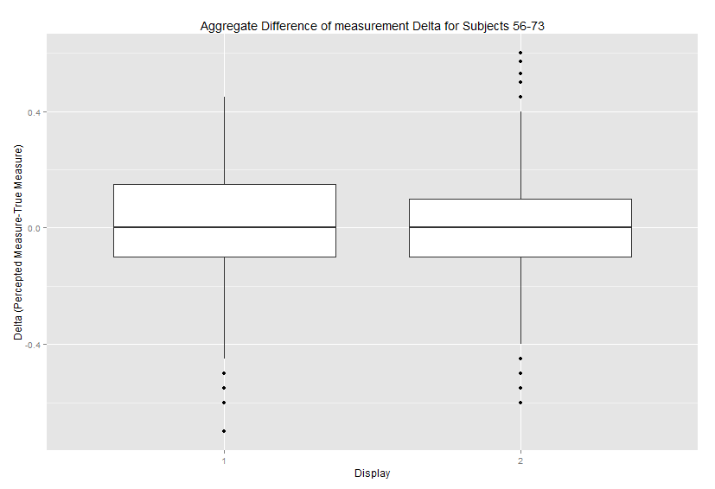
6. Chart below shows individuals with poor approximating skills: 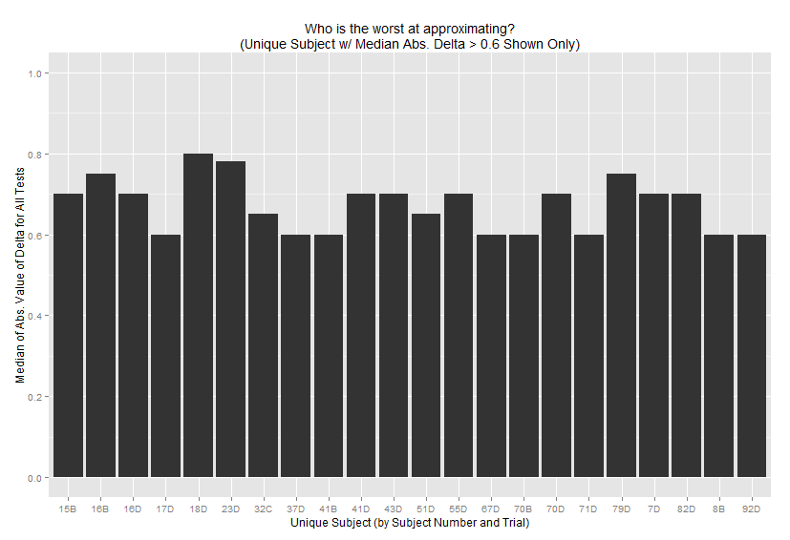

# Part 3 – Intel Stock Data

1. 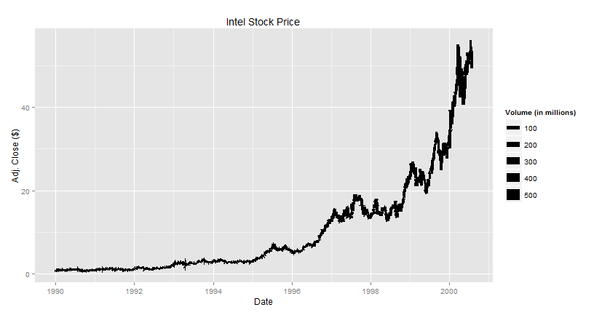
2. I think the line with Volume as color does a better job of communicating the data. In the chart above with line width as volume it is too hard to see because our data is of too high frequency and it’s hard to tell any difference in width from one pixel to another. Color makes it a bit easier and at least we can see days in which Volume was very high denoted by light blue. 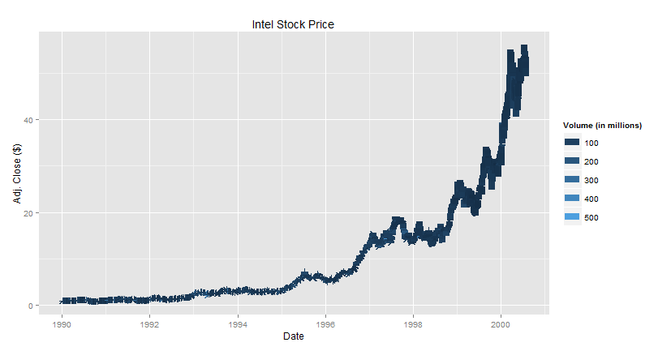
3. Changing the scale of the y-axis to log-base-2 makes the graph look very linear with a positive slop close to 1 over the long-term. This means that the price is doubling approximately every 1-2 years. 1992-1993, 1994-1995, 1996-1997 and 1999-2000 had the greatest increase in value percentage-wise. 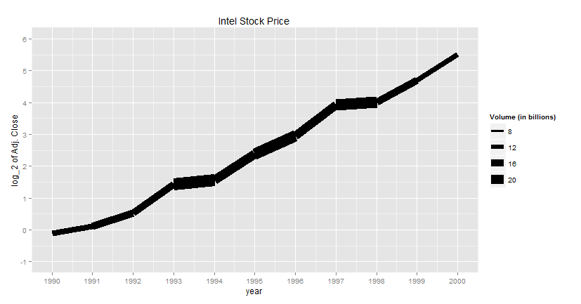

# Part 4 – Montana Population Data

1. 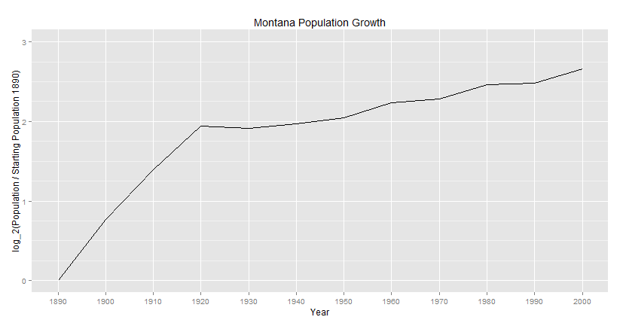
2. 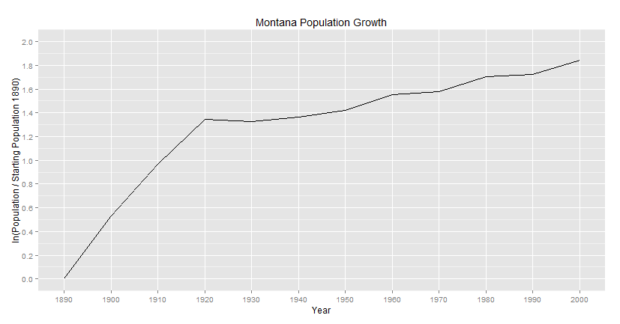
3. 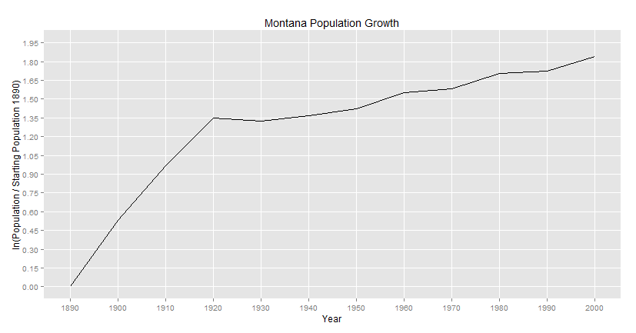

# Part 5 – Messier Data

1. 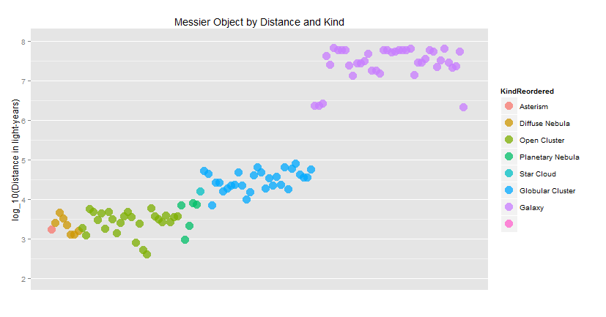
2. 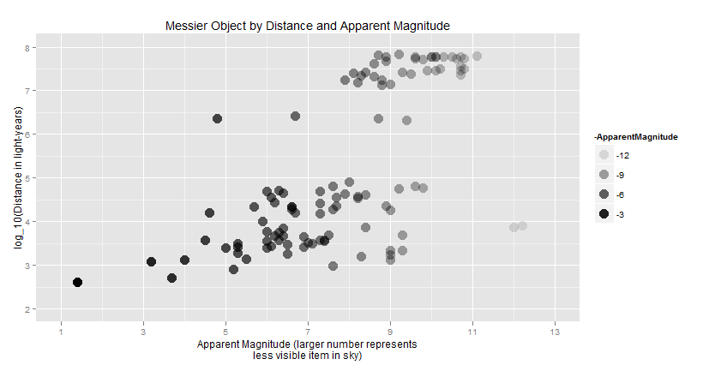

# Part 5 – Portland Water Level Data

1. 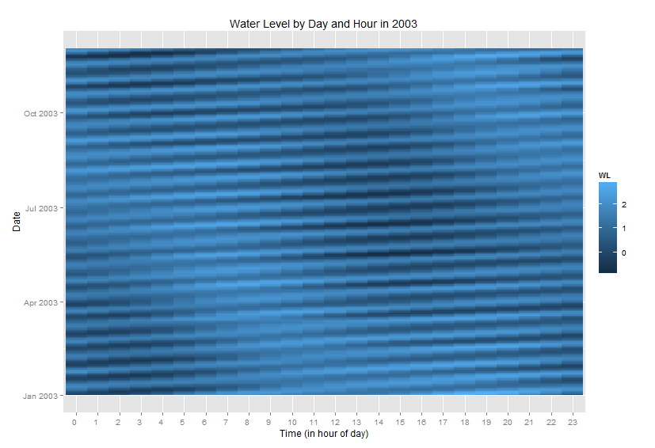
2. 