Game Design Document 仕様書

Technical Document

# Meta-data

Name: Hotel knock / PP dash

Genre: Rhythm game, competition

Players: 1P ~ 2P

Audience: children 3 ~ 12 years

# Overview

A competitive rhythm game where up to 2 players can fight each other with beats. 1 player sends a beat and the other must reproduce it, then counter attacks with his/her own beat. When one player fails to reproduce a beat, he/she receives a penalty.

# Start menu?

# Main stage

2-player mode

The 2 players characters’ are initialized.

Alternatively, player 1 and player 2 move as player A and player B.

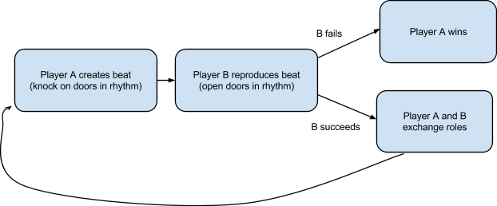

# 

Overall time between doors: 2s

Delay to knock the door: 0.050s (probably too short)

Time between last chance to knock and next door: 1.950s

## Graphics

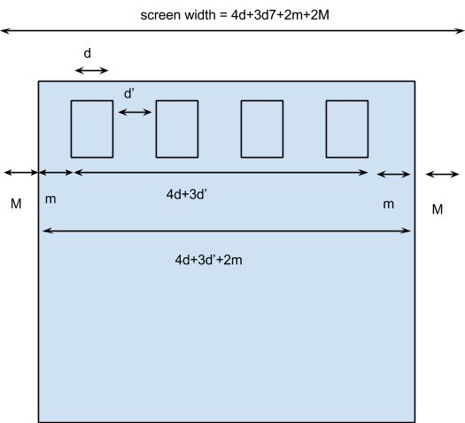

Screen

640*?px

= 4d+3d’+2m+2M

= 260+195+130+130

= 685

Door

d*h = 65*95px

Space between doors:

d’ = 65px

Building margin:

m = 65px

Background margin:

M = 65px

Door frame + side margins: 128*168px

Door itself: 76*132px

## Technology

Pure JS

DOM elements for sprites

# Game Over