**Problem Statement**

To build/predict a pickup transportation path for truck such that the total transportation cost will be minimum.

**Architecture**

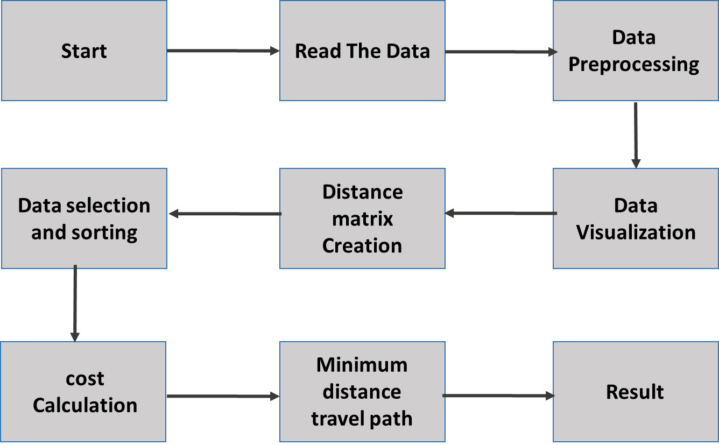

**Data Description**

Data Description: This dataset predicts the Vehicle Route Planning based on the different parameters as below:

1. place: The field "place" refers to a place where the truck needs to pick an item from. There are a total of 100 such places.

2. weight: Each place has an item of weight for pick up

3. "x_coordinate": All the places can be assumed to be on a 2-dimensional XY plot. This column values are x-coordinates of the place.

4. "y_coordinate": All the places can be assumed to be on a 2-dimensional XY plot. This column values are y-coordinates of the place.

**Vehicle Route Planning (VRP) Cost Estimation:**

1) Read Data - The data is exported as a CSV file to be used for VRP cost estimation.

2) Data Preprocessing

1. Check for duplicate numerical data in the columns. If present, the duplicate data is removed from the data based on “product_info”
2. Check for null values in the columns. If present, impute the null values.
3. Data understanding through Visualization.

3) Main Program

1. Created vertex points (pair) from x and y coordinate values.
2. Created Distance matrix of 100X100 for entire number of places.
3. Selected and sorted the route based on the starting point A (user provided place point from 1 to 100).
4. Get the cost of transportation to reach 1st nearest place (minimum distance) B from starting point A.
5. Then from that point B again created distance matrix (99X99) and selected route for point B as a starting point after removing point A from the data.
6. Now get the cost of transportation to reach 1st nearest place C from new starting point B.
7. This process is continued till destination point is reached.
8. The values of Cost, distance travelled, place point visit are stored at every stop point.

3) Cost Estimation: Based on minimum distance travelled from one point to other point, Cost is calculated.

Cost calculation is done as per formula given in reference data set:

*The truck has to start from any one place, collect the weight and then move to next place till it has covered all places and picked up all the items.*

*The cost of transportation can be estimated by the product of distance travelled & weight of items in the truck. Your objective is to devise a path such that the total* *cost is minimum. Write a function which return the best path(s) with the least cost of transportation.*

*Example:*

*Let say there were only 3 places: A,B,C and the path A-B-C is selected. The truck starts from place A picks up item of weight 10 and goes to place B which is at a distance of 2 units where it picks up another item of weight 20 and then goes to place C which is at a distance of 5 units from B to finally pickup an item of weight 7 then the cost of transportation can be computed as:*

*Cost(ABC) = 2 * 10 + 5 * (10+20) = 170*

*However, other paths like A-C-B, B-C-A, B-A-C, etc. also exists.*

*Note: To compute distance, you can use Euclidean distance formula for the distance between two points*

4) The Distance travelled by the truck to reach final destination point, Route for the transportation, Minimum Total Cost values for transportation are computed and printed out.