**Walnut Transcriptome Provides Evidence for Cell Wall Biogenesis as a Susceptibility Factor in Multiple Root Diseases**

Houston Saxe*, Sriema Walawage, Bipin Balan, Charles Leslie, and Abhaya M. Dandekar and ???

Department of Plant Sciences, University of California, Davis, CA,  95616

Abstract

*Agrobacterium tumefaciens* (Crown Gall Disease), *Phytophthora* (*Phytophthora* crown and root rot), and *Pratylenchus vulnus* (Root Lesion Nematode) are the leading rootstock pathogens for walnut in California. *A. tumefaciens* is a rod-shaped, Gram-negative soil bacterium, *P. cinnamomi* is a soil-borne water mold, and *P. vulnus* is a migratory endoparasitic nematode. These pathogens either kill root tissue directly (*P. cinnamomi* and *P. vulnus*) or obstruct the vasculature with tumors (*A. tumefaciens*). All cause disease by inhibiting the flow of nutrients and water to the grafted scion (upper portion of the plant), reducing crop productivity and plant health. Recent walnutbreeding efforts have generated hundreds of hybrid rootstocks that were phenotyped for all three pathogens. We selected six of these hybrid rootstocks and performed transcriptomic analysis without pathogen challenge. Our objectives were to identify potential biomarkers and molecular mechanisms driving basal immunity to these pathogens. Principal component analysis revealed unique transcriptomic profiles associated with each disease trait, suggesting the uninfected transcriptional repertoires are critical for resistance and that this may be a proactive defense mechanism. Modeling of the expressed genes revealed genetic circuits associated with each disease trait, many of which were shared across traits. Gene Ontology Overrepresentation Analysis of these genetic circuits suggested that host cell wall biogenesis may play a key role in pathogenesis. Furthermore, BUSCA subcellular localization analysis showed that, on average, the genes most associated with susceptibility were targeted to the plasma membrane and extracellular space, implicating barrier function as a susceptibility factor in these diseases. This research suggests that cell wall biogenesis and barrier function are involved in Crown Gall Disease, *Phytophthora* crown and root rot, and Root Lesion Nematode and that modulation of these processes may modulate disease development.

Introduction

Persian walnuts (*Juglans regia*) are crucial for California's agricultural economy. In 2019, walnuts ranked ninth in the top 20 California commodities and were valued at 1.29 billion dollars (CADFA, 2020). Several pathogens threaten California walnuts, including crown gall (*Agrobacterium tumefaciens*), *Phytophthora* crown and root rot (*Phytophthora spp.*), and root lesion nematode(*Pratylenchus vulnus*).

Crown gall and *Phytophthora* are critical rootstock pathogens for California walnuts (Levi et al., unpublished, CA Walnut Board). *A. tumefaciens* is a rod-shaped, Gram-negative soil bacterium, while *P. cinnamomi* is a soil-borne water mold. These microbes kill root tissue directly (*P. cinnamomi*) or obstruct the vasculature with tumors (*A. tumefaciens*). Both cause disease by inhibiting the flow of nutrients and water to the grafted scion (upper portion of the plant), reducing crop productivity and plant health. Nematodes also pose a substantial threat to the California walnut industry (Levi et al., unpublished, CA Walnut Board). *P. vulnus* is of primary concern, while root-knot (*Meloidogyne spp.*) and ring nematode (*Mesocriconema xenoplax*) seem less endemic. *P. vulnus* is an obligate migratory endoparasite that feeds mainly in the cortex. Like *A. tumefaciens* and *Phytophthora*, nematodes cause crop loss by damaging the root tissue and impeding the flow of nutrients and water to the scion.

Recent preliminary grower surveys report that crown gall is the most significant root problem in the California walnut industry, followed by nematodes, *Phytophthora*, replant problems, drought tolerance, and blackline disease (Levi et al., unpublished, CA Walnut Board). Moreover, grower surveys indicated a high interest in rootstocks resistant to crown gall, nematodes, and *Phytophthora*. These results are sensible, as walnut growers spend substantial financial resources managing these diseases. According to the 2017 UC Davis walnut production cost study, management costs for nematodes can be $1,400 per acre at planting and for *Phytophthora* are $97 per acre per year (Grant et al., 2017). Costs to manage crown gall have yet to be estimated but cannot be trivial as growers routinely perform surgery on existing galls to prevent further economic loss. Another important consideration is the economic loss due to these pathogens. One study on crown gall reported a 12% decrease in cumulative four-year yield per 25% of galled trunk diameter (Epstein et al., 2008). An unpublished walnut research report suggests that crown gall can cause crop loss between 25% and 50% per infected tree, depending on the gall size (Olson et al., 2002). *Phytophthora* was reported to kill over 99% of English walnuts over four years if not grafted to resistant rootstocks (Hasey et al., 1996). Yield and or survivability outcome data for nematodes are lacking. Overall, one estimate suggests that root system diseases cost the California walnut industry $241 million per year, an industry worth approximately $1.24 billion per year (Kluepfel et al., 2020).

The California walnut industry has long used grafting technology to combine elite phenotypic traits into a single plant. Grafting in walnuts is a horticultural practice where the scion of one genotype is physically combined with the roots of another genotype to form a new chimeric plant lacking the undesirable traits of its donors. The most popular California scion cultivar, *J. regia* cv. Chandler, is susceptible to crop loss caused by crown gall, *Phytophthora*, and nematode infestation. Thus, growers typically utilize a genetically different rootstock to reduce the economic loss caused by at least one but not all diseases mentioned above.

Walnut breeding efforts have generated several rootstocks with improved resistance to crown gall, *Phytophthora*, and nematode infestation over previously available rootstocks. Prior selections like Northern California Black (*Juglans hindsii*), Paradox (*J. hindsii* x *J. regia*), or English (*J. regia*) rootstocks only offered marginal resistance to *Phytophthora*. Clonal Paradox RX1 (*Juglans microcarpa* x *J. regia*) is now the rootstock of choice when *Phytophthora* and crown gall are of concern due to higher resistance to these pathogens. Another clonal Paradox, VX211 (*J. hindsii* x *J. regia*), is the preferred rootstock when nematodes are a problem due to its greater tolerance than any commercially available rootstock. For clarification, "Paradox" refers to any black walnut (*J. sect. Rhysocaryon*) x *J. regia*.

Recent preliminary breeding work seems to be improving on the previous selections with the ultimate goal of creating elite hybrids resistant to crown gall, *Phytophthora*, and nematode infection. Analysis of a collection of *Juglans spp.* x *J. regia* hybrids discovered improved usable resistance to crown gall and *Phytophthora* in *J. microcarpa* x *J. regia* crosses (Browne et al., 2015; Kluepfel et al., 2011). *J. microcarpa* is a short-statured black walnut native to riparian areas of North America, and its genome size and chromosome number are very similar to *J. regia* (Zhu et al., 2019). The publication of high-quality genomes of *J. microcarpa* and *J. regia* has facilitated genomic and functional genomic analyses of the hybrids mentioned above. QTL analysis of these hybrids showed a significant region on chromosome 4D of *J. microcarpa* correlated with *Phytophthora* and crown gall resistance (Ramasamy et al., 2021). These results support one of the major goals of the walnut breeding program, to accelerate the pace of and inform rootstock development through molecular genetics. This study aims to build on this goal with a functional genomics approach. Unlike QTL analysis, our RNA-seq study sheds some light on not just what loci are involved but estimates their physiological function and quantifies their expression. We detail how RNA-seq sheds light on what biological processes are associated with these diseases and how this improves our understanding of the effect of breeding on disease tolerance.

****Results****

### **Differential Expression Analysis**

**To identify putative host molecular mechanisms underlying disease states of crown gall, *Phytophthora*, and nematodes, we conducted RNA-seq on seven *J. microcarpa* x *J. regia* hybrid progeny representative of a breeding population of 353 individuals. Principal component analysis (PCA) of the counts per million (CPM) normalized reads revealed unbiased sources of variation within the data. Principal components two, five, and one from the analysis strongly correlated with crown gall, *Phytophthora*, and nematode traits, respectively (Fig. 1), suggesting that the unchallenged transcriptional profiles provide critical information about the diseases. This result also suggests a potentially proactive defense mechanism, as the plants were unchallenged when the RNA was extracted. Differential expression analysis revealed hundreds of differentially expressed genes (DEGs) in each pathosystem, with many DEGs shared across pathosystems (Fig. 2). Interestingly, modeling of *Phytophthora* crown and root rot yielded substantially fewer DEGs than either crown gall or nematode count (Table 1). In this paper, we define resistance genes as those negatively correlated with the disease trait and susceptibility genes as those positively correlated with the disease trait. For example, DEGs that are highly expressed in susceptible individuals (high disease score) are susceptibility genes. Conversely, resistance genes are DEGs highly expressed in resistant individuals (low disease score). In each pathosystem, the number of resistance genes (negative sign, negatively associated with the trait) expressed from the *J. microcarpa* haplotype tended to be larger than the *J.regia* haplotype. Conversely, the number of susceptibility genes (positive sign, positively associated with the trait) expressed from the *J. regia* haplotype tended to be larger than the *J. microcarpa* haplotype (Fig. 3). Regardless of haplotype, the number of differentially expressed resistance genes was always greater than susceptibility genes (Table 1).**

### **Biological Process Analysis**

**We used Gene Ontology (GO) Overrepresentation Analysis (OA) on the DEGs to reveal biological processes (BPs) overrepresented in the DEGs of each trait. GO OA resulted in 128, 64, and 75 terms overrepresented when comparing susceptibility genes to the resistance gene reference for crown gall, *Phytophthora* crown and root rot, and nematodes, respectively (Figs. 4, 5, & 6). The differences in number of overrepresented terms likely reflects the number of genes in the input of the analysis. A susceptibility theme unifying all three pathosystems in the GO OA included those BPs involved in cell wall organization, polysaccharides, glucans, and cellulose. By and large, susceptibility genes mapped to the terms mentioned above. This result suggests that increased expression of genes involved in cell wall biogenesis is associated with disease susceptibility. Genes that mapped to these terms included cellulose synthases, fasciclin-like arabinogalactan proteins, and xyloglucan endotransglucosylase/hydrolases (File S1). While vague, a resistance theme unifying all three pathosystems in the GO OA included some form of RNA metabolic processing. Geneontology.org defines RNA metabolic processing as “The chemical reactions and pathways involving mRNA, messenger RNA, which is responsible for carrying the coded genetic 'message', transcribed from DNA, to sites of protein assembly at the ribosomes.” This result suggests that increased expression of genes involved in RNA metabolism is associated with disease resistance. Interestingly, no terms mentioning defense response were significantly overrepresented in this analysis, suggesting genes commonly associated with plant defense were not involved in this resistance mechanism. Moreover, the expression of genes associated with crucial plant hormones BPs salicylic acid, jasmonic acid, ethylene, and abscisic acid were not overrepresented (File S1).**

### **Subcellular Localization Analysis**

**To better understand the overall localization of the DEGs within the cell, we analyzed the computationally predicted subcellular localization of each set of DEGs. We performed OA on the subcellular localizations for the DEGs with the same statistical test used in the GO OA, the Fisher's exact test. Using an FDR threshold of 0.05 for all three pathosystems, we observed that the plasma membrane, anchored component of plasma membrane, extracellular space, and cytoplasm were overrepresented in the suscptibility DEGs of crown gall and nematode traits (Figs. 7 & 9). However, only the plasma membrane, extracellular space, and cytoplasm were overrepresented in the susceptibility DEGs for *Phytophthora* with anchored component of plasma membrane just shy of the significance threshold at FDR 0.072 (Fig. 8). These observations suggest that expression of genes targeting the cellular barriers and likely cell wall is a susceptibility factor in all three diseases. Alternatively, a resistance theme of targeting to the nucleus was observed for all three traits with only nematode count additionally targeting the chloroplast (Figs. 7, 8, & 9), suggesting expression of genes targeting these locations is a resistance factor.**

****Discussion****

**Plant cell walls are perhaps the most critical and understated component of plant immunity and often the first obstacle a pathogen must overcome. Host manipulation, carbon acquisition, effector delivery, and defense response suppression often require breaching the cell wall (Nühse, 2012). Cellulose, hemicelluloses like xyloglucan and xylan, pectins, and cell wall proteins, in order of abundance, represent the predominant constituents of the cell wall (Lampugnani et al., 2018; Silva et al., 2020). Highlighting the importance of these polysaccharides are the myriad of cell wall degrading enzymes that some pathogens possess to breach this barrier. These enzymes are key virulence factors and include cellulase, xylanase, pectin methylesterase, polygalacturonase, and pectate lyase (Malinovsky et al., 2014). For our analysis, geneontology.org defines cell wall biogenesis as “A cellular process that results in the biosynthesis of constituent macromolecules, assembly, and arrangement of constituent parts of a cell wall. Includes biosynthesis of constituent macromolecules, such as proteins and polysaccharides, and those macromolecular modifications that are involved in synthesis or assembly of the cellular component. A cell wall is the rigid or semi-rigid envelope lying outside the cell membrane of plant, fungal and most prokaryotic cells, maintaining their shape and protecting them from osmotic lysis.” In our data, the first indication supporting the involvement of cell wall biogenesis in the pathogenesis of crown gall, *Phytophthora*, and nematodes in walnuts are our subcellular localization results. In each trait, the predicted subcellular localization for the susceptibility genes tended to target cellular barriers, such as the plasma membrane, its anchored components, and the extracellular space (Figs. 7, 8 & 9). In other words, significant increases in the expression of genes targeting the cellular barriers occur as the plants become more susceptible to these pathogens. We also observed a similar pattern in the biological processes associated with the susceptibility genes. As expression of genes associated with cell wall biogenesis increased (eg. cellulose synthase, xyloglucan endotransglucosylase, arabinogalactan proteins), so did susceptibility to crown gall, *Phytophthora* crown and root rot, and nematode traits (Figs. 4, 5 & 6, File S1).**

**Alterations in cell wall biogenesis are known to affect a plant's susceptibility to pathogens. For example, in *Arabidopsis thaliana*, impairment in five genes necessary for cellulose synthesis in primary cell walls resulted in enhanced resistance to *Fusarium oxysporum*, a root-infecting hemibiotrophic fungal pathogen (Menna et al., 2021). These genes included *cesa3-3* , *kor1-4*, *ctl1-2*, *cobra-6*, and *prc1-1*. *Cesa3-3 and prc1-1* are cellulose synthases (Fagard et al., 2000; Hernández-Blanco et al., 2007). *Kor1-4* is a plasma membrane-bound endo-1,4,-β-glucanase (Nicol et al., 1998). *Ctl1-2*  is an apoplastic chitinase-like protein regulating cellulose biosynthesis (Sánchez-Rodríguez et al., 2012). And *cobra-6* is a protein with a mostly unknown function but may interact with the orientation and synthesis of cellulose microfibrils (Roudier et al., 2005). A significant phenotype of these mutants is the downregulation of cellulose biosynthesis, which is likely involved in enhanced resistance to *F. oxysporum*. While we did not measure cellulose accumulation in these hybrids, the transcriptomic data indicate significant relationships between the expression of cellulose biosynthetic enzymes and susceptibility to all diseases (Figs. 4, 5, & 6, File S1). Moreover, the transcriptional changes in these resistant mutants mirror that of our resistant hybrids. Specifically, we observed reduced expression of *cesa*s (cellulose synthases), *ctl*s (chitinases), and *cobra*s (protein COBRA) (Files S1). The mechanism of how reduced cellulose biosynthesis affects disease resistance is unclear, but recomposition of cell wall polysaccharides may create a matrix that is more resistant to pathogenic cell wall degrading enzymes. For example, the proportion of pectin or hemicellulose could increase relative to that of cellulose, changing the characteristics of the cell wall considerably and possibly making a pathogenic cellulase less effective. The arabinogalactan proteins are another gene family significant for cell wall biogenesis and potentially pathogen defense (Silva et al., 2020). In Arabidopsis, downregulation of the arabinogalactan protein gene *AtAGP17* resulted in decreased efficiency of Agrobacterium transformation (Gaspar et al., 2004). We observed a similar relationship between the expression of two arabinogalactan proteins and pathogen infection, where both genes were lowly expressed in resistant hybrids (File S1). Microscopic investigation of the *AtAGP17* mutant indicated that *A. tumefaciens* could not bind to the root surface when compared to the wild-type. Moreover, nonspecific inhibition of arabinogalactan proteins with the Yariv reagent also reduced *A. tumefaciens* transformation of Arabidopsis roots (Gaspar et al., 2004).**

**Another potential pathogen resistance mechanism could be the upregulation of genes associated with defense responses, such as the family of Pathogenesis-Related (PR), Nonexpresser of PR genes (NPR) genes, or any plant hormone responses. For our analysis, genoontology.org defines “defense response” as “Reactions, triggered in response to the presence of a foreign body or the occurrence of an injury, which result in restriction of damage to the organism attacked or prevention/recovery from the infection caused by the attack.” A complete list of genes associated with this term can be found at** <http://amigo.geneontology.org/amigo/term/GO:0006952> **when applying the filter term “Juglans regia.” Interestingly, our expression data suggested that the resistance mechanism was not due to defense-related genes or plant hormones such as salicylic acid, ethylene, jasmonic acid, and abscisic acid (File S1). This result is somewhat corroborated in the literature. For example, the uninfected cellulose synthase mutant *irx1-6* did not display constitutive expression of genes related to salicylic acid, ethylene, or jasmonic acid biosynthesis, indicating its disease resistance was not related to these hormone responses (Hernández-Blanco et al., 2007). However, this is not always the case. Jasmonate and ethylene-responsive genes are constitutively expressed in the primary cell wall cellulose synthase mutant *cev1* (Ellis et al., 2002). Moreover, abscisic acid-responsive, defense-related genes are constitutively expressed in secondary cell wall cellulose synthase mutants *irx1-6* and *irx5-5* (Hernández-Blanco et al., 2007)*.***

****Conclusion****

**This epidemiological study provided functional genomic insights on potential host mechanisms of pathogenesis due to crown gall, *Phytophthora*, and nematodes. We observed that the susceptibility genes of all traits were enriched in GO terms mentioning cell wall organization/biogenesis. Moreover, these same genes targeted the cellular barriers significantly more than resistance genes. These results suggest that increased activity in gene expression related to cell wall biogenesis may be a susceptibility factor in these diseases and that modulating cell wall biogenesis may modulate pathogenesis. This new hypothesis must be validated by knocking out key genes involved in cell wall biogenesis, such as the cellulose synthases or arabinogalactan proteins. Alternatively, these genes could be inhibited via isoxaben for the cellulose synthases or the yariv reagent for the arabinogalactan proteins.**

****Methods****

### **Phenotypic Analysis**

The phenotyping of these hybrids for crown gall and *Phytophthora* is described in detail in (Ramasamy et al., 2021).

To phenotype for nematodes, at least eight clonal saplings of experimental *Juglans* genotypes and commercial comparative RX1 were planted in field plots in March 2014 (McGranahan et al., 2010a) and VX211 (McGranahan et al., 2010b). The experimental plants were propagated from tissue cultures and developed into saplings in greenhouse culture. At the Kearney Agricultural Research and Extension Center, saplings were planted in their genotype group in rows of 3.35 m distance at 1.65 m spacing within the row. About one month after planting, every tree was inoculated with ~1,000 vermiform *Pratylenchus vulnus* and second-stage juveniles (J2) of *Meloidogyne incognita* by dispensing infested field soil from underneath infected perennial crops at the base of the tree. Selected trees of the genotype groups were chosen for root collections for nematode evaluations. A 20-25-cm deep trench was dug next to the tree to collect young roots of the respective tree genotype avoiding suberized roots. Kept cool in plastic bags until processing within 48 hours of collection, the roots were chopped into 1.2-cm pieces, and 20-g portions placed on top of Baermann funnels. In a mist chamber apparatus, the roots were intermittently sprayed with water at 27 °C for five days. After this, the extracts were collected, and nematodes were identified and counted (Buzo et al., 2009). Nematode numbers were recorded on a per 1-gram basis.

### **Sample Collection, RNA Isolation, and Sequencing**

**Crown gall, *Phytophthora*, and root-lesion nematode resistant and susceptible genotypes MS1-36, MS1-41, MS1-56, MS1-122, STJM-4, 29JM-11, JMS-12 were used in this experiment. These plants were grown in pots in a greenhouse for six months. Six plants were chosen from each genotype, and healthy white actively growing root samples were collected. A total of 42 roots samples were chosen for RNA extraction. All the samples were collected in the lab and flash-frozen in liquid nitrogen immediately after harvesting. Collected samples were stored frozen at -80C prior to the analysis. For transcriptome analysis by deep sequencing, tissue samples were ground to a fine powder in liquid nitrogen, and total RNA was extracted using The MagMAX™ mirVana™ Total RNA Isolation Kit (Thermo Fisher Scientific, USA). Library preparation and transcriptome analysis were carried out by Seqmatic LLC (Fremont, CA). At Seqmatic, RNA library preparation was done using Illumina Stranded mRNA library preparation kit and transcriptome analysis was carried out using NextSeq High Output Run (Paired-End Read 2x150bp).**

### **Bioinformatics**

**Raw .fastq files from Seqmatic were preprocessed using an HTStream (v1.3.2) pipeline, for which the source code can be found at** <https://github.com/s4hts/HTStream>**. This included hts_SeqScreener to remove PhiX and rRNA sequences, hts_SuperDeduper to remove PCR duplicates, hts_AdapterTrimmer to trim adapters, hts_PolyATTrim to trim poly-A and poly-T sequences from the ends of reads, hts_NTrimmer which trims reads to the longest subsequence that contains no N characters, hts_QWindowTrim to remove low quality ends of the reads, and hts_LengthFilter to remove reads less than 50 bp in length. The details of the preprocessing results can be found in (html). The sequences used as a reference for rRNA removal were obtained by downloading all predicted rRNAs of the *J. microcarpa* genome from NCBI (**<https://www.ncbi.nlm.nih.gov/nuccore/?term=juglans+microcarpa+x+juglans+regia%5Borgn%5D>**). Processed .fastq files were then aligned to a combined genome reference of *J. microcarpa* ( and *J. regia*). Both the alignment and expression estimation were done using STAR (v2.7.9a) (Dobin et al., 2013). The scripts for read processing and alignment can be found at** <https://github.com/hsaxe/SCRI_ROOT_bash>**.**

### **Differential Expression Analysis**

**The gene counts were analyzed using the R programming language for statistical computing and graphics version 4.1.2 in R studio. All gene counts were normalized by the counts per million mapped reads (CPM) method, and any gene with maximum expression under 75 CPM was excluded from the downstream analysis. Principal Component Analysis (PCA) was conducted on the filtered expression matrix and the Principal Component (PC) scores were averaged for each hybrid and used for regression against each trait (Fig.1). Among others, the R packages edgeR and Limma were used to facilitate the differential expression analysis (DEA). A model was fit to each gene in the filtered expression matrix for crown gall size, percent root and crown rot, and root-lesion nematode count. To help reduce type I error, limma-voom and empirical Bayes smoothing of standard errors were employed. Moreover, to account for pseudoreplication, the biological replicates within each hybrid were treated as random effects within the model. After modeling, genes were considered differentially expressed if their false discovery rate (FDR) was less than or equal to 0.05.**

### **Gene Ontology Analysis**

**Unique lists of DEGs positively (positive gene set) and negatively (negative gene set) correlated with each trait were extracted from the DEA and used as inputs for the PANTHER Overrepresentation Test. *Juglans regia* was used as the species from which to derive the annotation set for this analysis. *Juglans regia* genes were inferred from *Juglans microcarpa* genes using BLAST (Basic Local Alignment Search Tool). The positive gene set was used as the analyzed list, while the negative gene set was used as the reference list. The Fisher's Exact test was used to compare the analyzed list to the reference list. GO biological process complete was used as the annotation data set, and only terms with FDR less than 0.05 were considered overrepresented. In figures 4, 5, and 6, the term labels are biased and limited to those terms mentioning “RNA,” “cell wall,” “polysaccharide,” “cellulose,” “glucan,” “defense,” “jasmonic acid,” “abscisic acid,” “salicylic acid,” or “ethylene” and FDR less than or equal to 0.05.**

### **Subcellular Localization Analysis**

Unlike the GO BP analysis, we did not need to infer *J. regia* genes from *J. microcarpa* genes with BLAST. Both the *J. microcarpa* (<https://ftp.ncbi.nlm.nih.gov/genomes/all/GCF/004/785/595/GCF_004785595.1_Jm3101_v1.0/GCF_004785595.1_Jm3101_v1.0_protein.faa.gz>) and *J. regia* (<https://ftp.ncbi.nlm.nih.gov/genomes/all/GCF/001/411/555/GCF_001411555.2_Walnut_2.0/GCF_001411555.2_Walnut_2.0_protein.faa.gz> ) proteomes were sent to Dr. Castrense Savojardo at the Bologna Biocomputing Group for subcellular localization prediction using the Bologna Unified Subcellular Component Annotator (BUSCA). These predictions were used to annotate the DEGs for each trait. The DEGs were then grouped by their subcellular localization, and mean log base two expression fold change was calculated for each subcellular localization. Additionally, the number of unique positive (susceptibility) and negative (resistance) DEGs were counted for each subcellular localization and compared for significant enrichment using Fisher's Exact test in R. **Only terms with FDR less than 0.05 were considered overrepresented.**

All the code used for the differential expression analysis, gene ontology analysis, and subcellular localization analysis can be found at <https://github.com/hsaxe/SCRI_ROOT_R>.

****Contributions****

**???**

****Acknowledgements****

**???**

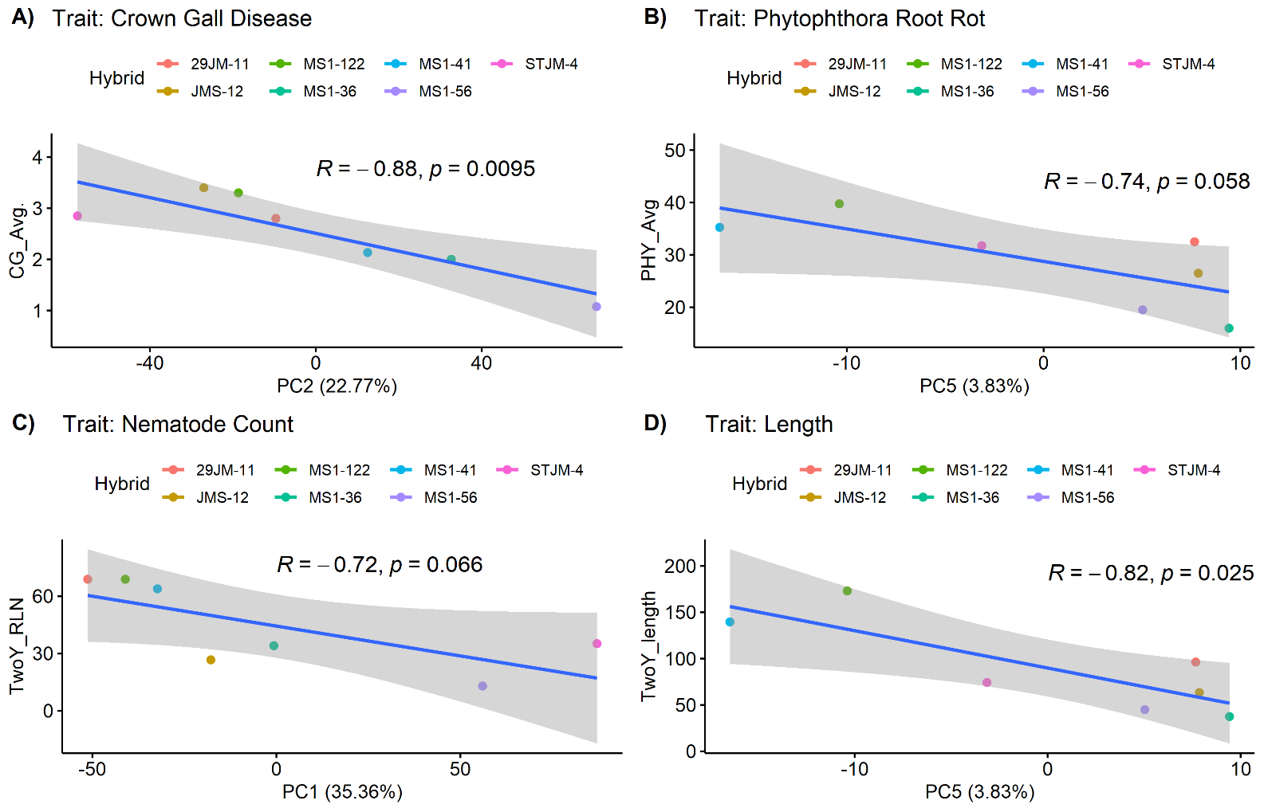

# Figure 1 | Regression of disease traits against principal components of variation from PCA of RNA data. Each dot represents the average principal component score of six biological replicates. Correlation coefficient and p-value are displayed in the plot. A) crown gll size, B) *Phytophthora* crown and root rot, C) root lesion nematode count, D) tree length at two years.

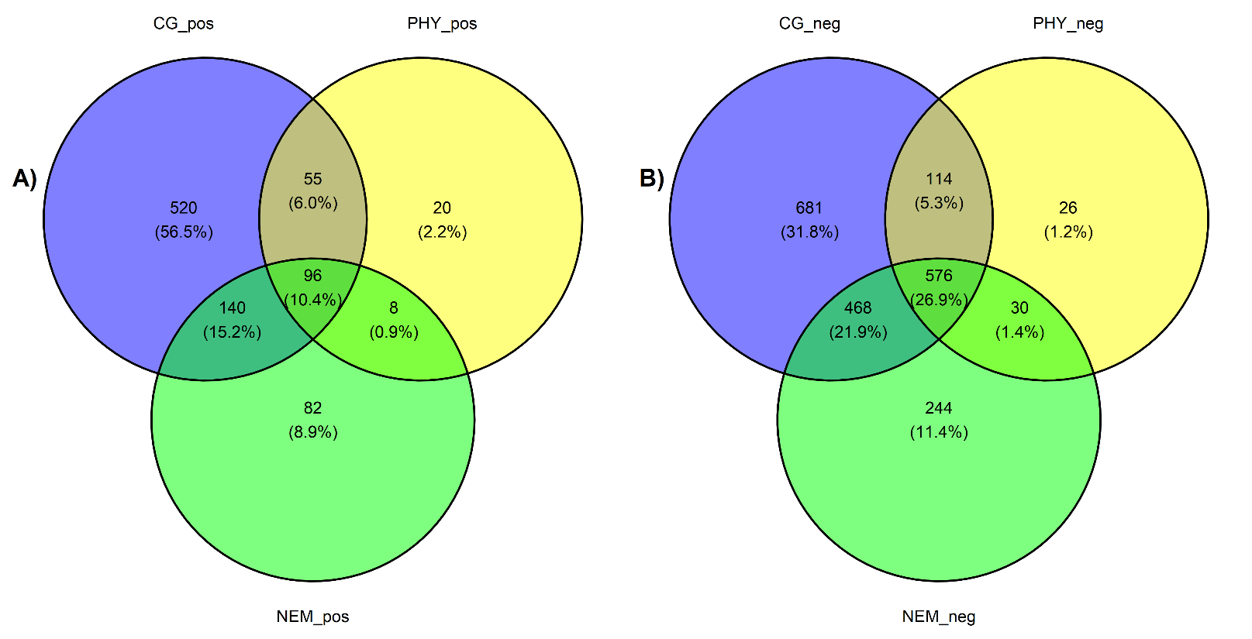

# Figure 2 | A) Venn diagram of differentially expressed genes positively correlated with crown gall (CG), *Phytophthora* (PHY), root lesion nematode (NEM), and tree length at two years (Length). These are "susceptibility genes." B) Venn diagram of differentially expressed genes negatively correlated with crown gall (CG), *Phytophthora* (PHY), root lesion nematode (NEM), and tree length at two years (Length). These are "resistance genes."

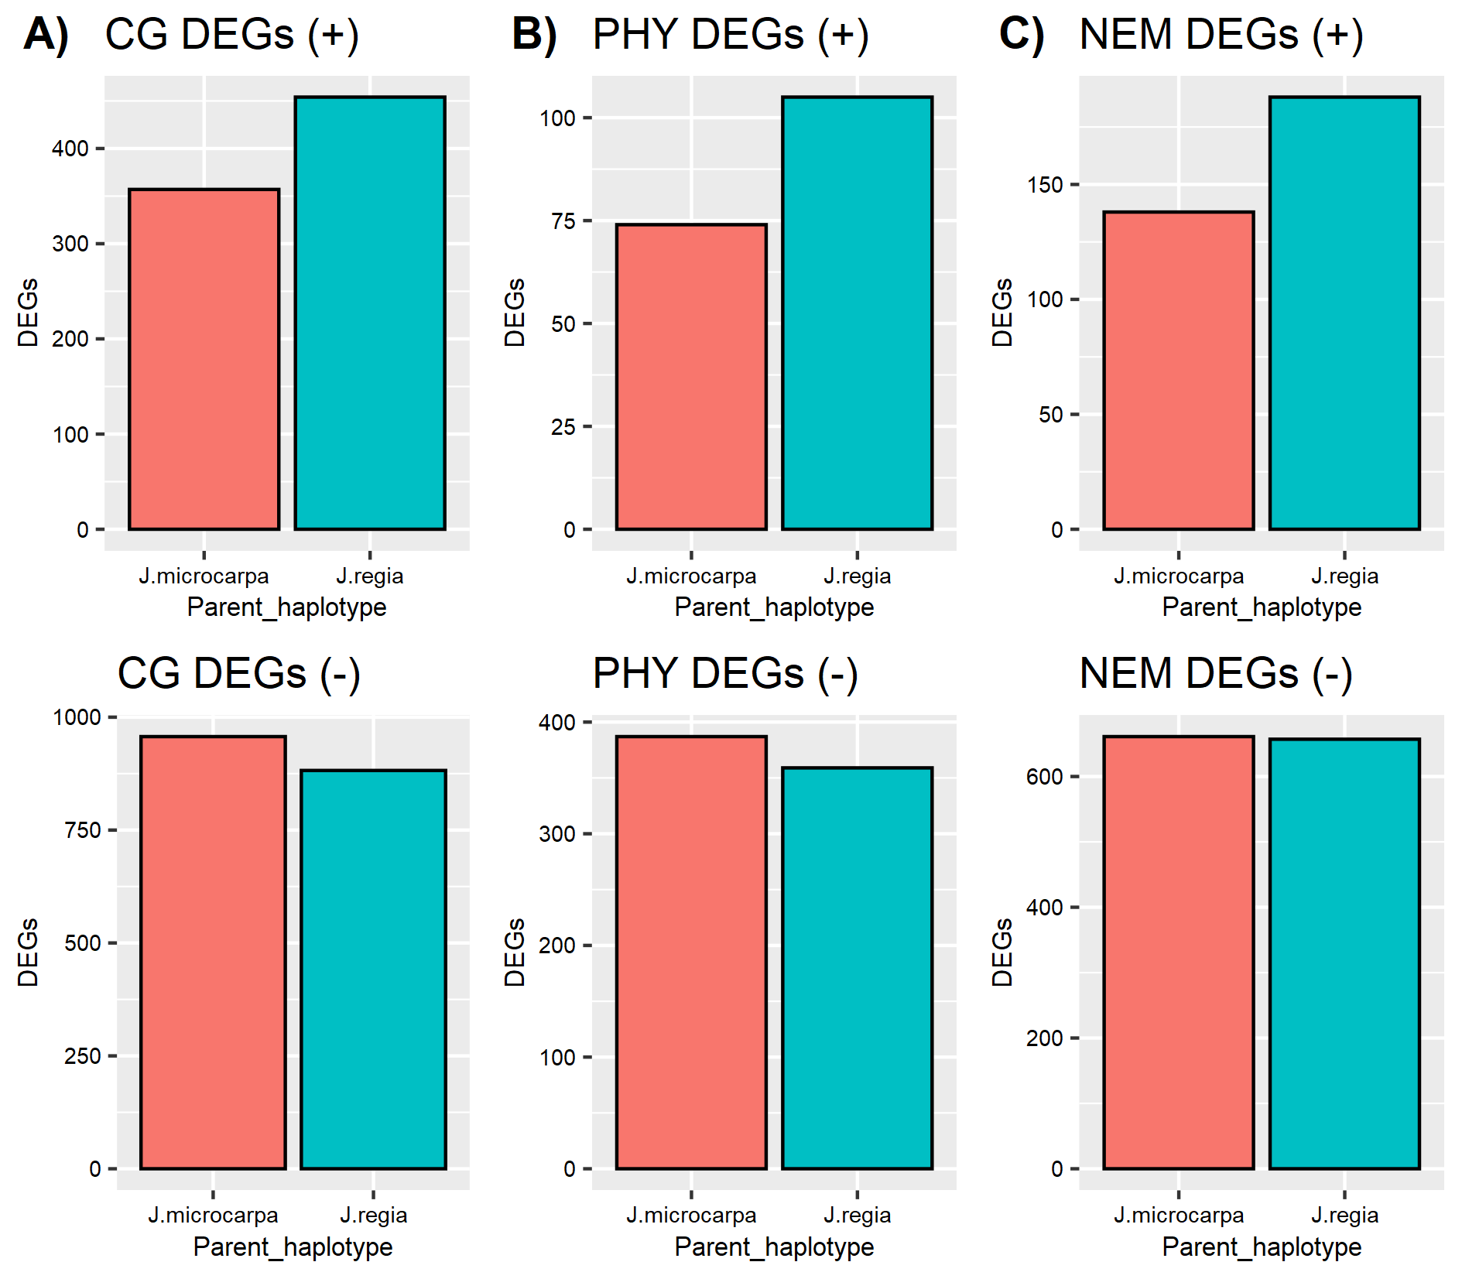

# Figure 3 | Expression of differentially expressed genes (DEGs) from each pathosystem colored by the haplotype the genes mapped to. A) crown gall (CG), B) *Phytophthora* (PHY), C) root lesion nematode (NEM), and D) tree length at two years (Length). A (+) signifies these DEGs are positively correlated with the trait. A (-) signifies these DEGs are negatively correlated with the trait. Total is the sum of (+) and (-) DEGs.

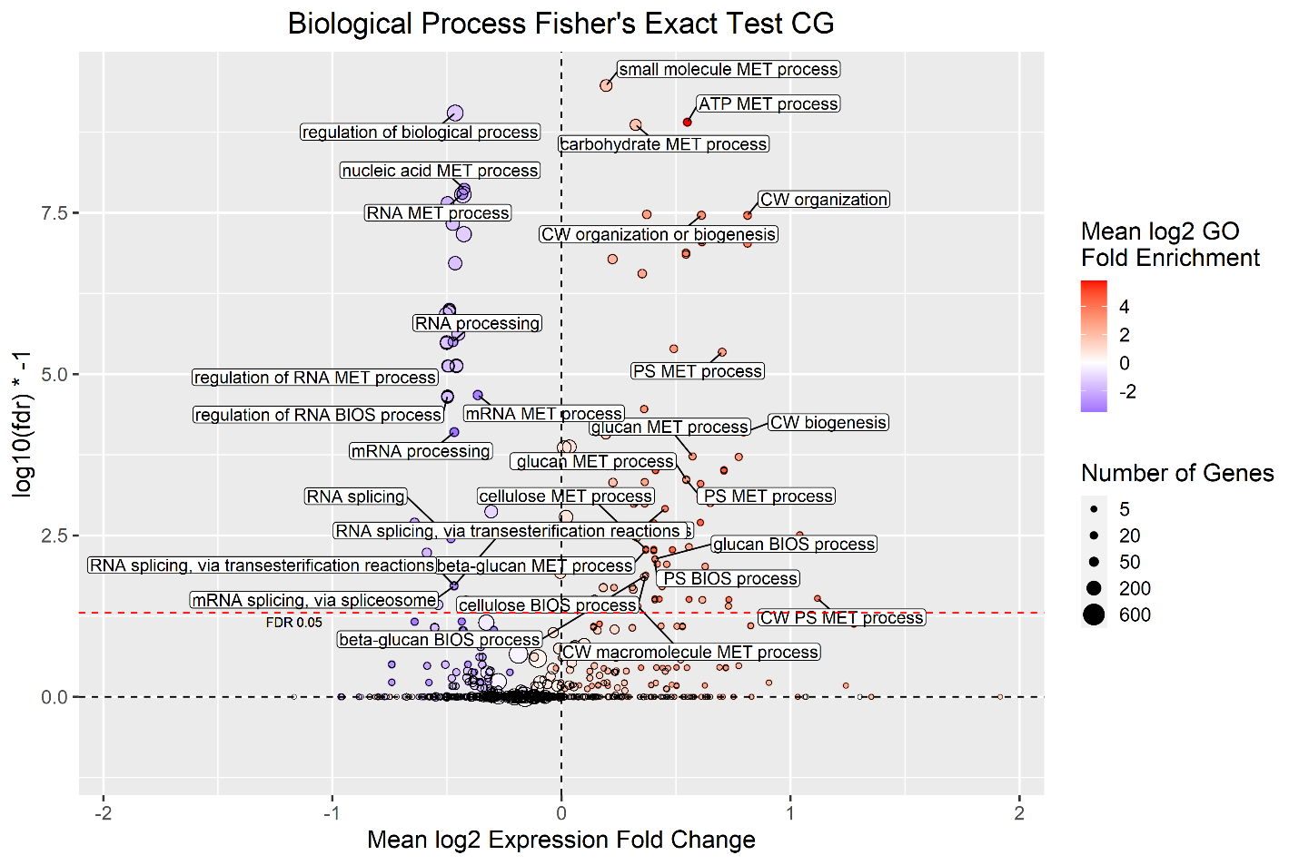

# Figure 4 | Gene Ontology (GO) Overrepresentation Analysis of differentially expressed genes (DEGs) for crown gall size. Each point represents a biological process term. See methods for term labeling. CW = Cell Wall, PS = Polysaccharide, MET = Metabolic, BIOS = Biosynthetic. The points are colored by log2 GO fold enrichment and sized by the number of genes mapped to that term. DEG log2 expression fold change averaged by term is on the x-axis. DEGs negatively associated with the trait (resistance genes) have negative expression fold change and were used as the reference list. DEGs positively associated with the trait (susceptibility genes) have positive expression fold change and were used as the analyzed list. Log10(fdr)*-1 is on the y-axis. The dashed red line indicates the fdr threshold of 0.05.

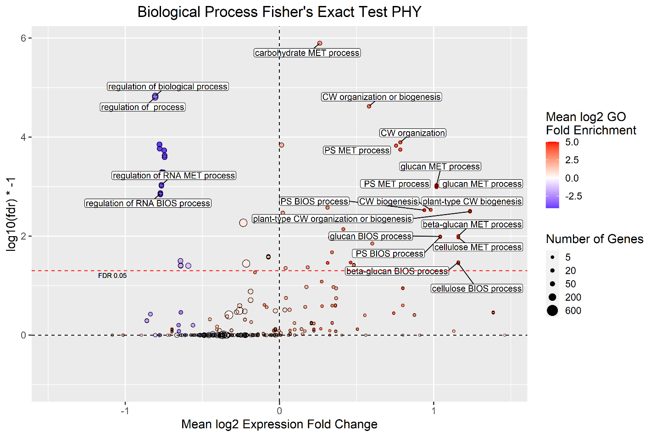

# Figure 5 | Gene Ontology (GO) Overrepresentation Analysis of differentially expressed genes (DEGs) for *Phytophthora* crown and root rot. Each point represents a biological process term. See methods for term labeling. CW = Cell Wall, PS = Polysaccharide, MET = Metabolic, BIOS = Biosynthetic. The points are colored by log2 GO fold enrichment and sized by the number of genes mapped to that term. DEG log2 expression fold change averaged by term is on the x-axis. DEGs negatively associated with the trait (resistance genes) have negative expression fold change and were used as the reference list. DEGs positively associated with the trait (susceptibility genes) have positive expression fold change and were used as the analyzed list. Log10(fdr)*-1 is on the y-axis. The dashed red line indicates the fdr threshold of 0.05.

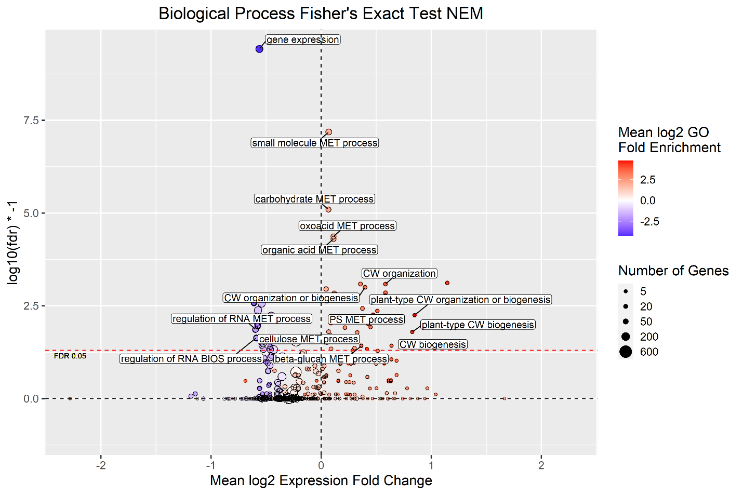

# Figure 6 | Gene Ontology (GO) Overrepresentation Analysis of differentially expressed genes (DEGs) for root lesion nematode count. Each point represents a biological process term. See methods for term labeling. CW = Cell Wall, PS = Polysaccharide, MET = Metabolic, BIOS = Biosynthetic. The points are colored by log2 GO fold enrichment and sized by the number of genes mapped to that term. DEG log2 expression fold change averaged by term is on the x-axis. DEGs negatively associated with the trait (resistance genes) have negative expression fold change and were used as the reference list. DEGs positively associated with the trait (susceptibility genes) have positive expression fold change and were used as the analyzed list. Log10(fdr)*-1 is on the y-axis. The dashed red line indicates the fdr threshold of 0.05.

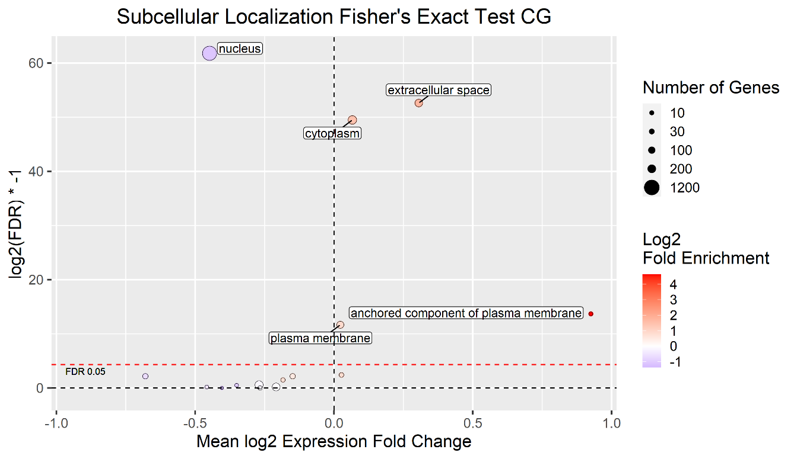

# Figure 7 | Subcellular localization analysis by Fisher's Exact Test for crown gall size. Differentially expressed genes (DEGs) were mapped to subcellular localizations and the average log fold change (logFC) in expression calculated for all DEGs mapped to a given subcellular localization. Only subcellular localizations with FDR <= 0.05 are labeled.

# Figure 8 | Subcellular localization analysis by Fisher's Exact Test for *Phytophthora* crown and root rot. Differentially expressed genes (DEGs) were mapped to subcellular localizations and the average log fold change (logFC) in expression calculated for all DEGs mapped to a given subcellular localization. Only subcellular localizations with FDR <= 0.05 are labeled.

# Figure 9 | Subcellular localization analysis by Fisher's Exact Test for nematode count. Differentially expressed genes (DEGs) were mapped to subcellular localizations and the average log fold change (logFC) in expression calculated for all DEGs mapped to a given subcellular localization. Only subcellular localizations with FDR <= 0.05 are labeled.

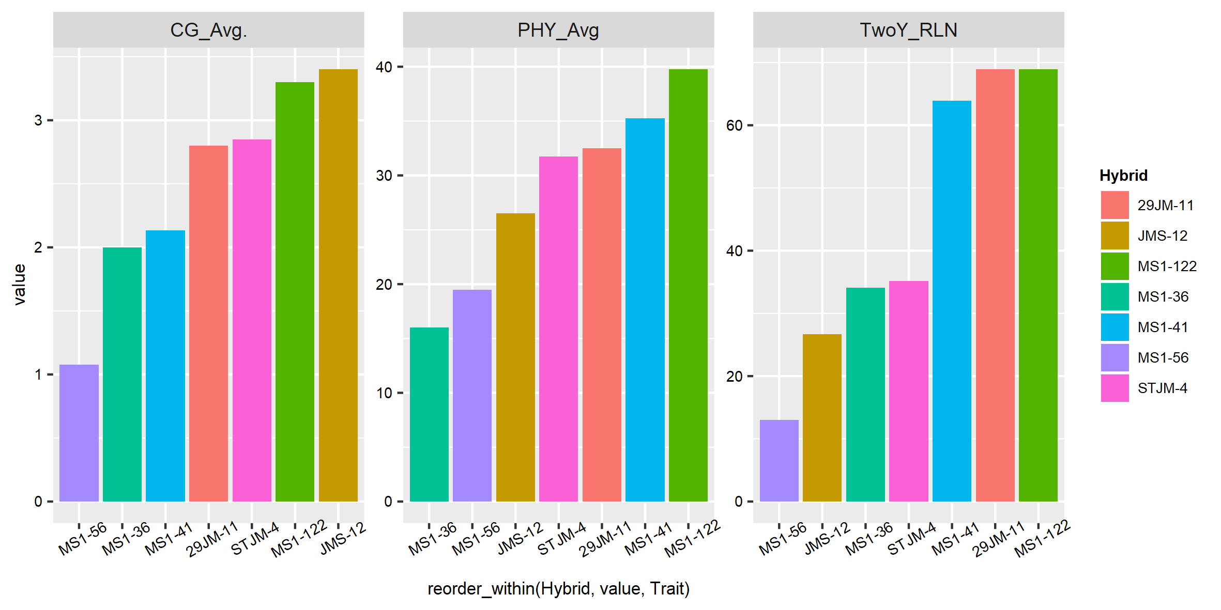

# Figure S1 | Bar plots of traits used in this study. CG_Avg. = crown gall size, PHY_Avg = *Phytophthora* crown and crown and root rot, TwoY_RLN = nematode count at two years.

# Table 1 | Summary of the results of the differential expression analysis. CG = crown gall size, PHY = *Phytophthora* crown and crown and root rot, NEM = nematode count at two years.

|  |  |  |  |
| --- | --- | --- | --- |
| Association | CG | PHY | NEM |
| Negative | 1839 | 746 | 1318 |
| NotSig | 5081 | 6806 | 6087 |
| Positive | 811 | 179 | 326 |

References

Browne, G.T., Leslie, C.A., Grant, J.A., Bhat, R.G., Schmidt, L.S., Hackett, W.P., Kluepfel, D.A., Robinson, R., and McGranahan, G.H. (2015). Resistance to species of Phytophthora identified among clones of juglans microcarpa × J. Regia. HortScience *50*, 1136–1142.

Buzo, T., Mckenna, J., Kaku, S., Anwar, S.A., and Mckenry, M. V. (2009). VX211, A vigorous new walnut hybrid clone with nematode tolerance and a useful resistance mechanism. J. Nematol. *41*, 211–216.

CADFA (2020). California Agricultural Statistics Review 2019-2020.

Dobin, A., Davis, C.A., Schlesinger, F., Drenkow, J., Zaleski, C., Jha, S., Batut, P., Chaisson, M., and Gingeras, T.R. (2013). STAR: Ultrafast universal RNA-seq aligner. Bioinformatics *29*, 15–21.

Ellis, C., Karafyllidis, I., Wasternack, C., and Turner, J.G. (2002). Erratum: The arabidopsis mutant cev1 links cell wall signaling to jasmonate and ethylene responses (Plant Cell (2002) 14 (1557-1566)). Plant Cell *14*, 1981.

Epstein, L., Kaur, S., McKenna, J.R., Grant, J.A., Olson, W.H., and Reil, W.O. (2008). Crown Gall Can Spread Between Walnut Trees in Nurseries and Reduce Future Yields. Hilgardia *62*, 111–115.

Fagard, M., Desnos, T., Desprez, T., Goubet, F., Refregier, G., Mouille, G., McCann, M., Rayon, C., Vernhettes, S., and Höfte, H. (2000). Procuste1 encodes a cellulose synthase required for normal cell elongation specifically in roots and dark-grown hypocotyls of arabidopsis. Plant Cell *12*, 2409–2423.

Gaspar, Y.M., Nam, J., Schultz, C.J., Lee, L.Y., Gilson, P.R., Gelvin, S.B., and Bacic, A. (2004). Characterization of the arabidopsis lysine-rich arabinogalactan-protein AtAGP17 mutant (rat1) that results in a decreased efficiency of agrobacterium transformation. Plant Physiol. *135*, 2162–2171.

Grant, J.A., Caprile, J.L., Doll, D.A., and Murdock, J. (2017). Sample costs to establish an orchard and produce walnuts, San Joaquin Valley - North (Cost Studies UC Davis).

Hasey, J., Browne, G., and Mircetich, J. (1996). Walnut Rootstock Tolerance to Phytophthora Cinnamomi (Walnut Research UC Davis).

Hernández-Blanco, C., Feng, D.X., Hu, J., Sánchez-Vallet, A., Deslandes, L., Llorente, F., Berrocal-Lobo, M., Keller, H., Barlet, X., Sánchez-Rodríguez, C., et al. (2007). Impairment of cellulose synthases required for Arabidopsis secondary cell wall formation enhances disease resistance. Plant Cell *19*, 890–903.

Kluepfel, D., McClean, A., Leslie, C., Aradhya, M., Luo, M.-C., Brown, P., Ramasamy, R., Dvorak, J., Browne, G., Hasey, J., et al. (2020). Putting Phenotypic and Genotypic Tools to Work for Improving Walnut Rootstocks.

Kluepfel, D.A., Aradhya, M.K., Moersfelder, J.W., Mcclean, A.E., Hackett, W.P., and Dull, A.J. (2011). Evaluation of wild walnut Juglans spp. for resistance to crown gall disease. Phytopathology.

Lampugnani, E.R., Khan, G.A., Somssich, M., and Persson, S. (2018). Building a plant cell wall at a glance. J. Cell Sci. *131*.

Malinovsky, F.G., Fangel, J.U., and Willats, W.G.T. (2014). The role of the cell wall in plant immunity. Front. Plant Sci. *5*, 1–12.

McGranahan, G., Browne, G., Leslie, C., Hackett, W., and McKenna, J. (2010a). WALNUT ROOTSTOCK “RX1".

McGranahan, G., Leslie, C., Hackett, W., Browne, G., McKenna, J., Buzo, T., Kaku, S., and McKenry, M. (2010b). WALNUT ROOTSTOCK “VX211".

Menna, A., Dora, S., Sancho-andrés, G., Kashyap, A., Meena, M.K., Sklodowski, K., Gasperini, D., Coll, N.S., and Sánchez-rodríguez, C. (2021). A primary cell wall cellulose-dependent defense mechanism against vascular pathogens revealed by time-resolved dual transcriptomics. 1–20.

Nicol, F., His, I., Jauneau, A., Vernhettes, S., Canut, H., and Höfte, H. (1998). A plasma membrane-bound putative endo-1,4-β-D-glucanase is required for normal wall assembly and cell elongation in Arabidopsis. EMBO J. *17*, 5563–5576.

Nühse, T.S. (2012). Cell wall integrity signaling and innate immunity in plants. Front. Plant Sci. *3*, 1–5.

Olson, B., Walton, J., Laminen, B., and Sam, M. (2002). The Effect of Crown Gall on Tree Growth and Productivity (Walnut Research UC Davis).

Ramasamy, R.K., Luo, M.C., Leslie, C.A., Velasco, D., Ott, N., McClean, A., Dandekar, A.M., Aradhya, M., Brown, P.J., Browne, G.T., et al. (2021). Co-located quantitative trait loci mediate resistance to Agrobacterium tumefaciens, Phytophthora cinnamomi, and P. pini in Juglans microcarpa × J. regia hybrids. Hortic. Res. *8*.

Roudier, F., Fernandez, A.G., Fujita, M., Himmelspach, R., Borner, G.H.H., Schindelman, G., Song, S., Baskin, T.I., Dupree, P., Wasteneys, G.O., et al. (2005). COBRA, an Arabidopsis extracellular glycosyl-phosphatidyl inositol-anchored protein, specifically controls highly anisotropic expansion through its involvement in cellulose microfibril orientation. Plant Cell *17*, 1749–1763.

Sánchez-Rodríguez, C., Bauer, S., Hématy, K., Saxe, F., Ibáñez, A.B., Vodermaier, V., Konlechner, C., Sampathkumar, A., Rüggeberg, M., Aichinger, E., et al. (2012). CHITINASE-LIKE1/POM-POM1 and its homolog CTL2 are glucan-interacting proteins important for cellulose biosynthesis in Arabidopsis. Plant Cell *24*, 589–607.

Silva, J., Ferraz, R., Dupree, P., Showalter, A.M., and Coimbra, S. (2020). Three Decades of Advances in Arabinogalactan-Protein Biosynthesis. Front. Plant Sci. *11*.

Zhu, T., Wang, L., You, F.M., Rodriguez, J.C., Deal, K.R., Chen, L., Li, J., Sandeep Chakraborty, B.B., Jiang, C.-Z., Brown, P.J., et al. (2019). Sequencing a Juglans regia × J. microcarpa hybrid yields high-quality genome assemblies of parental species. Hortic. Res. *6*, *55*.