Topic No.2

The computer has changed society today as much as the industrial revolution changed society in the eighteenth and nineteenth centuries. You may interact directly with computers in fields such as education, finance, government, health care, science, publishing, travel and industry. The given ed how computers have made a difference in people’s interactions with these disciplines.

Table of Contents

Education: 2
Study and Class uses: 2
Online Education: 2
Gathering information: 3
Finance: 3
Business purposes: 3
Online Banking: 4
Advertising: 4
Government: 5
Electronic voting: 5
Important Statistics: 5
Law Enforcements: 6
Diplomatic purposes: 6
Health Care: 7
Self remedy: 7
Consultation and Medicine: 7
Medical Technology: 8
Science: 8
Weather forecasting: 8
Astronomical Researches: 9
Experiments and Invention: 9

Computer has significantly changed the infrastructure of the world wide education system. Computer is using as a part of education. People from Kinder garden to doctorate all the walk of learning education, Computer are essential.

Education

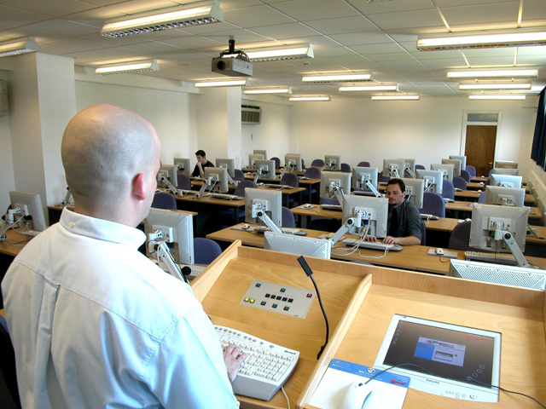
Study and Class uses:
In the class room, student use computer to develop science projects, prepare reports, doing assignments, presentation and gather information from electronic sources around the world. There is some mathematics which is very difficult to do in pencil and book equation but it is easier when it is Figure no.1: Computer using in class

graphically visualize. Student can make annual magazine by using power point.

Online Education:
Nowadays computer and communication combined assists together to make the education system a revolutionary way. Students of south Asia can get American Degree staying at his home by using internet. It is called Figure no.2: Online Education “distance learning” or “online
education”. Teacher can provide lecture and discuss with the Student through Web cam and Video Chat.

Gathering information:
Those students who want to pursue their higher study in abroad they can easily get information about his chasing destination. One can know about university or colleges faculties, course tuition fees, accommodation, departments, contact address, email and other facilities by browsing relevant Web sites.

Finance

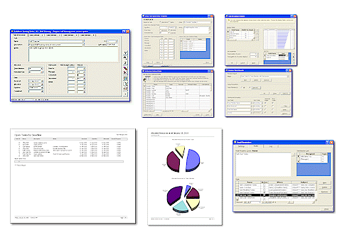
Today is an era of globalization. None but computer had made it possible. Communication and network helping together to get information about the world economical position.

Business purposes:
From small business man to huge business man can save the documents of their office workers, find information, manage projects and so on. A share holder can get information about the stock exchange markets.
Staffs can receive emergency email from his Boss by checking his mail Figure no.3: Business soft wares
account. Gigantic stock exchange firm provides online trading. One company can customized the soft wares what they need from packages software. After the invention of accounting software, now accounting is very easy, accurate and it’s also make the accounting calculation stronger and more effective than past.

Online Banking:
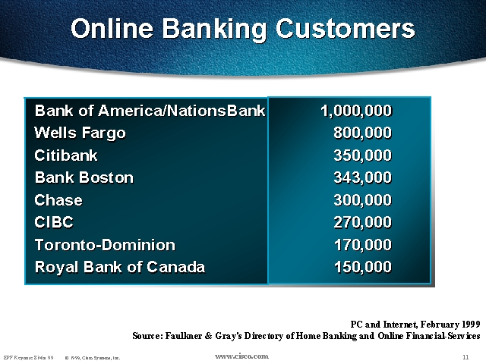
The advent of the Internet and the popularity of personal computers presented both an opportunity and a challenge for the banking industry.
For years, financial institutions have used powerful computer networks to automate millions of daily transactions; today, often the only paper record is the customer's receipt at the point of sale. Now that its customers are connected to the Internet via personal computers, banks envision similar economic advantages by adapting Figure no.4: Online Banking that same internal electronic processes to home use. Banks view online banking as a powerful "value added" tool to attract and retain new customers while helping to eliminate costly paper handling and teller interactions in an increasingly competitive banking environment.

Advertising:
Many manufacturing organizations advertise their products through internet. Buyers also can get information about those products and buy them using those sites. This is called online shopping. It is not only saving the money also save the valuable time.

Government

Those country who has increase their technological sites and computer education, are getting develop day by day. First world country like United state of America, Canada, England, they controlled their government polices, administration and internal revenue service by using hyper technological computers.

Electronic voting:
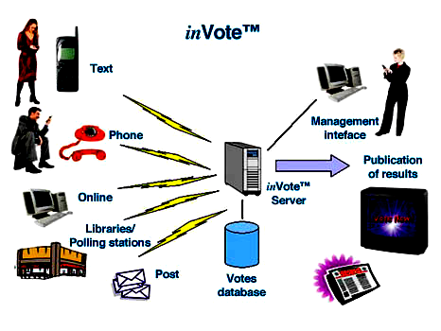
United States citizen elected their government by online voting. Online voting is a system where an eligible voter casts their vote using an online system including the Internet, Touch-tone Telephone voting using Interactive Voice Recognition (IVR), or Mobile Telephone SMS text facility. Once a voter selects/casts their vote, the details of the vote are transmitted in real time to a secure electronic store, pending tabulation (counting) of the results United States also provide yearly DV lottery for migration using online applications. Figure no.5: Online Voting
Thousand and hundred application submitting in this lottery, but computer handle this very smoothly. Its choose the right person according to the instructions and the conditions.

Important Statistics:
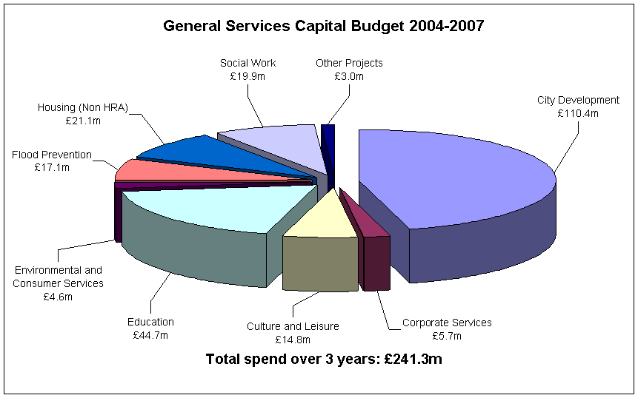
Nowadays it is easy for the government to collect the information about the population growth, people’s yearly income, percentages of literacy and other needy information. Government can also figure out the retirement benefits that should be paid to each person. Government can keep data about government and non government organization, bank, loans, Figure no.6: Budget Graph charts finance and also about the budget. It is very easy to calculate the equation of the monthly bills of electricity, water, gas and other sources which is provided by the government.

Law Enforcements:
The judiciary, the least computerized of the three branches can also require information from the executive departments and has the power to rule ineligible what ever evidence it chooses. In other words the judiciary can decide in particular case whether information is or is not relevant and thus may stymie the executive branches arguments by ruling its massive data files inadmissible to case at hand.

Diplomatic purposes:
Foreign investor can know about the situation by browsing government web sites. Governments at all levels use computers to function efficiently, more effectively and even more democratically.

Health Care

Computer has remarkably help to doctors to signify the exact dieses. Tiny remote cameras which take picture of the body are great surgical assistants.

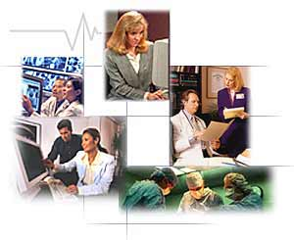
Self remedy:
Patient themselves are getting in an act of understanding their symptoms and drugs with called “Doc-in-box” software kits and on-line support groups and forums. The workstations are networked throughout the hospital, medical departments like radiology can file test results electronically Figure No.7: Computer working different uses
as they are completed and they are instantly available in any room.

Consultation and Medicine:
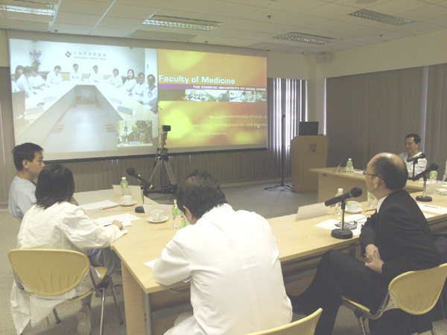
If doctor wit some complicate case with patient he can ask about that to an outside doctor through the internet. Pharmaceuticals Industries using computer to make better remedy and medicine. Use of telecommunications technology for medical diagnosis and patient care when the provider and client are separated by distance. Telemedicine includes pathology, radiology, and Figure no.8: Uses of Telemedicine patient consultation from the distance.
This use of audio, video, and other telecommunications and electronic information
processing technologies to provide health services or assist health care personnel at distant sites.

Medical Technology:
Medical technology based in computers has added new diagnosis tools unimaginable only a few years ago. The most well known one is probably computerized axial tomography, better known as the CAT or CT scanner. Today hospitals regularly use such devices to find brain tumors and other cancers and later to check for recurrence after surgery or chemotherapy. Magnetic resonance imaging employs a similar technology using the interaction of radio waves with hydrogen nuclei in water.

Science

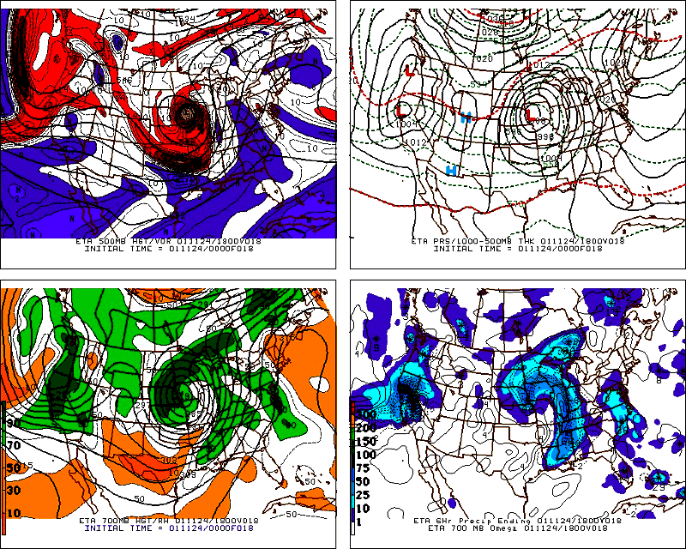
Computer playing a vital role in science and experiment, there is no doubt about that. Computer is very fast and accurate calculating engine that can help a researcher with his experiment.

Weather forecasting:
Weather forecasting is an everyday instance of super computing. Accurate weather prediction depends on the collection of temperature, wind velocity and air pressure reading from many stations. For decades scientists have known Figure no.9: Weather forecasting that solving a series of complex mathematical equations containing data from thousands of weather stations will give an accurate forecast. Nowadays we expect accuracy about five days in advance because supercomputers have increased calculating power dramatically.

Astronomical Researches:
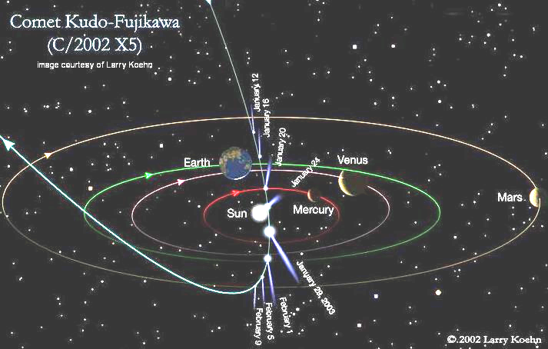
Astronomical Organization NASA uses super computer to explore outer space and snap the important and complex events of the moving Universe. That is how they are introducing thousand and hundred comets, stars, planets and lots of unknown things in this deep black Universe.

Experiments and Invention:
Chemist can find his experiment so Figure no.10: Courtesy of Larry Koehn
accurate by using microscope. Many robots have been created as a model of human being, they are treating like a human and they are also being used instead of human. Computer is using every sector of science such as Biology, Metrology, with collecting, analyzing, modifying and modeling the data.

