Setup for CTS2 Framework Plugin:

Required:

Java 1.6 or newer

MySQL 5.16

Maven 2.2.1

Eclipse (Instructions for Intellij Community Edition are also included)

Gene Ontology Data Base dump

Download and install MySQL

<http://www.mysql.com/downloads/mysql/5.1.html>

I used all the defaults except I pushed the character encoding to UTF-8 and included the option for the command line client

Download and install Maven:

<http://maven.apache.org/download.html>

We used version 2.2.1 (compatible with Intellij 11.1’s plugin).

This note on Maven’s install instructions in Windows 7: You may need to create the environmental variables in the system, rather than user, variables in order to get Maven working from the command line. To be sure your maven install works create all the recommended environmental variables including JAVA_HOME.

We’ll be using eclipse, but Included are instructions for Intellij

Intellij or Eclipse:

<http://www.jetbrains.com/idea/download/>

<http://www.eclipse.org/downloads/>

Intellij’s Maven integration works better for some than Eclipse. You can install Eclipse’s M2e plugin for maven if you don’t mind ignoring the errors it generates. We’ll be working with Eclipse for the most part during the tutorial. We’ll also use the M2e maven plugin to add dependencies. Code snippets and other materials for the tutorial are available in a zip file here:

From gitHub:

<https://github.com/hsbauer/cts2-example-service/archive/master.zip>

Take note that this file downloads as cts2-example-service-master.zip

Gene Ontology database import (from the zip file):

This is an ontology chosen for it’s small size and relatively rich ontology metadata table. It’s not the full Gene Ontology. You’ll need to create a new database named “godata” and import it into MySQL. File name in the zip folder is go_daily-termdb-data

MySQL client should be in your Program Files in the Start Menu.

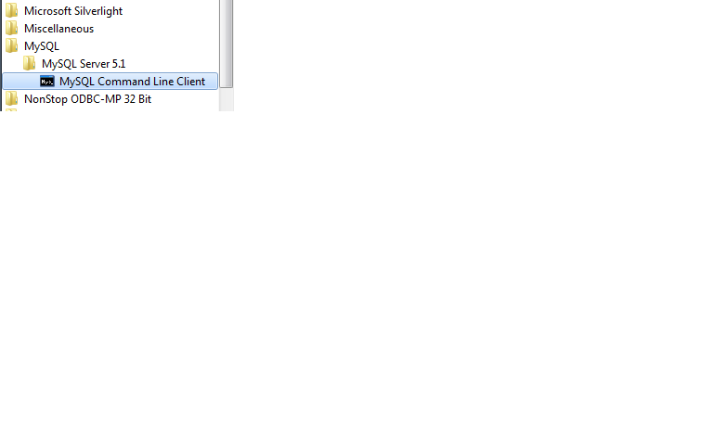

From the MySQL command line client you can execute:

Create database godata;

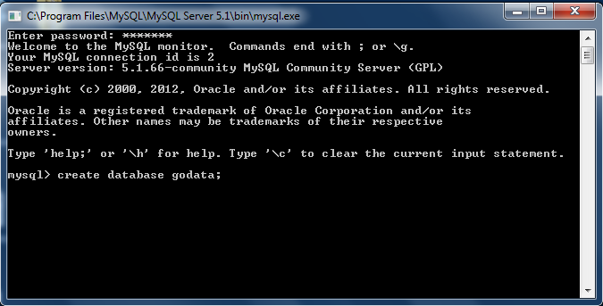

And then from a regular Microsoft terminal window:

Mysql –u “your username” –p”your password“ godata < path to go_daily-termdb-data

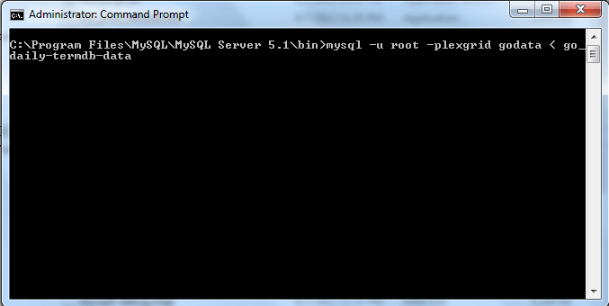

Download and copy to a convenient directory the cts2 standalone framework server:

http://informatics.mayo.edu/cts2/framework/downloads/cts2framework-standalone.jar

**Eclipse instructions:**

1. Install Eclipse and its Maven plugin.
2. Extract the example-service zip to the Eclipse workspace folder
3. Create a new project named example-service and you should see the project structure of the new project displayed in the package explorer.
4. Right click on the project and select Configure/Convert to Maven Project
5. Your pom file will have errors but they can be safely ignored.

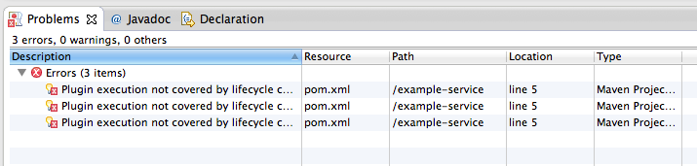

If any Java files still have errors, Right click the project and try running Maven => update project.

You may need to refresh, and clean the project.

Right click on the project folder and select refresh.

Find the project tab at the top and select clean.

Otherwise

Right click the project:

Choose run as => Maven Clean

Then run as => Maven Install

**This completes the set up, follow the slides presentation from here.**

**https://www.dropbox.com/s/1q4oe5aa7t48lhb/CTS2TutorialTechnical.pptx**

Intellij users can follow these directions but we won’t be making reference to intellij during the presentation but these should carry the user to the end of the exercise:

**Intellij:**

Create a new project:

* add a java SDK to the project
* copy source (src) directory and pom files to the project
* Right click on src directory and go to Mark Directory and choose Root Source.
* Right click on the pom.xml file and select add the project as Maven Project

Using the Maven Project view, do a clean install.

* Both should return a value of 0.
* You should see a small green popup in the upper right corner.
* Click on the upload link to upload all dependencies to maven so the application can be run.

From the cts2-example-service/example service zip, get the JDBCConnection.java file and place it in the source folder.

* If you run the main class here it will fail.
* Pull in a connector with adjustments to the pom file.
* Run the main class in the JDBC connector again and it should give you metadata about the GO ontology.

Add the MySQL connector to the build.

* Using additions to the pom file, add the connector to a maven build.

Do a clean install

Start up the stand alone server.

* from whatever directory you choose to install cts2 standalone framework server, run java -jar cts2framework-standalone.jar
* login as admin/admin
* Choose install update from the bar at the top of the list of plugins and find the jar constructed in the maven build target folder.
* Refresh the browser
* Click the play/stop button next to the example service plugin.

If there are no errors returned to the terminal window then the plugin has successfully installed. Time to test the plugin:

* Type localhost:8080/codesystem/GO
* This should give you a hard coded response

We’ll want a more dynamic interaction with a data source:

* replace the ExampleCodeSystemCatalogReadService method read with the one in the code fragments:
* Use alt enter to resolve dependencies.
* run clean install and upload changes to the framework.
* Once again we'll type localhost:8080/codesystem/GO
* This time the service goes to the database and returns GO metadata.