Harman Birring

7/19/25

**EDGAR API Data - EDA & Financial Ratios**

***Introduction***

This report presents an exploratory data analysis, as well as a financial ratio assessment of Google (Alphabet Inc.), which was built using data extracted from the SEC EDGAR API. This analysis spans the period from 2014 to 2021, providing a deeper understanding of Google’s growth trajectory by focusing on key financial ratios, including the Current Ratio, Quick Ratio, and Debt-to-Equity Ratio.

***Exploratory Data Analysis Process & Results***

My process is a structured approach similar to established financial analysis frameworks, utilizing the SEC EDGAR API's company facts endpoint to extract Google's economic data. My process involved extracting data by retrieving financial statement information from the SEC's EDGAR API. I have used the API Source and then fetched Alphabet's facts in XBRL format. I have also performed data cleaning through frame filtering, formatting, and annual 10-K extraction. Then, I performed the statistical analysis using pandas.DataFrame.describe() on the actual revenue values, which gave me the mean, median, min, max, standard deviation, and percentiles. Lastly, I have also performed the visualization by creating a Plotly line chart of val over time as one of the charts in this report, titled "Google Revenue Trend Over Time." Lastly, I have also created another visualization chart to observe the year-over-year growth rate in percentage.

Based on the statistical data, the mean annual revenue was $135.1 billion, with a standard deviation of $64.3 billion, resulting in a coefficient of variation of 47.6%. The actual revenue ranged from $66.0 billion to about $257.6 billion. These numbers imply that Google experienced strong revenue growth over the period I analyzed, with a high standard deviation and coefficient of variation, indicating that revenue didn’t grow at a steady rate; instead, some years saw significantly larger increases. However, in a business context, this type of growth can be attributed to various factors, such as acquisitions, market shifts, and product launches. A COV of 47.6% is high; however, I believe Google has been expanding rapidly as a company, reflecting a fast-moving, innovative environment in which it operates. One anomaly I have noticed in the charts and data is the 41.2% growth rate for 2021 revenue, which is above the historical average of approximately $257.63 billion. This could be because the pandemic accelerated this growth, in which retail advertisers became Google’s most significant contributor to growth and increased their digital advertising spend. Additionally, during the pandemic, people consumed more videos, resulting in a revenue jump for YouTube advertising. The pandemic appears to have created a growth opportunity for companies like Google, which has led to this pattern and a significant increase in revenue. I have also checked for any duplicate entries and none was found for any same reporting periods.

***Table for Annual Revenue Summary***

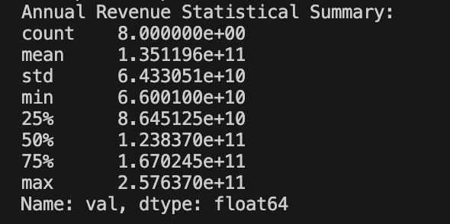

***Chart: Google Annual Revenue Trend Over Time***

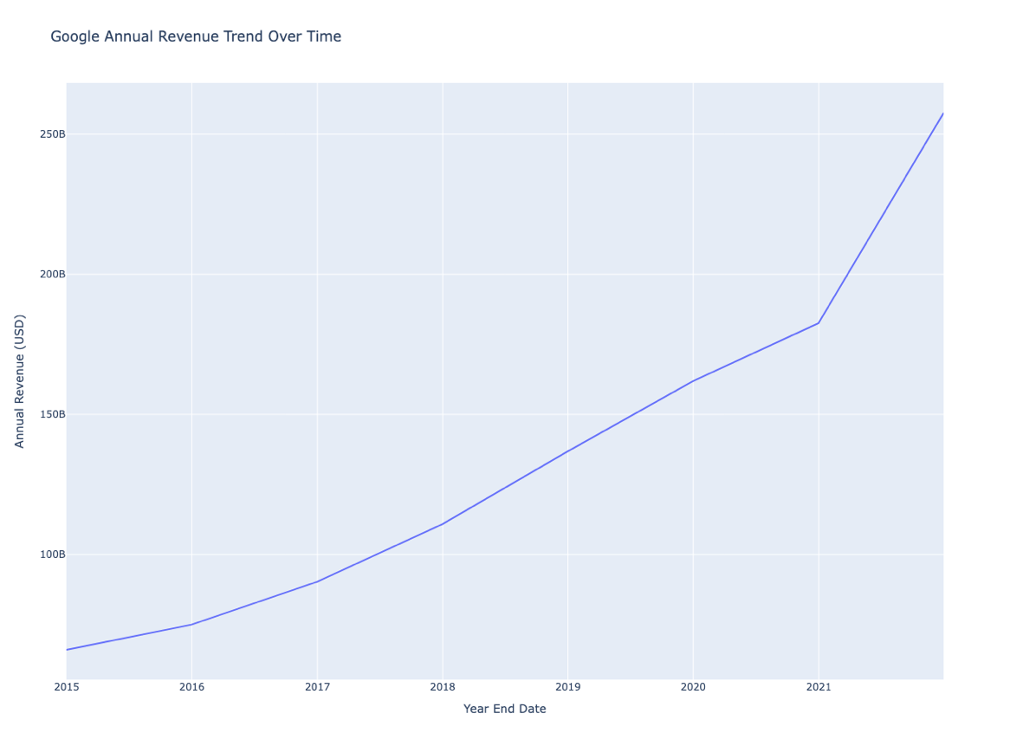

***Chart: Google Year over Year Annual Revenue Growth***

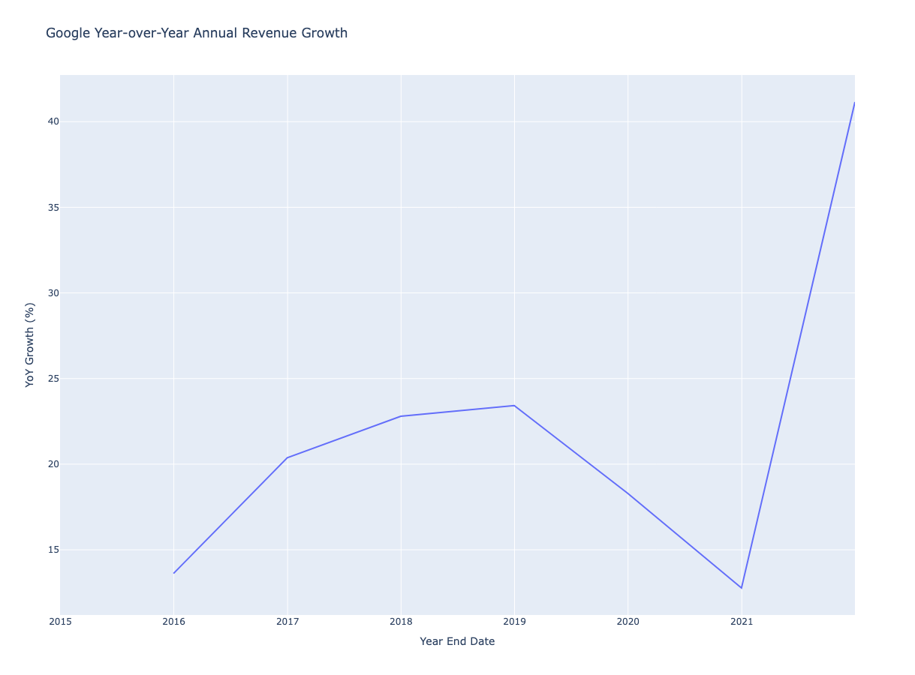

***Financial Ratio Analysis***

The financial ratio for this project I have selected to analyze current ratio, quick ratio and debt to equity ratio (D/E). Below are the ratio formulas used for the calculation of the ratios in VSC:

df['gross_profit'] = df['revenue'] - df['cost_of_revenue']

df['gross_profit_margin'] = df['gross_profit'] / df['revenue']

df['net_profit_margin'] = df['net_income'] / df['revenue']

df['current_ratio'] = df['current_assets'] / df['current_liabilities']

df['quick_ratio'] = (df['current_assets'] - df['inventory']) / df['current_liabilities']

df['debt_to_equity'] = df['total_liabilities'] / df['total_equity']

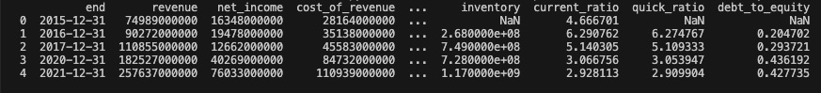

***3 Financial Ratios Current Ratio, Quick Ratio and D/E Ratio Charts***

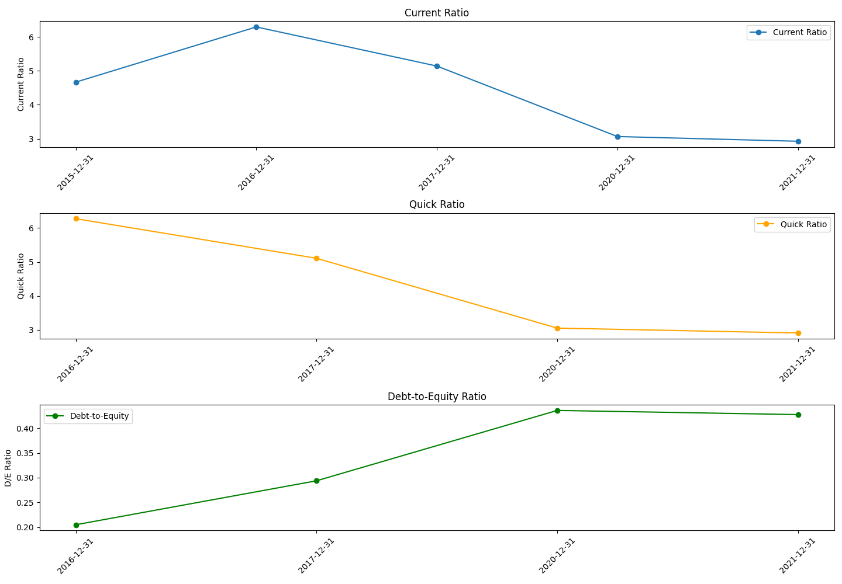

**Current Ratio**

The current ratio measures a company's ability to pay its short-term obligations with its current assets. This ratio can provide insight into the company's liquidity if it is needed over time. If we look at the chart from 2015 to 2016, the ratio peaked at about 6. However, from 2016 to 2021, it declined to about 3, and in 2021, it was positioned at about 3. The ratio is well above 1, meaning it has more current assets than current liabilities. The company must also have an excessive cash reserve. Thus, despite the decline that it might have used for growth initiatives, the company still has good short-term financial flexibility.

**Quick Ratio**

The quick ratio tends to evaluate a company’s ability to meet its short-term liabilities with its most liquid assets, excluding inventory. It’s a more immediate measure of liquidity, and it’s a more conservative ratio. If we examine the chart, the quick ratio from 2016 to 2021 has declined from approximately 6 to 3, representing a 50% reduction. It suggests that Google has effective liquidity management in the technology sector. The fact that Google can rapidly convert assets to cash without relying on inventory liquidation indicates a superior company.

**Debt to Equity Ratio (D/E)**

Lastly, the D/E ratio shows Google's approach to financial leverage and shows the balance between debt financing and equity funding. It's a significant financial metric to assess a business's financial leverage, risk appetite, and capital structure. Looking at the chart from 2016 to 2021, the D/E ratio increased from 0.2 to 0.4. Despite the increase, Google tends to be very conservative; it's trending below 1, indicating a low risk. The company moved from a highly conservative debt position of 0.2 to a more balanced capital structure. This could be a reason for financial flexibility, as well as support for acquisitions, investments in research and development, and expansion in different markets.

***In Conclusion***

In terms of Google as a company, these metrics demonstrate that it has transformed from a cash-rich growth company to a mature technology leader that has optimized its capital allocation. The decline in liquidity ratios, along with a measured increase in leverage, demonstrates effective financial management that is likely to maximize shareholder value. Its approach to capital allocation and risk management, combined with strategic investment, gives the company a competitive advantage in the IT and technology field within a rapidly evolving market environment.