**Using DrawCellEdges (a matlab user interface) to highlight the cell edges and to quantify fluorescence intensity of individual cells**

**Program introduction**

The DrawCellEdges program (Fig. 1) was developed to draw the cell edges using either the fluorescence channel or the bright field channel. The cell edges are also drawn on another channel to highlight the cell areas. The average fluorescence intensity of the cell areas is automatically quantified and saved to an excel file for further analysis.

The program was developed by following a published matlab code [1], and some important parameters in the ‘Draw Cell Edges’ panel can be modified to adapt to the user’s input image. Multiple separate images (single or multiple channels for each image) or an image stack containing many images can be analysed by running the program once. The details for using the program are introduced below.

**File table:**

**DrawCellEdges.m** contains the main code for analysing the imaging data.

**DrawCellEdges.fig** is a figure window, which contains the user interface, and all the functions in the interface are connected to the main code to do the mathematical analysis.

**User instruction:**

1. **Run the program.** Open DrawCellEdges.m in MATLAB R2014a installed on a windows computer and run this program. The user interface (Fig. 1) will be displayed on the screen.
2. **Load the first image (Fig. 1 ‘Load First Image’ panel).** If multiple separate images are to be analysed, the image files should be named as filename**0n**.lsm (n is a number from 1 (the first image) to n (number of the last image)). There is no special name requirement for an image stack. The fluorescence channel, bright field channel and the image bit-depth should be specified in the text box. Then, the first image or the image stack can be loaded by pushing ‘Load’ button and selecting the image file in the desired directory.

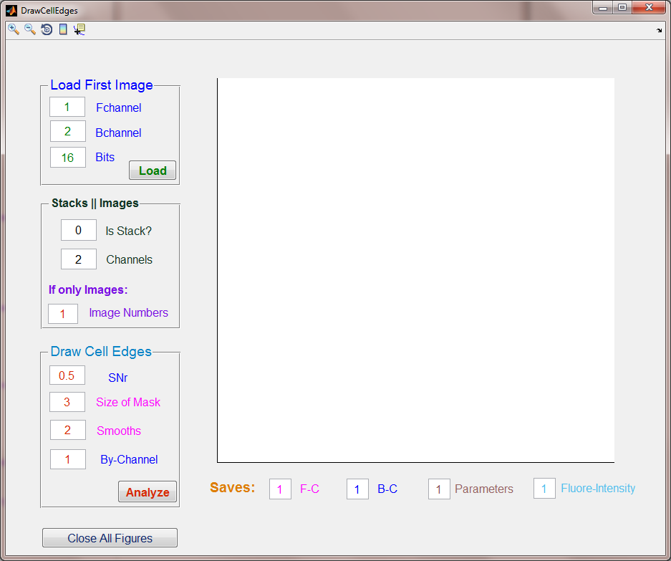

**Figure 1 User interface of DrawCellEdges program.** The user interface contains the parameters panels on the left side and image display box on the right side. The save functions are under the image display box.

1. **Select the image stack or multiple images (Fig. 1 ‘Stacks || Images’ panel).** If multiple images are to be analysed, the text box for ‘Is stack’ should be 0, which means no. The total number of images with same filename (‘Image Numbers’ text box) should be specified to analyse multiple images in a single run. If an image stack is to be analysed, the text box should be 1, which means yes.The total number of images in the stack (‘Image Numbers’ text box) should also be specified if the images in the stack are to be run once as a single batch. The number of total channels is required as well to logically analyse the desired image.
2. **Load parameters and analyse the cell edge (Fig. 1 ‘Draw Cell Edges’ panel).** The loaded image/images can be analysed with the default parameters. If the acquired results are not fit for purpose, the following parameters [1] can be modified to re-analyse the images.

The ‘SNr’ is a threshold parameter (0~1) used to separate the cell from background. The recommended range for this parameter is 0.35~0.65. The ‘Size of Mask’ (generally around 3) is used to dilate the image. Since the detected cell areas generally contain some gaps, the image should be dilated to fill the gaps. The ‘Size of Mask’ is based on the size of gaps. ‘Smooths’ is used to remove the small noisy areas, which are detected outside of cell areas. This positive integer number is the number of cycles for smoothing the image. The recommended number is 2~6 cycles.

1. **Saves.** The analysed images (fluorescence channel and bright filed channel) with highlighted cell edges are automatically saved in ‘analysed’ folder in the same directory with the loaded images. The parameters for image analysis and the averaged fluorescence intensities of the cell areas are saved in the same folder as well. The save function can be turned off by changing the corresponding parameters to 0.
2. The analysed images will be displayed on the screen and all of the figures can be closed by pushing ‘Close All Figures’ button.

Reference List

1 MathWorks. Detecting a cell using image segmentation. 2014 [cited 2015 21 January]; Available from: <http://uk.mathworks.com/help/images/examples/detecting-a-cell-using-image-segmentation.html>