**Using ImagingDataAnalyzerForFRAP (a matlab user interface) to analyse fluorescence recovery after photobleaching data**

**Program introduction**

The ImagingDataAnalyzerForFRAP program was developed to efficiently analyse fluorescence recovery after photobleaching (FRAP) data. Three main functions are included in the program: fluorescence recovery curve analysis, imaging data viewing and radial profile analysis (Fig. SM2).

The fluorescence intensity of the bleached area is analysed in box 1 (Fig. SM2: fluorescence recovery curve analysis) with the method described in materials and methods (manuscript). The half recovery time and final recovery level are also extracted (Fig. SM3). The raw FRAP imaging data can be loaded and viewed in box 2 (Fig. SM2: loading and viewing imaging data). The radial profile of the bleached area and surround is analysed in box 3 (Fig. SM2: radial profile analysis) to spatially investigate the fluorescence recovery. By default, the frame numbers (or image numbers) corresponding to before bleaching, immediately after bleaching and from 10% to 100% final recovery level in steps of 10% were extracted from the analysed fluorescence recovery curve (Fig. 2). The radial profiles of these twelve frames are extracted. More details of the files included in this programs and a user instruction are described below.

**File table:**

**ImagingDataAnalyzerForFRAP.m** (ImagingDataAnalyzerForFRAP.fig) is the main script, which contains the program interface (Fig. SM2) and the code for fluorescence recovery curve analysis. The view function of raw imaging data (.lsm format) is included in this script as well.

**rscan.m** is a published matlab code for radial profile extraction [1]. A profile example is presented in figure 2. The profile of one image was extracted from the bleaching centre to the circle (Fig. SM4).

**MoRscan.m** is a linker between the user interface and rscan.m. It passes the parameters to rscan.m and returns the collected radial profile data back to the main script.

**shadedErrorBar.m** is a published matlab code [2], which is used to add a shaded error bar to the plotted curve.

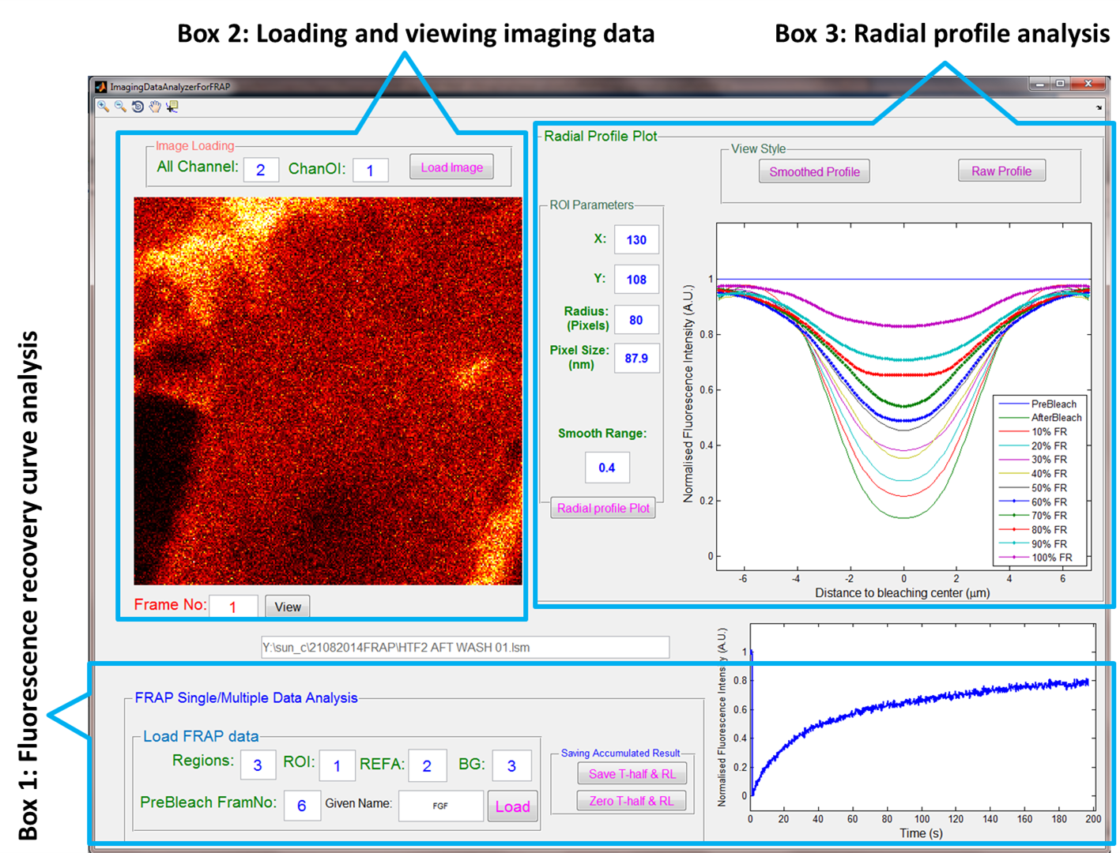

**Figure SM2: User interface of ImagingDataAnalyzerForFRAP.** Three main functions are shown in the interface. Box 1 is the fluorescence recovery curve analysis panel. Box 2 is used to view the images from the FRAP experiments. Box 3 combines the desired image numbers from box 1 and the images from box 2 to extract the radial profiles. The default parameters are the parameter used for the Halo-FGFs study.

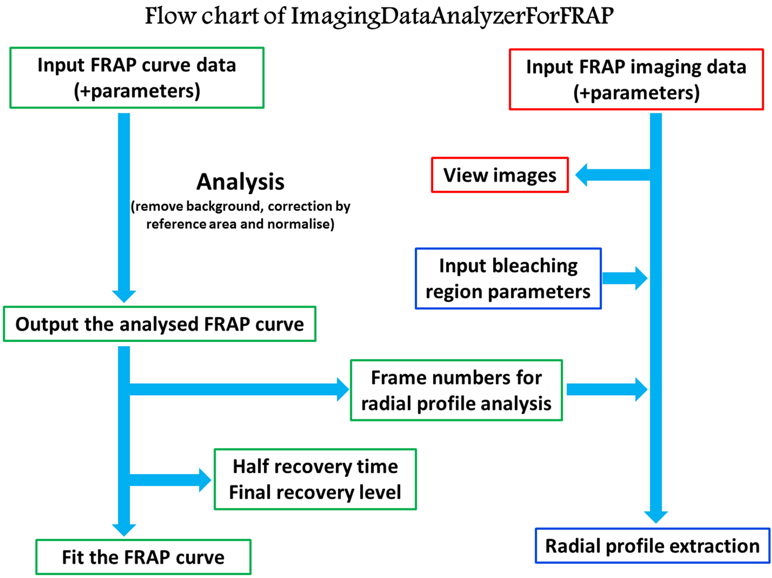

**Figure SM3: Flow chart of ImagingDataAnalyzerForFRAP.** The diagram shows how the program works and how the different functions communicate with each other.

**User instruction:**

**1 Run the program.** Download shadedErrorBar.m [2] and rscan.m [1] from the webpage link in the reference list and add these two files to the folder containing the program. Open ImagingDataAnalyzerForFRAP.m in MATLAB R2014a installed on a windows computer and run this program. The user interface (Fig. SM2) will be displayed on the screen and be ready to use.

**2 Fluorescence recovery curve analysis**

The fluorescence recovery curve is not fitted, but the FRAP curve fitting was described in another FRAP software paper [3]. As the half recovery time and final recovery level are extracted, a simulation curve is generated to test whether the fluorescence recovery curve can be fitted to the model:

Model: I = If – If * e(-ln(2) * t/t1/2)

I: Fluorescence intensity at time t; If: Final fluorescence intensity; t: time value; t1/2: Half recovery time.

The parameters in box 1 (Fig. SM2) are based on the fluorescence recovery input data. In general, the fluorescence intensities of three regions are included in the input data: fluorescence intensity of bleached area (ROI), fluorescence intensity of non-bleached reference area (REFA) and fluorescence intensity of background (BG). The number of regions and column position of the three regions in the file are required to be specified. The time values are always in first column of the input data, but it is not counted for the column position of the three regions.The number of images collected before bleaching should be input into the ‘PreBleach FramNo’ text box. ‘Given Name’ will give a name to the analysed half recovery time and final recovery level, but it is not required if the half recovery time and final recovery level will not be saved in an excel file by ‘Save T-half & RL’ button (‘Zero T-half & RL’ function is used to remove from memory the half recovery time and final recovery level).

The ‘Load’ button allows a file to be choosen (excel or txt) for analysis. A file containing both a single fluorescence recovery curve and multiple fluorescence recovery curves can be analysed. The analysed fluorescence recovery curve and the fluorescence intensity of the reference area will be presented in separate figures.

**3 Load imaging data**

The parameters for the image channel should be checked before loading the imaging data. The whole channel number (All Channel) and the channel of interest (ChanOI) are required to be specified. Image files (.lsm or .tif) can be loaded by ‘Load Image’ button. The desired frame specified by a frame number (‘Frame No’ button) can be viewed by ‘View’ button.

**4 Analysis of radial profiles**

The position of the bleaching centre (X: column and Y: row) is required to locate a position for analysis. Radius controls the size of the analysed area. The pixel size is used to scale the x axis for the radial profile plot. Then, the radial profile can be analysed by clicking on the ‘Radial profile Plot’ button. Smooth range is used to smooth the extracted raw radial profile, while the raw profile can also be presented by clicking on the ‘Raw Profile’ button.

**5 Saved files**

After the analysis, the FRAP curve data will be automatically saved to the anaFRAP folder, which is in the same folder as the input data. The four radial profiles of before bleaching, immediately after bleaching, after half of final recovery and final recovery will be saved to the same folder as the analysed FRAP curve data. The other figures in separate windows can be saved manually by using the ‘save as’ function.

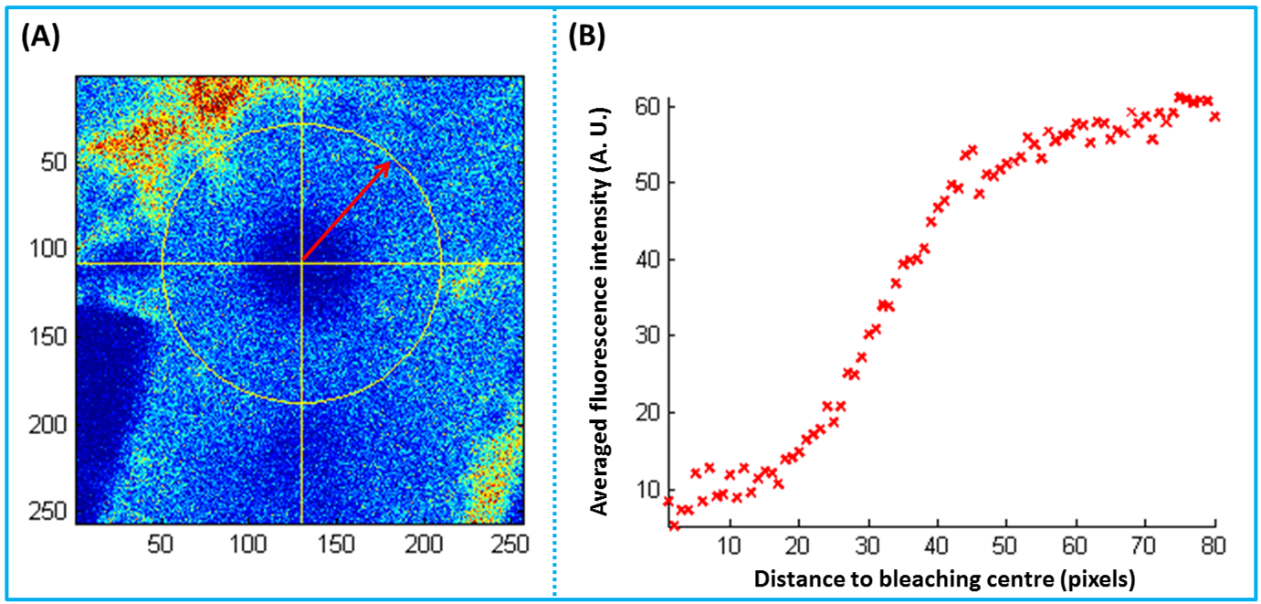

**Figure SM4: Radial profile analysis of an image.** The radial profile of the image from the circle centre to the circle edge was extracted. (A): An image from the FRAP experiment; (B): The extracted radial profile of the fluorescence intensity.

Reference List

1 Chattrapiban, N. Radial Scan. 2007 [cited 2014 03 June]; Available from: <http://www.mathworks.com/matlabcentral/fileexchange/18102-radial-scan>

2 Campbell, R. shadedErrorBar. 2010 [cited 2015 04 March]; Available from: <http://www.mathworks.com/matlabcentral/fileexchange/26311-shadederrorbar>

3 Rapsomaniki, M. A., Kotsantis, P., Symeonidou, I. E., Giakoumakis, N. N., Taraviras, S., Lygerou, Z. 2012 easyFRAP: an interactive, easy-to-use tool for qualitative and quantitative analysis of FRAP data. *Bioinformatics*. **28**, 1800-1801.