directory structure of G_plot

G_plot/

│

├── G_plot/

│ ├── __init__.py

│

├── CHANGELOG.txt

├── LICENCE.txt

├── MANIFEST.in

├── README.md

└── setup.py

File in details or what they contain inside

1. # inside __init__.py

/G_plot/__init__.py

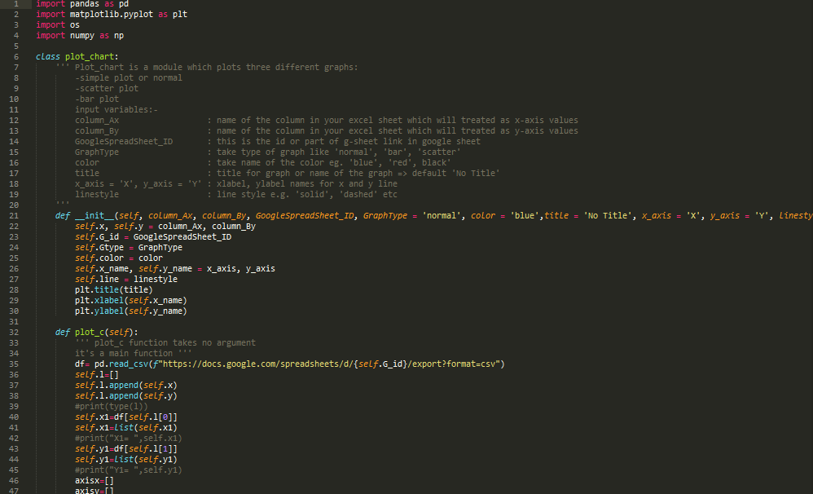

Basically script or program functions I want to use or class

1. Inside CHANGELOG.txt

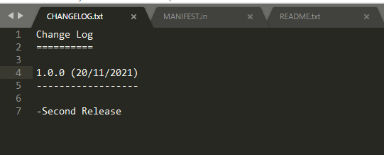

1. Inside LICENCE.txt

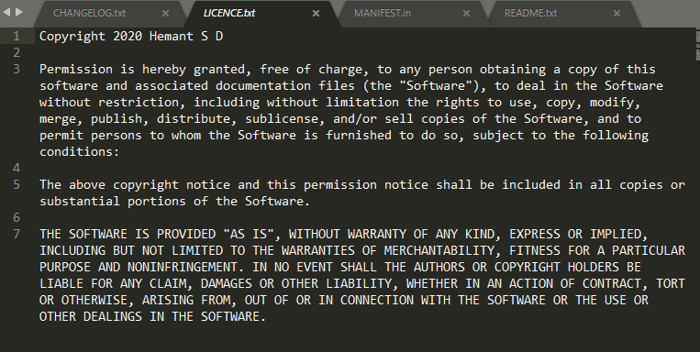

1. MANIFEST.in

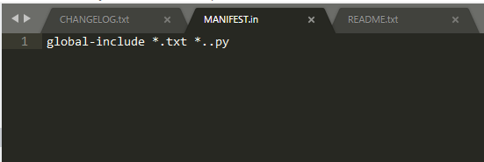

1. README.md

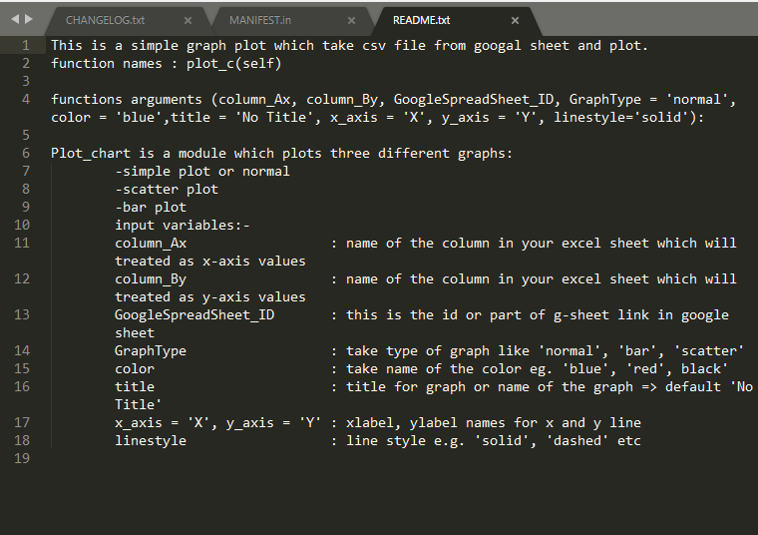

1. setup.py

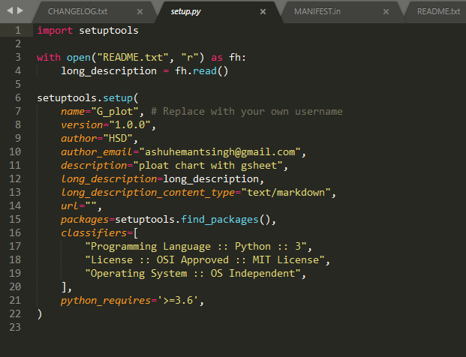

**OR**

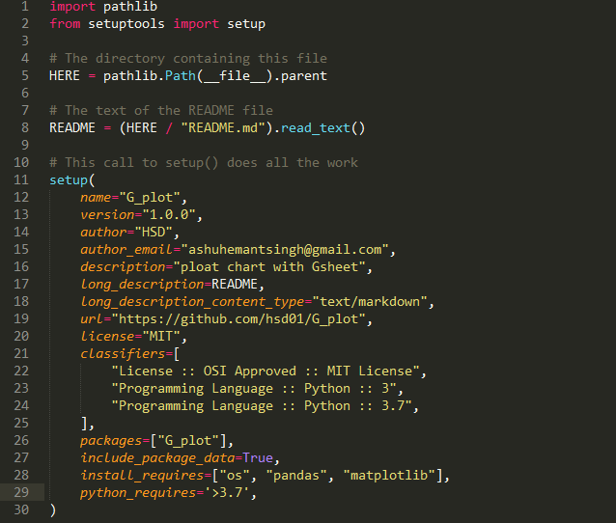

**Publishing to PyPI**

To upload your package to PyPI, you’ll use a tool called Twine. You can install Twine using Pip as usual:

pip install twine

Building Your Package

Packages on PyPI are not distributed as plain source code. Instead, they are wrapped into distribution packages. The most common formats for distribution packages are source archives and Python wheels.

A source archive consists of your source code and any supporting files wrapped into one tar file. Similarly, a wheel is essentially a zip archive containing your code. In contrast to the source archive, the wheel includes any extensions ready to use.

To create a source archive and a wheel for your package, you can run the following command:

python -m pip install -U pip wheel setuptools

python setup.py sdist bdist_wheel

This will create two files in a newly created dist directory, a source archive and a wheel:

G_plot/

│

└── dist/

├──filenamr.whl

└──filename.tar.gz

twine check dist/*

Uploading Your Package

Now you’re ready to actually upload your package to PyPI. For this, you’ll again use the Twine tool, telling it to upload the distribution packages you have built. First, you should upload to TestPyPI to make sure everything works as expected:

twine upload --repository-url https://test.pypi.org/legacy/ dist/*

Twine will ask you for your username and password.

Type ur pypi username and password password wont show in ur cmd

If the upload succeeds, you can quickly head over to TestPyPI, scroll down, and look at your project being proudly displayed among the new releases! Click on your package and make sure everything looks okay.

Below command upload ur package to pypi original site

twine upload dist/*

now its ready to pip install G-plot