在系统的/usr/local/www的目录下找到index.html、static.html、stream.html、static_simple.html、stream_simple.html这几个文件。将其中的代码改成如下内容。

index.heml
<!DOCTYPE html PUBLIC "-//W3C//DTD XHTML 1.1//EN"
"http://www.w3.org/TR/xhtml11/DTD/xhtml11.dtd">
<html xmlns="http://www.w3.org/1999/xhtml" xml:lang="en">
<head>
<title>视频监控</title>
<meta http-equiv="content-type" content="text/html; charset=utf-8" />
<link rel="stylesheet" href="style.css" type="text/css" />
<!--[if IE 6]>
<link rel="stylesheet" href="fix.css" type="text/css" />
<![endif]-->
</head>

<body>
<div id="sidebar">
<h1>视频监控</h1>
<h2>欢迎使用</h2>

<div id="menu">
<a class="active" href="index.html">主页</a>
<a href="static.html">静态图片</a>
<a href="stream.html">视频</a>
</div>

</div>

<div id="content">
<h1>欢迎使用本视频监控</h1>
<h2></h2>

<h3>恭喜你连接成功</h3>

<img src="example.jpg" width="512" height="160" alt="just an image" />

<a href="stream.html"><img src="/?action=snapshot" width="320" height="240" alt="static image example" /></a>
<p>左图为视频监控的一个静态预览，你可以点击图片查看视频</p>

</div>
</body>
</html>

static.html

<!DOCTYPE html PUBLIC "-//W3C//DTD XHTML 1.1//EN"
"http://www.w3.org/TR/xhtml11/DTD/xhtml11.dtd">
<html xmlns="http://www.w3.org/1999/xhtml" xml:lang="en">
<head>
<title>视频监控－静态图片</title>
<meta http-equiv="content-type" content="text/html; charset=utf-8" />
<link rel="stylesheet" href="style.css" type="text/css" />
<!--[if IE 6]>
<link rel="stylesheet" href="fix.css" type="text/css" />
<![endif]-->
</head>

<body>
<div id="sidebar">
<h1>视频监控</h1>
<h2>欢迎使用</h2>

<div id="menu">
<a href="index.html">主页</a>
<a class="active" href="static.html">静态图片</a>
<a href="stream.html">视频</a>
</div>

</div>

<div id="content">
<h1>静态图片</h1>
<h2></h2>

<p>这是视频的一个静态图片，如果你想单独查看图片可以点击<a href="static_simple.html">这里</a>.</p>

<p>或者使用下面的网址</p>
<p><pre>&lt;img src="/?action=snapshot" /&gt;</pre></p>

<img src="/?action=snapshot" alt="This is a static snapshot" width="512px" height="384px" />

</div>
</body>
</html>

stream.html

<!DOCTYPE html PUBLIC "-//W3C//DTD XHTML 1.1//EN"
"http://www.w3.org/TR/xhtml11/DTD/xhtml11.dtd">
<html xmlns="http://www.w3.org/1999/xhtml" xml:lang="en">
<head>
<title>视频监控－视频</title>
<meta http-equiv="content-type" content="text/html; charset=utf-8" />
<link rel="stylesheet" href="style.css" type="text/css" />
<script type="text/javascript" src="jquery.js"></script>
<script type="text/javascript" src="jquery.rotate.js"></script>
<!--[if IE 6]>
<link rel="stylesheet" href="fix.css" type="text/css" />
<![endif]-->
<script type="text/javascript">

var phi = 0, flipped = 0, mirrored = 0;

function setXformClass () {
$('.xform').each(function(idx,el) {
el.className = "xform x" +(flipped ? "-flipped":"") + (mirrored ? "-mirrored" : "") + "-rotated-" + phi;
});
}
$(document).ready(function() {
// set rotation angle phi and toggle rotate class
$('#rotate').click(function() {
phi = (phi + 90) % 360;
setXformClass();
if (phi % 180) {
$('.xform-p').addClass('rotated');
} else {
$('.xform-p').removeClass('rotated');
}
});
// toggle mirror class component
$('#mirror').click(function() {
mirrored = ! mirrored;
setXformClass();
});
// toggle flip class component
$('#flip').click(function() {
flipped = ! flipped;
setXformClass();
});
});
</script>
</head>

<body>
<div id="sidebar">
<h1>视频监控</h1>
<h2>欢迎使用</h2>

<div id="menu">
<a href="index.html">主页</a>
<a href="static.html">静态图片</a>
<a class="active" href="stream.html">视频</a>
</div>

</div>

<div id="content">
<h1>视频</h1>
<h2></h2>

<p>这是视频监控的页面，如果你想单独查看视频可以点击 <a href="stream_simple.html">这里</a>. </p>

<p>或者使用下面的网址</p>
<p><pre>&lt;img src="/?action=stream" /&gt;</pre></p>

<p id="xform">
<button id="rotate"><div class="btnface"></div></button>
<button id="mirror"><div class="btnface"></div></button>
<button id="flip"><div class="btnface"></div></button>
</p>
<p class="xform-p"></p>
<p id="streamwrap" class="xform-p">
<img id="streamimage" class="xform" src="/?action=stream" />
</p>

</body>
</html>

static_simple.html
<html>
<head>
<title>视频监控－静态图片</title>
<!-- refresh page after a few seconds, this works nearly in every browser -->
<meta http-equiv="refresh" content="10"; charset=utf-8 />

</head>
<body>
<center>
<img src="/?action=snapshot" alt="This is a static snapshot" />
</center>
</body>
</html>

stream_simple.html

<html>
<head>
<title>视频监控－视频</title>
</head>
<meta http-equiv="content-type" content="text/html"; charset=utf-8 />

<body>
<center>
<img src="/?action=stream" />
</center>
</body>
</html>

下载树莓派版的花生壳，并在终端运行代码dpkg –i phddns_rapi_3.0.1.armhf.deb安装花生壳。安装成功后会出现下图1所示情况。
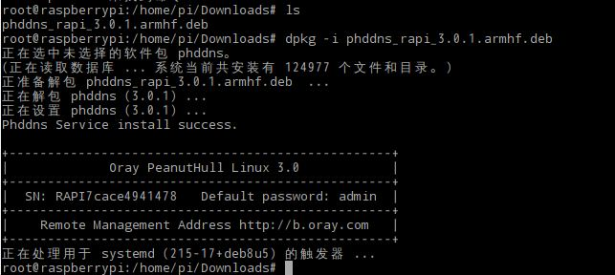
图1. 成功安装花生壳

在浏览器进入安装成功时提示的网站，注册账号，开通内网服务，将树莓派的IP添加到内网映射中，如图2所示。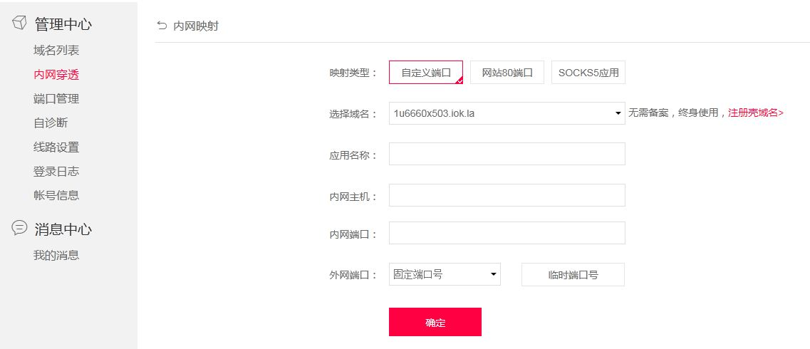
图2. 内网映射配置

在注册的账号的时候会免费给一个域名，这时就可以通过域名登录视频监控查看情况。如下图3所示为用域名登录的网址所看到的界面。
