在mjpg-streamer的配置文件目录中建立record.html，并编辑代码如下。

<!DOCTYPE html PUBLIC "-//W3C//DTD XHTML 1.1//EN"
"http://www.w3.org/TR/xhtml11/DTD/xhtml11.dtd">
<html xmlns="http://www.w3.org/1999/xhtml" xml:lang="en">
<head>
<title>视频监控－回放</title>
<meta http-equiv="content-type" content="text/html; charset=utf-8" />
<link rel="stylesheet" href="style.css" type="text/css" />
<script type="text/javascript" src="jquery.js"></script>
<script type="text/javascript" src="jquery.rotate.js"></script>

<script src="jquery.js?v=1.83.min"></script>
<script src="layer.min.js"></script>

<style>
html{background-color:#E3E3E3; font-size:14px; color:#000; font-family:'微软雅黑'}
a,a:hover{ text-decoration:none;}
pre{font-family:'微软雅黑'}
.box{padding:20px; background-color:#fff; margin:20px 100px; border-radius:5px;}
.box a{padding-right:15px;}
#about_hide{display:none}
.layer_text{background-color:#fff; padding:20px;}
.layer_text p{margin-bottom: 10px; text-indent: 2em; line-height: 23px;}
.button{display:inline-block; *display:inline; *zoom:1; line-height:30px; padding:0 20px; background-color:#56B4DC; color:#fff; font-size:14px; border-radius:3px; cursor:pointer; font-weight:normal;}
.imgs img{width:300px;padding:0 20px 20px;}
</style>

<!--[if IE 6]>
<link rel="stylesheet" href="fix.css" type="text/css" />
<![endif]-->

</head>

<body>
<div id="sidebar">
<h1>视频监控</h1>
<h2>欢迎使用</h2>

<div id="menu">
<a href="index.html">主页</a>
<a href="static.html">静态图片</a>
<a href="stream.html">视频</a>
<a class="active" href="record.html">回放</a>
</div>

</div>

<div id="content">
<h1>回放</h1>
<h2></h2>

<p>这是视频监控保存的图片预览，你可以直接点击图片单独查看.</p>
<P>如果想查看更多请点击<a href=" images/" target="_blank">这里</a>.</p>

<div class="box">
<div id="imgs" class="imgs">
<img src="images/1.jpg" layer-pname="1">
<img src="images/2.jpg" layer-pname="2">
<img src="images/3.jpg" layer-pname="3">
<img src="images/4.jpg" layer-pname="4">
</div>
<div style="text-align:center;clear:both;">
<script src="/gg_bd_ad_720x90.js" type="text/javascript"></script>
<script src="/follow.js" type="text/javascript"></script>
</div>
</div>
<script>
;!function(){
layer.use('layer.ext.js', function(){
layer.ext = function(){
layer.photosPage({
html:'<div style="padding:20px;"><p>支持左右方向键，支持Esc关闭</p><p id="change"></p></div>',
});
};
});
}();
</script>

</div>
</body>
</html>

在index.html，static.html，stream.html的相应位置，添加<a href="record.html">回放</a>代码。如index.html中
<div id="menu">
<a class="active" href="index.html">主页</a>
<a href="static.html">静态图片</a>
<a href="stream.html">视频</a>
<a href="record.html">回放</a>
</div>

运行后效果如下图1所示。
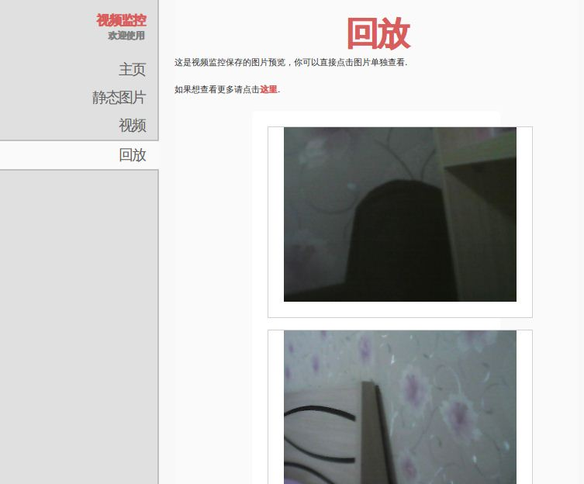
图1. 回放界面

点击图片以后的效果如下图2所示。
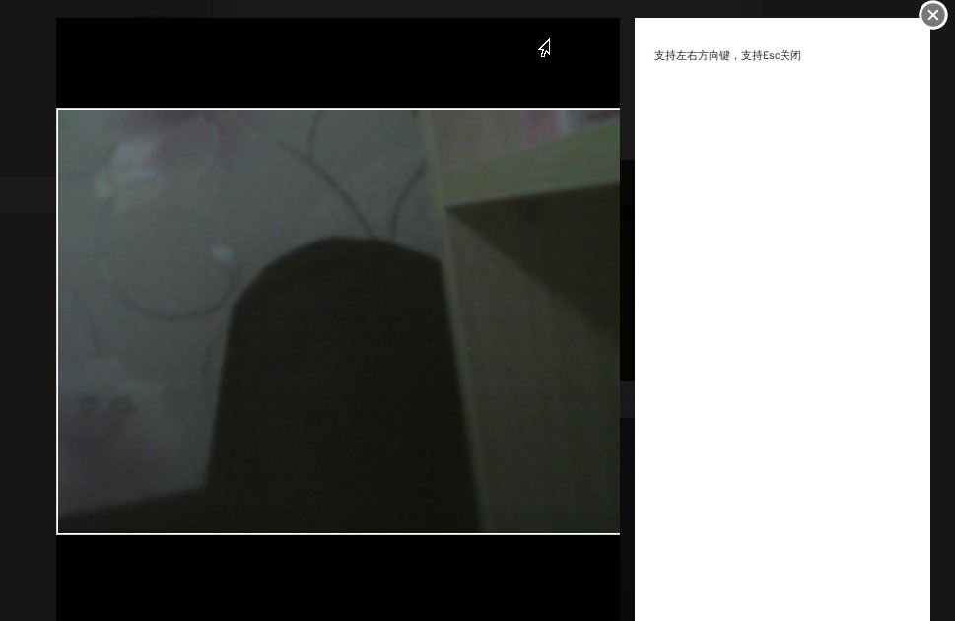
图2. 点击后效果

