Workflow eigenes Modell auf Raspi mit eigen trainiertem Modell

1. Folge dem Tutorial <https://tensorflow-object-detection-api-tutorial.readthedocs.io/en/latest/training.html#exporting-a-trained-inference-graph>

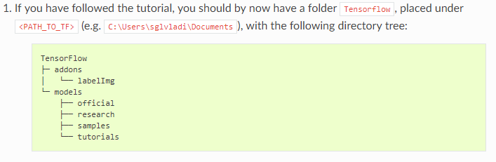

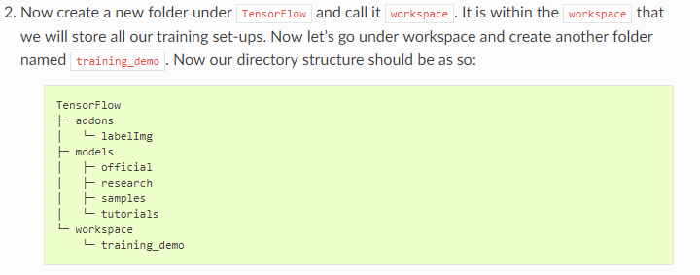

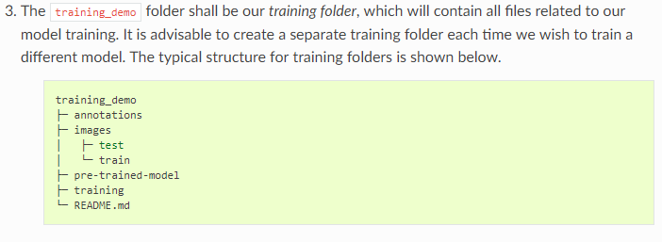

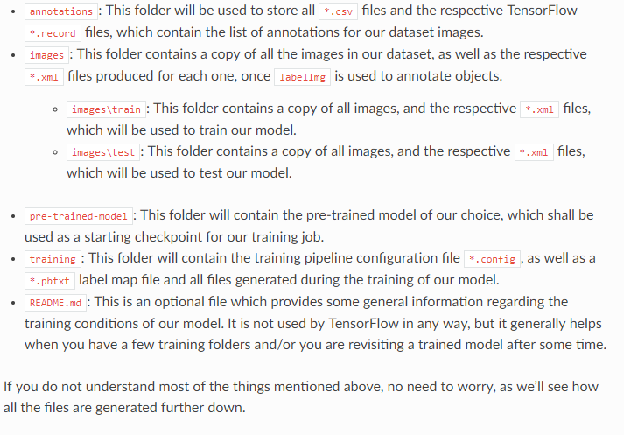

1. Label Images
2. Creating TF-Records
   1. Entweder weg über xml -> csv -> tf records
      1. *# python generate_tfrecord.py --label=ship --csv_input=C:\Users\sglvladi\Documents\TensorFlow\workspace\training_demo\annotations\train_labels.csv --output_path=C:\Users\sglvladi\Documents\TensorFlow\workspace\training_demo\annotations\train.record --img_path=C:\Users\sglvladi\Documents\TensorFlow\workspace\training_demo\images\train*
   2. Oder direkt mit skript in einem Zug
3. Download pre trained model from Model Zoo
   1. <https://github.com/tensorflow/models/blob/master/research/object_detection/g3doc/detection_model_zoo.md#coco-trained-models-coco-models>
4. Download according config file
   1. <https://github.com/tensorflow/models/tree/master/research/object_detection/samples/configs>
5. Edit Config file
   1. Num_classes
   2. Speicherort tfrecords und label_map
6. Train the model

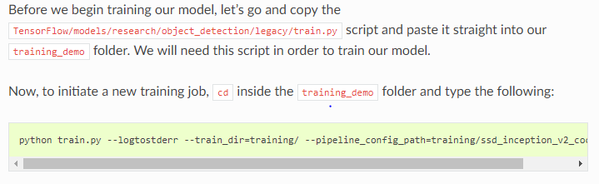

1. Watch it on tensorboard



1. Export frozen graph

python export_inference_graph.py --input_type image_tensor --pipeline_config_path training/ssd_inception_v2_coco.config --trained_checkpoint_prefix training/model.ckpt-38456 --output_directory trained-inference-graphs/

1. (Install Openvino on Main Machine if not done yet)
2. Convert TF Modell to IR
   1. CD in C:\Program Files (x86)\IntelSWTools\openvino_2019.1.148\deployment_tools\model_optimizer
   2. Copy frozen graph and pipeline.config in directory
   3. Copy ssd_support.json in directory
   4. Run as admin:

mo_tf.py \  
 --input_model ~/Path/to/frozen_inference_graph.pb \  
 --tensorflow_use_custom_operations_config /opt/intel/computer_vision_sdk/deployment_tools/model_optimizer/extensions/front/tf/ssd_support.json \  
 --tensorflow_object_detection_api_pipeline_config ~/Path/to/pipeline.config \  
 --data_type FP16

1. Copy the created Files in Directory and copy it on raspi
2. Make new directory on raspi
3. Run

python3 object_detection_demo_ssd_async.py \  
 -m frozen_inference_graph.xml \  
 -i cam \  
 -d MYRIAD \  
 -pt 0.6