Connect to gamedev server : ssh fcoulibaly3@gamedev.cs.gsu.edu
Password for gamedev server : Vna+c8giOwbacQ==
ABOUT GEMINI
Website to get the api key : https://aistudio.google.com/

PROJECT SCOPE
Pre-step : Getting the project ready
Build a VLM extraction script in python to try to catch the data from a provided image.
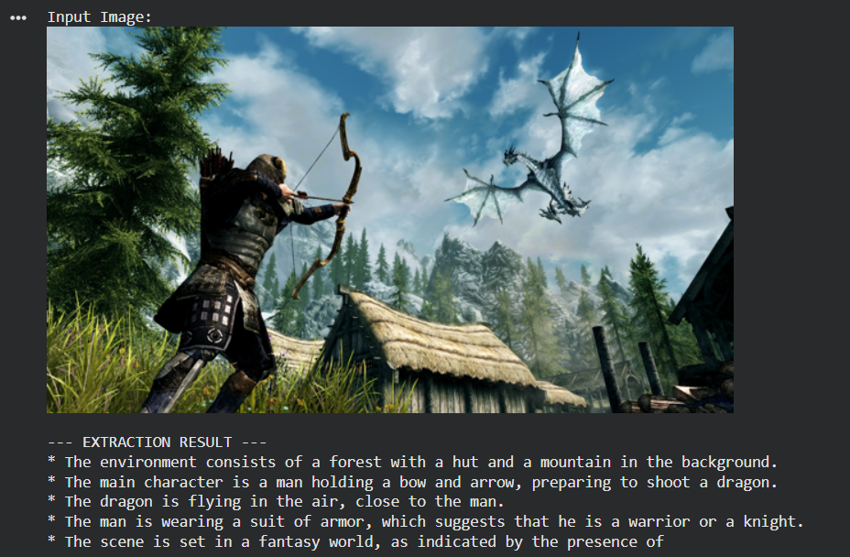
Script didn’t finish the “scene” part because maximum token generation was set to 100. I might increase it to 200 or more later
Build a script that generates a storytelling from prompt given

Phase 1: Pipeline Integration (Connecting the Dots)
Right now, there is 2 different file for the test, 1 for extraction of image context and the other one is to generate sample of a story telling from a prompt by the agent. The immediate next step is getting them to talk to each other seamlessly.
- Data Handoff: Structuration for the output from the VLM so it can be automatically fed into the LLM.
Instead of passing raw text, the VLM output a structured format like JSON (e.g., {"location": "tavern", "npc_name": "Garrick", "player_health": "low"}).
It will make the LLM generation much more reliable.
- Unified Execution: Transition from running separate Google Colab cells to having a single function / script where an image goes in one end, and a finished story comes out the other.
Phase 2: Robustness and Error Handling
- API Management: Implement try/except blocks to handle API timeouts, rate limits, or network failures.
- Hallucination Checks: What happens if the VLM completely misreads the screenshot? A fallback mechanism is needed or a way to validate the extracted data before it gets sent to the story generator.

Phase 3: Evaluation
- VLM Accuracy:
A small test dataset of 20-30 screenshots.
  - Manually writing down what the VLM should extract.
  - Run the code and calculate its accuracy.
- LLM Quality:
  - Does the generated story accurately reflect the extracted game state? Is the tone consistent? I need to make sure that it follows Dr. Weeks advices of What makes a good storytelling such as:

What is a good story?
•account of dramatically meaningful events
•must be credible
•must be coherent
•without undue repetition
•without arbitrary content

Factors for the story
- length
- characters
- degree of realism
- emotional richness

Ludonarrative Dissonance
This is a term for tension between narrative and play

Opening sequence to introduce story
•Ending sequence to wrap up the story

mystery is what the reader/viewer does not know
dramatic irony is what the reader/viewer knows that
the character does not
Latency Testing:
I need to measure how long the entire process takes from image upload to story generation.

Phase 4: Finalizing the Report
With the data from Phase 3, you can flesh out the rest of your Master's document.
- Methodology: Detail your prompt engineering choices and why you selected specific models (like gemini-2.0-flash).
- Results: Present your evaluation metrics in clear tables or charts.
- Limitations & Future Work: Candidly discuss where the pipeline struggles (e.g., confusing UI elements in the game) and how a future developer might fix it.

THINGS TO REMEMBER ABOUT THE DEADLINES
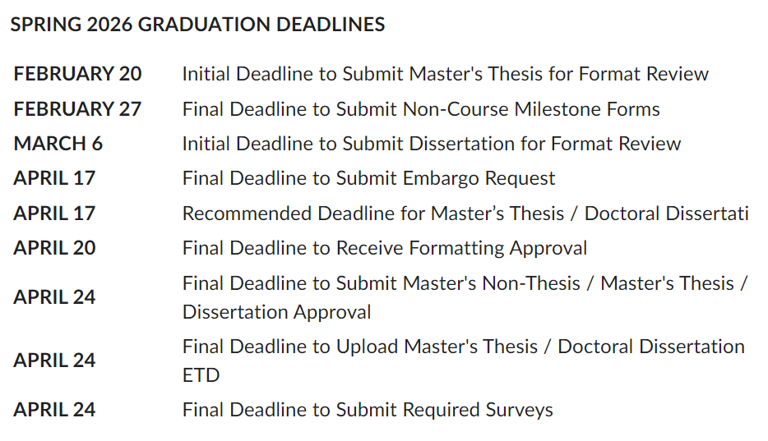

Notes from meeting of March 4th , 2026

Research question: Can a LLM generate a "good" story given a set of images?
What do we mean by "good"?
How do we envision someone using this?
Find a use case where this will be useful / acceptable ?
How much latency is acceptable? (Given the use case)
Example of a use case:
A person is playing a game, and wants a follower to talk about what they did. Imagine they (player and follower) are sitting at a campfire at night, and talking.
follower: (e.g.) "that was really scary when the dragon attacked. It's good that you were able to shout to bring it to the ground"
The series of images could be from a video capture of their play

Or a use case could be a player wants something new to do. Can the LLM generate a quest (from a series of images) that is new and interesting?

Identify the research question, discuss the use case, how are we addressing the question and how do we know if we answered it well.

Skyrim wiki (for getting some infos)
https://elderscrolls.fandom.com/wiki/Skyrim

