Lesson 5 Assignment Submission Instructions

*LIS 2360: Web Application Development*

Assignment Submission Due Date: **Wednesday, March 2, 2016 by 11:59pm**

Assignment Points: **80**

# Assignment Submission Instructions:

1. In the **Lesson 5 Submission Form**, include the **Cloud9** **URL** that contains the **Lesson 5 files**.
   * In **Cloud9**, select **Share** button.
   * Click on the URL in the **Preview** section and select copy.  ***(see below)***
   * Paste this URL in the **Lesson 5 Submission Form** provided. **(Files option!!)**

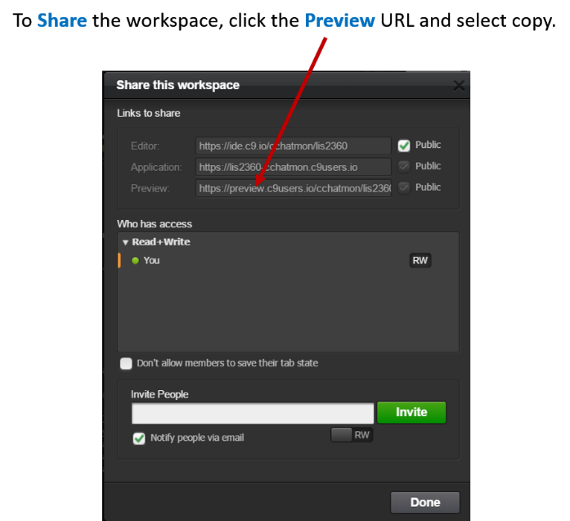

1. In the **Lesson 5 Submission Form**, include the **GitHub** **URL** for the remote repository**.**

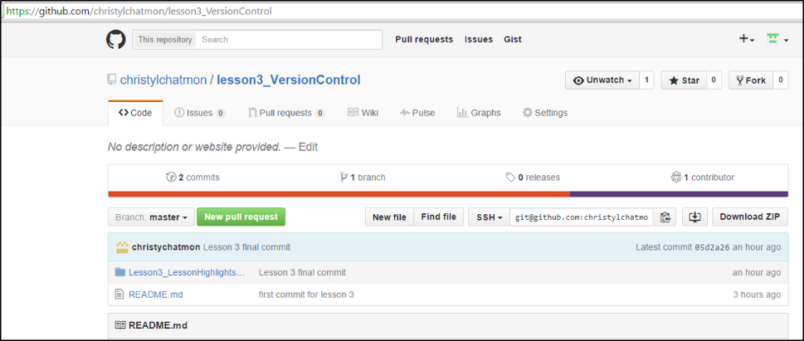

1. In the **Lesson 5 Submission Form**, provide your **GitHub** **Username.**