Lesson 5 Assignment

*LIS 2360: Web Application Development*

Assignment Submission Due Date: **Wednesday, March 2, 2016 by 11:59pm**

**Assignment Objectives:**

* To declare, initialize, modify and display variables.
* To use the ***getElementById( )*** method, a Document object method, to reference elements on a web page using its **id** value.
* To associate an event *(****onclick****)* with an HTML element and define an event handler, which is the code that will respond to that specific event on the specific element.
* To use ***if*** statements, ***if/else*** statements, and ***nested if*** statements to make decisions

**Assignment Description:**

The **Tax Calculator** application computes a user’s total income tax and determines the tax bracket the user falls in. The tax bracket is the tax rate a user will pay on the highest dollar of taxable income. The tax bracket determines the amount of the user’s income tax increases if the user earns one additional dollar of income (ignoring the effects of rounding). In the U.S., we have a progressive income tax system. This means that the more money you make, the higher a tax rate you pay. Your tax bracket becomes progressively higher.

This application will find the IRS tax bracket for a user. The calculator will return an estimate of the actual tax rate and tax amount for the user based on the users’ filing status and taxable income, which are provided by the user.

**Here’s how tax brackets work *(example)*:**

Let’s say you are a **Single** with no dependents and your **taxable income is $19,000**.

As a **Single** filer, you are in the **15%** tax bracket. You will pay **10%** on the first **$9,225**, **plus** **15%** of the *amount over* **$9,225**.

**Here is the math:**

|  |  |
| --- | --- |
| **First tax bracket:**  **$9,225 X 10% =** | $922.50 |
| **Second tax bracket: ($19,000 - $9,225) X 15% =** | $1,466.25 |
| **Total Income Tax:** | **$2,388.75** |

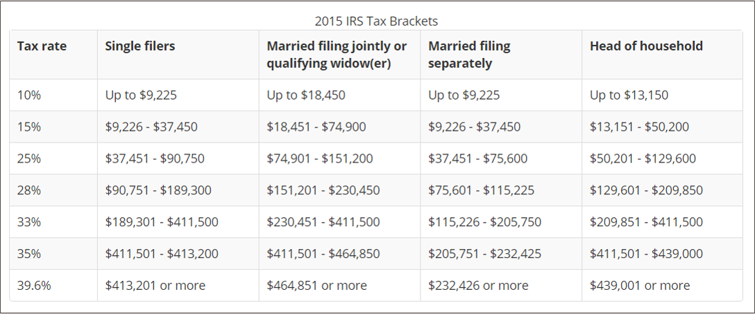

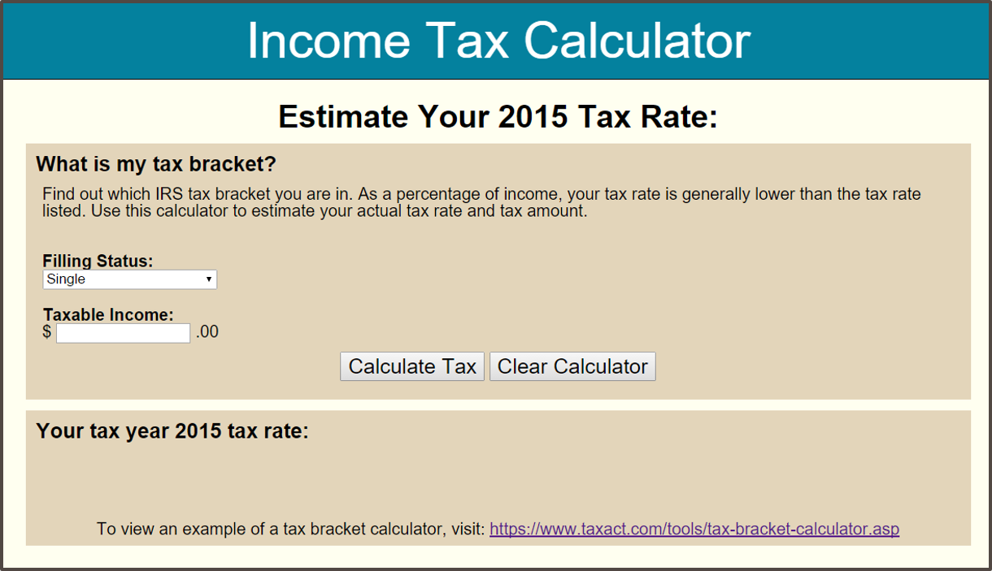**Below is an example of the initial application (top image) and an example of the application in use (bottom image).**

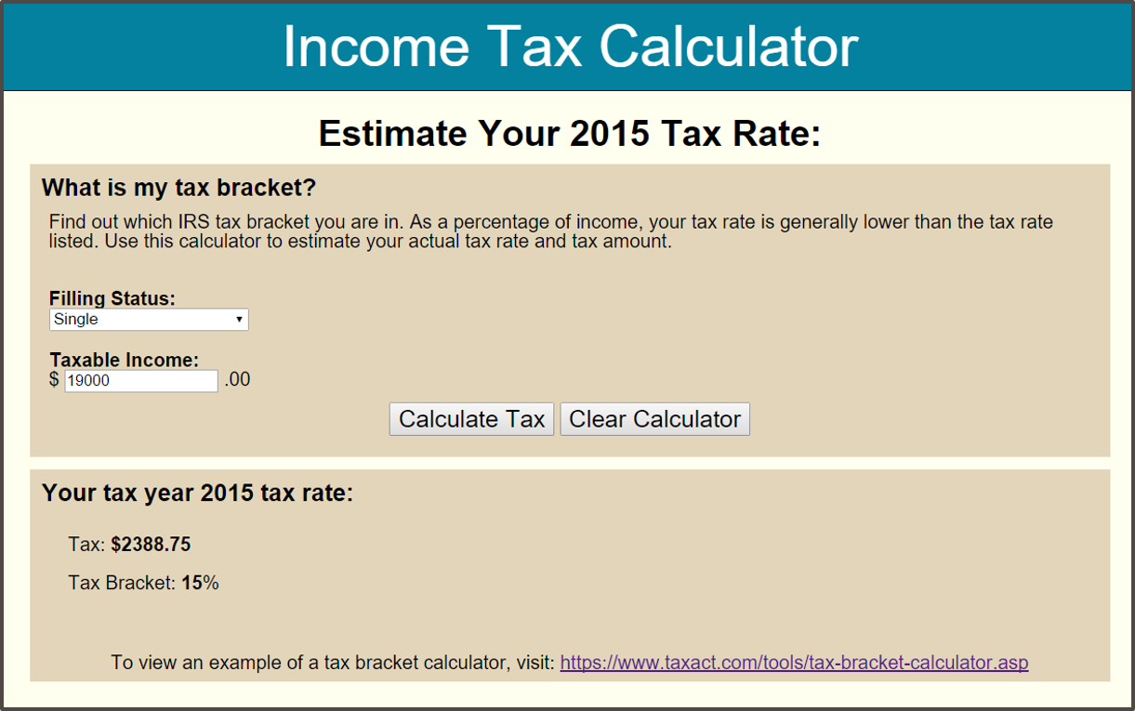

**REMINDER:**  Please remember to **SAVE** your files periodically in **Cloud9**!!!!

**Assignment Steps/Tasks:**

1. In **Cloud9**, open the file entitled: **taxCalculator.html** in the **lesson5_taxcalculator workspace.**
2. Enter your name for **Author** and today’s date for **Date**, where indicated in the commented section of the HTML document within the head tag.
3. Select **Preview 🡪 Live Preview File (taxCalculator.html)** to preview and render the web page so that you can view the HTML page prior to modifying the file.

**HINT: CURRENTLY THE APPLICATION ONLY WORKS FOR USERS WHO’S FILING STATUS IS “SINGLE”.** You must complete all steps/tasks to view all of the application’s features, which include filing for married jointly, married separately, and head of household.

1. Read and examine the code in the **taxCalculator.html** file!!!!! (THIS IS AN IMPORTANT STEP!)
2. **Complete each Task (1-4)** as stated in the comment sections in the **taxCalculator.html** file. A summary of the tasks are given below:
   * **Task 1:**  Complete the code to calculate the tax for the user filing as “***Married filing jointly***”. Also, set (or initialize) the tax rate for each bracket for this filing status.
   * **Task 2:**  Complete the code to calculate the tax for the user filing as “***Married filing separately***”. Also, set (or initialize) the tax rate for each bracket for this filing status.
   * **Task 3:**  Complete the code to calculate the tax for the user filing as “***Head of Household***”. Also, set (or initialize) the tax rate for each bracket for this filing status.
   * **Task 4:** Add the additional code needed to remove the tax calculation results and tax bracket information displayed in the HTML page. These values will be removed when the user clicks the ‘Clear Calculator’ button.
3. Test the application.
   * Select **Preview 🡪 Live Preview File (taxCalculator.html)** to preview and render the web page to ensure **Tasks** **1-4** were successful.
   * Use the following site to verify your results:

[**https://www.taxact.com/tools/tax-bracket-calculator.asp**](https://www.taxact.com/tools/tax-bracket-calculator.asp)