Engagement Budget vs. Actual Tracking & Forecasting Tool – Business Requirements Document

Purpose
A tool that enables engagement budget owners (PMDs and Partners) to track project margin in near real time and forecast/re-forecast projected outcomes and resource needs throughout the engagement’s lifecycle. This tool will enhance visibility into project margins which currently is only available during the traditional month end reporting cycle.

Objective
Bring near real-time data to the management of client projects to track against planned results and enhance visibility into resource allocation and work scope.

Target Users
Partners and Managing Directors
Partners
Strategic Finance

Key Features (Functional)
- Users can access the tool and only see engagements where they are listed as the Lead PMD/Partner on the original budget
  - Strategic Finance can see all engagements
- Users can select one engagement that populates the tool
- The tool will need to be updated frequently (exact frequency to be determined, but at least daily) with actual hours worked on the engagement
- The tool has initial calculations completed using the logic defined in “Engagement Tracker Tool – Mockup.xslx”
- The users are then able to edit the following fields (they are shown in yellow in “Engagement Tracker Tool – Mockup.xslx”):
  - Forecasted hours for all consultants
  - Revenue Adjustments (Agreed Base Fees and Contingent Fees)
  - Expense Adjustments
  - ETS Costs Adjustments (Digital Tools and ETS Costs)
  - Field that automatically removes all forecasted hours for any consultants listed as “TBD”
    - Field that removes all forecasted hours for the consultant on that line
  - Add rows for additional employees
    - Need to type in employee name and the employee details (level, rate, etc.) show
    - Users should be able to edit their forecasted hours after the employee is created
- After any edits are made by the user, they should be able to click a “calculate metrics” button the re-calculates all metrics for the engagement including projected project margin
- Once these calculations are made, the user should be able to save these changes, so they are available the next time the user accesses this engagement from the tool
- The user should also be able to export the data to excel including the metrics

Calculations and Definitions
Ideal Hours Coefficient
Mimic the current ideal hours coefficient calculation to apply against hours charged to the project. As a part of the current month end reporting process, the ideal hours coefficient is only calculated/refreshed on a monthly basis. For this tool, the ideal hours calculation will need to refresh as frequently as practical, but at a minimum on a weekly basis. This version of the ideal hours coefficient will only be used for this tool. The ideal hours coefficient used in the month end project margin reporting should not be altered or impacted.
The Ideal Hours are calculated at the Client – Timekeeper – Day level following a series of logical steps, which are summarized by the following diagram:
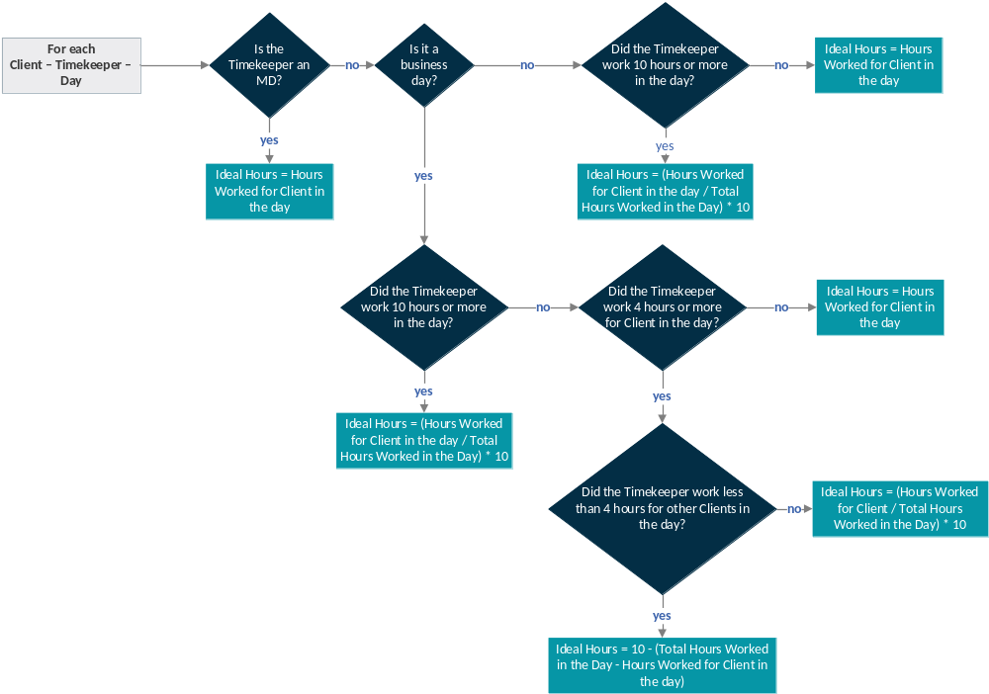
Note: a business day is that which is not weekends or holidays. Holidays are determined by the home office of the Timekeeper. Usually, the time worked during weekends and holidays is used to conclude projects and adjust details. As such, it is important to treat that time differently, so as to not charge the client for a full day of work when only minor adjustments were made to the deliverables.
Once Ideal Hours are calculated for every combination of Client – Timekeeper – Day, they have to be aggregated at the level of Year – Client – Timekeeper. Similarly, Hours Worked are also aggregated at the same level (i.e. Year – Client – Timekeeper). Then, a ratio of Ideal Hours versus Hours Worked is calculated at the Year – Client – Timekeeper as follows:
$$Ideal Hours Coefficient= \frac{Yearly Ideal Hours}{Yearly Hours Worked}$$
In other words, the hours are aggregated by year for every Client – Timekeeper combination, and then the ratio is calculated as described in the formula above. This is done in this way in order to consider late time entries and time transfers across days and Matters.
One may be tempted to think that the Yearly Hours Worked from the Ideal Hours Coefficient can cancel out with the Monthly Hours Worked present in the Employee Standard Cost formula. This is not possible, though, since the former are aggregated at the Year – Client – Timekeeper level, whereas the latter are aggregated at the Accounting period – Matter – Timekeeper level.
For the purpose of calculating the Ideal Hours Coefficient, the scope of Hours Worked includes hours worked from every timecard, including both billable and non-billable hours. The scope of Ideal Hours includes all billable hours and excludes all non-billable hours, except for the non-billable hours associated with:
- Legal - Support for Litigation against Firm
- Mergers & Acquisitions
- Consulting Services to Registered Charities
- Approved Time Out of Office
- Training
The scope of Ideal Hours must be implemented in such a way that is not necessary to update the list of what hours get included/excluded when new engagements are created. In other words, the logic that determines what non-billable hours are included/excluded in Ideal Hours should be robust and require no maintenance.
When the Ideal Hours Coefficient is used in the Employee Standard Cost calculation (see section 3.2.1.1), it has to be adjusted as described in the following diagram:
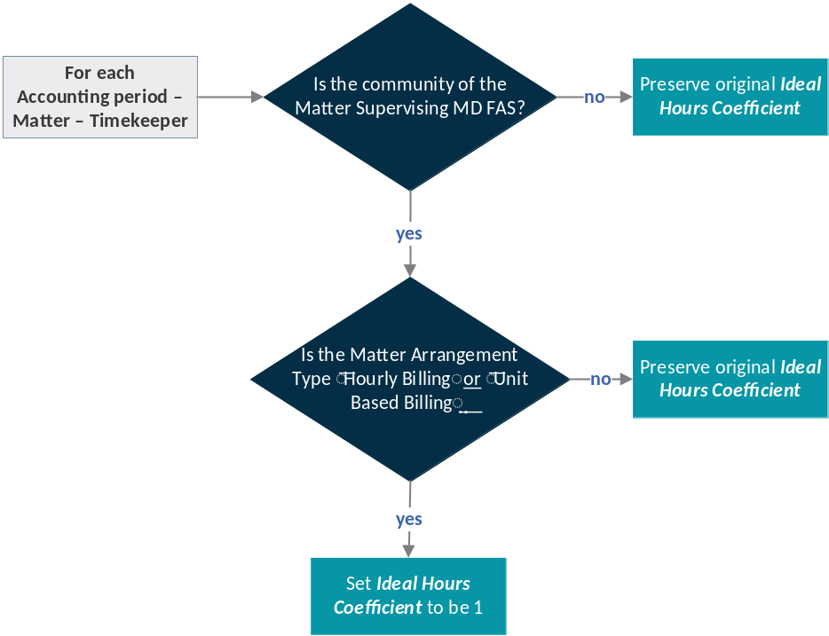

As a safeguard measure, if all the previous exercise results in a non-existent (i.e. null) Ideal Hours Coefficient, then the value should default to 1.
Calculations in the tool:
Forecasted Revenue = Budgeted revenue + revenue adjustments
- Budgeted revenue = from data lake
- Revenue adjustments = editable field in the tool
Estimated Margin = Estimated Revenue – Costs – Profit Hurdle
- Estimated revenue (see above)
- Costs = Standard costs + forecasted expenses + forecasted ETS costs
  - For each resource on the project:
    - Standard costs = ideal hours coefficient * total forecasted hours * standard hourly cost
      - Total forecasted hours = editable field in the tool
      - If there is no ideal hours coefficient available, then use the budget tool logic using forecasted hours
  - Forecasted expenses = budgeted expenses + expense adjustments
    - Expense adjustments = editable field in the tool
  - Forecasted ETS costs = budgeted ETS costs + ETS costs adjustments
    - ETS Costs adjustments = editable field in the tool
- Profit Hurdle = Forecasted Revenue * Percentage from the Profit Hurdle table in MDM for corresponding period
Estimated Margin % = Estimated Margin $ / Forecasted Revenue

Technical Requirements (Non-Functional)
- Security Access: Partners and Managing Directors, Partners, Global Strategic Finance
  - PMDs and Partners are only able to see engagements where they are the Lead PMD/Partner in the Engagement Budget Tool
  - Strategic Finance should be able to access all engagements
- Needs to be accessible by the internet browsers that are supported by the firm, does NOT need to be mobile friendly
- The tool needs to be available 24/7

Risks & Constraints
- Budget: TBD
- Timeline: TBD
  - The idea for this tool was presented to the Co-CEOs in the fall 2025 during the Wildcard sessions. Further exploration of the idea was approved and a demo of the tool was requested when available.
- Personnel:
  - If resources with no experience in the engagement budget tool and firm profitability logic and calculations are assigned to the project, it will likely prolong the amount of time required by IT and Finance to complete the project – could make the project infeasible
  - If this project continues into the Fall, Strategic Finance could have limited availability as the budget cycle ramps up

Out of Scope
- This is a new tool with new calculations. Even though some logic can and should be used from the original budget tool to expedite the creation of this tool, the current budget tool and profitability calculation is out of scope and should not be modified in any way as part of this project, as it serves different reporting goals.
- This is meant for a “Fixed Fee Budget” engagement (Weekly or Monthly). This is not intended for “Hourly Budget” engagements.

Timeline
<<Expected completion date>>

Signatures

