1. Sign in:

Email box

Email must be proper format and not blank

The email address you enter should follow this format: [name@domain.com](mailto:name@domain.com). Please try again.

Password box

Password must match rules and not blank

Please enter you password.

Email and Password

Displays after page refresh if the login failed

The email address and/or password you entered was incorrect. Please try again.

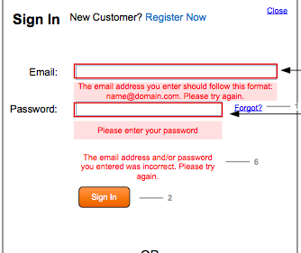

2. Sign in:

Email box

Failed Registration, Existing Email Address

Your email address is already associated with an account from one of our many websites (Sears.com, Kmart.com, Craftsman.com, Kenmore.com or Mygofer.com). Your existing account and password are valid for all of our sites. If you can’t remember your password, click “Forgot Password”.

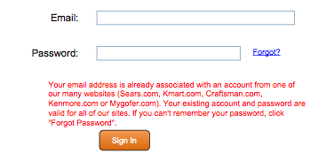

3. Forgot password:

Email box

Entered an invalid email address or format

Please enter a valid email address

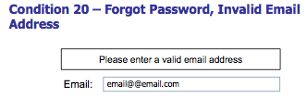

4. Registration:

Email box

Email must be proper format and not blank

Please enter a valid email address

Confirm email box

Must match previous email field and not blank

Your email does not match. Please check and try again

Password box

Must match rules and not blank

Please enter a valid password

Zip Code box

Must be a valid Zip code and not blank

Please enter a valid Zip code

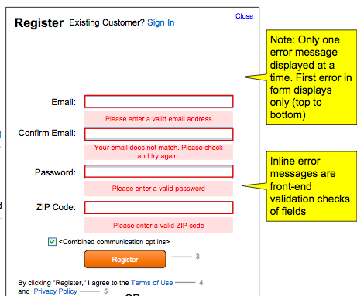

5. Post your question:

Question box (step 1 and step 2)

After clicking ‘Next’ w/out typing a question in the associate text field

Please enter your question

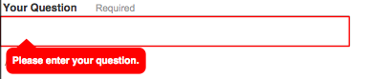

6. Post your question:

Category dropdown

Clicking ‘Post’ w/out selecting a category (I know right now it defaults to ‘General’ but will talk to the person who worked on this so it displays ‘Select’ on the dropdown.

Please choose a category

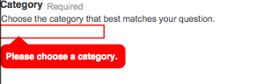

7. Comment/reply/Answer

Comment/reply/answer box

Error should be thrown if user tries to click on “Post” w/out entering a response

Please enter at least 3 characters

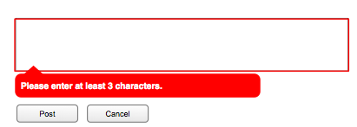

8. Screen name

Screen name box

Screen name violates guidelines (guidelines text appears below the error message

Please follow the screen name guidelines

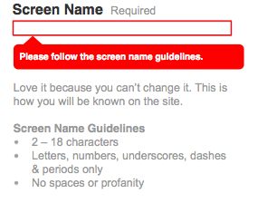

9. Screen name

Screen name box

Screen name not entered, Q&As (guideline text appears to the right of the text field)

Please follow the screen name guidelines

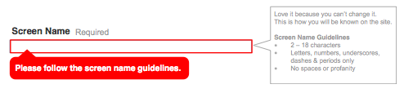

10. Screen name

Screen name box

Screen name exists

That screen name has already been taken. Please select a new one.

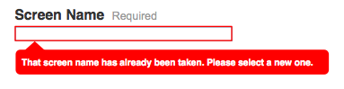

11. Flag

Flag box

Error should be thrown if user tries to click on “Flag” w/out entering a response

This field cannot be empty

