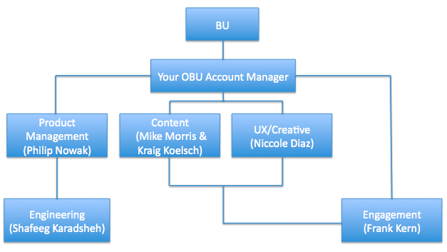

\* Types of requests that should be submitted to the different experiences from new requirements to site modifications:

Product Management:

* Analytics (Omniture/Google Analytics)
* Outages
* New Features
* Improvements
* Bugs

Content:

* Articles (Blog Posts & Guides with featured images)
* Videos (Youtube only)
* Related Products (Within Blog Posts or Guides)

UX/Creative:

* Hero images 580x315
* Ad units 300x250
* Banners (Width should be 624, height can be of any size)

Engagement:

* Layout/widget rearrangement
* Feature QA/Blog Post/Guide/Video
* Polls
* Product Carousel
* Menu links on right rail (ex. “First Time Here?”)
* Page Subtitles (Copy from Content Team)
* Hero slider (Creative from UX)
* Ads/Banners (Creative from UX)