

Communities Infrastructural Requirements

***SHC – Communities***

**Preliminary**

**Final**

Director: Brendan Gualdoni   
Application Technical Lead: Sebastian Frohm  
DevOps: John Patton

Business/Vertical Sponsor: *Don Fotsch, VP Customer Experience*

|  |  |
| --- | --- |
| ***Current Revision:*** | *Version 1.0* |
| ***Document Name:*** | *Communities_Infrastructural_Requirements.pdf* |

## Project Overview

**Work Lenz # 6064** - Social: Communities Viewpoints Migration

Convert a third party hosted website to an internal hosted site.

**1. Development Overview**

* 1. **Content**
* Blogs
* Articles
* Buying Guides
  1. **User-Generated Content (Question and Answers)**
* Ask questions
* Answer questions
* Comment on content
* Vote on content
* Flag content as inappropriate.
  1. **User Management**
* SSO
* Profile Integration
  1. **Redirects**
* Preserve 301 Redirects from Previous Provider
  1. **Content Administration**
* LDAP Authentication

**2. Product Overview**

**2.1 Mission**

* To provide an online social support community that replicates in-person interaction and conversation so that customers and prospective customers access information, customer service and expert advice from SHC associates, vendors and fellow members while providing invaluable feedback and customer behavior understanding to SHC.

**2.2 Strategy**

* Provide an online social support platform
* Strengthen Customer Engagement
* Leverage community feedback and insights

**2.3 Objectives**

* Deliver Phase 1 release of Communities by End of August 29,2012 to migrate Communities and Reviews off of the Viewpoints platform.
* Deliver Phase 2 release of additional functionality in two week iterations beginning August 29, 2012 through October 30, 2012.

**2.4 Guiding Principles**

* To be the leader in online social support communities and delight our customers through every touchpoint.

**2.5 For Customers**

* Opportunity to connect with SHC, product exports, and enthusiasts in order to ask questions, share advices, and provide feedback
* Chance to be heard, to be helped, and to receive excellent customer care
* Ability to find information through Guides, Articles, Blogs, Videos, etc.

**2.6 For SHC**

* Obtain a deeper engagement with our customers to create brand ambassadors
* Reduce contact costs through digital interactions
* Drive conversion/sales by influencing, shaping, informing and enabling customer shopping behaviors and buying decisions
* Provide ongoing feedback on our products and marketing initiatives
* Gain valuable UGC which is optimized for SEO and is considered more reliable
* Connect our customers with our brands, products and initiatives, to provide increased customer conversion and in turn increase lifetime value.

## What Are We Building?

**1. Description**

A cluster of servers that will serve as the single endpoint that handles multiple front paths. The server will handle requests from both sears.com/communities and kmart.com/communities. Although the first sites will be the communities, the long-term plan is to add other sites using different URLs in order to suit business needs.

**2. URLs**

**2. 1 Existing URLs**

* mysears.com - sears owned
* mykmart.com - sears owned

**2. 2 New URLs**

* sears.com/communities
* kmart.com/communities

**2.3 Requests**

* Exclude Akamai - Do not edge cache sears.com/communities, kmart.com/communities.
* Signed Cert - Can we use the Global Cert?
* Datacenter CH4 - We need to be in CH4 because of the root level URL
* Stateadm - All application server require the 'stateadm' user
* Preferred server namespace: php40X.

## Shopping List

**1. Production**

* 1. **www**
* 5 VMs (1 Core, 4 GB RAM, 20 GB Hard Drive)

**1.2 Storage**

* NFS Mount for media (images) 200 GB shared across the cluster
* Ability to scale up to 500 GB
  1. **Utility**
* 1 VM (1 core, 4 GB RAM, 20 GB Hard Drive)
* Standalone server for crons, Responsys and reporting
  1. **Memcache**
* 1 physical server 16 GB RAM scale up to 64 GB

**1. 5 Database**

* 100 GB dedicated cluster
* Ability to scale up to 500 GB

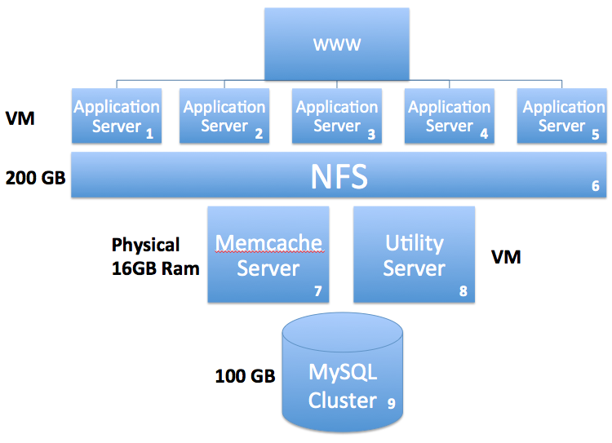

**2. QA**

**2.1 www**

* 2 VMs (1 Core, 4 GB RAM, 20 GB Hard Drive)

**2.2 Storage**

* NFS Mount for media (images) 100 GB shared across the cluster
* Ability to scale up to 500 GB
  1. **Utility**
* 1 VM (1 core, 4 GB RAM, 20 GB Hard Drive)
* Standalone server for crons, Responsys and reporting.
  1. **Memcache**
* 1 VM (1 Core, 4GB RAM, 20GB Hard Drive)

**2.5 Database**

* 100 GB QA cluster
* Ability to scale up to 500 GB

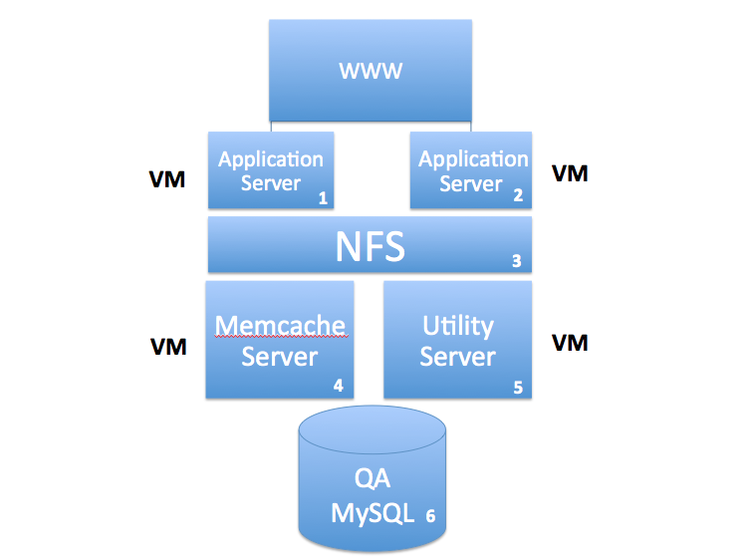

## Appendix A:

* MySQL Cluster instance - 100 GB of storage
* Memcache - physical hardware. Need to procure it. Ability to increase memory. 16 - 32 GB of RAM.
* 200 GB for NFS
* 4 GB, one core, 20 GB of disk
* Stateadm access on all servers
* **Work Lenz # 6064** - Social: Communities Viewpoints Migration
* Monitoring team - escalation information. TBD

## Appendix B: 2011-2012 Traffic Overview

|  |  |  |  |
| --- | --- | --- | --- |
| **Jan 1, 2011 - Jun 6, 2011 Visitors and Page Views** | | | |
|
| **Site** | **Visitors** | **Lower Bound** | **Page Views** |
| MyKmart Author Rollup | 125,356 | 119,013 | 250,991 |
| MyKmart Category Rollup | 6,314,720 | 6,009,088 | 18,295,770 |
| MyKmart Page Type Rollup | 6,312,067 | 6,006,563 | 17,762,622 |
| MySears Author Rollup | 2,022,785 | 326,275 | 3,225,509 |
| MySears Category Rollup | 10,657,596 | 4,460,204 | 29,645,730 |
| MySears Page Type Rollup | 10,631,818 | 4,440,910 | 28,603,990 |

|  |  |  |  |
| --- | --- | --- | --- |
| **Jan 1, 2012 - Jun 6, 2012 Visitors and Page Views** | | | |
|
| **Site** | **Visitors** | **Lower Bound** | **Page Views** |
| MyKmart Author Rollup | 4,864 | 2,213 | 0 |
| MyKmart Category Rollup | 1,655,171 | 1,499,419 | 5,161,387 |
| MyKmart Page Type Rollup | 1,654,018 | 1,498,375 | 4,676,548 |
| MySears Author Rollup | 4,864 | 2,213 | 0 |
| MySears Category Rollup | 3,367,535 | 1,869,319 | 11,517,797 |
| MySears Page Type Rollup | 3,345,032 | 1,850,806 | 10,029,365 |

## Appendix C: Jan 1, 2011 – Dec 31, 2011

## Browser Traffic

|  |  |  |  |  |  |  |
| --- | --- | --- | --- | --- | --- | --- |
| **MyKmart Browser Traffic** | | | | | | |
|
|  | **MyKmart Author** | | **MyKmart Cat. Rollup** | | **MyKmart Page Type.** | |
| Browser Name | **Visits** | **%** | **Visits** | **%** | **Visits** | **%** |
| Internet Explorer | 80,561 | 64.37% | 4,503,261 | 71.45% | 4,503,261 | 71.45% |
| Firefox | 23,243 | 18.57% | 897,476 | 14.24% | 897,476 | 14.24% |
| Chrome | 11,901 | 9.51% | 449,380 | 7.13% | 449,380 | 7.13% |
| Safari | 8,282 | 6.62% | 348,319 | 5.53% | 348,319 | 5.53% |
| Android Browser | 497 | 0.40% | 65,590 | 1.04% | 65,590 | 1.04% |
| IE with Chrome | 112 | 0.09% | 5,679 | 0.09% | 5,679 | 0.09% |
| Opera | 326 | 0.26% | 12,064 | 0.19% | 12,064 | 0.19% |
| Mozila Compatible | 103 | 0.08% | 15,626 | 0.25% | 15,626 | 0.25% |
| Other | 133 | 0.11% | 5,094 | 0.08% | 5,094 | 0.08% |
| **Total** | **125,158** |  | **6,302,489** |  | **6,302,489** |  |

|  |  |  |  |  |  |  |
| --- | --- | --- | --- | --- | --- | --- |
| **MySears Browser Traffic** | | | | | | |
|
|  | **MySears Author** | | **MySears Cat. Rollup** | | **MySears Page Type.** | |
| Browser Name | **Visits** | **%** | **Visits** | **%** | **Visits** | **%** |
| Internet Explorer | 974,100 | 48.30% | 5,429,991 | 51.11% | 5,416,540 | 51.11% |
| Firefox | 458,966 | 22.76% | 2,395,400 | 22.55% | 2,391,403 | 22.56% |
| Chrome | 225,485 | 11.18% | 1,061,988 | 10.00% | 1,059,570 | 10.00% |
| Safari | 296,267 | 14.69% | 1,380,010 | 12.99% | 1,375,622 | 12.98% |
| Android Browser | 31,575 | 1.57% | 193,794 | 1.82% | 192,827 | 1.82% |
| IE with Chrome | 1,783 | 0.09% | 10,599 | 0.10% | 10,568 | 0.10% |
| Opera | 9,956 | 0.49% | 39,317 | 0.37% | 39,031 | 0.37% |
| Mozila Compatible | 14,854 | 0.74% | 99,189 | 0.93% | 99,056 | 0.93% |
| Other | 3,601 | 0.18% | 13,913 | 0.13% | 13,883 | 0.13% |
| **Total** | **2,016,587** |  | **10,624,201** |  | **10,598,500** |  |

|  |  |  |  |  |  |  |
| --- | --- | --- | --- | --- | --- | --- |
| **MyKmart Internet Explorer Traffic** | | | | | | |
|  | **MyKmart Author Rollup** | | **MyKmart Cat. Rollup** | | **MyKmart Page Type Roll.** | |
| **Version** | **Visits** | **Percentage** | **Visits** | **Percentage** | **Visits** | **Percentage** |
| 9.0 | 16,474 | 20.45% | 575,912 | 12.59% | 575,499 | 12.78% |
| 8.0 | 53,354 | 68.23% | 3,091,033 | 68.64% | 3,090,377 | 68.64% |
| 7.0 | 8,980 | 11.15% | 479,487 | 10.65% | 479,388 | 10.65% |
| Other | 1,753 | 0.17% | 356,826 | 8.12% | 356,788 | 7.93% |
| **Total** | **80,561** |  | **4,503,258** |  | **4,502,052** |  |
|  |  |  |  |  |  |  |
| **MySears Internet Explorer Traffic** | | | | | | |
|  | **MySears Author Rollup** | | **MySears Cat. Rollup** | | **MySears Page Type Roll.** | |
| **Version** | **Visits** | **Percentage** | **Visits** | **Percentage** | **Visits** | **Percentage** |
| 9.0 | 132,074 | 13.56% | 949,901 | 17.49% | 946,381 | 17.47% |
| 8.0 | 655,075 | 67.25% | 3,442,018 | 63.39% | 3,434,040 | 63.40% |
| 7.0 | 155,279 | 15.94% | 776,197 | 14.29% | 774,778 | 14.30% |
| Other | 31,672 | 3.25% | 261,863 | 4.83% | 261,329 | 4.83% |
| **Total** | **974,100** |  | **5,429,979** |  | **5,416,528** |  |
|  |  |  |  |  |  |  |
| **MyKmart Firefox Traffic** | | | | | | |
|  | **MyKmart Author Rollup** | | **MyKmart Cat. Rollup** | | **MyKmart Page Type Roll.** | |
| **Version** | **Visits** | **Percentage** | **Visits** | **Percentage** | **Visits** | **Percentage** |
| 3.6.13 | 3,693 | 15.89% | 129,395 | 14.42% | 129,394 | 14.42% |
| 4.0.1 | 2,916 | 12.55% | 85,446 | 9.52% | 85,437 | 9.52% |
| 5.0 | 2,659 | 11.44% | 68,786 | 7.66% | 68,777 | 7.67% |
| Other | 13,975 | 60.12% | 613,849 | 68.40% | 613,536 | 68.39% |
| **Total** | **23,243** |  | **897,476** |  | **897,144** |  |
|  |  |  |  |  |  |  |
| **MySears Firefox Traffic** | | | | | | |
|  | **MySears Author Rollup** | | **MySears Cat. Rollup** | | **MySears Page Type Roll.** | |
| **Version** | **Visits** | **Percentage** | **Visits** | **Percentage** | **Visits** | **Percentage** |
| 3.6.13 | 107,705 | 23.47% | 379,827 | 15.86% | 379,478 | 15.87% |
| 4.0.1 | 47,729 | 10.40% | 190,881 | 7.97% | 190,723 | 7.98% |
| 5.0 | 44,078 | 9.60% | 168,889 | 7.05% | 168,630 | 7.05% |
| Other | 259,454 | 56.53% | 1,655,803 | 69.12% | 1,652,572 | 69.10% |
| **Total** | **458,966** |  | **2,395,400** |  | **2,391,403** |  |

## Appendix D: Jan 1, 2012 – Jun 6, 2012

## Browser Traffic

|  |  |  |  |  |  |  |
| --- | --- | --- | --- | --- | --- | --- |
| **MyKmart Browser Traffic** | | | | | | |
|
|  | **MyKmart Author** | | **MyKmart Cat. Rollup** | | **MyKmart Page Type.** | |
| Browser Name | **Visits** | **%** | **Visits** | **%** | **Visits** | **%** |
| Internet Explorer | 2,120 | 43.60% | 1,088,047 | 65.82% | 1,087,549 | 65.79% |
| Firefox | 1,101 | 22.65% | 258,743 | 15.65% | 258,627 | 15.65% |
| Chrome | 970 | 19.95% | 132,498 | 8.02% | 132,391 | 8.01% |
| Safari | 502 | 10.32% | 109,513 | 6.62% | 109,138 | 6.60% |
| Android Browser | 139 | 2.86% | 52,781 | 3.19% | 52,768 | 3.19% |
| IE with Chrome | 8 | 0.16% | 3,145 | 0.19% | 3,144 | 0.19% |
| Opera | 15 | 0.31% | 2,367 | 0.14% | 2,327 | 0.14% |
| Mozila Compatible | 3 | 0.06% | 4,123 | 0.25% | 4,122 | 0.25% |
| Other | 4 | 0.08% | 1,832 | 0.11% | 1,832 | 0.11% |
| **Total** | **4,862** |  | **1,653,049** |  | **1,651,898** |  |

|  |  |  |  |  |  |  |
| --- | --- | --- | --- | --- | --- | --- |
| **MySears Browser Traffic** | | | | | | |
|
|  | **MySears Author** | | **MySears Cat. Rollup** | | **MySears Page Type.** | |
| Browser Name | **Visits** | **%** | **Visits** | **%** | **Visits** | **%** |
| Internet Explorer | 2,120 | 43.60% | 1,367,984 | 40.82% | 1,358,093 | 40.80% |
| Firefox | 1,101 | 22.65% | 830,471 | 24.78% | 827,565 | 24.86% |
| Chrome | 970 | 19.95% | 503,703 | 15.03% | 404,923 | 12.16% |
| Safari | 502 | 10.32% | 407,290 | 12.15% | 498,814 | 14.99% |
| Android Browser | 139 | 2.86% | 142,895 | 4.26% | 141,099 | 4.24% |
| IE with Chrome | 8 | 0.16% | 5,314 | 0.16% | 5,273 | 0.16% |
| Opera | 15 | 0.31% | 11,074 | 0.33% | 10,836 | 0.33% |
| Mozila Compatible | 3 | 0.06% | 69,698 | 2.08% | 69,486 | 2.09% |
| Other | 4 | 0.08% | 12,686 | 0.38% | 12,645 | 0.38% |
| **Total** | **4,862** |  | **3,351,115** |  | **3,328,734** |  |

|  |  |  |  |  |  |  |
| --- | --- | --- | --- | --- | --- | --- |
| **MyKmart Internet Explorer Traffic** | | | | | | |
|  | **MyKmart Author Rollup** | | **MyKmart Cat. Rollup** | | **MyKmart Page Type Roll.** | |
| **Version** | **Visits** | **Percentage** | **Visits** | **Percentage** | **Visits** | **Percentage** |
| 9.0 | 876 | 41.32% | 300,111 | 27.58% | 299,935 | 27.58% |
| 8.0 | 1,019 | 48.07% | 673,581 | 61.91% | 673,309 | 61.91% |
| 7.0 | 219 | 10.33% | 92,629 | 8.51% | 92,596 | 8.51% |
| Other | 6 | 0.28% | 21,726 | 2.00% | 21,709 | 2.00% |
| **Total** | **2,120** |  | **1,088,047** |  | **1,087,549** |  |

|  |  |  |  |  |  |  |
| --- | --- | --- | --- | --- | --- | --- |
| **MySears Internet Explorer Traffic** | | | | | | |
|  | **MySears Author Rollup** | | **MySears Cat. Rollup** | | **MySears Page Type Roll.** | |
| **Version** | **Visits** | **Percentage** | **Visits** | **Percentage** | **Visits** | **Percentage** |
| 9.0 | 876 | 41.32% | 606,619 | 44.34% | 602,287 | 44.35% |
| 8.0 | 1,019 | 48.07% | 621,861 | 45.46% | 617,271 | 45.45% |
| 7.0 | 219 | 10.33% | 126,153 | 9.22% | 125,369 | 9.23% |
| Other | 6 | 0.28% | 13,351 | 0.98% | 13,166 | 0.97% |
| **Total** | **2,120** |  | **1,367,984** |  | **1,358,093** |  |

|  |  |  |  |  |  |  |
| --- | --- | --- | --- | --- | --- | --- |
| **MyKmart Firefox Traffic** | | | | | | |
|  | **MyKmart Author Rollup** | | **MyKmart Cat. Rollup** | | **MyKmart Page Type Roll.** | |
| **Version** | **Visits** | **Percentage** | **Visits** | **Percentage** | **Visits** | **Percentage** |
| 9.0.1 | 220 | 19.98% | 112,198 | 43.36% | 112,170 | 43.37% |
| 12.0 | 195 | 17.71% | 17,644 | 6.82% | 17,640 | 6.82% |
| 10.0.2 | 177 | 16.08% | 27,739 | 10.72% | 27,716 | 10.72% |
| 11.0 | 166 | 15.08% | 26,306 | 10.17% | 26,290 | 10.17% |
| Other | 343 | 31.15% | 74,856 | 28.93% | 74,811 | 28.93% |
| **Total** | **1,101** |  | **258,743** |  | **258,627** |  |

|  |  |  |  |  |  |  |
| --- | --- | --- | --- | --- | --- | --- |
| **MySears Firefox Traffic** | | | | | | |
|  | **MySears Author Rollup** | | **MySears Cat. Rollup** | | **MySears Page Type Roll.** | |
| **Version** | **Visits** | **Percentage** | **Visits** | **Percentage** | **Visits** | **Percentage** |
| 9.0.1 | 220 | 19.98% | 310,102 | 37.34% | 309,605 | 37.41% |
| 12.0 | 195 | 17.71% | 79,418 | 9.56% | 79,072 | 9.55% |
| 10.0.2 | 177 | 16.08% | 108,890 | 13.11% | 108,592 | 13.12% |
| 11.0 | 166 | 15.08% | 71,392 | 8.60% | 70,544 | 8.52% |
| Other | 343 | 31.15% | 260,669 | 31.39% | 259,752 | 31.39% |
| **Total** | **1,101** |  | **830,471** |  | **827,565** |  |