**Steps to populate data:**

1. Open Microsoft SQL Server Management Studio
2. Run the following DDL script attached with the project.
3. Right-click on the database name “Steam” on the Object Explorer, then click on “Tasks” and then “Import Data…”

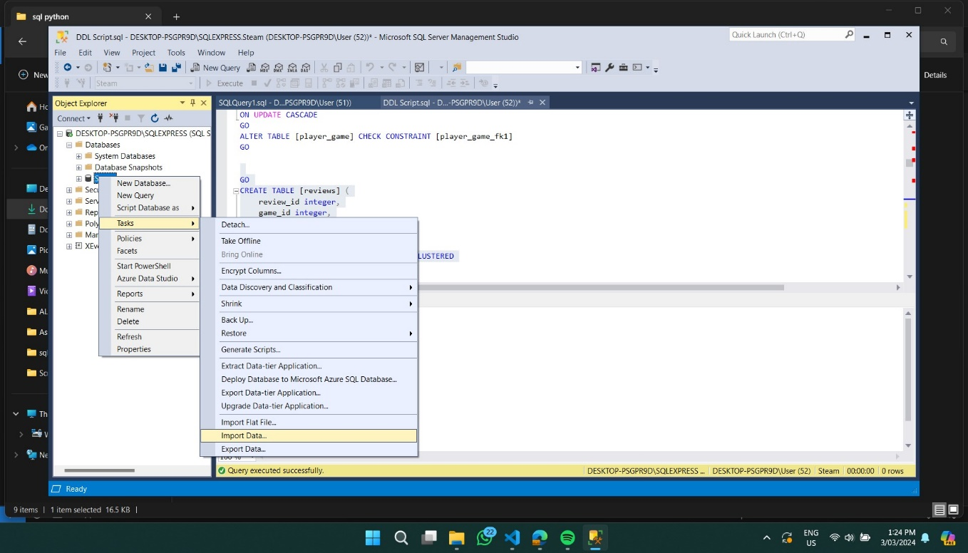

1. Select “Flat File Source”, and then browse your computer and upload anyone of the CSV’s provided. **Note:** The name of the CSV represents its corresponding table i.e. uploading the file ‘reviews.csv’ will populate the ‘reviews’ table.

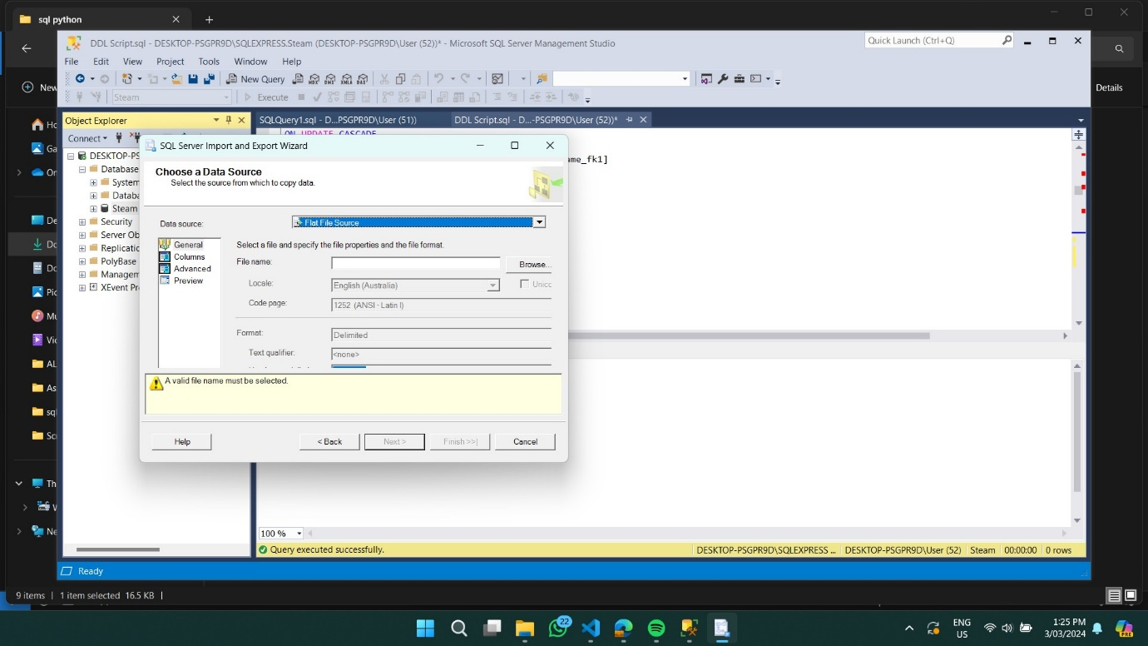

1. For columns with large sentences, always make sure to go to “Advanced”, select the column and change its data type to “text stream” to avoid truncation when uploading. This step will be repeated when uploading any CSV file which has large sentences such as descriptions or messages.

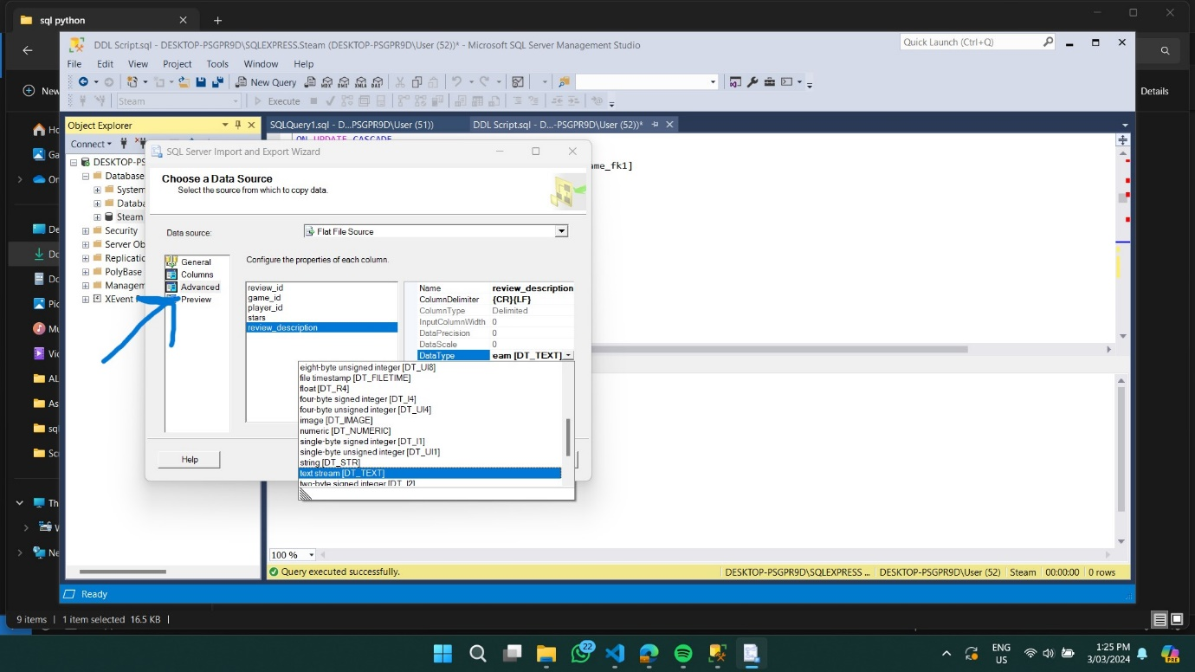

1. Select “SQL Server Native Client 11.0” as your destination for the data

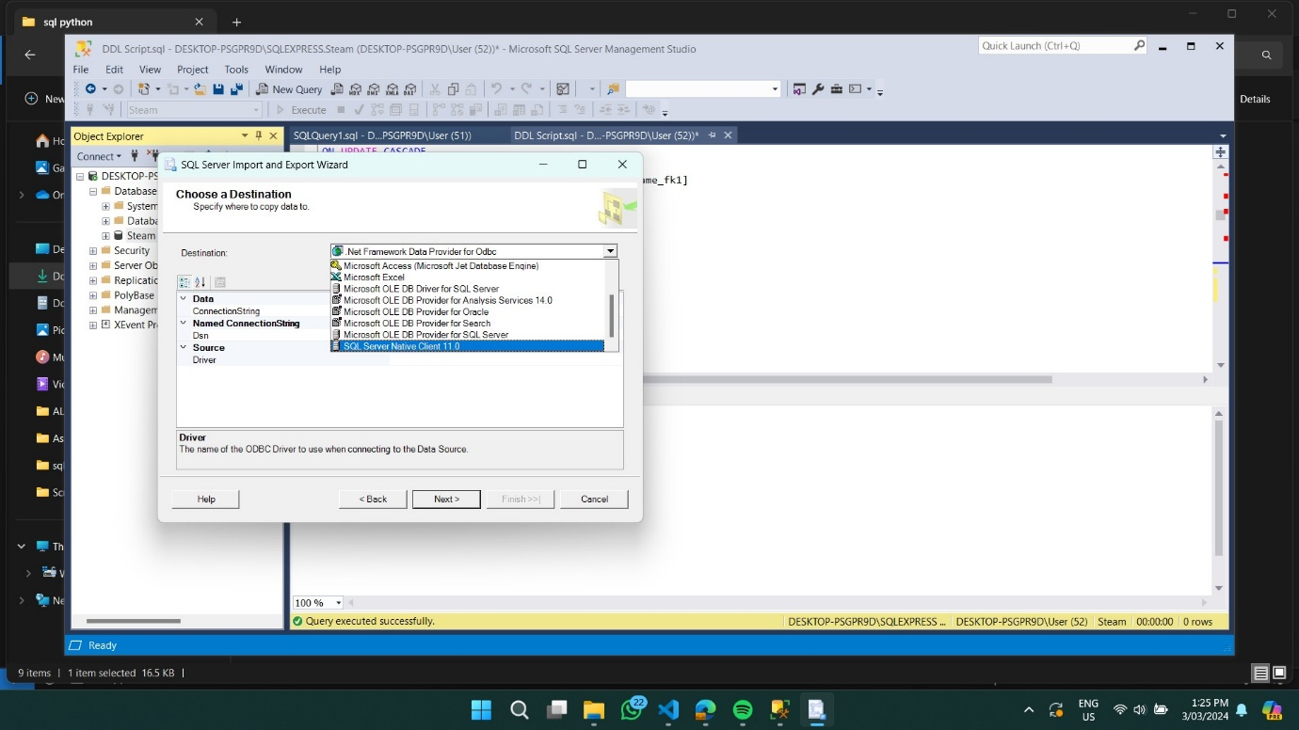

1. Keep clicking “Next” and then finally “Finish” and your data will be imported to its corresponding table.

Link to our Data: [dwh/Data at main · hshariq/dwh (github.com)](https://github.com/hshariq/dwh/tree/main/Data)

Link to our Python Notebooks used to populate: [hshariq/dwh (github.com)](https://github.com/hshariq/dwh)