

Python Vs R : The Battle is On !!!

So here we are in 21st century and according to Harvard Business Review Data scientist is the sexiest job of 21st century..

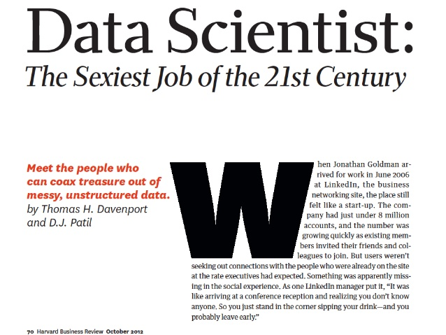

So this battle is about which programming is best for Machine Learning. Is it R or Python ?

Let’s talk about these two :

Python

Python is a general purpose language created by Guido Van Rossum which is designed to be simple to read and write.

Python emphasize more on logic rather than syntax that’s why it is a loosely typed language.

People from any background like bio, math, commerce, electronics can easily learn python. Python allows programmers to express concept in fewer lines of code than any other language.

Python is not a new language. It was first appeared on Feb 20, 1991.

R Programming

R is an open source programming language that is mainly focused on delivering a better and more user-friendly way to do data analysis, statistics and graphical model.

R is one of the fastest growing statistical language in corporate world. R also emphasize on logic rather than syntax. R is also a loosely typed language.

R was designed by Ross Ihaka and [Robert Gentleman](https://en.wikipedia.org/wiki/Robert_Gentleman_(statistician)) and was first appeared on August 1993.

Now the differences are :

1. R is only found in Data Science Environment whereas Python is a general purpose language and it is widely used in many fields like web development, software development and testing.

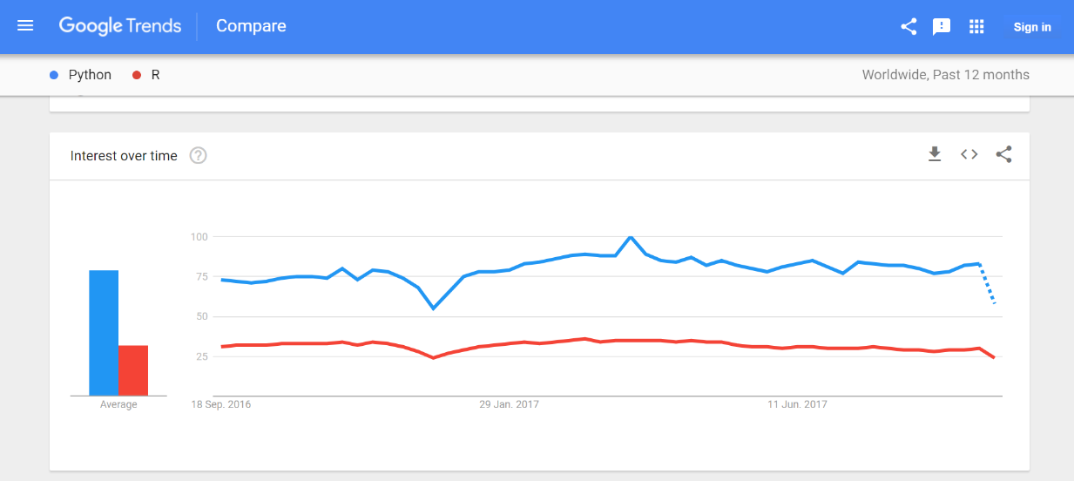

1. R is a low level programming language and simple procedures can take longer codes while Python is a high level programming language and known for its simplicity in programming world.

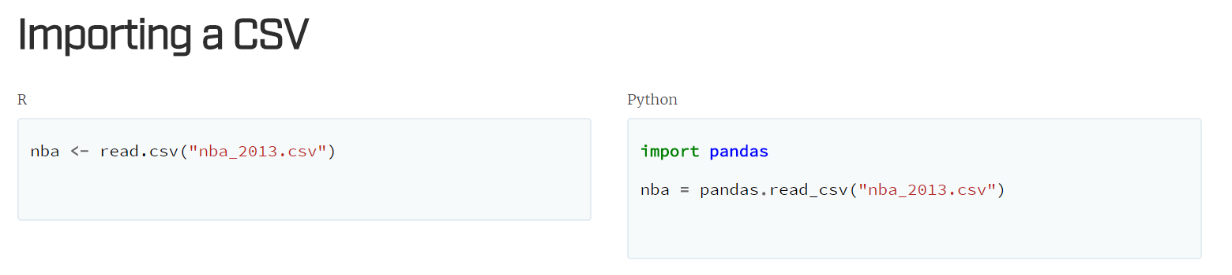

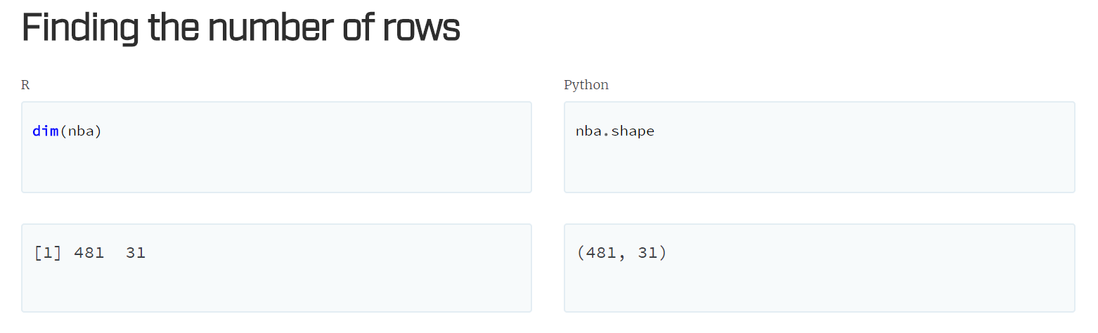

1. R has highly advanced Graphical Capabilities. There are numerous packages which provides you advanced graphical capabilities. But seaborn library of python makes custom plots never been easier.



1. When it comes to job, most of the big organizations are using R. Python on the other hand have been reported to increase over last few years. Companies like Google, NASA and Dropbox are using python which makes it different from other languages.

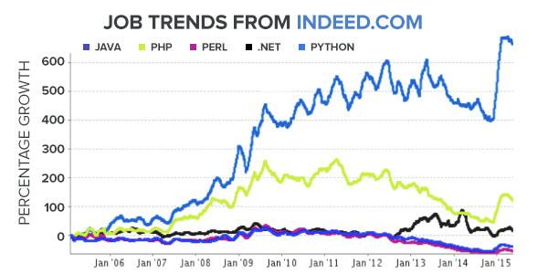

1. In terms of features, R got the packages like dplyr, plyr, caret, ggplot, zoo etc. Python is also popular for its rich set of libraries for machine learning like Numpy, Scipy, Matplotlib, Pandas and most important is scikit-learn.

